UNITED STATES

SECURITIES AND EXCHANGE COMMISSION
Washington, D.C. 20549

SCHEDULE 14A INFORMATION

Proxy Statement Pursuant to Section 14(a) of the

Securities Exchange Act of 1934
(Amendment No. )

Filed by the Registrant ☒ Filed by a Party other than the Registrant ☐

Check the appropriate box:

- Preliminary Proxy Statement

- Confidential, for Use of the Commission Only (as permitted by Rule 14a-6(e)(2))

- Definitive Proxy Statement

- Definitive Additional Materials

- Soliciting Material under §240.14a-12

NN, INC.

(Name of registrant as specified in its charter)

(Name of person(s) filing proxy statement, if other than the registrant)

Payment of Filing Fee (Check the appropriate box):

- No fee required

- Fee computed on table below per Exchange Act Rules 14a-6(i)(1) and 0-11

  - Title of each class of securities to which transaction applies:

  - Aggregate number of securities to which transaction applies:

  - Per unit price or other underlying value of transaction computed pursuant to Exchange Act Rule 0-11 (set forth the amount on which the filing fee is calculated and state how it was determined):

  - Proposed maximum aggregate value of transaction:

  - Total fee paid:

- Fee paid previously with preliminary materials.

- Check box if any part of the fee is offset as provided by Exchange Act Rule 0-11(a)(2) and identify the filing for which the offsetting fee was paid previously. Identify the previous filing by registration statement number, or the Form or Schedule and the date of its filing.

  - Amount Previously Paid:

  - Form, Schedule or Registration Statement No.:

  - Filing Party:

- Date Filed:


Your Vote Counts!

NN, INC.

2021 Annual Meeting

Vote by May 26, 2021
11:59 PM EDT

NN, INC.


6210 ARDREY KELL ROAD, SUITE 600
CHARLOTTE, NC 28277


D50414-P52329


You invested in NN, INC. and it’s time to vote!

You have the right to vote on proposals being presented at the Annual Meeting. This is an important notice regarding the availability of proxy material for the stockholder meeting to be held on May 27, 2021.

Get informed before you vote

View the Notice and Proxy Statement and Form 10-K online OR you can receive a free paper or email copy of the material(s) by requesting prior to May 13, 2021. If you would like to request a copy of the material(s) for this and/or future stockholder meetings, you may (1) visit www.ProxyVote.com, (2) call 1-800-579-1639 or (3) send an email to sendmaterial@proxyvote.com. If sending an email, please include your control number (indicated below) in the subject line. Unless requested, you will not otherwise receive a paper or email copy.
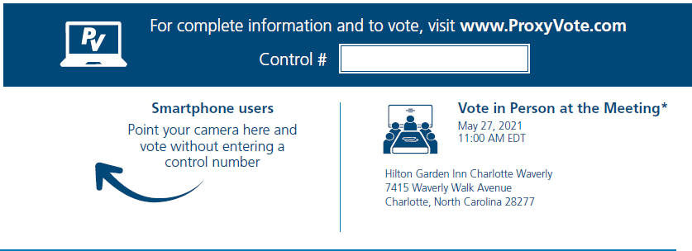

*Please check the meeting materials for any special requirements for meeting attendance. At the meeting, you will need to request a ballot to vote these shares.

V1

Vote at www.ProxyVote.com

THIS IS NOT A VOTABLE BALLOT

This is an overview of the proposals being presented at the upcoming

stockholder meeting. Please follow the instructions on the reverse side

to vote these important matters.

 |  |  |  |  |  |  | Board
Voting Items |  |  |  |  |  |  | Recommends
1. | Election of Directors
 | Nominees:
 | 01) | Raynard D. Benvenuti | 04) | João Faria | 07) | Warren A. Veltman | For
 | 02) | Robert E. Brunner | 05) | Jeri J. Harman | 08) | Thomas H. Wilson, Jr.
 | 03) | Christina E. Carroll | 06) | Dr. Shihab Kuran
2. | Advisory (non-binding) vote to approve the compensation of the named executive officers of NN, Inc. |  |  |  |  |  | For
3. | Advisory (non-binding) vote to ratify the selection of Grant Thornton LLP as registered independent public accounting firm. |  |  |  |  |  | For
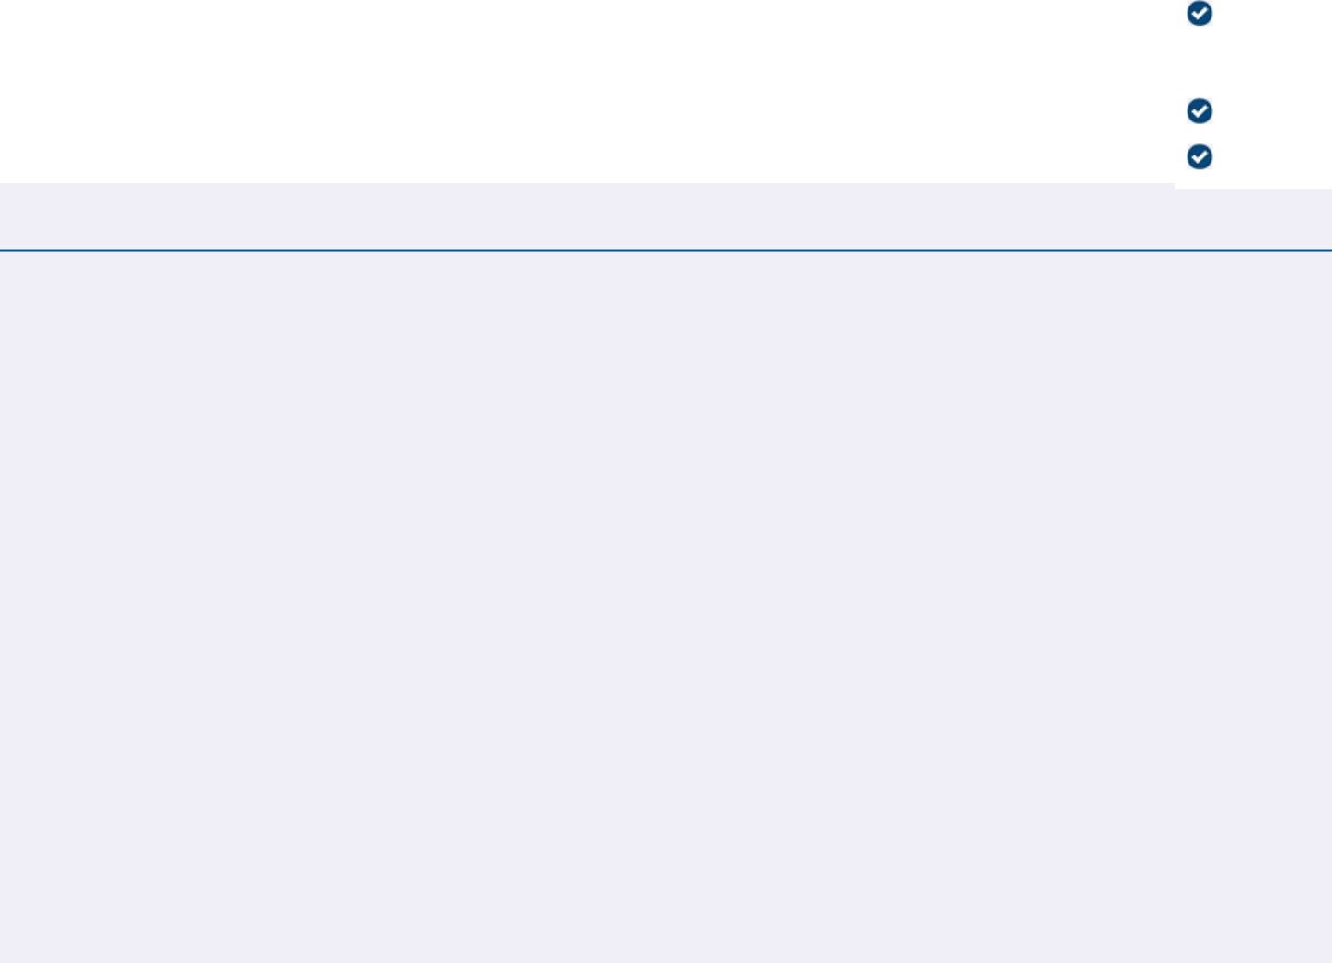
NOTE: In their discretion, the proxies are authorized to vote on such other business as may properly come before the meeting or any adjournment thereof.

Prefer to receive an email instead? While voting on www.ProxyVote.com, be sure to click “Sign up for E-delivery”.

D50415-P52329

