UNITED STATES

SECURITIES AND EXCHANGE COMMISSION
WASHINGTON, DC 20549

FORM 8-K

CURRENT REPORT PURSUANT TO

SECTION 13 OR 15(d) OF THE
SECURITIES EXCHANGE ACT OF 1934

Date of Report (Date of earliest event reported): November 5, 2015 (November 4, 2015)


NN, INC.

(Exact name of registrant as specified in its charter)

Delaware

0-23486

62-1096725

(State or Other Jurisdiction of Incorporation)

(Commission File Number)

(I.R.S. Employer Identification No.)

207 Mockingbird Lane,

Johnson City, Tennessee

37604

(Address of principal executive offices)

(Zip Code)

(423) 743-9151

(Registrant’s telephone number, including area code)

(Former name or former address, if changed since last report)

Check the appropriate box if the Form 8-K filing is intended to simultaneously satisfy the filing obligation of the registrant under any of the following provisions (see General Instruction A.2. below):

- Written communications pursuant to Rule 425 under the Securities Act (17 CFR 230.425)

- Soliciting material pursuant to Rule 14a-12 under the Exchange Act (17 CFR 240.14a-12)

- Pre-commencement communications pursuant to Rule 14d-2(b) under the Exchange Act (17 CFR 240.14d- 2(b))

- Pre-commencement communications pursuant to Rule 13e-4(c) under the Exchange Act (17 CFR 240.13e- 4(c))

ITEM 2.02 RESULTS OF OPERATIONS AND FINANCIAL CONDITION

On November 4, 2015, NN, Inc. (the “Company”) issued a press release announcing the Company’s results of operations and financial condition for the three months ended September 30, 2015. The full text of the press release is furnished as Exhibit 99.1 and is incorporated herein by reference.

ITEM 7.01 REGULATION FD DISCLOSURE

On November 4, 2015, the Company posted a presentation regarding the Company’s results of operations and financial condition for the three months ended September 30, 2015 to the Investor Relations section of its website at www.nninc.com. A copy of the presentation is furnished as Exhibit 99.2 and is incorporated herein by reference.

On November 4, 2015, the Company also posted to its website a presentation containing a reconciliation of the non-GAAP financial measures included in Exhibit 99.2 to their nearest GAAP (as defined below) financial measures. A copy of the presentation is furnished as Exhibit 99.3 and is incorporated herein by reference.

Pursuant to the rules and regulations of the U.S. Securities and Exchange Commission (the “SEC”), the information furnished pursuant to Item 2.02 and 7.01 of this Current Report on Form 8-K is deemed to have been furnished and shall not be deemed to be “filed” for purposes of Section 18 of the Securities Exchange Act of 1934, as amended, or otherwise subject to the liabilities of that section. Such information shall not be incorporated by reference into any filing of the Company, whether made before or after the date hereof, regardless of any general incorporation language in such filing.

Exhibit 99.1 and Exhibit 99.2 contain certain “non-GAAP financial measures” as that term is defined by the rules and regulations of the SEC. The non-GAAP financial measures used in Exhibit 99.1 and Exhibit 99.2 have inherent limitations as performance measures and should not be considered in isolation of, as a substitute for, or superior to, financial information prepared in accordance with U.S. generally accepted accounting principles (“GAAP”). The non-GAAP financial measures contained in Exhibit 99.1 and Exhibit 99.2 may differ from similarly titled measures presented by other companies. The non-GAAP financial measures, as well as other information contained in Exhibit 99.1 and Exhibit 99.2, should be read in conjunction with the Company’s financial statements filed with the SEC.

ITEM 9.01 FINANCIAL STATEMENTS AND EXHIBITS

Exhibit No. |  | Description
99.1 |  | Press Release of NN, Inc. dated November 4, 2015.
99.2 |  | Third Quarter 2015 |  | Earnings Release Presentation of NN, Inc. dated November 4, 2015.
99.3 |  | Third Quarter 2015 |  | Non-GAAP to GAAP Reconciliation Presentation of NN, Inc. dated November 4, 2015.

SIGNATURES

Pursuant to the requirements of the Securities Exchange Act of 1934, the registrant has duly caused this report to be signed on its behalf by the undersigned hereunto duly authorized.

Date: November 5, 2015

NN, INC.

By: | /s/ Matthew S. Heiter
Name: | Matthew S. Heiter
Title: | Senior Vice President and General Counsel

 |  |  |  | EXHIBIT INDEX
Exhibit No. |  | Description
99.1 |  | Press Release of NN, Inc. dated November 4, 2015.
99.2 |  | Third Quarter 2015 |  | Earnings Release Presentation of NN, Inc. dated November 4, 2015.
99.3 |  | Third Quarter 2015 |  | Non-GAAP to GAAP Reconciliation Presentation of NN, Inc. dated November 4, 2015.

Exhibit 99.1



RE: NN, Inc.

207 Mockingbird Lane

3rd Floor

Johnson City, TN 37604

FOR FURTHER INFORMATION:

AT THE COMPANY

Robbie Atkinson

Corporate Treasurer & Investor Relations

(423) 434-8398

AT FINANCIAL RELATIONS BOARD

Marilynn Meek

(General info)

212-827-3773

FOR IMMEDIATE RELEASE

November 4, 2015

NN, INC. REPORTS THIRD QUARTER 2015 RESULTS

- Net sales of $154.8 million, an increase of $29.2 million

- Adjusted income from operations grew to $15.3 million

- Adjusted net income of $8.3 million or $0.31 per diluted share

Johnson City, Tenn, November 4, 2015 –NN, Inc., (NASDAQ: NNBR) a diversified industrial company, today reported its financial results for the third quarter ended September 30, 2015.

Third Quarter 2015 Results

Net sales for the third quarter of 2015 increased $29.2 million, or 23% to $154.8 million, compared to $125.6 million for the third quarter of 2014. Acquisitions added $41.6 million in revenue. Negative currency impacts reduced reported net sales by $7.8 million versus the third quarter of last year.

Adjusted income from operations for the third quarter of 2015 was $15.3 million, an increase of 44%, compared to $10.6 million for the same period in 2014. Adjusted net income, which excludes the after-tax impact of foreign exchange on inter-company loans and after-tax acquisition and integration expenses, increased to $8.3 million, or $0.31 per diluted share, compared to $6.3 million, or $0.34 per diluted share for the same period in 2014. In the quarter the Company also issued 7.6 million shares related to the completion of the follow-on stock offering earlier this year.

On a GAAP basis, income from operations for the third quarter of 2015 was $10.1 million, compared to $2.6 million for the same period in 2014. Net income on a GAAP basis for the third quarter of 2015 was $4.6 million, or $0.17 per diluted share. This compares to a net loss $3.8 million, or $0.21 per diluted share in the third quarter of 2014.

Richard Holder, President and Chief Executive Officer, commented, “The third quarter presented a series of challenges in the broader economy that impacted our sales during the quarter. Despite these headwinds we began to see the impact of the NN Operating System as we were able to appropriately manage our business in a rapidly changing environment and deliver strong operating performance.”

Business Group Results

Metal Bearing Components

Net sales for the group decreased $9.0 million to $60.5 million during the third quarter of 2015, compared to $69.6 million for third quarter 2014. Negative currency impacts of $6.7 million as well as volume and price/mix reductions of $2.3 million accounted for the decline. Income from operations for the third quarter was $6.6 million, compared to $7.6 million in the third quarter of 2014.

“Changes in demand in Asia as well as the continued effects of negative currency translation weighed on our MBC business during the quarter as sales declined $9.0 million,” said Holder. “However, the business was still able to hold operating margins on a year over year basis as we continue to drive results through the operating system.”

Autocam Precision Components

Net sales for the third quarter of 2015 were $83.2 million, compared to $46.6 million in the third quarter of 2014, an increase of $36.6 million. Acquisitions accounted for $39.7 million of the increase. Income from operations for the quarter increased $5.4 million to $10.9 million, compared to $5.5 million in the third quarter of 2014.

Holder commented, “The Autocam Precision Components Group continued to perform well despite the conditions in Asia and Brazil. APC’s focus is on CAFE technologies that have adoption rates and growth trends not tied to normal end market cyclicality. In accordance with our continued execution of our Autocam synergy plan we’re announcing the closure of one of our APC facilities early next year.”

Plastic and Rubber Components

Net sales for the third quarter increased $1.6 million to $11.0 million, compared to $9.4 million for the same period in 2014. Income from operations for the quarter was $0.6 million, compared to $0.2 million in 2014.

Precision Engineered Products (PEP) Acquisition Update

Holder commented, “As announced during the third quarter we closed the PEP acquisition in October. Year to date PEP’s sales and margins continue to be in line with our expectations. Starting with the fourth quarter we will be reporting PEP as a segment within our portfolio. Additionally, the PEP Group will include our existing Plastic and Rubber Components Group as part of our continued focus on properly aligning all of our businesses to address the end markets we serve. PEP is an important part of our strategic plan and we again welcome the team to our family.”

Guidance

Holder continued, “As previously committed, beginning with the fourth quarter we will initiate a more comprehensive set of financial guidance designed to help our shareholders have the appropriate information to accurately evaluate our performance. This will include sales, adjusted EBITDA, adjusted operating margin, and adjusted earnings per share. With the completion of the PEP acquisition we will also begin excluding non-cash amortization charges from our adjusted earnings per share. We believe removing these charges provides the shareholder with the best evaluation of the Company’s performance.”

The full set of financial guidance for the fourth quarter and 2016 can be found in our supplemental deck on our website.

Holder concluded, “I am encouraged with our results in the face of an ever changing macro environment. Our focus this year on implementing the NN Operating System and managing our organizational flex has had a significant impact on the quarter as we were able to deliver operating improvements in all of our businesses. Finally, with the announcement and subsequent close of the PEP acquisition we remain focused on executing our strategic plan.”

- will discuss its results during its quarterly investor conference call tomorrow morning starting at 9:00 a.m. ET. The call and an accompanying slide presentation may be accessed via NN’s website. The conference call can also be accessed by dialing 888-427-9376; conference id – 5901109. For those who are unavailable to listen to the live broadcast, a replay will be available shortly after the call for 90 days.

The attached financial tables include a reconciliation of adjusted income from operations, adjusted net income and adjusted earnings per share to the U.S. GAAP financial measures of income from operations and net income.

NN, Inc., a diversified industrial company manufactures and supplies high precision metal bearing components, industrial plastic and rubber products and precision metal components to a variety of markets on a global basis. Headquartered in Johnson City, Tennessee, NN has 43 manufacturing plants in the North America, Western Europe, Eastern Europe, South America and China.

Except for specific historical information, many of the matters discussed in this press release may express or imply projections of revenues or expenditures, statements of plans and objectives or future operations or statements of future economic performance. These, and similar statements, are forward-looking statements concerning matters that involve risks, uncertainties and other factors which may cause the actual performance of NN, Inc. and its subsidiaries to differ materially from those expressed or implied by this discussion. All forward-looking information is provided by the Company pursuant to the safe harbor established under the Private Securities Litigation Reform Act of 1995 and should be evaluated in the context of these factors. Forward-looking statements generally can be identified by the use of forward-looking terminology such as “assumptions”, “target”, “guidance”, “outlook”, “plans”, “projection”, “may”, “will”, “would”, “expect”, “intend”, “estimate”, “anticipate”, “believe”, “potential” or “continue” (or the negative or other derivatives of each of these terms) or similar terminology. Factors which could materially affect actual results include, but are not limited to: general economic conditions and economic conditions in the industrial sector, inventory levels, regulatory compliance costs and the Company’s ability to manage these costs, start-up costs for new operations, debt reduction, competitive influences, risks that current customers will commence or increase captive production, risks of capacity underutilization, quality issues, availability and price of raw materials, currency and other risks associated with international trade, the Company’s dependence on certain major customers, and the successful implementation of the global growth plan including development of new products. Similarly, statements made herein and elsewhere regarding pending or completed acquisitions are also forward-looking statements, including statements relating to the anticipated closing date of an acquisition, the Company’s ability to obtain required regulatory approvals or satisfy closing conditions, the costs of an acquisition and the Company’s source(s) of financing, the future performance and prospects of an acquired business, the expected benefits of an acquisition on the Company’s future business and operations and the ability of the Company to successfully integrate recently acquired businesses.

For additional information concerning such risk factors and cautionary statements, please see the section titled “Risk Factors” in the Company’s periodic reports filed with the Securities and Exchange Commission, including, but not limited to, the Company’s Annual Report on Form 10-K for the fiscal year ended December 31, 2014 and quarterly report on form 10-Q for the quarterly period ended September 30, 2015. Except as required by law, we undertake no obligation to update or revise any forward-looking statements we make in our press releases, whether as a result of new information, future events or otherwise.

Financial Tables Follow

NN, Inc.

Consolidated Statements of Income

(In thousands, except per share amounts)

(Unaudited)

 |  |  |  | Three Months Ended |  |  |  |  |  |  |  | Nine Months Ended
(In Thousands of Dollars, Except Per Share Data) |  |  |  | September 30, |  |  |  |  |  |  |  | September 30,
 |  |  |  | 2015 |  |  |  | 2014 |  |  |  | 2015 |  |  | 2014
 | Net sales |  | $ | 154,824 |  |  | $ | 125,632 |  |  | $ | 483,425 |  | $ | 334,840
 | Cost of products sold (exclusive of depreciation and amortization shown separately below) |  |  | 120,195 |  |  |  | 100,441 |  |  |  | 378,220 |  |  | 265,010
 | Selling, general and administrative |  |  | 11,949 |  |  |  | 11,124 |  |  |  | 37,910 |  |  | 29,799
 | Acquisition related costs excluded from selling, general and administrative |  |  | 3,948 |  |  |  | 5,651 |  |  |  | 3,948 |  |  | 7,080
 | Depreciation and amortization |  |  | 8,610 |  |  |  | 5,864 |  |  |  | 25,702 |  |  | 13,824
Income from operations |  |  |  | 10,122 |  |  |  | 2,552 |  |  |  | 37,645 |  |  | 19,127
 | Interest expense |  |  | 4,584 |  |  |  | 5,622 |  |  |  | 16,543 |  |  | 6,737
 | Other expense, net |  |  | 593 |  |  |  | 1,557 |  |  |  | 2,012 |  |  | 1,769
 | Income (loss) before provision (benefit) for income taxes and share of net income from joint venture |  |  | 4,945 |  |  |  | (4,627) |  |  |  | 19,090 |  |  | 10,621
 | Provision (benefit) for income taxes |  |  | 936 |  |  |  | (562) |  |  |  | 4,009 |  |  | 4,247
 | Share of net income from joint venture |  |  | 621 |  |  |  | 225 |  |  |  | 2,503 |  |  | 225
 | Net income (loss) |  |  | 4,630 |  |  |  | (3,840) |  |  |  | 17,584 |  |  | 6,599
 | Basic income (loss) per common share: |  | $ | 0.17 |  | $ |  | (0.21) |  | $ |  | 0.87 |  | $ | 0.36
Weighted average shares outstanding
 |  |  |  | 26,839 |  |  |  | 17,979 |  |  |  | 20,122 |  |  | 17,749
 | Diluted income (loss) per common share: |  | $ | 0.17 |  | $ |  | (0.21) |  | $ |  | 0.86 |  | $ | 0.36
Weighted average shares outstanding
 |  |  |  | 27,167 |  |  |  | 17,979 |  |  |  | 20,467 |  |  | 18,120
 | Cash dividends per common share |  | $ | 0.07 |  | $ |  | 0.07 |  | $ |  | 0.21 |  | $ | 0.21

NN, Inc.

Condensed Balance Sheets

(In thousands)

(Unaudited)

 |  |  | September 30, |  |  |  | December 31,
(In Thousands of Dollars) |  |  |  | 2015 |  |  |  | 2014
 | Assets
 | Current assets:
 | Cash | $ |  | 40,102 |  | $ |  | 37,317
 | Accounts receivable, net |  |  | 108,144 |  |  |  | 97,510
 | Inventories |  |  | 92,579 |  |  |  | 91,469
 | Other current assets |  |  | 17,560 |  |  |  | 16,503
 | Total current assets |  |  | 258,385 |  |  |  | 242,799
 | Property, plant and equipment, net |  |  | 266,562 |  |  |  | 278,442
 | Goodwill, net |  |  | 85,447 |  |  |  | 83,941
 | Intangible asset, net |  |  | 51,829 |  |  |  | 52,827
 | Investment in joint venture |  |  | 37,088 |  |  |  | 34,703
 | Other non-current assets |  |  | 20,165 |  |  |  | 20,001
 | Total assets | $ |  | 719,476 |  | $ |  | 712,713
Liabilities and Stockholders’ Equity
 | Current liabilities:
 | Accounts payable | $ |  | 60,338 |  | $ |  | 71,094
 | Accrued salaries, wages and benefits |  |  | 18,362 |  |  |  | 21,148
 | Current maturities of long-term debt |  |  | 21,677 |  |  |  | 22,160
 | Income taxes payable |  |  | 4,933 |  |  |  | 3,274
 | Current portion of obligations under capital lease |  |  | 5,066 |  |  |  | 5,418
 | Other current liabilities |  |  | 10,747 |  |  |  | 14,504
 | Total current liabilities |  |  | 121,123 |  |  |  | 137,598
 | Non-current deferred tax liabilities |  |  | 46,950 |  |  |  | 49,461
 | Long-term debt, net of current portion |  |  | 184,356 |  |  |  | 328,026
 | Obligations under capital lease, net of current portion |  |  | 10,759 |  |  |  | 14,539
 | Other non-current liabilities |  |  | 12,584 |  |  |  | 9,390
 | Total liabilities |  |  | 375,772 |  |  |  | 539,014
 | Total stockholders’ equity |  |  | 343,704 |  |  |  | 173,699
 | Total liabilities and stockholders’ equity | $ |  | 719,476 |  | $ |  | 712,713

NN, Inc.

Reconciliation of Non-GAAP to GAAP Financial Measures

(Unaudited)

Reconciliation of net income to adjusted net income:

 |  |  |  |  | Three Months Ended |  |  |  |  |  |  |  |  |  | Three Months Ended
 |  |  |  |  | September 30, 2015 |  |  |  |  |  |  |  |  |  | September 30, 2014
 |  |  |  |  |  |  |  |  |  | Diluted |  |  |  |  |  |  |  |  |  |  | Diluted
 |  |  |  | (In Thousands) |  |  |  |  |  | Earnings |  |  |  | (In Thousands) |  |  |  |  |  | Earnings Per
 |  |  |  |  |  |  |  |  |  | Per Share |  |  |  |  |  |  |  |  |  |  | Share
 | Net Income |  | $ |  | 4,630 |  |  | $ |  | 0.17 |  |  | $ |  | (3,840) |  |  |  | $ |  | (0.21)
 | After tax acquisition and integration expenses |  |  |  | 3,372 |  |  |  |  | 0.13 |  |  |  |  | 9,222 |  |  |  |  |  | 0.50
 | After-tax foreign exchange gain on inter-company loans |  |  |  | 284 |  |  |  |  | 0.01 |  |  |  |  | 880 |  |  |  |  |  | 0.05
Adjusted Net Income |  |  | $ |  | 8,286 |  |  | $ |  | 0.31 |  |  | $ |  | 6,262 |  |  |  | $ |  | 0.34
Reconciliation of net income to adjusted net income:
 |  |  |  |  | Nine Months Ended |  |  |  |  |  |  |  |  |  | Nine Months Ended
 |  |  |  |  | September 30, 2015 |  |  |  |  |  |  |  |  |  | September 30, 2014
 |  |  |  |  |  |  |  |  |  | Diluted |  |  |  |  |  |  |  |  |  |  | Diluted
 |  |  |  | (In Thousands) |  |  |  |  |  | Earnings |  |  |  | (In Thousands) |  |  |  |  |  | Earnings Per
 |  |  |  |  |  |  |  |  |  | Per Share |  |  |  |  |  |  |  |  |  |  | Share
 | Net Income |  |  | $ | 17,584 |  |  |  | $ | 0.86 |  |  |  | $ | 6,599 |  |  |  |  | $ | 0.36
 | After tax acquisition and integration expenses |  |  |  | 3,808 |  |  |  |  | 0.19 |  |  |  |  | 10,354 |  |  |  |  |  | 0.57
 | After-tax foreign exchange loss on inter-company loans |  |  |  | 939 |  |  |  |  | 0.04 |  |  |  |  | 880 |  |  |  |  |  | 0.05
Adjusted Net Income |  |  |  | $ | 22,331 |  |  |  | $ | 1.09 |  |  |  | $ | 17,833 |  |  |  |  | $ | 0.98

Reconciliation of income from operations to adjusted income from operations:

 |  |  |  | Three Months |  |  | Three Months |  |  | Nine Months |  |  | Nine Months
 |  |  |  | Ended |  |  | Ended |  |  | Ended |  |  | Ended
 |  |  |  | September 30, |  |  | September 30, |  |  | September 30, |  |  | September 30,
 |  |  |  | 2015 |  |  | 2014 |  |  | 2015 |  |  | 2014
 |  |  | (In Thousands) |  |  | (In Thousands) |  |  | (In Thousands) |  |  | (In Thousands)
 | Income from operations |  | $ | 10,122 |  | $ | 2,552 |  | $ | 37,645 |  | $ | 19,127
 | Acquisition and integration expenses |  |  | 5,138 |  |  | 8,088 |  |  | 5,819 |  |  | 9,858
 | Adjusted Income from operations | $ |  | 15,260 | $ |  | 10,640 | $ |  | 43,464 | $ |  | 28,985

The Company discloses in this press release the non-GAAP financial measures of adjusted income from operations and adjusted net income. Each of adjusted income from operations and adjusted net income provide supplementary information about the impacts of acquisition related expenses and foreign-exchange impacts on intercompany loans. We believe the presentation of adjusted income from operations and adjusted net income provides useful information in assessing our results of operations and potential future results. These measures should not be considered as an alternative to their comparable GAAP measures, nor should they be considered in isolation, or as a substitute for analysis of our results reported under GAAP.



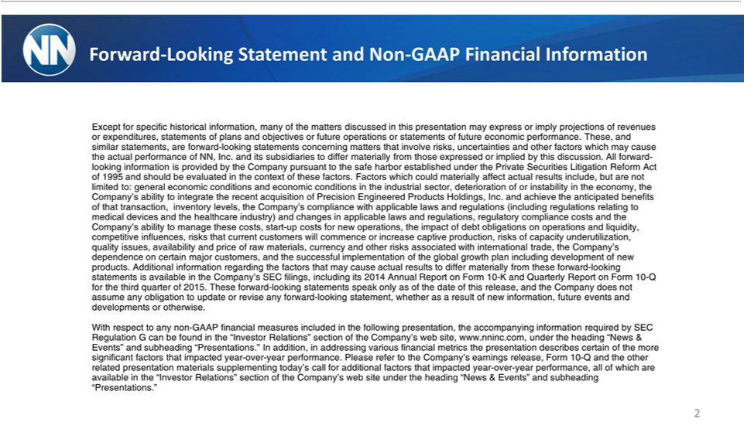

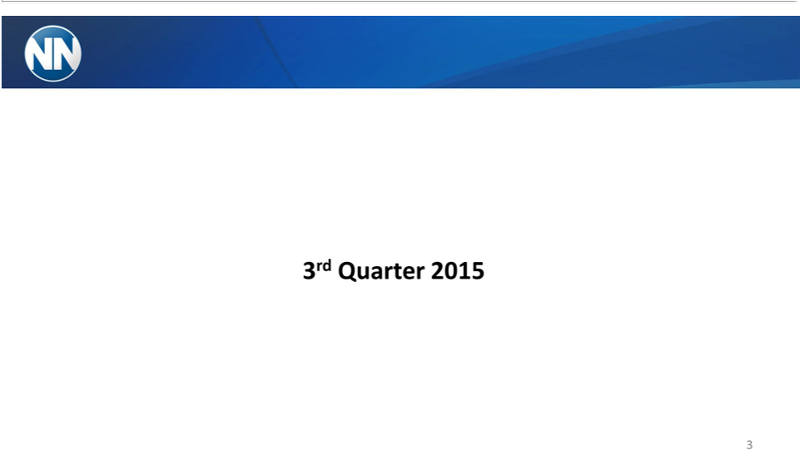

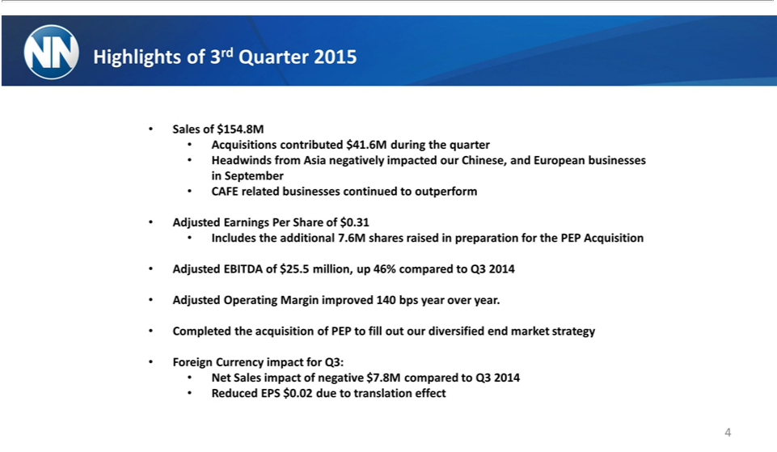

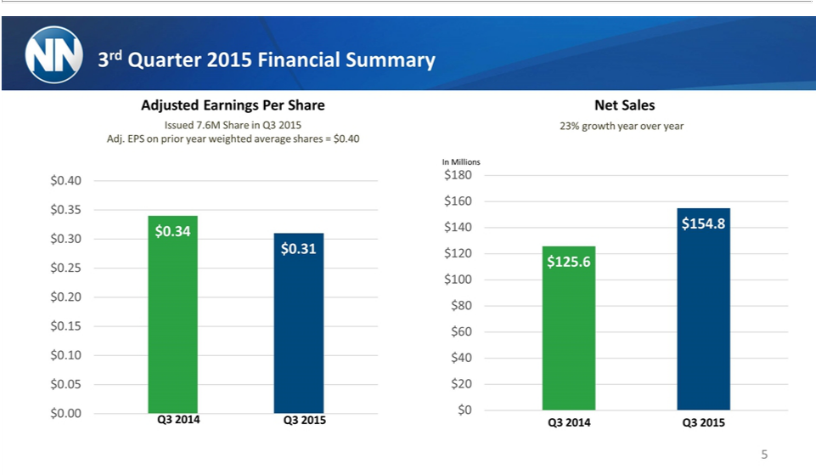

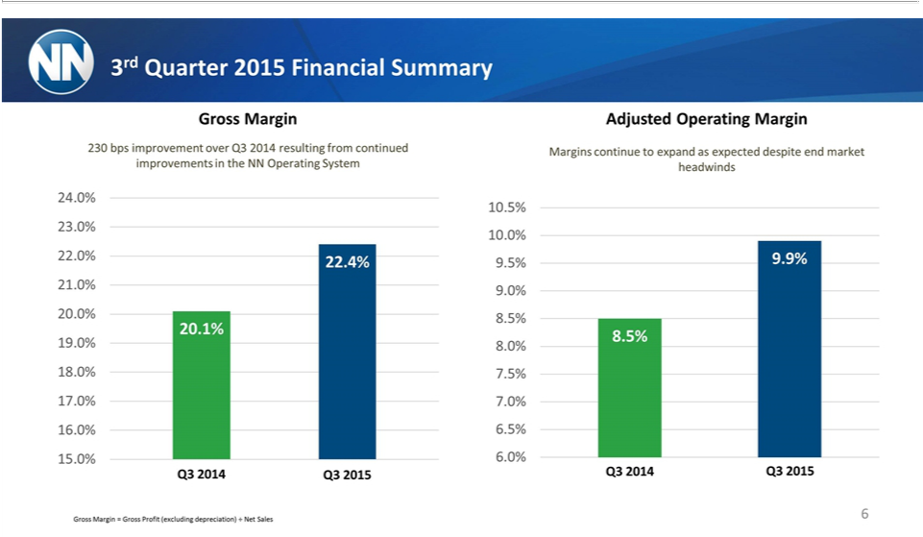

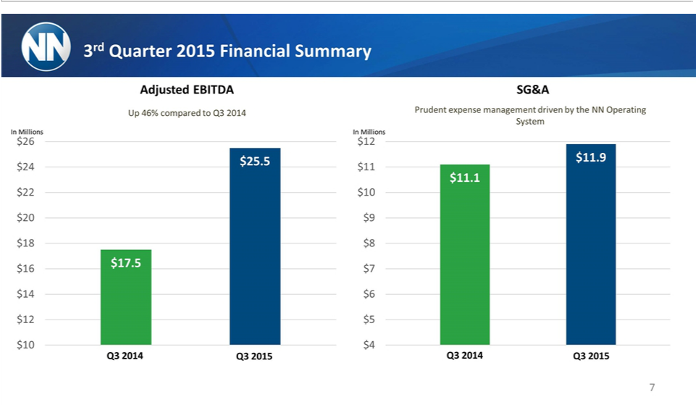

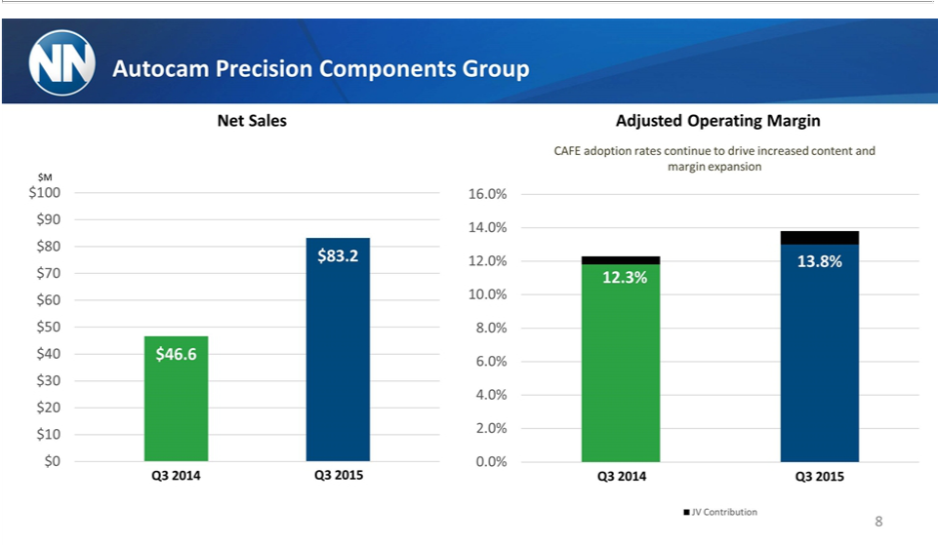

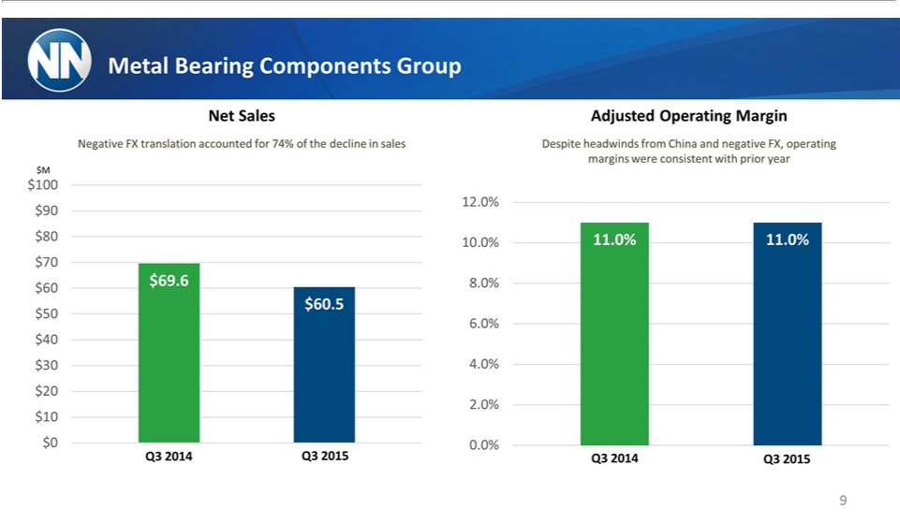

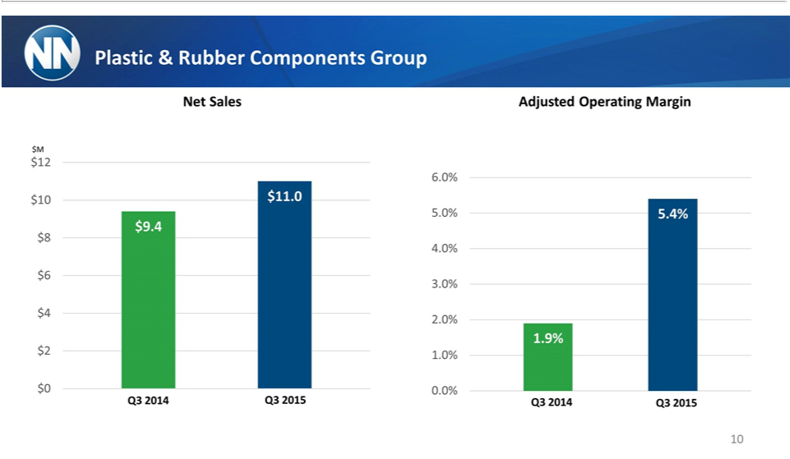

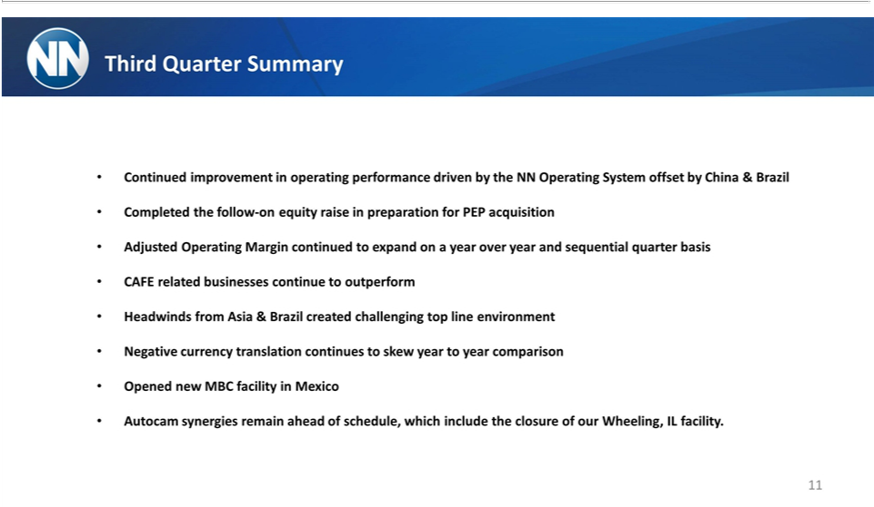

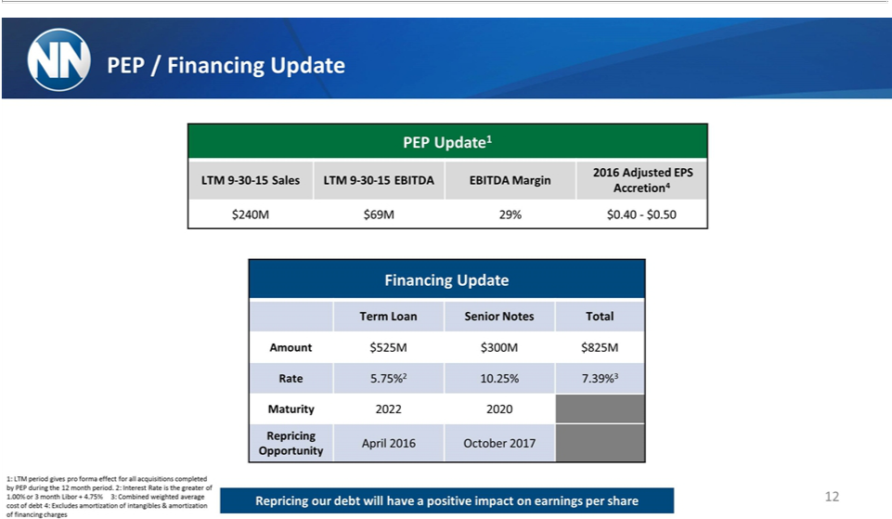

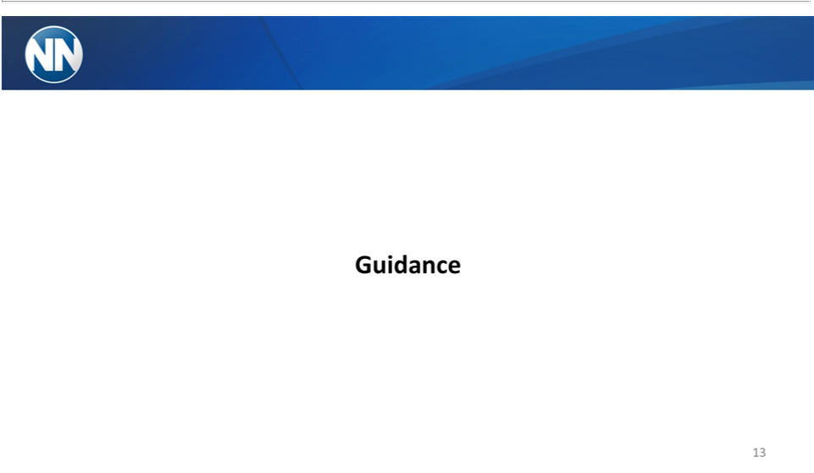

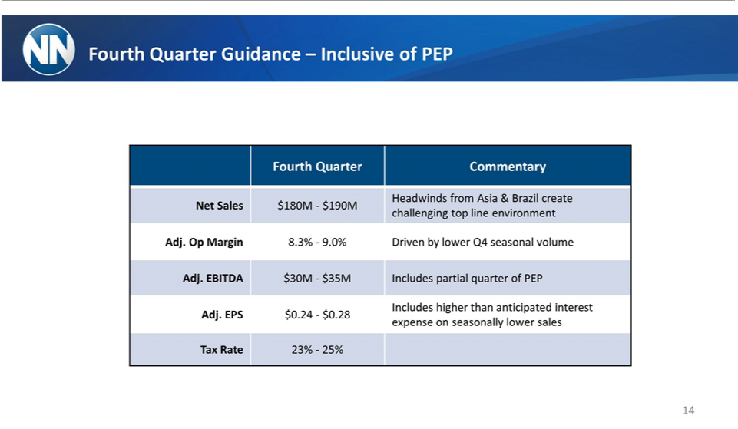

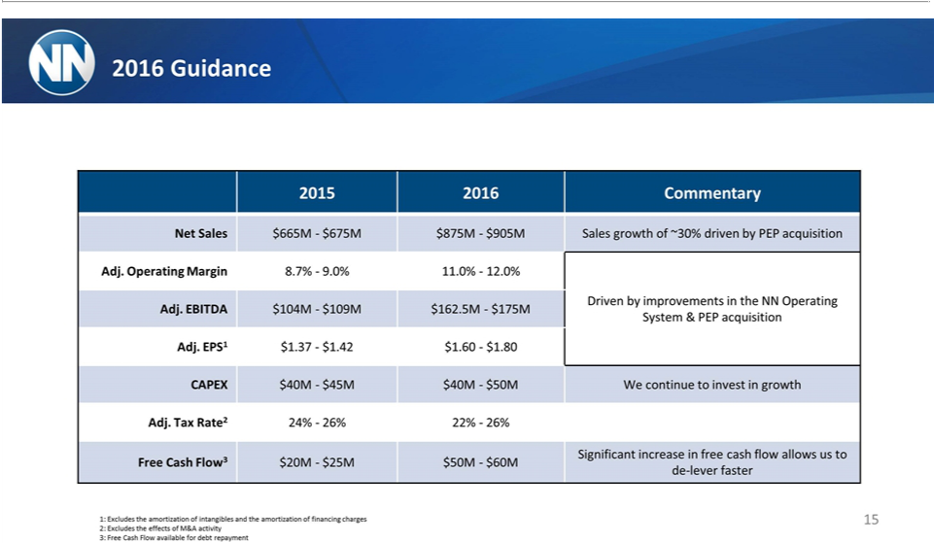

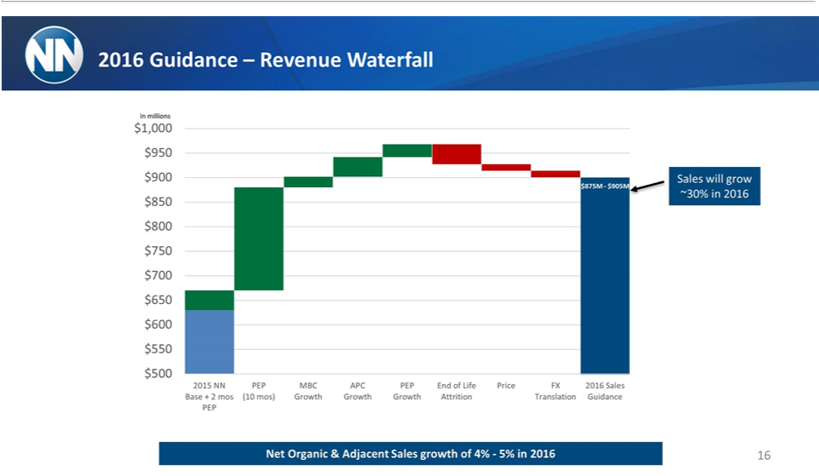

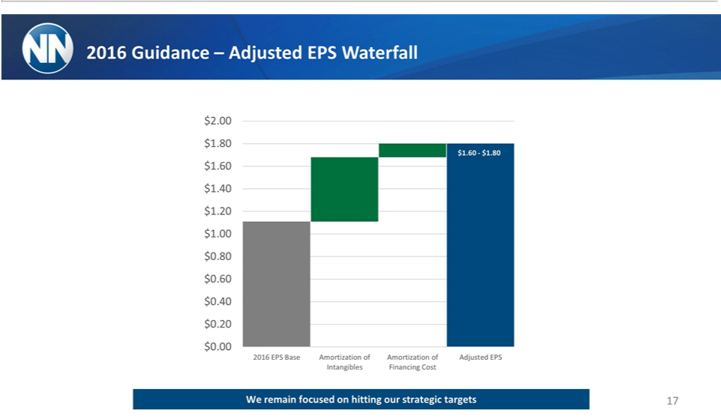

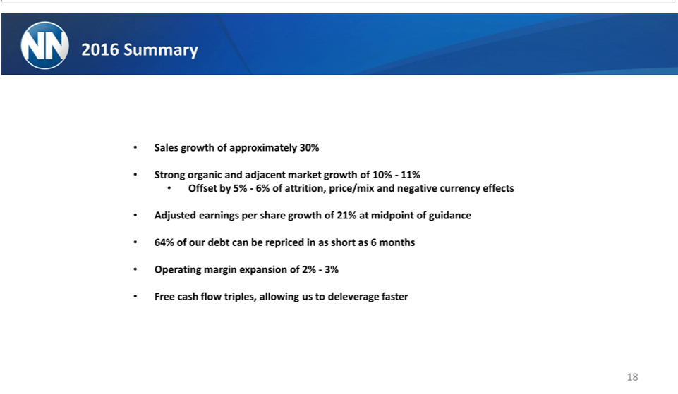



Exhibit 99.3


Exhibit 99.3
Third Quarter 2015
_{November}n-GAAP4,to2015GAAP Reconciliation

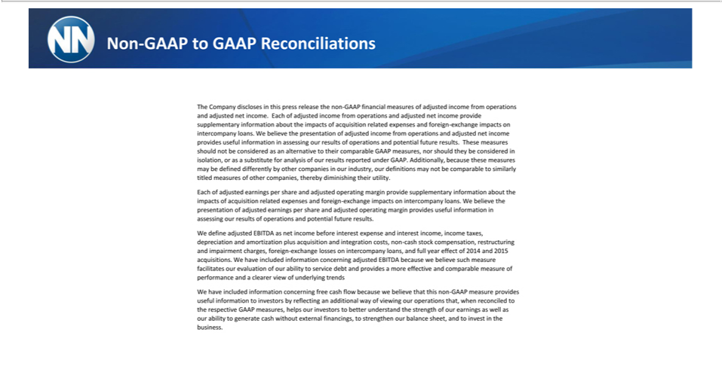

Non-GAAP to GAAP Reconciliations

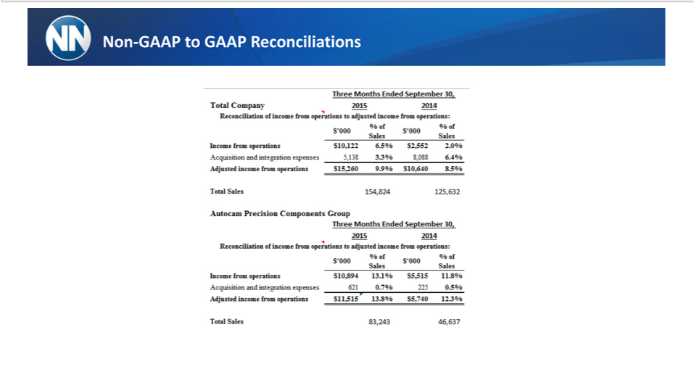

Non-GAAP to GAAP Reconciliations

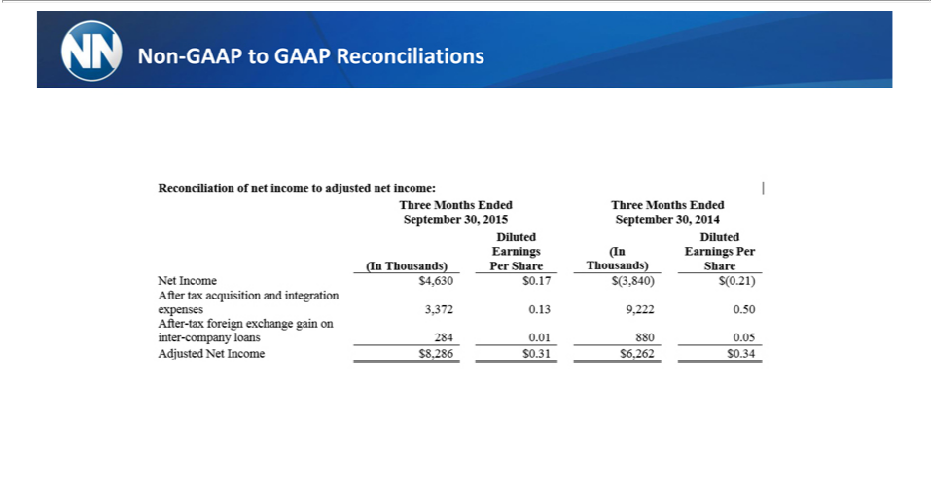

Non-GAAP to GAAP Reconciliations

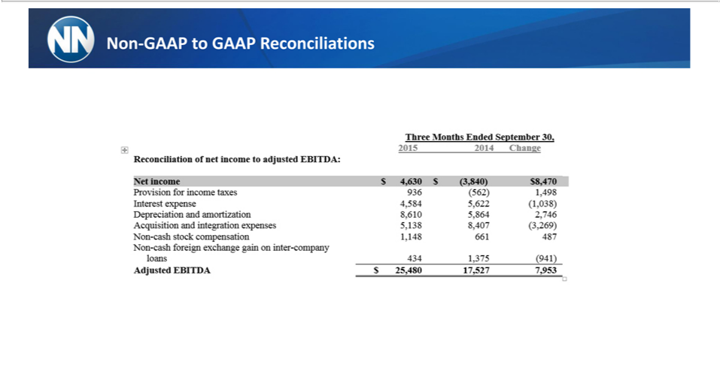

Non-GAAP to GAAP Reconciliations

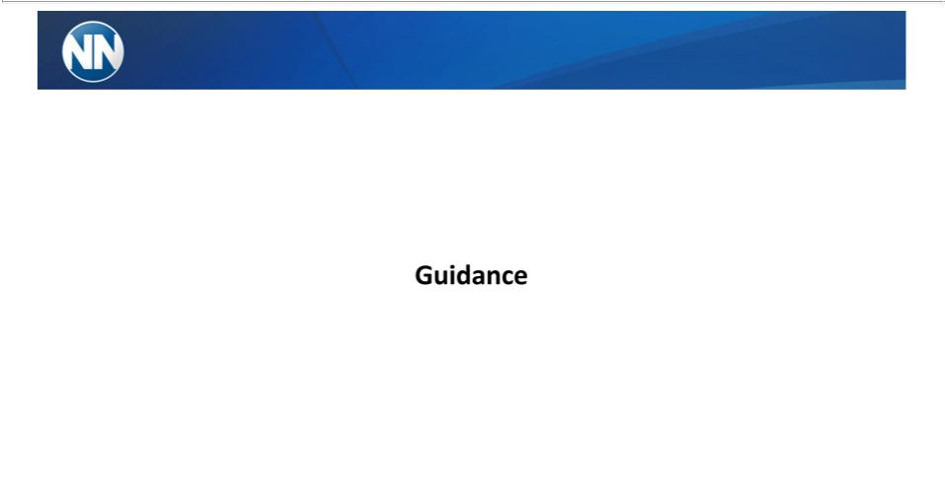

Guidance

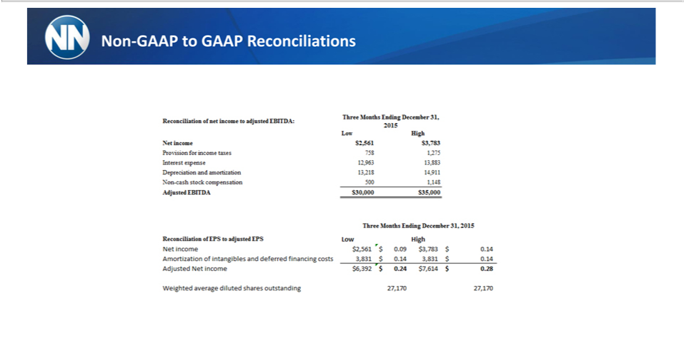

Non-GAAP to GAAP Reconciliations

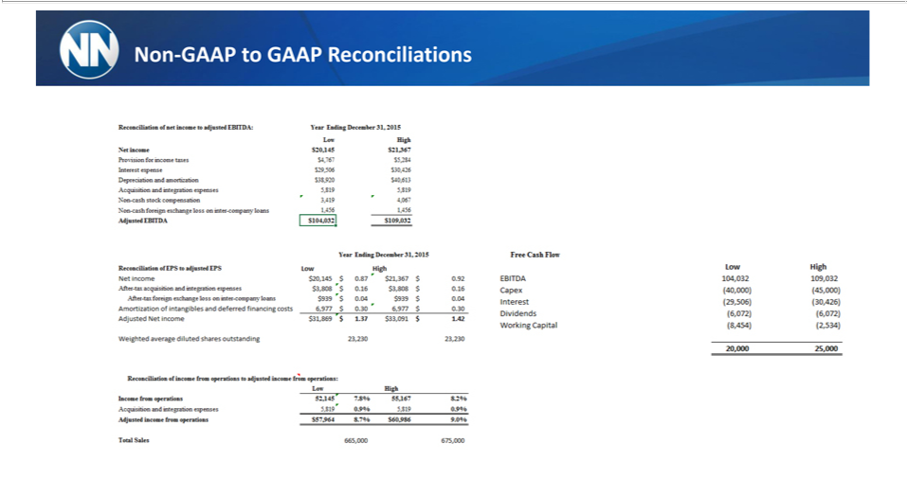

Non-GAAP to GAAP Reconciliations

Non-GAAP to GAAP Reconciliations



Third Quarter 2015
_{November}n-GAAP4,to2015GAAP Reconciliation

