UNITED STATES
SECURITIES AND EXCHANGE COMMISSION
Washington, D.C. 20549
FORM 8-K
CURRENT REPORT
Pursuant to Section 13 OR 15(d) of The Securities Exchange Act of 1934
Date of Report (Date of earliest event reported): July 23, 2026

NN, Inc.
(Exact name of registrant as specified in its charter)

Delaware |  |  | 001-39268 |  |  | 62-1096725
(State or other jurisdiction of  incorporation) |  |  | (Commission File Number) |  |  | (I.R.S. Employer  Identification No.)
6210 Ardrey Kell Road, Suite 120
Charlotte, North Carolina |  |  |  |  |  | 28277
(Address of principal executive offices) |  |  |  |  |  | (Zip Code)
(980) 264-4300
(Registrant’s telephone number, including area code)
(Former name or former address, if changed since last report)
Check the appropriate box if the Form 8-K filing is intended to simultaneously satisfy the filing obligation of the registrant under any of the following provisions (see General Instruction A.2. below):
☐ |  |  | Written communications pursuant to Rule 425 under the Securities Act (17 CFR 230.425)
☐ |  |  | Soliciting material pursuant to Rule 14a-12 under the Exchange Act (17 CFR 240.14a-12)
☐ |  |  | Pre-commencement communications pursuant to Rule 14d-2(b) under the Exchange Act (17 CFR 240.14d- 2(b))
☐ |  |  | Pre-commencement communications pursuant to Rule 13e-4(c) under the Exchange Act (17 CFR 240.13e- 4(c))
Securities registered pursuant to Section 12(b) of the Act:
Title of each class |  |  |  |  |  | Trading symbol |  |  |  |  |  | Name of each exchange on which registered
Common Stock, par value $0.01 |  |  |  |  |  | NNBR |  |  |  |  |  | The Nasdaq Stock Market LLC
Indicate by check mark whether the registrant is an emerging growth company as defined in Rule 405 of the Securities Act of 1933 (§230.405 of this chapter) or Rule 12b-2 of the Securities Exchange Act of 1934 (§240.12b-2 of this chapter).
Emerging growth company. |  |  | ☐
If an emerging growth company, indicate by check mark if the registrant has elected not to use the extended transition period for complying with any new or revised financial accounting standards provided pursuant to Section 13(a) of the Exchange Act. ☐

Item 5.02 Departure of Directors or Certain Officers; Election of Directors; Appointment of Certain Officers; Compensatory Arrangements of Certain Officers

On July 23, 2026 (the “Grant Date”), the Board of Directors (the “Board”) of NN, Inc. (the “Company”) and the Compensation Committee of the Board (the “Committee”), approved the grant of 250,000, 140,000 and 110,000 performance share units (at target) (“PSUs”) pursuant to the Company’s Amended and Restated Omnibus Incentive Plan (the “Plan”) and an award agreement thereunder (the “Award Agreement”) to each of Harold Bevis, the Company’s President and Chief Executive Officer, Tim French, the Company’s Chief Operating Officer, and Chris Bohnert, the Company’s Senior Vice President and Chief Financial Officer, respectively, to reward each such executive for their performance to date, motivate the achievement of the Company’s strategy, and retain each such executive’s leadership.
The vesting of the PSUs is subject to the achievement of certain performance goals based on four metrics (weighted 25% each): (i) the Company’s cumulative adjusted EBITDA, free cash flow, and net sales, respectively, during the period beginning January 1, 2026 and ending December 31, 2028, and (ii) the Company’s total shareholder return (“TSR”) as compared to the TSR of a specified group of peer companies during the three-year period beginning on the Grant Date and ending on the third anniversary of the Grant Date. Payouts of the PSUs will range from 0% to 200% of the target number of PSUs based on actual achievement against the performance goals.

Vesting generally requires each executive’s continued service to the Company through the date that the Committee certifies whether the performance goals have been achieved. However, in the event of a termination of the executive’s service due to death or disability, the PSUs will vest, either at target or based on actual performance, prorated based on the amount of time the executive remained in service with the Company during the applicable performance period. In the event of a Change in Control, vesting will be determined on a prorated basis, using only the relative TSR component.

The foregoing description of the PSUs is a summary of their material terms, does not purport to be complete and is qualified in its entirety by reference to the full text of Plan and Award Agreements. A copy of the form of Award Agreement is filed as Exhibit 10.1 hereto and is incorporated herein by reference. A copy of the Plan is filed as Appendix A to the Company’s definitive proxy statement on Schedule 14A, filed with the Securities and Exchange Commission on April 6, 2026, and is incorporated herein by reference.

ITEM 9.01 FINANCIAL STATEMENTS AND EXHIBITS
(d) Exhibits.
Exhibit  No. |  |  |  |  |  | Description of Exhibit
10.1 |  |  |  |  |  | Form of Award Agreement.
104 |  |  |  |  |  | Cover Page Interactive Data File (embedded within the Inline XBRL document)

SIGNATURES

Pursuant to the requirements of the Securities Exchange Act of 1934, the registrant has duly caused this report to be signed on its behalf by the undersigned hereunto duly authorized.
Date: |  |  | July 24, 2026

 |  |  | NN, INC.
 |  |  | By: |  |  | /s/ Christopher H. Bohnert
 |  |  | Name: |  |  | Christopher H. Bohnert
 |  |  | Title: |  |  | Senior Vice President and Chief Financial Officer

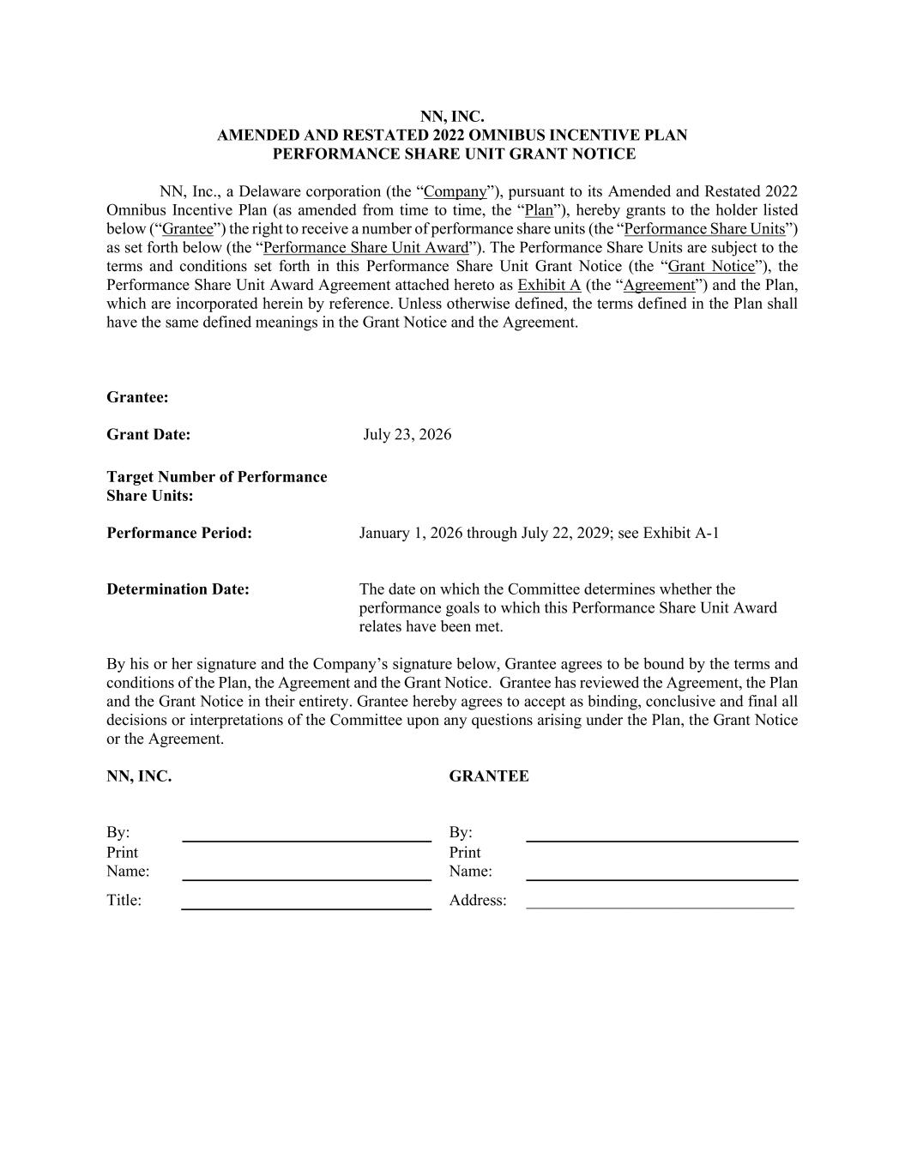

NN, INC. AMENDED AND RESTATED 2022 OMNIBUS INCENTIVE PLAN PERFORMANCE SHARE UNIT GRANT NOTICE NN, Inc., a Delaware corporation (the “Company”), pursuant to its Amended and Restated 2022 Omnibus Incentive Plan (as amended from time to time, the “Plan”), hereby grants to the holder listed below (“Grantee”) the right to receive a number of performance share units (the “Performance Share Units”) as set forth below (the “Performance Share Unit Award”). The Performance Share Units are subject to the terms and conditions set forth in this Performance Share Unit Grant Notice (the “Grant Notice”), the Performance Share Unit Award Agreement attached hereto as Exhibit A (the “Agreement”) and the Plan, which are incorporated herein by reference. Unless otherwise defined, the terms defined in the Plan shall have the same defined meanings in the Grant Notice and the Agreement. By his or her signature and the Company’s signature below, Grantee agrees to be bound by the terms and conditions of the Plan, the Agreement and the Grant Notice. Grantee has reviewed the Agreement, the Plan and the Grant Notice in their entirety. Grantee hereby agrees to accept as binding, conclusive and final all decisions or interpretations of the Committee upon any questions arising under the Plan, the Grant Notice or the Agreement. NN, INC. GRANTEE By: By: Print Name: Print Name: Title: Address: _________________________________ Grantee: Grant Date: July 23, 2026 Target Number of Performance Share Units: Performance Period: January 1, 2026 through July 22, 2029; see Exhibit A-1 Determination Date: The date on which the Committee determines whether the performance goals to which this Performance Share Unit Award relates have been met.

