UNITED STATES

SECURITIES AND EXCHANGE COMMISSION
WASHINGTON, DC 20549

FORM 8-K

CURRENT REPORT

PURSUANT TO SECTION 13 OR 15(d)
OF THE SECURITIES EXCHANGE ACT OF 1934

Date of Report (Date of earliest event reported): March 24, 2016


NN, INC.

(Exact name of registrant as specified in its charter)

Delaware

000-23486

62-1096725

(State or Other Jurisdiction
of Incorporation)

(Commission
File Number)

(I.R.S. Employer
Identification No.)

207 Mockingbird Lane, Johnson City, Tennessee

37604

(Address of principal executive offices)

(Zip Code)

(423) 434-8310

(Registrant’s telephone number, including area code)

(Former name or former address, if changed since last report)

Check the appropriate box if the Form 8-K filing is intended to simultaneously satisfy the filing obligation of the registrant under any of the following provisions (see General Instruction A.2. below):

- Written communications pursuant to Rule 425 under the Securities Act (17 CFR 230.425)

- Soliciting material pursuant to Rule 14a-12 under the Exchange Act (17 CFR 240.14a-12)

- Pre-commencement communications pursuant to Rule 14d-2(b) under the Exchange Act (17 CFR 240.14d- 2(b))

- Pre-commencement communications pursuant to Rule 13e-4(c) under the Exchange Act (17 CFR 240.13e- 4(c))

ITEM 7.01 RESULTS OF OPERATIONS AND FINANCIAL CONDITION

On March 24, 2016, NN, Inc. (the “Company”) will hold its Annual Investor Day where it will present information to investors about the Company.

Attached to this Current Report on Form 8-K is Exhibit 99.1, which is a copy of the slides to be furnished at the presentation.

Pursuant to the rules and regulations of the U.S. Securities and Exchange Commission, the information furnished pursuant to Item 7.01 of this Current Report on Form 8-K (including the Exhibit attached hereto), is deemed to have been furnished and shall not be deemed to be “filed” for purposes of Section 18 of the Securities Exchange Act of 1934, as amended, or otherwise subject to the liabilities of that section. Such information shall not be incorporated by reference into any filing of the Company, whether made before or after the date hereof, regardless of any general incorporation language in such filing.

ITEM 9.01 FINANCIAL STATEMENTS AND EXHIBITS

Exhibit
No. Description

99.1 Investor Day Presentation of NN, Inc. dated March 24, 2016

SIGNATURES

Pursuant to the requirements of the Securities Exchange Act of 1934, the registrant has duly caused this report to be signed on its behalf by the undersigned hereunto duly authorized.

Date: March 24, 2016

NN, INC.

By: | /s/ Matthew S. Heiter
Name: | Matthew S. Heiter
Title: | Senior Vice President and General Counsel

EXHIBIT INDEX

Exhibit
No. Description

99.1 Investor Day Presentation of NN, Inc. dated March 24, 2016

Exhibit 99.1


Annual Investor Day
March 24, ₂₀₁₆ • New York City
Exhibit 99.

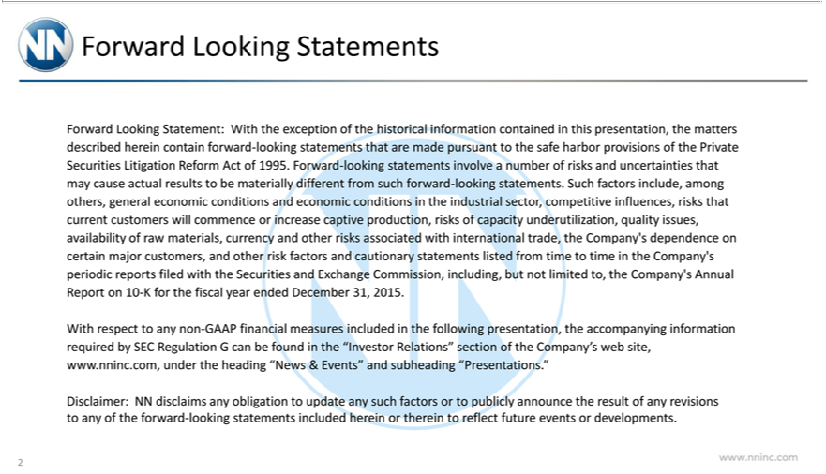

 | s | the matters described herein contain forward-looking statements that are made pursuant to the safe harbor
Forward Looking Statement: With the exception of the historical information contained in this
provisions of the Private Se urities Litigation Reform Act of 1995. Forward-looking statementspresentation,involvenumber of risks and uncertainties that may cause actual results to be materially different from such forward-
looking statements. Such factors include, among others, general economic conditions and economic conditio s in the industrial sector, competitive influences, risks that current customers will commence or increase
captive production, risks of capacity und rutilization, quality issues, availability of raw |  | currency and other risks associated with international trade, the Company’s dependence on certain major
and other risk factors and utionary statements listed from time to time in the Company’materials,periodic reports filed with the Securities and Exchange Commission, including, but not limited to, the Company’customers,Annual
Report on 10-K for the fiscal year ended December 31, 2015.
With | to any non-GAAP financial measures included in the following presentation, the accompanying information required by SEC Regulation G can be found in the “Investor Relations” section of the
Company’respectweb _{disclaims}te,www.nninc.com, under the heading “News & Events” and subheading “Presentations.”
Disclaimer: NN any obligation to update any such factors or to publicly announce the result of any revisions to any of the forward-looking statements included herein or therein to reflect future events or developments.
www.nninc.com
2

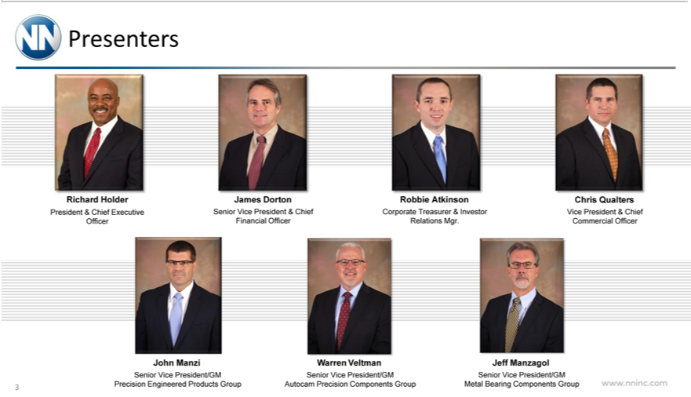

RichardPresentersHolder
JamesPresidentDorton&Chief Executive Officer
RSenior_{o}bbie_{porate}ViceAtkinsonPresident & Chief Financial Officer
^{Chris}
QualtersTreasurer & Investor Relations Mgr.
JohnVice PresidentManzi & Chief Commercial Officer
WarrenSeniorViceVeltmanPresident/GM Precision Engineered Products Group
JeffSeniorManzagolVicePresident/GM Autocam Precision Components Group
www.nninc.comSeniorVicePresident/GM Metal Bearing Components Group
3

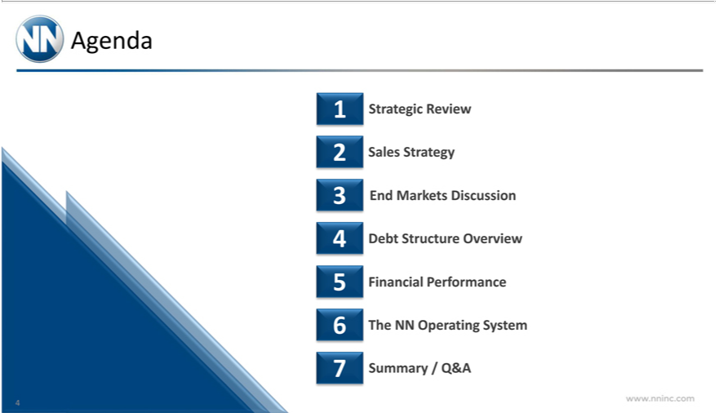

Agenda
1 | trategic Review
2 | Sales St ategy
3 | End Markets Discussion
4 | Debt Structure Overview
5 | Financial Performance
6 | The NN Operating System
7 Summary / Q&A
4www.nninc.com



Strategic Review

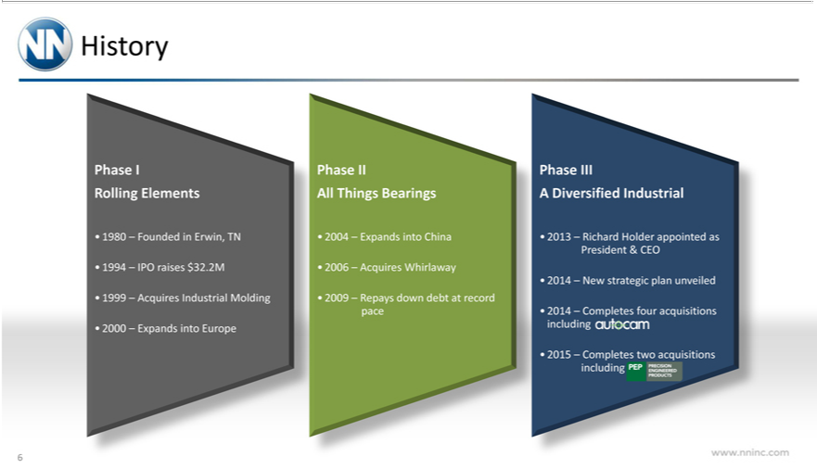

History
Phase I
Rolling Elements
80 |  | Founded in Erwin, TN
4 |  | IPO raises $32.2M
1999 | – | Acquires Industrial Molding
2000 | – | Expands into Europe
Phase II
All Things Bearings
4 |  | Expands into China
6 | – | Acquires Whirlaway
2009 | – | Repays down debt at record pace
Phase III
A Diversified Industrial
3 |  | Richard Holder appointed as President & CEO
4 |  | New strategic plan unveiled
4 |  | four acquisitions including
2015 | – Completes two acquisitions including
www.nninc.comPDPPRECISION ENGINEERED PRODUCTS
6

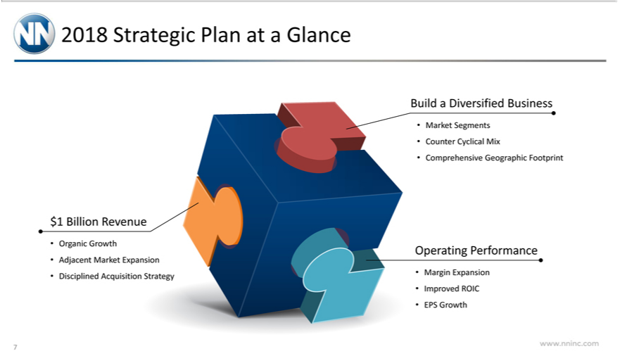

$20181BillionStrategicRevenuePlan at a Glance
Organic Growth
Adjacent Market Expansion
Disciplined Acquisition Strategy
Build a Diversified Business
Market Segments
_{Comprehensive}unterCyclical Mix
Geographic Footprint
Operating Performance
Margin Expansion
Improved ROIC
EPS Growth
7www.nninc.com

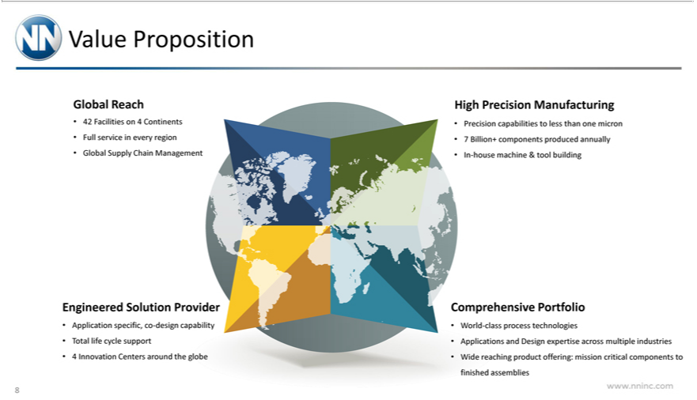

GlobalValuePropositionReach
42FullFacilitiesservice inonevery4Continentsregion
HighGlobalPrecisionSupply ChainManufacturingManagement
Precision capabilities to less than one micron
7 Billion+ components produced annually
EngineeredIn-housemachineSolution& toolProviderbuilding
TotalApplicationlifecyclespecific,supportco-design capability
4 Innovation Centers around the globe
WorldComprehensive-classprocessPortfoliotechnologies_{expertise}
Applications and Design across multiple industries
www.nninc.comWidereachingproduct offering: mission critical components to finished assemblies
8

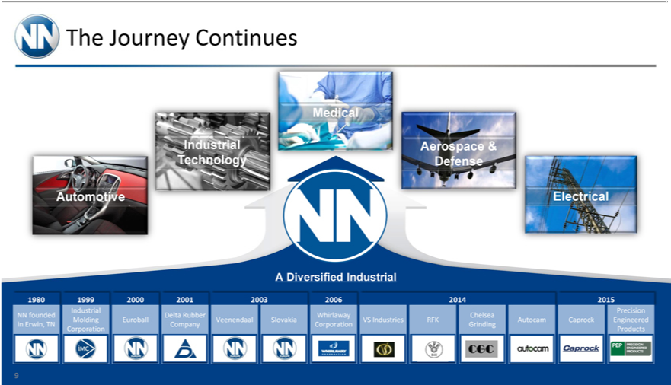

The Journey Continues
Automotive
Industrial Technology
Medical
ElectricalAerospace & Defense
A Diversified Industrial
1980 1999 2000 2001 2003 2006 2014 2015
Industrial Precision NN founded Delta Rubber Whirlaway Chelsea Molding Euroball Veenendaal Slovakia VS Industries RFK Autocam Caprock Engineered in Erwin, TN Company Corporation Grinding Corporation Products
9

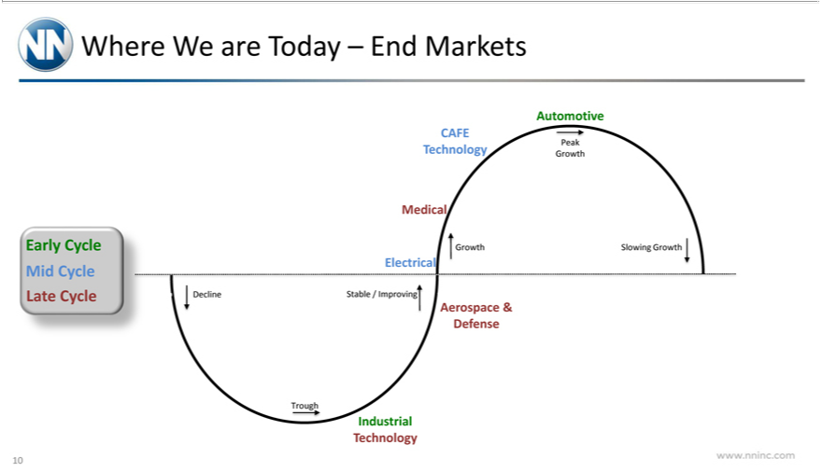

Where_{Cycle}Ware Today – End Markets
Early Mid Cycle Late Cycle
CAFE Technology
Automotive
Peak
Growth
GrowthMedical
Electrical
A_{Decline}Stablerospace/Improvin&Defense
Trough
Industrial Technology
www.nninc.comSlowingGrowt
10

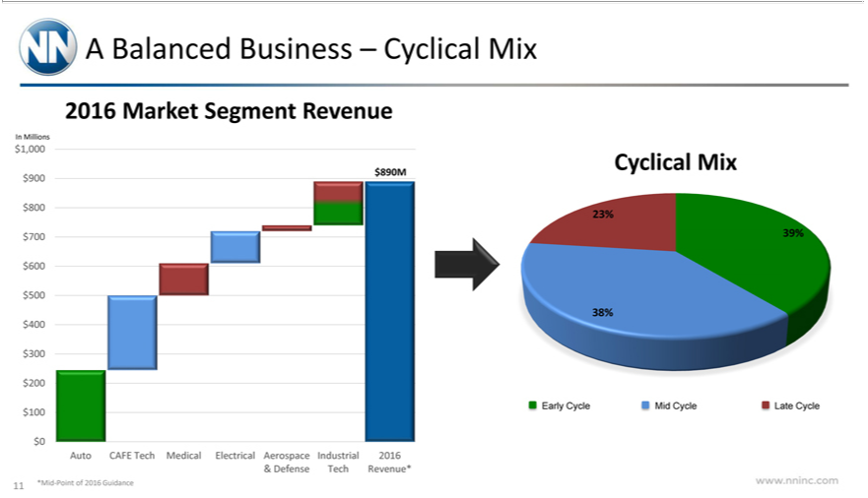

2016ABalancedMarketBusinessSegment–RevenueCyclical Mix
In Millions
$1,000_{890M} $900 $800 $700 $600 $500 $400 $300 $200 $100 $0
&AutoDefenseCAFETechTechRevenue*Medical Electrical Aerospace Industrial 2016
Cyclical*Mid-PointMixof 2016 Guidance
23%_{9%}
38%
www.nninc.comEarlyCycleMid Cycle Late Cycle
11

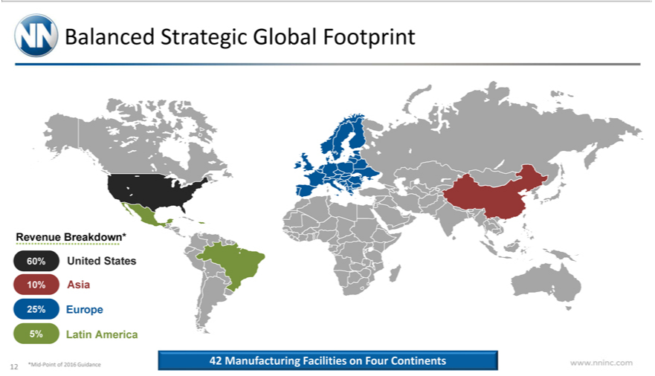

Balanced Strategic Global Footprint
_{25%}RevenueEuropeBreakdown* 60% United States 10% Asia
*MidLatin-PointAmericaof2016 Guidance
www.nninc.com42Manufacturing Facilities on Four Continents
12

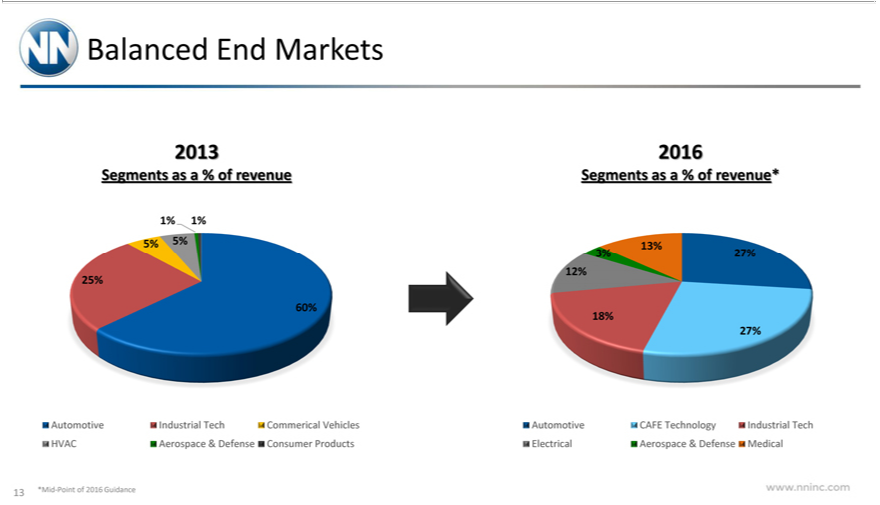

2013Balanced End Markets
Segments as a % of revenue
5%^{1%} 5%^{1%} 25%
60%
Automotive Industrial Tech Commerical Vehicles HVAC Aerospace & Defense Consumer Products 2016
Segments as a % of revenue*
13%27% 12%
27%^{18%}
Automot^{Point}ve CAFE Technology Industrial Tech Electrical Aerospace & Defense Medical
www.nninc.com*Mid-of2016 Guidance
13

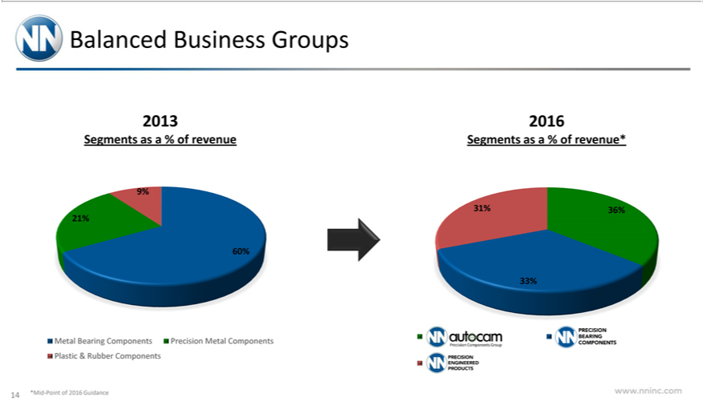

2013Balanced Business Groups
9%Segments as a % of revenue
60%^{21%}
*MidMetal-PointBearingof 2016ComponentsGuidancePrecision Metal Components Plastic & Rubber Components
2016
Segments_{33%}1%36% as a % of revenue*
www.nninc.com
14



Sales Strategy

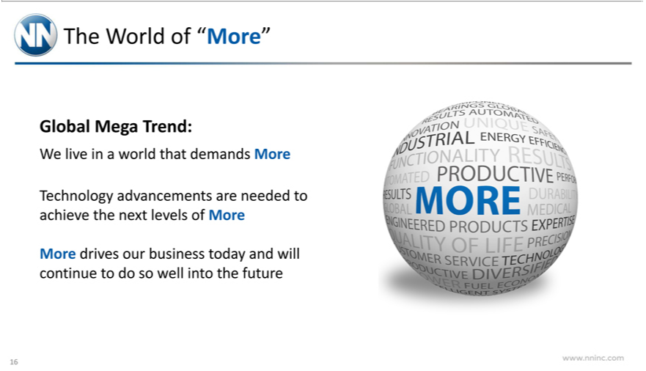

The World of “More”
Global Trend:
Mega
W_{echnology}livein world that demands More
T advancements are needed to achieve the next levels of More
www.nninc.comMoredrivesour business today and will continue to do so well into the future
16

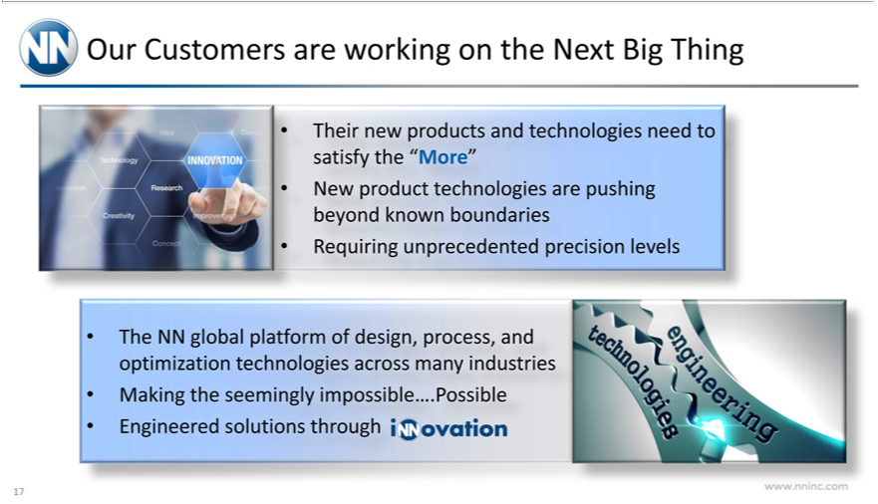

Our Customers are working on the Next Big Thing
Their new products and technologies need to satisfy the “More”
RequiringNewproduct^{global}unprecedentedtechnologiesprecisionarepushinglevelsbeyond known boundaries
The NN platform of design, process, and optimization technologies across many industries Making the seemingly impossible….Possible
www.nninc.comEngineeredsolutions through
17

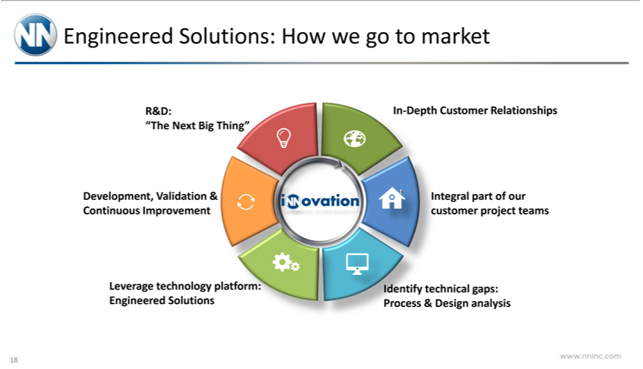

R&D:Engineered Solutions: How we go to market
In“The-DepthNextCustomerBigThing”Relationships
Development, Validation & Continuous Improvement
LeverageIntegralparttechnologyofourcustomerplatform:projectEngineeredteams Solutions
www.nninc.comIdentifytechnical gaps: Process & Design analysis
18

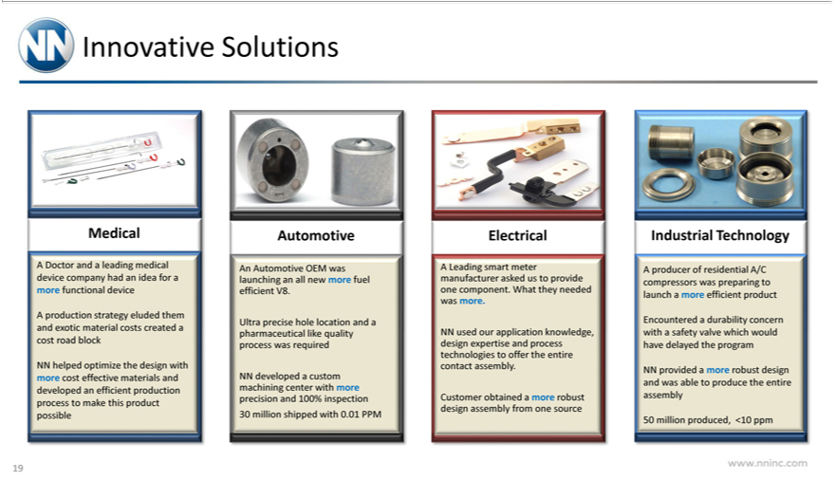

Innovative Solutions
Medical | leading medical device company had an idea for more functional device
Doctor and
A production strategy eluded them and exotic material costs created |  |  |  | cost road block
NN helped optimize the design with more cost effective materials and developed an efficient production process to make this product possible
utomotive |  |  | an all new more fuel efficient V8.
An Automotive OEM was
Ultra pr cise hole location launchingandpharmaceutical like quality process was required
NN developed a custom machining center with more precision and 100% inspection 30 million shipped with 0.01 PPM
Electrical
A Leading smart meter manufacturer asked us to provide one component. What they needed was more.
NN used our |  | knowledge, design expertise and process technologies to offer the entire contact assembly.
Customer obtainedapplicationmore robust design assembly from one source
Industrial Technology |  |  |  | more efficient product
A producer of residential A/C compressors was preparing to launch |  |  |  | more efficient product
have
NNEncounteredprovided aa durabilitymorerobustconcerndesignwithand awassafetyablevalvetoproducewhich thewouldentire assemblydelayed the program
www.nninc.com50millionproduced, <10 ppm
19

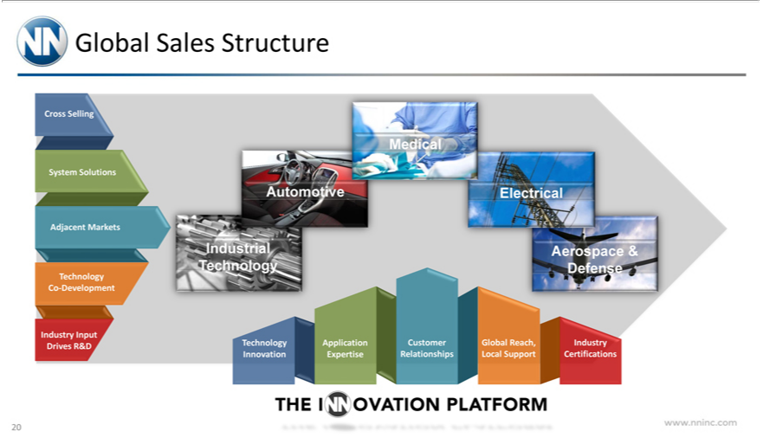

^{Cross}Glbal Sales Structure
T_{echnology}SellingCoSystem-DevelopmentSolutions Adjacent Markets
_{Industrial}InputTechnologyDrives R&D
Automotive^{M}Electrical^{dical}
Aerospace & Defense
Technology Innovation
CustomerApplicationRelationshipsExpertise
IndustryGlobalReach,CertificationsLocalSupport
www.nninc.comTHEINNOVATION PLATFORM
20

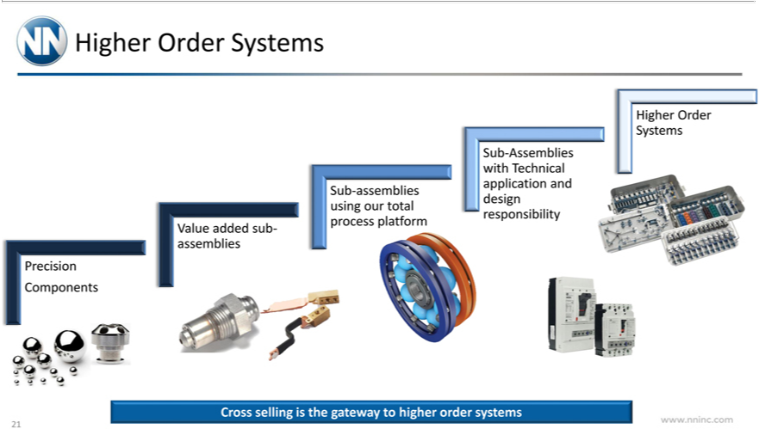

Higher Order Systems
ValuePrecisionaddedComponentssub-assemblies
^{Sub-}assemblies using our total process platform
HigherAssembliesOrderSystemswithTechnical application and design responsibility
www.nninc.comCrosssellingisthe gateway to higher order systems
21

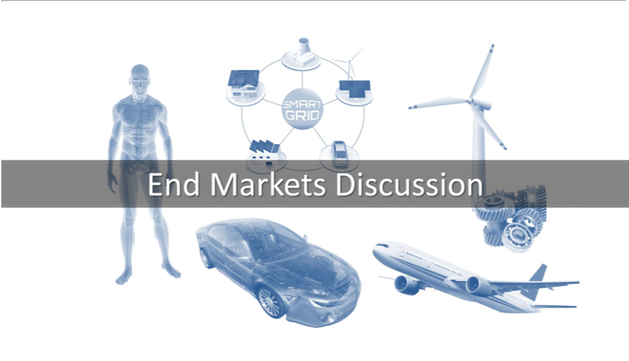

End Markets Discussion



Medical & Electrical

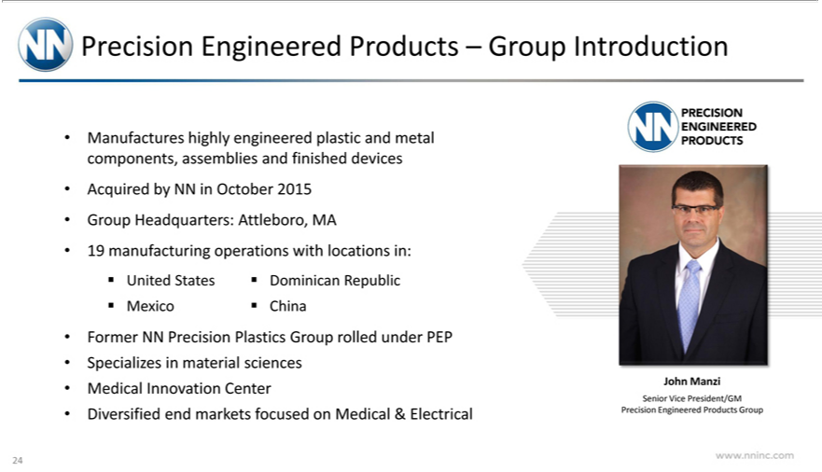

Precision Engineered Products – Group Introduction
AcquiredManufacturesbyNNhighlyinOctoberengineered2015plastic and metal components, assemblies and finished devices
Group Headquarters: Attleboro, MA
Former19manufacturingNNPrecisionoperationsPlasticswithGrouplocationsrolled underin:UnitedPEP States Dominican Republic Mexico China
MedicalSpecializesInnovationinmaterialCentersciences
Diversified end markets focused on Medical & Electrical
JohnPRECISIONManzi ENGINEERED PRODUCTS
www.nninc.comSeniorVicePresident/GM Precision Engineered Products Group
24

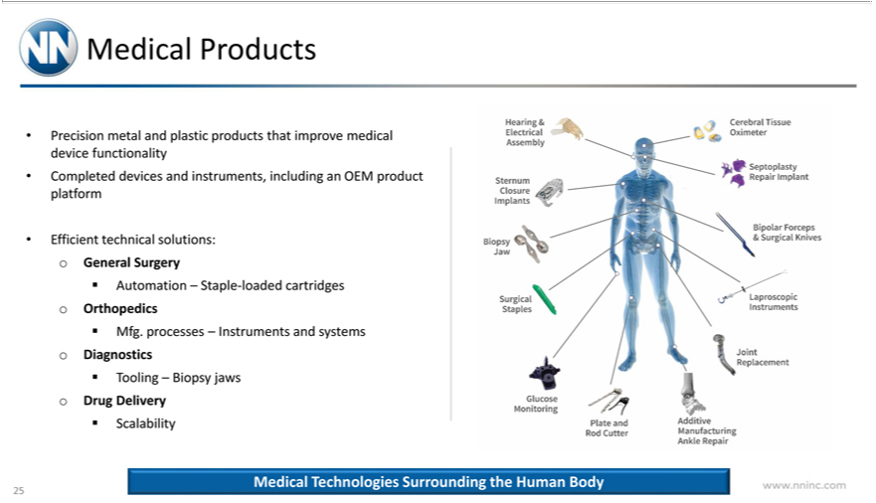

_{Precision}MdicalProducts
metal and plastic products that improve medical device functionality
EfficientCompletedtechnicaldevicessolutions:andinstruments,oGeneralincludingSurgeryan OEM product platform
Automation – Staple-loaded cartridges o _{Orthopedics}
ToolingMfg.processes–Biopsy– InstrumentsjawsoDrugandDeliverysystems Diagnostics
Scalability
Hearing & Electrical Assemble
Cerebral Tissue Oximeter
_{Septoplasty}ternumClosure Implants
_{Bipolar}opsy Jaw ^{Repair Implant}
SurgicalForcepsStaples & Surgical Knives
Laproscopic Instruments
Joint Replacement
Glucose Monitaring
Plate and Rod Cutter
Additive Manufacturing Ankle Repair
www.nninc.comMedicalTechnologies Surrounding the Human Body
25

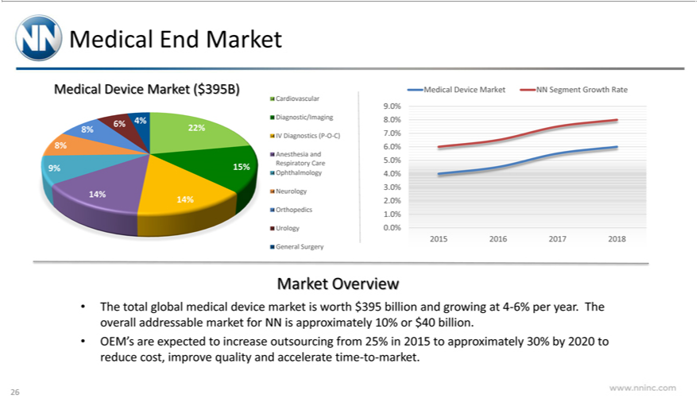

Medical EndDeviceMarketMarket ($395B)
Cardiovascular Diagnostic/Imaging IV Diagnostics (P-O-C)
NeurologyAnesthesia OrthopedicsandRespiratoryUrologyCare GeneralOphthalmologySurgery
Medical Device Market NN Segment Growth Rate
20159.0% 20168.0%2017.0%20186.0% 5.0% 4.0% 3.0% 2.0% 1.0% 0.0%

Market Overview
The total global medical device market is worth $395 billion and growing_{approximately}4-6% per year. The overall addressable market for NN is approximately 10% or $40 billion.
OEM’s are expected to increase outsourcing from 25% in 2015 to 30% by 2020 to reduce cost, improve quality and accelerate time-to-market. www.nninc.com
26

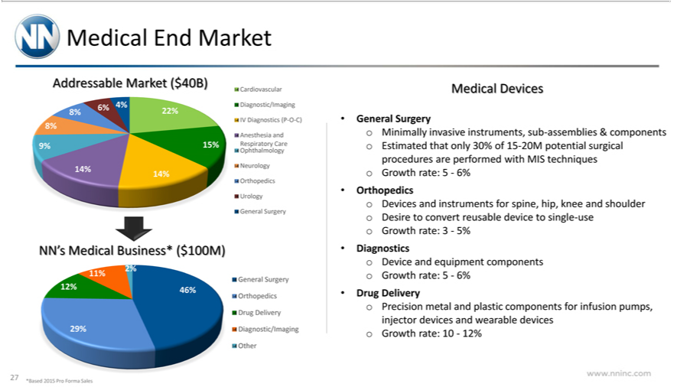

Medical End Market
Addressable Market ($40B)
6% 4%
8% | 22% 8%
9% 15%
14%
Cardiovascular Diagnostic/Imaging IV Diagnostics (P-O-C)
Anesth sia and Ophthalmology Respiratory Care Neurology
 |  |  | Urology General Surgery
OrthopedicsNN’Medical Business* ($100M)
 | 11%
12% |  | 46%
29%
General Surgery Orthopedics Drug Delivery Diagnostic/Imaging Other
Medical Devices |  |  |  | o Estimated that only 30% of 15-20M | surgical procedures are performed with MIS techniques o Growth rate: 5—6%
General Surgery o Minimally invasive instruments, sub-assemblies & |  |  |  | o Estimated that only 30% of 15-20M
components potential
DrugOrthopedicsiagnostics oo DeviceDevicesandandequipmentinstrumentscomponentsforspine,componentship,Growthknee andrate:shoulder5—6% Desire to convert reusable device to single-use Growth rate: 3—5%
Delivery^{Pro}Precision metal and plastic for infusion pumps, injector devices and wearable devices o Growth rate: 10—12% *Based 2015 Forma Sales
27

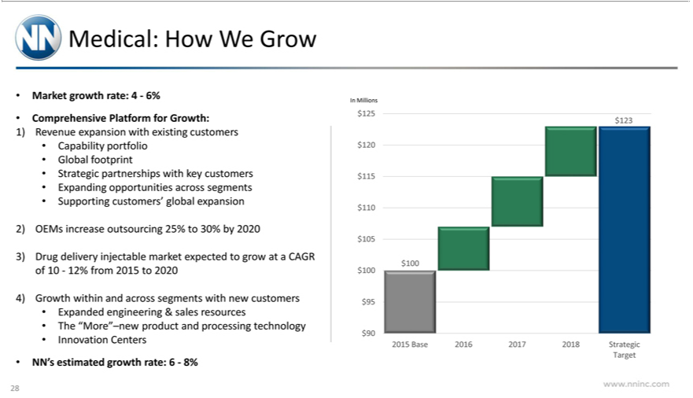

Marketedical:growthHow Wrate:Grow4—6%
Comprehensive Platform for Growth:
Capability1)Revenueportfolioexpansion with existing customers
Global footprint
ExpandingStrategicpartnershipsopportunitieswithacrosskey customerssegments
Supporting customers’ global expansion
4)3)2) DGrowthOEMsugdeliveryincreaseinjectableoutsourcingmarket25%expectedto30% byto 2020grow at a CAGR of 10—12% from 2015 to 2020
within and across segments with new customers
TheExpanded“More”–newengineeringproduct&salesand processingresources technology
Innovation C nters
InNN’Millionsestimated growth rate: 6—8%
²³
$1005 $120 $115 $110 $105 $100 $95 $90
www.nninc.com2015Base2016 2017 2018 Strategic Target
28

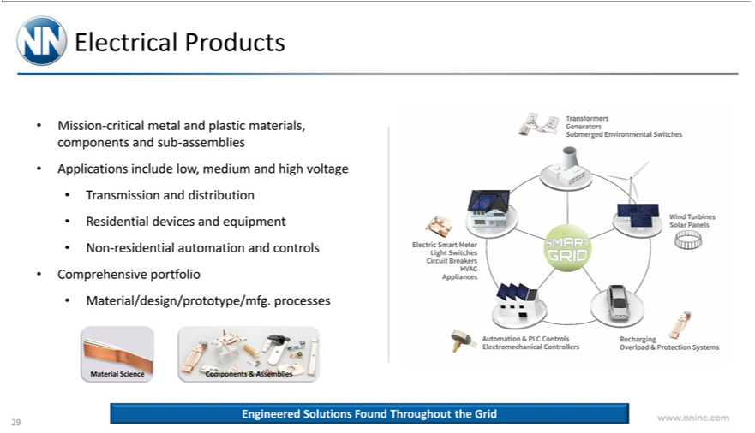

Electrical Products
ApplicationsMission-criticalincludemetallow,andmediumplasticmaterials,andhigh voltagecomponents and sub-assemblies
Transmission and distribution
NonResidential-residentialdevicesautomationandequipmentandcontrols
^{Material}Comprehensive/design/prototype/mfg.portfolio processes
Science
Components & Assemblies
TransformersEngineeredSolutionsGeneratorsFoundSubmer^{Switches}_{Throughout}dEnvironmenttheGrid Switches
WindElectricTurbinesSmart MeterSolar PanelsLight Circuit Breakers HVAC Appliances
Automation & PLC Controls Electromechanical Controllers
www.nninc.comRechargingOverload & Protection Systems
29

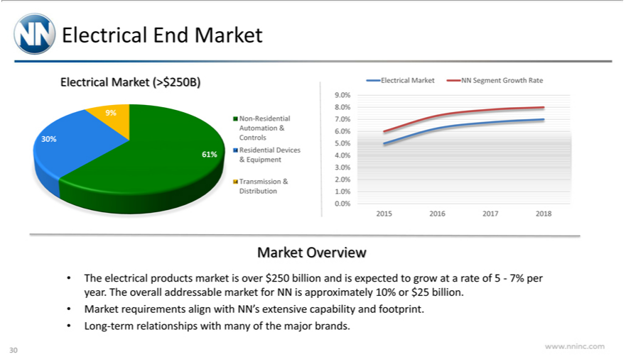

 | End Market
Electrical Market (>$250B)
9%
30%
61%
Non-Residential Automation & Controls Residential Devices
& Equipment
Transmission & Distribution
Non-Residential Automation & Controls Residential Devices
& Equipment
Transmission & Distribution
9.0% 8.0% |  | .0% 6.0% 5.0% 4.0% 3.0% 2.0% 1.0% 0.0%
2015 2016 |  | 2017 | 2018
Market Overview
MarketTheelectricalrequirementsproductsalignmarketwithisNN’sover extensive$250billioncapabilityandisexpectedandfootprint.togrow at a rate of 5—7% per year. The overall addressable market for NN is approximately 10% or $25 billion.
www.nninc.comLong-termrelationships with many of the major brands.
30

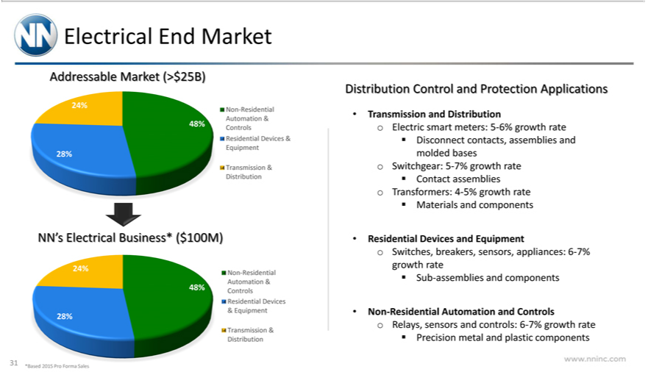

Electrical End Market
Addressable Market (>$25B)
24%
28%
Non-Residential Automation & Controls Residential Devices & Equipment
T | & Distribution
NN’ransmissionElectrical Business* ($100M)
24%
28%
Non-Residential Automation & Controls Residential Devices
& Equipment
Transmission & Distribution |  | Applications
Distribution Control and |  | Applications
Transmission and DistributionProtectionElectric smart meters: 5-6% growth rate Disconnect contacts, assemblies and molded bases o Switchgear: 5-7% growth rate Contact assemblies o Transformers: 4-5% growth rate
Materials and components |  | Switches, breakers, sensors, appliances: 6-7% growth rate Sub-assemblies and components
Residential Devices and Equipment
Controls
www.nninc.comNon-Residential Automation and o Relays, sensors and controls: 6-7% growth rate Precision metal and plastic components

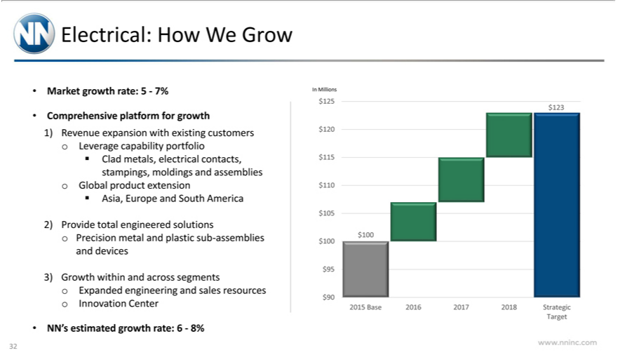

Electrical: How W Grow
Market growth rate: 5—7%
Comprehensive platform for growth |  |  | Leverage capability portfolio Clad metals, electrical contacts, stampings, moldings and assemblies o Global product extension Asia, Europe and South America
1) | Revenue expansion with exis ng
2) | Provide total engineered solutions Precision metal and plastic sub-assemblies and devices
3) | Growth within and across segmentscustomersExpanded engineering and sales resources o Innovation Center
NN’ |  | estimated growth rate: 6—8%
In | Millions |  | $90
 | 5 | $120 $115 $110 $105 $100 $95 | $90
 | 23
$100 |  | Base 2016 2017 2018 Strategic
2015 |  | Base 2016 2017 2018 Strategic
Target
www.nninc.com
32



Industrial Technology & Aerospace

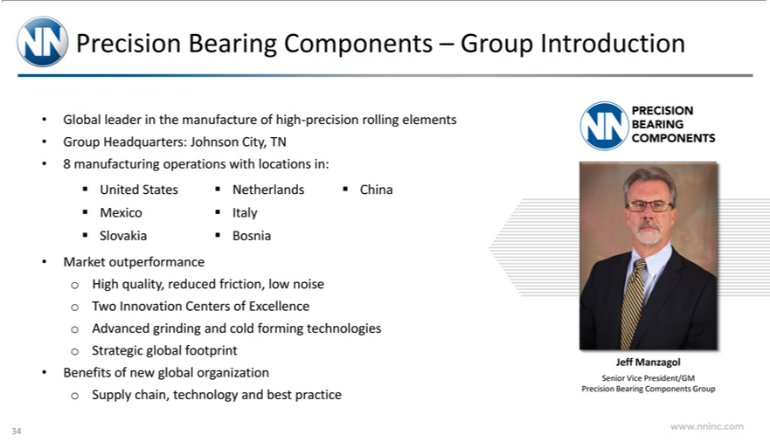

Precision B Components – Group Introduction
leaderaring
_{Group}lobal _{Headquarters:}hemanufactureJohnsonCity,of TNhigh-precision rolling elements
8 manufacturing_{Netherlands}opertions with locations in:
United States China Mexico Italy Slovakia Bosnia
Market outperformance o High quality, reduced friction, low noise o Two Innovation Centers of Excellence o Advanced grinding and cold forming technologies o Strategic global footprint Benefits of new global organization o Supply chain, technology and best practice
JeffPRECISIONManzagolBEARING COMPONENTS
www.nninc.comSeniorVicePresident/GM Precision Bearing Components Group
34

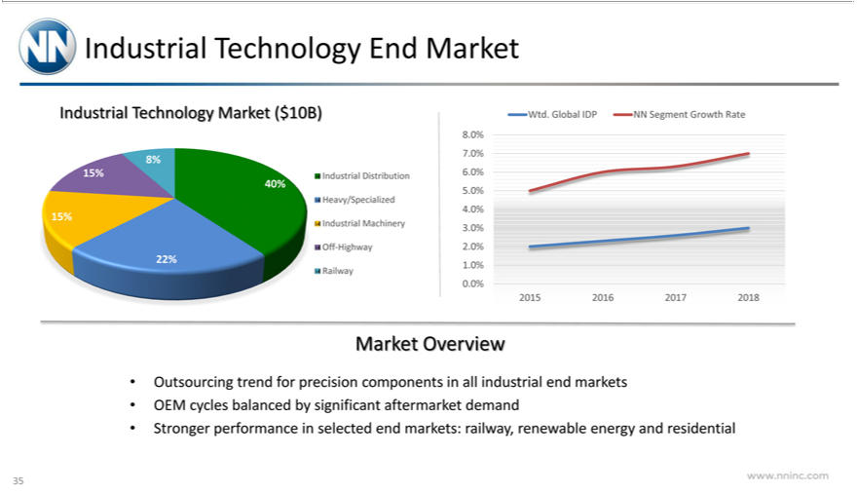

Industrial Technology Market ($10B)
T End Market
8% 15%
_{15%}40%
22%
Wtd.IndustrialGlobalDistributionIDPNNSegmentHeavy/SpecializedGrowthRateIndustrial Machinery Off-Highway Railway
8.0% 7.0% 6.0% 5.0% 4.0% 3.0% 2.0% 1.0% 0.0%
Market20152016Overview20172018
_{OEM}utsourcing trend for precision_{significant}omponents in all industrial end markets
cycles balanced by aftermarket demand
www.nninc.comStrongerperformance in selected end markets: railway, renewable energy and residential
35

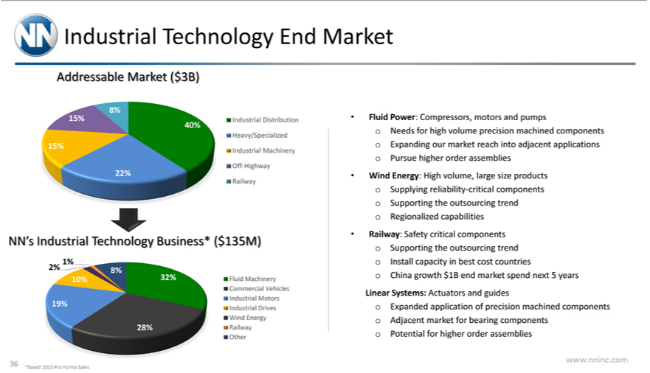

Industrial Technology End Market
Addressable Market ($3B)
8% | 15%
40%
15% |  | Distribution Heavy/Specialized Industrial Machinery Off-Highway Railway
22%
IndustrialNN’Industrial Technology Business* ($135M)
1% | 8% 32% 10%
2%
19% |  | Machinery Commercial Vehicles Industrial Motors Industrial Drives Wind Energy Railway Other
28%
Fluid Power: Compressors, motors and pumps o Needs for high volume precision machined components o Expanding our market reach into adjacent applications o Pursue higher order assemblies
Wind Energy: High volume, large size products |  |  | Supplying reliability-critical components o Supporting the | trend o Regionalized capabilities
Railway: Safety critical components |  |  | the outsourcing trend o Install capacity in best cost countriesoutsourcingChinagrowth $1B end market spend next 5 years Linear Systems: Actuators and guides o Expanded
application of precision machined componentsSupportingAdjacent market for bearing components o Potential for higher order assemblies www.nninc.com

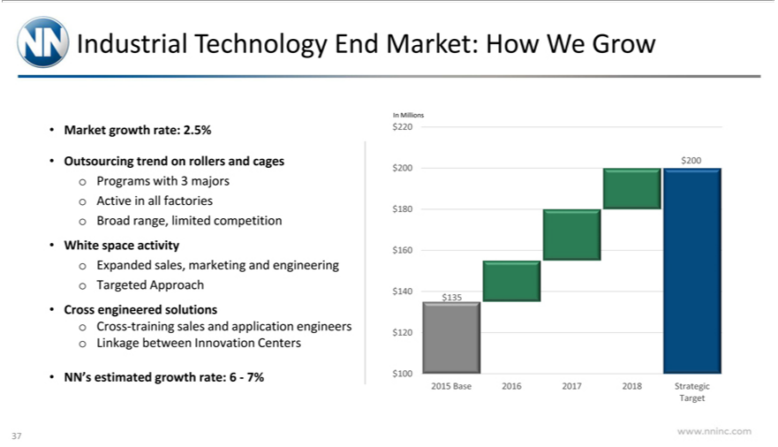

Industrial T |  | End Market: How We Grow
Market growechnologyrate:2.5% |  |  | cages o Programs with 3 majors o Active in all factories o Broad range, limited competition
Outsourcing trend on rollers
White space activity |  | Expanded sales, marketing and engineering o Targeted Approach
 | engineered solutions o Cross-training sales and application engineers o Linkage between Innovation Centers
CrossNN’ estimated growth rate: 6—7%
In Millions |  | $140 $120 | $100
200 | $200 $180 $160 | $140 $120 | $100
$135 | Base 2016 2017 2018 Strategic
2015
Target
www.nninc.com
37

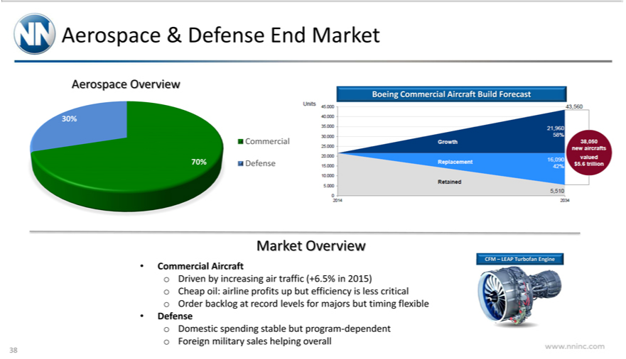

_{Aerospace} & Defense End Market
_{70%}3 ^{Overview}
Commercial
Defense
Boeing Commercial Aircraft Build Forecast
Units 45,000 40,000 35,000 30,000 25,000 20,000 15,000 10,000 5,000 0 2014
Growth Replacement Retained 43,560 21,960 58% 38,050 new aircrafts valued $5.6 trillion 16,090 42% 5,510 2034 Market Overview
_{Commercial} Aircraft o Driven by increasing air traffic (+6.5% in 2015) o Cheap oil: airline profits up but efficiency is less critical o Order backlog at record levels for majors but timing flexible Defense Domestic spending stable but program-dependent o Foreign military sales helping overall
www.nninc.comCFM–LEAPTurbofan Engine
38

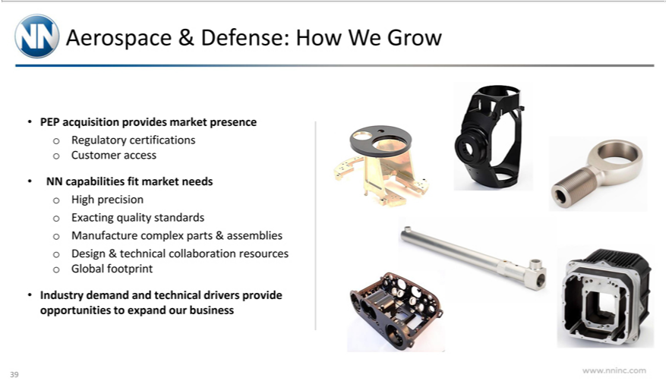

Aerospace & Defense: How W Grow | certifications o | access
PEP acquisition provides market presence | certifications o | access
NN capabilities fit market needs o High precisionRegulatoryExacting quality standardsCustomerManufacture complex parts & assemblies o Design & technical collaboration resources o Global footprint Industry demand and technical drivers provide opportunities to expand our business
www.nninc.com
39



Automotive

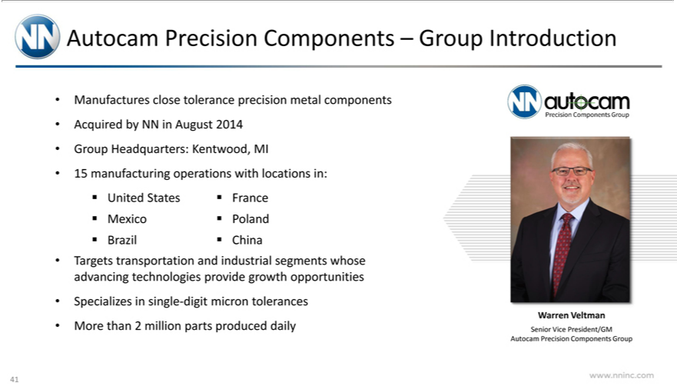

Autocam Precision Components – Group Introduction
AcquiredManufacturesbyNNclosein Augusttolerance2014precision metal components
Group Headquarters: Kentwood, MI
15 manufacturing operations with locations in: United States France Mexico Poland Brazil China
Targets transportation and industrial segments whose advancing technologies provide growth opportunities Specializes in single-digit micron tolerances
More than 2 million parts produced daily
WarrenAutocamVeltmanPrecision Components Group
www.nninc.comSeniorVicePresident/GM Autocam Precision Components Group
41

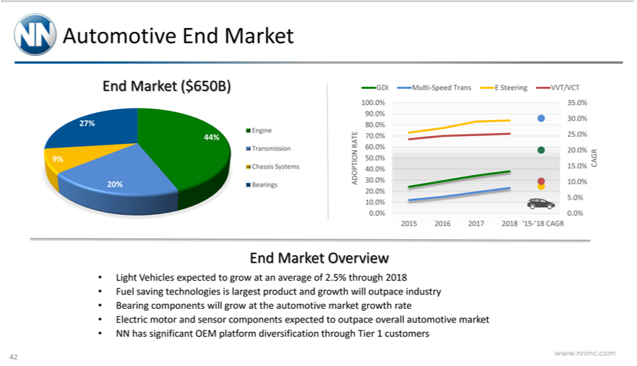

EndAutomotiveMarket (End$650B)Market
44%^{27%} 9% 20%
Engine_{ADOPTION}ransmission Chassis Systems Bearings
G I Multi-SpeedRATETrans E Steering VVT/VCT
100.0% 90.0% 80.0% 70.0% 60.0% 50.0% 40.^{0%} 30.0% 20.0% 10.0% 0.0%
CAGR35.0% 30.0% 25.0% 20.0% 15.0% 10.0% 5.0% .0%
End2015Market20162017Overview2018 ‘15-‘18 CAGR
Light Vehicles expected to grow at an average of 2.5% through 2018
BearingFuelsavingcomponentstechnologieswill isgrowlargestattheproductautomotiveandgrowthmarketwillgrowthoutpacerateindustry
Electric motor and sensor components expected to outpace overall automotive market
www.nninc.comNNhassignificant OEM platform diversification through Tier 1 customers
42

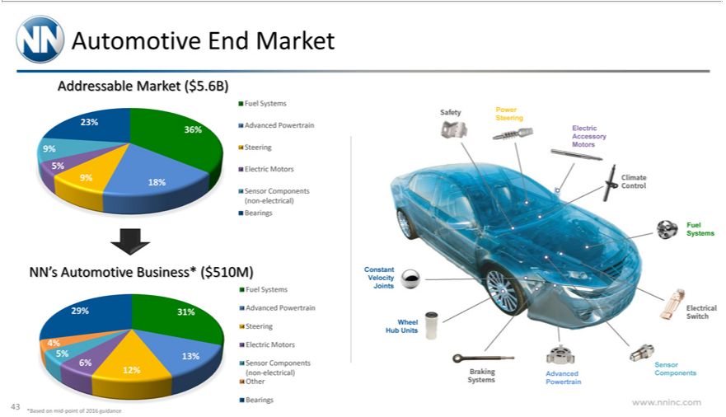

_{Addressable}utomotive End Market
_{36%}23%_{18%9% 5%} ^{Market ($5.6B)}
9%
Fuel Systems
Advanced Powertrain Steering Electric Motors
^{Sensor}
NN’ AutomotiveComponentsBusiness*(non-electrical)($510M)Bearings
29% 31%
Fuel4%5%13%Systems6%12%
Advanced Powertrain Steering Electric Motors
Sensor Components (non-electrical) Other
Bearings
Safety Power Steering Electric Accessory Motors Climate Control Fuel Systems Electrical Switch Sensor Components Advanced Powertrain Braking Systems Wheel Hub Units Constant Velocity Joints www.nninc.com
43
*Based on mid-point of 2016 guidance

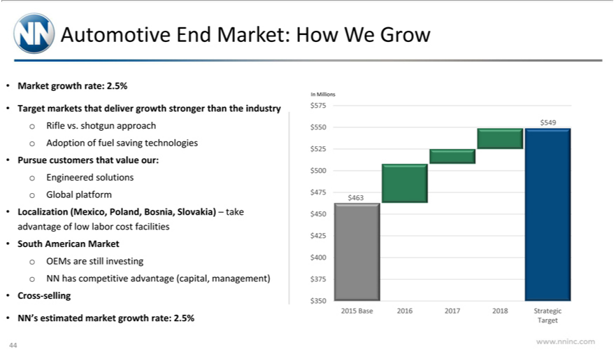

Automotive End Market: How We Grow
 | growth rate: 2.5%
MarketTgetmarkets that deliver growth stronger than the industry Rifle vs. shotgun approach o Adoption of fuel saving technologies
Pursue customers that value our: Engineered solu ions o Global platform
Localization (Mexico, |  | Bosnia, | Slovakia) – take advantage of low labor cost facilities
South American MarketPoland,OEMs are still investing o NN has competitive advantage (capital, management)
 | -selling
CrossNN’ estimated market growth rate: 2.5%
In Millions |  | $450 $425 | $400 $375 $350
75 | $550 $525 $500 $475 | $450 $425 | $400 $375 $350
549
$463 | Base 2016 2017 2018 Strategic
2015
Target
www.nninc.com
44

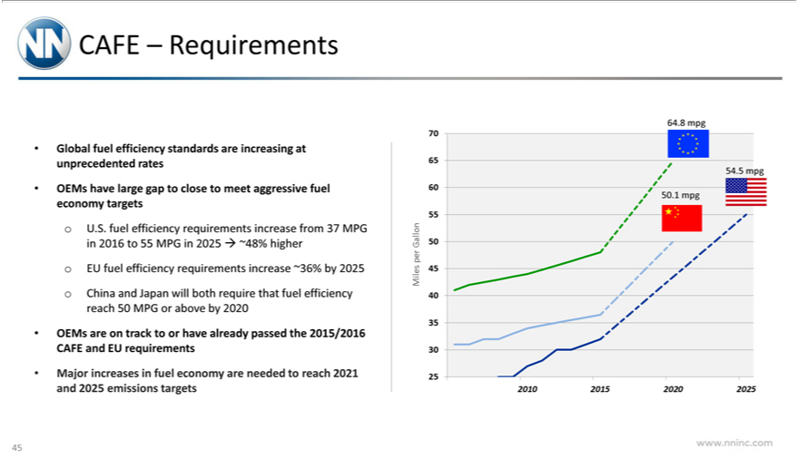

CAFE – Requirements
Global fuel efficiency standards are increasing at unprecedented rates
OEMs have large gap to close to meet aggressive fuel economy targets o U.S. fuel efficiency requirements increase from 37 MPG in 2016 to 55 MPG in 2025 ~48% higher o EU fuel efficiency requirements increase ~36% by 2025 o China and Japan will both require that fuel efficiency reach 50 MPG or above by 2020
_{Miles}OEMsajor increasesareontrackin fueltooreconomyhavealreadyareneededpassedtothereach2015/20162021andCAFE2025andemissionsEUrequirementstargets
www.nninc.comperGallon 70 65 60 55 50 45 40 35 30 25 64.8 mpg 54.5 mpg 50.1 mpg 2010 2015 2020 2025
45

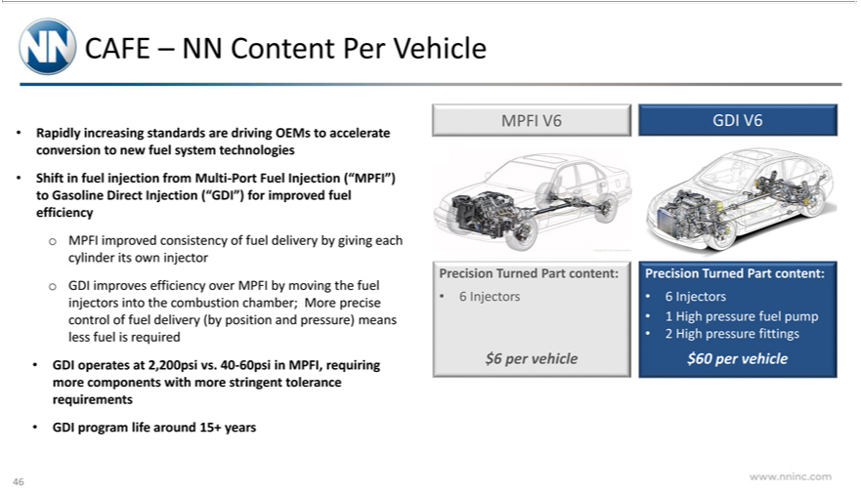

CAFE – NN Content Per Vehicle
Rapidly increasing standards are driving OEMs to accelerate conversion to new fuel system technologies
Shift in fuel injection from Multi-Port Fuel Injection (“MPFI”)_{injectors}Gasoline Direct Injection (“GDI”) for improved fuel efficiency o MPFI improved consistency of fuel delivery by giving each cylinder its own injector
o GDI improves efficiency over MPFI by moving the fuel into the combustion chamber; More precise control of fuel delivery (by position and pressure) means less fuel is required ^{GDI} operates at 2,200psi vs. 40-60psi in MPFI, requiring more components with more stringent tolerance requirements
program life around 15+ years
MPFI V6 GDI V6
$Precision⁶InjectorsTurned Part content:
per vehicle
Precision Turned Part content:
6 Injectors
¹ High pressure fittings^{uelpump}
2
$60 per vehicle
46www.nninc.com

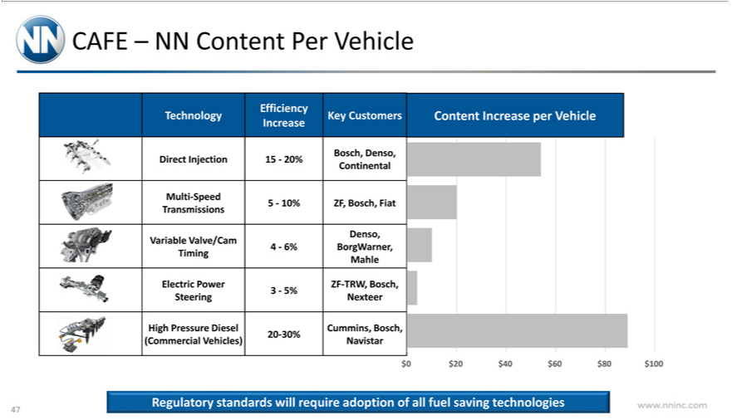

CAFE – NN Content Per Vehicle
Technology
Direct Injection
Multi-Speed Transmissions
Variable Valve/Cam Timing
Electric Power Steering
High Pressure Diesel (Commercial Vehicles)
Efficiency Increase
15 | —20%
15 | 10%
4 | 6%
3—5% 20-30%
Key Customers
 | Denso, Continental
Bosch,ZFBosch, Fiat
Denso, BorgWarner, Mahle
ZF-TRW Bosch, Nexteer
ummins, Bosch, Navistar
Content Increase per Vehicle
$0 | $20 $40 $60 $80 $100
www.nninc.comRegulatorystandards will require adoption of all fuel saving technologies
47

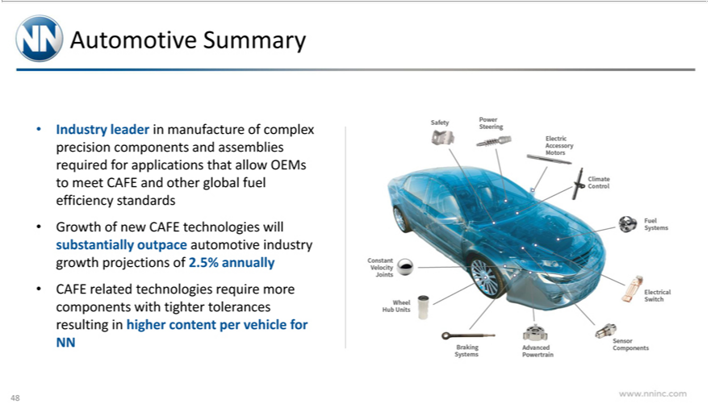

Automotive Summary
Industry leader in manufacture of complex precision components and assemblies required for applications that allow OEMs to meet CAFE and other global fuel efficiency standards Growth of new CAFE technologies will substantially outpace automotive industry growth projections of 2.5% annually
CAFE _{Power}relatd technologies require more components_{Climate}wih tighter tolerances resulting in higher content per vehicle for NN
_{Electrical}Safey Steering Electric Accessory Motors Control Fuel Systems
Switch Sensor Components Advanced Powertrain Braking Systems Wheel Hub Units Constant Velocity Joints www.nninc.com
48



Capital Structure Overview

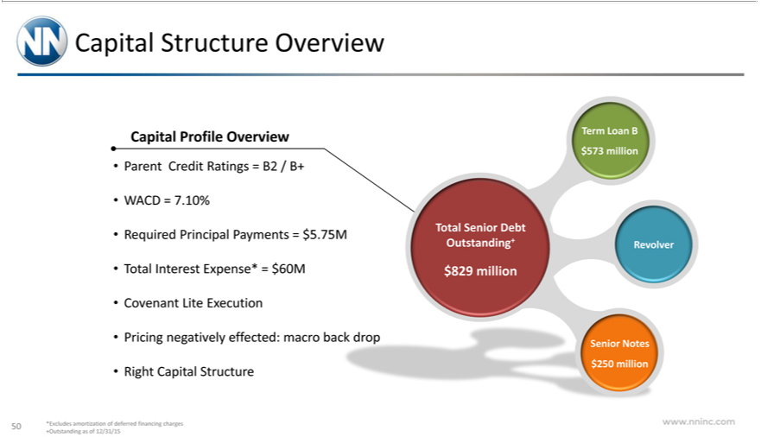

^{Capital}
ProfileStructureOverviewOverview
WACDParentCredit=7.10%Ratings = B2 / B+
Required Principal Payments = $5.75M
Total Interest Expense* = $60M
Covenant Lite Execution
RightPricingCapitalnegativelyStructureeffected: macro ba
$Total829 millionSenior Debt Outstanding+
RevolverTermLoan B $573 million
www.nninc.comSeniorNotes$250 million
50 *Excludes amortization of deferred financing charges +Outstanding as of 12/31/15

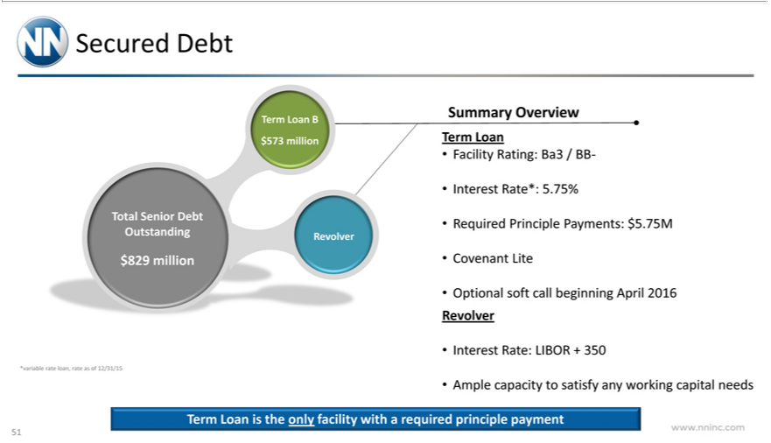

Secured Debt
$Total829 millionSenior Debt Outstanding
RevolverTermLoan B $573 million
Summary*variable rateOverviewloan,rate as of 12/31/15
Term Loan
Facility Rating: Ba3 / BB-
Interest Rate*: 5.75%
CovenantRequired_{softPrinciple}Li Payments: $5.75M
RevolverOptional call beginning April 2016
Interest Rate: LIBOR + 350
Ample capacity to satisfy any working capital needs
www.nninc.comTermLoanisthe only facility with a required principle payment
51

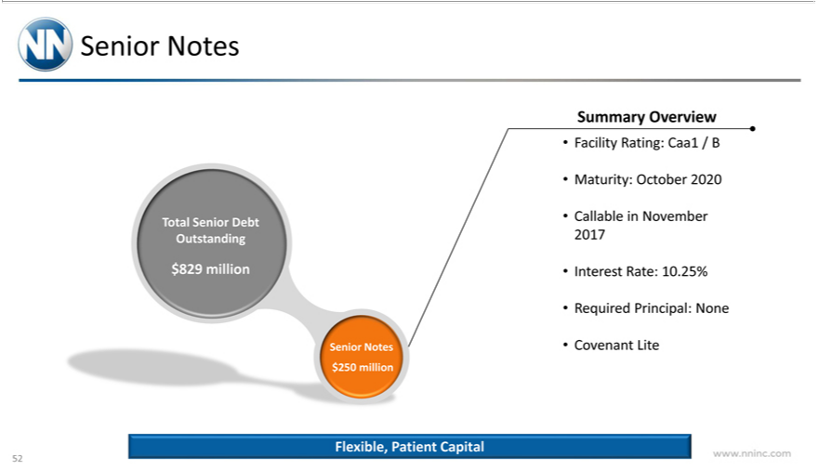

Senior Notes
Total Senior Debt Outstanding
_{Summary}$829eniormillionNotes $250 million
Overview
Facility Rating: Caa1 / B
Maturity: October 2020
Callable in November 2017
Interest Rate: 10.25%
Required Principal: None
Covenant Lite
www.nninc.comFlexible,Patient Capital
52

De-Leveraging Profile
In Millions | $500 | $400 | $300 | $200 | $100
900 $800 $700 $600
$0
Net Debt Outstanding
5 0
5
4 0
5
3 0
5
2.00x
Leverage
YE 2015 2016 2017 2018
No es Term Loan Leverage
Institutional focus | deleveraging
^{Free} provisions
lexiblecashcallflow will be directed&ratingsto debtincreasesrepaymentcanspeed up deleveraging
www.nninc.comWithnoEBITDA growth we are still less than 3.5x levered at that end of 2018.
53

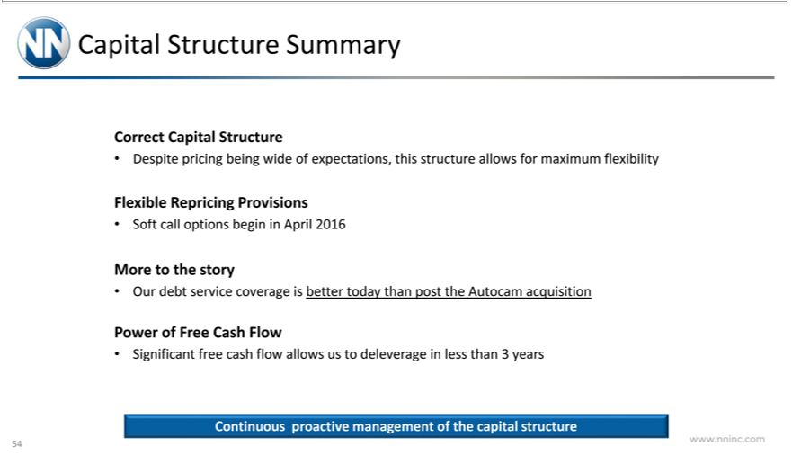

_{Correct}apital StructureCap_{pricing}talStructureSummary
FlexibleDespite RepricingbeingProvisionswideof expectations, this structure allows for maximum flexibility
MoreSoftcallto theoptionsstorybegin in April 2016
PowerOurdebtof serviceFreeCashcoverageFlow is better today than post the Autocam acquisition
Significant free cash flow_{management}llowsus to deleverage in less than 3 years
www.nninc.comContinuousproactive of the capital structure
54



Financial Performance

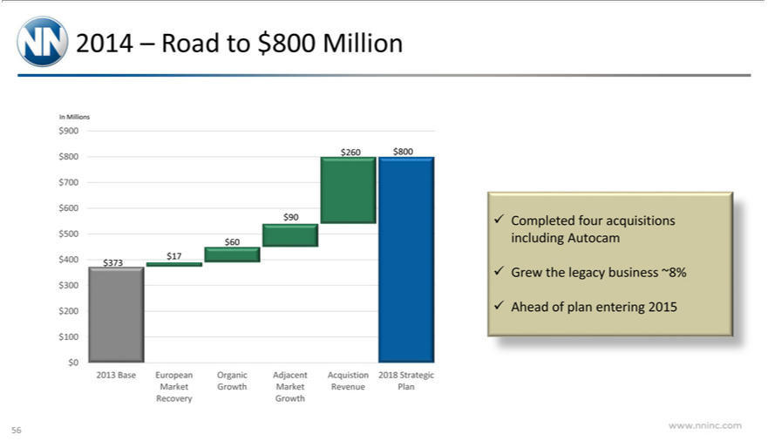

In2014Millions–Road to $800 Million
900_{260 $800} $700 $600 $500 $400 $300 $200 $100 $0
$9060 $17 $373
2013 Base European Organic Adjacent Acquistion 2018 Strategic Market Growth Market Revenue Plan Recovery Growth Completed four acquisitions including Autocam
Grew the legacy business ~8%
www.nninc.comAheadofplanentering 2015
56

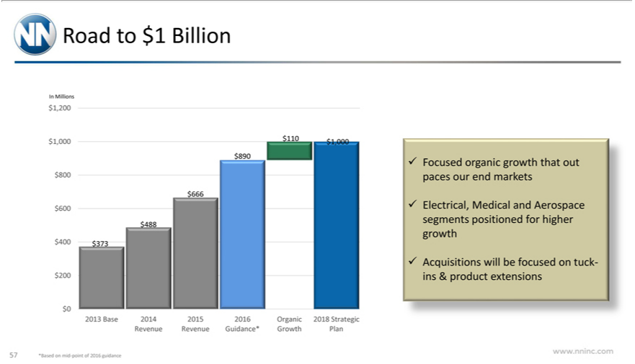

InRoadMillionsto$1 Billion
¹
₆₆₆10,200$1,000$1,000$890$800 $600 $400 $200 $0
$488373
Focused2013Baseorganic2014 2015growth2016thatOrganicoutpaces2018ourStrategicendmarketsRevenue Revenue Guidance* Growth Plan
Electrical, Medical and Aerospace segments positioned for higher growth
www.nninc.comAcquisitionswill be focused on tuck-ins & product extensions
57 *Based on mid-point of 2016 guidance

2013—2018 Strategic Targets
EPS CAGR
ROICSalesCAGR
^{22%}3 Gross Margin
^{18%} EBITDA Margin
^{6%} Operating Margin*
20%
13%
www.nninc.com-16%
58 *Top to bottom of economic cycle range

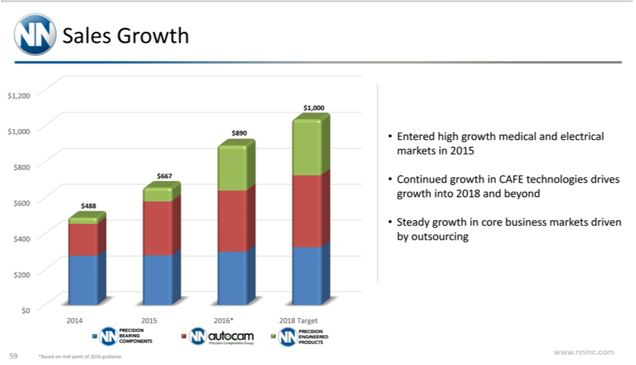

Sales Growth
_{1,000}8902 $1,000 $800 $600 $400 $200 $0
$667488
2014 2015 2016* 2018 Target
PRECISION BEARING COMPONENTS AUTOCAM Precision Components Group PRECISION ENGINEERED PRODUCTS • Entered high growth medical and electrical markets in 2015 Continued growth in CAFE technologies drives gr_{outsourcing}wthinto2018 and beyond
www.nninc.comSteadygrowthin core business markets driven by
59 *Based on mid-point of 2016 guidance

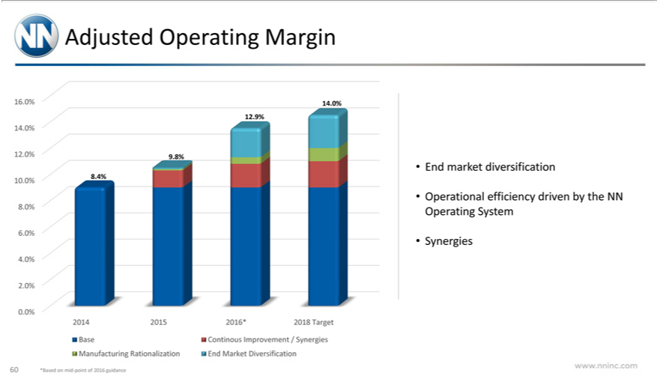

Adjusted Operating Margin
⁴6 ^{0%} 14.0% 12.0% 10.0% 8.0% 6.0% 4.0% 2.0% 0.0%
12.9%
9_{.4%}8%
8
2014 2015 2016* 2018 Target Base Continous Improvement / Synergies Manufacturing Rationalization End Market Diversification End market diversification
SynergiesOperational efficiency driven by the NN Operating System
www.nninc.com
60 *Based on mid-point of 2016 guidance

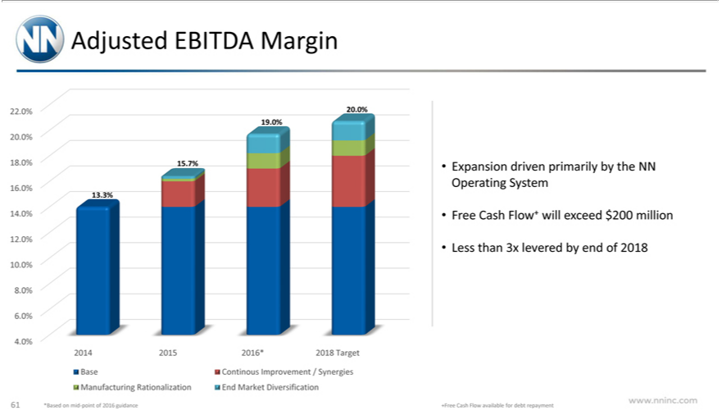

Adjusted EBITDA Margin
20 | 0% | 20 | 18.0% 16.0% 14.0% 12.0% 10.0% 8.0% 6.0% 4.0%
20 | 0% | 19.0%
5 | 7%
13.3%
2014 2015 2016* 2018 T get Base Continous Improvement / Synergies Manufacturing Rationalization End Market Diversification
Expansion driven primarily by the NN Operating System
Free Cash Flow+ will exceed $200 million
Less than 3x levered by end of 2018
www.nninc.com
61 | *Based on mid-point of 2016 guidance
+Free Cash Flow available for debt repayment

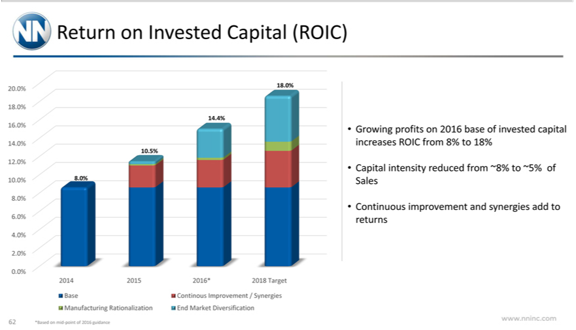

Return on Invested Capital (ROIC)
20 ^{0%} 18.0% 16.0% 14.0% 12.0% 10.0% 8.0% 6.0% 4.0% 2.0% 0.0%
4⁸ 4%
10.5%
8.0%
2014 2015 2016* 2018 Target Base Continous Improvement / Synergies Manufacturing Rationalization End Market Diversification Growing profits on 2016 base of invested capital increases ROIC from 8% to 18%
_{Continuous}apitalintensityimprovementreduced fromandsynergies~8%to~5%add ofto Salesreturns
www.nninc.com
62 *Based on mid-point of 2016 guidance

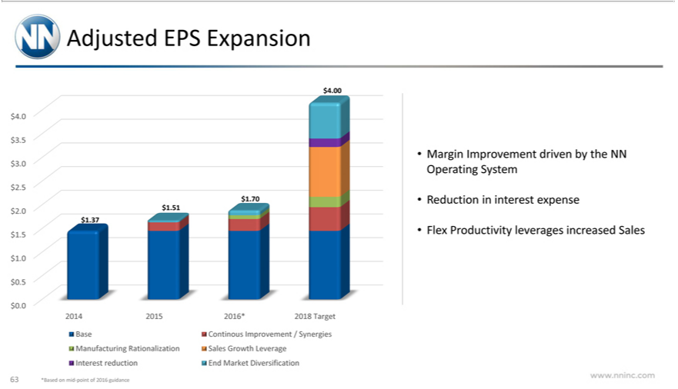

Adjusted EPS Expansion
⁴ ⁰⁰
70$3.5 $3.0 $2.5 $2.0 $1.5 $1.0 $0.5 $0.0
$1.37⁵¹
2014 2015 2016* 2018 Target Base Continous Improvement / Synergies Manufacturing Rationalization Sales Growth Leverage Interest reduction End Market Diversification Margin Improvement driven by the NN Operating System
Reduction in interest expense
www.nninc.comFlexProductivity leverages increased Sales
63 *Based on mid-point of 2016 guidance

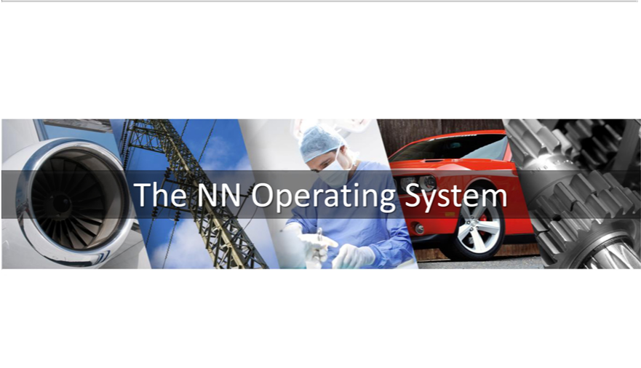

The NN Operating System

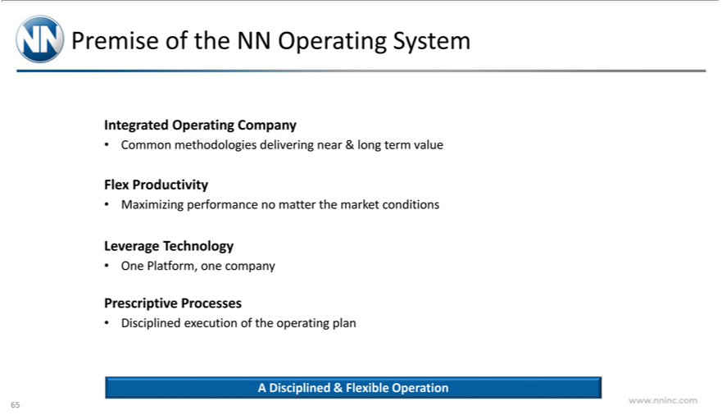

IntegratedPremiseofOperatingtheNNOperatingCompanySystem
FlexCommonProductivitymethodologies delivering near & long term value
LeverageMaximizingTechnologyperformance no matter the market conditions
PrescriptiveOnePlatform,_{Processes}necompany
Disciplined execution of the operating plan
www.nninc.comADisciplined& Flexible Operation
65

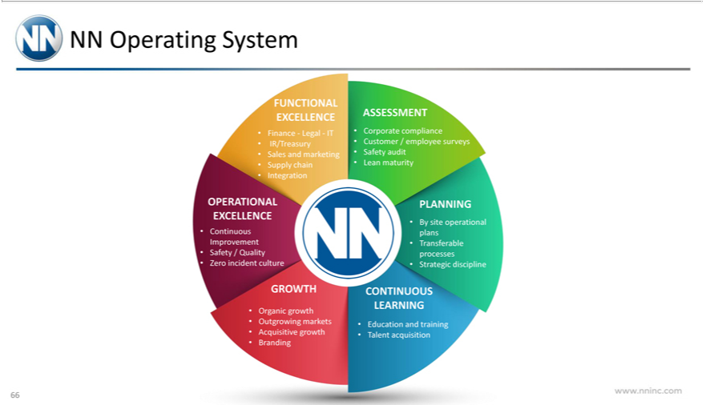

NN Operating System
^{Finance}
UNCTIONAL—Legal—ITEXCELLENCE
_{Supply}IR/Treasuryalesandmarketing
chain
Integration
^{Customer}ASSESSMENTorporatecompliance
Safety audit/employee surveys
Lean maturity
OPERATIONAL EXCELLENCE
Continuous Improvement
Safety / Quality
Zero incident culture
PLANNING
By site operational plans
StrategicTransferabledisciplineprocesses
_{Outgrowing}GROWTHganicgrowth
markets
BrandingAcquisitive growth
CONTINUOUSEducationandtrainingLEARNING
www.nninc.comTalentacquisition
66

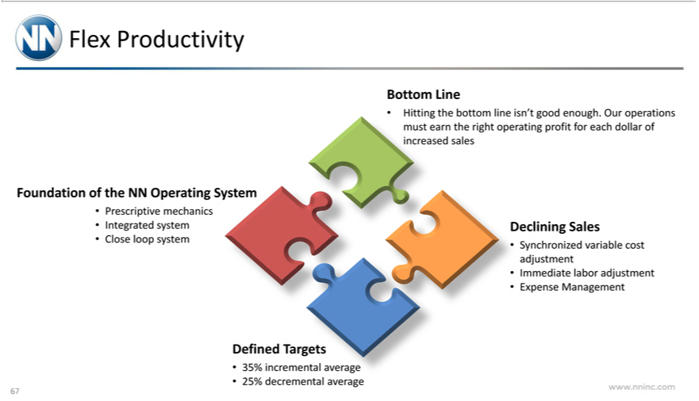

_{Foundation}lexProductivity
Prescriptive ofmechanicstheNNOperating System
Integrated system
BottomCloseloopLinesystem
Hitting the bottom line isn’t good enough. Our operations must earn the right operating profit for each dollar of increased sales Declining Sales
Synchronized variable cost adjustment
ExpenseImmediateManagementlaboradjustment
Defined Targets
^{25%}
3 decrementalincremental averageaverage
www.nninc.com
67



Summary / Q&A

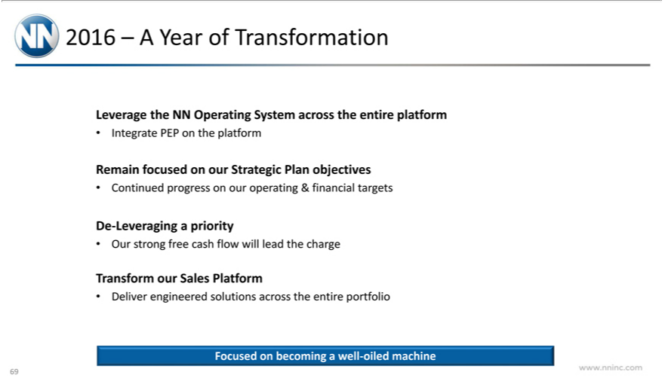

2016 – A Year of Transformation
IntegrateLeverage PEPtheNNon theOperatingplatformSystem across the entire platform
Remain focused on our Strategic Plan objectives
DeContinued-Leveragingprogressapriorityonour operating & financial targets
TransformOurstrong ourfreeSalescash Platformflowwill lead the charge
Deliver engineered solutions across the entire portfolio
www.nninc.comFocusedonbecoming a well-oiled machine
69



^{Who}Engineered^{WAre}Solutions…
InspiredAutomotivebyinnovationIndustrial Technology Medical Aerospace Electrical
www.nninc.com
70

