UNITED STATES
SECURITIES AND EXCHANGE COMMISSION
Washington, D.C. 20549
FORM 8-K
CURRENT REPORT
Pursuant to Section 13 OR 15(d) of The Securities Exchange Act of 1934
Date of Report (Date of earliest event reported): July 29, 2026

NN, Inc.
(Exact name of registrant as specified in its charter)

Delaware |  |  | 001-39268 |  |  | 62-1096725
(State or other jurisdiction of  incorporation) |  |  | (Commission File Number) |  |  | (I.R.S. Employer  Identification No.)
6210 Ardrey Kell Road, Suite 120
Charlotte, North Carolina |  |  |  |  |  | 28277
(Address of principal executive offices) |  |  |  |  |  | (Zip Code)
(980) 264-4300
(Registrant’s telephone number, including area code)
(Former name or former address, if changed since last report)
Check the appropriate box if the Form 8-K filing is intended to simultaneously satisfy the filing obligation of the registrant under any of the following provisions (see General Instruction A.2. below):
☐ |  |  | Written communications pursuant to Rule 425 under the Securities Act (17 CFR 230.425)
☐ |  |  | Soliciting material pursuant to Rule 14a-12 under the Exchange Act (17 CFR 240.14a-12)
☐ |  |  | Pre-commencement communications pursuant to Rule 14d-2(b) under the Exchange Act (17 CFR 240.14d- 2(b))
☐ |  |  | Pre-commencement communications pursuant to Rule 13e-4(c) under the Exchange Act (17 CFR 240.13e- 4(c))
Securities registered pursuant to Section 12(b) of the Act:
Title of each class |  |  |  |  |  | Trading symbol |  |  |  |  |  | Name of each exchange on which registered
Common Stock, par value $0.01 |  |  |  |  |  | NNBR |  |  |  |  |  | The Nasdaq Stock Market LLC
Indicate by check mark whether the registrant is an emerging growth company as defined in Rule 405 of the Securities Act of 1933 (§230.405 of this chapter) or Rule 12b-2 of the Securities Exchange Act of 1934 (§240.12b-2 of this chapter).
Emerging growth company. |  |  | ☐
If an emerging growth company, indicate by check mark if the registrant has elected not to use the extended transition period for complying with any new or revised financial accounting standards provided pursuant to Section 13(a) of the Exchange Act. ☐

Item 1.01 – Entry into a Material Definitive Agreement

As previously disclosed, NN, Inc. (the “Company”) entered into a cooperation agreement, dated January 16, 2026 (the “Cooperation Agreement”), with Legion Partners Asset Management, LLC and certain of its affiliates (collectively, the “Legion Parties”). On July 29, 2026, the Company and the Legion Parties entered into a letter agreement pursuant to which the Company agreed to accelerate the vesting of 49,079 shares of restricted stock award to Raymond T. White in connection with his service as a director and the Legion parties irrevocably waived their replacement rights pursuant to Section 1(f) of the Cooperation Agreement.

ITEM 9.01 FINANCIAL STATEMENTS AND EXHIBITS
(d) Exhibits.
Exhibit  No. |  |  |  |  |  | Description of Exhibit
10.1 |  |  |  |  |  | Letter Agreement
104 |  |  |  |  |  | Cover Page Interactive Data File (embedded within the Inline XBRL document)

SIGNATURES

Pursuant to the requirements of the Securities Exchange Act of 1934, the registrant has duly caused this report to be signed on its behalf by the undersigned hereunto duly authorized.
Date: |  |  | July 31, 2026

 |  |  | NN, INC.
 |  |  | By: |  |  | /s/ Christopher H. Bohnert
 |  |  | Name: |  |  | Christopher H. Bohnert
 |  |  | Title: |  |  | Senior Vice President and Chief Financial Officer

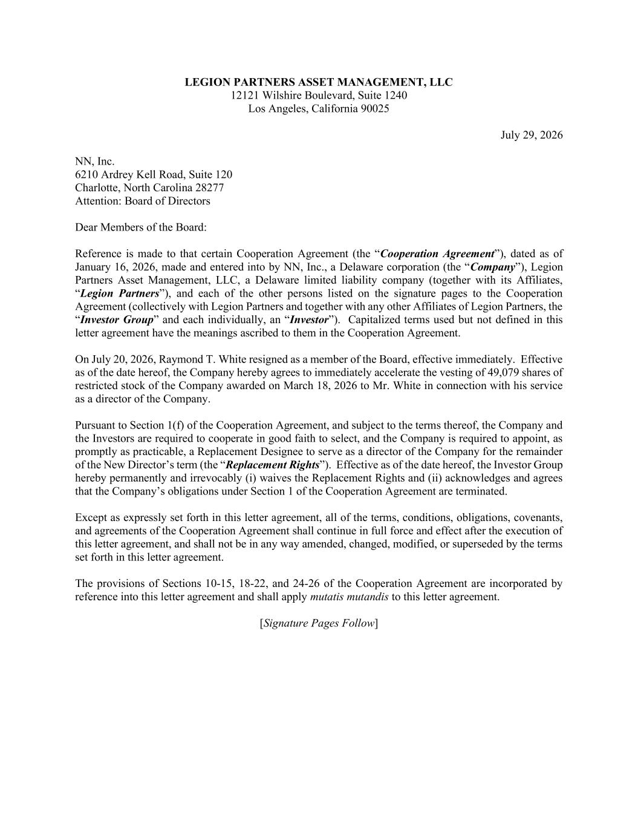

LEGION PARTNERS ASSET MANAGEMENT, LLC 12121 Wilshire Boulevard, Suite 1240 Los Angeles, California 90025 July 29, 2026 NN, Inc. 6210 Ardrey Kell Road, Suite 120 Charlotte, North Carolina 28277 Attention: Board of Directors Dear Members of the Board: Reference is made to that certain Cooperation Agreement (the “Cooperation Agreement”), dated as of January 16, 2026, made and entered into by NN, Inc., a Delaware corporation (the “Company”), Legion Partners Asset Management, LLC, a Delaware limited liability company (together with its Affiliates, “Legion Partners”), and each of the other persons listed on the signature pages to the Cooperation Agreement (collectively with Legion Partners and together with any other Affiliates of Legion Partners, the “Investor Group” and each individually, an “Investor”). Capitalized terms used but not defined in this letter agreement have the meanings ascribed to them in the Cooperation Agreement. On July 20, 2026, Raymond T. White resigned as a member of the Board, effective immediately. Effective as of the date hereof, the Company hereby agrees to immediately accelerate the vesting of 49,079 shares of restricted stock of the Company awarded on March 18, 2026 to Mr. White in connection with his service as a director of the Company. Pursuant to Section 1(f) of the Cooperation Agreement, and subject to the terms thereof, the Company and the Investors are required to cooperate in good faith to select, and the Company is required to appoint, as promptly as practicable, a Replacement Designee to serve as a director of the Company for the remainder of the New Director’s term (the “Replacement Rights”). Effective as of the date hereof, the Investor Group hereby permanently and irrevocably (i) waives the Replacement Rights and (ii) acknowledges and agrees that the Company’s obligations under Section 1 of the Cooperation Agreement are terminated. Except as expressly set forth in this letter agreement, all of the terms, conditions, obligations, covenants, and agreements of the Cooperation Agreement shall continue in full force and effect after the execution of this letter agreement, and shall not be in any way amended, changed, modified, or superseded by the terms set forth in this letter agreement. The provisions of Sections 10-15, 18-22, and 24-26 of the Cooperation Agreement are incorporated by reference into this letter agreement and shall apply mutatis mutandis to this letter agreement. [Signature Pages Follow]

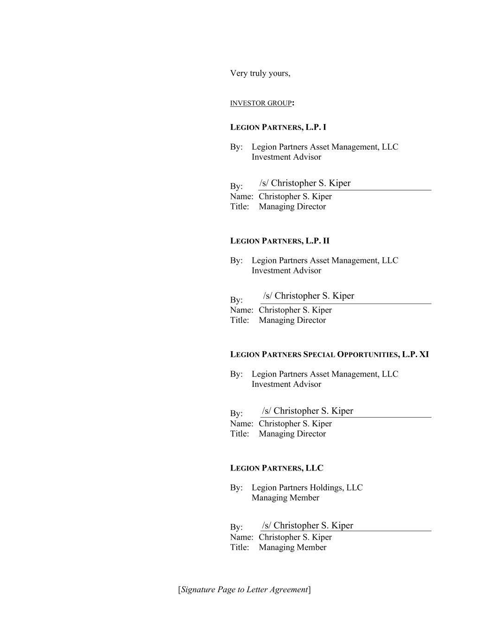
[Signature Page to Letter Agreement] Very truly yours, INVESTOR GROUP: LEGION PARTNERS, L.P. I By: Legion Partners Asset Management, LLC Investment Advisor By: Name: Christopher S. Kiper Title: Managing Director LEGION PARTNERS, L.P. II By: Legion Partners Asset Management, LLC Investment Advisor By: Name: Christopher S. Kiper Title: Managing Director LEGION PARTNERS SPECIAL OPPORTUNITIES, L.P. XI By: Legion Partners Asset Management, LLC Investment Advisor By: Name: Christopher S. Kiper Title: Managing Director LEGION PARTNERS, LLC By: Legion Partners Holdings, LLC Managing Member By: Name: Christopher S. Kiper Title: Managing Member /s/ Christopher S. Kiper /s/ Christopher S. Kiper /s/ Christopher S. Kiper /s/ Christopher S. Kiper

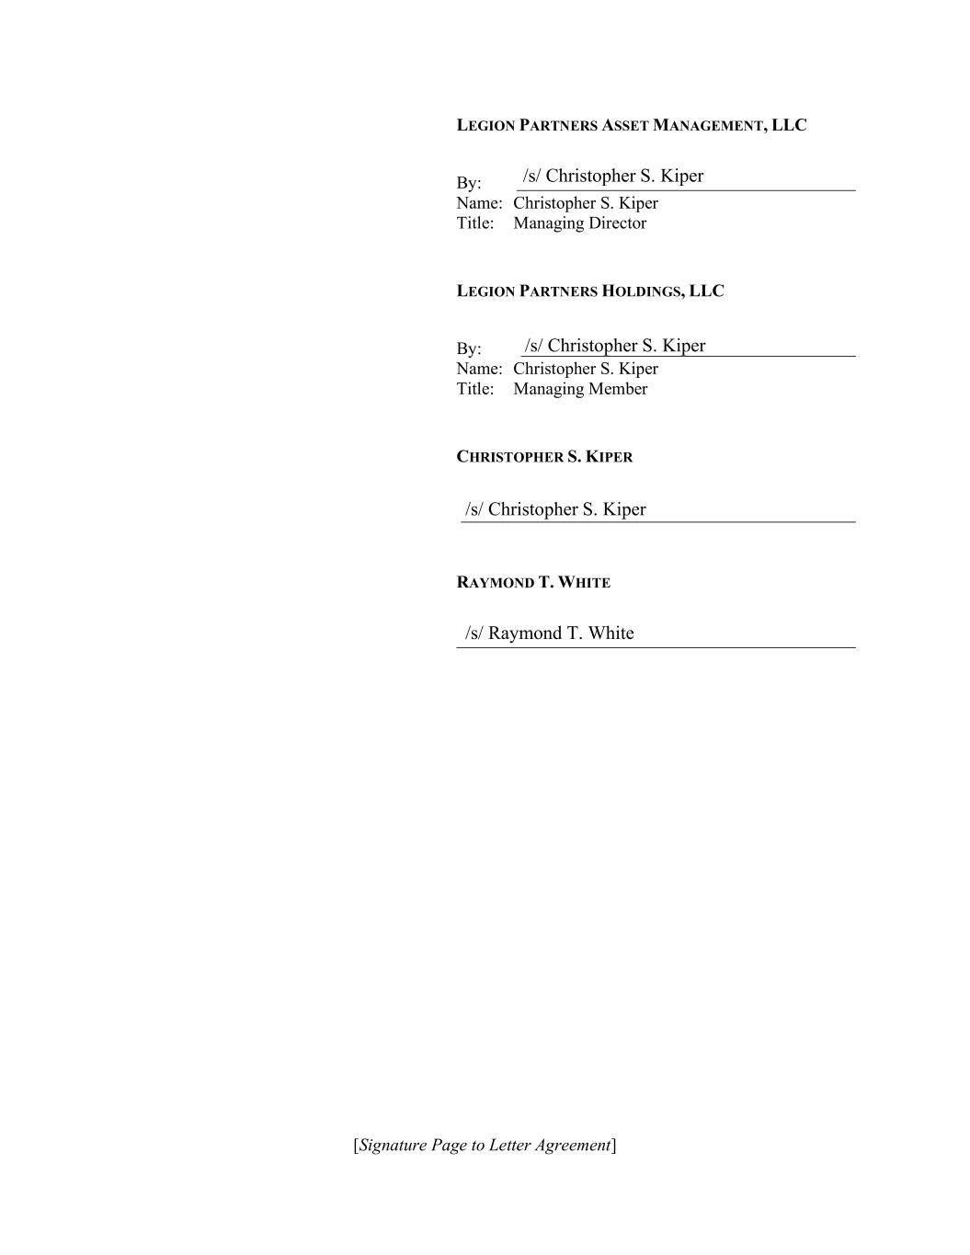
[Signature Page to Letter Agreement] LEGION PARTNERS ASSET MANAGEMENT, LLC By: Name: Christopher S. Kiper Title: Managing Director LEGION PARTNERS HOLDINGS, LLC By: Name: Christopher S. Kiper Title: Managing Member CHRISTOPHER S. KIPER RAYMOND T. WHITE /s/ Christopher S. Kiper /s/ Christopher S. Kiper /s/ Christopher S. Kiper /s/ Raymond T. White

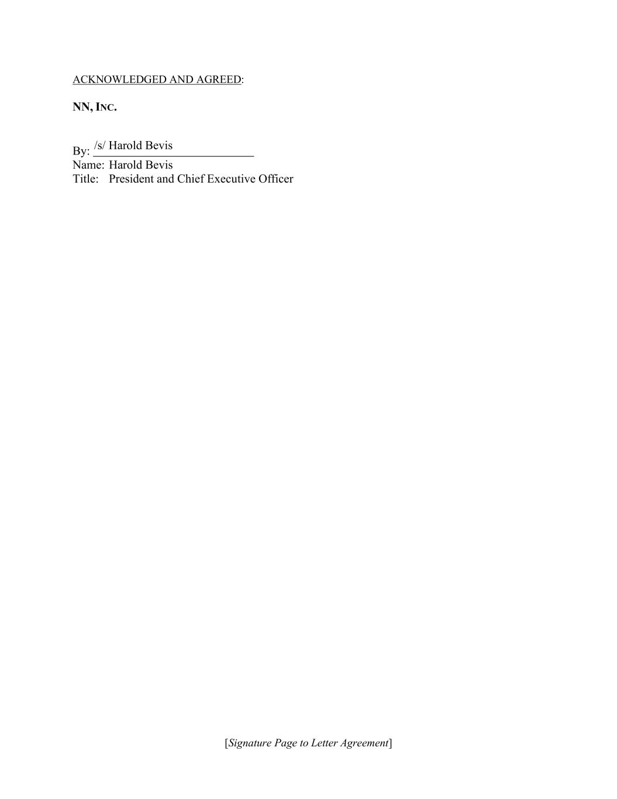
[Signature Page to Letter Agreement] ACKNOWLEDGED AND AGREED: NN, INC. By: Name: Harold Bevis Title: President and Chief Executive Officer /s/ Harold Bevis

