UNITED STATES

SECURITIES AND EXCHANGE COMMISSION
WASHINGTON, DC 20549

FORM 8-K

CURRENT REPORT

PURSUANT TO SECTION 13 OR 15(d)
OF THE SECURITIES EXCHANGE ACT OF 1934

Date of Report (Date of earliest event reported): November 18, 2014


NN, INC.

(Exact name of registrant as specified in its charter)

Delaware

0-23486

62-1096725

(State or Other Jurisdiction
of Incorporation)

(Commission
File Number)

(I.R.S. Employer
Identification No.)

2000 Waters Edge Drive, Johnson City, Tennessee

37604

(Address of principal executive offices)

(Zip Code)

(423) 743-9151

(Registrant’s telephone number, including area code)

(Former name or former address, if changed since last report)

Check the appropriate box if the Form 8-K filing is intended to simultaneously satisfy the filing obligation of the registrant under any of the following provisions (see General Instruction A.2. below):

- Written communications pursuant to Rule 425 under the Securities Act (17 CFR 230.425)

- Soliciting material pursuant to Rule 14a-12 under the Exchange Act (17 CFR 240.14a-12)

- Pre-commencement communications pursuant to Rule 14d-2(b) under the Exchange Act (17 CFR 240.14d-2(b))

- Pre-commencement communications pursuant to Rule 13e-4(c) under the Exchange Act (17 CFR 240.13e-4(c))

ITEM 7.01 REGULATION FD DISCLOSURE

Attached as Exhibit 99.1 to this Current Report on Form 8-K is a PowerPoint presentation, which provides an update to investors. The attached presentation updates NN, Inc.’s previously provided investor presentation.

The information presented in Item 7.01 to this Current Report on Form 8-K is being furnished in accordance with Rule 101(e)(1) under Regulation FD and shall not be deemed to be “filed” for purposes of Section 18 of the Securities Exchange Act of 1934, as amended, and will not be incorporated by reference into any registration statement filed under the Securities Act of 1933, as amended, unless specifically identified therein as being incorporated by reference.

ITEM 9.01 FINANCIAL STATEMENTS AND EXHIBITS

Exhibit
No. Description

99.1 Investor Presentation of NN, Inc.

SIGNATURES

Pursuant to the requirements of the Securities Exchange Act of 1934, the registrant has duly caused this report to be signed on its behalf by the undersigned hereunto duly authorized.

Date: November 18, 2014

NN, INC.

By: /s/ William C. Kelly, Jr.

Name: William C. Kelly, Jr.

Title: Vice President and

Chief Administrative Officer

EXHIBIT INDEX

Exhibit
No. Description

99.1 Investor Presentation of NN, Inc.

Exhibit 99.1
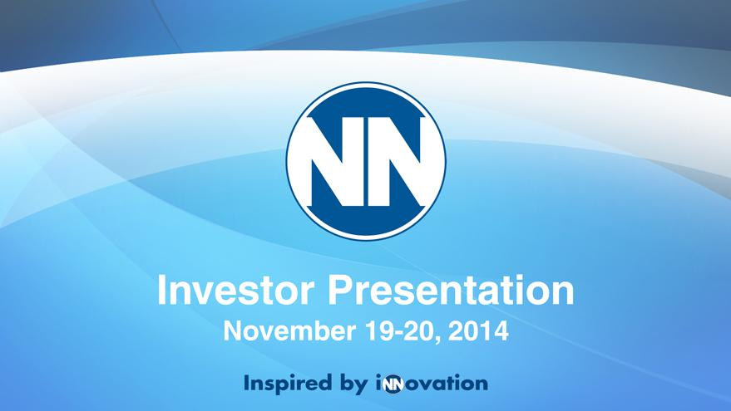

Exhibit 99.1
Investor Presentation
November 19-20, 2014

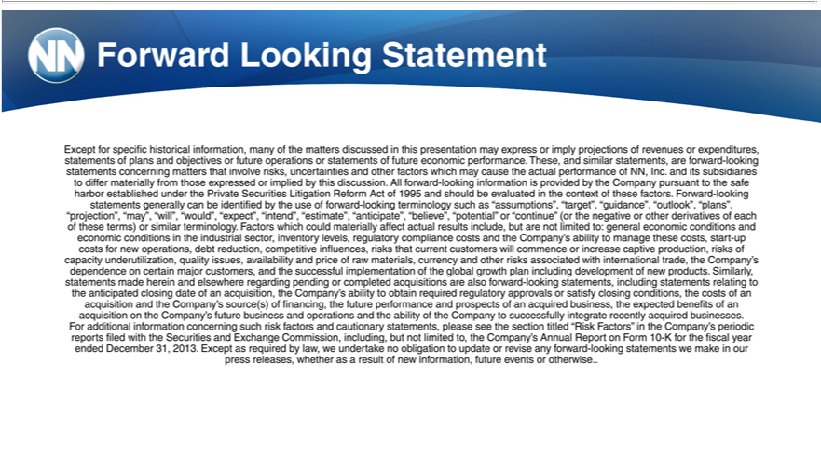

Forward Looking Statement
Except for specific historical informatio , many of the matters discuss d in this presentation may express or imply projections of revenues or expenditures, statements of plans and objectives or future operations
statements of future economic performance. These, and similar statements, are forward-looking statements concerning matters that involve risks, uncertainties and other factors which may cause the actual performance
of NN, Inc. and its subsidiaries to differ materially from those expressed or implied by this discussion. All forward-looking information is provided by the Company pursuant to the safe harbor established under the
Private Securities Litigation Reform Act of 1995 and should be evaluated in the context of these factors. Forward-looking statements generally can identified by the use of forward-looking |  |  |  | such as
“ ssumptions”, “target”, “guidance”, “outlook”, “plans”, “projection”, “may”, “will”, “would”, “expect”, “intend”, “estimate”, “anticipate”, “believe”, “potential” or “continue” (or the negativeterminologyorothderivatives of
each of these terms) or similar terminology. Factors which could materially affect actual results include, but are not limited to: general economic conditions and economic conditions in the industrial sector, inventory
levels, regulatory compliance costs and the Company’s ability to manage these costs, start-up costs for new operations, debt reduction, competitive influences, risks that current |  |  | will commence or increase
aptive production, risks of capacity underutilization, quality issues, availability and price of raw materials, currency and other risks associated with international trade, the Company’customersdependence |  |  |  | certain major
customers, and the successful implementation of the global growth plan including development of new products. Similarly, statements made herein and elsewhere regarding pending or completed acquisitions are also
forward-looking statements, including tatements relating to the anticipated closing date of an acquisition, the Company’s ability to obtain required regulatory approvals or |  |  | closing conditions, the costs of an
cquisition and the Company’ source(s) of financing, the future performance and prospects of an acquired business, the expected benefits of an acquisition on the Company’satisfyfuture business and operations and the
ability of the Company to successfully integrate recently acquired businesses.
For additional information concerning such risk factors and | statements, please see the section titled “Risk Factors” in the Company’s periodic reports filed with the Securities and Exchange Commission,
including, but not limited to, the Company’s Annual Report cautionaryForm10-K |  | the fiscal year ended December 31, 2013. Except as required by law, we undertake no obligation to update or revise any forward-looking
statements we make in our press releases, whether as a result of new information, future events or otherwise

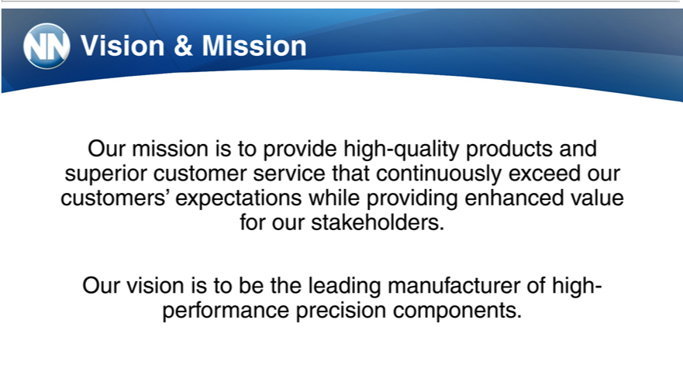

Vision & _{Mission}
^{Our}
visionmission totobeprovidetheleadinghigh-manufacturerqualityproductsofhighand-superiorperformancecustomerprecisionservicecomponents.thatcontinuously exceed our customers’ expectations while providing enhanced value for our stakeholders.

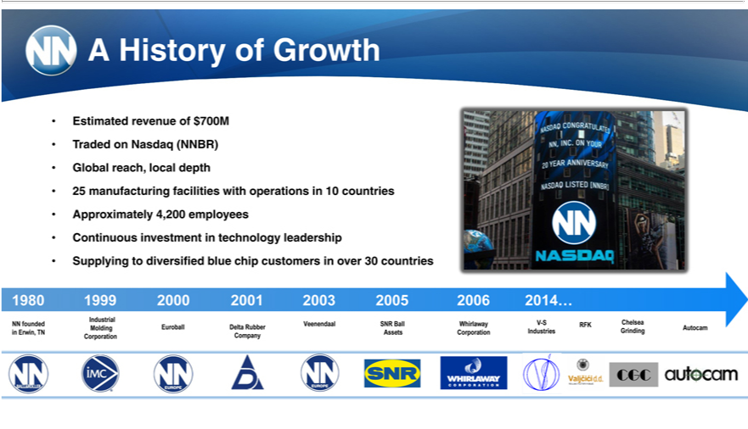

AEstimatedHistory ofrevenueGrowthof $700M
GlobalTraded reach,onNasdaqlocal(NNBR)depth
Approximately25manufacturing4,200facilitiesemployeeswithoperations in 10 countries
Continuous investment in technology leadership
Supplying to diversified blue chip customers in over 30 countries
Industrial1980MetalVeenendaalBearing1999Components2000SNRBallWhirlaway2001V-S 2003Chelsea2005 2006 2014…
NN founded Molding Euroball Delta Rubber RFK Autocam
CorporationinErwin,TNCompanyAssetsCorporation Industries Grinding

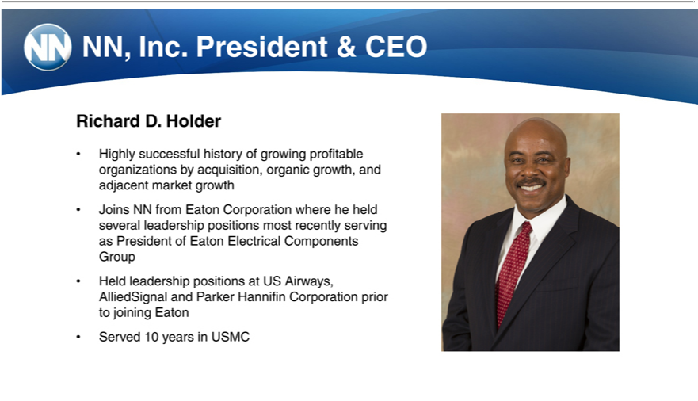

NN,RichardInc.D.PresidentHolder & CEO
JoinsHighlyNNsuccessfulfromEatonhistory of growingwhereprofitableheheldorganizationsseveralleadershipbyacquisition,positions organicmostrecentlygrowth,servingandadjacentasPresidentmarketofgrowthEatonElectrical Components Group

Held leadership positionsCorporationUSAirways,

AlliedSignal and Parker Hannifin Corporation prior to joining Eaton

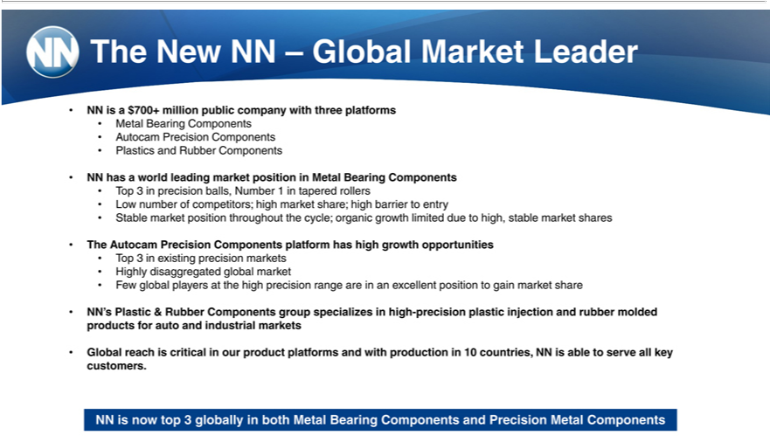

The New NN – Global Market Leader
NN is | $700+ million public company with three platforms
Metal Bearing Components
Autocam Precision Components
Plastics and Rubber Components
NN has a world leading market position in Metal Bearing Components
Top 3 in precision balls, Number 1 in tapered rollers
Low number of competitors; high market share; high barrier to entry
Stable market position thr ughout the cycle; organic growth limited due to high, stable market shares
he Autocam Precision Components platform has high growth opportunities
Top 3 in existing precision markets
Highly | global market
Few globaldisaggregatedplayers the high precision range are in an excellent position to gain market share
NN’s Plastic & Rubber Components group specializes in high-precision plastic injection and rubber molded products for auto and industrial markets Global reach is critical in our product platforms and with production in 10 countries, NN is able to serve all key customers.

NN is now top 3 globally in both Metal Bearing Components and Precision Metal Components

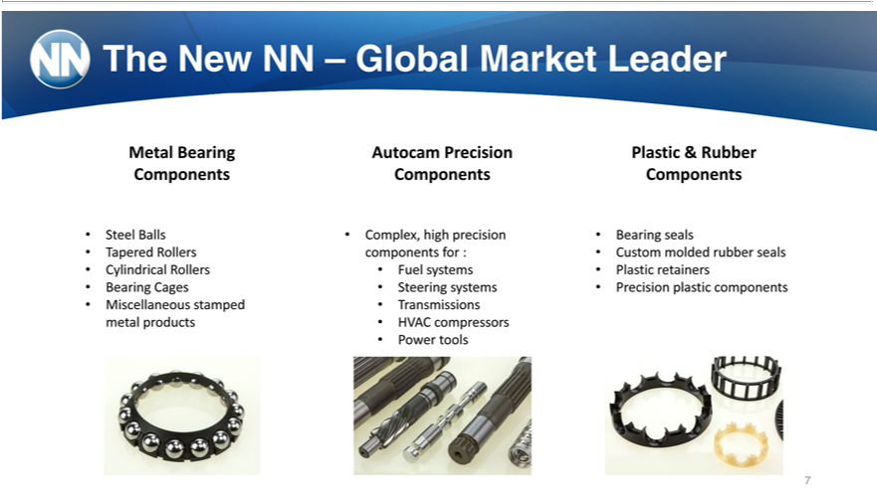

MetalTheNewBearingNN–ComponentsGlobalMarket Leader
Steel Balls Tapered Rollers Cylindrical Rollers Bearing Cages Miscellaneous stamped metal products Autocam Precision Components
FuelComplex,systemshigh precision components for :
SteeringTransmissionssystems
_{Plastic}HVACower toolscompressors
Bearing&sealsRubber Components
Custom molded rubber seals Plastic retainers Precision plastic components

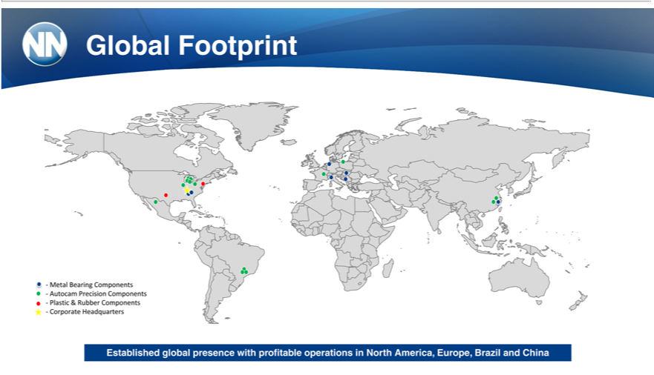

Global Footprint
—Metal Bearing Components —Autocam Precision Components —Plastic & Rubber Components —Corporate Headquarters Established global presence with profitable operations in North America, Europe, Brazil and China

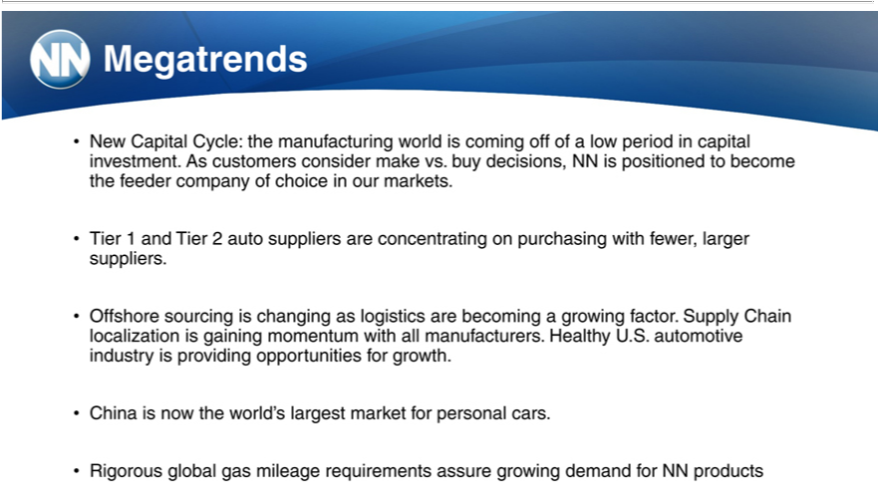

Megatrends
New Capital Cycle: the manufacturing world is coming off of a low period in capital investment. As customers consider make vs. buy decisions, NN is positioned to become the feeder company of choice in our markets.
Tier 1 and Tier 2 auto suppliers are concentrating on _{purchasing} with fewer, larger suppliers.
Offshore sourcing is changing as logistics are becoming growing factor. Supply Chain localization is gaining momentum with all manufacturers. Healthy U.S. automotive industry is providing opportunities for growth.
China is now the world’s largest market for personal cars.
Rigorous global gas mileage requirements assure growing demand for NN products

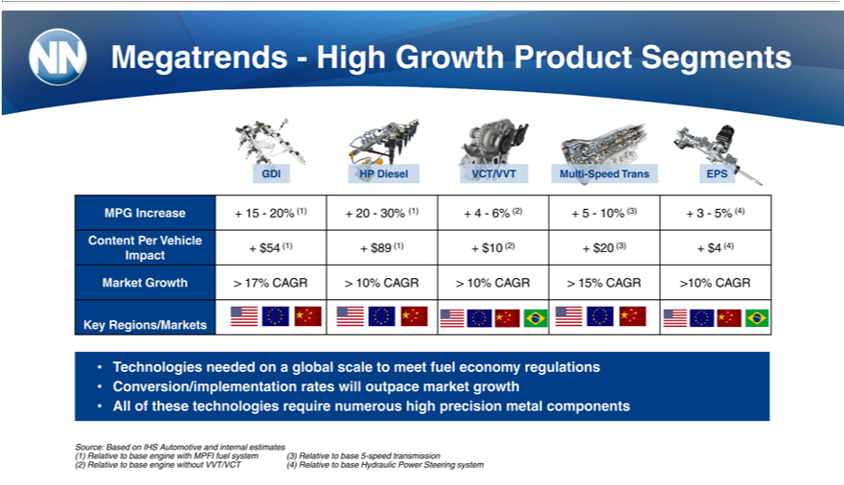

GDIMegatrends—HighHPDieselVCT/VVTGrowthMultiProduct-SpeedSegmentsTrans EPS
ContentMPGIncreasePerVehicle+15 —20% (1) + 20 —30% (1) + 4 —6% (2) + 5 —10% (3) + 3 —5% (4)
Impact + $54 (1) + $89 (1) + $10 (2) + $20 (3) + $4 (4)
KeyMarketRegions/MarketsGrowth>17% CAGR > 10% CAGR > 10% CAGR > 15% CAGR >10% CAGR
Technologies needed on a global scale to meet fuel economy regulations Conversion/implementation rates will outpace market growth All of these technologies require numerous high precision metal components Source: Based on IHS Automotive and internal estimates
(1) Relative to base engine with MPFI fuel system
(3) Relative to base 5-speed transmission
(2) Relative to base engine without VVT/VCT
(4) Relative to base Hydraulic Power Steering system

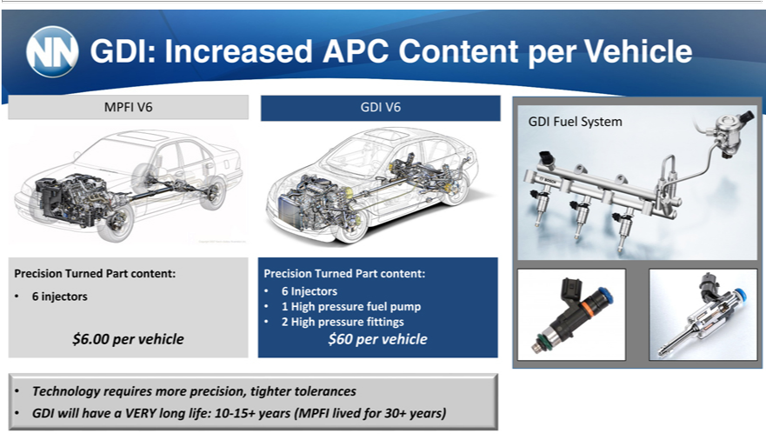

GDI:MPFIIncreasedV6GDIV6APC Content per Vehicle
Precision Turned Part content:
$66.00 perinjectorsvehicle
6PrecisionInjectorsTurned Part content:
21 HighHigh pressurepressure fittingsfuelpump
$60 per vehicle
Technology requires more precision, tighter tolerances
^{GDI}
Fuelwill haveSystemaVERY long life: 10-15+ years (MPFI lived for 30+ years)

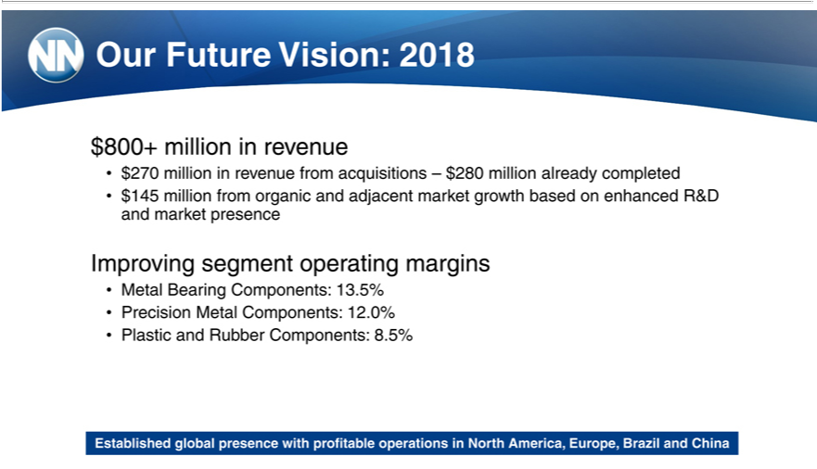

Our80₂₇₀Future+millionVision:inrevenue2018

in revenue from acquisitions – $280 million already completed

$145 million from organic and adjacent market growth based on enhanced R&D and market presence Improving segment operating margins
M_{recision}talBearing Components: 13.5%
_{Plastic} andMetalRubberComponents:Components:12.0%8.5%
Established global presence with profitable operations in North America, Europe, Brazil and China

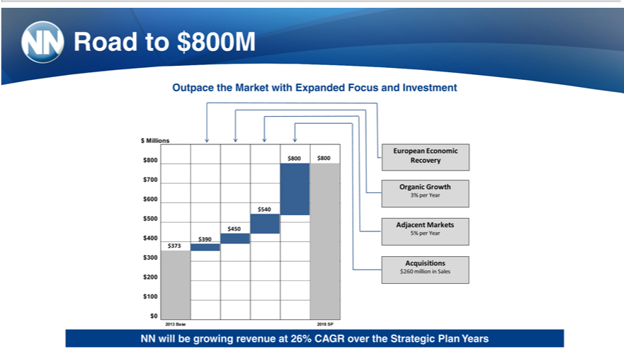

Road to $800M
$OutpaceMillionsthe Market with Expanded Focus and Investment
European Economic
$8⁷⁰⁰ $800 $800 Recovery
Organic Growth
3% per Year
$600500₄₀
$Adjacent450 Markets
5% per Year
$400300₇₃ $390
Acquisitions
²60 million in Sales
$1000
2013 Base 2018 SP
NN will be growing revenue at 26% CAGR over the Strategic Plan Years

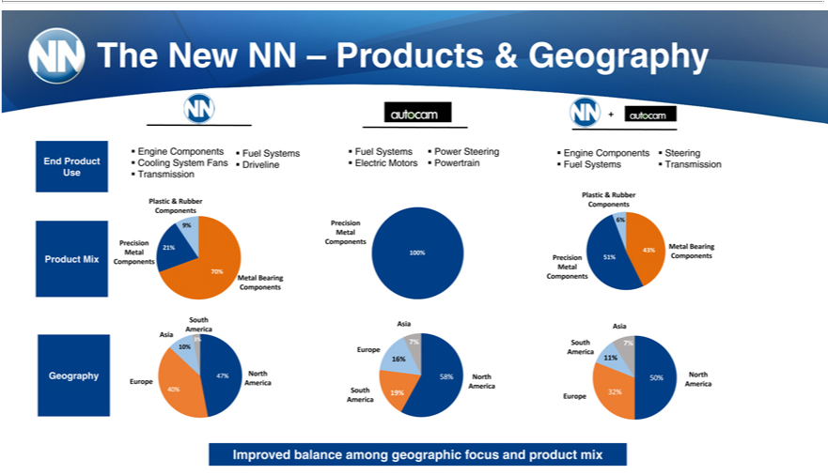

^{End}ThegineNewComponentsNN–ProductsFuel&SystemsGeography
Use TransmissionProductCooling System Fans Driveline
Plastic & Rubber
9%Components
Precision
Metal21%
70%Product Mix Components
Metal Bearing
Components
_{Asia}Southmerica
10%3%
Geography 47% North
40%Europe America
Fuel Systems Power Steering
MetalEl_{Prcision}tricMotors Powertrain
Components
Asia100%
Europe7%
58%^{16%} North
America
South 19%
America
+
Engine Components Steering
Fuel Systems Transmission
Plastic & Rubber
Components
6%
43% Metal Bearing
Pr^{Metal}cision 51% Components
Components
AsiaSouth 7%
11%America
50% North
EuropeAmerica32%
Improved balance among geographic focus and product mix

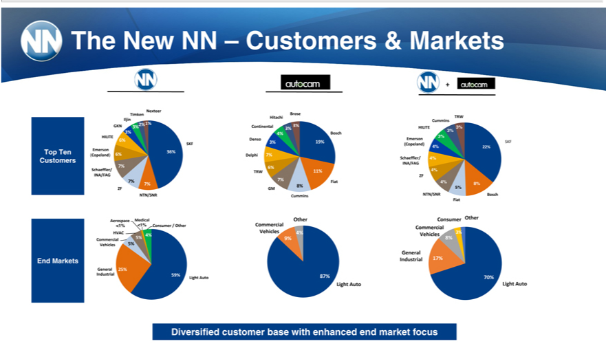

NexteerTheNew NN – Customers & Markets
IljinTimken
2%GKN1%3%
HILITE3%
SKF6%
CustomersTopTen(Copeland) Emerson 6% 36%
7%
Schaeffler/
INA/FAG
ZF7% 7%
AerospaceNTN/SNR
HVAC<1%<1%4% Consumer / Other
Commercial 5%
Vehicles 5%
End Markets
General 25%
Industrial 59%
Light Auto
Brose
Hitachi
Continental 3%
4%^{3%}
Bosch
_{Delphi}nso 3%7% 19%
TRW_{6%} 11%
^{8%}7% Fiat
GM
OtherCummins
Commercial
9%Vehicles 4%
Light87% Auto
+
TRW
HILITECummins3%
Emerson3% 3%
SKF
Schaeffler/(Copeland) 4%4% 22%
INA/FAG
ZF4%
4%_{5%} 8%
NTN/SNR Bosch
_{Commercial}Fiatnsumer2% Other
Vehicles 3%
8%General
70%Industrial 17%
Light Auto
Diversified customer base with enhanced end market focus

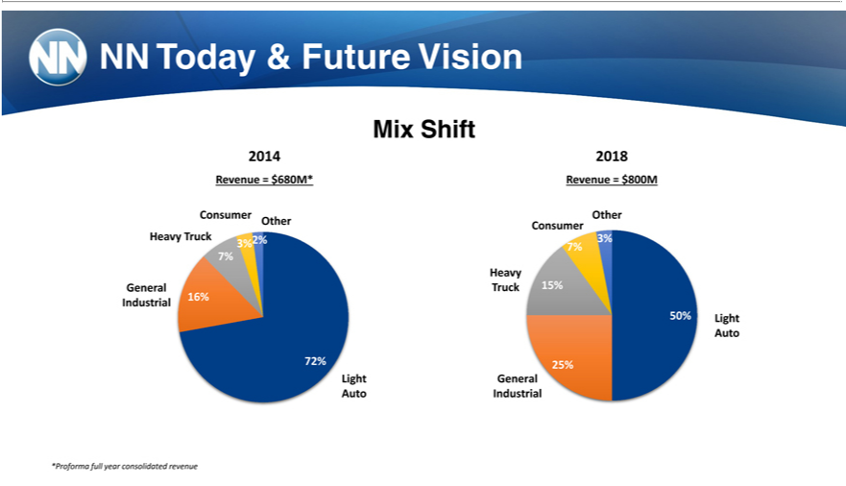

MixNN TodayShift & Future Vision
2014
Revenue = $680M*
Consumer Other
Heavy Truck 2%
3%_{7%}
General
72%Industrial 16%
Light
2018Auto
Revenue = $800M
Other
Consumer
_{7%}3%
HeavyTruck15%
50% Light
25%Auto
IndustrialGeneral
*Proforma full year consolidated revenue

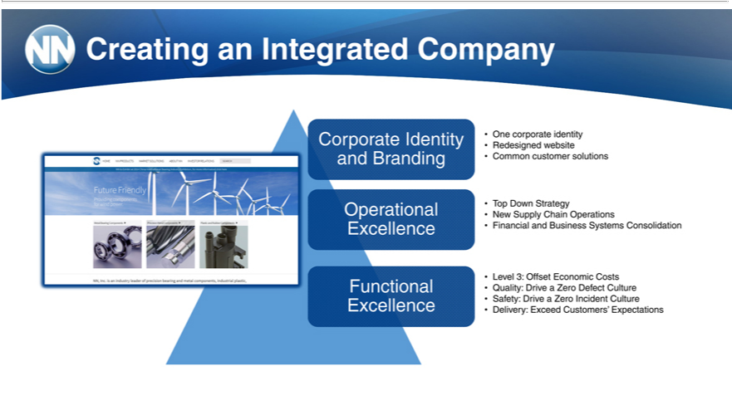

_{Corporate}reatinganIdentityIntegratedOneCompanycorporate identity
Redesigned website
OperationalandBrandingTopCommonDown Strategycustomer solutions
New Supply Chain Operations
^{Level}
Exc lence3:OffsetFinancialEconomicandBusinessCosts Systems Consolidation
Functional Quality: Drive a Zero Defect Culture
Excellence Safety: Drive a Zero Incident Culture
Delivery: Exceed Customers’ Expectations

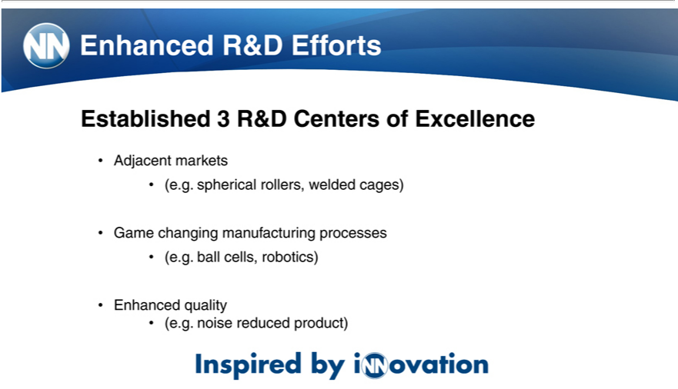

_{Established}nhancedR&D Efforts
Adjacent markets3R&D Centers of Excellence
(e.g. spherical rollers, welded cages)
(e.g.Gameballchangingcells,robotics)manufacturing processes
Enhanced quality
(e.g. noise reduced product)

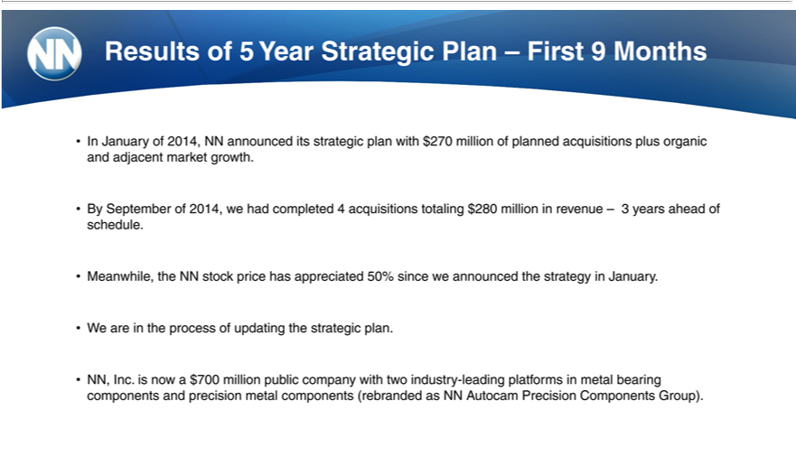

Results of 5 Year Strategic Plan – First 9 Months
ByInJanuarySeptemberof2014,of2014,NN weannouncedhadcompleteditsstrategic4acquisitionsplanwithtotaling$270million$280 millionofplannedinrevenueacquisitions–3yearsplus aheadorganicofandschedule.adjacent market growth.
W_{Meanwhile,}areinthetheprocessNNstockofupdatingpricehastheappreciatedstrategicplan.50% since we announced the strategy in January.
NN, Inc. is now a $700 million public company with two industry-leading platforms in metal bearing components and precision metal components (rebranded as NN Autocam Precision Components Group).

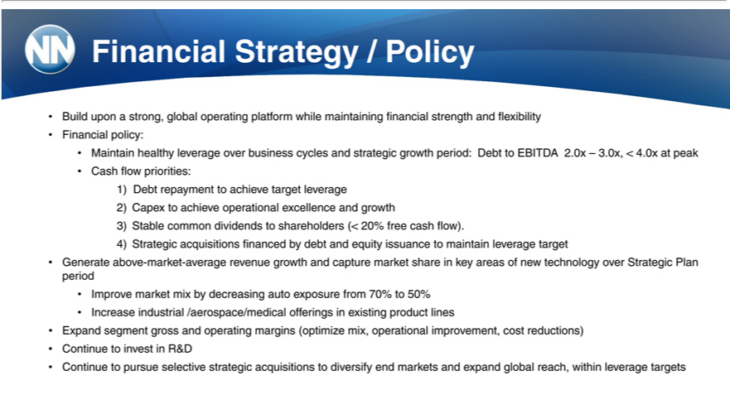

Financial _{Strategy} / Policy
Build upon strong, global operating platform while maintaining financial strength and flexibility Financial policy:
CashMaintainflowhealthypriorities:leverage over business cycles and strategic growth period: Debt to EBITDA 2.0x – 3.0x, < 4.0x at peak
1)²⁾ Debt repayment to achieve target leverage
³⁾ Capex to achieve operational excellence and growth
_{4) Strategic}ablecommon dividends to shareholders (< 20% free cash flow).
acquisitions financed by debt and equity issuance to maintain leverage target
Generate above-market-average revenue growth and capture market share in key areas of new technology over Strategic Plan period _{Increase}mprove market mix by decreasing auto exposure from 70% to 50%
industrial /aerospace/medical offerings in existing product lines
Expand segment gross and operating margins (optimize mix, operational improvement, cost reductions) Continue to invest in R&D Continue to pursue selective strategic acquisitions to diversify end markets and expand global reach, within leverage targets

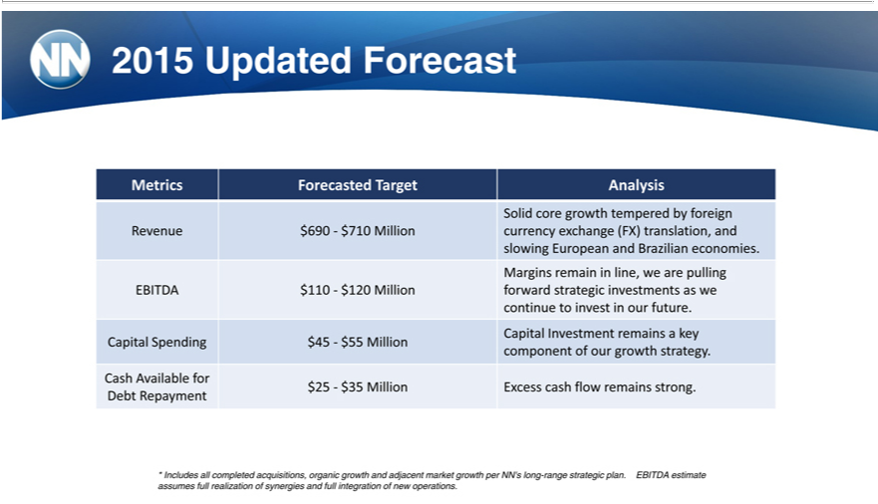

2015 Updat_{Forecasted}Forecast
SolidMetricscore growth temperedTargetAnalysisbyforeign
slowingRevenueEuropean$690—$710and BrazilianMillioncurrencyeconomies.exchange (FX) translation, and
Margins remain in line, we are pulling
continueEBITDA to$110—invest$in120ourMillionfuture.forward strategic investments as we
^{Capital}
SpendingInvestment$45—remains$55aMillionkey
CashcomponentAvailableofourforgrowth strategy.
Debt$25—Repayment$35Million Excess cash flow remains strong.
* Includes all completed acquisitions, organic growth and adjacent market growth per NN’s long-range strategic plan. EBITDA estimate assumes full realization of synergies and full integration of new operations.

