UNITED STATES

SECURITIES AND EXCHANGE COMMISSION
WASHINGTON, DC 20549

FORM 8-K

CURRENT REPORT

PURSUANT TO SECTION 13 OR 15(d)
OF THE SECURITIES EXCHANGE ACT OF 1934

Date of Report (Date of earliest event reported): May 5, 2016 (May 4, 2016)


NN, INC.

(Exact name of registrant as specified in its charter)

Delaware | 000-23486 | 62-1096725
(State or Other Jurisdiction | (Commission | (I.R.S. Employer
of Incorporation) | File Number) | Identification No.)
207 Mockingbird Lane, Johnson City, Tennessee |  | 37604
(Address of principal executive offices) |  | (Zip Code)

(423) 434-8310

(Registrant’s telephone number, including area code)

(Former name or former address, if changed since last report)

Check the appropriate box if the Form 8-K filing is intended to simultaneously satisfy the filing obligation of the registrant under any of the following provisions (see General Instruction A.2. below):

- Written communications pursuant to Rule 425 under the Securities Act (17 CFR 230.425)

- Soliciting material pursuant to Rule 14a-12 under the Exchange Act (17 CFR 240.14a-12)

- Pre-commencement communications pursuant to Rule 14d-2(b) under the Exchange Act (17 CFR 240.14d- 2(b))

- Pre-commencement communications pursuant to Rule 13e-4(c) under the Exchange Act (17 CFR 240.13e- 4(c))

ITEM 2.02 RESULTS OF OPERATIONS AND FINANCIAL CONDITION

On May 4, 2016, NN, Inc. (the “Company”) issued a press release announcing the Company’s results of operations and financial condition for the three months ended March 31, 2016. The full text of the press release is furnished as Exhibit 99.1 and is incorporated herein by reference.

ITEM 7.01 REGULATION FD DISCLOSURE

On May 4, 2016, the Company posted a presentation regarding the Company’s results of operations and financial condition for the three months ended March 31, 2016 to the Investor Relations section of its website at www.nninc.com. A copy of the presentation is furnished as Exhibit 99.2 and is incorporated herein by reference.

Pursuant to the rules and regulations of the U.S. Securities and Exchange Commission (the “SEC”), the information furnished pursuant to Item 2.02 and 7.01 of this Current Report on Form 8-K (including Exhibit 99.1 and Exhibit 99.2) is deemed to have been furnished and shall not be deemed to be “filed” for purposes of Section 18 of the Securities Exchange Act of 1934, as amended, or otherwise subject to the liabilities of that section. Such information shall not be incorporated by reference into any filing of the Company, whether made before or after the date hereof, regardless of any general incorporation language in such filing.

Exhibit 99.1 and Exhibit 99.2 contain certain “non-GAAP financial measures” as that term is defined by the rules and regulations of the SEC. The non-GAAP financial measures used in Exhibit 99.1 and Exhibit 99.2 have inherent limitations as performance measures and should not be considered in isolation of, as a substitute for, or superior to, financial information prepared in accordance with U.S. generally accepted accounting principles (“GAAP”). The non-GAAP financial measures contained in Exhibit 99.1 and Exhibit 99.2 may differ from similarly titled measures presented by other companies. The non-GAAP financial measures, as well as other information contained in Exhibit 99.1 and Exhibit 99.2, should be read in conjunction with the Company’s financial statements filed with the SEC.

ITEM 9.01 |  | FINANCIAL STATEMENTS AND EXHIBITS
Exhibit |  | Description
No. |  | Description
99.1 |  | Press Release of NN, Inc. dated May 4, 2016.
99.2 |  | Investor Presentation of NN, Inc. dated May 4, 2016.

SIGNATURES

Pursuant to the requirements of the Securities Exchange Act of 1934, the registrant has duly caused this report to be signed on its behalf by the undersigned hereunto duly authorized.

Date: May 5, 2016

NN, INC.

By: | /s/ Matthew S. Heiter
Name: | Matthew S. Heiter
Title: | Senior Vice President and General Counsel

EXHIBIT INDEX

Exhibit |  | Description
No. |  | Description
99.1 |  | Press Release of NN, Inc. dated May 4, 2016.
99.2 |  | Investor Presentation of NN, Inc. dated May 4, 2016.

Exhibit 99.1



RE: NN, Inc.

207 Mockingbird Lane

3rd Floor

Johnson City, TN 37604

FOR FURTHER INFORMATION:

AT THE COMPANY

Robbie Atkinson

VP, Corporate Treasurer & Investor Relations

(423) 434-8398

AT FINANCIAL RELATIONS BOARD

Marilynn Meek

(General info)

212-827-3773

FOR IMMEDIATE RELEASE

May 4, 2016

NN, INC. REPORTS FIRST QUARTER 2016 RESULTS IN LINE WITH COMPANY GUIDANCE

- Net sales of $212.2 million, an increase of $48.5 million

- Adjusted income from operations increased $9.1 million to $24 million

- Adjusted net income of $7.1 million or $0.27 per diluted share

Johnson City, Tenn, May 4, 2016 – NN, Inc., (NASDAQ: NNBR), a diversified industrial company, today reported its financial results for the first quarter ended March 31, 2016.

First Quarter 2016 Results

Net sales for the first quarter of 2016 increased $48.5 million, or 30% to $212.2 million, compared to $163.7 million for the first quarter of 2015. Acquisitions added $55.6 million in revenue. Negative currency and price/mix impacts reduced reported net sales by $7.1 million versus the first quarter of last year.

Adjusted income from operations for the first quarter of 2016 was $24.0 million, an increase of 61%, compared to $14.9 million for the same period in 2015.

Adjusted net income was $7.1 million, or $0.27 per diluted share, compared to $8.0 million, or $0.41 per diluted share for the same period in 2015.

Richard Holder, President and Chief Executive Officer, commented, “Our performance for the quarter was in line with our expectations as we continue to see the positive effects of the NN Operating System. The first quarter also marked our first full period post the acquisition of PEP. We are very pleased with where we are in our integration efforts as we continue to find more opportunities to deliver engineered solutions to our customers.”

Business Group Results

Autocam Precision Components

Net sales for the first quarter of 2016 were $84.0 million, compared to $82.6 million in the first quarter of 2015, an increase of $1.4 million. Adjusted income from operations for the quarter increased $1.1 million to $9.7 million, compared to $8.6 million in the first quarter of 2015.

Holder commented, “The Autocam Group continues to perform well with the continued adoption of CAFE technologies driving our performance, and we are pleased with the margin expansion the team has achieved.”

Precision Bearing Components

Net sales for the first quarter of 2016 were $64.7 million, compared to $73.2 million in the first quarter of 2015, a decrease of $8.5 million. Negative currency impacts of $1.4 million and a soft industrial market accounted for the decline. Adjusted income from operations for the first quarter was $7.1 million, compared to $9.2 million in the first quarter of 2015.

Holder commented, “The Group rebounded in the first quarter from the challenges during the fourth quarter of 2015. Operating performance returned to our expectations, and we continue to drive margin expansion throughout 2016.”

Precision Engineered Products

Net sales for the first quarter of 2016 were $63.5 million, compared to $7.9 million in the first quarter of 2015, an increase of $55.6 million. The acquisition of PEP accounted for $56.0 million of the increase. Adjusted income from operations for the quarter was $13.2 million, compared to $0.2 million in 2015.

Holder commented, “The integration of PEP is off to a good start. The strong operating performance in the quarter met our expectations. We expect to see improvements throughout the year as we implement the NN Operating System.”

Guidance

Holder continued, “Our businesses have performed to our expectations thus far in 2016. We are encouraged by the positive trends in the macro back drop and reaffirm our guidance for the year.”

The full set of financial guidance for the second quarter and full year 2016 can be found in our supplemental presentation posted in the Investor Relations section of our website at www.nninc.com.

Holder concluded, “We are pleased with our performance to start the year. The team continues to focus on the disciplined execution of the NN Operating System.”

GAAP Results

On a GAAP basis, income from operations for the first quarter of 2016 was $11.9 million, compared to $13.9 million for the same period in 2015. Net loss on a GAAP basis for first quarter of 2016 was $1.3 million, or ($0.05) per diluted share. This compares to net income of $6.0 million, or $0.31 per diluted share in the first quarter of 2015.

On a GAAP basis, income from operations for first quarter 2016 in the Autocam Precision Components Group was $6.5 million compared to $7.7 million for the same period in 2015.

On a GAAP basis, income from operations for first quarter 2016 in the Precision Bearing Components Group was $6.3 million compared to $9.1 million for the same period in 2015.

On a GAAP basis, income from operations for first quarter 2016 in the Precision Engineered Products Group was $5.4 million compared to $0.2 million for the same period in 2015.

- will discuss its results during its quarterly investor conference call tomorrow morning starting at 9:00 a.m. ET. The call and supplemental presentation may be accessed via NN’s website, www.nninc.com. The conference call can also be accessed by dialing 888-505-4368 or 719-325-2281 Conference ID: 9964576. For those who are unavailable to listen to the live broadcast, a replay will be available shortly after the call for 90 days.

The Company discloses in this press release the non-GAAP financial measures of adjusted income from operations and adjusted net income. Each of adjusted income from operations and adjusted net income provide supplementary information about the impacts of acquisition related expenses, foreign-exchange and other non-operating impacts on our business.

The attached financial tables include a reconciliation of adjusted income from operations and adjusted net income to the U.S. GAAP financial measures of income from operations and net income.

NN, Inc., a diversified industrial company combines advanced engineering and production capabilities with in-depth materials science expertise to design and manufacture high-precision components and assemblies for a variety of markets on a global basis. Headquartered in Johnson City, Tennessee, NN has 42 manufacturing plants in North America, Western Europe, Eastern Europe, South America and China.

Except for specific historical information, many of the matters discussed in this press release may express or imply projections of revenues or expenditures, statements of plans and objectives or future operations or statements of future economic performance. These, and similar statements, are forward-looking statements concerning matters that involve risks, uncertainties and other factors which may cause the actual performance of NN, Inc. and its subsidiaries to differ materially from those expressed or implied by this discussion. All forward-looking information is provided by the Company pursuant to the safe harbor established under the Private Securities Litigation Reform Act of 1995 and should be evaluated in the context of these factors. Forward-looking statements generally can be identified by the use of forward-looking terminology such as “assumptions”, “target”, “guidance”, “outlook”, “plans”, “projection”, “may”, “will”, “would”, “expect”, “intend”, “estimate”, “anticipate”, “believe”, “potential” or “continue” (or the negative or other derivatives of each of these terms) or similar terminology. Factors which could materially affect actual results include, but are not limited to: general economic conditions and economic conditions in the industrial sector, inventory levels, regulatory compliance costs and the Company’s ability to manage these costs, start-up costs for new operations, debt reduction, competitive influences, risks that current customers will commence or increase captive production, risks of capacity underutilization, quality issues, availability and price of raw materials, currency and other risks associated with international trade, the Company’s dependence on certain major customers, and the successful implementation of the global growth plan including development of new products. Similarly, statements made herein and elsewhere regarding completed acquisitions are also forward-looking statements, including statements relating to the future performance and prospects of an acquired business, the expected benefits of an acquisition on the Company’s future business and operations and the ability of the Company to successfully integrate recently acquired businesses.

For additional information concerning such risk factors and cautionary statements, please see the section titled “Risk Factors” in the Company’s periodic reports filed with the Securities and Exchange Commission, including, but not limited to, the Company’s Annual Report on Form 10-K for the fiscal year ended December 31, 2015. Except as required by law, we undertake no obligation to update or revise any forward-looking statements we make in our press releases, whether as a result of new information, future events or otherwise.

Financial Tables Follow

NN, Inc.

Condensed Consolidated Statements Income (Loss)

(Unaudited)

 |  |  | Three Months ended
 |  |  | March 31,
(in thousands, except per share data) |  |  | 2016 |  |  | 2015
Net sales |  | $ | 212,226 |  | $ | 163,746
Cost of products sold (exclusive of depreciation and amortization shown separately below) |  |  | 159,754 |  |  | 129,317
Selling, general and administrative |  |  | 20,712 |  |  | 12,001
Depreciation and amortization |  |  | 17,348 |  |  | 8,494
Restructuring and impairment charges |  |  | 2,538 |  |  | —
Income from operations |  |  | 11,874 |  |  | 13,934
Interest expense |  |  | 16,422 |  |  | 5,938
Other (income) expense, net |  |  | (1,129) |  |  | 1,400
Income (loss) before provision (benefit) for income taxes and share of net income from joint venture |  |  | (3,419) |  |  | 6,596
Provision (benefit) expense for income taxes |  |  | (720) |  |  | 1,456
Share of net income from joint venture |  |  | 1,400 |  |  | 861
Net (loss) income |  | $ | (1,299) |  | $ | 6,001
Basic income (loss) per share:
Net income (loss) |  | $ | (0.05) |  | $ | 0.32
Weighted average shares outstanding |  |  | 26,869 |  |  | 18,996
Diluted income (loss) per share:
Net income (loss) |  | $ | (0.05) |  | $ | 0.31
Weighted average shares outstanding
 |  |  | 26,869 |  |  | 19,380
Cash dividends per common share |  | $ | 0.07 |  | $ | 0.07

NN, Inc.

Condensed Consolidated Balance Sheets

(Unaudited)

(in thousands, except per share data) |  |  |  | March 31, |  | December 31,
 |  |  |  | 2016 |  |  | 2015
Assets
Current assets:
Cash |  | $ |  | 15,079 |  | $ | 15,087
Accounts receivable, net |  |  |  | 143,323 |  |  | 123,005
Inventories |  |  |  | 120,119 |  |  | 119,836
Income tax receivable |  |  |  | 3,989 |  |  | 3,989
Current deferred tax assets |  |  |  | — |  |  | 6,696
Other current assets |  |  |  | 13,125 |  |  | 11,568
Total current assets |  |  |  | 295,635 |  |  | 280,181
Property, plant and equipment, net |  |  |  | 325,222 |  |  | 318,968
Goodwill, net |  |  |  | 450,190 |  |  | 449,898
Intangible assets, net |  |  |  | 273,807 |  |  | 282,169
Non-current deferred tax assets |  |  |  | — |  |  | 742
Investment in joint venture |  |  |  | 39,862 |  |  | 38,462
Other non-current assets |  |  |  | 10,901 |  |  | 10,147
Total assets |  | $ |  | 1,395,617 |  | $ | 1,380,567
Liabilities and Stockholders’ Equity
Current liabilities:
Accounts payable |  | $ |  | 70,292 |  | $ | 69,101
Accrued salaries, wages and benefits |  |  |  | 24,341 |  |  | 21,125
Income taxes payable |  |  |  | 3,525 |  |  | 5,350
Current maturities of long-term debt |  |  |  | 11,947 |  |  | 11,714
Current portion of obligation under capital lease |  |  |  | 4,440 |  |  | 4,786
Other current liabilities |  |  |  | 26,938 |  |  | 21,275
Total current liabilities |  |  |  | 141,483 |  |  | 133,351
Non-current deferred tax liabilities |  |  |  | 111,050 |  |  | 117,459
Long-term debt, net of current portion |  |  |  | 804,672 |  |  | 795,400
Accrued post-employment benefits |  |  |  | 6,177 |  |  | 6,157
Obligation under capital lease, net of current portion |  |  |  | 8,646 |  |  | 9,573
Other |  |  |  | 6,257 |  |  | 4,746
Total liabilities |  |  |  | 1,078,285 |  |  | 1,066,686
Total stockholders’ equity |  |  |  | 317,332 |  |  | 313,881

Reconciliation of income from operations to adjusted income from operations:

NN, Inc - Total Company |  | 2016 |  | Three Months Ended March 31, |  |  |  |  |  |  | 2015
 |  | $’000 |  |  | % of Sales |  |  |  | $’000 |  |  | % of Sales
Income from operations | $ | 11,874 |  | 5.6% |  |  | $ |  | 13,934 |  | 8.5%
Restructuring & impairment charges |  | 2,963 |  | 1.4% |  |  |  |  | — |  | 0.0%
Acquisition & integration expenses |  | 3,263 |  | 1.5% |  |  |  |  | — |  | 0.0%
Amortization of intangibles |  | 5,926 |  | 2.8% |  |  |  |  | 983 |  | 0.6%
Adjusted income from operations | $ | 24,026 |  | 11.3% |  |  | $ |  | 14,917 |  | 9.1%
Total Sales
Total Sales | $ | 212,226 |  |  |  |  | $ |  | 163,746
Total liabilities and stockholders’ equity | $1,395,617 |  |  |  |  |  | $1,380,567
Reconciliation of income from operations to adjusted income from operations:
NN, Inc - Autocam Precision Components Group |  | 2016 |  | Three Months Ended March 31, |  |  |  |  |  |  | 2015
 |  | $’000 |  |  | % of Sales |  |  |  | $’000 |  |  | % of Sales
Income from operations | $ | 6,527 |  | 7.8% |  |  | $ |  | 7,718 |  | 9.3%
Restructuring & impairment Charges |  | 2,274 |  | 2.7% |  |  |  |  | — |  | 0.0%
Acquisition & integration expenses |  | — |  | 0.0% |  |  |  |  | — |  | 0.0%
Amortization of intangibles |  | 885 |  | 1.1% |  |  |  |  | 910 |  | 1.1%
Adjusted income from operations | $ | 9,686 |  | 11.5% |  |  | $ |  | 8,628 |  | 10.4%
China JV Contribution |  | 1,400 |  |  |  |  |  |  | 861
Adjusted income from operations | $ | 11,086 |  | 13.2% |  |  | $ |  | 9,489 |  | 11.5%
Total Sales | $ | 83,990 |  |  |  |  | $ |  | 82,622

Reconciliation of income from operations to adjusted income from operations:

NN, Inc - Precision Bearing Components Group |  |  |  |  |  | Three Months Ended March 31,
 |  |  |  |  |  | 2016 |  |  |  |  |  |  |  |  |  | 2015
 |  |  | $’000 |  |  |  |  | % of Sales |  |  |  |  | $’000 |  |  |  | % of Sales
Income from operations | $ |  | 6,326 |  |  | 9.8% |  |  |  |  | $ |  | 9,089 |  |  | 12.4%
Restructuring & impairment Charges |  |  | 689 |  |  | 1.1% |  |  |  |  |  |  | — |  |  | 0.0%
Amortization of intangibles |  |  | 58 |  |  |  |  | 0.1% |  |  |  |  | 73 |  |  | 0.1%
Adjusted income from operations
Adjusted income from operations | $ |  | 7,073 |  |  | 10.9% |  |  |  |  | $ |  | 9,162 |  |  | 12.5%
Total Sales | $64,745 |  |  |  |  |  |  |  |  |  | $73,236
Reconciliation of income from operations to adjusted income from operations:
NN, Inc - Precision Engineered Products Group |  |  |  |  |  | Three Months Ended March 31, |  |  |  |  |  |  |  |  |  | 2015
 |  |  | 2016 |  |  |  |  |  |  |  |  |  |  |  |  | 2015
 | $’000 |  |  |  |  |  | % of Sales |  |  |  |  | $’000 |  |  |  |  | % of Sales
Income from operations | $ 5,421 |  |  |  |  | 8.5% |  |  |  |  | $ |  | 213 |  |  | 2.7%
Restructuring & impairment Charges |  |  | — |  |  | 0.0% |  |  |  |  |  |  | — |  |  | 0.0%
Acquisition & integration expenses | 2,777 |  |  |  |  | 4.4% |  |  |  |  |  |  | — |  |  | 0.0%
Amortization of intangibles | 4,983 |  |  |  |  | 7.8% |  |  |  |  |  |  | — |  |  | 0.0%
Adjusted income from operations | $13,181 |  |  |  |  | 20.8% |  |  |  |  | $ |  | 213 |  |  | 2.7%
Total Sales
Total Sales | $63,491 |  |  |  |  |  |  |  |  |  | $7,888

Reconciliation of net income to adjusted net income:

NN, Inc - Total Company |  |  | Three Months Ended March 31, 2016 |  |  |  |  |  |  | Three Months Ended March 31, 2015
 |  | In Thousands |  |  |  | Diluted Earnings |  |  | In Thousands |  |  |  | Diluted Earnings
 |  |  |  |  |  |  | Per Share |  |  |  |  |  |  | Per Share
Net income |  | ($ | 1,299) |  |  |  | (0.05) |  |  | 6,001 |  |  | $ | 0.31
After-tax acquisition and integration costs |  |  | 2,422 |  |  |  | 0.09 |  |  | — |  |  |  | —
After-tax foreign exchange loss on inter-company loans |  |  | (654) |  |  |  | (0.02) |  |  | 886 |  |  |  | 0.04
Restructuring & impairment charges |  |  | 2,198 |  |  |  | 0.08 |  |  | — |  |  |  | —
Amortization of intangibles & deferred financing costs |  |  | 4,459 |  |  |  | 0.17 |  |  | 1,140 |  |  |  | 0.06
Adjusted net income
Adjusted net income | $ |  | 7,126 |  |  | $ | 0.27 |  | $ | 8,027 |  | $ |  | 0.41

The Company discloses in this press release the non-GAAP financial measures of adjusted income from operations and adjusted net income. Each of adjusted income from operations and adjusted net income provide supplementary information about the impacts of acquisition related expenses and foreign-exchange impacts on inter-company loans. Over the past three years, we have completed six acquisitions, two of which were transformative for the Company. The costs we incurred in completing such acquisitions, including the amortization of intangibles and deferred financing costs, have been excluded from these measures because their size and inconsistent frequency are unrelated to our commercial performance during the period, and which we believe are not indicative of our ongoing operating costs. We exclude the impact of currency translation from these measures because foreign exchange rates are not under management’s control and are subject to volatility. We believe the presentation of adjusted income from operations and adjusted net income provides useful information in assessing our underlying business trends and facilitates comparison of our long-term performance over given periods

The non-GAAP financial measures provided herein may not provide information that is directly comparable to that provided by other companies in the Company’s industry, as other companies may calculate such financial results differently. The Company’s non-GAAP financial measures are not measurements of financial performance under GAAP, and should not be considered as alternatives to actual net income growth derived from income amounts presented in accordance with GAAP. The Company does not consider these non-GAAP financial measures to be a substitute for, or superior to, the information provided by GAAP financial results.

Exhibit 99.2


First Quarter 2016 Earnings Release
May 4, 2016

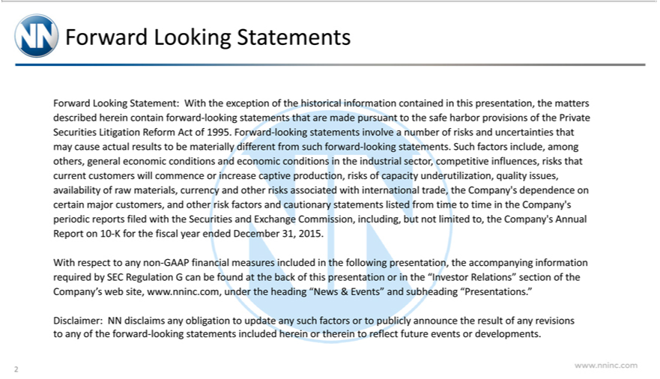

Forward Looking Statement:s
provisions of the Private SecuritiesWith theLitigationexceptionReformoftheActhistoricalof1995.—informationnumber containedofrisksandin uncertaintiesthispresentation,that maythematterscause actualdescribedresultshereintobecontainmateriallyforwarddifferent-lookingfromstatementssuchforwardthat-arelookingmadestatements.pursuanttoSuchthesafefactorsharbor include, among others, general economic conditions nd economic conditions in the industrial sector, competitive influences, risks that current customers will commence increase captive production, risks of capacity
statementsunderutilization,listed qualityfromtimeissues,totimeavailabilityintheCompany’ofrawmaterials,periodiccurrencyreports filedand otherwith therisksSecuritiesassociatedandwithExchangeinternationalCommission,trade,theincluding,Company’sbut dependencenotlimited to,on thecertainCompany’smajorcustomers,AnnualReportandotheron10risk-K factorsforthe fiscalandcautionaryyearended December 31, 2015.

Relations”Withrespectsectiontoanyofnonthe-GAAP financialswebmeasuressite,www.nninc.com,includedintheunderfollowingtheheadingpresentation,“News &theEvents”accompanyingandsubheadinginformation“Presentations.”requiredby SEC Regulation G can be found at the back of this presentation or in the “Investor
Disclaimer: NN disclaimsCompany’obligation to update any such factors or to publicly announce the result of any revisions to any of the forward-looking statements included herein or therein to reflect future events or developments.
www.nninc.com
2



First Quarter

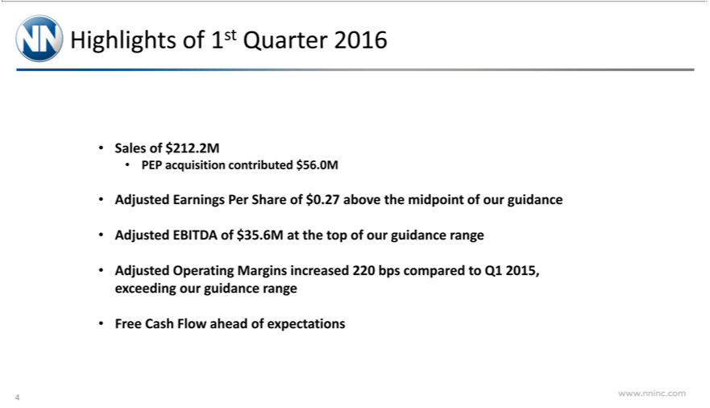

SalesHighlightsof$212.2Mof1stQuarter 2016
PEP acquisition contributed $56.0M
_{EBITDA}arnings Per Share of $0.27 above the midpoint of our guidance
_{Adjusted} of $35.6M at the top of our guidance range
Operating Margins increased 220 bps compared to Q1 2015, exceeding our guidance range Free Cash Flow ahead of expectations
www.nninc.com
4

1st Quarter 2016 Financial Summary
Adjusted Earnings Per Share Net Sales
ssued 7.6M shares in Q3 2015 30% growth compared to prior year
In Millions
$0.45 |  | $ 220.0
210.0 |  | $ 212.2
$0.40 |  | $ 212.2
0.41 $ 200.0
0.35
190.0 |  | $ 180.0
$0.30 |  | $ 180.0
170.0 |  | $0.27
$0.25 |  | $0.27
160.0 |  | $163.7
0.20 | .0 | $ 140.0
$0150. | .0 | $ 140.0
130.0
0.10
120.0
0.05
110.0 |  | $ 100.0
$0.00 |  | $ 100.0
www.nninc.com201520162015 2016
5

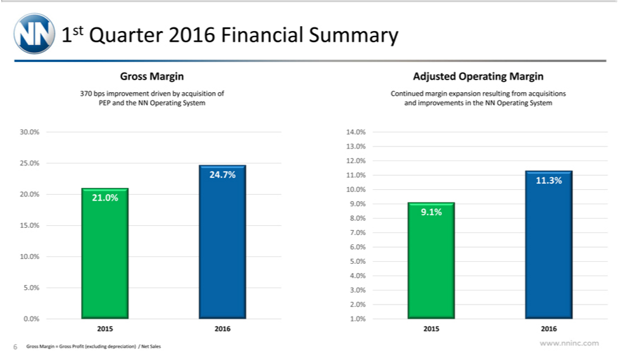

1st Quarter 2016 Financial Summary
Gross Margin Adjusted Operating Margin |  | margin expansion resulting from acquisitions
370 bps improvement driven by acquisition of |  | margin expansion resulting from acquisitions
PEP and the NN Operating System and improvementsContinued the NN Operating System
30.0% | 14.0%
13 | 12.0%
25.0% | 12.0%
24.7% | 11.0% 11.3%
10 | 21.0%
20.0% | 21.0%
9 1%
8.0%
15.0%
7
6.0%
10.0%
5
4 | 3.0%
5.0% | 3.0%
2 | 1.0%
0.0% | 1.0%
2015 2016 2015 2016

Gross Margin = Gross Profit (excluding depreciation) / Net Sales
6

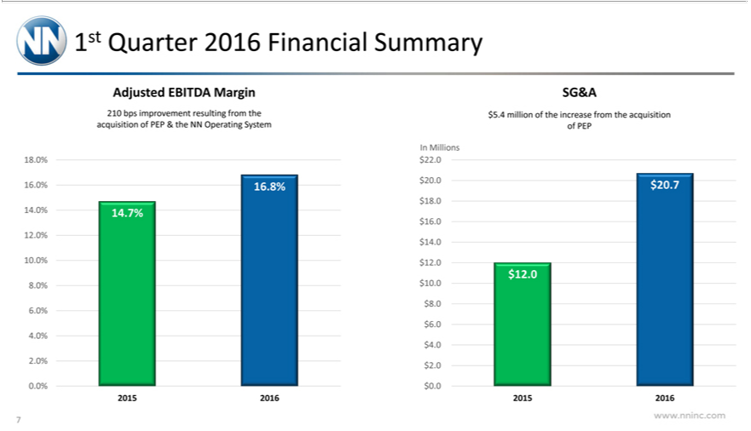

Adjusted1stQuarterEBITDA2016FinancialMargin SummarySG&A
acquisition210bpsimprovementofPEP&theresultingNNOperatingfromtheSystem$5.4millionofPEPof the increase from the acquisition
In Millions
18.0% $22.0
$16.18_{0%}0%. 16.8% $20.0 $20.7
$14.16_{0%}. 14.7%
$12.14.
$10.12.0 $12.0
8.0% $10.0
$$.68.
$.4_{0%}..
2. $2.0
0.0% $0.0
www.nninc.com201520162015 2016
7

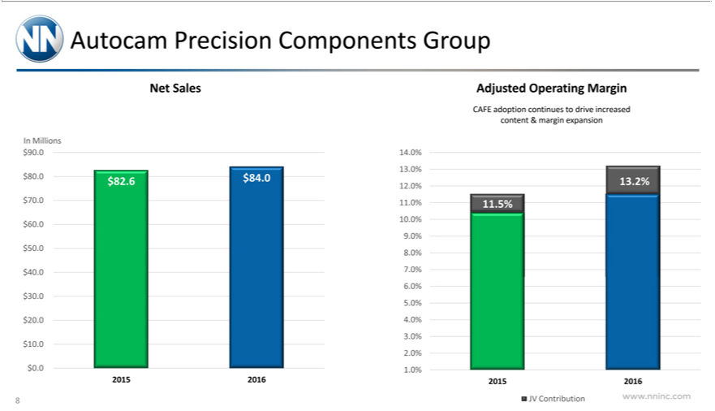

Autocam Precision Components Group
Net Sales Adjusted Operating Margin
CAFE adoption continues to drive increased
content & margin expansion
In Millions
$90.0 | 14.0%
13. | $82.6 $84.0 13.2%
$80.0% | $82.6 $84.0 13.2%
12. | 11.0% 11.5%
$70.0% | 11.0% 11.5%
$60.0 | 10.0%
9.0% | 8.0%
$50.0 | 8.0%
$40.0 | 7.0%
6.0%
$30.0
5.0% | 4.0%
$20.0 | 4.0%
3.0%
$10.0
2. | 1.0%
$0.0% | 1.0%
2015 2016 2015 2016
www.nninc.comJVContribution
8

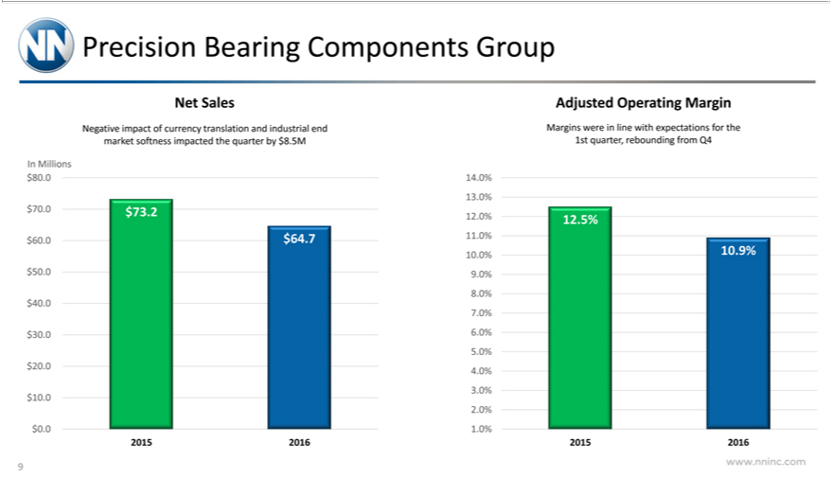

Precision Bearing Components Group
Sales Adjusted Operating Margin
Negative impact of currency translation and indu rial end Margins were in line with expectations for the
market softness impacted the quarter by $8.5M |  | 1st quarter, rebounding from Q4
In Millions
$80.0 | 14.0%
13. | $73.2 12.0% 12.5%
$70.0% | $73.2 12.0% 12.5%
$60.0 | $64.7 11.0%
10.0% | 10.9%
$50.0 | 9.0%
8.0%
$40.0
7.0% | 6.0%
$30.0 | 6.0%
5.0% | 4.0%
$20.0 | 4.0%
3.0%
$10.0
2. | 1.0%
$0.0% | 1.0%
2015 2016 2015 2016
www.nninc.com
9

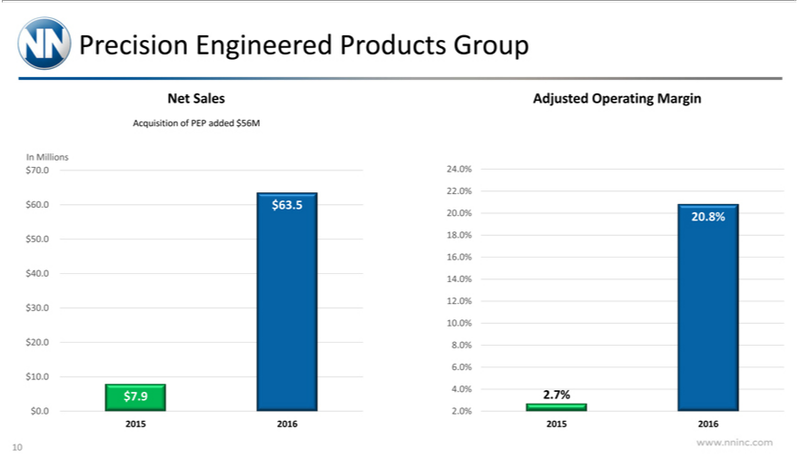

Precision Engineered Products Group
Net Sales Adjusted Operating argin
Acquisition of PEP added $56M
In Millions
$70.0 | 24.0%
22. | $63.5
$60.0% | $63.5
20.0% | 20.8%
$50.0 | 18.0%
16. | 14.0%
$40.0% | 14.0%
12.
$30.
10. | 8.0%
$20.0% | 8.0%
6.0%
$10.0
4.0% | 2.7%
$7.9 | 2.7%
$0.0 | 2.0%
www.nninc.com201520162015 2016
10

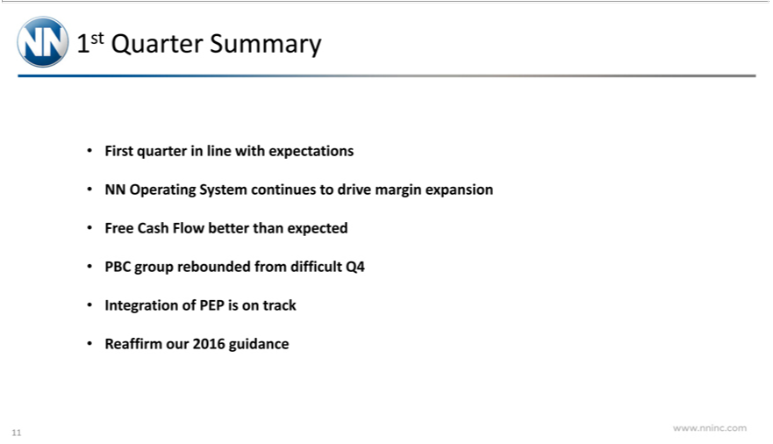

1st Quarter Summary
First quarter in line with expectations
NN Operating System continues to drive margin expansion Free Cash Flow better than expected PBC group rebounded from difficult Q4 Integration of PEP is on track Reaffirm our 2016 guidance www.nninc.com
11



Guidance

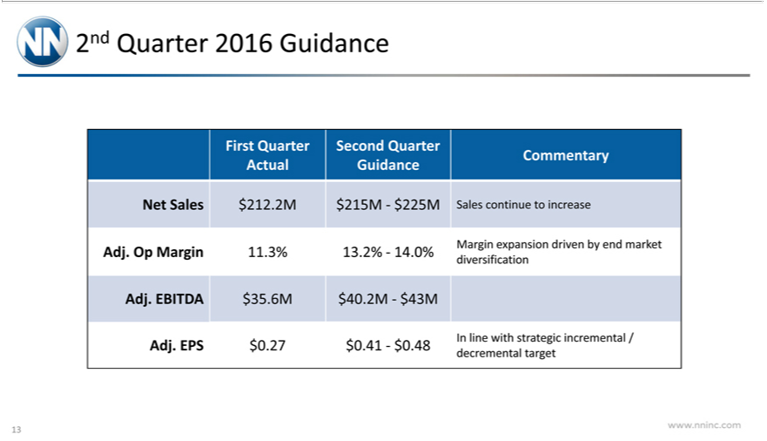

2nd Quarter 2016 Guidance
CommentaryFirstQuarter Second Quarter
^{Net}Acual Guidance
Sales $212.2M $215M—$225M Sales continue to increase
diversificationAdj.OpMargin 11.3% 13.2%—14.0% Margin expansion driven by end market
_{Adj. EPS}BITDA $35.6M $40.2M—$43M
decremental$0.27target$0.41—$0.48 In line with strategic incremental /
www.nninc.com
13

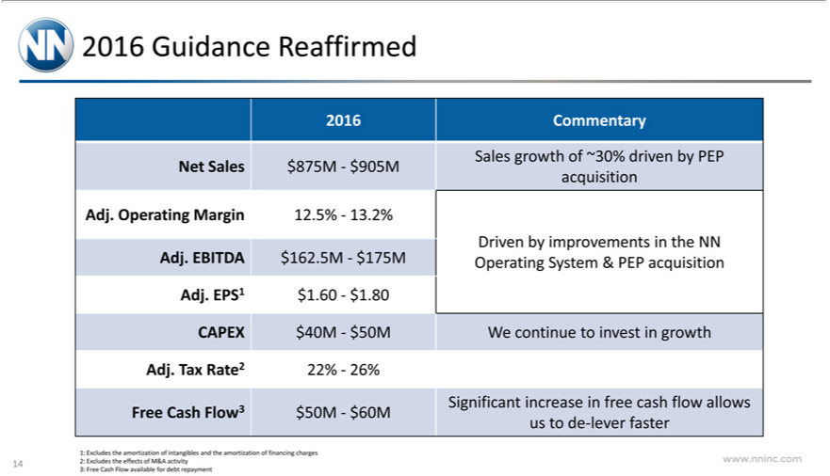

²⁰¹⁶
CommentaryGuidanceReaffirmed
Sales growth of ~30% driven by PEP
acquisitionNetSales$875M—$905M
DrivenAdj.OperatingbyimprovementsMargin12.5%—13.2%intheNN
^{Adj. EPS1}
BITDA$1.60—$162.5M—$1.80$175M Operating System & PEP acquisition
Adj.CAPEXTax $Rate240M—22%—26%$50MWe continue to invest in growth
usFree_{Excludes}toCash-leverFlow3faster$50M—$60M Significant increase in free cash flow allows
^{2:} ^{the}
1: effectsamortizationofM&Aof intangiblesactivity and the amortization of financing charges
3:
www.nninc.comFreeCashFlow available for debt repayment
14



Reconciliation Tables

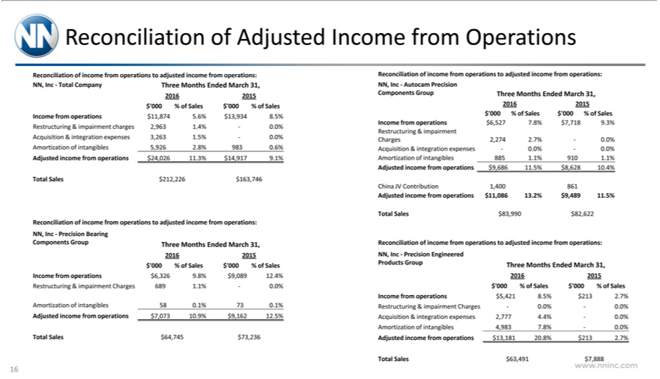

Adjusted Income from Operations
Reconciliation of income from operations to adjusted income from operations:
NN, Inc—Total Company Three Months Ended March 31,
2016 2015
$‘000% of Sales $‘000% of Sales |  |  | 8.5%
Income from operations $11,874 5.6% |  |  | 8.5%
Restructuring & imp irment charges 2,963 |  |  | .4%—0.0%
cquisition & integration expenses 3,263$13,934.5%—0.0%
mortization of intangibles 5,926 |  | .8% 983 0.6%
Adjusted income from operations |  | $24,026 | 11.3% $14,917 9.1%
Total Sales $212,226 $163,746
Reconciliation of | come from operations to adjusted income from operations:
NN, Inc—Precision Bearing
Components Group Three Months Ended March 31,
2016 2015
$‘000% of Sales $‘000% of Sales
Income from operations $6,326 9.8% $9,089 12.4%
Restructuring & impairment Charges 689 1.1%—0.0%
mortization of intangibles 58 0.1% 0.1%
Adjusted income from operations |  | $7,073 10.9% $9,162 12.5%
Total Sales $64,745 | $73,236
Reconciliation of income from operations to adjusted income from operations:
NN, Inc—Autocam Precision
Components Group Three Months Ended March 31,
2016 2015
$‘000 % of Sales $‘000 % of Sales
Income from operations $6,527 7.8% $7,718 9.3%
Restructuring & impairment
Charges 2,274 2.7%—0.0%
cquisition & integration expenses—0.0%—0.0%
mortization of intangibles 885 1.1% 910 1.1%
Adjusted income from operations $9,686 11.5% $8,628 10.4%
China JV Contribution 1,400 861
Adjusted income from operations $11,086 13.2% $9,489 11.5%
Total Sales $83,990 | $82,622
Reconciliation of | come from operations to adjusted income from operations:
NN, Inc—Precision Engineered
Products Group Three Months Ended March 31,
2016 2015
$‘000% of Sales $‘000% of Sales
Income from operations $5,421 8.5% $213 2.7%
Restructuring & imp irment Charges—0.0%—0.
cquisition & integration expenses 2,777 4 4%—0%.0%
mortization of intangibles 4,983 7.8%—0.0%
Adjusted income from operations $13,181 20.8% $213 2.7%
Total Sales $63,491 | $7,888
www.nninc.com
16

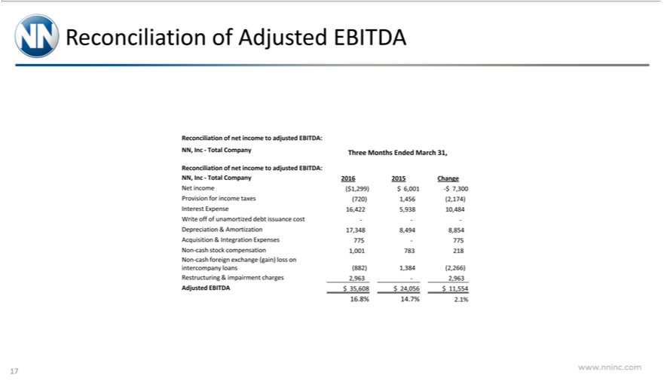

Reconciliation of ^{Adjusted EBITDA}
net income to adjusted EBITDA:
ReconciliationNN,Inc—TotalofCompanynetincomeThreetoadjustedMonths EBITDA:EndedMarch 31,
^{Net}
N,income(Inc—Total$1,299)Company$6,0012016-$7,3002015 Change
InterestProvisionExpenseforincome16,422taxes(720)5,93810,4841,456(2,174)
DepreciationWriteoffofunamortized&_{Integration}Amorzationdebt 17,348issuance8,494cost 8,854—-
^{Non}Acquisition^{-cash}stock& compensationExpenses1,001 775—775783218
foreign exchange (gain) loss on
Restructuringintercompany &loans(882)impairment1,384(2,266)charges2,963—2,963
16.Adjusted8%14.7%EBITDA2.1%$ 35,608 $ 24,056 $ 11,554
www.nninc.com
17

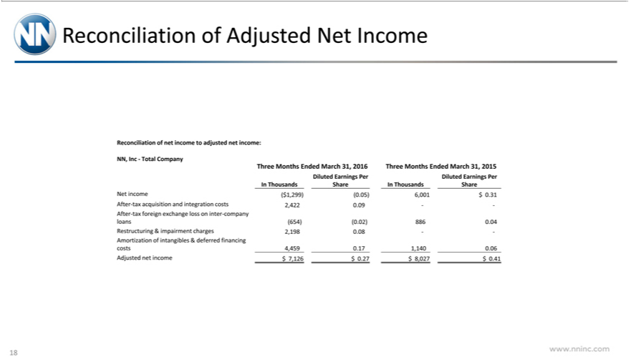

_{Reconciliation of} Adjusted Net Income
NN, Inc—Total Companynetincome to adjusted net income:
DilutedThreeMonthsEarningsEndedPer DilutedMarch31,Earnings2016ThreePer Months Ended March 31, 2015
NetInThousandsincome($1,299)(0.05)ShareInThousands6,001$ Share0.31
_{After-tax} foreignacquisitionexchangeand_{integration}lossintercosts-company2,4220.09 —
loans(654)(0.02) 886 0.04
Restructuring & impairment charges 2,198 0.08 —
costsAmortization4,4590.17of intangibles1,1400.06 & deferred financing
www.nninc.comAdjustednetincome $ 7,126 $ 0.27 $ 8,027 $ 0.41
18

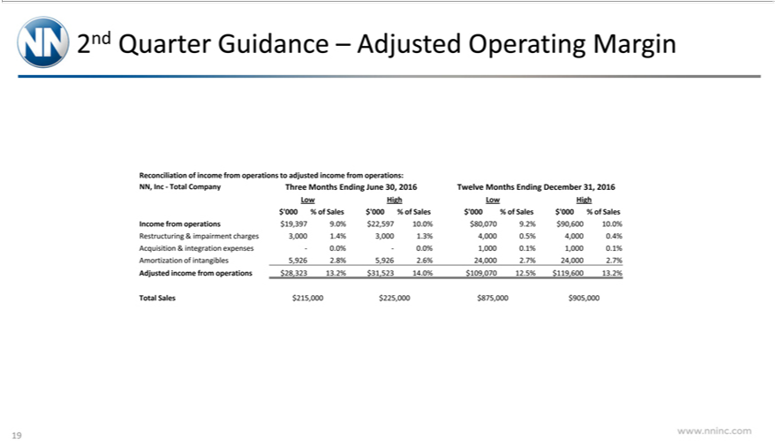

2nd Quarter Guidance – Adjusted Operating Margin
Reconciliation of income from operations to adjusted income from operations:
NN, Inc—Total Company Three Months Ending June 30, 2016 Twelve Months Ending December 31, 2016
Low High Low High |  | of Sales $‘000% of Sales
$‘000% of Sales $‘000% of Sales |  | of Sales $‘000% of Sales
Income from operations $19,397 9.$‘000%$22,597 10.0% $80,070 9.2% $90,600 10.0%
Restructuring & imp irment charges |  | 1.4% 3,000 .3% 4,000 .5% 4,000 0.4%
cquisition & integration expenses—3,000.0%—0.0% 1,000 .1% 1,000 .1%
mortization of intangibles 5,926 | .8% 5,926 .6% 24,000 2.7% 24,000 2.7%
Adjusted income from operations | $28,323 13.2% $31,523 14.0% $109,070 12.5% $119,600 13.2%
Total Sales $215,000 $225,000 $875,000 |  | $905,000
www.nninc.com
19

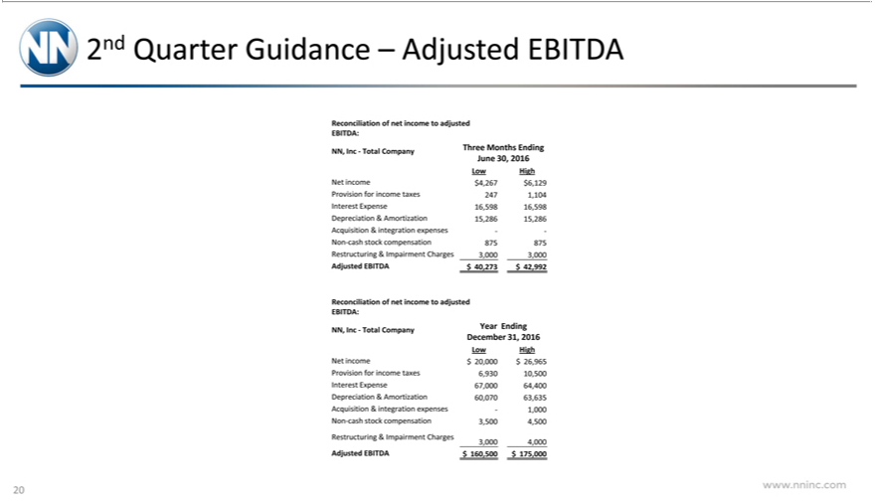

Reconciliation2ndQuarterGuidanceofnetincome–AdjustedtoadjustedEBITDA
EBITDA:
JuneNN, Inc—Total30,2016 Company Three Months Ending
Low High
Net income $4,267 $6,129
Provision for income taxes 247 1,104
DepreciationInterestExpense&Amortization16,59816,59815,286 15,286
Acquisition & integration expenses —
RestructuringNon-cashstock&compensationImpairmentCharges8758753,000 3,000
ReconciliationAdjustedEBITDAofnet$ 40,273income$to42,992adjusted
EBITDA:
DecemberNN,Inc—Total31,2016Company Year Ending
Low High
Net income $ 20,000 $ 26,965
InterestProvisionExpenseforincome67,000taxes64,4006,930 10,500
Depreciation & Amortization 60,070 63,635
NonAcquisition-cashstock&integrationcompensationexpenses—1,0003,5004,500
3,000Restructuring4,000 & Impairment Charges
www.nninc.comAdjustedEBITDA $ 160,500 $ 175,000
20

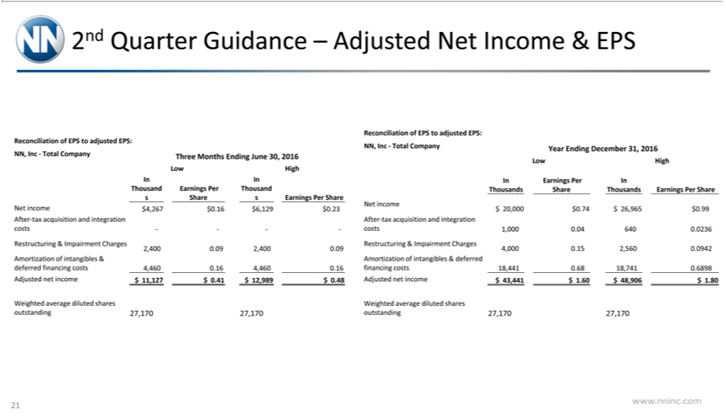

2nd Quarter Guidance – Adjusted Net Income & EPS
Reconciliation of EPS to adjusted EPS:
NN, Inc—Total Company Three Months Ending June 30, 2016
Low High |  | Earnings Per Thousand
In In
ThousandShareEarnings Per Share
Net income $4,267 $0.16 $6,129 $0.23
After-tax acquisition and integration
costs — —
Restructuring & Impairment Charges
2,400 0.09 2,400 0.09
Amortization of intangibles & |  |  | .16 4,460 0.16
deferred financing costs 4,460
Adjusted net income $ 11,127 |  |  | $0.41 $ 12,989 | $0.48
Weighted average diluted shares
outstanding 27,170 27,170
Reconciliation of EPS to adjusted EPS:
NN, Inc—Total Company Year Ending December 31, 2016
Low High
In Earnings Per In
Thousands Share Thousands Earnings Per Share
Net income
$ 20,000 | $0.74 $ 26,965 $0.99
After-tax acquisition and integration
costs 1,000 0.04 640 0.0236
Restructuring & Impairment Charges
4,000 0.15 2,560 0.0942
Amortization of intangibles & deferred
financing costs 18,441 0.68 18,741 0.6898 |  |  |  | $1.80
Adjusted net income $ 43,441 |  |  | $1.60 $ 48,906 | $1.80
Weighted average diluted shares
outstanding 27,170 27,170
www.nninc.com
21

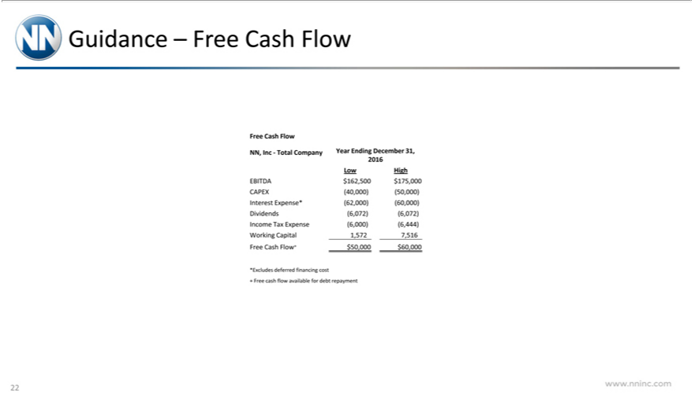

FreeGuidanceCash –FlowFree Cash Flow
2016NN,Inc—Total Company Year Ending December 31,
Low High
CAPEX(40,000)(50,000)EBITDA$162,500$175,000
Dividends(6,072)(6,072)InterestExpense*(62,000)(60,000)
IncomeWorkingTaxCapitalExpense(6,000)(6,444)1,5727,516
*ExcludesFreeCash Flow+deferred$50,000financing$60,000cost
www.nninc.com+Freecashflow available for debt repayment
22

