UNITED STATES

SECURITIES AND EXCHANGE COMMISSION
WASHINGTON, DC 20549

FORM 8-K/A

CURRENT REPORT

PURSUANT TO SECTION 13 OR 15(d)
OF THE SECURITIES EXCHANGE ACT OF 1934

Date of Report (Date of earliest event reported): March 17, 2015


NN, INC.

(Exact name of registrant as specified in its charter)

Delaware | 0-23486 | 62-1096725
(State or Other Jurisdiction | (Commission | (I.R.S. Employer
of Incorporation) | File Number) | Identification No.)
207 Mockingbird Lane, Johnson City, Tennessee |  | 37604
(Address of principal executive offices) |  | (Zip Code)

(423) 743-9151

(Registrant’s telephone number, including area code)

(Former name or former address, if changed since last report)

Check the appropriate box if the Form 8-K filing is intended to simultaneously satisfy the filing obligation of the registrant under any of the following provisions (see General Instruction A.2. below):

- Written communications pursuant to Rule 425 under the Securities Act (17 CFR 230.425)

- Soliciting material pursuant to Rule 14a-12 under the Exchange Act (17 CFR 240.14a-12)

- Pre-commencement communications pursuant to Rule 14d-2(b) under the Exchange Act (17 CFR 240.14d- 2(b))

- Pre-commencement communications pursuant to Rule 13e-4(c) under the Exchange Act (17 CFR 240.13e- 4(c))

ITEM 7.01 REGULATION FD DISCLOSURE

On March 18, 2015, NN, Inc. (the “Company”) furnished an update to its Investor Presentation on a Current Report on Form 8-K. The Company subsequently determined that, due to an inadvertent error in production, Slide 9 contained incorrect information. Attached as Exhibit 99.1 to this Current Report on Form 8-K/A is an updated PowerPoint presentation, which includes the corrected Slide 9.

The information presented in Item 7.01 to this Current Report on Form 8-K is being furnished in accordance with Rule 101(e)(1) under Regulation FD and shall not be deemed to be “filed” for purposes of Section 18 of the Securities Exchange Act of 1934, as amended, and will not be incorporated by reference into any registration statement filed under the Securities Act of 1933, as amended, unless specifically identified therein as being incorporated by reference.

ITEM 9.01 FINANCIAL STATEMENTS AND EXHIBITS

Exhibit
No. Description

99.1 Investor Presentation of NN, Inc., dated March 17, 2015.

SIGNATURES

Pursuant to the requirements of the Securities Exchange Act of 1934, the registrant has duly caused this report to be signed on its behalf by the undersigned hereunto duly authorized.

Date: March 18, 2015

NN, INC.

By: | /s/ William C. Kelly, Jr.
Name: | William C. Kelly, Jr.
Title: | Vice President and Chief Administrative Officer

EXHIBIT INDEX

Exhibit
No. Description

99.1 Investor Presentation of NN, Inc., dated March 17, 2015.

Exhibit 99.1
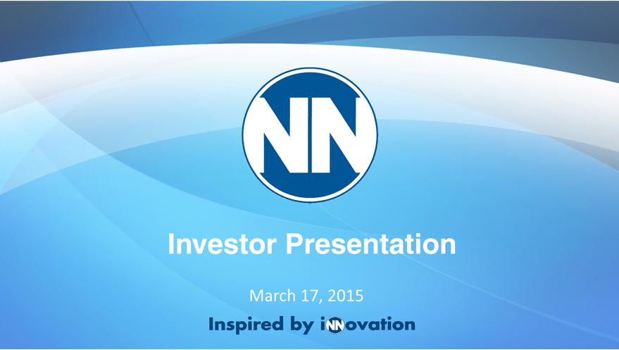

Investor Presentation
March 17, 2015

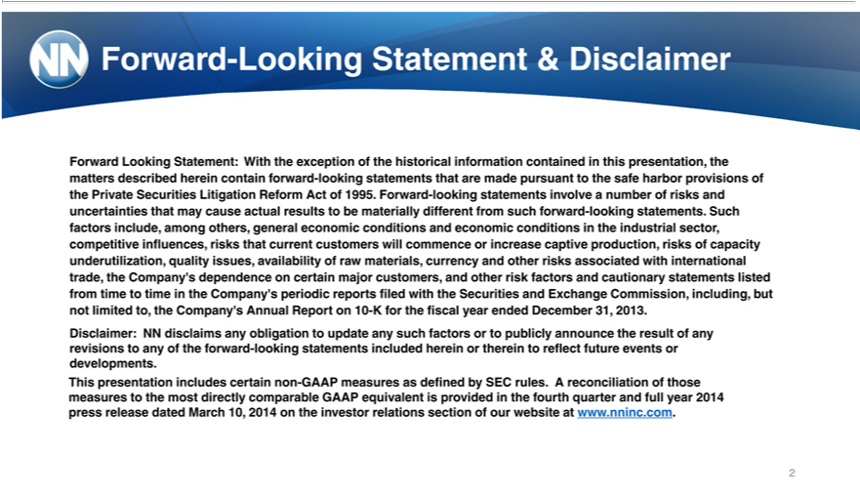

-Looking | & Disclaimer | the matters described herein contain forward-looking statements that are made pursuant to the safe harbor
Forward Looking Statement: With the exception of the historical information contained in this
provisions of the Private Se urities Litigation Reform Act of 1995. Forward-looking statementspresentation,involvenumber of risks and uncertainties that may cause actual results to be materially different from such forward-
looking statements. Such factors include, among others, general economic conditions and economic conditio s in the industrial sector, competitive influences, risks that current customers will commence or increase
captive production, risks of capacity und rutilization, quality issues, availability of raw |  | currency and other risks associated with international trade, the Company’s dependence on certain major
and other risk factors and | utionary statements listed from time to time in the Company’materials,periodic reports filed with the Securities and Exchange Commission, including, but not limited to, the Company’customers,Annual
Report on 10-K for the fiscal year ended December 31, 2013.
Disclaimer: NN disclaims any obligation to update any such factors or to publicly announce the result of any revisions to any of the forward-looking statements included herein or therein to reflect future events or
developments. |  | of those measures to the most directly comparable GAAP equivalent is provided in the fourth quarter and full year
This presentation includes certain non-GAAP measures as defined by SEC rules. A
2014 press release dated March 10, 2014 on the investor relations section of our websitereconciliationwww.nninc.com.

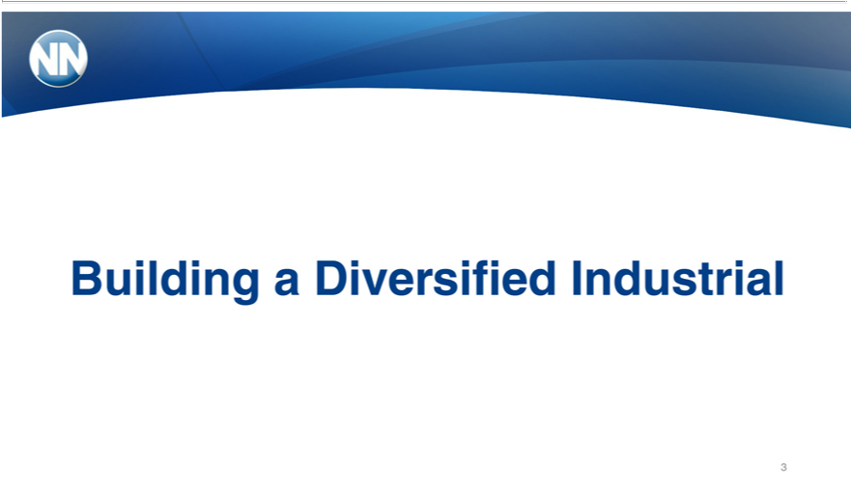

Building a Diversified Industrial

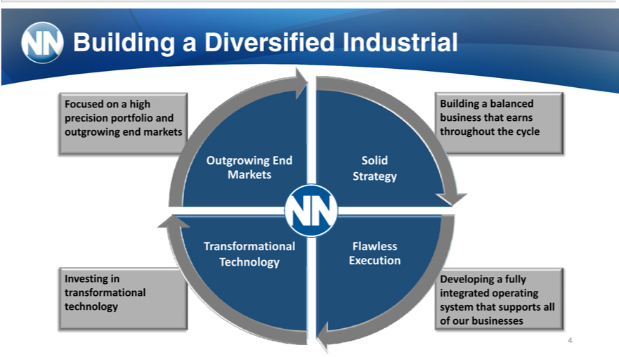

Building a Diversified
Focu ed on a high BuildingIndustrialbalanced
precision portfolio and Gr business that earns
outgrowing end ma k oughout the cycle
Outgrowing End Str Solid
Markets Strategy
Outgrowing | Flawless
ets | Flawless
ansformationalTechnology ExecutionT
Investing in
ransformational
technology | fully
Developing | fully
egratedsystem thatoperatingsupports all
[GraphicofourbusinessesAppears Here]

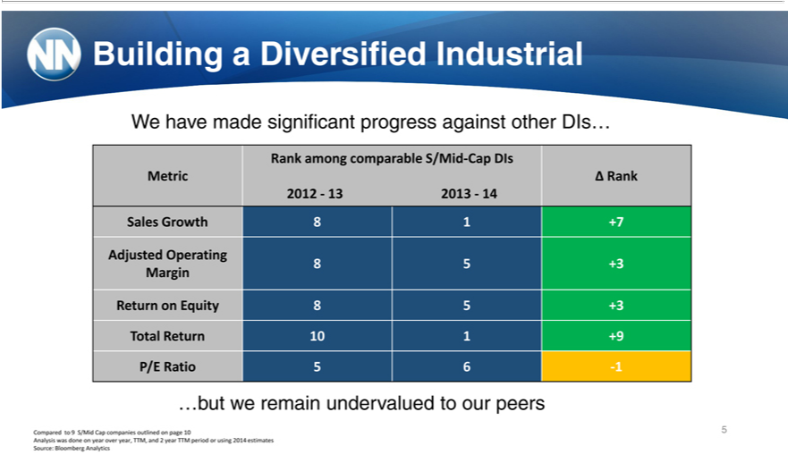

Building ^{made}Diversified Industrial
RankWehaveamong comparablesignificantS/Midprogress-CapagainstDIs other DIs…
Metric Ä Rank
Sales2012—13Growth2013—1481+7
8Adjusted5+3 Operating
Margin
Return on Equity 8 5 +3
P/ETotalRatioReturn5610-1 1 +9
…but we remain undervalued to our peers
Compared to 9 S/Mid Cap companies outlined on page 10 5 Analysis was done on year over year, TTM, and 2 year TTM period or using 2014 estimates Source: Bloomberg Analytics

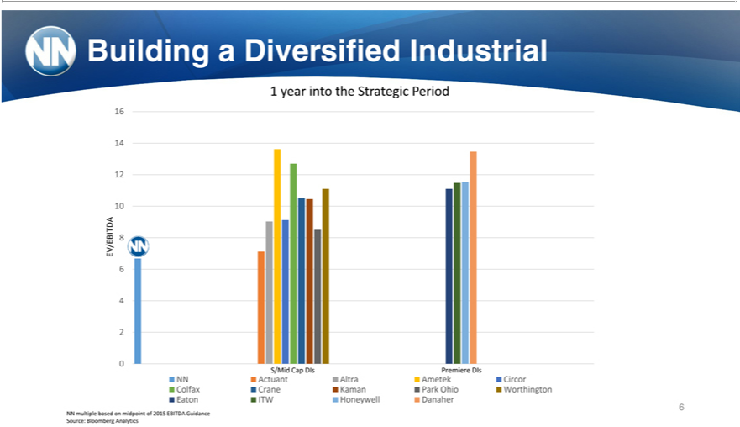

Building⁶ a Diversified Industrial
4year into the Strategic Period
102
EV/EBITDA 8
46
02
NNS/MidActuantCapDIsAltraPremiereAmetek^{Park}DIsCircor
EatonColfaxITWCraneHoneywellKaman DanaherOhio Worthington
6

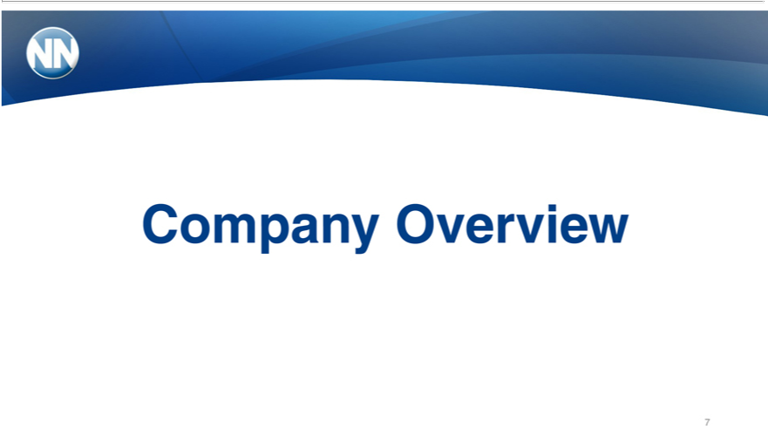

- multiple based on midpoint of 2015 EBITDA Guidance Source: Bloomberg Analytics

Company Overview 7

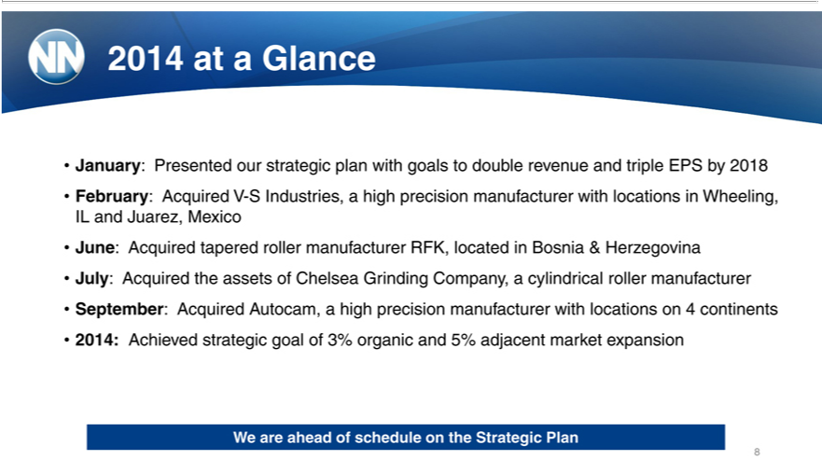

_{February:}2014at Glance
IL and Juarez,AcquiredMexicoV-S Industries, a high precision manufacturer with locations in Wheeling,
^{July:}
ne: AcquiredAcquired thetaperedassetsrollerof_{Chelsea}manufacturerGrindingRFK,Company,_{manufacturer}locatedincylindricalBosnia& rollerHerzegovinamanufacturer
September: Acquired Autocam, high precision with locations_{expansion} 4 continents
We2014:areAchievedaheadof strategicschedule goalontheof Strategic3%organicPlanand 5% adjacent market
8

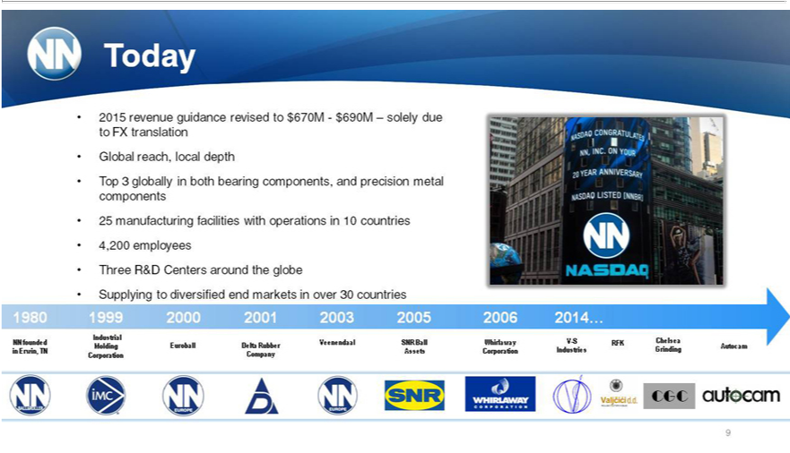

Today
Global2015forecastedreach,localrevenuedepthof $690M—$710M
Top_{manufacturing}3globally both bearing components, and precision metal components
25 facilities with operations in 10 countries
4,200 employees
Three R&D Centers around the globe
[GraphicSupplyingAppearstodiversifiedHere] end markets in over 30 countries
1980 1999 2000 2001 2003 2005 2006 2014…
NN founded SNR Ball Whirlaway V-S RFK Chelsea
^{CGC}inorporationErwin,TNCompanyAssetsCorporation Industries Grinding Autocam
9

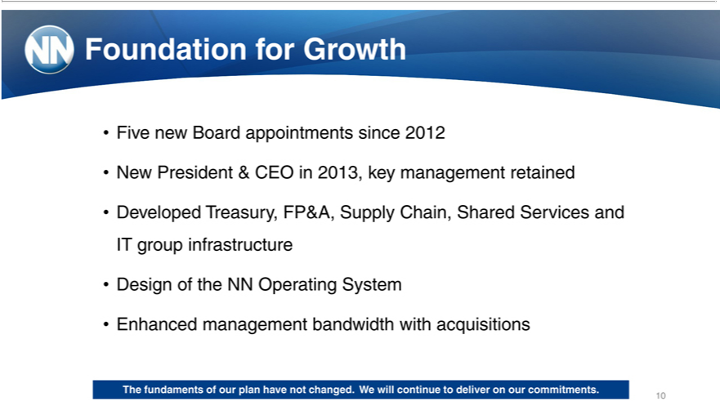

oundation for Growth | since 2012
Five new Board | since 2012
N ^{veloped}wPresident &appointmentsCEO2013, key management retained
^{Design}
of theTreasury,NNOperatingFP&A, SystemSupply Chain, Shared Services and IT group infrastructure
Enhanced management bandwidth with acquisitions
10The fundaments of our plan have not changed. We will continue to deliver on our commitments.

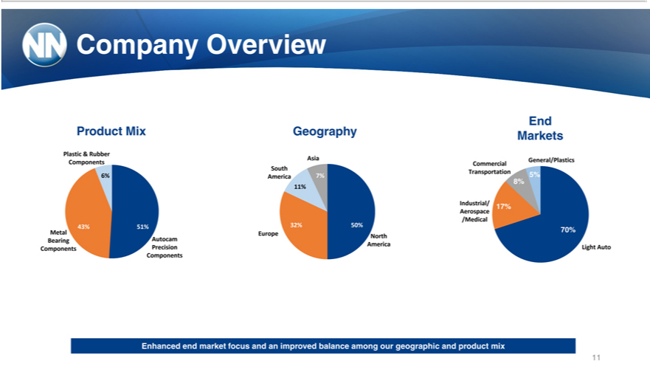

EndCompany Overview
_{Plastic}roduct&MixRubberGeography Markets
Asia General/Plastics
Components Commercial
South Transportation
6%^{8%} America 7% 5%
11%
7%
Industrial/ 17%
/MedicalAerospace
43%Metal51%Europe32%North50% 70%
_{Components}BearingAutocamPrecisionAmericaLight Auto
32%
11Enhanced end market focus and an improved balance among our geographic and product mix

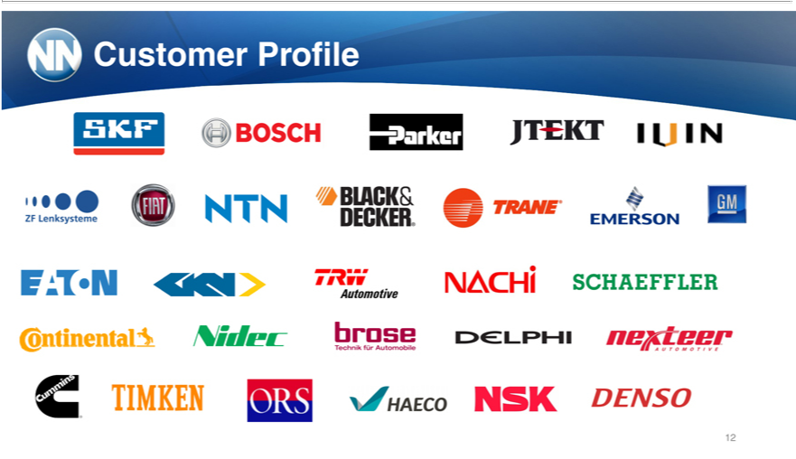

12Customer Profile

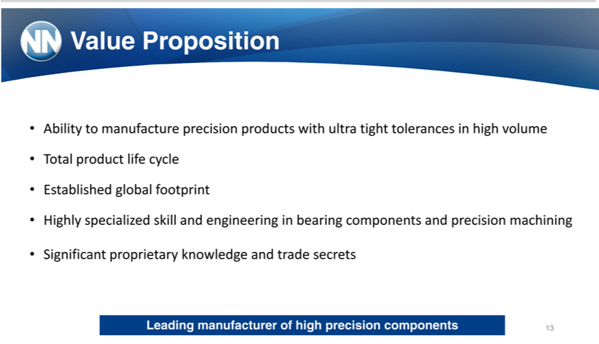

Value Proposition
TotalAbilityproducttomanufacturelifecycle precision products with ultra tight tolerances in high volume
Established global footprint
SignificantHighlyspecializedproprietaryskillknowledgeandengineeringandtradeinbearingsecrets components and precision machining
Leading manufacturer of high precision components 13

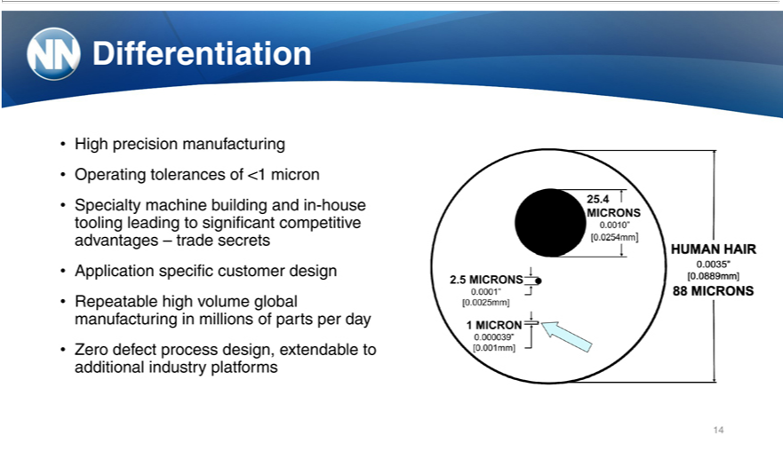

^{High}Dfferentiation
Operatingprecisiontolerancesmanufacturingof<1micron
Specialty machine building and in-house tooling leading to significant competitive advantages – trade secrets Application specific customer design
Repeatable high volume global manufacturing in millions of parts per day
14Zero defect process design, extendable to additional industry platforms

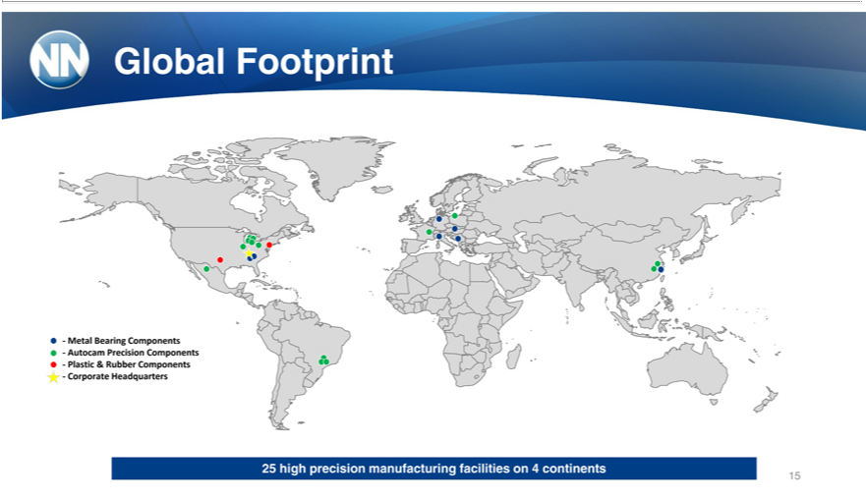

Global Footprint
Metal Bearing Components
Autocam Precision Components
Plastic & Rubber Components
Corporate Headquarters
₁₅25 high precision manufacturing facilities on 4 continents



Moving Forward 16

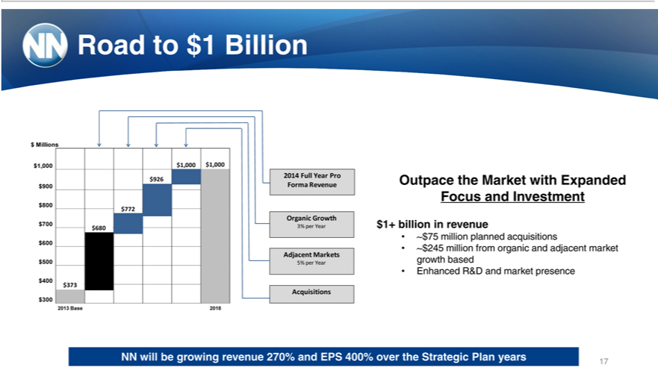

Road to $1 Billion
Millions
1,000 $1,000 $1,000
9 | 26 | 2014 Full Year Pro
9 |  | Forma Revenue
800
$772
Organic Growth
7 |  | $680 3% per Year
$600
Adjacent Markets
5 |  | 5% per Year
400
$373
Acquisitions
3 |  | 2013 Base 2018
$200 |  | 2013 Base 2018
FocusOutpaceandtheInvestmentMarketwith Expanded
$1+ billion in revenue
~$75²⁴⁵million planned acquisitions
EnhancedmillionR&Dfromand organicmarket presenceandadjacent market growth based
17NN will be growing revenue 270% and EPS 400% over the Strategic Plan years

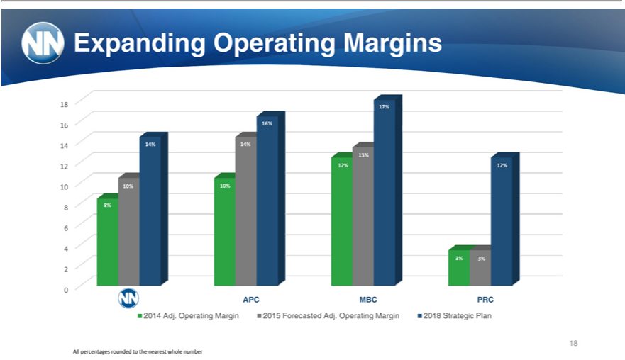

Expanding Operating Margins
^{8 7%}
_{3%}6414%6% 14%
102 10%^{2%} 10%^{2%}
8 8%
46
3% 3%
2
0
APC MBC PRC
182014 Adj. Operating Margin 2015 Forecasted Adj. Operating Margin 2018 Strategic Plan
All percentages rounded to the nearest whole number

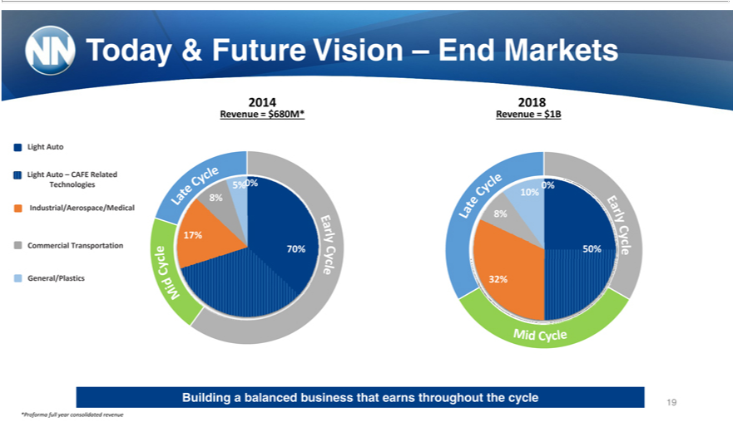

2014Today2018&Future Vision – End Markets
Revenue = $680M* Revenue = $1B
Light Auto – CAFE Related
Technologies 5% 0% 0%
8%Industrial/Aerospace/Medical10%
17%8%
General/PlasticsCommercialTransportation^{32%} 70% 50%
*ProformaBuilding balancedfullyear consolidatedbusinessthat revenueearnsthroughout the cycle 19

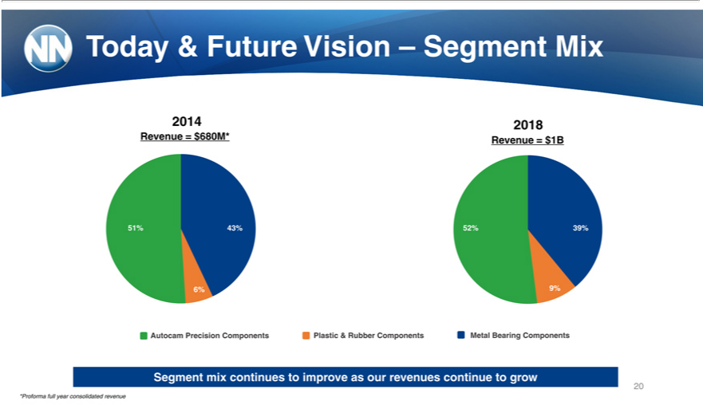

2014Today2018&Future Vision – Segment Mix
Revenue = $680M* Revenue = $1B
43%51
51% 43% 52% 39%
43
_{6%} 9%
31 43% 51 50
%%%
Autocam Precision60Components Plastic & Rubber Components Metal Bearing Components
%
25
%
20Segment mix continues to improve as our revenues continue to grow
*Proforma full year consolidated revenue

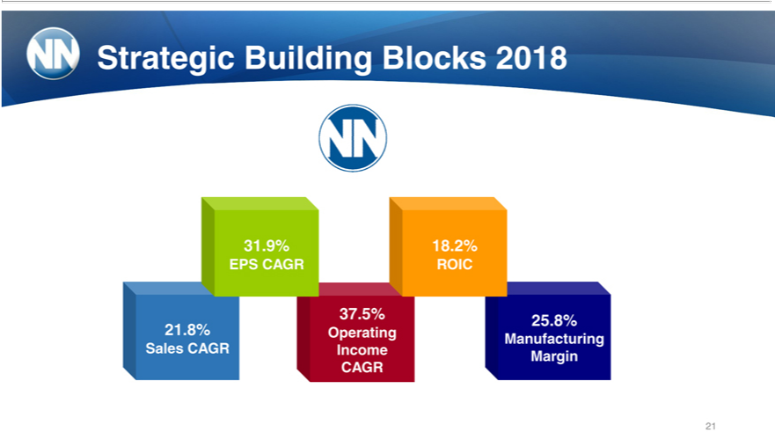

31.Strategic9%18.2%Building Blocks 2018
37EPS_{.8%}5%CAGR25.8%ROIC
Sales21 CAGROperatingIncomeManufacturingMargin
21CAGR

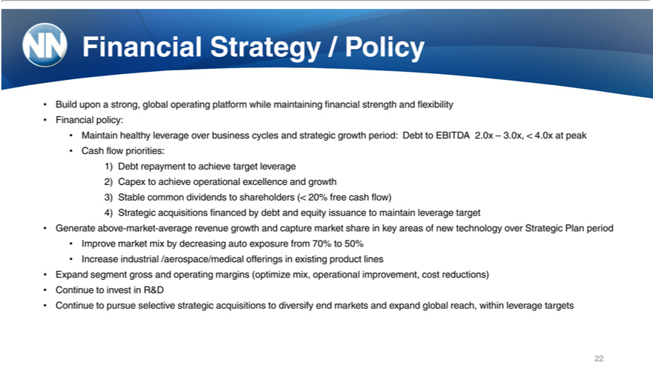

Financial |  | / Policy
Build uponStrategystrong, global operating platform while maintaining financial strength and flexibility
Financial policy:
Maintain healthy leverage over business cycles and strategic growth period: Debt to EBITDA 2.0x – 3.0x, < 4.0x at peak
Cash flow priorities:
1) | Debt repayment to achieve target leverage
2) | Capex to achieve operational excellence and growth
3) | able common dividends to shareholders (< 20% free cash flow)
4) | Strategic acquisitions financed by debt and equity issuance to maintain leverage target
Generate above-market-average revenue growth and capture market share in key areas of new technology over Strategic Plan period
mprove market mix by decreasing auto exposure from 70% to 50%
ExpandIncreasesegmentindustrialgross/aerospace/medicalandoperatingmarginsofferings(optimizeinexistingmix,productoperationallines improvement, cost reductions)
Continue to pursueinvestinselectiveR&D strategic acquisitions to diversify end markets and expand global reach, within leverage targets 22



23Precision components group

Macro Trend: CAFE Standards
77Global Fuel Efficiency Standards
50⁶ mpg
U.S. fuel efficiency requirements increase from 35 MPG in 2014 to 56 MPG in 2025 ? 60% higher
The EU’_{increasing}2020requirement of 77 MPG is ~40% higher than the U.S. same-year requirement China and Japan will both require fuel efficiency to reach 50 MPG or above by 2020
TechnologyRapidly IncreasestandardsinFuel are driving OEMs to accelerate new technology development
Efficiency
DirectMulti-SpeedfuelInjectionTransmissions/High Pressure(6-9gears)Diesel5-10%15-30%
ElectricVariable PowerValve TimingSteering/ 1Variablempg Cam Timing 4-6%
24Source: ICCT

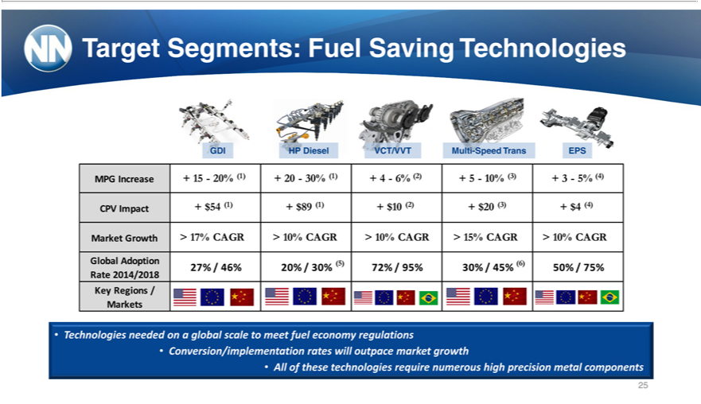

Target Segments: Fuel Saving Technologies
GDI HP Diesel VCT/VVT Multi-Speed Trans EPS
CPVMPG ImpactIncrease+ +$5415—20%(1)+$89(1)(1)+ 20—30%+$10(2) +(1)$20+4—6%(3)+$4(2)(4)+ 5—10% (3) + 3—5% (4)
GlobalMarket _{Adoption(5)(6)}Grwth>17% CAGR > 10% CAGR > 10% CAGR > 15% CAGR > 10% CAGR
Rate27% _{2014/2018}46%20% / 30% 72% / 95% 30% / 45% 50% / 75%
MarketsKeyRegions
•_{Conversion/implementation}Technologiesneededa globalrateswillscaleoutpacetomeetmarketfueleconomygrowth regulations
25All of these technologies require numerous high precision metal components

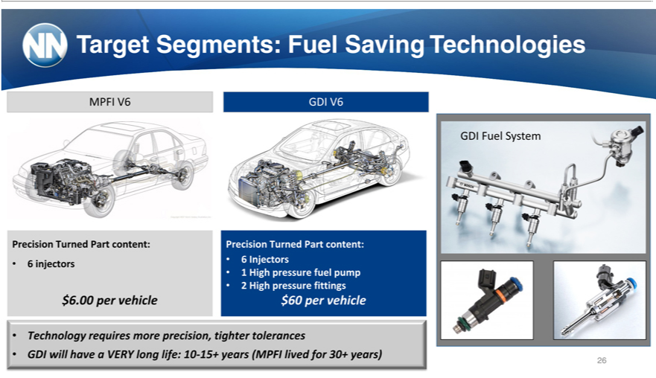

Target Segments: Fuel Saving Technologies
MPFI V6 GDI V6
GDI Fuel System
Precision6injectorsTurned•6InjectorsPartcontent: Precision Turned Part content:
• 2¹ High pressure fittings^{uelpump}
$6.00 per vehicle $60 per vehicle
• Technology requires more precision, tighter tolerances
26GDI will have a VERY long life: 10-15+ years (MPFI lived for 30+ years)

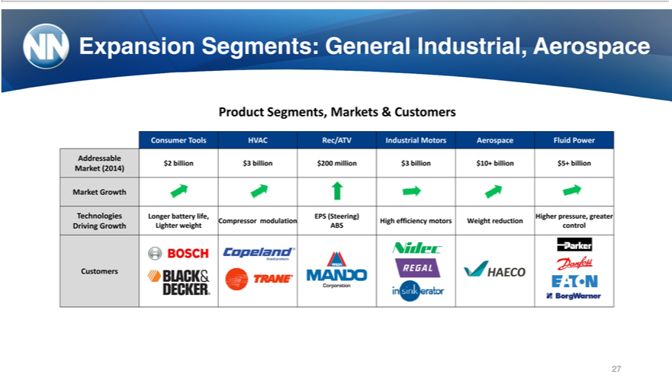

ProductExpansionSegments,Segments:MarketsGeneral& CustomersIndustrial, Aerospace
AddressableConsumerTools HVAC Rec/ATV Industrial Motors Aerospace Fluid Power
_{Market}$2billion(2014)$3billion $200 million $3 billion $10+ billion $5+ billion
Growth
Technologies Longer battery life, EPS (Steering) Higher pressure, greater
DrivingCompressorGrowthmodulationLighter weightHighefficiencyABScontrolmotors Weight reduction
27Customers



28Bearing Components group

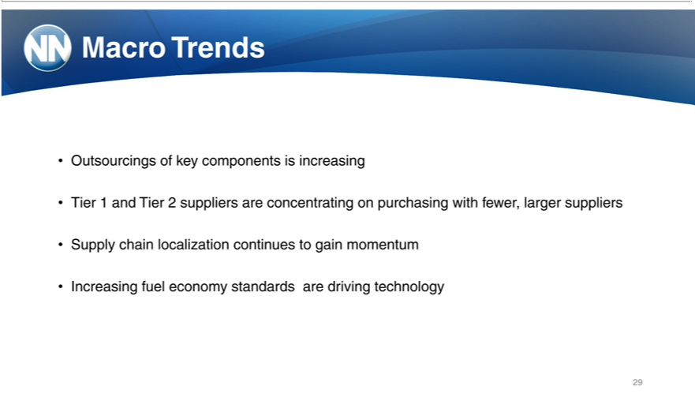

Macro Trends
Outsourcings of key components is increasing
SupplyTier1andchainTierlocalization2supplierscontinuesareconcentratingtogainmomentumonpurchasing with fewer, larger suppliers
29Increasing fuel economy standards are driving technology

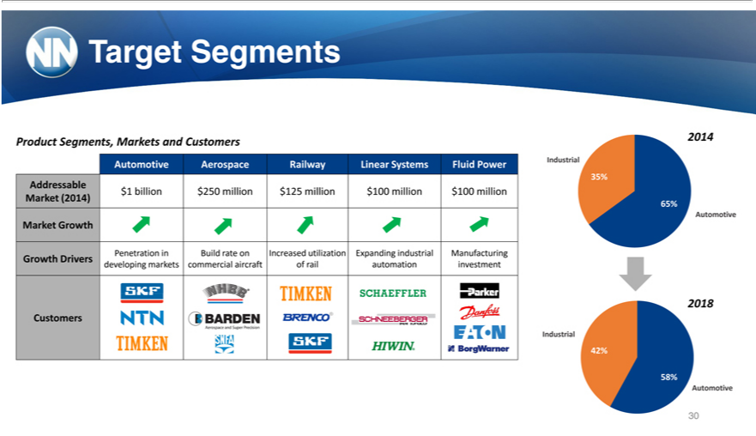

Target Segments
Product Segments, Markets and Customers 2014
35%Automotive Aerospace Railway Linear Systems Fluid Power Industrial
Addressable
Market$1billion(2014)$25065%million $125 million $100 million $100 million
MarketAutomotiveGrowth
Penetration in Build rate on Increased utilization Expanding industrial Manufacturing
2018Growth Drivers developing markets commercial aircraft of rail automation investment
Customers
Industrial
^{42%}58%
30Automotive

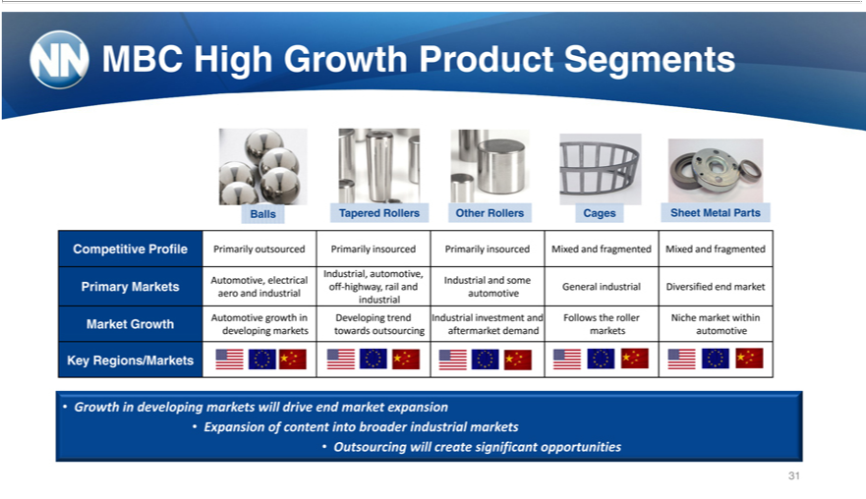

MBC High Growth Product Segments
Balls Tapered Rollers Other Rollers Cages Sheet Metal Parts
Competitive Profile Primarily outsourced Primarily insourced Primarily insourced Mixed and fragmented Mixed and fragmented Industrial, automotive,
Automotive, electrical Industrial and some
aeroPrimaryand Marketsindustrialoffautomotive-highway, rail and General industrial Diversified end market
industrial
Automotive growth_{developing}Developing trend Industrial investment and Follows the roller Niche market within
Market Growth markets towards outsourcing aftermarket demand markets automotive Key Regions/Markets
Growth in developing markets will drive end_{markets} expansion
•
OutsourcingExpansionofwillcontentcreateintosignificantbroaderindustrialopportunities
31



MarchInvestor17,Presentation2015

