UNITED STATES

SECURITIES AND EXCHANGE COMMISSION
WASHINGTON, DC 20549

FORM 8-K

CURRENT REPORT

PURSUANT TO SECTION 13 OR 15(d)
OF THE SECURITIES EXCHANGE ACT OF 1934

Date of Report (Date of earliest event reported): August 3, 2016 (August 3, 2016)


NN, INC.

(Exact name of registrant as specified in its charter)

Delaware | 000-23486 | 62-1096725
(State or Other Jurisdiction | (Commission | (I.R.S. Employer
of Incorporation) | File Number) | Identification No.)
207 Mockingbird Lane
Johnson City, Tennessee |  | 37604
(Address of principal executive offices) |  | (Zip Code)

(423) 434-8310

(Registrant’s telephone number, including area code)

(Former name or former address, if changed since last report)

Check the appropriate box if the Form 8-K filing is intended to simultaneously satisfy the filing obligation of the registrant under any of the following provisions (see General Instruction A.2. below):

- Written communications pursuant to Rule 425 under the Securities Act (17 CFR 230.425)

- Soliciting material pursuant to Rule 14a-12 under the Exchange Act (17 CFR 240.14a-12)

- Pre-commencement communications pursuant to Rule 14d-2(b) under the Exchange Act (17 CFR 240.14d- 2(b))

- Pre-commencement communications pursuant to Rule 13e-4(c) under the Exchange Act (17 CFR 240.13e- 4(c))

ITEM 2.02 RESULTS OF OPERATIONS AND FINANCIAL CONDITION

On August 3, 2016, NN, Inc. (the “Company”) issued a press release announcing the Company’s financial results for the quarter ended June 30, 2016. The full text of the press release is furnished as Exhibit 99.1 and is incorporated herein by reference.

ITEM 7.01 REGULATION FD DISCLOSURE

On August 3, 2016, the Company posted a presentation regarding the Company’s financial results for the quarter ended June 30, 2016 to the Investor Relations section of its website at www.nninc.com. A copy of the presentation is furnished as Exhibit 99.2.

Pursuant to the rules and regulations of the U.S. Securities and Exchange Commission (the “SEC”), the information furnished pursuant to Item 2.02 and 7.01 of this Current Report on Form 8-K (including Exhibit 99.1 and Exhibit 99.2) is deemed to have been furnished and shall not be deemed to be “filed” for purposes of Section 18 of the Securities Exchange Act of 1934, as amended, or otherwise subject to the liabilities of that section. Such information shall not be incorporated by reference into any filing of the Company, whether made before or after the date hereof, regardless of any general incorporation language in such filing.

ITEM 9.01 FINANCIAL STATEMENTS AND EXHIBITS

Exhibit
No. Description

99.1 Press Release of NN, Inc. dated August 3, 2016.

99.2 Second Quarter 2016 Earnings Release Presentation of NN, Inc. dated as of August 4, 2016.

SIGNATURES

Pursuant to the requirements of the Securities Exchange Act of 1934, the registrant has duly caused this report to be signed on its behalf by the undersigned hereunto duly authorized.

Date: August 3, 2016

NN, INC.

By: | /s/ Matthew S. Heiter
Name: | Matthew S. Heiter
Title: | Senior Vice President and General Counsel

 |  |  | EXHIBIT INDEX
Exhibit |  | Description
No. |  | Description
99.1 |  | Press Release of NN, Inc. dated August 3, 2016.
99.2 |  | Second Quarter 2016 Earnings Release Presentation of NN, Inc. dated as of August 4, 2016.

Exhibit 99.1



RE: NN, Inc.

207 Mockingbird Lane

3rd Floor

Johnson City, TN 37604

FOR FURTHER INFORMATION:

AT THE COMPANY

Robbie Atkinson

VP, Corporate Treasurer & Investor Relations

(423) 434-8398

AT FINANCIAL RELATIONS BOARD

Marilynn Meek

(General info)

212-827-3773

FOR IMMEDIATE RELEASE

August 3, 2016

NN, INC. REPORTS SECOND QUARTER 2016 RESULTS

Johnson City, Tenn, August 3, 2016 –NN, Inc., (NASDAQ: NNBR), a diversified industrial company, today reported its financial results for the second quarter ended June 30, 2016.

Richard Holder, President and Chief Executive Officer, commented, “Commencing with this quarter and in accordance with updated regulatory guidance we have reformatted our earnings release to report our GAAP results first, followed by our adjusted operating results.”

GAAP Results

Net sales for the second quarter of 2016 increased $49.4 million, or 30.0% to $214.3 million, compared to $164.9 million for the second quarter of 2015. Acquisitions added $57.8 million in revenue. Sales in the legacy business were negatively impacted $8.4 million primarily from weakness in the industrial end market.

On a GAAP basis, income from operations for the second quarter of 2016 was $16.7 million, compared to $13.6 million for the same period in 2015. Net income on a GAAP basis for second quarter of 2016 was $2.0 million, or $0.07 per diluted share. This compares to net income of $7.0 million, or $0.36 per diluted share in the second quarter of 2015.

On a GAAP basis, income from operations for second quarter 2016 in the Autocam Precision Components Group was $7.8 million compared to $9.1 million for the same period in 2015.

On a GAAP basis, income from operations for second quarter 2016 in the Precision Bearing Components Group was $6.5 million compared to $9.4 million for the same period in 2015.

On a GAAP basis, income from operations for second quarter 2016 in the Precision Engineered Products Group was $10.8 million compared to $0.5 million for the same period in 2015.

Adjusted Second Quarter 2016 Results

Adjusted income from operations for the second quarter of 2016 was $28.7 million, an increase of 89%, compared to $15.2 million for the same period in 2015.

Adjusted net income was $12.4 million, or $0.46 per diluted share, compared to $8.3 million, or $0.42 per diluted share for the same period in 2015.

Richard Holder, President and Chief Executive Officer, commented, “The NN Operating System continues to drive solid improvement throughout our business. Our operating performance this quarter is a great example of our ability to drive margin expansion.”

Business Group Results

Autocam Precision Components

Net sales for the second quarter of 2016 were $83.0 million, compared to $86.5 million in the second quarter of 2015, a decrease of $3.5 million. Weakness in the industrial end market accounted for the decline. Adjusted income from operations for the quarter increased $0.7 million to $10.7 million, compared to $10.0 million in the second quarter of 2015.

Holder commented, “Focus on our CAFE Technologies and improvements driven by the NN Operating System continue to drive margin expansion in our APC group.”

Precision Bearing Components

Net sales for the second quarter of 2016 were $65.2 million, compared to $69.3 million in the second quarter of 2015, a decrease of $4.1 million. Soft industrial market demand accounted for the decline. Adjusted income from operations for the second quarter was $8.2 million, compared to $9.5 million in the second quarter of 2015.

Holder commented, “Despite continued weakness in the industrial market our PBC team continues to focus on margin expansion driven by the tenets of the NN Operating System.”

Precision Engineered Products

Net sales for the second quarter of 2016 were $66.1 million, compared to $9.1 million in the second quarter of 2015, an increase of $57.0 million. The acquisition of PEP accounted for $58.4 million of the increase. Adjusted income from operations for the quarter was $16.3 million, compared to $0.5 million in 2015.

Holder commented, “We continue to be pleased with the performance of our PEP group. Our integration efforts are on track and we are beginning to see the benefits of the NN Operating System.”

Holder concluded, “Driven by the NN Operating System and growth in our non-industrial end markets we continue to deliver solid operating results.”

The full set of financial guidance for the third quarter and full year 2016 can be found in our supplemental presentation posted in the Investor Relations section of our website at www.nninc.com.

- will discuss its results during its quarterly investor conference call tomorrow morning starting at 9:00 a.m. ET. The call and supplemental presentation may be accessed via NN’s website, www.nninc.com. The conference call can also be accessed by dialing 800-723-6575 or 785-830-1997 Conference ID: 7483731. For those who are unavailable to listen to the live broadcast, a replay will be available shortly after the call for 90 days.

The Company discloses in this press release the non-GAAP financial measures of adjusted income from operations and adjusted net income. Each of adjusted income from operations and adjusted net income provide supplementary information about the impacts of acquisition related expenses, foreign-exchange and other non-operating impacts on our business.

The attached financial tables include a reconciliation of adjusted income from operations, adjusted net income and adjusted diluted earnings per share to the U.S.

GAAP financial measures of income from operations, net income and diluted earnings per share.

NN, Inc., a diversified industrial company combines advanced engineering and production capabilities with in-depth materials science expertise to design and manufacture high-precision components and assemblies for a variety of markets on a global basis. Headquartered in Johnson City, Tennessee, NN has 41 manufacturing plants in North America, Western Europe, Eastern Europe, South America and China.

Except for specific historical information, many of the matters discussed in this press release may express or imply projections of revenues or expenditures, statements of plans and objectives or future operations or statements of future economic performance. These, and similar statements, are forward-looking statements concerning matters that involve risks, uncertainties and other factors which may cause the actual performance of NN, Inc. and its subsidiaries to differ materially from those expressed or implied by this discussion. All forward-looking information is provided by the Company pursuant to the safe harbor established under the Private Securities Litigation Reform Act of 1995 and should be evaluated in the context of these factors. Forward-looking statements generally can be identified by the use of forward-looking terminology such as “assumptions”, “target”, “guidance”, “outlook”, “plans”, “projection”, “may”, “will”, “would”, “expect”, “intend”, “estimate”, “anticipate”, “believe”, “potential” or “continue” (or the negative or other derivatives of each of these terms) or similar terminology. Factors which could materially affect actual results include, but are not limited to: general economic conditions and economic conditions in the industrial sector, inventory levels, regulatory compliance costs and the Company’s ability to manage these costs, start-up costs for new operations, debt reduction, competitive influences, risks that current customers will commence or increase captive production, risks of capacity underutilization, quality issues, availability and price of raw materials, currency and other risks associated with international trade, the Company’s dependence on certain major customers, and the successful implementation of the global growth plan including development of new products. Similarly, statements made herein and elsewhere regarding completed acquisitions are also forward-looking statements, including statements relating to the future performance and prospects of an acquired business, the expected benefits of an acquisition on the Company’s future business and operations and the ability of the Company to successfully integrate recently acquired businesses.

For additional information concerning such risk factors and cautionary statements, please see the section titled “Risk Factors” in the Company’s periodic reports filed with the Securities and Exchange Commission, including, but not limited to, the Company’s Annual Report on Form 10-K for the fiscal year ended December 31, 2015. Except as required by law, we undertake no obligation to update or revise any forward-looking statements we make in our press releases, whether as a result of new information, future events or otherwise.

Financial Tables Follow

NN, Inc.

Condensed Consolidated Statements of Net Income

(Unaudited)

 |  |  |  | Three Months ended |  |  |  |  |  |  | Six Months ended
(in thousands, except per share data) |  |  |  | June 30, 2016 |  |  |  |  |  |  | June 30, 2016
 |  |  |  | 2016 |  |  |  | 2015 |  |  | 2016 |  |  | 2015
Net sales |  |  | $ | 214,272 |  |  | $ | 164,856 |  | $ | 426,498 |  | $ | 328,601
Cost of products sold (exclusive of depreciation and amortization shown separately below) |  |  |  | 156,794 |  |  |  | 128,708 |  |  | 316,548 |  |  | 258,025
Selling, general and administrative |  |  |  | 21,592 |  |  |  | 13,962 |  |  | 42,304 |  |  | 25,961
Depreciation and amortization |  |  |  | 15,136 |  |  |  | 8,597 |  |  | 32,484 |  |  | 17,091
Restructuring and impairment charges |  |  |  | 4,047 |  |  |  | — |  |  | 6,585 |  |  | —
Income from operations |  |  |  | 16,703 |  |  |  | 13,589 |  |  | 28,577 |  |  | 27,524
Interest expense |  |  |  | 16,165 |  |  |  | 6,021 |  |  | 32,587 |  |  | 11,959
Other (income) expense, net |  |  |  | (824) |  |  |  | 19 |  |  | (1,953) |  |  | 1,419
Income (loss) before provision (benefit) for income taxes and share of net income from joint venture |  |  |  | 1,362 |  |  |  | 7,549 |  |  | (2,057) |  |  | 14,146
Provision (benefit) expense for income taxes |  |  |  | 674 |  |  |  | 1,617 |  |  | (46) |  |  | 3,073
Share of net income from joint venture |  |  |  | 1,343 |  |  |  | 1,021 |  |  | 2,743 |  |  | 1,882
Net income |  | $ |  | 2,031 |  | $ |  | 6,953 |  | $ | 732 |  | $ | 12,955
Basic income per share:
Net income |  | $ |  | 0.08 |  | $ |  | 0.36 |  | $ | 0.03 |  | $ | 0.68
Weighted average shares outstanding |  |  |  | 27,024 |  |  |  | 19,215 |  |  | 26,923 |  |  | 19,064
Diluted income per share:
Net income |  | $ |  | 0.07 |  | $ |  | 0.36 |  | $ | 0.03 |  | $ | 0.67
Weighted average shares outstanding
 |  |  |  | 27,187 |  |  |  | 19,582 |  |  | 27,050 |  |  | 19,416
Cash dividends per common share |  | $ |  | 0.07 |  | $ |  | 0.07 |  | $ | 0.14 |  | $ | 0.14

NN, Inc.

Condensed Consolidated Balance Sheets

(Unaudited)

(in thousands, except per share data) |  |  |  | June 30, |  | December 31,
 |  |  |  | 2016 |  |  | 2015
Assets
Current assets:
Cash |  | $ |  | 15,080 |  | $ | 15,087
Accounts receivable, net |  |  |  | 147,053 |  |  | 123,005
Inventories |  |  |  | 118,784 |  |  | 119,836
Income tax receivable |  |  |  | 4,046 |  |  | 3,989
Current deferred tax assets |  |  |  | — |  |  | 6,696
Other current assets |  |  |  | 12,920 |  |  | 11,568
Total current assets |  |  |  | 297,883 |  |  | 280,181
Property, plant and equipment, net |  |  |  | 323,244 |  |  | 318,968
Goodwill, net |  |  |  | 448,690 |  |  | 449,898
Intangible assets, net |  |  |  | 267,769 |  |  | 282,169
Non-current deferred tax assets |  |  |  | — |  |  | 742
Investment in joint venture |  |  |  | 41,205 |  |  | 38,462
Other non-current assets |  |  |  | 10,950 |  |  | 10,147
Total assets |  |  | $ | 1,389,741 |  | $ | 1,380,567
Liabilities and Stockholders’ Equity
Current liabilities:
Accounts payable |  | $ |  | 65,862 |  | $ | 69,101
Accrued salaries, wages and benefits |  |  |  | 23,392 |  |  | 21,125
Income taxes payable |  |  |  | 2,042 |  |  | 5,350
Current maturities of long-term debt |  |  |  | 19,537 |  |  | 11,714
Current portion of obligation under capital lease |  |  |  | 4,101 |  |  | 4,786
Other current liabilities |  |  |  | 23,941 |  |  | 21,275
Total current liabilities |  |  |  | 138,875 |  |  | 133,351
Non-current deferred tax liabilities |  |  |  | 112,256 |  |  | 117,459
Long-term debt, net of current portion |  |  |  | 801,213 |  |  | 795,400
Accrued post-employment benefits |  |  |  | 6,045 |  |  | 6,157
Obligation under capital lease, net of current portion |  |  |  | 7,656 |  |  | 9,573
Other |  |  |  | 6,290 |  |  | 4,746
Total liabilities |  |  |  | 1,072,335 |  |  | 1,066,686
Total stockholders’ equity |  |  |  | 317,406 |  |  | 313,881
Total liabilities and stockholders’ equity |  |  | $ | 1,389,741 |  | $ | 1,380,567

Reconciliation of GAAP net income to Non-GAAP adjusted net income:

NN, Inc - Total Company |  | Three Months Ended June 30, 2016 |  |  |  |  |  |  |  | Three Months Ended June 30, 2015
 | In Thousands |  |  |  | Diluted Earnings |  |  |  | In Thousands |  |  |  | Diluted Earnings
 |  |  |  |  |  | Per Share |  |  |  |  |  |  |  | Per Share
GAAP Net income | $ | 2,031 |  |  | $ | 0.07 |  |  | $ | 6,953 |  |  | $ | 0.36
After-tax acquisition and integration costs |  | 1,285 |  |  |  | 0.05 |  |  |  | 436 |  |  |  | 0.02
After-tax foreign exchange gain on inter-company
loans |  | (700) |  |  |  | (0.02) |  |  |  | (232) |  |  |  | (0.01)
After-tax restructuring and impairment charges |  | 5,174 |  |  |  | 0.19 |  |  |  | — |  |  |  | —
Amortization of intangibles & deferred financing
costs |  | 4,642 |  |  |  | 0.17 |  |  |  | 1,148 |  |  |  | 0.06
Non-GAAP Adjusted net income (b)
Non-GAAP Adjusted net income (b) | $ | 12,432 |  |  | $ | 0.46 |  | $ |  | 8,305 |  | $ |  | 0.42

Reconciliation of GAAP income from operations to Non-GAAP adjusted income from operations:

NN, Inc - Total Company |  |  |  | 2016 |  | Three Months Ended June 30, |  |  |  |  | 2015
 |  |  |  | $’000 |  | % of Sales |  |  | $’000 |  |  | % of Sales
 | GAAP Income from operations | $ |  | 16,703 |  | 7.8% |  | $ | 13,589 |  | 8.2%
 | Restructuring & impairment charges |  |  | 4,745 |  | 2.2% |  |  | — |  | 0.0%
 | Acquisition & integration expenses |  |  | 1,178 |  | 0.5% |  |  | 681 |  | 0.4%
 | Amortization of intangibles |  |  | 6,101 |  | 2.8% |  |  | 962 |  | 0.6%
 | Non-GAAP Adjusted income from operations (a) | $ |  | 28,727 |  | 13.4% |  | $ | 15,232 |  | 9.2%
GAAP Total Sales
 |  | $214,272 |  |  |  |  |  | $164,856

Reconciliation of GAAP income from operations to Non-GAAP adjusted income from operations:

NN, Inc - Autocam Precision Components Group |  | 2016 |  | Three Months Ended June 30, |  |  |  |  | 2015
 |  | $’000 |  | % of Sales |  |  | $’000 |  |  | % of Sales
 | GAAP Income from operations | $ 7,770 |  | 9.4% |  | $ | 9,095 |  | 10.5%
 | Restructuring & impairment Charges | 2,085 |  | 2.5% |  |  | — |  | 0.0%
 | Acquisition & integration expenses | — |  | 0.0% |  |  | — |  | 0.0%
 | Amortization of intangibles | 885 |  | 1.1% |  |  | 885 |  | 1.0%
 | Non-GAAP Adjusted income from operations | $10,740 |  | 12.9% |  | $ | 9,980 |  | 11.5%
China JV Contribution
 |  | 1,343 |  |  |  |  | 1,021
 | Non-GAAP Adjusted income from operations | $12,083 |  | 14.6% |  | $ 11,001 |  |  | 12.7%
GAAP Total Sales |  | $82,991 |  |  |  | $86,471

Reconciliation of GAAP income from operations to Non-GAAP adjusted income from operations:

NN, Inc - Precision Bearing Components Group |  |  | 2016 |  | Three Months Ended June 30, |  |  |  |  | 2015
 |  |  | $’000 |  | % of Sales |  |  | $’000 |  |  | % of Sales
GAAP Income from operations | $ |  | 6,474 |  | 9.9% |  | $ | 9,403 |  | 13.6%
Restructuring & impairment Charges |  |  | 1,651 |  | 2.5% |  |  | — |  | 0.0%
Amortization of intangibles |  |  | 57 |  | 0.1% |  |  | 57 |  | 0.1%
Non-GAAP Adjusted income from operations
Non-GAAP Adjusted income from operations | $ |  | 8,182 |  | 12.6% |  | $ | 9,460 |  | 13.7%
GAAP Total Sales | $65,157 |  |  |  |  |  | $69,261

Reconciliation of GAAP income from operations to Non-GAAP adjusted income from operations:

NN, Inc - Precision Engineered Components Group | 2016 |  | Three Months Ended June 30, |  |  |  |  | 2015
 | $’000 |  | % of Sales |  | $’000 |  |  |  | % of Sales
GAAP Income from operations | $10,782 |  | 16.3% |  | $ | 501 |  | 5.5%
Acquisition & integration expenses | 311 |  | 0.5% |  |  | — |  | 0.0%
Amortization of intangibles | 5,159 |  | 7.8% |  |  | 20 |  | 0.2%
Non-GAAP Adjusted income from operations (a)
Non-GAAP Adjusted income from operations (a) | $16,252 |  | 24.6% |  | $ | 521 |  | 5.7%
GAAP Total Sales | $66,124 |  |  |  | $9,124

The Company discloses in this presentation the non-GAAP financial measures of adjusted income from operations, adjusted net income and adjusted diluted earnings per share. Each of these non-GAAP financial measures provide supplementary information about the impacts of acquisition related expenses and foreign-exchange impacts on inter-company loans. Over the past three years, we have completed six acquisitions, two of which were transformative for the Company. The costs we incurred in completing such acquisitions, including the amortization of intangibles and deferred financing costs, have been excluded from these measures because their size and inconsistent frequency are unrelated to our commercial performance during the period, and which we believe are not indicative of our ongoing operating costs. We exclude the impact of currency translation from these measures because foreign exchange rates are not under management’s control and are subject to volatility. We believe the presentation of adjusted income from operations, adjusted net income and adjusted diluted earnings per share provide useful information in assessing our underlying business trends and facilitates comparison of our long-term performance over given periods

The non-GAAP financial measures provided herein may not provide information that is directly comparable to that provided by other companies in the Company’s industry, as other companies may calculate such financial results differently. The Company’s non-GAAP financial measures are not measurements of financial performance under GAAP, and should not be considered as alternatives to actual net income growth derived from income amounts presented in accordance with GAAP. The Company does not consider these non-GAAP financial measures to be a substitute for, or superior to, the information provided by GAAP financial results.

- Non-GAAP Adjusted income from operations, represents GAAP income from operations, adjusted to exclude the effects of restructuring and non-cash impairment charges (related to plant closures and other charges incurred to implement our strategic goals, that do not necessarily represent a major strategic shift in operations), one-time charges related to acquisition and integration costs, intangible amortization costs for fair value step-up in values related to acquisitions, and when applicable, our share of income from joint venture operations. We believe this presentation is commonly used by investors and professional research analysts in the valuation, comparison, rating and investment recommendations of companies in the industrial industry. We use this information for comparative purposes within the industry. Non-GAAP adjusted income from operations, is not a measure of financial performance under GAAP and should not be considered as a measure of liquidity or as an alternative to GAAP income from operations.

- Non-GAAP adjusted net income and adjusted diluted earnings per share, represents GAAP net income, adjusted to exclude the tax-affected effects of restructuring and non-cash impairment charges (related to plant closures and other charges incurred to implement our strategic goals, that do not necessarily represent a major strategic shift in operations), one-time charges related to acquisition and integration costs, amortization of intangibles costs for fair value step-up in values related to acquisitions and amortization of deferred financing costs, and foreign exchange gain (loss) on inter-company loans. We believe this presentation is commonly used by investors and professional research analysts in the valuation, comparison, rating and investment recommendations of companies in the industrial industry. We use this information for comparative purposes within the industry. Non-GAAP adjusted net income and adjusted diluted earnings per share, is not a measure of financial performance under GAAP and should not be considered as a measure of liquidity or as an alternative to GAAP net income.

Exhibit 99.2


Second Quarter 2016 Earnings Release
August 4, 2016

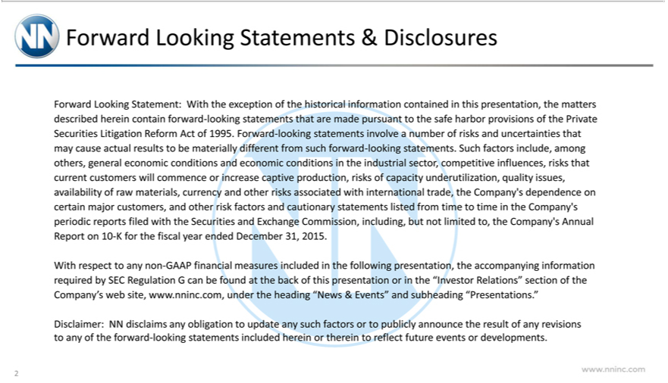

 | s & Disclosures | the matters described herein contain forward-looking statements that are made pursuant to the safe harbor
Forward Looking Statement: With the exception of the historical information contained in this
provisions of the Private Se urities Litigation Reform Act of 1995. Forward-looking statementspresentation,involvenumber of risks and uncertainties that may cause actual results to be materially different from such forward-
looking statements. Such factors include, among others, general economic conditions and economic conditio s in the industrial sector, competitive influences, risks that current customers will commence or increase
captive production, risks of capacity und rutilization, quality issues, availability of raw |  | currency and other risks associated with international trade, the Company’s dependence on certain major
and other risk factors and | utionary statements listed from time to time in the Company’materials,periodic reports filed with the Securities and Exchange Commission, including, but not limited to, the Company’customers,Annual
Report on 10-K for the fiscal year ended December 31, 2015.
With respect to any non-GAAP financial measures included in the following presentation, the accompanying information required by SEC Regulation G can be found at the back of this presentation or in the “Investor
Relations” section of the | s web site, www.nninc.com, under the heading “News & Events” and subheading “Presentations.”
Disclaimer: NN disclaimsCompany’obligation to update any such factors or to publicly announce the result of any revisions to any of the forward-looking statements included herein or therein to reflect future events or developments.
2

Second Quarter

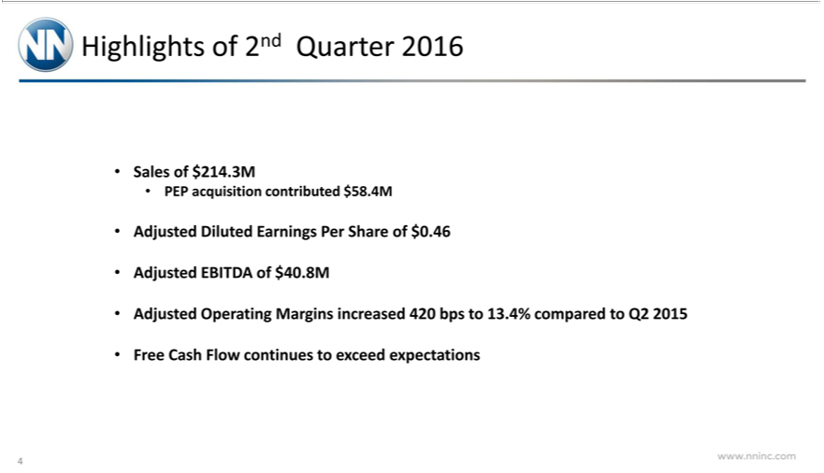

Highlights of 2nd
SalesQuarterof 2016$214.3M
PEP acquisitionDilutedcontributedEarningsPer$58.4MShare of $0.46
_{Adjusted} EBITDA of $40.8M
Free CashOperatingFlowcontinuesMarginsto increasedexceedexpectations420bpsto 13.4% compared to Q2 2015
4

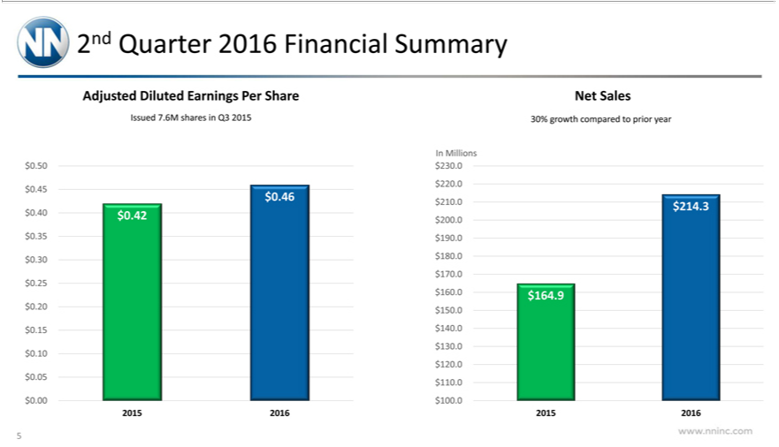

2nd Quarter 2016 Financial Summary
Adjusted Diluted |  |  | Per Share Net Sales
ssued 7.6M sharesEarningsQ3 201530% growth compared to prior year
In Millions
50 |  | 30
$0.45_{.46} $220.0
$210.0$214.3
40 | $0.42$200.0
5 |  | 90
$0.30 | $180.0
$170.0
$0.25
$160.0$164.9
20 |  | 50
$0.15 | $140.0
$130.0
$0.10
$120.0 |  | 10.
5 |  | 10.
$0.00 | $ 00.0
2015 | 201620152016

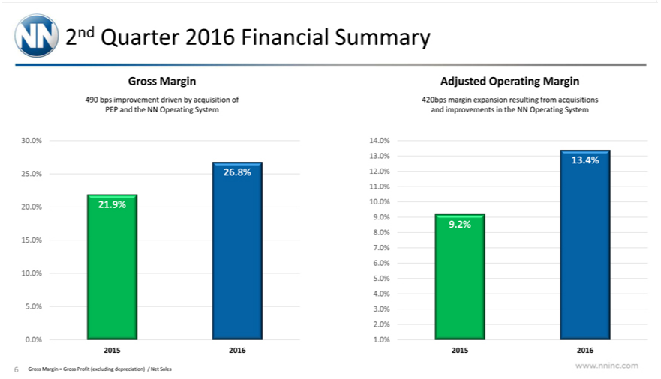

2nd Quarter 2016 Financial Summary
Gross Margin Adjusted Operating Margin
490 bps improvement driven by acquisition of 420bps margin expansion resulting from acquisitions
PEP and the NN Operating System and improvements in the NN Operating System
30.0% |  |  | 14.0%
13.0%13.4%
25.0% |  |  | 26.8%12.0%
11.0% |  |  | 21.9% 10.0%
20.0% |  |  | 21.9% 10.0%
9 2%
8.0%
15.0%
7
6.0%
10.0%
5
4.0% |  | 3.0%
5.0%
2.0% |  |  | .0%
.0% |  |  | .0%
2015 | 201620152016
6 Gross Margin = Gross Profit (excluding depreciation) / Net Sales

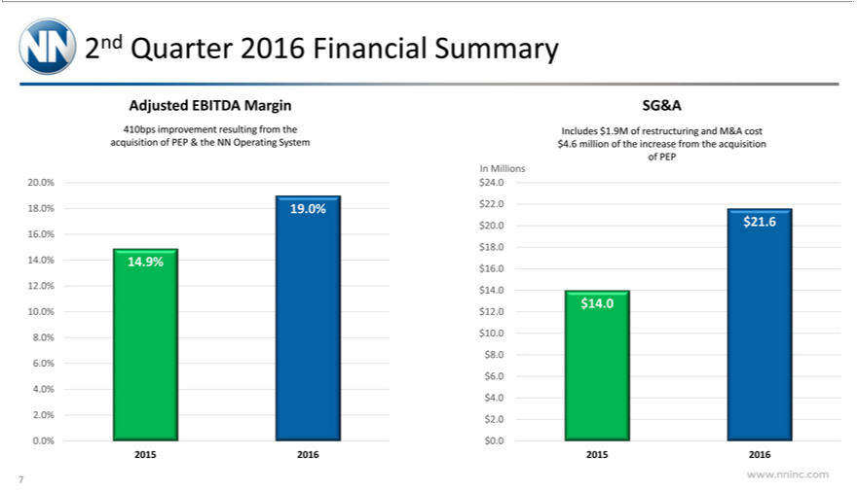

2nd Quarter 2016 Financial Summary
Adjusted EBITDA Margin SG&A
410bps improvement resulting from the Includes $1.9M of restructuring and M&A cost
acquisition of PEP & the NN Operating System $4.6 million of the increase from theacquisition
 | of PEP
20 | In Millions
20 |  |  |  | $24.
18.0% |  |  | 19.0% $22.0
 | $20.0$21.6
16.0% |  |  | 14.9% $16.0
₄$18.0
12.0% |  |  |  | $14.0
 | $14.0 |  |  | $12.0
10.0% |  |  |  | $12.0
8.0% |  |  | $10.0
 | $8.0
6.0%
 | $6.0
4.0%
 | $4.0
².0% $²0.0
2015 |  | 201620152016
7

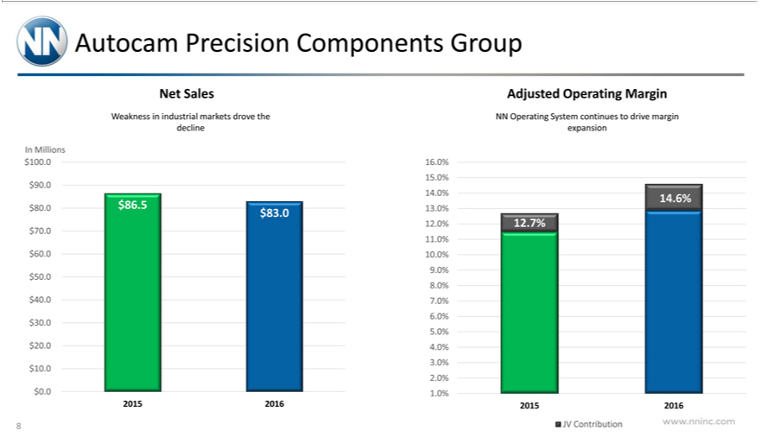

Autocam Precision Components Group
Net SalesAdjusted Operating Margin
Weakness industrial markets drove the NN Operating System continues to drive margin
declineexpansion
In Millions
$100 |  |  | 16.0%
15.0%
$90.0
14.0%14.6%
$80.0 |  | $86.5 13.0%
$83.
12.0%12.7%
$70.0
11.0%
$60 | % | 10.0%
9 | %
$50 | %
8 | % | 7.0%
$40 | %
6 | %
$30 | %
5 | % | 4.0%
$20 | %
3 | %
$10_{.0%} |  | .0%
$0.0
2015 | 201620152016
8 JV Contribution

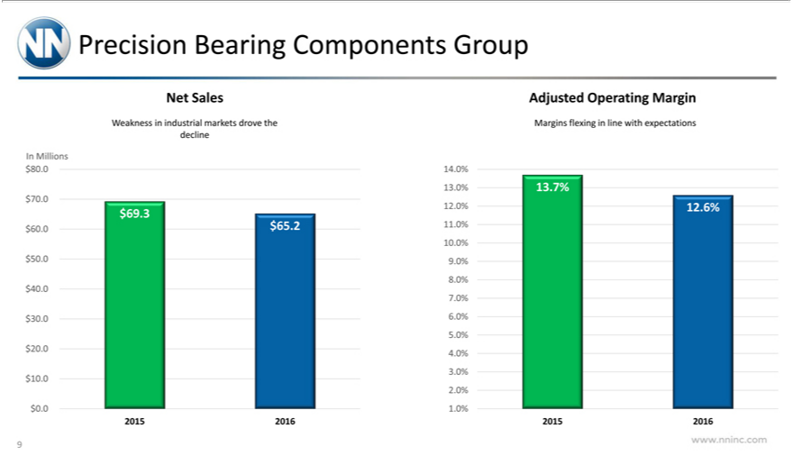

PrecisionNetSalesAdjustedBearingComponentsOperating GroupMargin
Weaknessdecline in industrial markets drove the Margins flexing in line with expectations
In Millions
$80.013.0%13.7%14.0%
70⁹ 0
$60.0³ ^{12.}$65.210%12.0%^{.6%}
$5010.0%%9.0%
$408 %
$307 % 6.0%
$205 % 4.0%
$103_{.0%}
2015^{$0.0} 201620152016^{.0%}
9

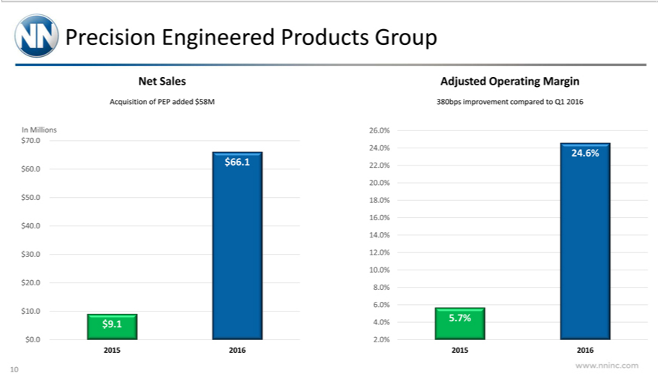

Precision Engineered Products Group
Net Sales |  |  |  |  | Adjusted Operating Margin
Acquisition of PEP added $58M 380bps improvement compared to Q1 2016
In Millions |  |  |  |  |  | 26.0%
$70.0
 |  | 24.0%24.6%
 |  | $66.122.0%
$60.0
 |  | 20.0%
$50.0 |  |  |  | 18.0%
 |  | 16.0%
$40.0
 |  | 14.0%
$30.0 |  |  |  | 12.0%
 |  | 10.0%
$20 |  |  | % | 8.0%
 |  | 6 | %
 | 10.0 |  | 4. |  |  | .7%
 | 9 |  | 4. | 0%5. |  | .7%
$0.0
2 |  | 15 | 201620152016
10

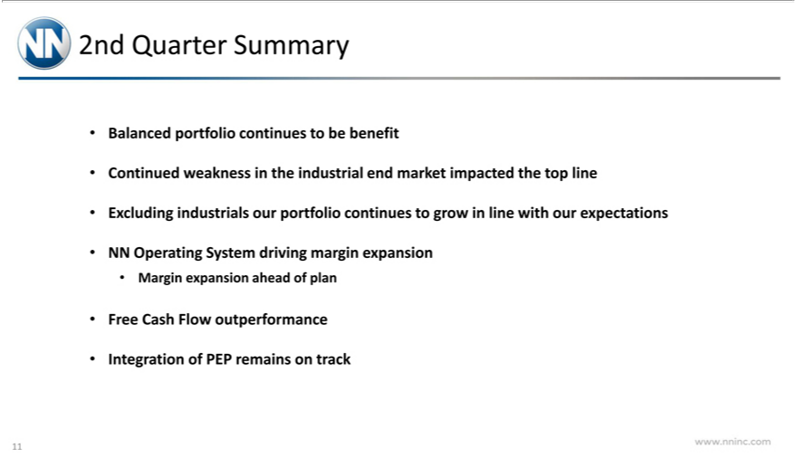

2nd Quarter Summary
Balanced portfolio _{continues} to be benefit
Continued weakness the industrial end market impacted the top line
NNExcludingOperatingindustrialsSystemourdrivingportfoliomargincontinuesexpansiontogrow in line with our expectations
MarginFreeCashexpansionFlowoutperformanceaheadofplan
11Integration of PEP remains on track



Guidance

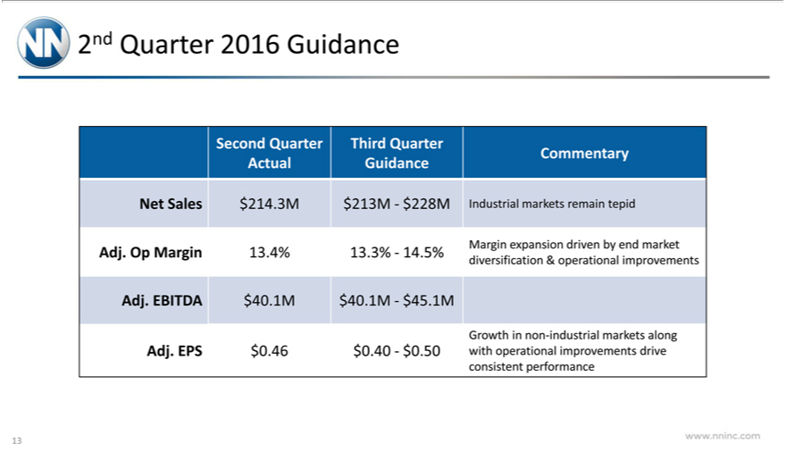

2nd Quarter 2016 Guidance
Second Quarter |  | Third Quarter
Commentary
Ac ual Guidance |  |  | -$228MIndustrial markets remain tepid
Net Sales | $214.3M |  | -$228MIndustrial markets remain tepid
Adj. Op Margin |  | 13.4%$213M.3%-14.5%Margin expansion driven by end market
diversification & operational improvements
Adj. EBITDA |  | $40.1M $40.1M-$45.1M
Growth in non-industrial markets along
Adj. EPS | $0.46 $0.40-$0.50with operational improvements drive
₁₃consistent performance

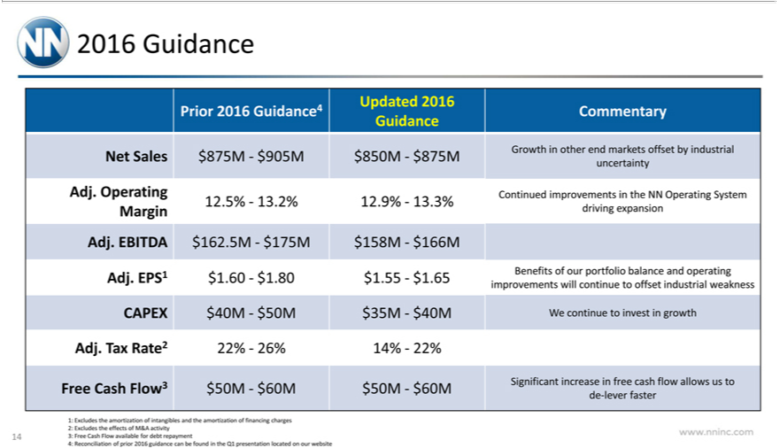

2016 Guidance
 | Updated 2016
 | Prior 2016 Guidance 4Commentary
 | Guidance
Net Sales |  |  | $875M -$905M$850M -$875MGrowth in other end markets offset by industrial
 | uncertainty |  |  |  | Continued improvements in the NN Operating System
Adj. Operating
 | 12.5% -13.2%12.9% -13.3%
Margin |  | driving expansion |  |  |  | -$166M
 | BITDA |  |  | $162.5M—
Adj. EPS1 |  |  | $1.60 -$1.80$1.55$175M- |  |  | $.65Benefits158M | of our portfolio balance and operating
 | improvements will continue to offset industrial weakness
CAPEX |  |  | $40M -$50M$35M -$40MWe continue to invest in growth
Adj. Tax Rate2 |  |  |  |  | 22% -26%14% -22%
Free Cash Flow3 $50M -$60M$50M -$60MSignificant increase in free cash flow allows us to
1: | de-lever faster
1: |  |  |  | amortization of intangibles and the amortization of financing charges
2: Excludes the effects of M&A activity
14 3: Free Cash Flow available for debt repayment
4: Reconciliation of prior 2016 guidance can be found in the Q1 presentation located on our website



Reconciliation Tables

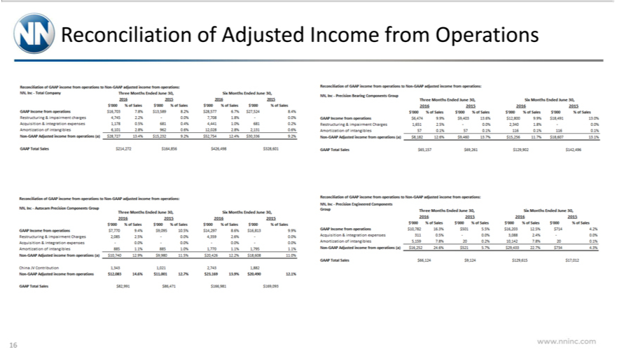

16Reconciliation of Adjusted Income from Operations

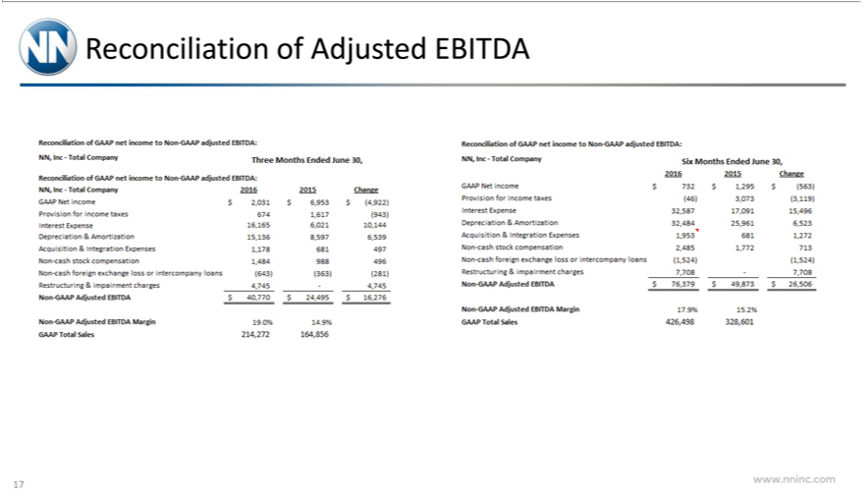

17Reconciliation of Adjusted EBITDA

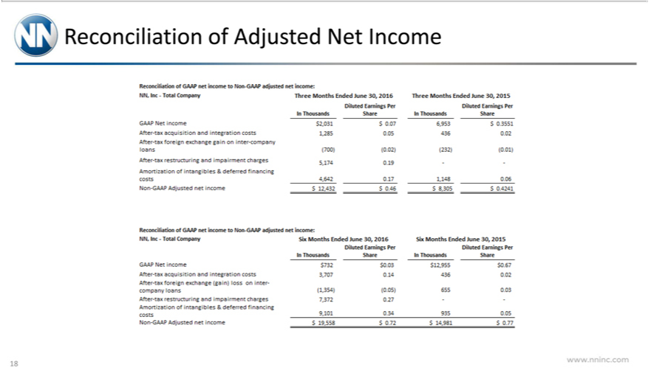

18Reconciliation of Adjusted Net Income

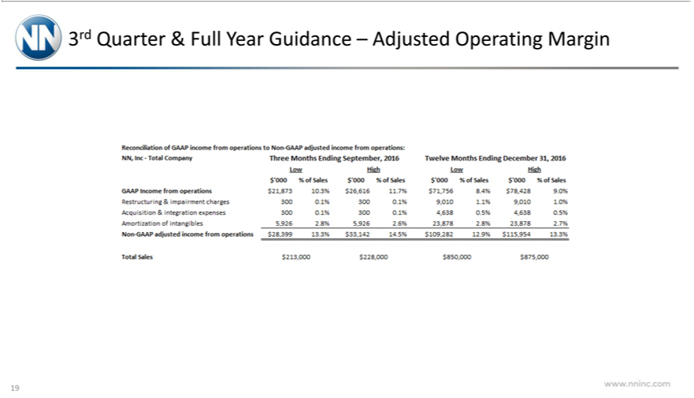

193rd Quarter & Full Year Guidance – Adjusted Operating Margin

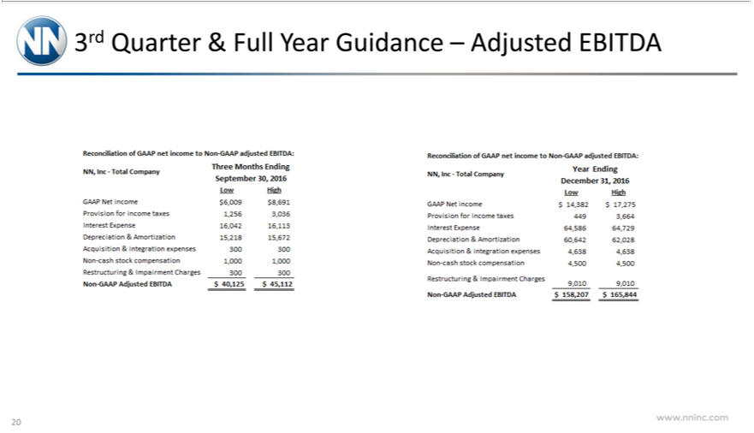

203rd Quarter & Full Year Guidance – Adjusted EBITDA

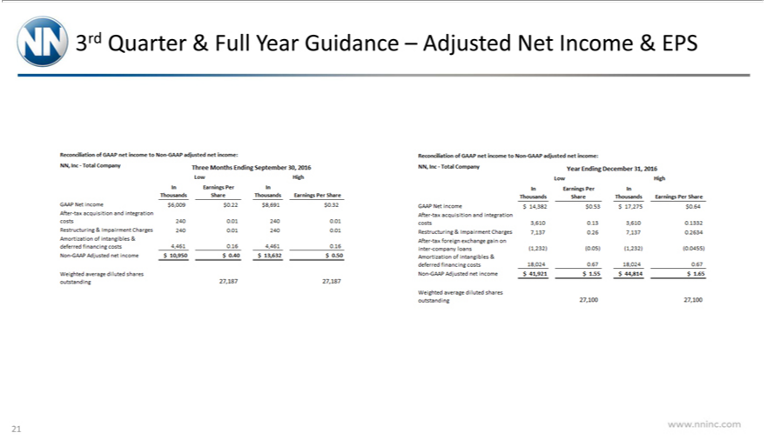

213rd Quarter & Full Year Guidance – Adjusted Net Income & EPS

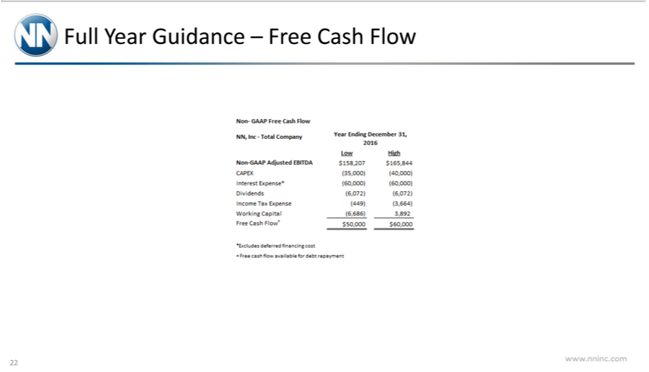

22Full Year Guidance – Free Cash Flow

