UNITED STATES

SECURITIES AND EXCHANGE COMMISSION
Washington, D.C. 20549

SCHEDULE 14A INFORMATION

Proxy Statement Pursuant to Section 14(a) of the

Securities Exchange Act of 1934
(Amendment No. )

Filed by the Registrant ☒ Filed by a Party other than the Registrant ☐

Check the appropriate box:

- Preliminary Proxy Statement

- Confidential, for Use of the Commission Only (as permitted by Rule 14a-6(e)(2))

- Definitive Proxy Statement

- Definitive Additional Materials

- Soliciting Material under §240.14a-12

NN, INC.

(Name of registrant as specified in its charter)

(Name of person(s) filing proxy statement, if other than the registrant)

Payment of Filing Fee (Check the appropriate box):

- No fee required

- Fee computed on table below per Exchange Act Rules 14a-6(i)(1) and 0-11

  - Title of each class of securities to which transaction applies:

  - Aggregate number of securities to which transaction applies:

  - Per unit price or other underlying value of transaction computed pursuant to Exchange Act Rule 0-11 (set forth the amount on which the filing fee is calculated and state how it was determined):

  - Proposed maximum aggregate value of transaction:

  - Total fee paid:

- Fee paid previously with preliminary materials.

- Check box if any part of the fee is offset as provided by Exchange Act Rule 0-11(a)(2) and identify the filing for which the offsetting fee was paid previously. Identify the previous filing by registration statement number, or the Form or Schedule and the date of its filing.

  - Amount Previously Paid:

  - Form, Schedule or Registration Statement No.:

  - Filing Party:

  - Date Filed:

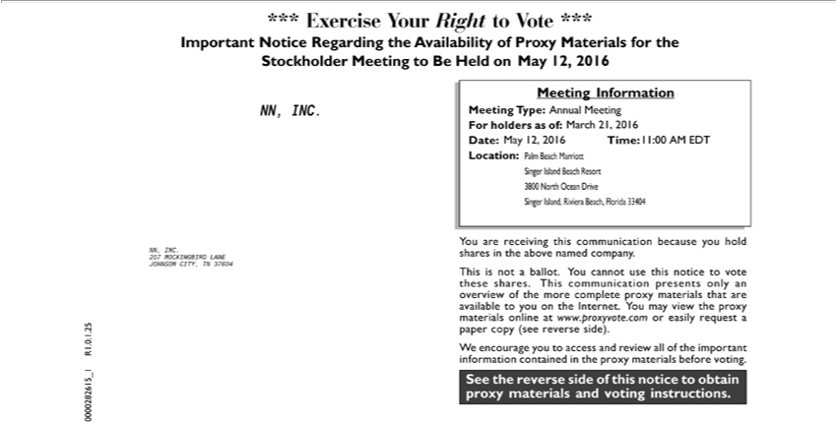

*** Exercise Your Right to Vote ***Important Notice Regarding the Availability of Proxy Materials for the Stockholder Meeting to Be Held on <mtgdate>. May 12, 2016 NN, INC. Meeting Information
Meeting Type: Annual Meeting For holders as of: March 21, 2016 Date: May 12, 2016 Time: 11:00 AM EDT Location: Palm Beach Marriott Singer Island Beach Resort 3800 North Ocean Drive Singer Island,
Riviera Beach, | 33404 NN, INC. 207 MOCKINGBIRD LANE JOHNSON CITY, TN 37604 0000282615_1 R1.0.1.25 You are receiving this communication because you hold shares in the above named
. This isFloridanot | ballot. You cannot use this notice to vote these shares. This communication presents only an overview of the more complete proxy materials that are available to you the Internet. You
company contained
_{materials}view the proxy materials online at www.proxyvote.com or easily request_{materials}paper copy (see reverse side). We encourage you to access and review all of the important information in the proxy
before voting. See the reverse side of this notice to obtain proxy and voting instructions.

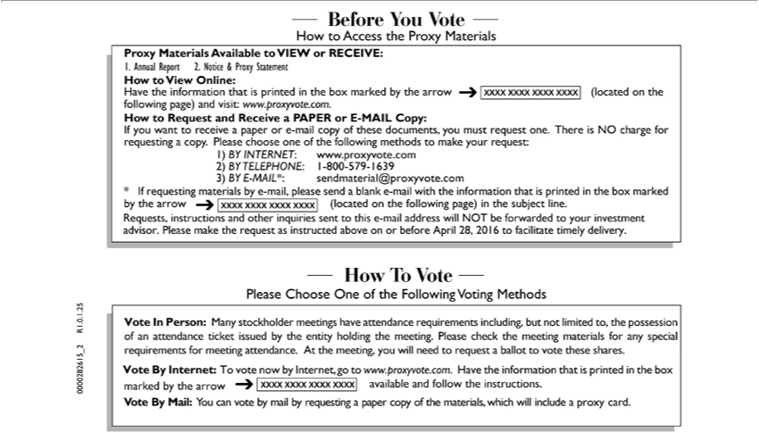

Before You Vote How to Access the Proxy Materials Proxy Materials Available to VIEW or RECEIVE: 1. Annual Report 2. Notice & Proxy Statement How to View Online: |  |  |  | the | that is printed
in the box marked by the arrow (located on the following page) and visit: www.proxyvote.com. How to Request and Receive |  |  | PAPER or E-MAIL Copy: If you want to receiveHavepaperinformatione-mailcopy of these
documents, you must request one. There is NO charge for requesting a copy. Please choose | of the following | to make your request: 1) BY INTERNET: www.proxyvote.com 2) BY TELEPHONE: 1-
800-579-1639 3) BY E-MAIL*: sendmaterial@proxyvote.com * If requesting materials by one-mail, please send a methodsblank-mail with the information that printed in the box marked by the arrow (located on the
following page) in the subject line. Requests, instructions and other inquiries sent to this -mail address will NOT be forwarded to your investment advisor. Please make the request as instructed above on or
before April 28, 2016 to facilitate timely delivery. How To Vote Please Choose One of the Following Voting Methods Vote In Person: Many stockholder meetings have attendance requirements including, but not
limited to, the possession of an attendance ticket issued by the entity holding the meeting. Please check the meeting materials |  |  | any special requirements for meeting attendance. At the meeting, you will need
to request a ballot to vote these shares. Vote By Internet: To vote now by Internet, go to www.proxyvote.com. |  | the information that is printed in the box marked by the arrow available and follow the
instructions. Vote By Mail: You can vote by mail by requesting a paper copy of the materials, which will includeHaveproxy card. 0000282615_2 R1.0.1.25

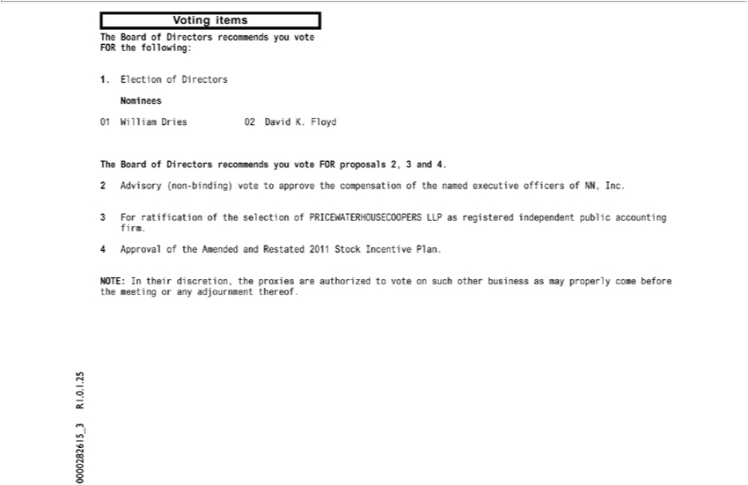

Voting items The Board of Directors recommends you vote FOR the following: 1. Election of Directors Nominees 01 William Dries 02 David K. Floyd The Board of Directors recommends you vote FOR proposals 2, 3 and 4. 2 Advisory (non-binding) vote to approve the^{Amended}compnsation of the named executive officers of NN, Inc. 3 For ratification of the selection of PRICEWATERHOUSECOOPERS LLP as
registered independent public accounting firm. 4 Approval_{thereof} the and Restated 2011 Stock Incentive Plan. NOTE: In their discretion, the proxies are authorized to vote on such other business as may
properly come before the meeting or any adjournment . 0000282615_3 R1.0.1.25

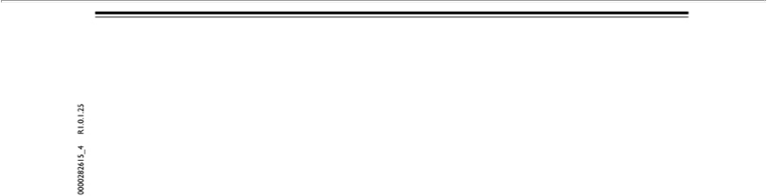

0000282615_4 R1.0.1.25

