UNITED STATES

SECURITIES AND EXCHANGE COMMISSION
WASHINGTON, DC 20549

FORM 8-K

CURRENT REPORT

PURSUANT TO SECTION 13 OR 15(d)
OF THE SECURITIES EXCHANGE ACT OF 1934

Date of Report (Date of earliest event reported): February 5, 2015


NN, INC.

(Exact name of registrant as specified in its charter)

Delaware | 0-23486 | 62-1096725
(State or Other Jurisdiction | (Commission | (I.R.S. Employer
of Incorporation) | File Number) | Identification No.)
207 Mockingbird Lane, Johnson City, Tennessee |  | 37604
(Address of principal executive offices) |  | (Zip Code)

(423) 743-9151

(Registrant’s telephone number, including area code)

(Former name or former address, if changed since last report)

Check the appropriate box if the Form 8-K filing is intended to simultaneously satisfy the filing obligation of the registrant under any of the following provisions (see General Instruction A.2. below):

- Written communications pursuant to Rule 425 under the Securities Act (17 CFR 230.425)

- Soliciting material pursuant to Rule 14a-12 under the Exchange Act (17 CFR 240.14a-12)

- Pre-commencement communications pursuant to Rule 14d-2(b) under the Exchange Act (17 CFR 240.14d- 2(b))

- Pre-commencement communications pursuant to Rule 13e-4(c) under the Exchange Act (17 CFR 240.13e- 4(c))

ITEM 7.01 REGULATION FD DISCLOSURE

On Thursday, February 5, 2015, beginning at 8:30 a.m. eastern time, NN, Inc. (the “Company”) will host its Investor & Analyst Day in New York City. A copy of the slide presentation for the event is furnished as Exhibit 99.1 to this Current Report on Form 8-K and will also be accessible through the Company’s website at www.nninc.com in the Investor Relations section under Events and Presentations.

The information presented in Item 7.01 to this Current Report on Form 8-K is being furnished in accordance with Rule 101(e)(1) under Regulation FD and shall not be deemed to be “filed” for purposes of Section 18 of the Securities Exchange Act of 1934, as amended, and will not be incorporated by reference into any registration statement filed under the Securities Act of 1933, as amended, unless specifically identified therein as being incorporated by reference.

ITEM 9.01 FINANCIAL STATEMENTS AND EXHIBITS

Exhibit

No. Description

99.1 Investor & Analyst Presentation of NN, Inc., dated February 5, 2015.

SIGNATURES

Pursuant to the requirements of the Securities Exchange Act of 1934, the registrant has duly caused this report to be signed on its behalf by the undersigned hereunto duly authorized.

Date: February 5, 2015

NN, INC.

By: /s/ William C. Kelly, Jr.

Name: William C. Kelly, Jr.

Title: Vice President and Chief

Administrative Officer

EXHIBIT INDEX

Exhibit
^{No.} Description

99.1 Investor & Analyst Presentation of NN, Inc., dated February 5, 2015.

Exhibit 99.1
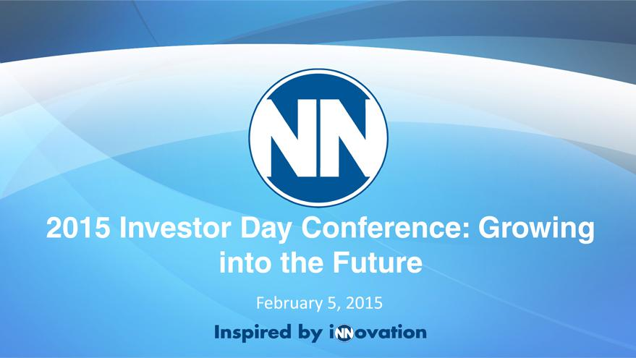

February2015Investor5,2015Day Conference: Growing into the Future

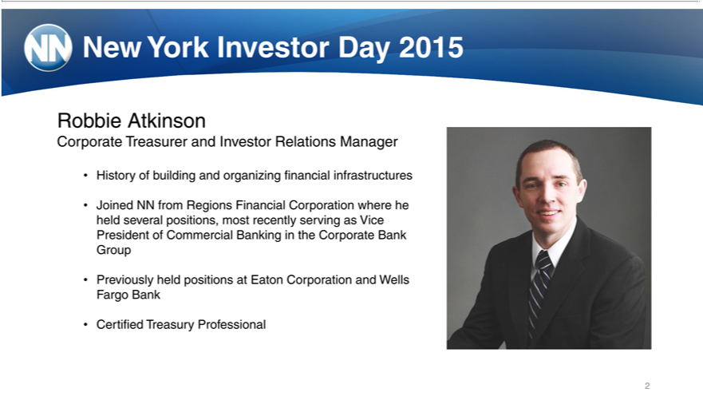

R_{Corporate}NewbbieYorkAtkinsonInvestor Day 2015
History of TreasurerbuildingandandorganizingInvestorRelationsfinancialManagerinfrastructures
Joined NN from Regions Financial Corporation where he held several positions, most recently serving as Vice President of Commercial Banking in the Corporate Bank Group Previously held positions at Eaton Corporation and Wells Fargo Bank

2Certified Treasury Professional

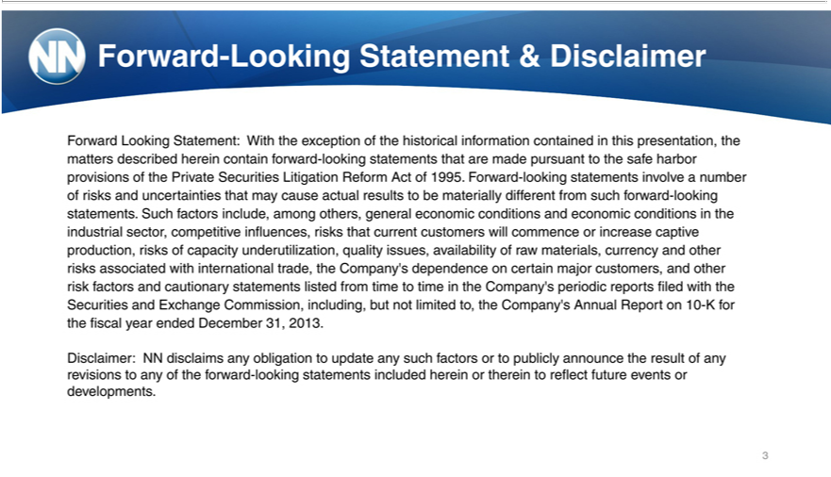

-Looking | & Disclaimer | the matters described herein contain forward-looking statements that are made pursuant to the safe harbor
Forward Looking Statement: With the exception of the historical information contained in this
provisions of the Private Se urities Litigation Reform Act of 1995. Forward-looking statementspresentation,involvenumber of risks and uncertainties that may cause actual results to be materially different from such forward-
looking statements. Such factors include, among others, general economic conditions and economic conditio s in the industrial sector, competitive influences, risks that current customers will commence or increase
captive production, risks of capacity und rutilization, quality issues, availability of raw |  | currency and other risks associated with international trade, the Company’s dependence on certain major
and other risk factors and | utionary statements listed from time to time in the Company’materials,periodic reports filed with the Securities and Exchange Commission, including, but not limited to, the Company’customers,Annual
Report on 10-K for the fiscal year ended December 31, 2013.
Disclaimer: NN disclaims any obligation to update any such factors or to publicly announce the result of any revisions to any of the forward-looking statements included herein or therein to reflect future events or developments.
3

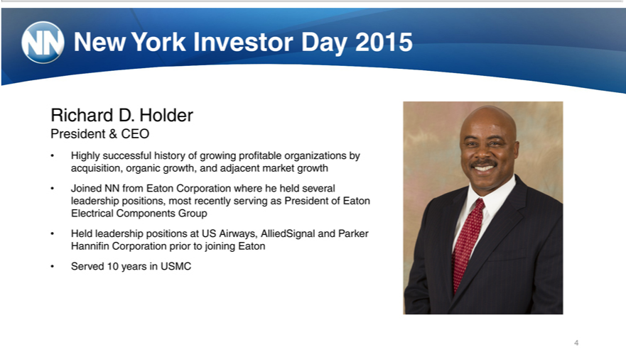

New York Investor Day 2015
Richard D. Holder
President & CEO
Highly successful history of growing profitable organizations by acquisition, organic growth, and adjacent market growth
Joined NN from Eaton _{Corporation} where he held several leadership positions, most recently serving as President of Eaton Electrical Components Group Held leadership positions US Airways, AlliedSignal and Parker Hannifin Corporation prior to joining Eaton

4Served 10 years in USMC

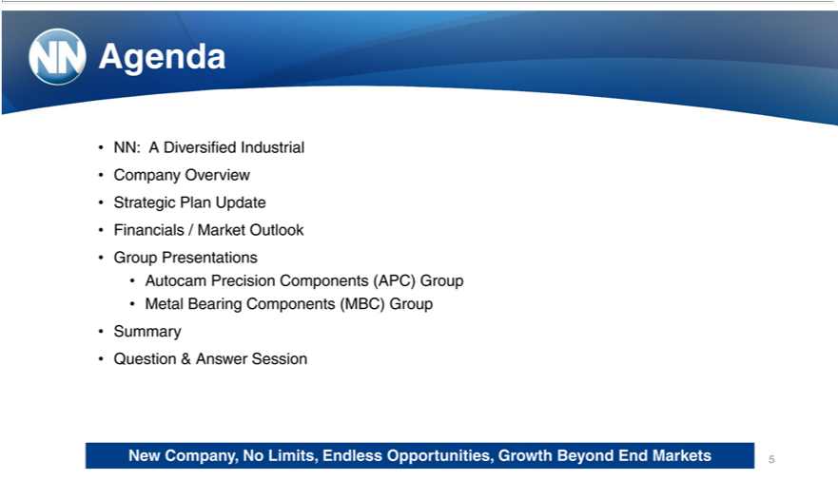

AgendaNN:Diversified Industrial
Company Overview
Strategic Plan Update
Financials / Market Outlook
Group Presentations
Autocam Precision Components (APC) Group
Metal Bearing Components (MBC) Group
Summary
Question & Answer Session
5New Company, No Limits, Endless Opportunities, Growth Beyond End Markets

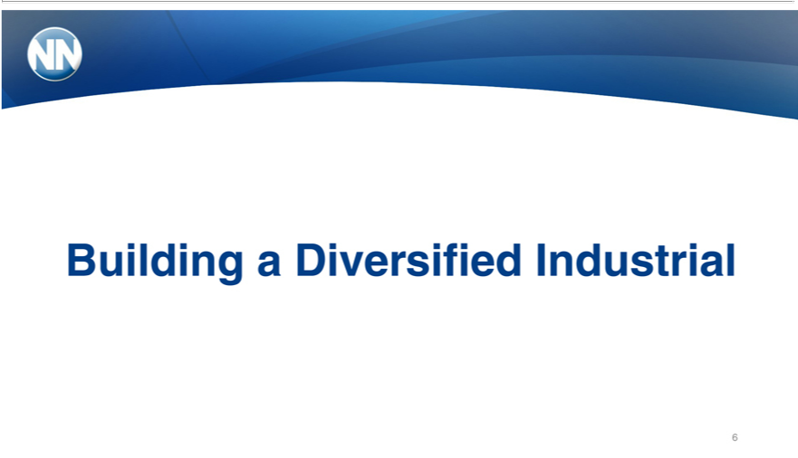

6Building a Diversified Industrial

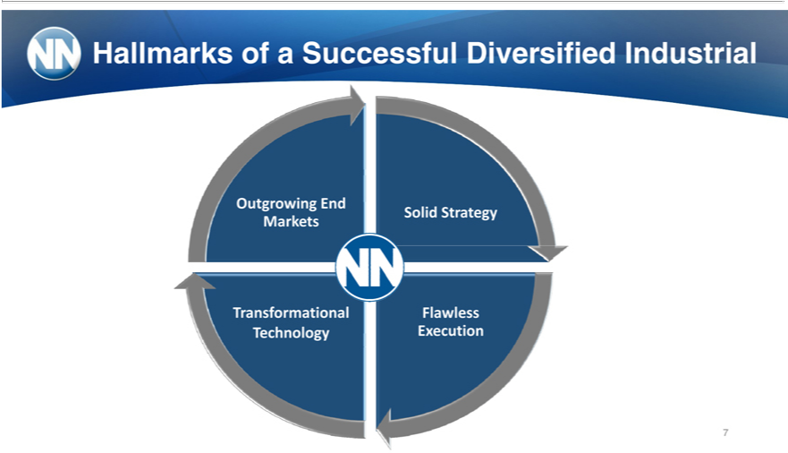

OutgrowingHallmarksofEndaSuccessfulMarkets Diversified Industrial
Solid Strategy
Transformational T_{echnology}
Flawless Execution T
7

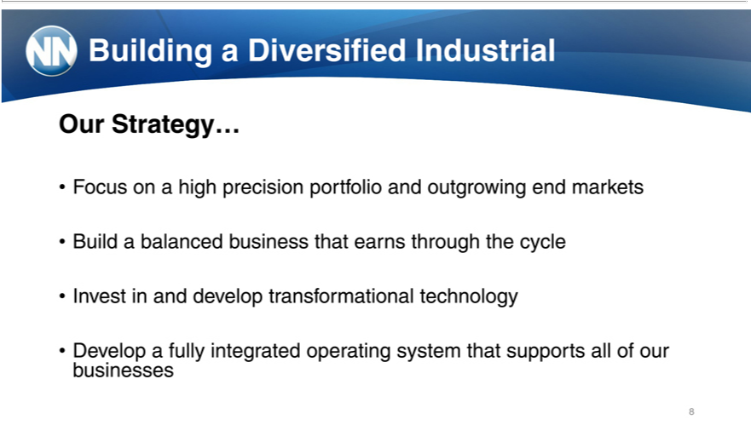

Building Diversified Industrial
FocusOur on high… precision portfolio and outgrowing end markets
Strategy
InvestBuild inbalancedanddevelopbusinesstransformationalthatearnsthroughtechnologythecycle
8Develop a fully integrated operating system that supports all of our businesses

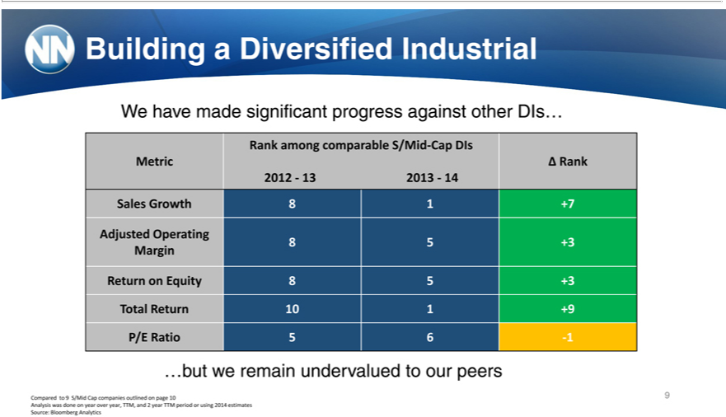

Building Diversified Industrial
We have made significant progress against other DIs…
Rank among comparable S/Mid-Cap DIs
Metric Rank
2012—13 2013—14
Sales Growth 8 1 +7
Adjusted Operating Margin
8 | 5 +3
Return on Equity 8 5 +3
P/ETotalRatioReturn5610-1 1 +9
but we remain undervalued to our peers
Compared to 9 S/Mid Cap companies outlined on page 10
Analysis was done on year over year, TTM, and 2 year TTM period or using 2014 estimates Source: Bloomberg Analytics 9

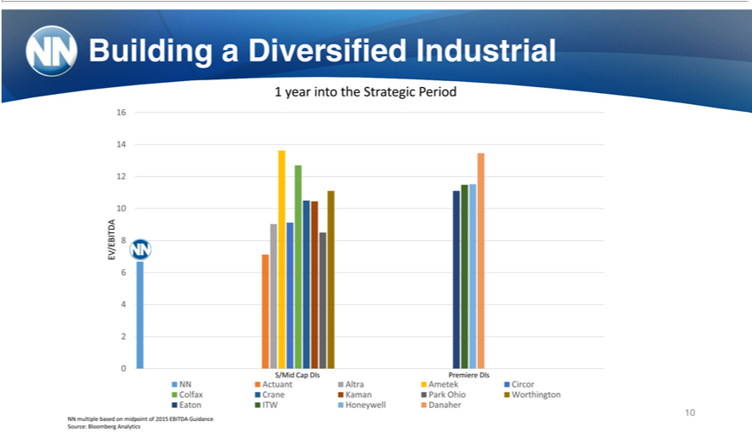

Building^{year}Diversified Industrial
146 into the Strategic Period
2
10
6EV/EBITDA 8

4

2

0
NNS/MidActuantCapDIsAltraPremiereAmetekParkDIsCircor
EatonColfaxITWCrane Kaman DanaherOhio Worthington
Honeywell
10NN multiple based midpoint of 2015 EBITDA Guidance Source: Bloomberg Analytics

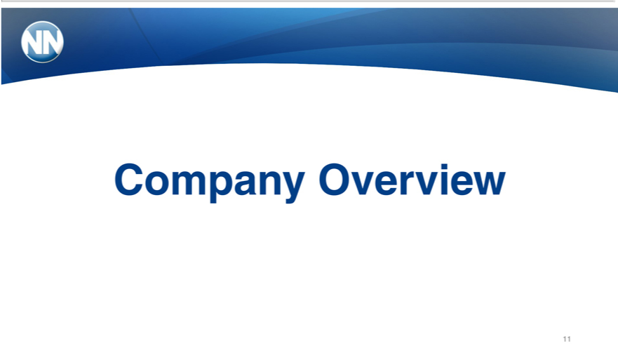

11Company Overview

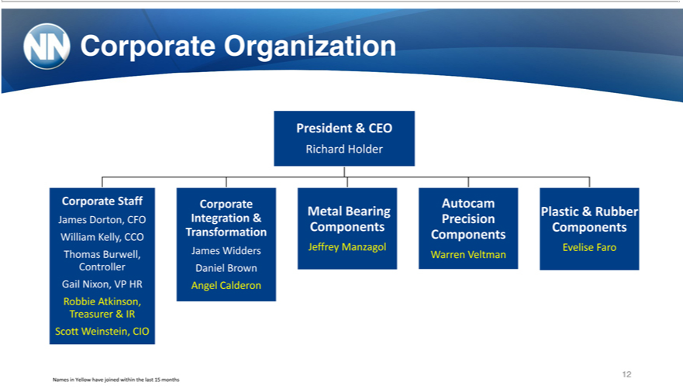

Corporate Organization
President & CEO
Richard Holder
James Dorton, CFO William Kelly, CCO Thomas Burwell, Controller Gail Nixon, VP HR Robbie Atkinson, Treasurer & IR Scott Weinstein, CIO Corporate Integration & Transformation
MetalJames BearingWiddersComponentsDanielBrown Angel Calderon
Jeffrey Manzagol
WarrenAutocamVeltmanPrecision Components
EvelisePlastic&FaroRubber Components
12Names in Yellow have joined within the last 15 months

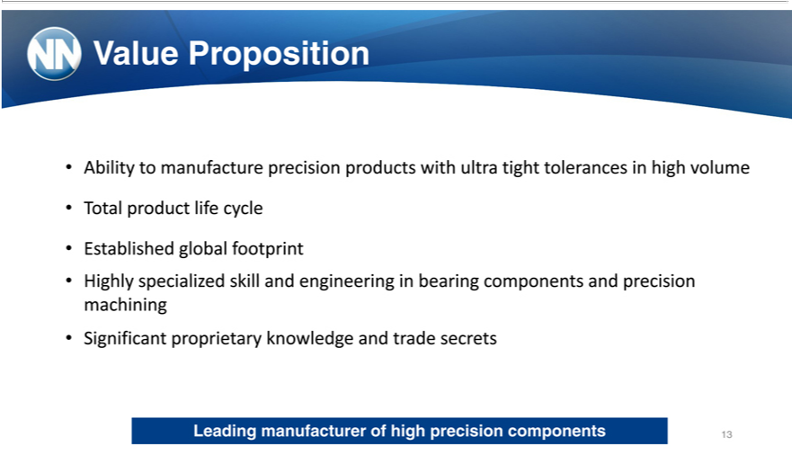

Value Proposition
TotalAbilityproducttomanufacturelifecycle precision products with ultra tight tolerances in high volume
Established global footprint
SignificantHighlyspecializedproprietaryskillknowledgeandengineeringandtradeinbearingsecrets components and precision machining
13Leading manufacturer of high precision components

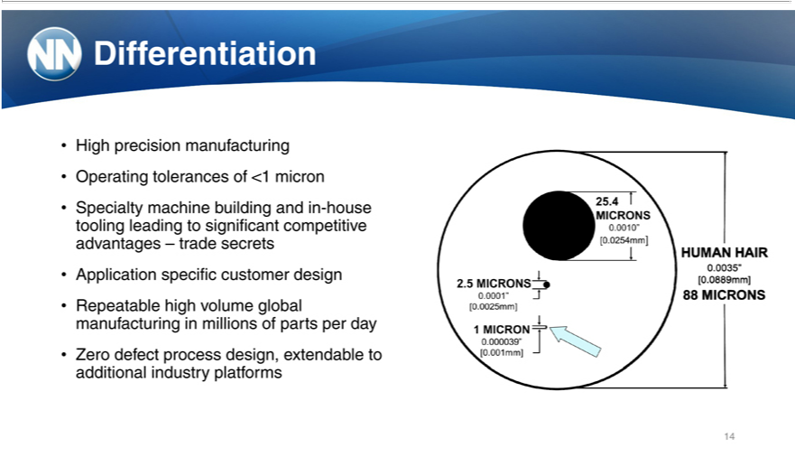

^{High}Dfferentiation
Operatingprecisiontolerancesmanufacturingof<1micron
Specialty machine building and in-house tooling leading to significant competitive advantages – trade secrets Application specific customer design
Repeatable high volume global manufacturing in millions of parts per day
14Zero defect process design, extendable to additional industry platforms

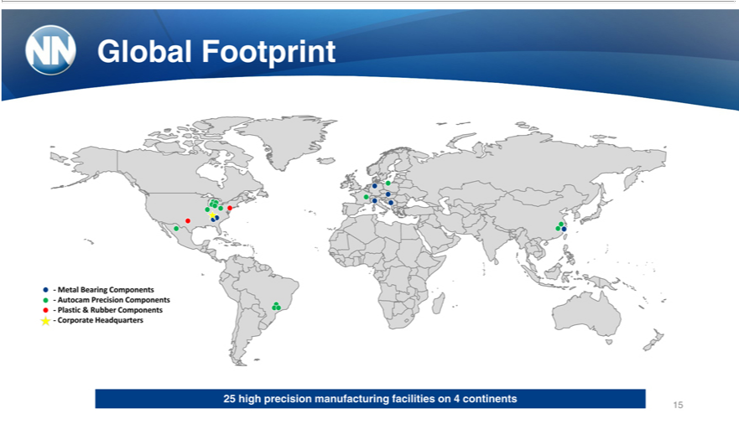

Global Footprint
AutocamMetalBearingPrecisionComponentsComponents
⁻
CorporatePlastic&RubberHeadquartersComponents
25₁₅ high precision manufacturing facilities on 4 continents

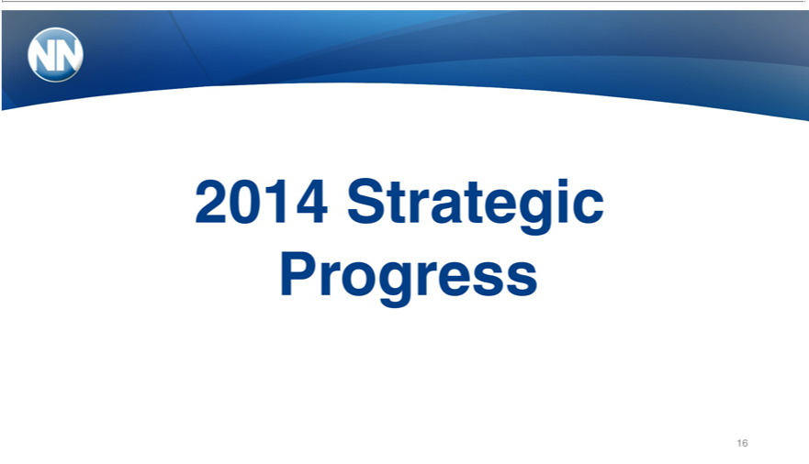

2014 Strategic Progress
16

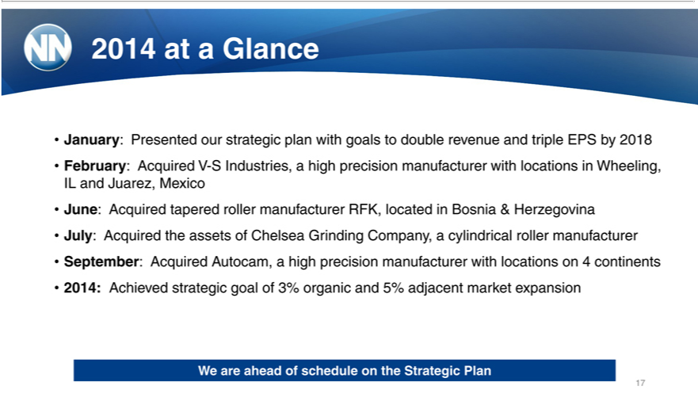

2014 at a Glance
—,January:,ILandPresentedJuarez, ourMexicostrategic plan with goals to double revenue and triple EPS by 2018
^{July:}
ne: AcquiredAcquired thetaperedassetsrollerof_{Chelsea}manufacturerGrindingRFK,Company,_{manufacturer}locatedincylindricalBosnia& rollerHerzegovinamanufacturer
September: Acquired Autocam, high precision with locations_{expansion} 4 continents
We2014:areAchievedaheadof strategicschedule goalontheof Strategic3%organicPlanand 5% adjacent market
17

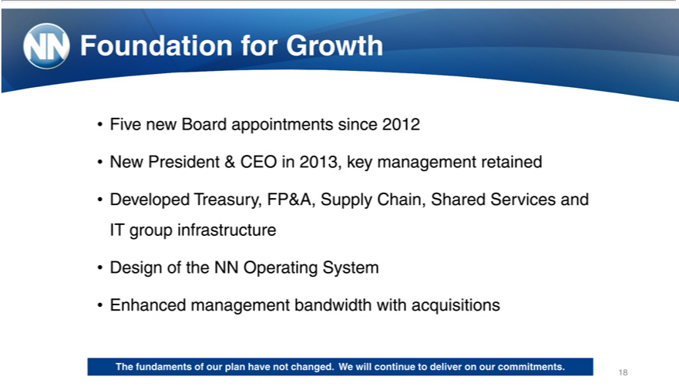

^{Five}oundation for Growth
N_{Developed}wnewPresidentBoard&_{appointments}CEO2013,sincekey 2012management retained
IT group infrastructureTreasury,FP&A, Supply Chain, Shared Services and
Design of the NN Operating System
Enhanced management bandwidth with acquisitions
18The fundaments of our plan have not changed. We will continue to deliver on our commitments.

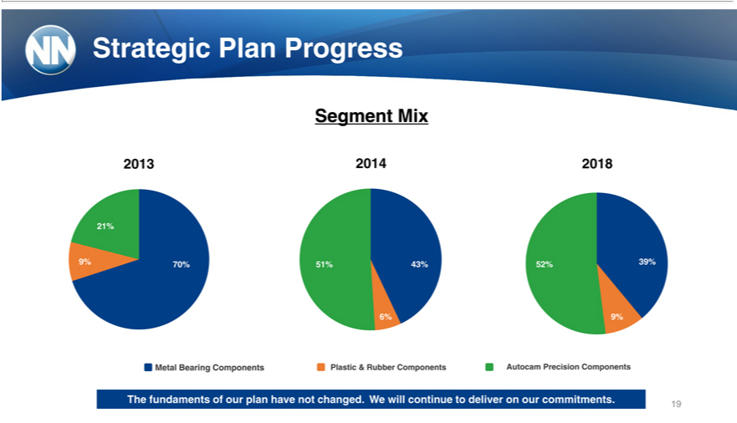

trategic Plan Progress
_{21%Segment} Mix
9%
51%^{70%}
43%
52%
39%
6%
10
9%
Metal Bearing Components Plastic & Rubber _{Components Autocam Precision} Components
19The fundaments of our plan have not changed. W will continue deliver our commitments.

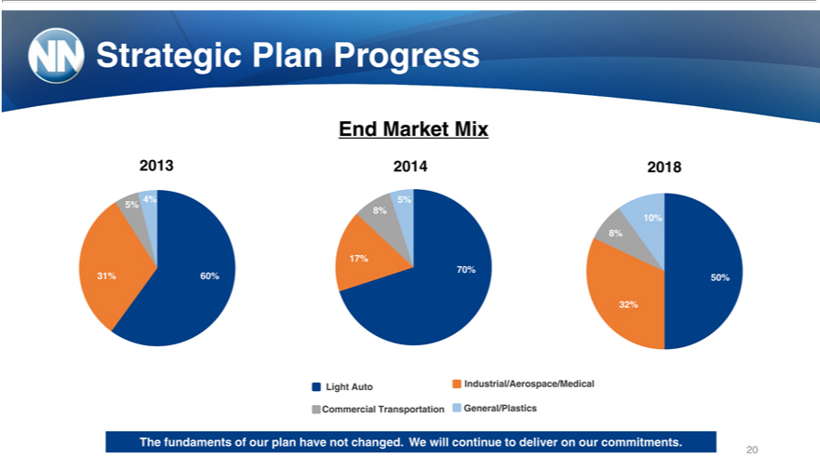

Strategic Plan Progress
4³
2018
4%
5%
8%
10%
8%
70%^{17%}
9%
⁶31%
50%
39%
5
32%
End Market Mix
CommercialLightAutoIndustrial/Aerospace/MedicalTransportationGeneral/Plastics
20The fundaments of our plan have not changed. We will continue to deliver on our commitments.

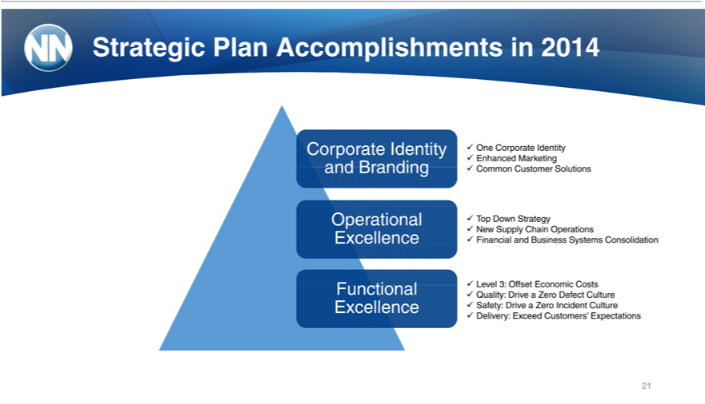

Strategic Plan Accomplishments in 2014
Corporate Identity and Branding
Operational Excellence
Functional Excellence
TopOne DownCorporateStrategyIdentity Enhanced Marketing Common Customer Solutions
New Supply Chain Operations
Financial and Business Systems Consolidation
Level 3: Offset Economic Costs Quality: Drive a Zero Defect Culture Safety: Drive a Zero Incident Culture Delivery: Exceed Customers’ Expectations 21

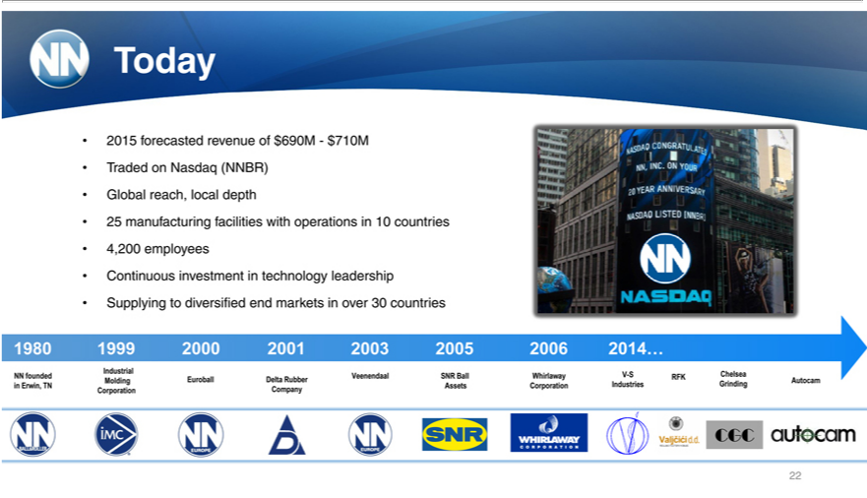

Today
Traded2015forecastedonNasdaqrevenue(NNBR)of $690M—$710M
Global reach, local depth
25 manufacturing facilities with operations in 10 countries
4,200 employees
Continuous investment in technology leadership
NNSupplyingfoundedto indiversifiedErwin,TNend markets in over 30 countries
Industrial
Molding
Corporation
Euroball
Delta Rubber
Company
Veenendaal
SNR Ball
Assets
Whirlaway
Corporation
V-S
Industries
RFK
GrindingChelsea
22Autocam

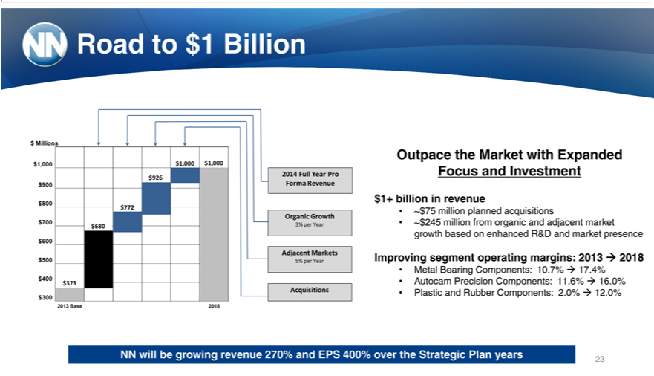

Road_{1,000}Millionsto$1 Billion
9₂₆ $1,000 $1,000
800
72
700
₆80
5
400
₃73
$200 2013 Base 2018
Organic2014FullGrowthYearPro Forma Revenue
3%AdjacentperYearMarkets
Acquisitions5%perYear
$Outpace1+billiontheinMarketrevenuewith Expanded Focus and Investment
~$75²⁴⁵million planned acquisitions
million from organic and adjacent market growth based on enhanced R&D and market presence Improving segment operating margins: 2013 2018
Metal Bearing Components: 10.7% 17.4%
Autocam Precision Components: 11.6% 16.0%
Plastic and Rubber Components:^{270%}.0% 12.0%
23NN will be growing revenue and EPS 400% over the Strategic Plan years

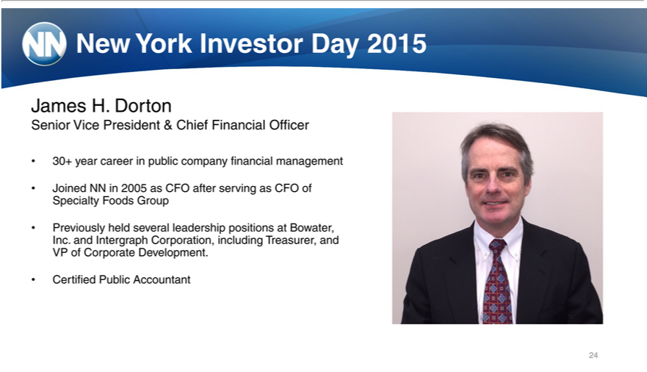

JamesNewYorkH.DortonInvestor Day 2015
Senior Vice President & Chief Financial Officer
30+ year career in public company financial management
Joined NN in 2005 as CFO after serving as CFO of Specialty Foods Group
CertifiedPreviouslyPublicheld severalAccountantleadership positions at Bowater, Inc. and Intergraph Corporation, including Treasurer, and VP of Corporate Development.
24

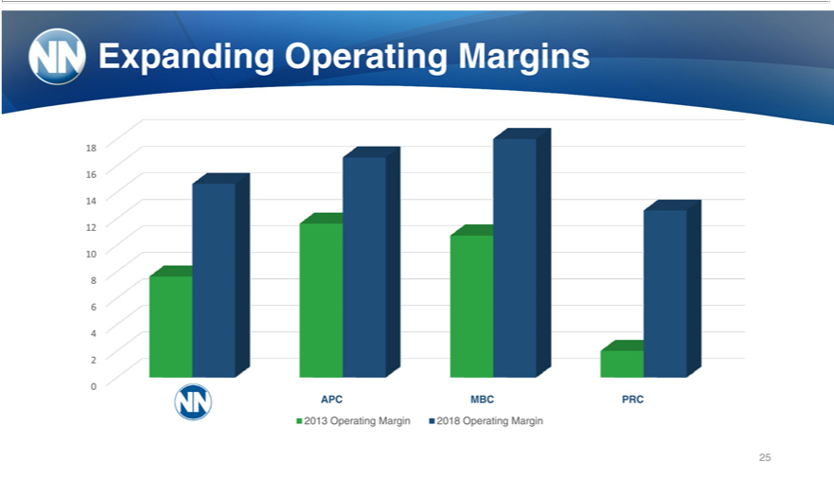

Expanding8₆ Operating Margins
1024
8

6

4

2
0
APC MBC PRC
₂₅013 Operating Margin 2018 Operating Margin

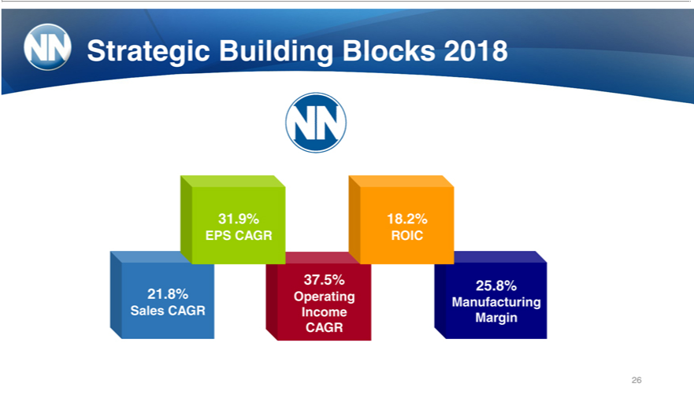

31.Strategic9% Building Blocks 2018
EPS CAGR
ROIC18.2%
21.8%
37.Sales5%CAGR
Operating25.8% Income CAGR
26Manufacturing Margin

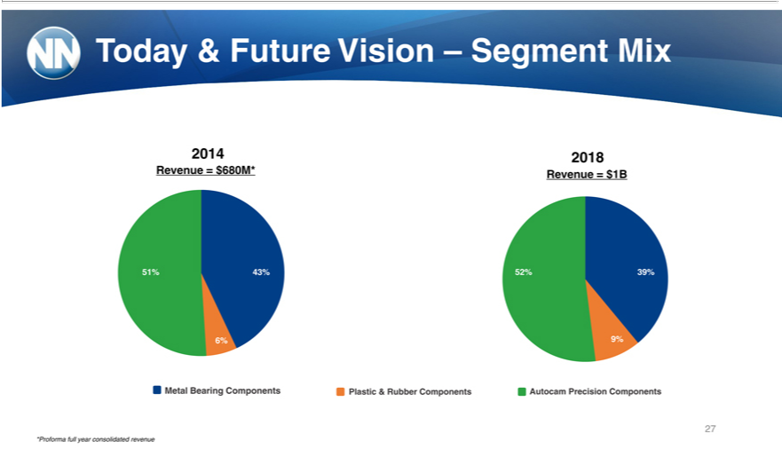

2014Today & Future Vision – Segment Mix
2018Revenue = $680M*
Revenue = $1B
Metal Bearing Components
AutocamPlastic& PrecisionRubberComponentsComponents
27*Proforma full year consolidated revenue

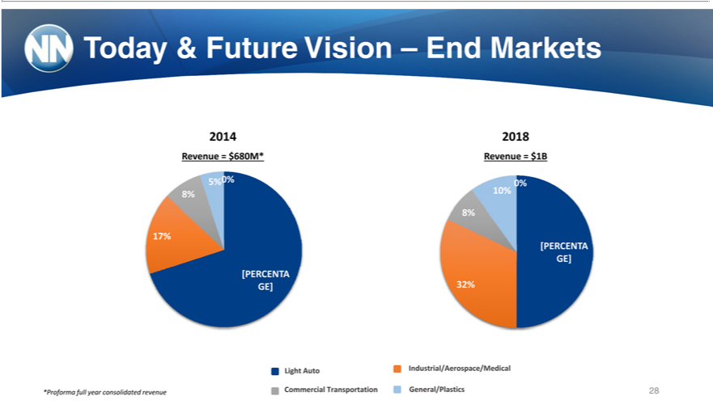

2014Today & Future Vision – End Markets
2018Revenue = $680M*
Revenue = $1B
_{8%}5% 0%
17%
[PERCENTAGE]
8%10% 0%
32%[PERCENTAGE]
Light Auto
Industrial/Aerospace/Medical
Commercial Transportation
General/Plastics
28*Proforma full year consolidated revenue

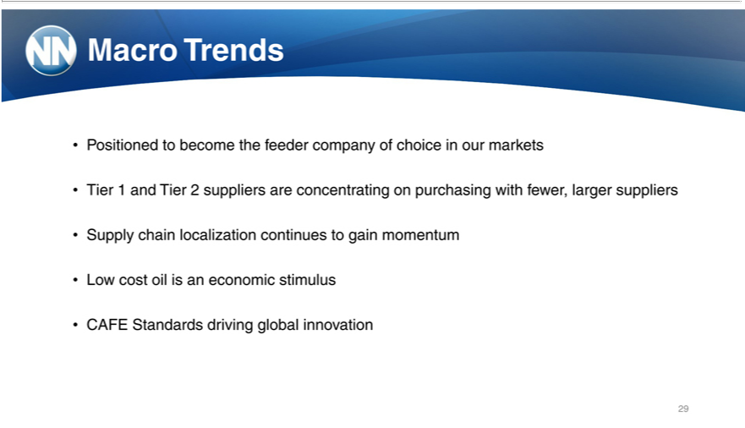

Macro Trends
Positioned to become the feeder company of choice_{purchasing}ourmarkets
SupplyTier1andchainTierlocalization2supplierscontinuesareconcentratingtogainmomentumon with fewer, larger suppliers
Low cost oil is an economic stimulus
29CAFE Standards driving global innovation

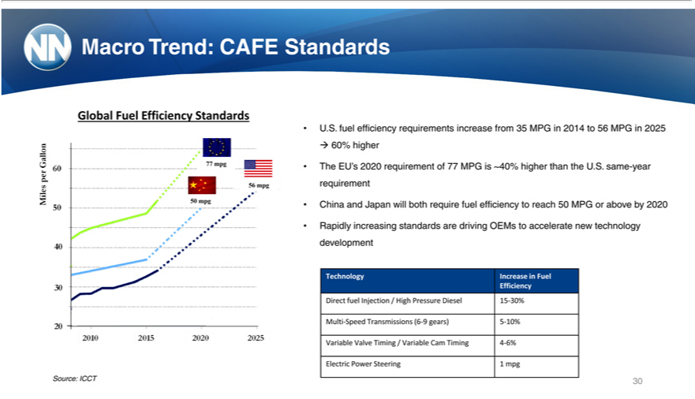

Macro Trend: CAFE Standards
Global Fuel Efficiency Standards
U.S. fuel efficiency requirements increase from 35 MPG in 2014 to 56 MPG in 2025 ? 60% higher
ChinaTheEU’sand2020Japanrequirementwillbothrequireof77 MPGfuelefficiencyis~40% highertoreachthan50 theMPGU.S.or sameabove-yearby2020requirement
TechnologyRapidlyincreasingIncreasestandardsinFuel Efficiencyaredriving OEMs to accelerate new technology development
Direct fuel Injection / High Pressure Diesel 15-30% Multi-Speed Transmissions (6-9 gears) 5-10% Variable Valve Timing / Variable Cam Timing 4-6% Electric Power Steering 1 mpg

30Source: ICCT

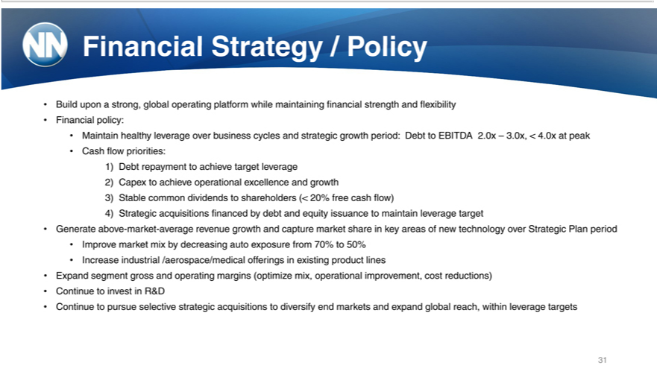

Financial |  | / Policy
Build uponStrategystrong, global operating platform while maintaining financial strength and flexibility
Financial policy:
Maintain healthy leverage over business cycles and strategic growth period: Debt to EBITDA 2.0x – 3.0x, < 4.0x at peak
Cash flow priorities:
1) | Debt repayment to achieve target leverage
2) | Capex to achieve operational excellence and growth
3) | able common dividends to shareholders (< 20% free cash flow)
4) | Strategic acquisitions financed by debt and equity issuance to maintain leverage target
Generate above-market-average revenue growth and capture market share in key areas of new technology over Strategic Plan period
mprove market mix by decreasing auto exposure from 70% to 50%
ExpandIncreasesegmentindustrialgross/aerospace/medicalandoperatingmarginsofferings(optimizeinexistingmix,productoperationallines improvement, cost reductions)
Continue to pursueinvestinselectiveR&D strategic acquisitions to diversify end markets and expand global reach, within leverage targets 31



32

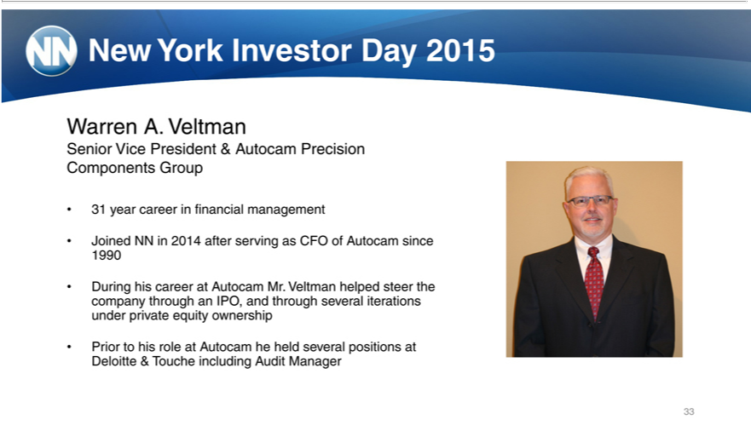

WarrenNewYorkA. InvestorVeltman Day 2015
31SenioryearVicecareerPresidentinfinancial&AutocammanagementPrecision Components Group
Joined NN in 2014 after serving as CFO of Autocam since 1990
_{Deloitte}uringhis career at Autocam Mr. Veltman helped steer the company through an IPO, and through several iterations under private equity ownership
₃₃ & Touche including Audit Manager

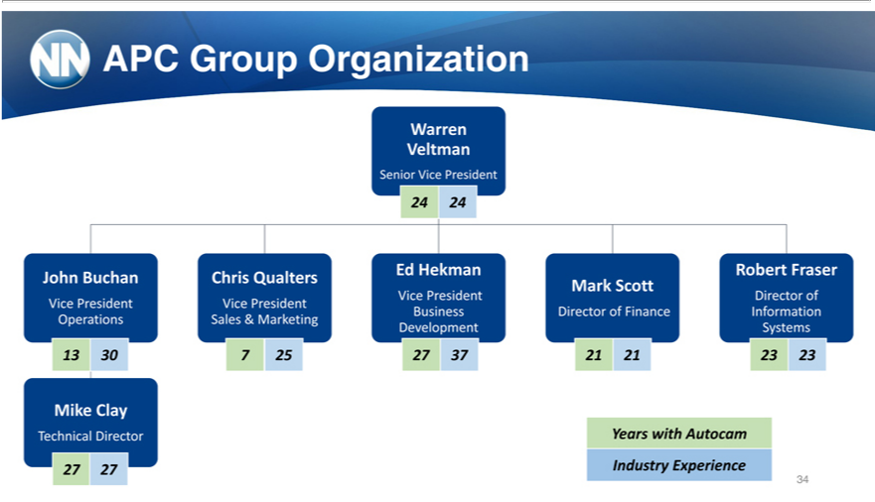

JohnAPC BuchanGroupOrganization
EdViceHekmanPresident Operations
MarkVicePresidentScott Business Development
RobertDirectorFraserofFinance
MikeDirectorClayof Information Systems
TechnicalYearswithDirectorAutocam
34Industry Experience

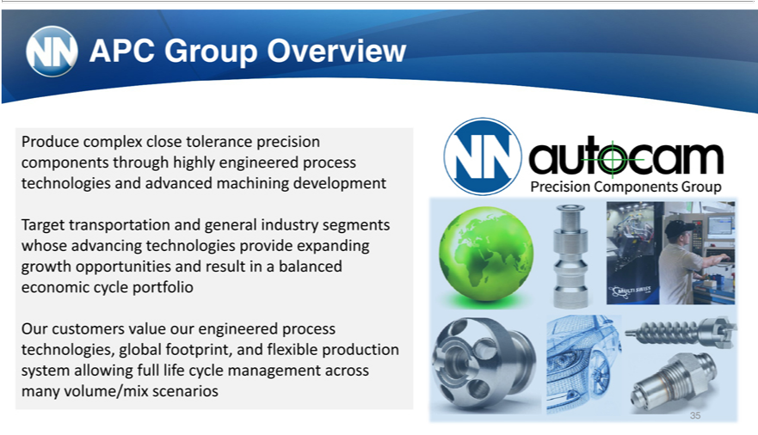

APC Group Overview
Produce complex close tolerance precision components through highly engineered process technologies and advanced machining development
Target transportation and general industry segments whose advancing technologies provide expanding growth opportunities and result_{management}inbalanced economic cycle portfolio
Our customers value our engineered process technologies, global footprint, and flexible production system allowing full life cycle across many volume/mix scenarios 35

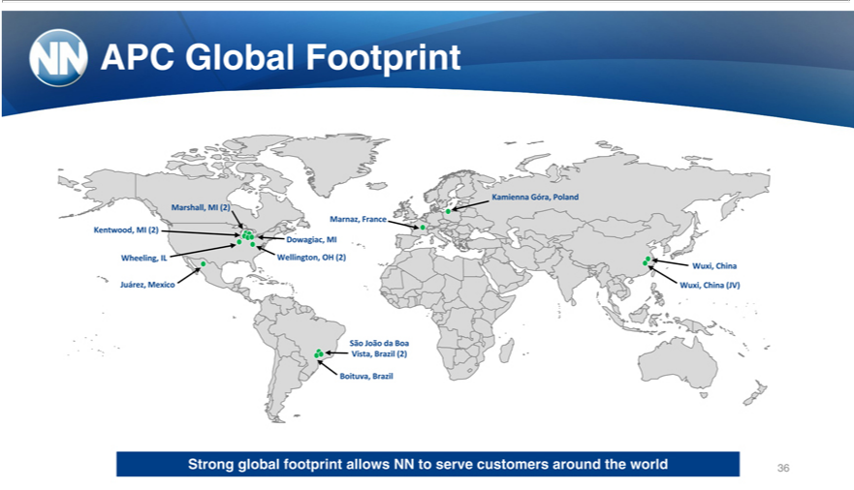

Marshall, MI (2)
Kentwood, MI (2)
Juá_{Marnaz,}Wheeling,ez,MexicoIL
France
Dowagiac, MI
Wellington, OH (2)
Kamienna Góra, Poland
Boituva,SãoJoão BrazildaBoa Vista, Brazil (2)
Wuxi, China (JV)
36Strong global footprint allows NN to serve customers around the world

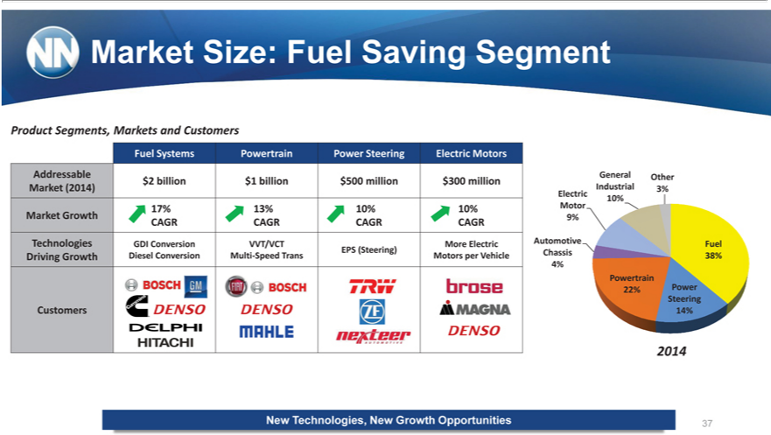

ProductMarket Size:Segments,FuelSavingMarketsSegmentandCustomers
AddressableFuelSystems Powertrain Power Steering Electric Motors
Market$2billion(2014)$1billion $500 million $300 million
Market17%13%Growth10% 10%
CAGR CAGR CAGR CAGR
EPSTechnologies(Steering)GDI Conversion VVT/VCT More Electric
CustomersDrivingGrowth Diesel Conversion Multi-Speed Trans Motors per Vehicle
General Other
Industrial 3%
MotorElectric 10%
9%
AutomotiveChassis38%Fuel
Powertrain4%
22%SteeringPower
201414%
37New Technologies, New Growth Opportunities

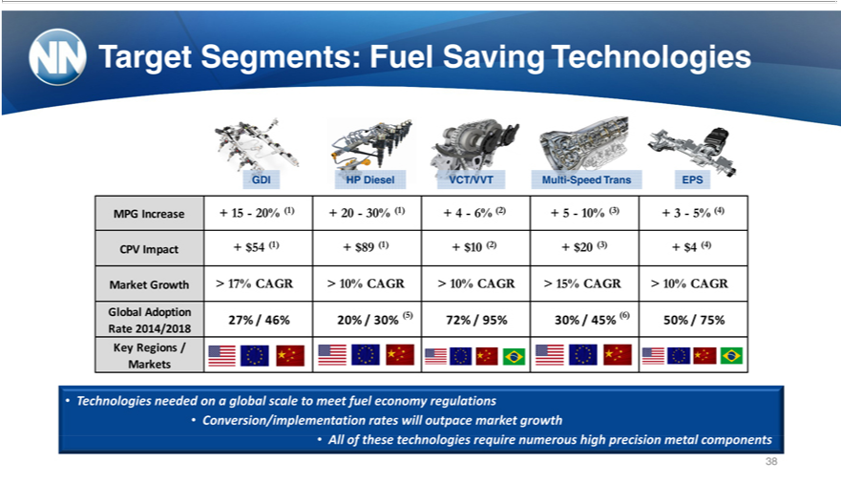

Target Segments: Fuel Saving Technologies
GDI HP Diesel VCT/VVT Multi-Speed Trans EPS
MPG Increase + 15—20% (1) + 20—30% (1) + 4—6% (2) + 5—10% (3) + 3—5% (4)
CPV Impact + $54 (1) + $89 (1) + $10 (2) + $20 (3) + $4 (4)
Market Gr wth > 17% CAGR > 10% CAGR > 10% CAGR > 15% CAGR > 10% CAGR
Global Adoption (5) (6)
27% 46% 20% / 30% 72% / 95% 30% / 45% 50% / 75%
Rate
Key Regions2014/2018
Markets | global scale to meet fuel economy regulations
Technologies needed | global scale to meet fuel economy regulations
Conversion/implementation rates will outpace market growth
38All of these technologies require numerous high precision metal components

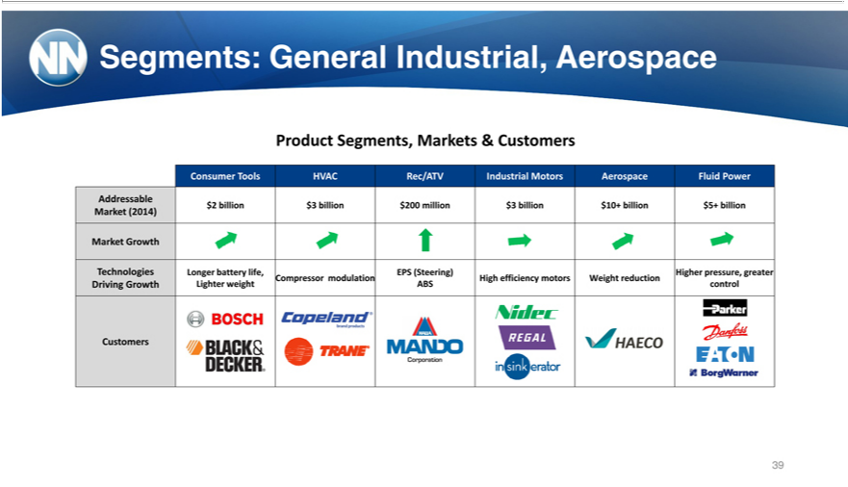

Segments: General Industrial, Aerospace
Product Segments, Markets & Customers
AddressableConsumerTools HVAC Rec/ATV Industrial Motors Aerospace Fluid Power
_{Market}$2billion(2014)$3billion $200 million $3 billion $10+ billion $5+ billion
Growth
Technologies Longer battery life, EPS (Steering) Higher pressure, greater
DrivingCompressorGrowthmodulationLighter weightHighefficiencyABScontrolmotors Weight reduction
39Customers

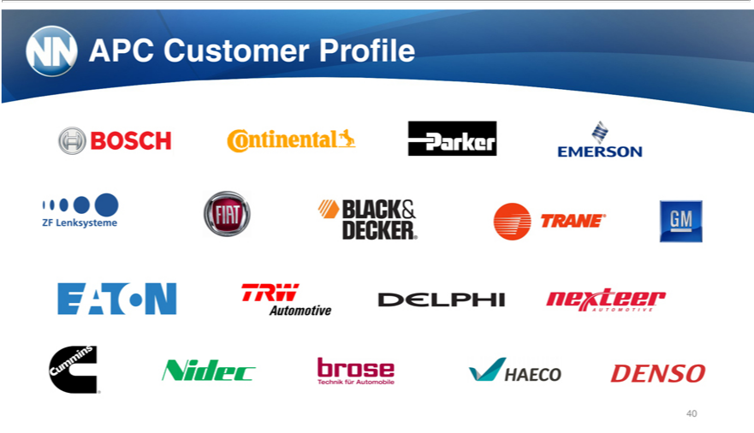

40APC Customer Profile

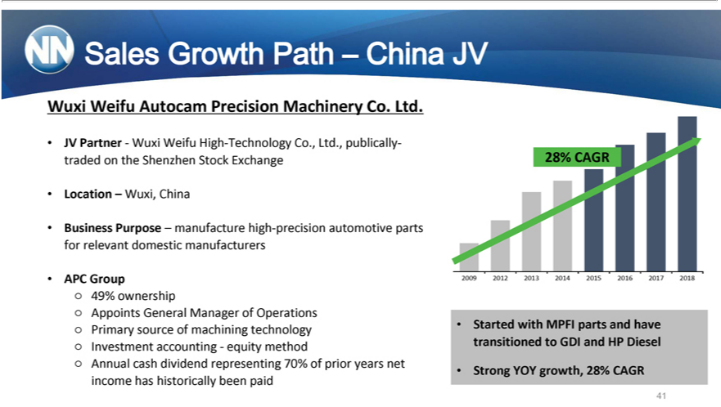

Sales Growth Path – China JV
Wuxi Weifu Autocam Precision Machinery Co. Ltd.
JV Partner - W Weifu High-Technology Co., Ltd., publically traded on the Shenzhen Stock Exchange
Location — Wuxi, China |  | high-precision automotive parts
• Business Purpose— |  | high-precision automotive parts
for relevant domestic manufacturers
• APC Group
49% ownership
Appoints General Manager of Operations
Primary source of machining technology
Investment accounting - equity method
o Annual cash dividend representing 70% of prior years net income has historically been paid
arted with MPFI parts and have transitioned to GDI and HP Diesel
Strong YOY growth, 28% CAGR
8% CAGR
2009 | 2012 2013 2014 2015 2016 2017 2018
41

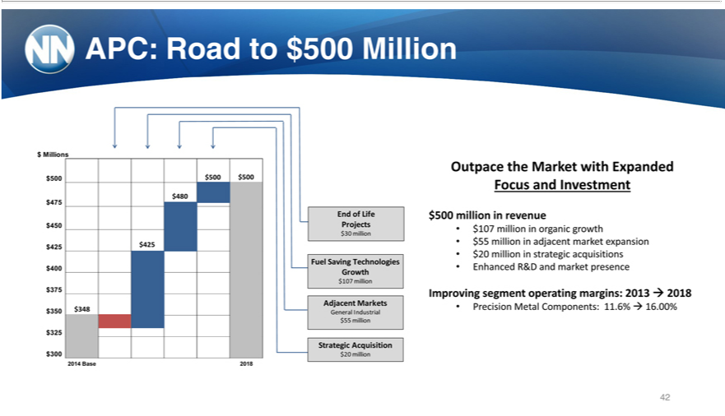

APC: Road to $500 Million
Millions
500 | $500 $500
80
75
50 | $425
25 | $425
400
75 | $348
50 | $348
₃25 | 2014 Base 2018
$200
End of Life Projects
$30 million
Fuel Saving Technologies Growth
$107 million
Adjacent Markets
General Industrial $55 million
Strategic Acquisition
$20 million
Outpace the Market with Expanded Focus and Investment
 |  | revenue
107 million in organic growth
55 | adjacent market expansion
$20 million in strategic acquisitions
Enhanced R&D and market presence
Improvi g s gment operating margins: 2013 ?2018
Precision Metal |  | Components: 11.6% ?16.00%
42

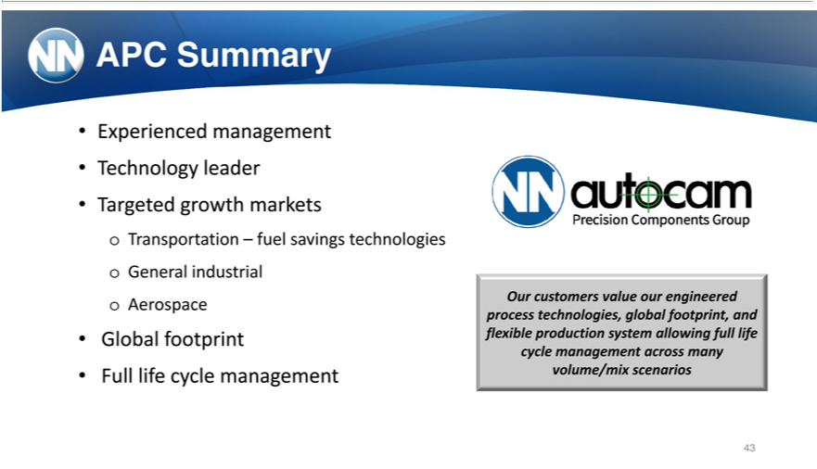

APC Summary
^{T}Experiencedechnologyleadermanagement
argeted growth markets
_{o} G_{Aerospace}Transportationneralindustrial–fuel savings technologies
Global footprint
Full life cycle management
Our customers value our engineered process technologies, global footprint, and flexible production system allowing full life cycle management across many volume/mix scenarios 43

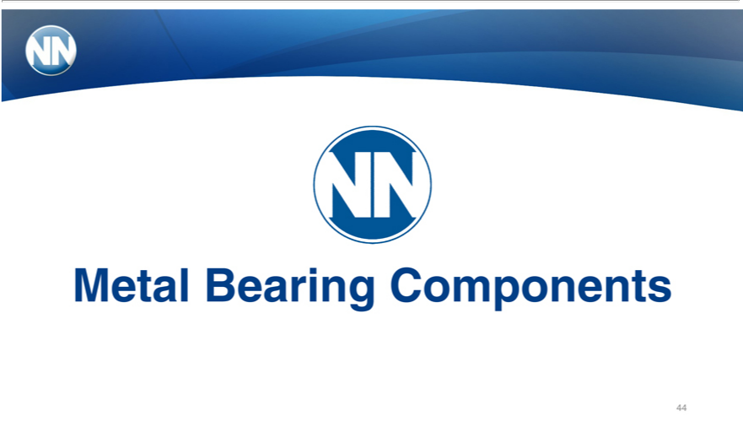

44Metal Bearing Components

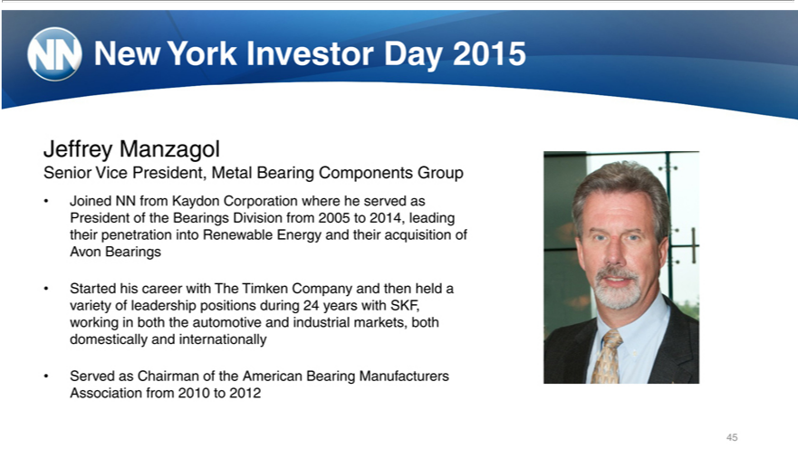

JeffreyNewYorkManzagolInvestor Day 2015
Senior Vice President, Metal Bearing Components Group
Joined NN from Kaydon Corporation where he served as President of the Bearings Division from 2005 to 2014, leading their penetration into Renewable Energy and their acquisition of Avon Bearings
^{Served}tarted his career with The Timken Company and then held a variety of leadership positions during 24 years with SKF, working in both the automotive and industrial markets, both domestically and internationally
₄₅ as Chairman of the American Bearing Manufacturers Association from 2010 to 2012

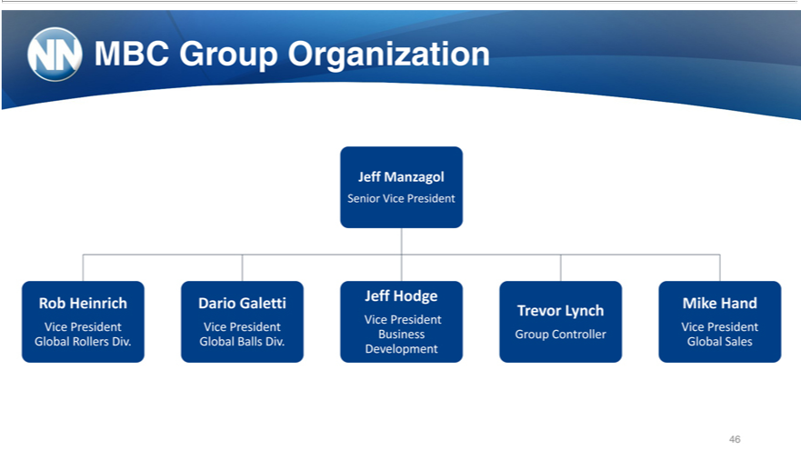

RobMBCHeinrichGroupOrganization
SeniorJeffManzagolVicePresident
DarioVicePresidentGaletti Global Rollers Div.
JeffViceHodgePresident Global Balls Div.
TrevorVicePresidentLynch Business Development
MikeGroupHandController
46Vice President Global Sales

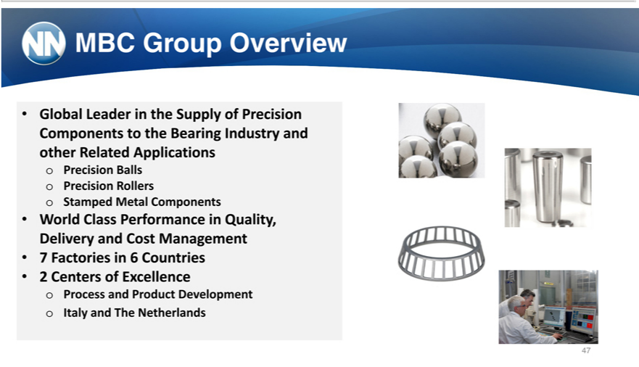

MBC Group Overview |  | Components to the Bearing Industry and other Related Applications
 | Leader in the Supply of
GlobalPrecision Balls Precision RolPrecisionersStamped Metal Components
World Class Performance in Quality, Delivery and Cost Management
7 | Factories in 6 Countries
2 | Centers of Excellence
o | Process and Product Development o Italy and The Netherlands
47

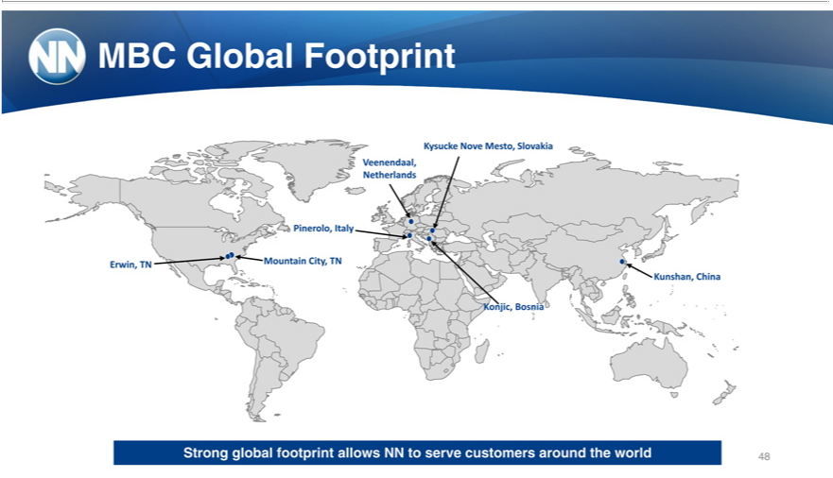

Pinerolo,MBCGlobalItalyFootprint
Erwin, TN Mountain City, TN
Veenendaal,KysuckeNove Mesto, Slovakia
_{Kunshan,}Netherlandsojic,Bosnia
China
48Strong global footprint allows NN to serve customers around the world

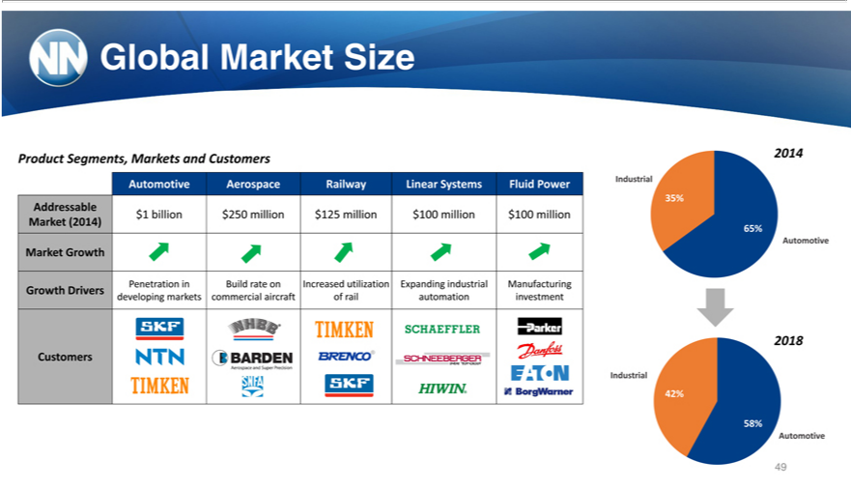

Global Market Size
Product Segments, Markets and Customers
_{Addressable}utomotive Aerospace Railway Linear Systems Fluid Power
_{Market}$1billion(2014)$250 million $125 million $100 million $100 million
Growth
Growth Drivers Penetration in Build rate on Increased utilization Expanding industrial Manufacturing developing markets commercial aircraft of rail automation investment
Customers
Industrial2014
³65%
Automotive
2018
58%Industrial
49Automotive

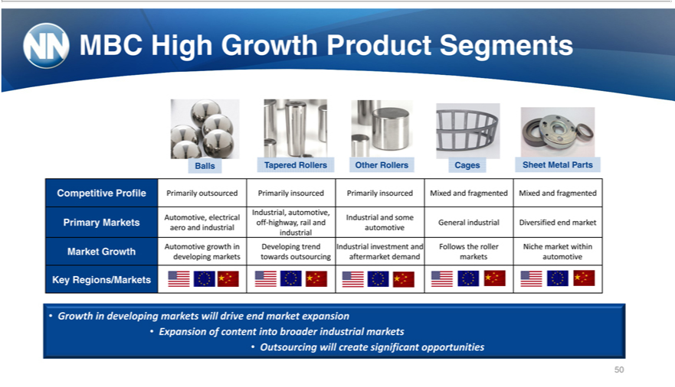

MBC High Growth Product Segments
Co petitive Profile
Primary Markets
Market Growth
Key
Regions/Markets
Balls Tapered Rollers Other Rollers Cages Sheet Metal Parts
Primarily outsourced
, electrical a ro and industrial
Automotive growth in developing markets
Primarily insourced
Industrial, automotive, off-highway, rail and industrial Developing trend towards outsourcing
Primarily insourced
and some automotive
investment and aftermarket demand
IndustrialMixand fragmented
General industrial
Follows the roller markets
Mixed and fragmented
D versified end market
Niche market within automotive | expansion
Growth in developing markets will drive end | expansion
Expansion of content into broader industrial markets
50Outsourcing will create significant opportunities

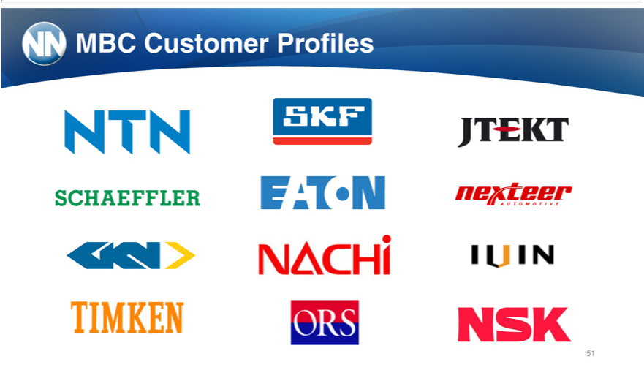

51MBC Customer Profiles

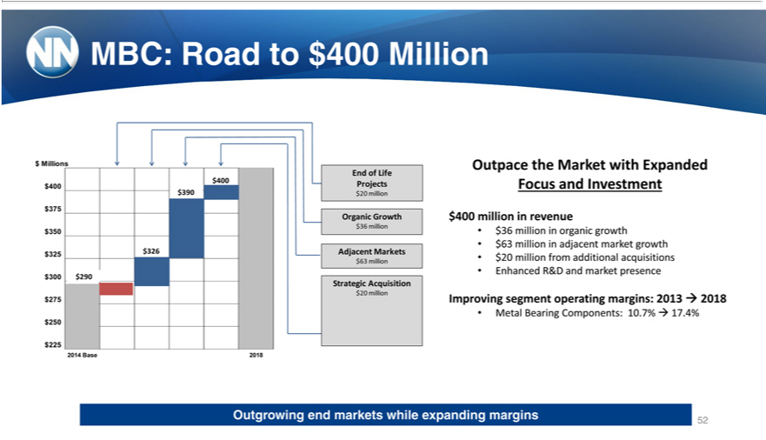

MBC: Road to $400 Million
Millions
400
90
75
50 | 326
25 | 326
300 | $290
75
50
$225 | Base 2018
2014
End of Life Projects
$20 million
Organic Growth
$36 million
Adjacent Markets
$63 million
Strategic Acquisition
$20 million
Outpace the Market with Expanded Focus and Investment
400 million in evenue
36 |  | organic growth
63 |  | in adjacent market growth
$20 million from additional acquisitions
Enhanced R&D and market presence
MetalImprovingBearingsegmentComponents:operating10.7%margins:?17.4%2013 ?2018
52Outgrowing end markets while expanding margins

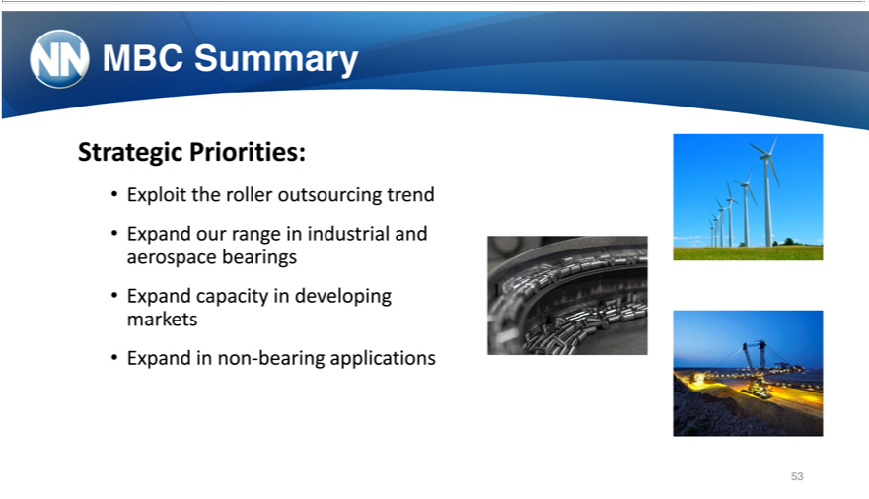

MBC Summary
Strategic Priorities: | trend
loit the roller | trend
our rangeoutsourcingindustrial and aerospace bearings
capacity | developing markets
Expand bearing
53 in non- applications

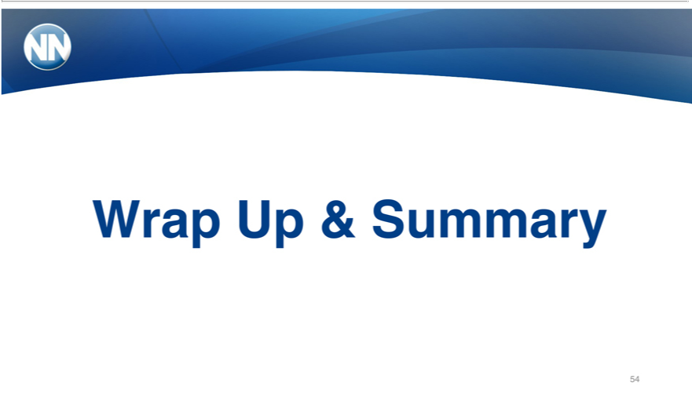

54Wrap Up & Summary

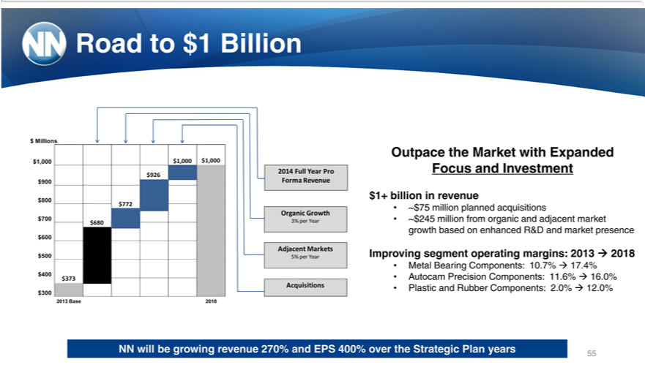

Road_{1,000}Millionsto$1 Billion
9₂₆ $1,000 $1,000
800
72
700
₆80
5
400
₃73
$200 2013 Base 2018
Organic2014FullGrowthYearPro Forma Revenue
3%AdjacentperYearMarkets
Acquisitions5%perYear
$Outpace1+billiontheinMarketrevenuewith Expanded Focus and Investment
~$75²⁴⁵million planned acquisitions
million from organic and adjacent market growth based on enhanced R&D and market presence Improving segment operating margins: 2013 ? 2018
Metal Bearing Components: 10.7% ? 17.4%
Autocam Precision Components: 11.6% ? 16.0%
Plastic and Rubber Components:^{270%}.0% ? 12.0%
55NN will be growing revenue and EPS 400% over the Strategic Plan years

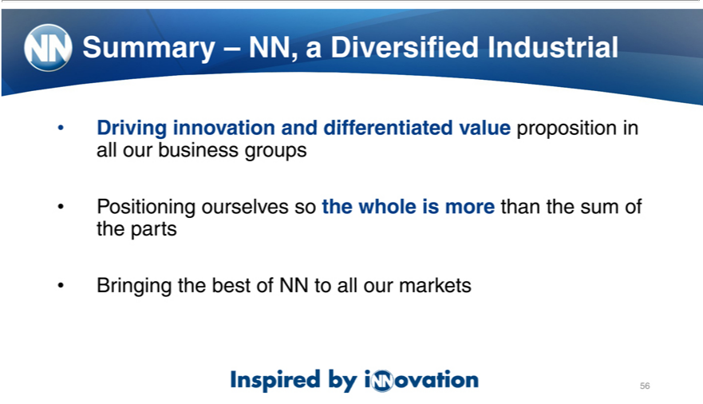

allSummaryourbusiness–NN,groupsaDiversified Industrial
the parts
56Bringing the best of NN to all our markets



57

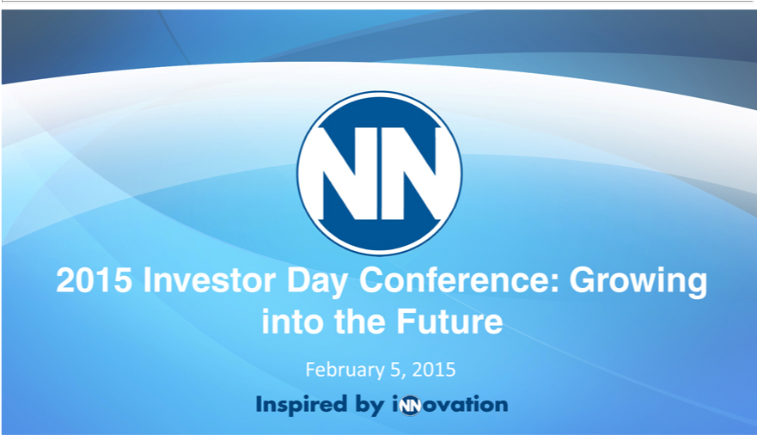

February2015Investor5,2015Day Conference: Growing into the Future

