UNITED STATES

SECURITIES AND EXCHANGE COMMISSION
WASHINGTON, DC 20549

FORM 8-K

CURRENT REPORT

PURSUANT TO SECTION 13 OR 15(d)
OF THE SECURITIES EXCHANGE ACT OF 1934

Date of Report (Date of earliest event reported): March 23, 2015


NN, INC.

(Exact name of registrant as specified in its charter)

Delaware

0-23486

62-1096725

(State or Other Jurisdiction
of Incorporation)

(Commission
File Number)

(I.R.S. Employer
Identification No.)

207 Mockingbird Lane, Johnson City, Tennessee

37604

(Address of principal executive offices)

(Zip Code)

(423) 743-9151

(Registrant’s telephone number, including area code)

(Former name or former address, if changed since last report)

Check the appropriate box if the Form 8-K filing is intended to simultaneously satisfy the filing obligation of the registrant under any of the following provisions (see General Instruction A.2. below):

- Written communications pursuant to Rule 425 under the Securities Act (17 CFR 230.425)

- Soliciting material pursuant to Rule 14a-12 under the Exchange Act (17 CFR 240.14a-12)

- Pre-commencement communications pursuant to Rule 14d-2(b) under the Exchange Act (17 CFR 240.14d- 2(b))

- Pre-commencement communications pursuant to Rule 13e-4(c) under the Exchange Act (17 CFR 240.13e- 4(c))

ITEM 7.01 REGULATION FD DISCLOSURE

Attached as Exhibit 99.1 to this Current Report on Form 8-K is a PowerPoint presentation, which provides an update to investors. The attached presentation updates NN, Inc.’s previously provided investor presentation.

The information presented in Item 7.01 to this Current Report on Form 8-K is being furnished in accordance with Rule 101(e)(1) under Regulation FD and shall not be deemed to be “filed” for purposes of Section 18 of the Securities Exchange Act of 1934, as amended, and will not be incorporated by reference into any registration statement filed under the Securities Act of 1933, as amended, unless specifically identified therein as being incorporated by reference.

ITEM 9.01 FINANCIAL STATEMENTS AND EXHIBITS

Exhibit
No. Description

99.1 Investor Presentation of NN, Inc., dated March 23, 2015.

SIGNATURES

Pursuant to the requirements of the Securities Exchange Act of 1934, the registrant has duly caused this report to be signed on its behalf by the undersigned hereunto duly authorized.

Date: March 23, 2015

NN, INC.

By: | /s/ William C. Kelly, Jr.
Name: | William C. Kelly, Jr.
Title: | Vice President and Chief Administrative Officer

EXHIBIT INDEX

Exhibit
No. Description

99.1 Investor Presentation of NN, Inc., dated March 23, 2015.

Exhibit 99.1
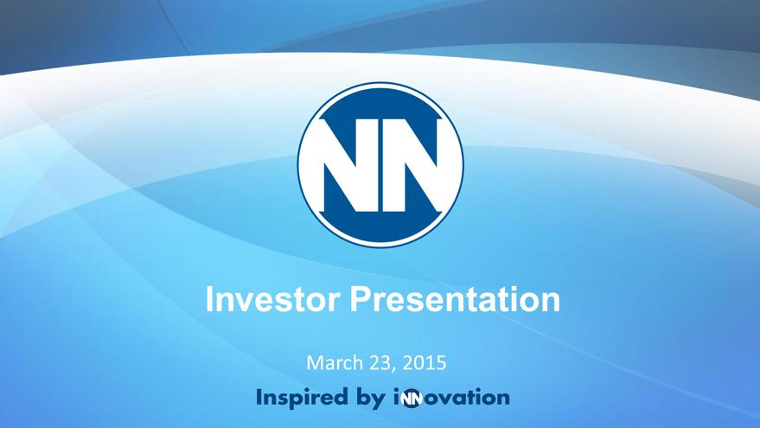

Exhibit 99.1
Investor Presentation
March 23, 2015

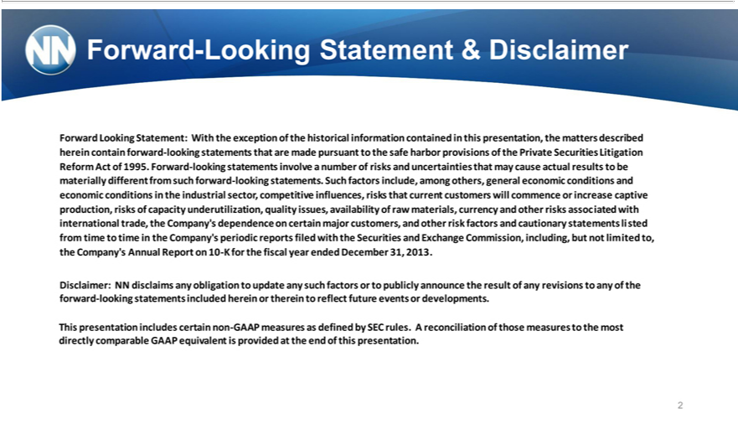

 | -Looking | & Disclaimer
Forward Looking Statement: With the exception of the historical information contained in this presentation, the matters described
herein contain forward-looking statements that are made |  |  |  | to the safe harbor provisions of the Private Securities Litigation
Refo | Act of 1995. Forward-looking statements involvepursuantnumber of risks and uncertainties that may cause actual results to be
materially different from such forward-looking statements. Such factors include, among others, general economic conditions and
economic conditions in the industrial sector competitive influences, risks that current customers will commence or increase captive
produc | , risks of capacity underutilization, quality issues, availability of raw materials, currency and other risks associated with
international trade, the Company’s dependence on certain major customers, and other risk factors and cautionary statements listed
from time to time in the Company’s periodic r ports filed with the Securities and Exchange Commission, including, but not limited to,
the Company’s Annu |  | Report | 10 -K for the fisc l year ended December 31, 2013 .
Disclaimer: NN disclaims any obligation to update any such factors or to publicly announce the result of any revisions to any of the forward-looking statements included herein or therein to reflect future events or developments.
This presentation includes c_{equivalent}rtainnon-GAAP measures as defined by SEC rules. A reconciliation of those measures to the most
2directly comparable GAAP is provided at the end of this presentation.

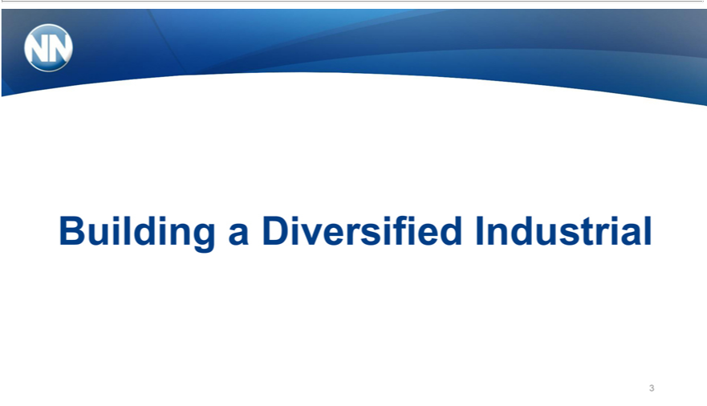

3Building a Diversified Industrial

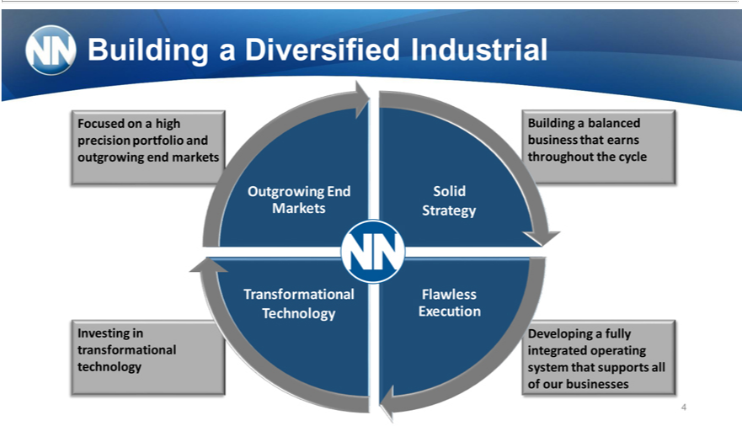

Building a Diversified Industrial
Focused on_{balanced}highprecision portfolio and outgrowing end markets
InvestingBuilding ain transformationalbusiness technologythatearnsthroughout the cycle
OutgrowingDeveloping aEndfullyMarketsintegrated operating system that supports all of our businesses
Strategy^{olid}
FlawlessTransformationalexecutiontechnology
4

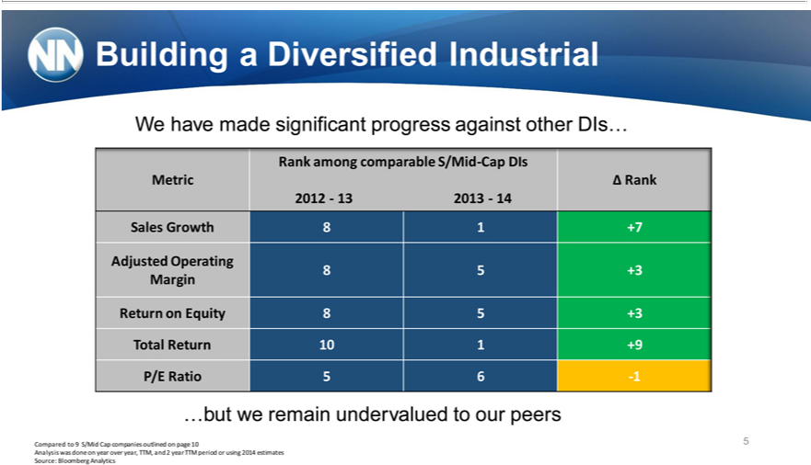

Building ^{made}Diversified Industrial
RankWehaveamong comparablesignificantS/Midprogress-CapagainstDIs other DIs…
Metric Ä Rank
Sales2012—13Growth2013—1481+7
8Adjusted5+3 Operating
Margin
Return on Equity 8 5 +3
P/ETotalRatioReturn5610-1 1 +9
…but we remain undervalued to our peers
Compared to 9 S/Mid Cap companies outlined on page 10 5
Source:AnalysisBloombergwasdoneonAnalyticsyearover year, TTM, and 2 year TTM period or using 2014 estimates

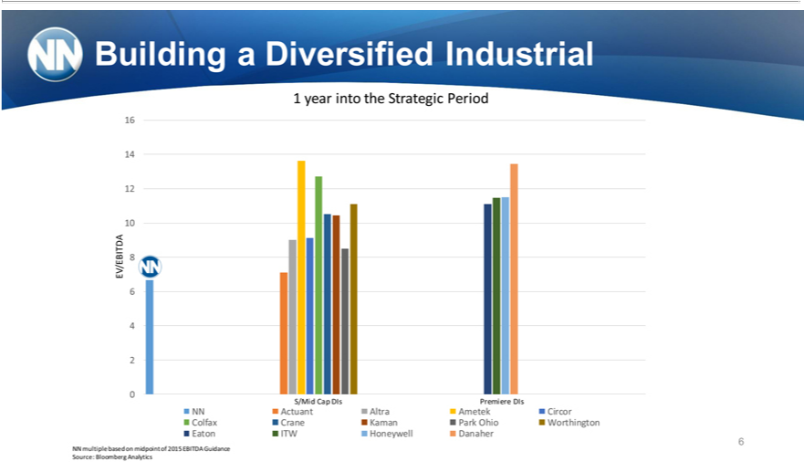

Building⁶ a Diversified Industrial
4year into the Strategic Period
102
EV/EBITDA 8
46
02
NNS/MidActuantCapDIsAltraPremiereAmetek^{Park}DIsCircor
EatonColfaxITWCraneHoneywellKaman DanaherOhio Worthington
6
Source:NNmultipleBloombergbased onAnalyticsmidpoint of 2015 EBITDA Guidance

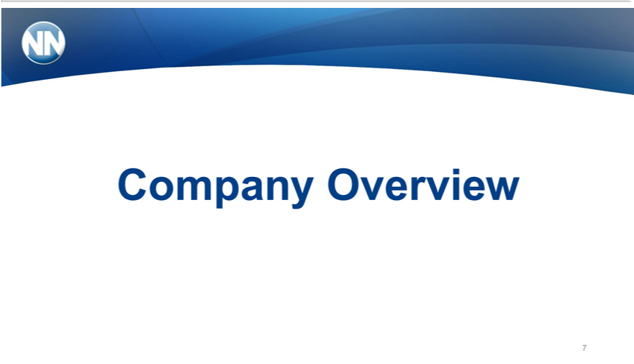

7Company Overview

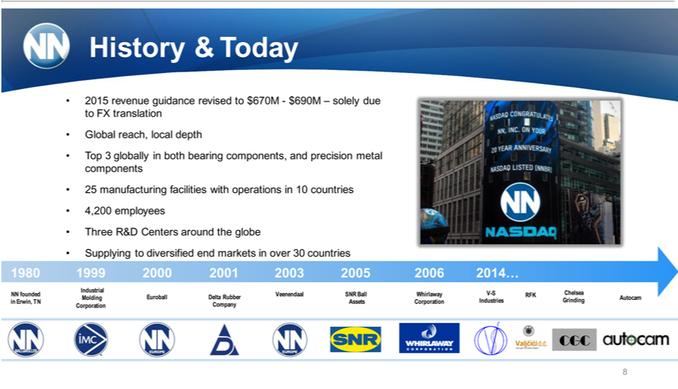

History & Today
Global2015revenuereach, localguidancedepthrevised to $670M—$690M – solely due to FX translation
Top_{manufacturing}3globally both bearing components, and precision metal components
25 facilities with operations in 10 countries
4,200 employees
Three R&D Centers around the globe
Supplying to diversified end markets in over 30 countries
Industrial1980MetalVeenendaalBearing1999ComponentsSNRBallWhirlaway2000 2001V-SChelsea20032005 2006 2014…
NN founded Molding Euroball Delta Rubber RFK Autocam
CorporationinErwin,TNCompanyAssetsCorporation Industries Grinding
8

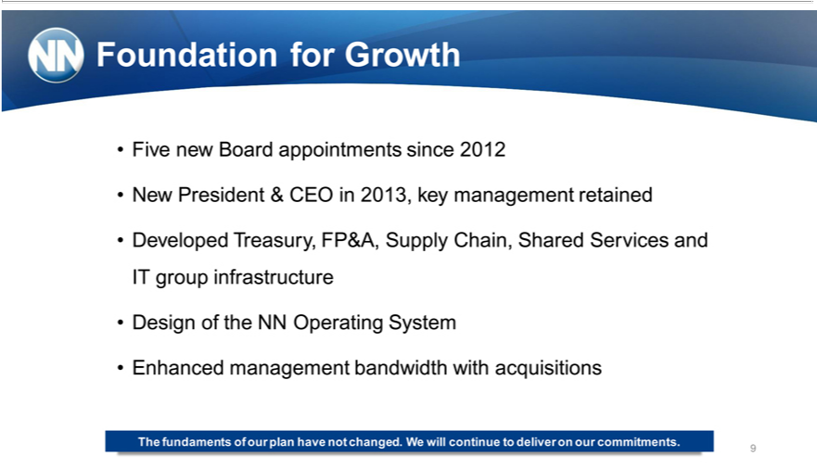

^{Five}oundation for Growth
N_{Developed}wnewPresidentBoard&_{appointments}CEO2013,sincekey 2012management retained
IT group infrastructureTreasury,FP&A, Supply Chain, Shared Services and
Design of the NN Operating System
Enhanced management bandwidth with acquisitions
The fundaments of our plan have not changed. We will continue to deliver on our commitments. 9

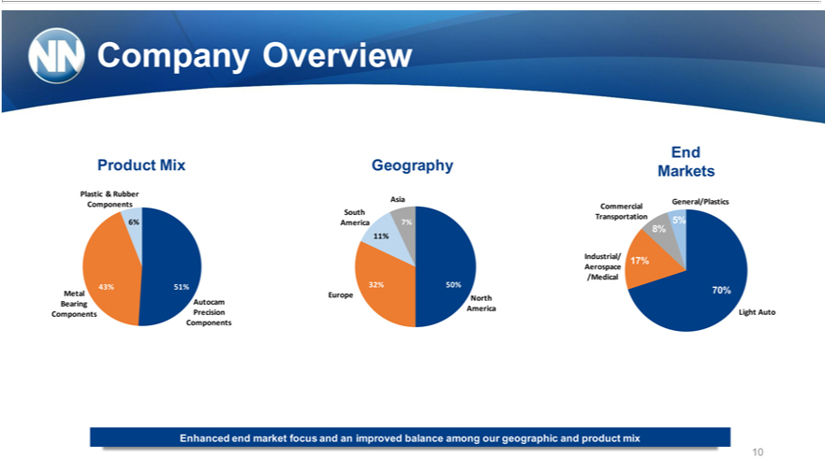

_{Plastic}CompanyroductMixOverview
& Rubber
6%Components
Metal43%51%
Bearing Autocam
Components ^{Precision}
Geography
Asia
SouthAmerica 7%
7%11%
32% 50%
AmericaEuropeNorth
MarketsEnd
TransportationCommercialGeneral/Plastics5%
8%
Industrial/Aerospace 17%
70%/Medical
Light Auto
10Enhanced end market focus and an improved balance among our geographic and product mix

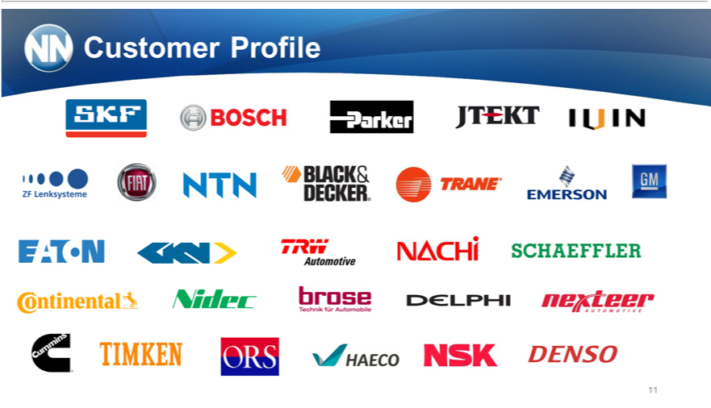

11Customer Profile

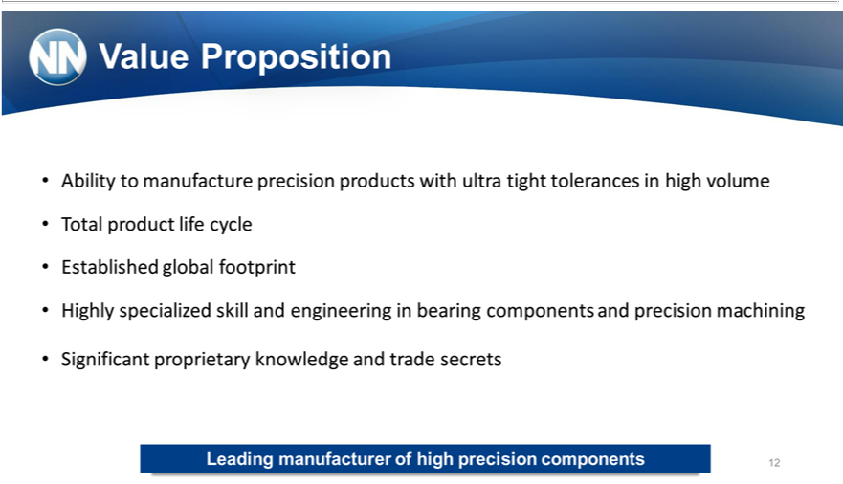

Value Proposition
TotalAbilityproducttomanufacturelifecycle precision products with ultra tight tolerances in high volume
Established global footprint
SignificantHighlyspecializedproprietaryskillknowledgeandengineeringandtradeinbearingsecrets components and precision machining
Leading manufacturer of high precision components 12

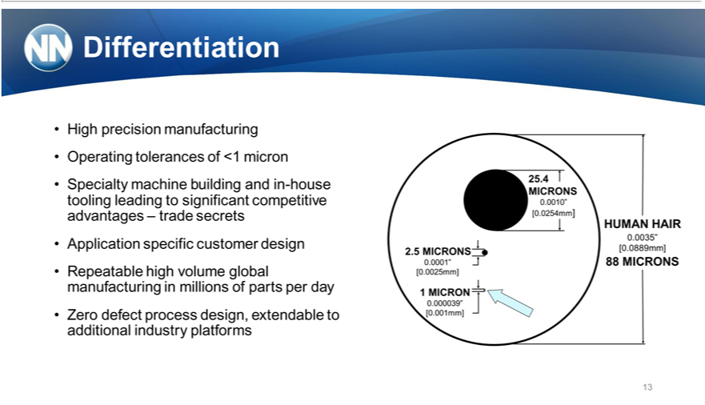

^{High}Dfferentiation
Operatingprecisiontolerancesmanufacturingof<1micron
Specialty machine building and in-house tooling leading to significant competitive advantages – trade secrets Application specific customer design
Repeatable high volume global manufacturing in millions of parts per day
13Zero defect process design, extendable to additional industry platforms

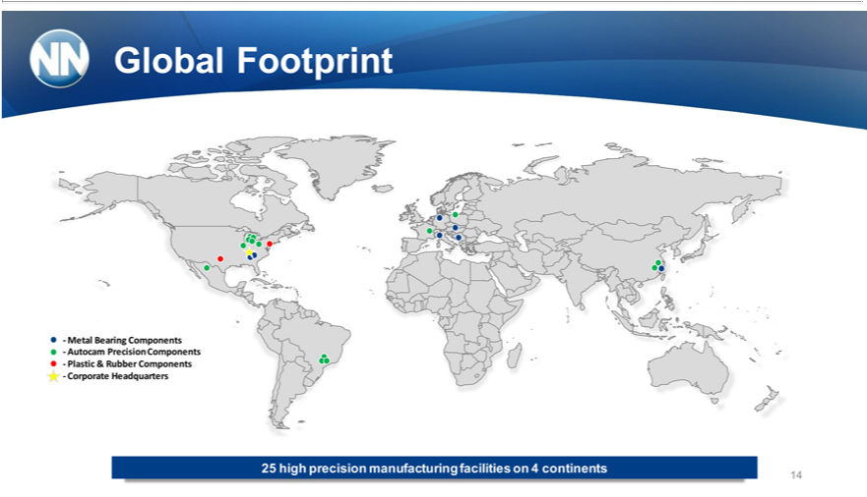

Global Footprint
AutocamMetalBearingPrecisionComponentsComponents
—
CorporatePlastic&RubberHeadquartersComponents
25 high precision manufacturing facilities on 4 continents
14



15Moving Forward

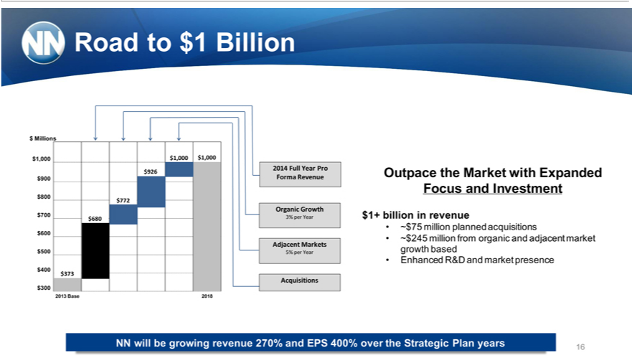

$Road_{1,000}Millionsto$1 Billion
$1,000 $1,000
2014 Full Year Pro $926 Forma Revenue
$⁹800 $772
Organic Growth
$7₆₀₀ 3% per Year $680
$Adjacent5₄₀₀5% perMarketsYear
$373
Acquisitions
$300 $200 2013 Base 2018
$Outpace1+billiontheinMarketrevenuewith Expanded Focus and Investment
~$75²⁴⁵million planned acquisitions
EnhancedmillionR&Dfromand organicmarket presenceandadjacent market growth based
NN will be growing revenue 270% and EPS 400% over the Strategic Plan years 16

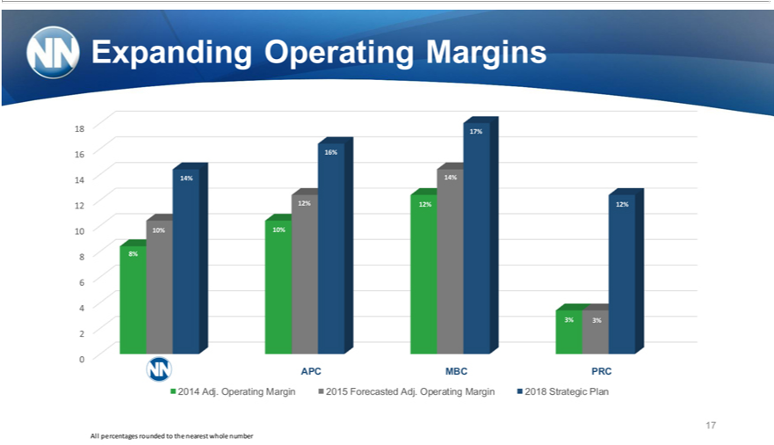

Expanding Operating Margins
48₆ 4%7%_{6%}
2 2% 2%^{4%}
10 10% 10% ^{12%}
8 8%
6
4
3% 3%
2
0
APC MBC PRC
172014 Adj. Operating Margin 2015 Forecasted Adj. Operating Margin 2018 Strategic Plan
All percentages rounded to the nearest whole number

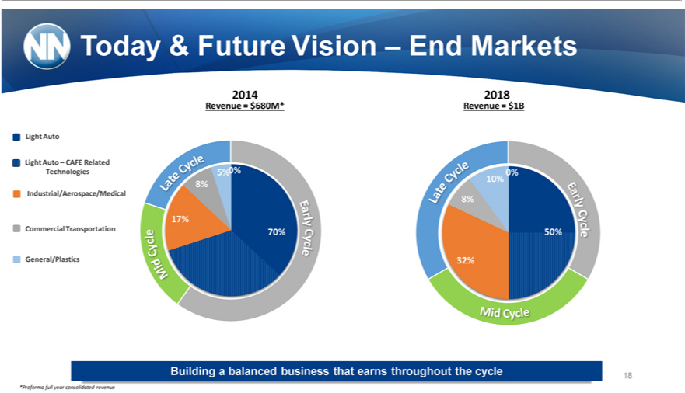

Today & Future Vision – End Markets
Light Auto – CAFE Related
Technologies
Industrial/Aerospace/Medical
Commercial Transportation
General/Plastics
2014 2018
Revenue = $680M* Revenue = $1B
8%^{5%}
17%
10%
8%
32%^{50%}
Building_{*Proforma} balancedfullyear consolidatedbusinessthat revenueearnsthroughout the cycle 18

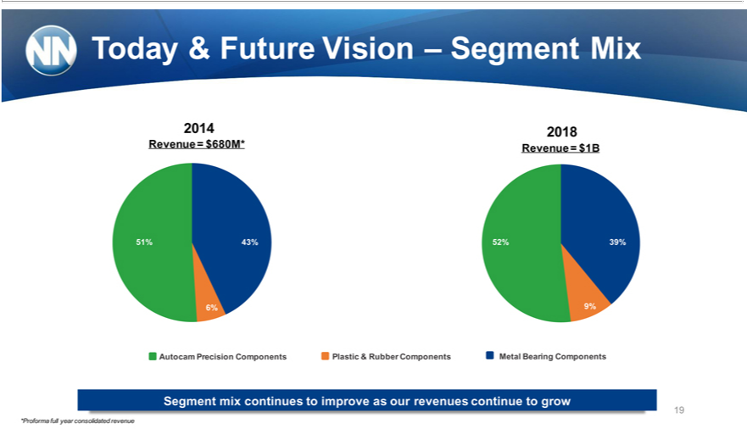

2014Today2018&Future Vision – Segment Mix
_{51%}Revenue43%%= $680M* Revenue = $1B
43% 43 52% 39% %
6% 9% 6%
31 _{43%} 50 51
% % Autocam Precision 60 Components Plastic & Rubber Components Metal Bearing Components % 25 % Segment mix continues to improve as our revenues continue to grow 19
*Proforma full year consolidated revenue

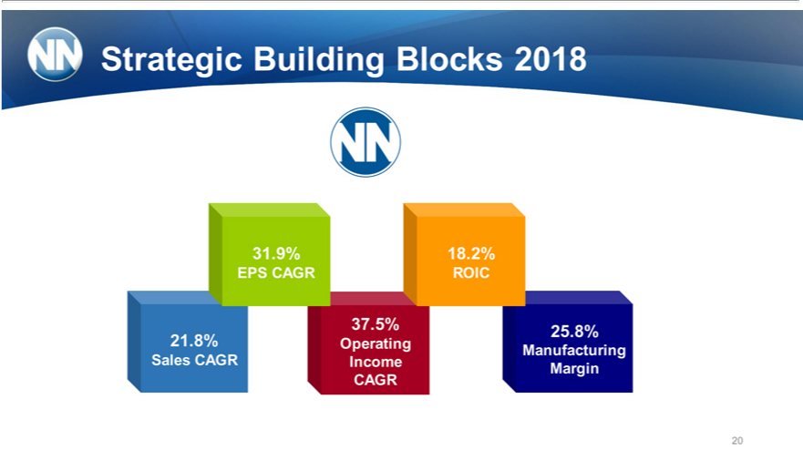

31.Strategic9%18.2%Building Blocks 2018
37EPS_{.8%}5%CAGR8%25.ROIC
21 Operating
20Manufacturing Sales CAGR Income Margin CAGR

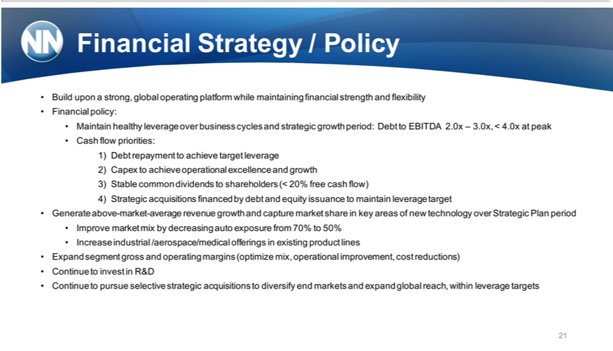

Financial |  | / Policy
Build uponStrategystrong, global operating platform while maintaining financial strength and flexibility
Financial policy:
Maintain healthy leverage over business cycles and strategic growth period: Debt to EBITDA 2.0x – 3.0x, < 4.0x at peak
Cash flow priorities:
1) | Debt repayment to achieve target leverage
2) | Capex to achieve operational excellence and growth
3) | able common dividends to shareholders (< 20% free cash flow)
4) | Strategic acquisitions financed by debt and equity issuance to maintain leverage target
Generate above-market-average revenue growth and capture market share in key areas of new technology over Strategic Plan period
mprove market mix by decreasing auto exposure from 70% to 50%
ExpandIncreasesegmentindustrialgross/aerospace/medicalandoperatingmarginsofferings(optimizeinexistingmix,productoperationallines improvement, cost reductions)
Continue to pursueinvestinselectiveR&D strategic acquisitions to diversify end markets and expand global reach, within leverage targets 21

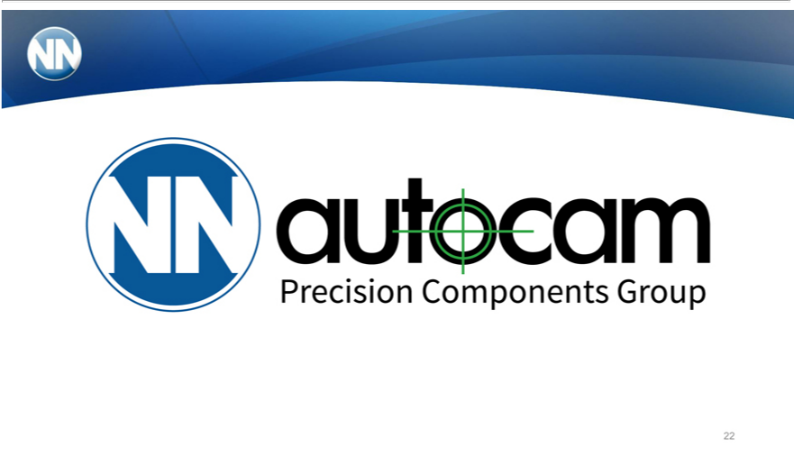

22

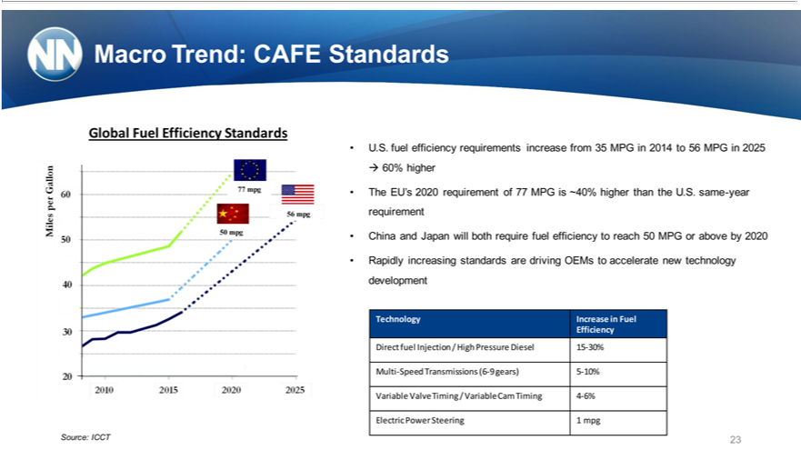

Macro Trend: CAFE Standards
77Global Fuel Efficiency Standards
50⁶ mpg
Source: ^{ICCT}
?U60%..fuelhigherefficiency requirements increase from 35 MPG in 2014 to 56 MPG in 2025
requirementTheEU’s2020 requirement of 77 MPG is ~40% higher than the U.S. same-year
China and Japan will both require fuel efficiency to reach 50 MPG or above by 2020
developmentRapidlyincreasing standards are driving OEMs to accelerate new technology
EfficiencyTechnology Increase in Fuel
DirectMulti-SpeedfuelInjectionTransmissions/High Pressure(6-9gears)Diesel5-10%15-30%
ElectricVariable PowerValve TimingSteering/ 1Variablempg Cam Timing 4-6%
23

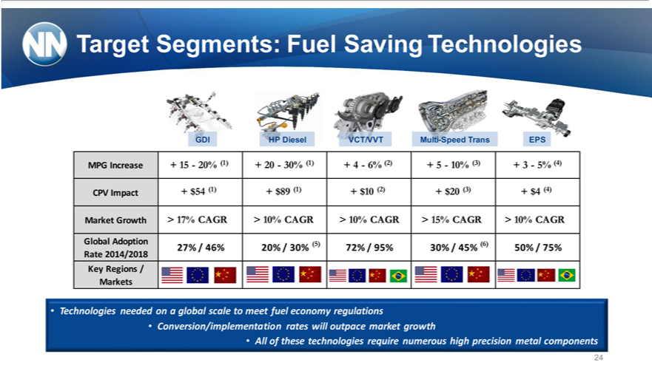

Target Segments: Fuel Saving Technologies
GDI HP Diesel VCT/VVT Multi-Speed Trans EPS
MPG Increase + 15—20% (1) + 20—30% (1) + 4—6% (2) + 5—10% (3) + 3—5% (4)
CPV Impact + $54 (1) + $89 (1) + $10 (2) + $20 (3) + $4 (4)
Market Gr wth > 17% CAGR > 10% CAGR > 10% CAGR > 15% CAGR > 10% CAGR
Global Adoption (5) (6)
27% 46% 20% / 30% 72% / 95% 30% / 45% 50% / 75%
Rate
Key Regions2014/2018
Markets | global scale to meet fuel economy regulations
Technologies needed | global scale to meet fuel economy regulations
Conversion/implementation rates will outpace market growth
24•All of these technologies require numerous high precision metal components

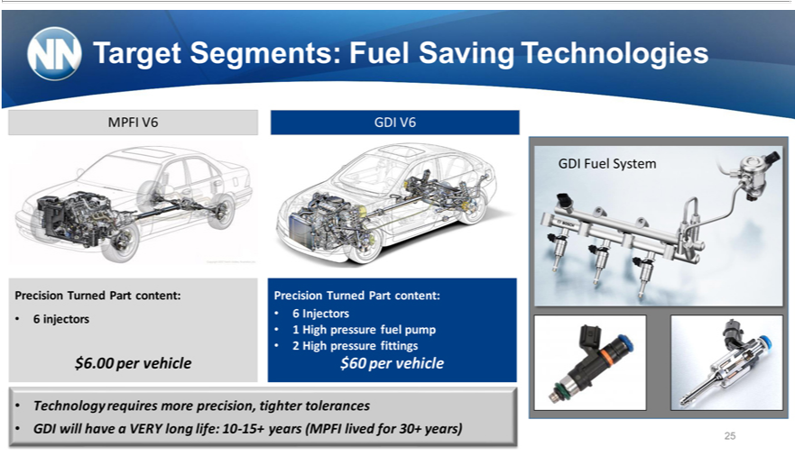

Target Segments: Fuel Saving Technologies
MPFI V6 GDI V6
GDI Fuel System
Precision Turned Part content: Precision Turned Part content:
6 injectors 6 Injectors
• 2¹ High pressure fittings^{uelpump}
$6.00 per vehicle $60 per vehicle
Technology requires more precision, tighter tolerances
GDI will have a VERY long life: 10-15+ years (MPFI lived for 30+ years) 25

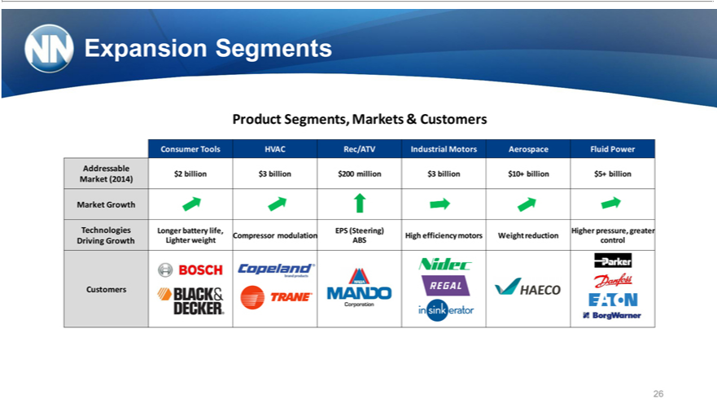

Expansion Segments
Product Segments, Markets & Customers
Consumer Tools HVAC Rec/ATV Industrial Motors Aerospace Fluid Power
_{Market}Addressable(2014)$2 billion $3 billion $200 million $3 billion $10+ billion $5+ billion
Growth
Technologies Longer battery life, EPS (Steering) Higher pressure, greater Compressor modulation High efficiency motors Weight reduction Driving Growth Lighter weight ABS control Customers
26

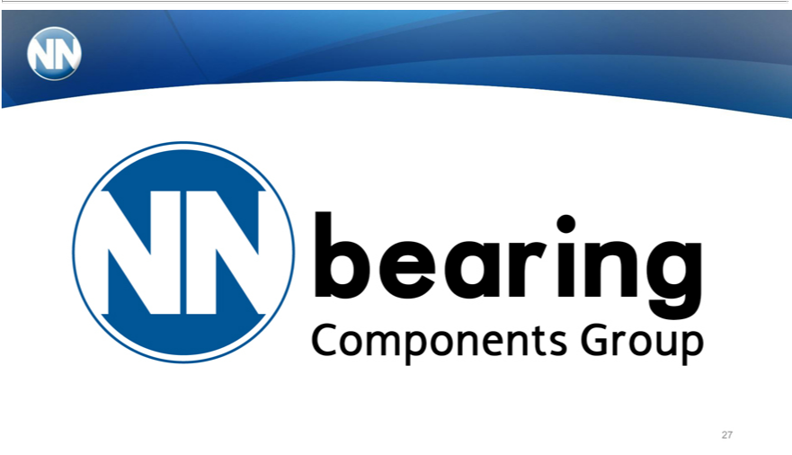

27

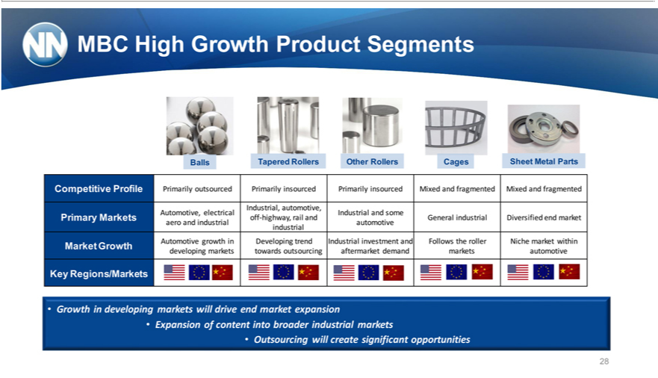

MBC High Growth Product Segments
Balls Tapered Rollers Other Rollers Cages Sheet Metal Parts
Competitive Profile Primarily outsourced Primarily insourced Primarily insourced Mixed and fragmented Mixed and fragmented Industrial, automotive,
Automotive, electrical Industrial and some
aeroPrimaryand Marketsindustrialoffautomotive-highway, rail and General industrial Diversified end market
industrial
Market Growth Automotive growth_{outsourcing}Developing trend Industrial investment and Follows the roller Niche market within
KeydevelopingRegions/Marketsmarketstowards aftermarket demand markets automotive
ExpansionGrowthin developingofcontentintomarketsbroaderwillindustrialdriveend_{markets} expansion
28•Outsourcing will create significant opportunities

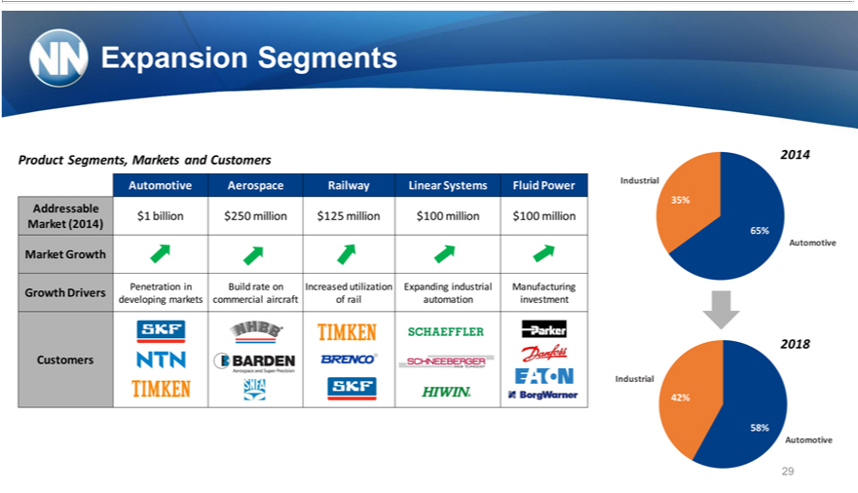

Expansion Segments
Product Segments, Markets and Customers 2014
35%Automotive Aerospace Railway Linear Systems Fluid Power Industrial
Addressable
Market$1billion(2014)$250 million $125 million $100 million $100 million
65%
MarketAutomotiveGrowth
Growth Drivers Penetration in Build rate on Increased utilization Expanding industrial Manufacturing developing markets commercial aircraft of rail automation investment
2018
IndustrialCustomers
^{42%}58%
29Automotive

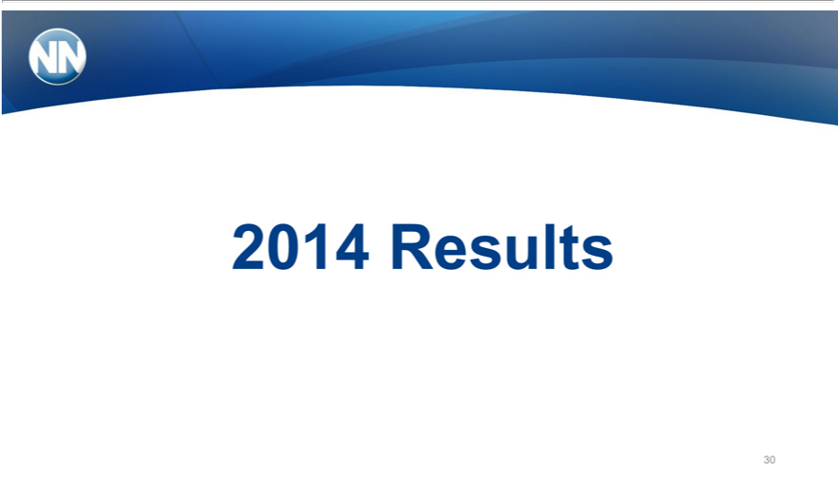

₃₀214 Results

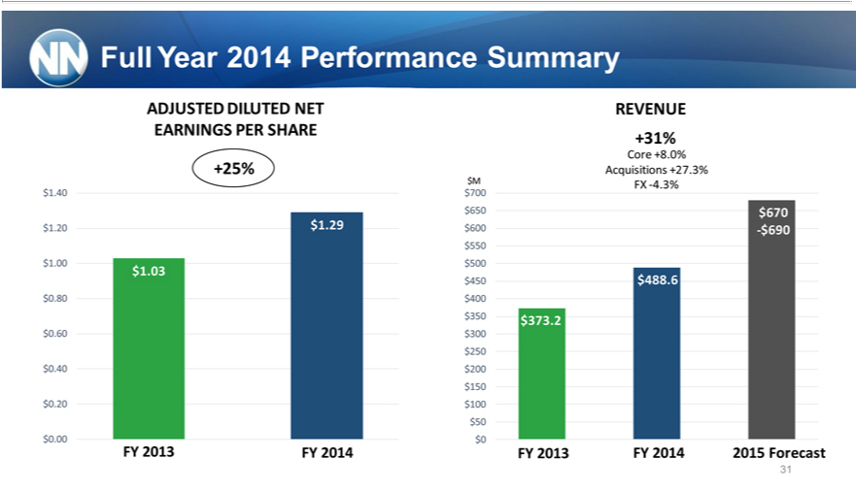

Full Year 2014 Performance Summary
ADJUSTED DILUTED NET
+25%EARNINGS PER SHARE
40²⁰ _{$1.29}
1 03
80₆₀
40
$0.0020
FY 2013 FY 2014
+31%REVENUE
Core +8.0%
Acquisitions +27.3%
M₇₀₀FX -4.3%
50
₆₀₀ $670
₅₀₀ -$690
₄₀₀ $488.6
50
₃₀₀ $373.2
50
200
150
$500
31FY 2013 FY 2014 2015 Forecast

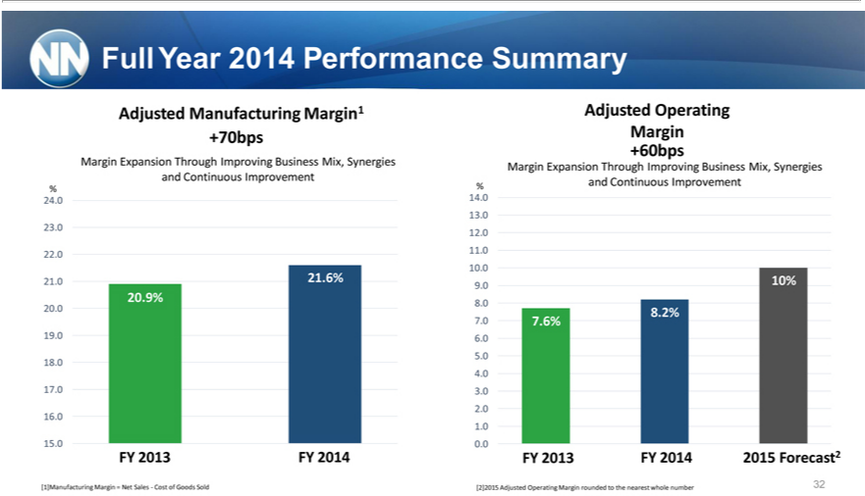

Adjusted Operating Margin +60bps
Margin Expansion Through Improving Business Mix, Synergies % and Continuous Improvement
Full Year 2014 Performance Summary
Adjusted Manufacturing Margin1 +70bps
Margin Expansion Through Improving Business Mix, Synergies and Continuous Improvement
%
4
3
2 |  |  | 21 6% |  | .9%
1 |  |  |  |  | .9%
20 |  |  | 19.0 18.20 |  | 17.0 16.0
15.0 |  |  |  | FY
FY |  |  |  | FY
14.02013.0 12.02014.0 10.0
9 |  | 10%
8 |  | 8 2%
7 |  | 7.6%
6
5
4
3
2
1
0.0
FY 2013 FY 2014 2015 Forecast2
 | Manufacturing Margin = Net Sales—Cost of Goods Sold
[2]2015 |  |  |  | Adjusted Operating Margin rounded to the nearest whole number
32

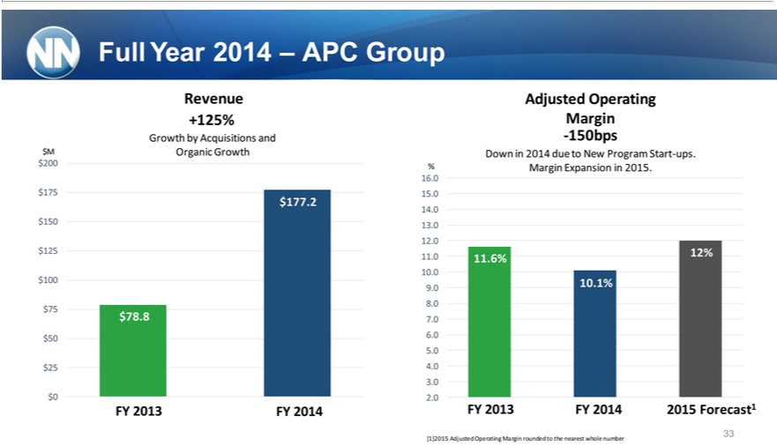

RevenueFullYear +125%2014– APC Group
Growth⁵ by Acquisitions and $M Organic Growth
20077
₅₀.2
$10025
20.9%
78₅₀.8
$250
FY 2013 FY 2014
MarginAdjusted Operating
-150bps
%DownMarginin2014Expansiondueto Newin2015.Program Start-ups.
5⁶
4
3
2.0
_{1.}0 12%
6%
10.⁰
₉ 1%
8
7
6
5
4
³.0
2
33FY 2013 FY 2014 2015 Forecast1
[1]2015 Adjusted Operating Margin rounded to the nearest whole number

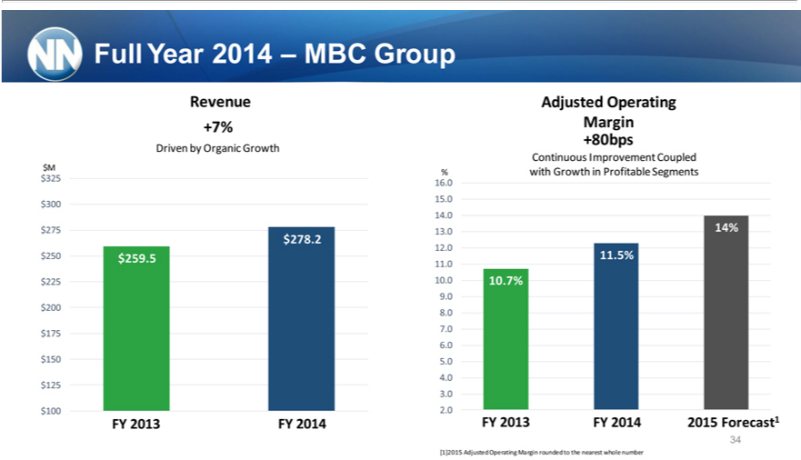

RevenueFullYear 2014 – MBC Group
+7%
Driven^{M}25 by Organic Growth
300
75
50 $259⁷⁸.²
25 ⁵
200
75
50
$10025
FY 2013 FY 2014
MarginAdjusted Operating
+80bps
Continuous Improvement Coupled
%₅6 with Growth in Profitable Segments
34
_{2.0} 14%
₁₀.^{5%}
0
.0 10.7% 8.2
9 6%
8
7
6
5
4
³.0
2
34FY 2013 FY 2014 2015 Forecast1
[1]2015 Adjusted Operating Margin rounded to the nearest whole number

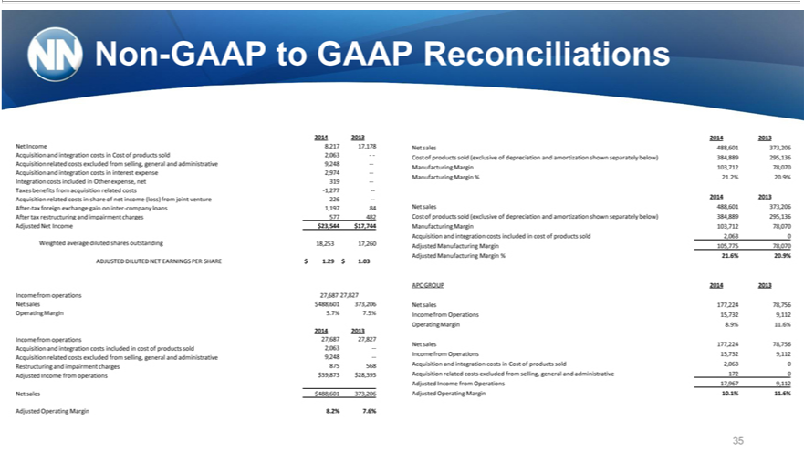

Non-GAAP to GAAP Reconciliations
2014 2013 2014 2013
Net Income 8,217 17,178 Net sales 488,601 373,206 Acquisition and integration costs Cost of products sold 2,063 — Cost of products sold (exclusive of depreciation and amortization shown separately below)
384,889 295,136 Acquisition related costs excluded from selling, general and administrative 9,248 — Manufacturing Margin 103,712 78,070 Acquisition and integration costs in interest expense 2,974 —
Manufacturing Margin % 21.2% 20.9% Integration costs included in Other expense, net 319 — Taxes benefits from acquisition related costs -1,277 — 2014 2013
cquisition related costs in share of net income (loss) from joint venture 226 —
After-tax foreign exchange gain on inter-company loans 1,197 84 Net sales 488,601 373,206 After tax restructuring and impairment charges 577 482 Cost of products sold (exclusive of depreciation and amortization
shown separately below) 384,889 295,136 Adjusted Net Income $23,544 $17,744 Manufacturing Margin 103,712 78,070 Acquisition and integration costs included in cost of products sold 2,063 0 Weighted average
diluted shares outstanding 18,253 17,260 Adjusted Manufacturing Margin 105,775 78,070 Adjusted Manufacturing Margin % 21.6% 20.9% ADJUSTED DILUTED NET EARNINGS PER SHARE $ 1.29 $ 1.03
APC GROUP 2014 2013
Income from operations 27,687 27,827
Net sales $488,601 373,206 Net sales 177,224 78,756 Operating Margin 5.7% 7.5% Income from Operations 15,732 9,112 Operating Margin 8.9% 11.6%
2014 2013
Income from operations 27,687 27,827 | costs included in cost of products sold 2,063 —Income from Operations 15,732 9,112 Acquisition related costs excluded from selling, general and administrative
Net sales 177,224 78,756 Acquisition and
9,248 —875 568 Acquisition and integrationintegrationcosts Cost of products sold 2,063 0 Restructuring and impairment charges Adjusted Income from operations $39,873 $28,395 Acquisition related costs excluded from
selling, general and administrative 172 0 Adjusted | Income from Operations 17,967 9,112 Net sales $488,601 373,206 Adjusted Operating Margin 10.1% 11.6%
Adjusted Operating Margin 8.2% 7.6%
35

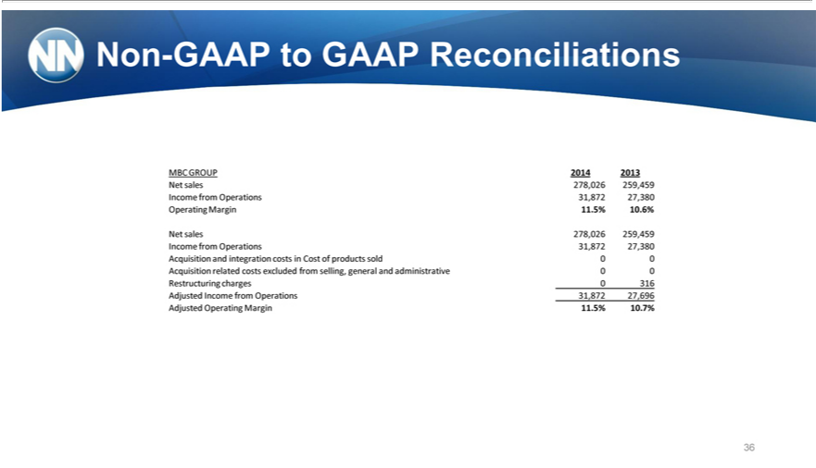

Non-GAAP to GAAP Reconciliations
MBC GROUP 2014 2013 Net sales 278,026 259,459 Income from Operations 31,872 27,380 _{Operating} Margin 11.5% 10.6%
Net sales 278,026 259,459 Income from Operations 31,872 27,380 Acquisition and integration costs Cost of products sold 0 0 Acquisition related costs excluded from selling, general and administrative 0 0 Restructuring charges 0 316 Adjusted Income from Operations 31,872 27,696 Adjusted Operating Margin 11.5% 10.7%
36

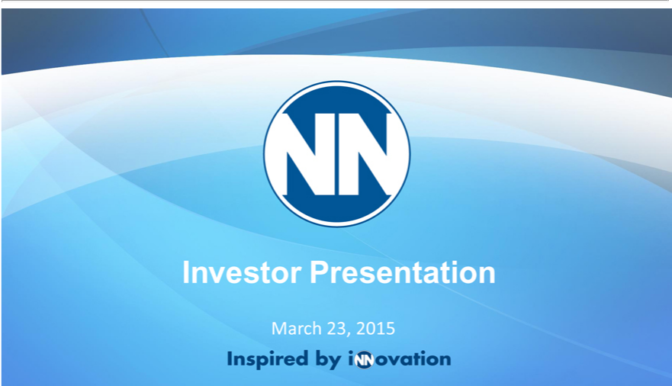

MarchInvestor23,Presentation2015

