UNITED STATES
SECURITIES AND EXCHANGE COMMISSION
Washington, D.C. 20549
FORM 8-K
CURRENT REPORT
Pursuant to Section 13 OR 15(d) of The Securities Exchange Act of 1934
Date of Report (Date of earliest event reported): March 14, 2024

NN, Inc.
(Exact name of registrant as specified in its charter)
Delaware |  |  | 000-23486 |  |  | 62-1096725
(State or other jurisdiction of  incorporation) |  |  | (Commission File Number) |  |  | (I.R.S. Employer  Identification No.)

6210 Ardrey Kell Road, Suite 120
Charlotte, North Carolina |  |  |  |  |  | 28277
(Address of principal executive offices) |  |  |  |  |  | (Zip Code)

(980) 264-4300
(Registrant’s telephone number, including area code)
(Former name or former address, if changed since last report)
Check the appropriate box if the Form 8-K filing is intended to simultaneously satisfy the filing obligation of the registrant under any of the following provisions (see General Instruction A.2. below):
☐ |  |  | Written communications pursuant to Rule 425 under the Securities Act (17 CFR 230.425)
☐ |  |  | Soliciting material pursuant to Rule 14a-12 under the Exchange Act (17 CFR 240.14a-12)
☐ |  |  | Pre-commencement communications pursuant to Rule 14d-2(b) under the Exchange Act (17 CFR 240.14d- 2(b))
☐ |  |  | Pre-commencement communications pursuant to Rule 13e-4(c) under the Exchange Act (17 CFR 240.13e- 4(c))

Securities registered pursuant to Section 12(b) of the Act:
Title of each class |  |  |  |  |  | Trading symbol |  |  |  |  |  | Name of each exchange on which registered
Common Stock, par value $0.01 |  |  |  |  |  | NNBR |  |  |  |  |  | The Nasdaq Stock Market LLC

Indicate by check mark whether the registrant is an emerging growth company as defined in Rule 405 of the Securities Act of 1933 (§230.405 of this chapter) or Rule 12b-2 of the Securities Exchange Act of 1934 (§240.12b-2 of this chapter).
Emerging growth company. |  |  | ☐
If an emerging growth company, indicate by check mark if the registrant has elected not to use the extended transition period for complying with any new or revised financial accounting standards provided pursuant to Section 13(a) of the Exchange Act. ☐

ITEM 7.01 REGULATION FD DISCLOSURE
NN, Inc., a Delaware corporation (the “Company”), will present virtually at the Sidoti Small-Cap Virtual Conference (the “Conference”) on March 14, 2024. The Company posted an investor presentation to its website, https://investors.nninc.com/, which will be presented at the Conference and is included as Exhibit 99.1 to this Current Report.
Pursuant to the rules and regulations of the U.S. Securities and Exchange Commission, the information furnished pursuant to this Item 7.01 of this Current Report (including Exhibit 99.1) is deemed to have been furnished and shall not be deemed “filed” for the purposes of Section 18 of the Securities Exchange Act of 1934, as amended (the “Exchange Act”), or otherwise subject to the liabilities of that section. Such information shall not be incorporated by reference into any other filing of the Company, whether made before or after the date hereof, regardless of any general incorporation language in such filing.

ITEM 9.01 FINANCIAL STATEMENTS AND EXHIBITS
(d) Exhibits.
Exhibit  No. |  |  |  |  |  | Description of Exhibit
99.1 |  |  |  |  |  | Investor Presentation, dated March 14, 2024
104 |  |  |  |  |  | Cover Page Interactive Data File (embedded within the Inline XBRL document)

SIGNATURES

Pursuant to the requirements of the Securities Exchange Act of 1934, the registrant has duly caused this report to be signed on its behalf by the undersigned hereunto duly authorized.
Date: |  |  | March 14, 2024

 |  |  | NN, INC.
 |  |  | By: |  |  | /s/ Michael C. Felcher
 |  |  | Name: |  |  | Michael C. Felcher
 |  |  | Title: |  |  | Senior Vice President and Chief Financial Officer

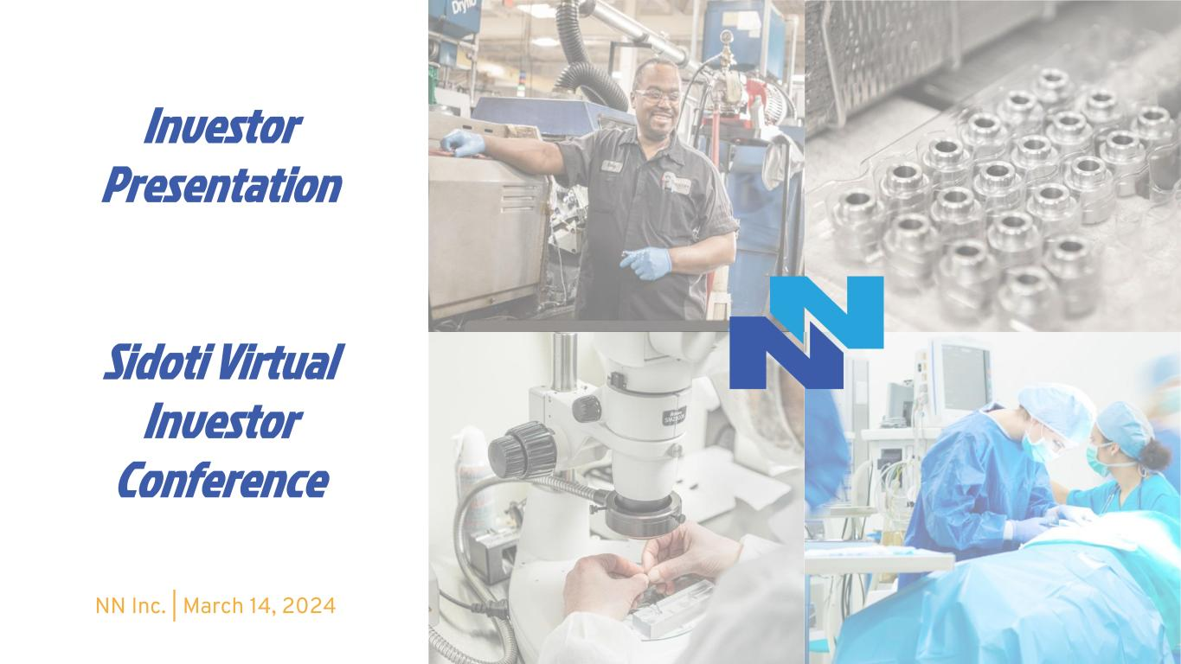

Investor Presentation Sidoti Virtual Investor Conference NN Inc. | March 14, 2024

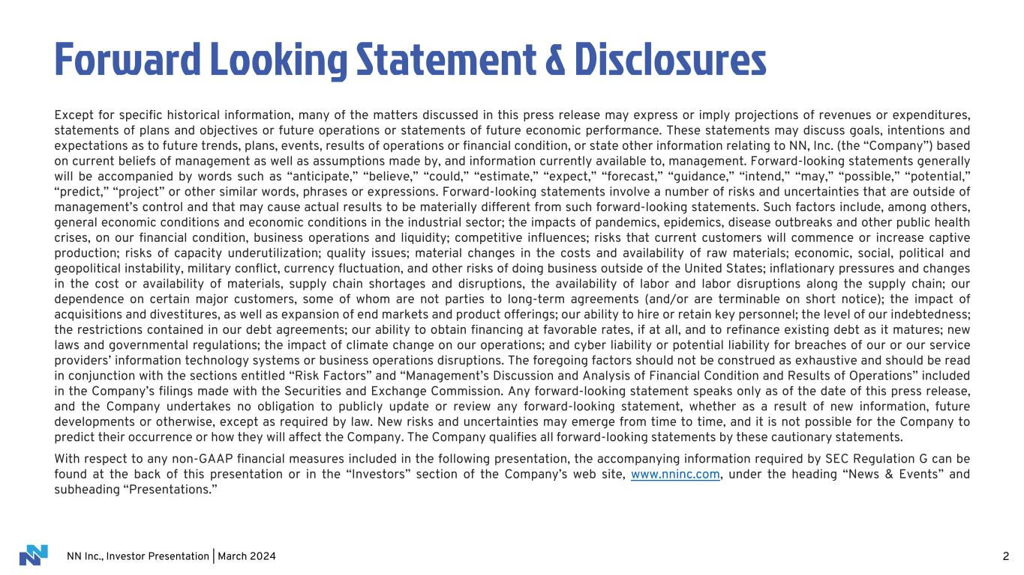
NN Inc., Investor Presentation | March 2024 2 Forward Looking Statement & Disclosures Except for specific historical information, many of the matters discussed in this press release may express or imply projections of revenues or expenditures, statements of plans and objectives or future operations or statements of future economic performance. These statements may discuss goals, intentions and expectations as to future trends, plans, events, results of operations or financial condition, or state other information relating to NN, Inc. (the “Company”) based on current beliefs of management as well as assumptions made by, and information currently available to, management. Forward-looking statements generally will be accompanied by words such as “anticipate,” “believe,” “could,” “estimate,” “expect,” “forecast,” “guidance,” “intend,” “may,” “possible,” “potential,” “predict,” “project” or other similar words, phrases or expressions. Forward-looking statements involve a number of risks and uncertainties that are outside of management’s control and that may cause actual results to be materially different from such forward-looking statements. Such factors include, among others, general economic conditions and economic conditions in the industrial sector; the impacts of pandemics, epidemics, disease outbreaks and other public health crises, on our financial condition, business operations and liquidity; competitive influences; risks that current customers will commence or increase captive production; risks of capacity underutilization; quality issues; material changes in the costs and availability of raw materials; economic, social, political and geopolitical instability, military conflict, currency fluctuation, and other risks of doing business outside of the United States; inflationary pressures and changes in the cost or availability of materials, supply chain shortages and disruptions, the availability of labor and labor disruptions along the supply chain; our dependence on certain major customers, some of whom are not parties to long-term agreements (and/or are terminable on short notice); the impact of acquisitions and divestitures, as well as expansion of end markets and product offerings; our ability to hire or retain key personnel; the level of our indebtedness; the restrictions contained in our debt agreements; our ability to obtain financing at favorable rates, if at all, and to refinance existing debt as it matures; new laws and governmental regulations; the impact of climate change on our operations; and cyber liability or potential liability for breaches of our or our service providers’ information technology systems or business operations disruptions. The foregoing factors should not be construed as exhaustive and should be read in conjunction with the sections entitled “Risk Factors” and “Management’s Discussion and Analysis of Financial Condition and Results of Operations” included in the Company’s filings made with the Securities and Exchange Commission. Any forward-looking statement speaks only as of the date of this press release, and the Company undertakes no obligation to publicly update or review any forward-looking statement, whether as a result of new information, future developments or otherwise, except as required by law. New risks and uncertainties may emerge from time to time, and it is not possible for the Company to predict their occurrence or how they will affect the Company. The Company qualifies all forward-looking statements by these cautionary statements. With respect to any non-GAAP financial measures included in the following presentation, the accompanying information required by SEC Regulation G can be found at the back of this presentation or in the “Investors” section of the Company’s web site, www.nninc.com, under the heading “News & Events” and subheading “Presentations.”

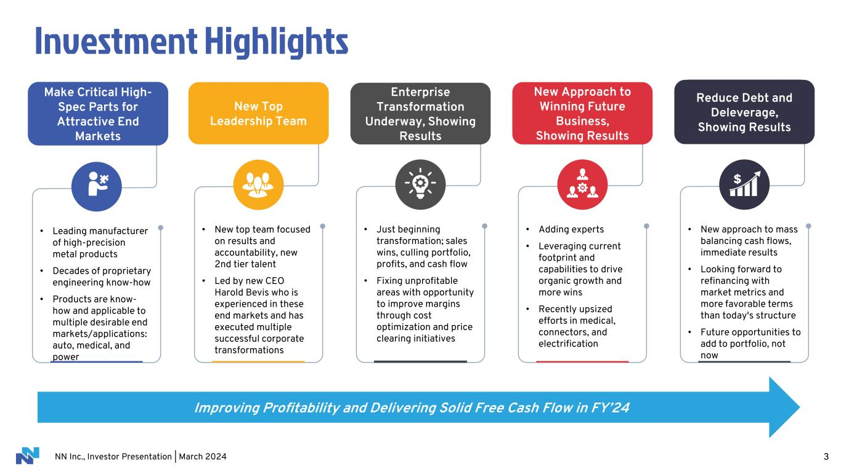
NN Inc., Investor Presentation | March 2024 3 • Leading manufacturer of high-precision metal products • Decades of proprietary engineering know-how • Products are know- how and applicable to multiple desirable end markets/applications: auto, medical, and power Make Critical High- Spec Parts for Attractive End Markets • New top team focused on results and accountability, new 2nd tier talent • Led by new CEO Harold Bevis who is experienced in these end markets and has executed multiple successful corporate transformations New Top Leadership Team • Just beginning transformation; sales wins, culling portfolio, profits, and cash flow • Fixing unprofitable areas with opportunity to improve margins through cost optimization and price clearing initiatives Enterprise Transformation Underway, Showing Results • Adding experts • Leveraging current footprint and capabilities to drive organic growth and more wins • Recently upsized efforts in medical, connectors, and electrification New Approach to Winning Future Business, Showing Results • New approach to mass balancing cash flows, immediate results • Looking forward to refinancing with market metrics and more favorable terms than today's structure • Future opportunities to add to portfolio, not now Reduce Debt and Deleverage, Showing Results Investment Highlights Improving Profitability and Delivering Solid Free Cash Flow in FY’24

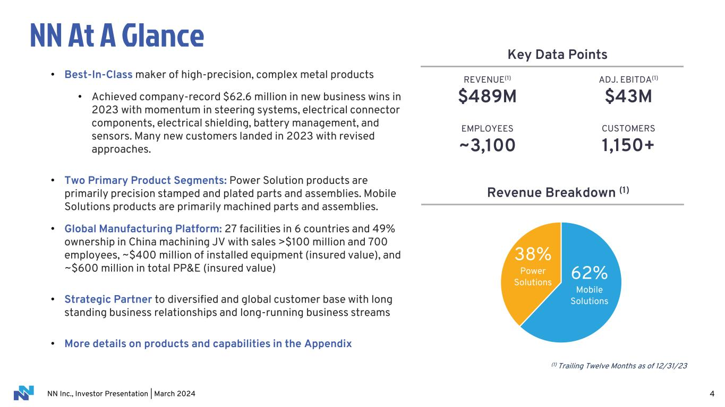
NN Inc., Investor Presentation | March 2024 NN At A Glance 4 (1) Trailing Twelve Months as of 12/31/23 • Best-In-Class maker of high-precision, complex metal products • Achieved company-record $62.6 million in new business wins in 2023 with momentum in steering systems, electrical connector components, electrical shielding, battery management, and sensors. Many new customers landed in 2023 with revised approaches. • Two Primary Product Segments: Power Solution products are primarily precision stamped and plated parts and assemblies. Mobile Solutions products are primarily machined parts and assemblies. • Global Manufacturing Platform: 27 facilities in 6 countries and 49% ownership in China machining JV with sales >$100 million and 700 employees, ~$400 million of installed equipment (insured value), and ~$600 million in total PP&E (insured value) • Strategic Partner to diversified and global customer base with long standing business relationships and long-running business streams • More details on products and capabilities in the Appendix Key Data Points REVENUE(1) $489M ADJ. EBITDA(1) $43M CUSTOMERS 1,150+ EMPLOYEES ~3,100 Revenue Breakdown (1) 62% Mobile Solutions 38% Power Solutions

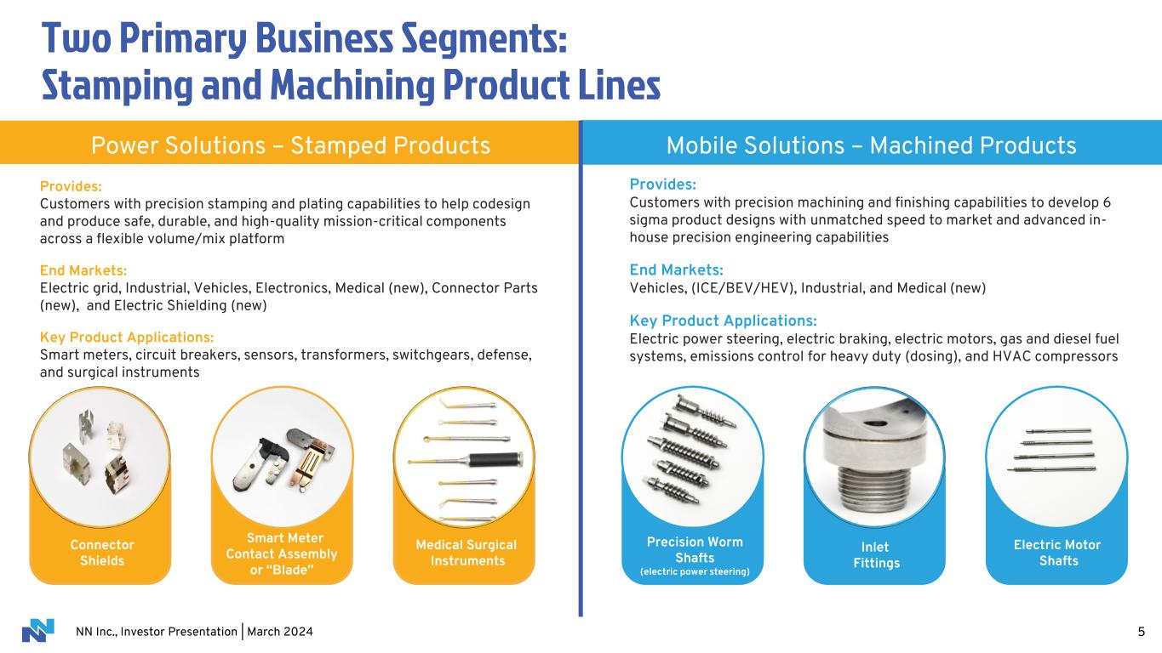
NN Inc., Investor Presentation | March 2024 Two Primary Business Segments: Stamping and Machining Product Lines 5 Provides: Customers with precision stamping and plating capabilities to help codesign and produce safe, durable, and high-quality mission-critical components across a flexible volume/mix platform End Markets: Electric grid, Industrial, Vehicles, Electronics, Medical (new), Connector Parts (new), and Electric Shielding (new) Key Product Applications: Smart meters, circuit breakers, sensors, transformers, switchgears, defense, and surgical instruments Power Solutions – Stamped Products Mobile Solutions – Machined Products Provides: Customers with precision machining and finishing capabilities to develop 6 sigma product designs with unmatched speed to market and advanced in- house precision engineering capabilities End Markets: Vehicles, (ICE/BEV/HEV), Industrial, and Medical (new) Key Product Applications: Electric power steering, electric braking, electric motors, gas and diesel fuel systems, emissions control for heavy duty (dosing), and HVAC compressors Precision Worm Shafts (electric power steering) Inlet Fittings Electric Motor Shafts Connector Shields Smart Meter Contact Assembly or “Blade” Medical Surgical Instruments

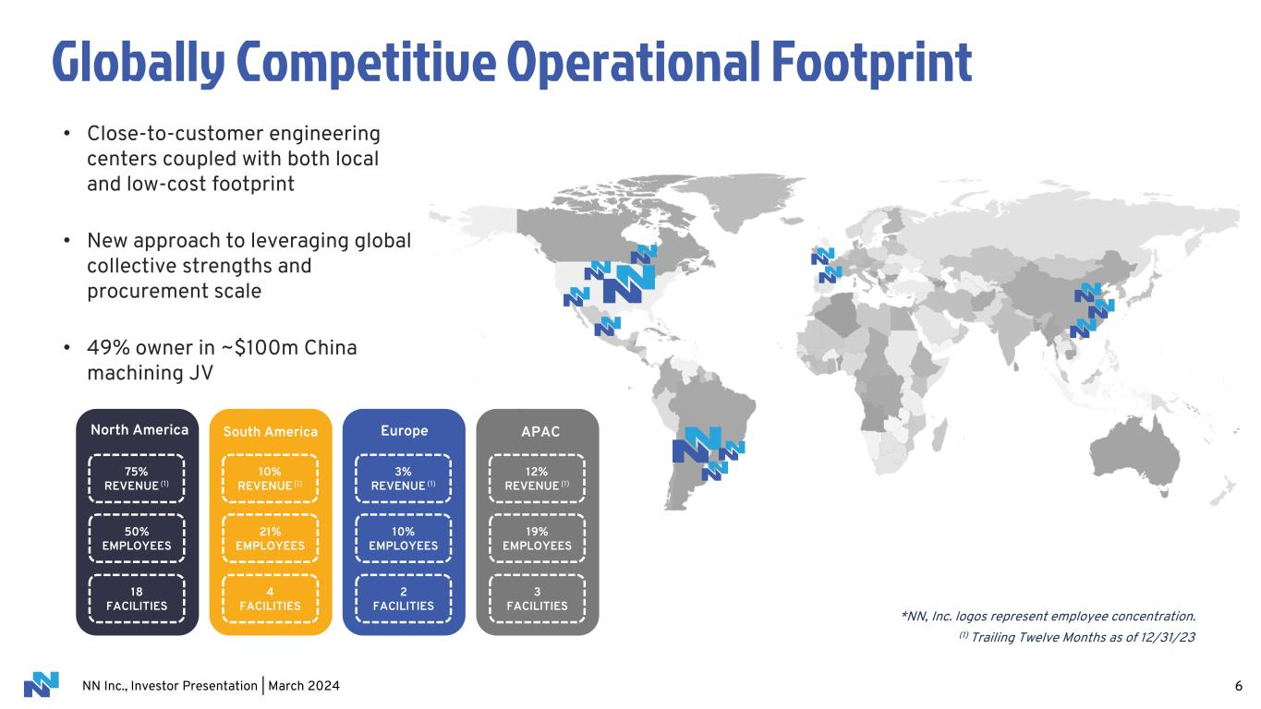
NN Inc., Investor Presentation | March 2024 • Close-to-customer engineering centers coupled with both local and low-cost footprint • New approach to leveraging global collective strengths and procurement scale • 49% owner in ~$100m China machining JV Globally Competitive Operational Footprint 6 North America 75% REVENUE (1) 50% EMPLOYEES 18 FACILITIES Europe 3% REVENUE (1) 10% EMPLOYEES 2 FACILITIES South America 10% REVENUE (1) 21% EMPLOYEES 4 FACILITIES APAC 12% REVENUE (1) 19% EMPLOYEES 3 FACILITIES (1) Trailing Twelve Months as of 12/31/23 *NN, Inc. logos represent employee concentration.

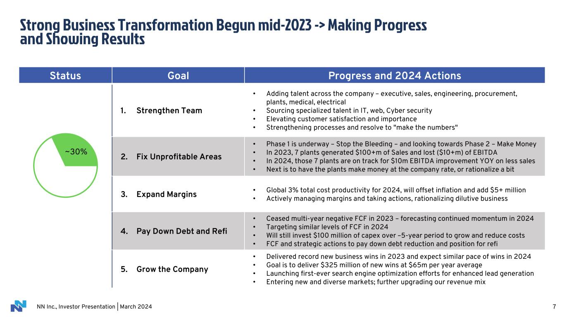
NN Inc., Investor Presentation | March 2024 7 Status Goal Progress and 2024 Actions 1. Strengthen Team • Adding talent across the company – executive, sales, engineering, procurement, plants, medical, electrical • Sourcing specialized talent in IT, web, Cyber security • Elevating customer satisfaction and importance • Strengthening processes and resolve to "make the numbers" 2. Fix Unprofitable Areas • Phase 1 is underway – Stop the Bleeding – and looking towards Phase 2 – Make Money • In 2023, 7 plants generated $100+m of Sales and lost ($10+m) of EBITDA • In 2024, those 7 plants are on track for $10m EBITDA improvement YOY on less sales • Next is to have the plants make money at the company rate, or rationalize a bit 3. Expand Margins • Global 3% total cost productivity for 2024, will offset inflation and add $5+ million • Actively managing margins and taking actions, rationalizing dilutive business 4. Pay Down Debt and Refi • Ceased multi-year negative FCF in 2023 – forecasting continued momentum in 2024 • Targeting similar levels of FCF in 2024 • Will still invest $100 million of capex over –5-year period to grow and reduce costs • FCF and strategic actions to pay down debt reduction and position for refi 5. Grow the Company • Delivered record new business wins in 2023 and expect similar pace of wins in 2024 • Goal is to deliver $325 million of new wins at $65m per year average • Launching first-ever search engine optimization efforts for enhanced lead generation • Entering new and diverse markets; further upgrading our revenue mix ~30% Strong Business Transformation Begun mid-2023 -> Making Progress and Showing Results

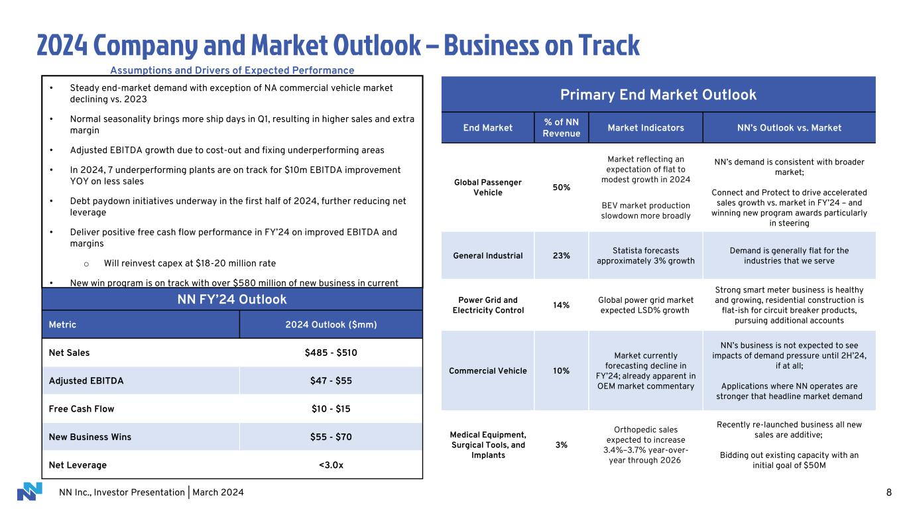
NN Inc., Investor Presentation | March 2024 2024 Company and Market Outlook – Business on Track 8 Assumptions and Drivers of Expected Performance • Steady end-market demand with exception of NA commercial vehicle market declining vs. 2023 • Normal seasonality brings more ship days in Q1, resulting in higher sales and extra margin • Adjusted EBITDA growth due to cost-out and fixing underperforming areas • In 2024, 7 underperforming plants are on track for $10m EBITDA improvement YOY on less sales • Debt paydown initiatives underway in the first half of 2024, further reducing net leverage • Deliver positive free cash flow performance in FY’24 on improved EBITDA and margins o Will reinvest capex at $18-20 million rate • New win program is on track with over $580 million of new business in current pipeline NN FY’24 Outlook Metric 2024 Outlook ($mm) Net Sales $485 - $510 Adjusted EBITDA $47 - $55 Free Cash Flow $10 - $15 New Business Wins $55 - $70 Net Leverage <3.0x Primary End Market Outlook End Market % of NN Revenue Market Indicators NN’s Outlook vs. Market Global Passenger Vehicle 50% Market reflecting an expectation of flat to modest growth in 2024 BEV market production slowdown more broadly NN’s demand is consistent with broader market; Connect and Protect to drive accelerated sales growth vs. market in FY’24 – and winning new program awards particularly in steering General Industrial 23% Statista forecasts approximately 3% growth Demand is generally flat for the industries that we serve Power Grid and Electricity Control 14% Global power grid market expected LSD% growth Strong smart meter business is healthy and growing, residential construction is flat-ish for circuit breaker products, pursuing additional accounts Commercial Vehicle 10% Market currently forecasting decline in FY’24; already apparent in OEM market commentary NN’s business is not expected to see impacts of demand pressure until 2H’24, if at all; Applications where NN operates are stronger that headline market demand Medical Equipment, Surgical Tools, and Implants 3% Orthopedic sales expected to increase 3.4%–3.7% year-over- year through 2026 Recently re-launched business all new sales are additive; Bidding out existing capacity with an initial goal of $50M

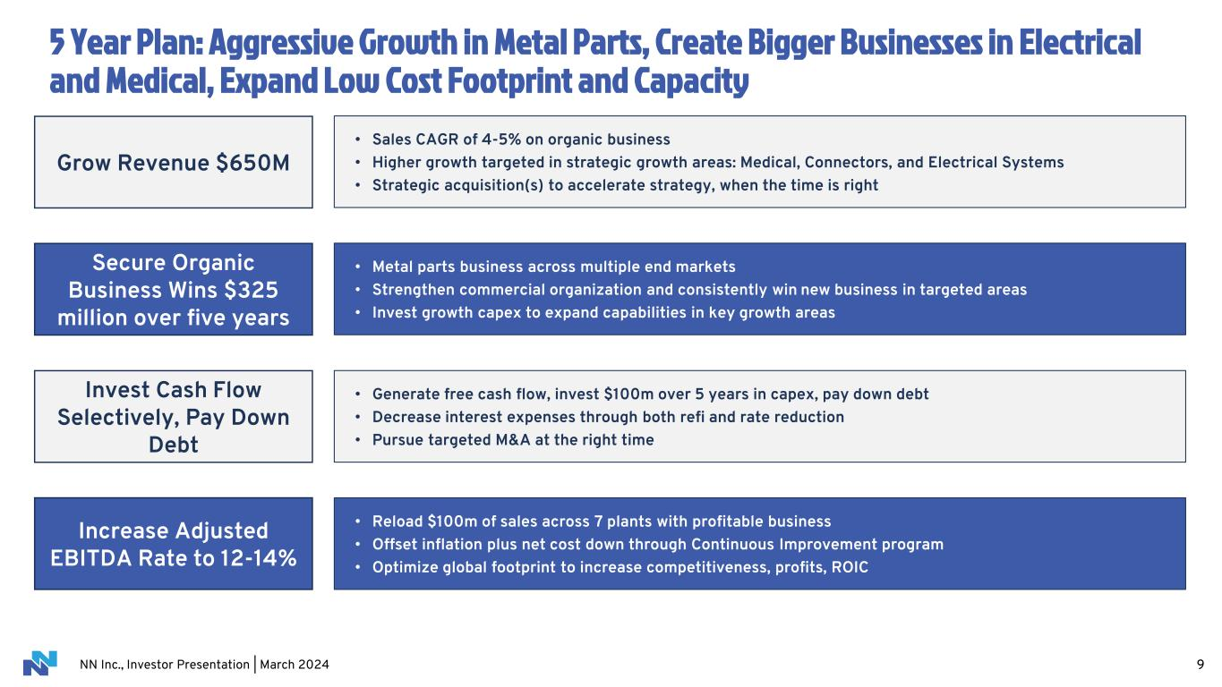
NN Inc., Investor Presentation | March 2024 5 Year Plan: Aggressive Growth in Metal Parts, Create Bigger Businesses in Electrical and Medical, Expand Low Cost Footprint and Capacity 9 • Sales CAGR of 4-5% on organic business • Higher growth targeted in strategic growth areas: Medical, Connectors, and Electrical Systems • Strategic acquisition(s) to accelerate strategy, when the time is right • Generate free cash flow, invest $100m over 5 years in capex, pay down debt • Decrease interest expenses through both refi and rate reduction • Pursue targeted M&A at the right time • Metal parts business across multiple end markets • Strengthen commercial organization and consistently win new business in targeted areas • Invest growth capex to expand capabilities in key growth areas • Reload $100m of sales across 7 plants with profitable business • Offset inflation plus net cost down through Continuous Improvement program • Optimize global footprint to increase competitiveness, profits, ROIC Grow Revenue $650M Secure Organic Business Wins $325 million over five years Invest Cash Flow Selectively, Pay Down Debt Increase Adjusted EBITDA Rate to 12-14%

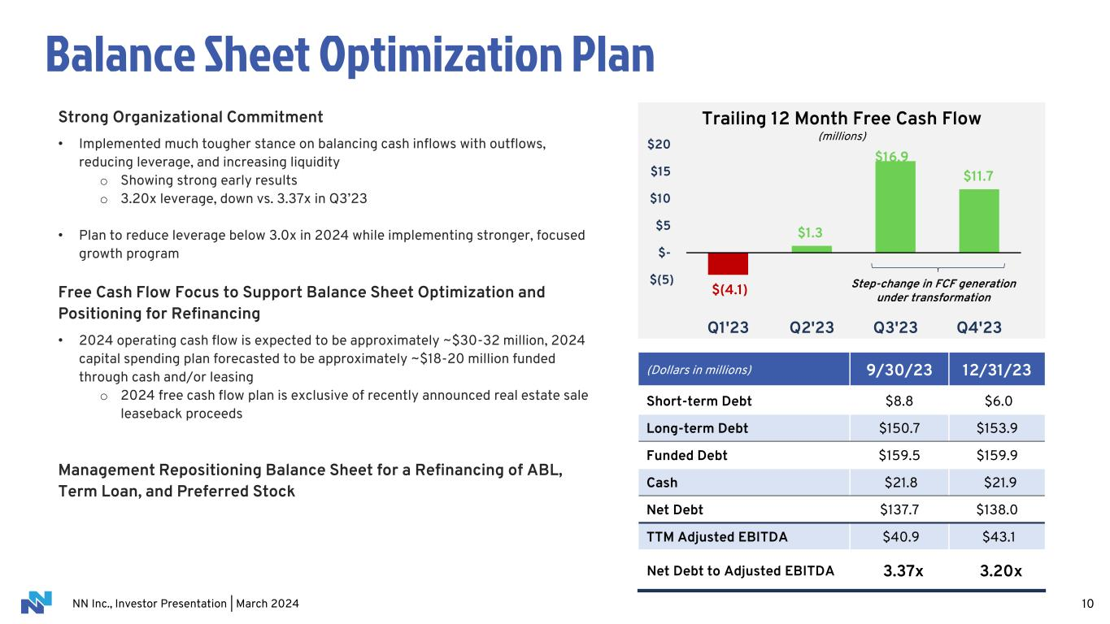
NN Inc., Investor Presentation | March 2024 10 Balance Sheet Optimization Plan Strong Organizational Commitment • Implemented much tougher stance on balancing cash inflows with outflows, reducing leverage, and increasing liquidity o Showing strong early results o 3.20x leverage, down vs. 3.37x in Q3’23 • Plan to reduce leverage below 3.0x in 2024 while implementing stronger, focused growth program Free Cash Flow Focus to Support Balance Sheet Optimization and Positioning for Refinancing • 2024 operating cash flow is expected to be approximately ~$30-32 million, 2024 capital spending plan forecasted to be approximately ~$18-20 million funded through cash and/or leasing o 2024 free cash flow plan is exclusive of recently announced real estate sale leaseback proceeds Management Repositioning Balance Sheet for a Refinancing of ABL, Term Loan, and Preferred Stock (Dollars in millions) 9/30/23 12/31/23 Short-term Debt $8.8 $6.0 Long-term Debt $150.7 $153.9 Funded Debt $159.5 $159.9 Cash $21.8 $21.9 Net Debt $137.7 $138.0 TTM Adjusted EBITDA $40.9 $43.1 Net Debt to Adjusted EBITDA 3.37x 3.20x $(4.1) $1.3 $11.7 $(5) $- $5 $10 $15 $20 Q1'23 Q2'23 Q3'23 Q4'23 Trailing 12 Month Free Cash Flow (millions) Step-change in FCF generation under transformation $16.9

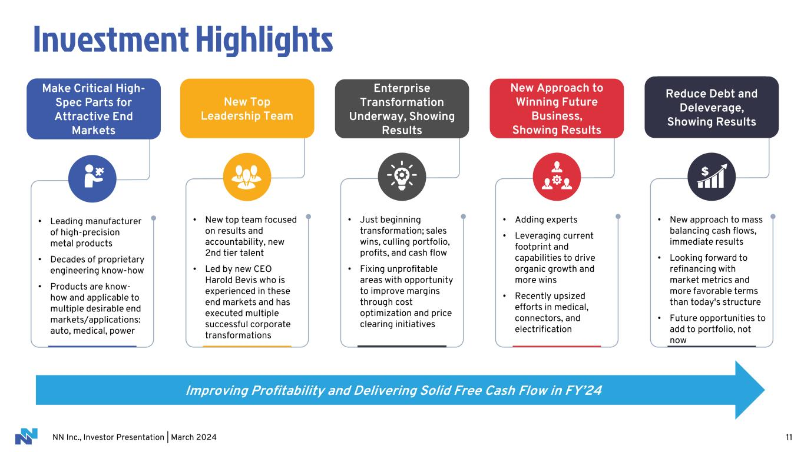
NN Inc., Investor Presentation | March 2024 11 • Leading manufacturer of high-precision metal products • Decades of proprietary engineering know-how • Products are know- how and applicable to multiple desirable end markets/applications: auto, medical, power Make Critical High- Spec Parts for Attractive End Markets • New top team focused on results and accountability, new 2nd tier talent • Led by new CEO Harold Bevis who is experienced in these end markets and has executed multiple successful corporate transformations New Top Leadership Team • Just beginning transformation; sales wins, culling portfolio, profits, and cash flow • Fixing unprofitable areas with opportunity to improve margins through cost optimization and price clearing initiatives Enterprise Transformation Underway, Showing Results • Adding experts • Leveraging current footprint and capabilities to drive organic growth and more wins • Recently upsized efforts in medical, connectors, and electrification New Approach to Winning Future Business, Showing Results • New approach to mass balancing cash flows, immediate results • Looking forward to refinancing with market metrics and more favorable terms than today's structure • Future opportunities to add to portfolio, not now Reduce Debt and Deleverage, Showing Results Investment Highlights Improving Profitability and Delivering Solid Free Cash Flow in FY’24

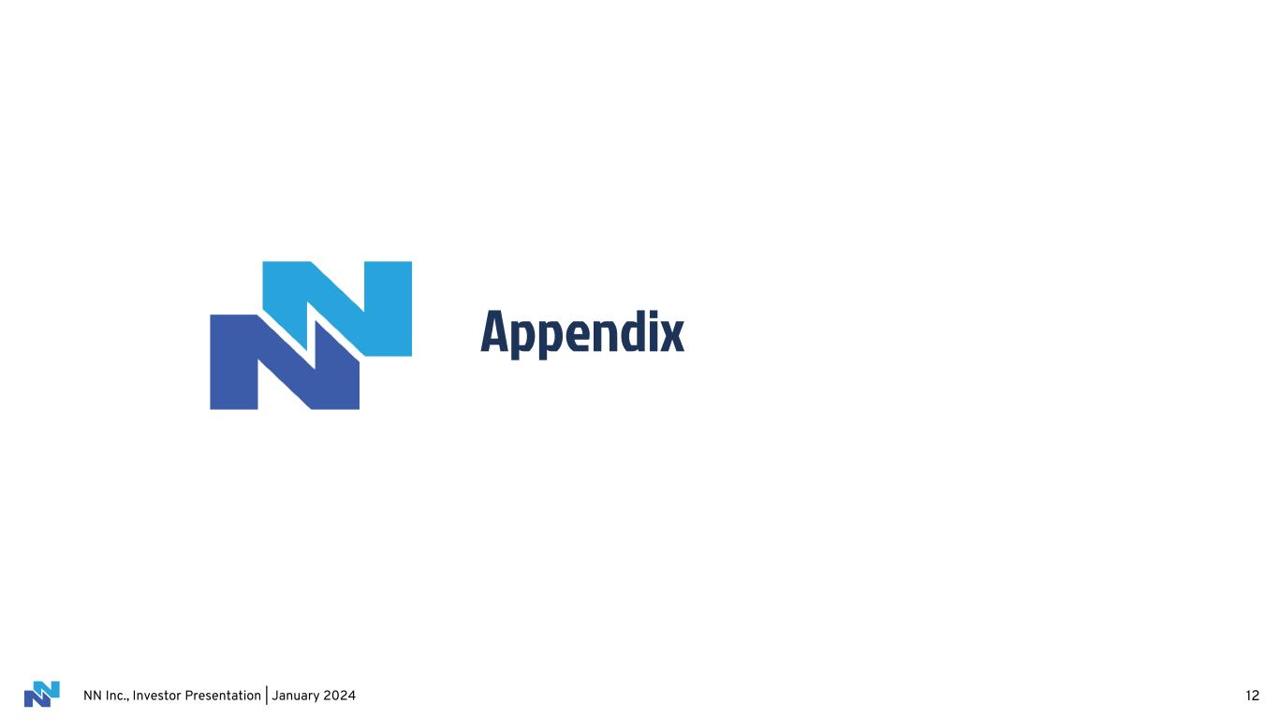
NN Inc., Investor Presentation | January 2024 Appendix 12

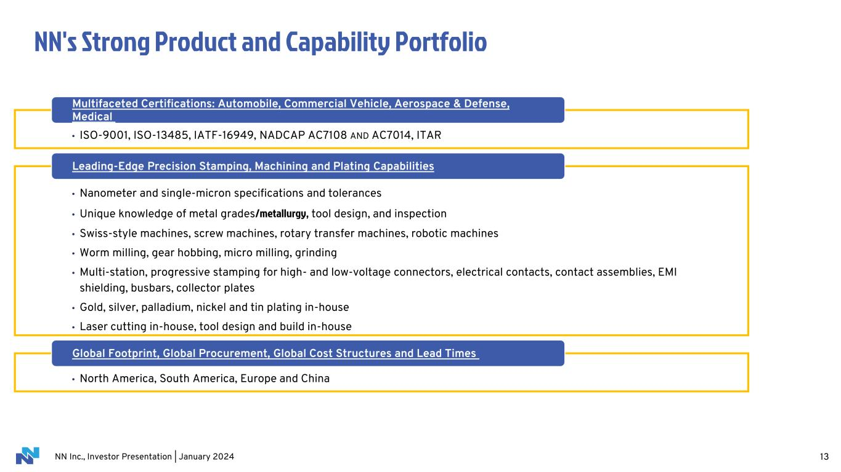
NN Inc., Investor Presentation | January 2024 NN's Strong Product and Capability Portfolio 13 • ISO-9001, ISO-13485, IATF-16949, NADCAP AC7108 AND AC7014, ITAR Multifaceted Certifications: Automobile, Commercial Vehicle, Aerospace & Defense, Medical • Nanometer and single-micron specifications and tolerances • Unique knowledge of metal grades/metallurgy, tool design, and inspection • Swiss-style machines, screw machines, rotary transfer machines, robotic machines • Worm milling, gear hobbing, micro milling, grinding • Multi-station, progressive stamping for high- and low-voltage connectors, electrical contacts, contact assemblies, EMI shielding, busbars, collector plates • Gold, silver, palladium, nickel and tin plating in-house • Laser cutting in-house, tool design and build in-house Leading-Edge Precision Stamping, Machining and Plating Capabilities • North America, South America, Europe and China Global Footprint, Global Procurement, Global Cost Structures and Lead Times

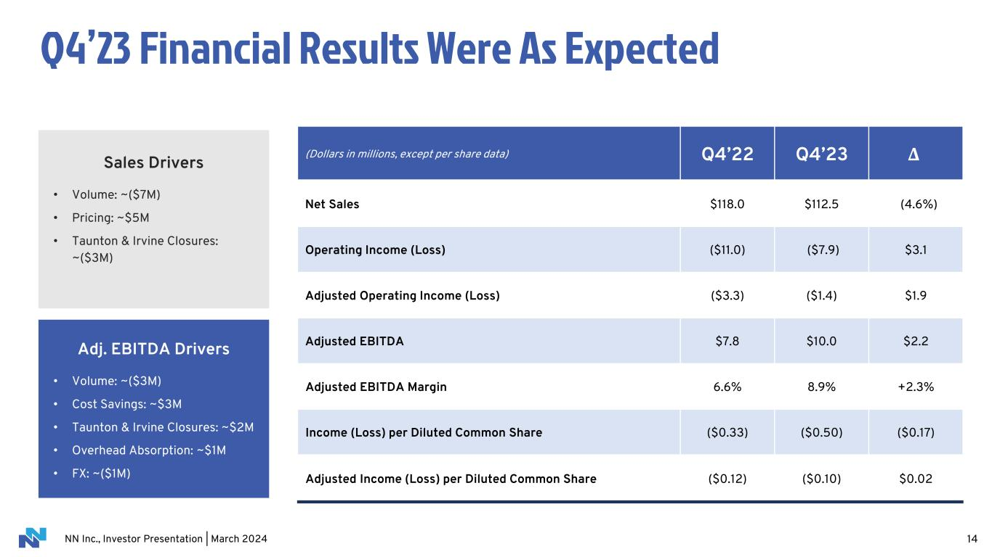
NN Inc., Investor Presentation | March 2024 14 Q4’23 Financial Results Were As Expected Sales Drivers • Volume: ~($7M) • Pricing: ~$5M • Taunton & Irvine Closures: ~($3M) (Dollars in millions, except per share data) Q4’22 Q4’23 Δ Net Sales $118.0 $112.5 (4.6%) Operating Income (Loss) ($11.0) ($7.9) $3.1 Adjusted Operating Income (Loss) ($3.3) ($1.4) $1.9 Adjusted EBITDA $7.8 $10.0 $2.2 Adjusted EBITDA Margin 6.6% 8.9% +2.3% Income (Loss) per Diluted Common Share ($0.33) ($0.50) ($0.17) Adjusted Income (Loss) per Diluted Common Share ($0.12) ($0.10) $0.02 Adj. EBITDA Drivers • Volume: ~($3M) • Cost Savings: ~$3M • Taunton & Irvine Closures: ~$2M • Overhead Absorption: ~$1M • FX: ~($1M)

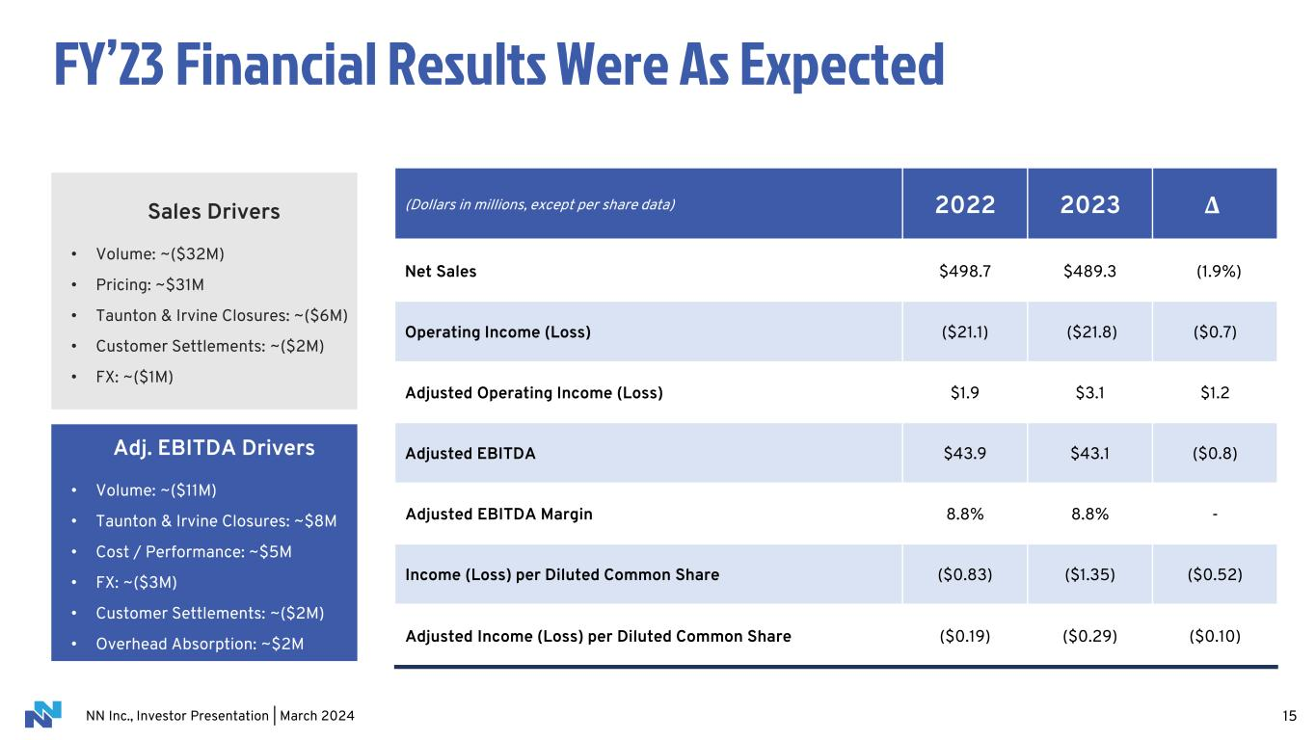
NN Inc., Investor Presentation | March 2024 15 FY’23 Financial Results Were As Expected (Dollars in millions, except per share data) 2022 2023 Δ Net Sales $498.7 $489.3 (1.9%) Operating Income (Loss) ($21.1) ($21.8) ($0.7) Adjusted Operating Income (Loss) $1.9 $3.1 $1.2 Adjusted EBITDA $43.9 $43.1 ($0.8) Adjusted EBITDA Margin 8.8% 8.8% - Income (Loss) per Diluted Common Share ($0.83) ($1.35) ($0.52) Adjusted Income (Loss) per Diluted Common Share ($0.19) ($0.29) ($0.10) Sales Drivers • Volume: ~($32M) • Pricing: ~$31M • Taunton & Irvine Closures: ~($6M) • Customer Settlements: ~($2M) • FX: ~($1M) Adj. EBITDA Drivers • Volume: ~($11M) • Taunton & Irvine Closures: ~$8M • Cost / Performance: ~$5M • FX: ~($3M) • Customer Settlements: ~($2M) • Overhead Absorption: ~$2M

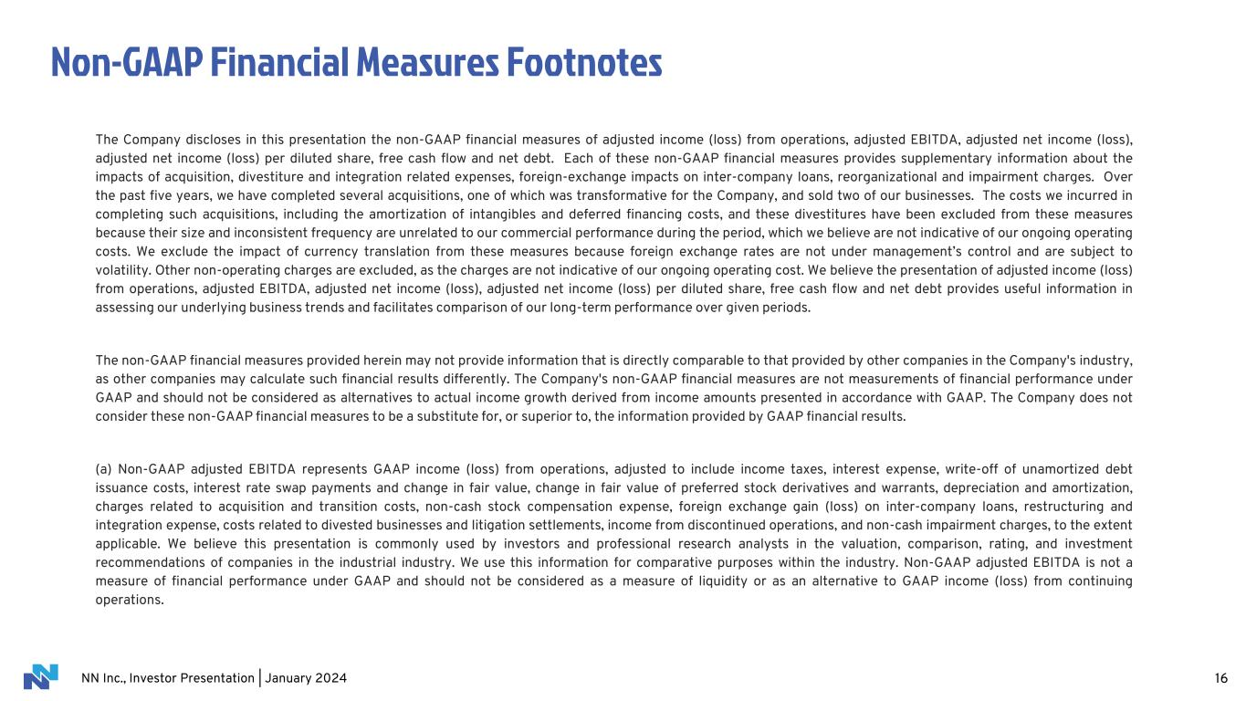
NN Inc., Investor Presentation | January 2024 Non-GAAP Financial Measures Footnotes The Company discloses in this presentation the non-GAAP financial measures of adjusted income (loss) from operations, adjusted EBITDA, adjusted net income (loss), adjusted net income (loss) per diluted share, free cash flow and net debt. Each of these non-GAAP financial measures provides supplementary information about the impacts of acquisition, divestiture and integration related expenses, foreign-exchange impacts on inter-company loans, reorganizational and impairment charges. Over the past five years, we have completed several acquisitions, one of which was transformative for the Company, and sold two of our businesses. The costs we incurred in completing such acquisitions, including the amortization of intangibles and deferred financing costs, and these divestitures have been excluded from these measures because their size and inconsistent frequency are unrelated to our commercial performance during the period, which we believe are not indicative of our ongoing operating costs. We exclude the impact of currency translation from these measures because foreign exchange rates are not under management’s control and are subject to volatility. Other non-operating charges are excluded, as the charges are not indicative of our ongoing operating cost. We believe the presentation of adjusted income (loss) from operations, adjusted EBITDA, adjusted net income (loss), adjusted net income (loss) per diluted share, free cash flow and net debt provides useful information in assessing our underlying business trends and facilitates comparison of our long-term performance over given periods. The non-GAAP financial measures provided herein may not provide information that is directly comparable to that provided by other companies in the Company's industry, as other companies may calculate such financial results differently. The Company's non-GAAP financial measures are not measurements of financial performance under GAAP and should not be considered as alternatives to actual income growth derived from income amounts presented in accordance with GAAP. The Company does not consider these non-GAAP financial measures to be a substitute for, or superior to, the information provided by GAAP financial results. (a) Non-GAAP adjusted EBITDA represents GAAP income (loss) from operations, adjusted to include income taxes, interest expense, write-off of unamortized debt issuance costs, interest rate swap payments and change in fair value, change in fair value of preferred stock derivatives and warrants, depreciation and amortization, charges related to acquisition and transition costs, non-cash stock compensation expense, foreign exchange gain (loss) on inter-company loans, restructuring and integration expense, costs related to divested businesses and litigation settlements, income from discontinued operations, and non-cash impairment charges, to the extent applicable. We believe this presentation is commonly used by investors and professional research analysts in the valuation, comparison, rating, and investment recommendations of companies in the industrial industry. We use this information for comparative purposes within the industry. Non-GAAP adjusted EBITDA is not a measure of financial performance under GAAP and should not be considered as a measure of liquidity or as an alternative to GAAP income (loss) from continuing operations. 16

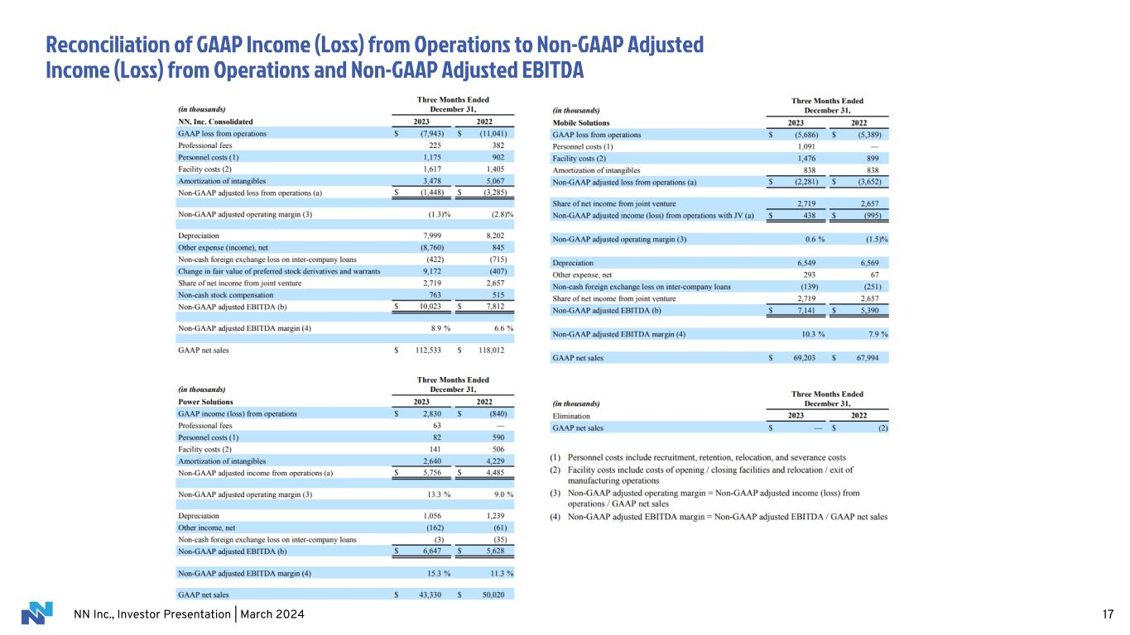
NN Inc., Investor Presentation | March 2024 Reconciliation of GAAP Income (Loss) from Operations to Non-GAAP Adjusted Income (Loss) from Operations and Non-GAAP Adjusted EBITDA 17

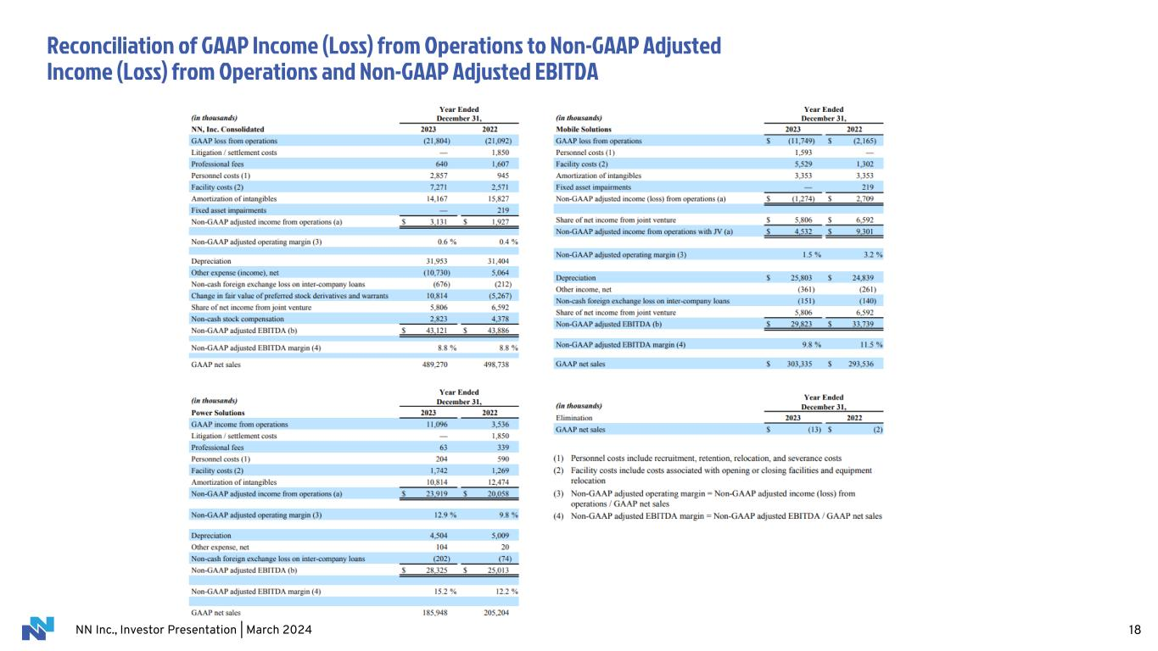
NN Inc., Investor Presentation | March 2024 Reconciliation of GAAP Income (Loss) from Operations to Non-GAAP Adjusted Income (Loss) from Operations and Non-GAAP Adjusted EBITDA 18

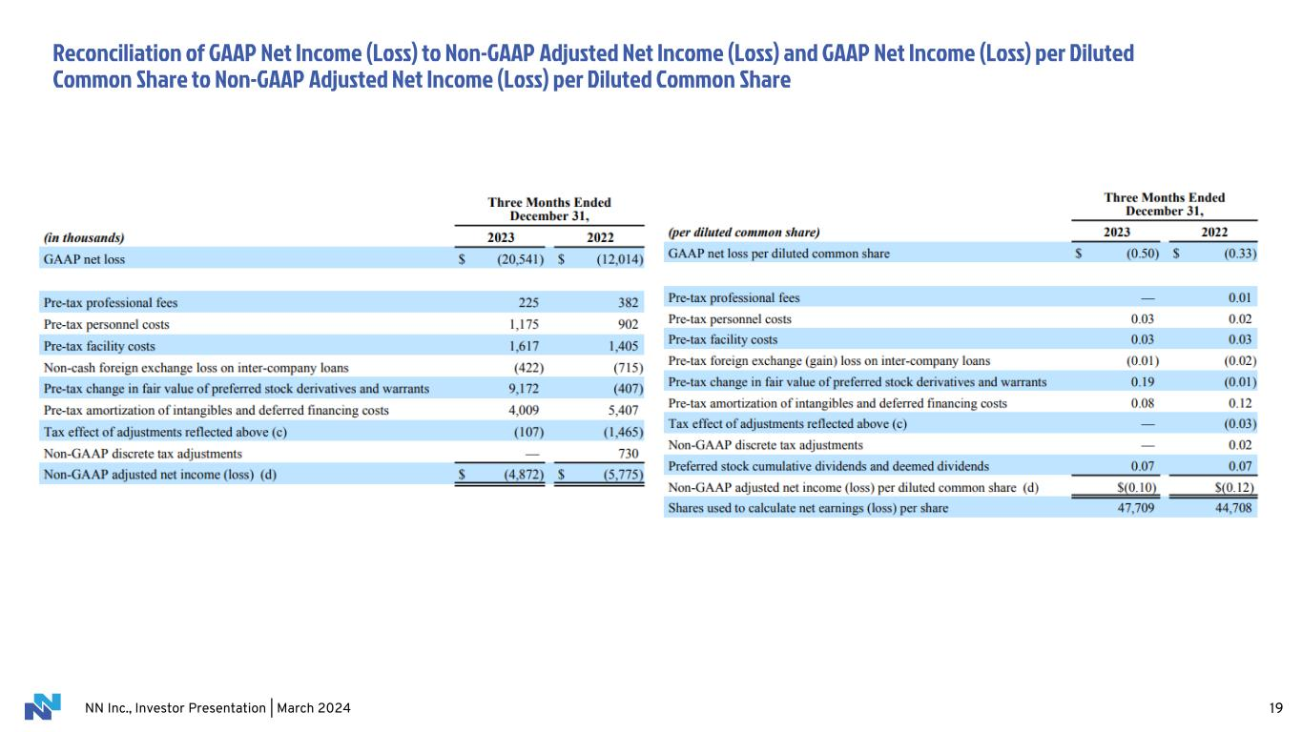
NN Inc., Investor Presentation | March 2024 Reconciliation of GAAP Net Income (Loss) to Non-GAAP Adjusted Net Income (Loss) and GAAP Net Income (Loss) per Diluted Common Share to Non-GAAP Adjusted Net Income (Loss) per Diluted Common Share 19

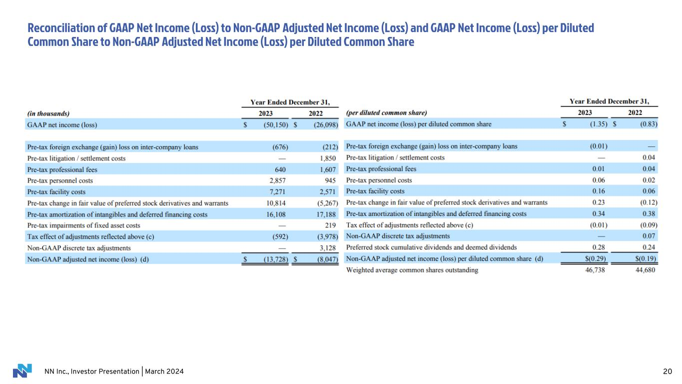
NN Inc., Investor Presentation | March 2024 Reconciliation of GAAP Net Income (Loss) to Non-GAAP Adjusted Net Income (Loss) and GAAP Net Income (Loss) per Diluted Common Share to Non-GAAP Adjusted Net Income (Loss) per Diluted Common Share 20

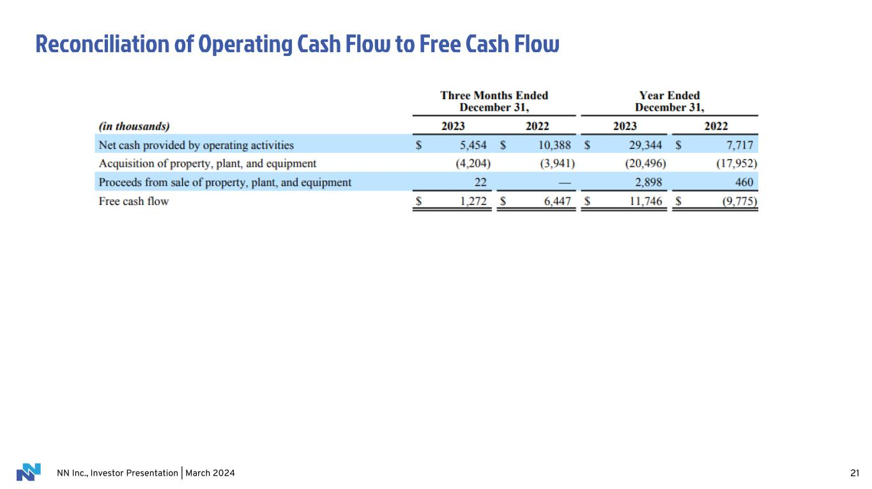
NN Inc., Investor Presentation | March 2024 Reconciliation of Operating Cash Flow to Free Cash Flow 21

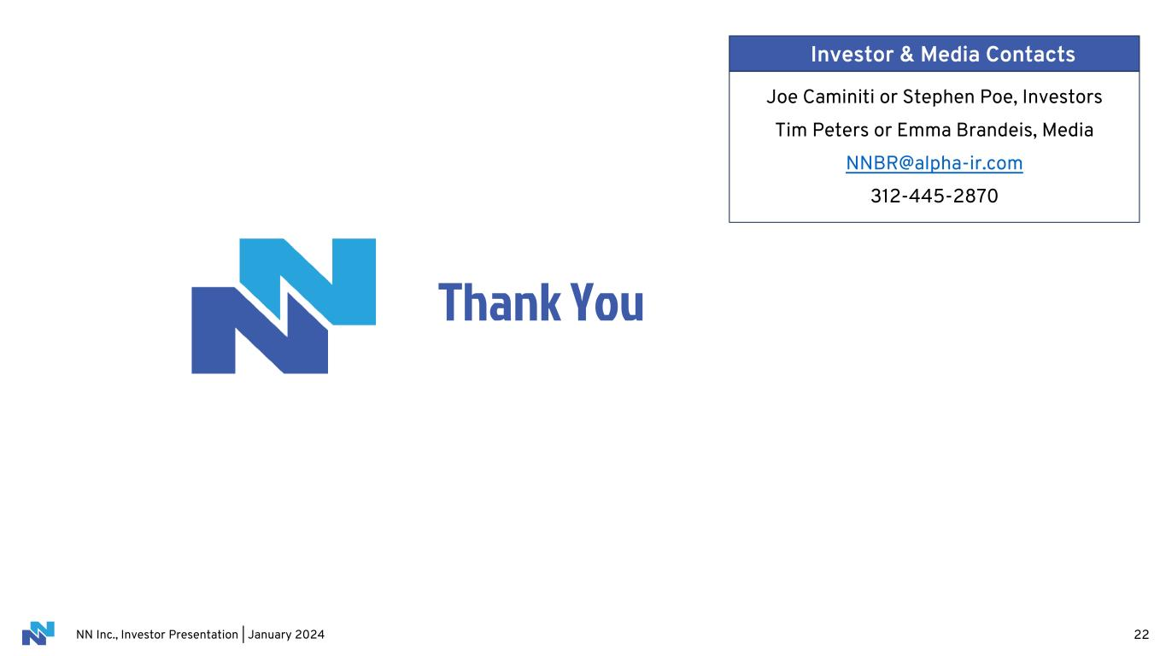
NN Inc., Investor Presentation | January 2024 Thank You 22 Joe Caminiti or Stephen Poe, Investors Tim Peters or Emma Brandeis, Media NNBR@alpha-ir.com 312-445-2870 Investor & Media Contacts

