UNITED STATES

SECURITIES AND EXCHANGE COMMISSION
WASHINGTON, DC 20549

FORM 8-K/A

(Amendment No. 2)

CURRENT REPORT

PURSUANT TO SECTION 13 OR 15(d)
OF THE SECURITIES EXCHANGE ACT OF 1934

Date of Report (Date of earliest event reported): July 21, 2014


NN, INC.

(Exact name of registrant as specified in its charter)

Delaware | 0-23486 | 62-1096725
(State or Other Jurisdiction | (Commission | (I.R.S. Employer
of Incorporation) | File Number) | Identification No.)
2000 Waters Edge Drive, Johnson City, Tennessee |  | 37604
(Address of principal executive offices) |  | (Zip Code)

(423) 743-9151

(Registrant’s telephone number, including area code)

(Former name or former address, if changed since last report)

Check the appropriate box if the Form 8-K filing is intended to simultaneously satisfy the filing obligation of the registrant under any of the following provisions (see General Instruction A.2. below):

- Written communications pursuant to Rule 425 under the Securities Act (17 CFR 230.425)

- Soliciting material pursuant to Rule 14a-12 under the Exchange Act (17 CFR 240.14a-12)

- Pre-commencement communications pursuant to Rule 14d-2(b) under the Exchange Act (17 CFR 240.14d- 2(b))

- Pre-commencement communications pursuant to Rule 13e-4(c) under the Exchange Act (17 CFR 240.13e- 4(c))

EXPLANATORY NOTE

This Amendment No. 2 on Form 8-K/A amends the Current Report on Form 8-K of NN, Inc. (the “Company”) filed with the Securities and Exchange Commission on July 22, 2014 (the “Original 8-K”), as amended by the Company’s Current Report on Form 8-K/A filed with the SEC on August 8, 2014. The Company has further revised the investor presentation filed as Exhibit 99.3 to the Original 8-K. No other changes were made to the Original 8-K or the other exhibits filed therewith.

Item 8.01 OTHER EVENTS

On August 12, 2014, the Company posted a revised investor presentation to its website regarding the merger contemplated by that certain Agreement and Plan of Merger, dated July 18, 2014, by and among the Company, PMC Global Acquisition Corporation, a Michigan corporation, Autocam Corporation, a Michigan corporation, Newport Global Advisors, L.P., a Delaware limited partnership, solely in its capacity as a shareholder representative, and John C. Kennedy, solely in his capacity as a shareholder representative and with respect to certain sections of the merger agreement. A copy of the revised investor presentation is attached hereto as Exhibit 99.1.

Item 9.01 |  |  | FINANCIAL STATEMENTS AND EXHIBITS
Exhibit |  |  | Description
No.
99.1 |  |  | Investor Presentation Slides, dated August 12, 2014.

SIGNATURES

Pursuant to the requirements of the Securities Exchange Act of 1934, the registrant has duly caused this report to be signed on its behalf by the undersigned hereunto duly authorized.

Date: August 12, 2014 NN, INC.

By: | /s/ William C. Kelly, Jr.
Name: | William C. Kelly, Jr.
Title: | Vice President and Chief
 | Administrative Officer

EXHIBIT INDEX

Exhibit
No. Description

99.1 Investor Presentation Slides, dated August 12, 2014.

Exhibit 99.1
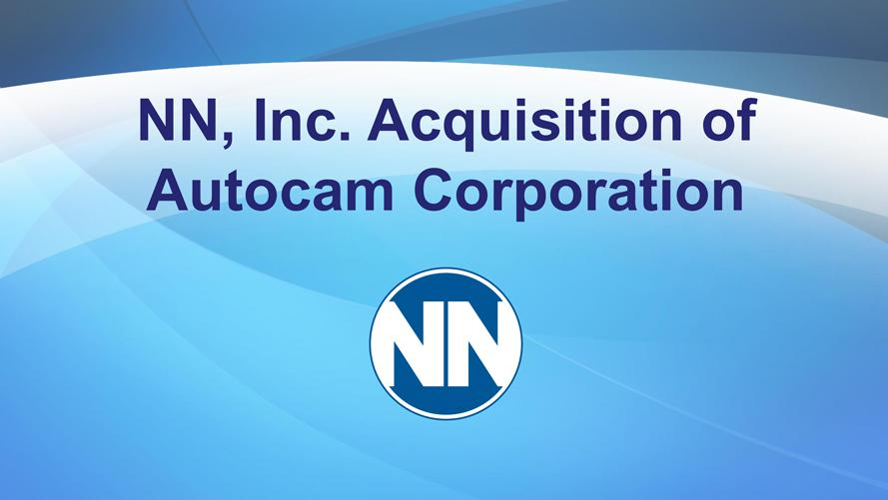

NN, Inc. Acquisition of Autocam Corporation



Cautionary Note Regarding Forward-Looking Sta ements
All statemen s in these slides, other than statements of historical fact, are “forward-looking statements” that are made pursuant to the safe harbor provisions of the Private
Securities Litigation Reform Act of 1995. These forward-looking statements, which are based on current expectations, estimates and projections about the industry and markets which NN and Autocam operate and
beliefs of and assumptions made by NN management, nvolve uncertainties that could significantly affect the financial results of NN or the combined company. Such forward-looking statements include, but are not
limited to, statements about the benefits of the transaction involving NN and Autocam, including future | and operating results and the combined company’s plans, objectives, expectations and intentions. All
statements that address operating performance, events or developments that we expect or anticipate will financialoccur the future—including statements relating to creating value for stockholders, benefits of the transaction to
customers and employees of the combined company, integrating our companies, cost savings, synergies, earnings per share, and the expected timetable for completing the proposed transaction—are forward-looking |  | -
statements. These statements are not guarantees of future performance and involve certain risks, uncertainties and assumptions that are difficult to predict. Although we believe the expectations reflected in any |  | -
looking statements are based on reasonable assumptions, we can give no assurance that our expectations will be attained and therefore, actual outcomes and results may differ materially from what is expressed forward
forecasted in such forward-looking statements. For example, these forward-looking statements could be affected by factors including, without limitation:
risks associated with the ability to consummate the merger and the timing of_{connection}theclosig of the merger; the failure to obtain the necessary debt financing arrangements set forth in the commitment letter received in
connection with the merger; the interest rate on any borrowings incurred in with the transaction; the impact of the indebtedness incurred to finance the transaction; the ability to successfully integrate our operations and employees; the ability_{competitors;}realize anticipated benefits and synergies of the transaction; the potential impact of announcement of the transaction or consummation of the transaction on relationships, including
with employees, customers and the outcome of any legal proceedings that have been or may be instituted against NN following announcement of the transaction; the ability to retain key personnel; the amount of the costs, fees, expenses and charges related to the merger and the actual terms of the financings that will be obtained for the merger; and changes in financial markets, interest rates and foreign currency exchange rates.
Additional factors that could cause actual results to differ materially from the forward-looking statements included in this presentation include those additional risks and factors discussed in NN’s periodic reports filed with the SEC. NN does not intend, and undertakes no obligation, to update any forward-looking statement.

2

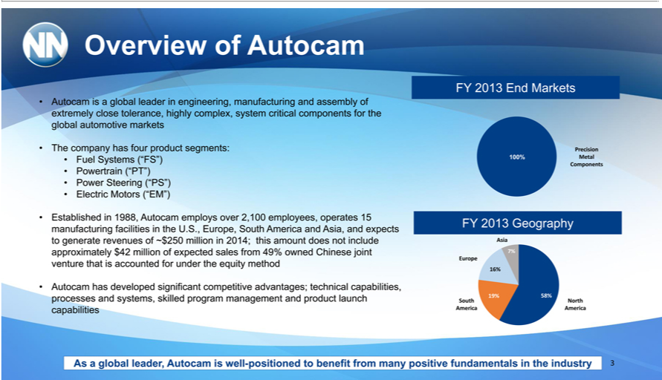

Overview of Autocam
TheAutocamcompanyis globalhasfourleaderproductinengineering,segments: manufacturing and assembly of extremely close tolerance, highly complex, system critical components for the global automotive markets
EstablishedFuelSystems (“FS”)1988, AutocamPowertrainemploys(“PT”) overPower2,100Steeringemployees,(“PS”) operatesElectric Motors15manufacturing(“EM”) facilities in the U.S., Europe, South America and Asia, and expects to generate revenues of ~$250 million in 2014; this amount
does not include approximately $42 million of expected sales from 49% owned Chinese joint venture that is accounted for under the equity method
Autocam has developed significant competitive advantages; technical capabilities, processes and systems, skilled program management and product launch capabilities FY 2013 End Markets
100%Pr_{Metal}cision
Components
EuropeFY2013 Geography
North^{Sou} America
Asia
58%^{16%}
19%
7%
3As a global leader, Autocam is well-positioned to benefit from many positive fundamentals in the industry

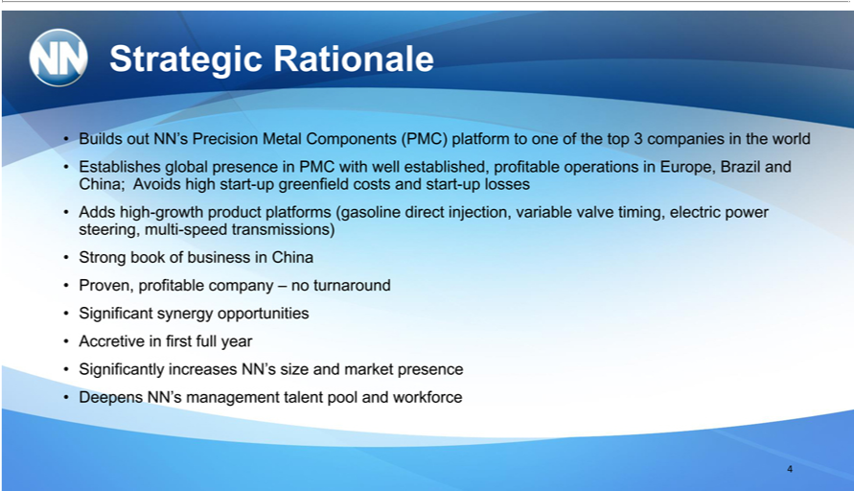

Strategic Rationale
EstablishesBuildsoutNN’sglobalPrecisionpresenceMetalinPMCComponentswithwell (PMC)established,platformprofitabletooneoperationsofthetop in3companiesEurope,Brazilintheandworld
AddsChina;highAvoids-growthhighproductstart-upplatformsgreenfield(gasolinecostsanddirectstart-injection,uplosses variable valve timing, electric power steering, multi-speed transmissions) Strong book of business in China Proven, profitable company – no turnaround synergy Accretive first full year
Significantly increasesopportunitiesNN’size and market presence Deepens NN’s management talent pool and workforce 4

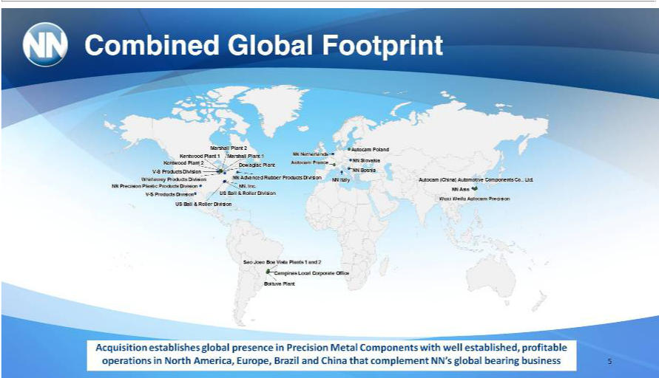

Combined Global Footprint
Marshall ll Plant 2 Autocam Poland Kentwood Plant 1 Marshall Plant 1 NN Netherlands
Autocam France NN Slovakia Kentwood Plant 2 Dowagiac Plant V-S Products Division NN Bosnia Whirlaway Products Division NN Advanced Rubber Products Division NN Italy Autocam (China) Automotive Components Co., Ltd.
NN Precision Plastic Products Division NN,, Inc.
US Ball & Roller Division NN Asia V-S Products Division
SaoWuxiiJoaoWeifuBoaAutocamVistaPlantsPrecision1and 2US Ball & Roller Division
BoituvaCampinasPlantLocall Corporate Office
Acquisition establishes global presence in Precision Metal Components with well established, profitable operations in North America, Europe, Brazil and China that complement NN’s global bearing business 5

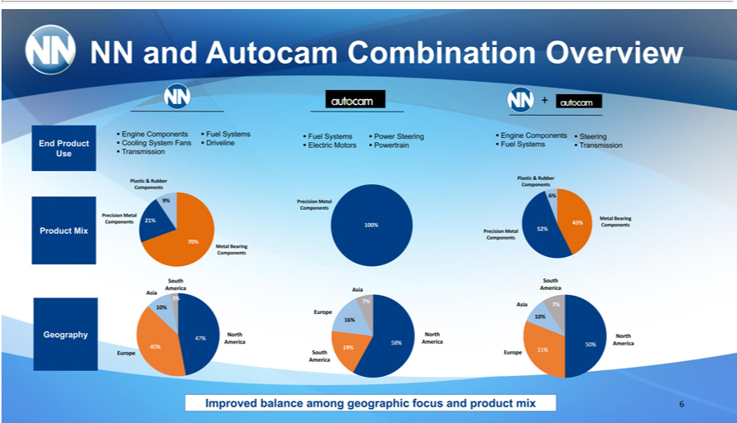

EndNN andProductAutocam Combination Overview
Use
Engine Components Fuel_{Driveline}Systms
TransmissionCoolingSystem Fans
Fuel Systems Power Steering
Electric Motors Powertrain Engine Components Steering
Fuel Systems Transmission Product Mix Geography Plastic & Rubber Components Precision Metal Components Metal Bearing Components 21% 9% 70% South America 3% Asia 10% 40% 47% North America
EuropePrecision Metal
100%Components
AsiaEurope
South America
58%19%^{6%}
7%
North America
_{Precision}MPlastictalBearing&RubberComponentsComponents
Metal
Components
43%_{52%}
6%
South America
10%Asia 7%
31%North 50% America
Europe
6Improved balance among geographic focus and product mix

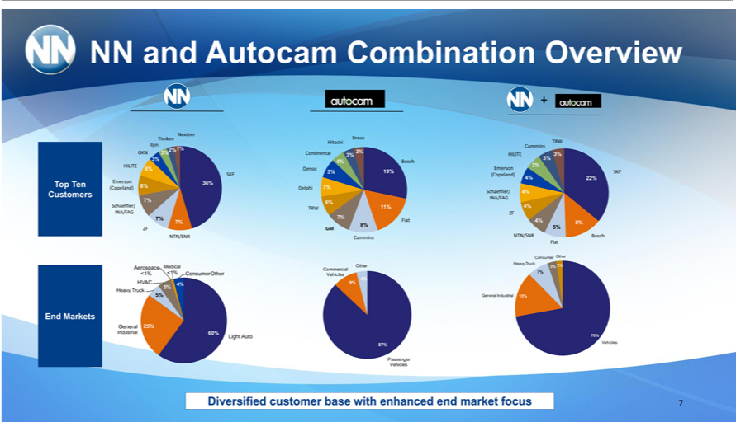

^{Nexteer}and Autocam Combination Overview
Timken Brose
Hitachi TRW
2%Iljin1%Cummins
^{3%}GKNHILITE3%Continental3% 3%
4% Bosch^{3%}
HILITE 3%
^{3%}6% Denso Emerson
19% SKF
SKF (Copeland)
Emerson4%22% 6% 36%
(Copeland) Delphi 7% Schaeffler/
7%4% 6% INA/FAG
Schaeffler/ 11% 4%
ZFINA/FAG TRW
ZF7% GM7%8% Fiat5% 4% 8%
FiatNTN/SNR Cummins NTN/SNR Bosch
H_{Aerospace}ConsumeravyTruckOther
<1% <1% ConsumerMedicalCommercial-Other7% Other 3% 2%
4%Vehicles
_{H}VAC_{avy} Truck5%4%5%9%
_{General} 25%Industrial 15%
Industrial 60%
VehiclesLightAuto 70%
87%
VehiclesPassenger
EndTop TenMarketsCustomers
7Diversified customer base with enhanced end market focus

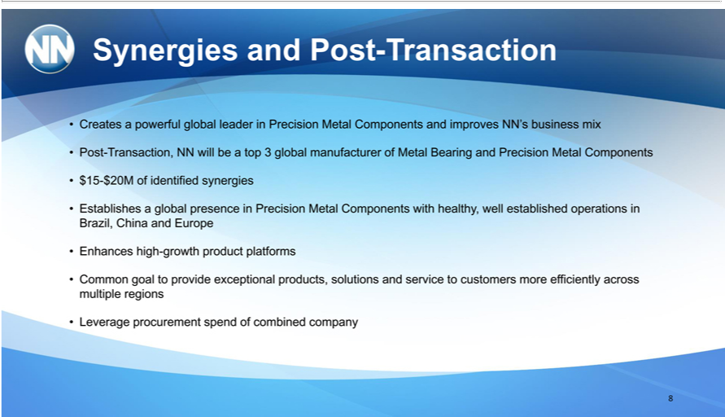

Synergies and Post-Transaction
Creates_{ransaction,}powerful global _{leader} in Precision Metal Components and improves NN’_{Precision}business mix
Post-T NN will be top 3 global manufacturer of Metal Bearing and Metal Components $15-$20M of identified synergies
_{Enhances}stablishes a global presence in Precision Metal Components with healthy, well established operations in Brazil, China and Europe high-growth product platforms
Common goal to provide exceptional products, solutions and service to customers more efficiently across multiple regions Leverage procurement spend of combined company
8

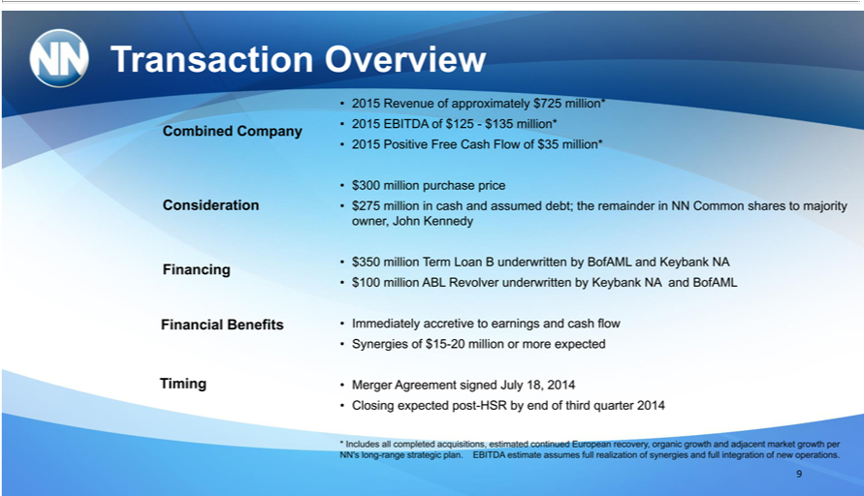

Transaction Overview
Consideration^{mbinedCompany}
Financial^{ng}
Timing Benefits
2015 Revenue of approximately $725 million* 2015 EBITDA of $125—$135 million* 2015 Positive Free Cash Flow of $35 million*
_{$350}00 _{million} purchase price $275 million in cash and assumed debt; the remainder in NN Common shares to majority owner, John Kennedy Term Loan B underwritten by BofAML and Keybank NA $100 million ABL Revolver underwritten by Keybank NA and BofAML
MergerImmediatelyAgreementaccretivesignedtoearningsJuly18,and2014cash flow Synergies of $15-20 million or more expected
Closing expected post-HSR by end of third quarter 2014
* Includes all completed acquisitions, estimated continued European recovery, organic growth and adjacent market growth per NN’s long-range strategic plan. EBITDA estimate assumes full realization of synergies and full integration of new operations.
9

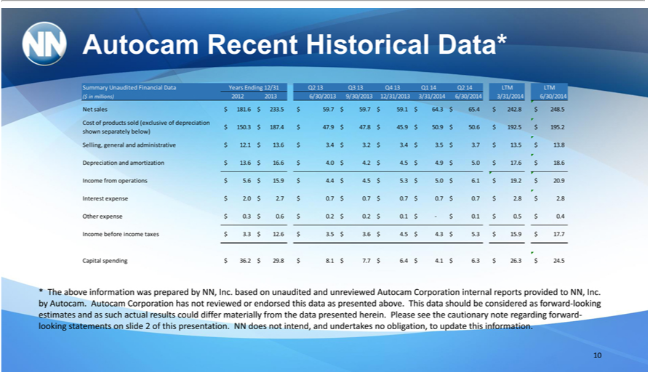

Autocam Recent Historical Data* |  | Q2 13 Q3 13 Q4 13 Q1 14 Q2 LTM LTM
Summary Unaudited Financial Data Years Ending
($ in millions) 2012 2013 6/30/2013 |  |  | 3/31/2014 6/30/2014 3/31/2014 |  | 6/30/2014
Net sales $ 181.6 $ 233.5 $ 59.7 $ 59.79/30/2013$59.$12/31/201364.$65.4 $ 242.8 $ 248.5
Cost of products sold (exclusive of depreciation | $ 192.5 |  | $ 195.2
$ 150.3 $ 187.4 $ 47.9 $ 47.8 $ 45.9 $ 50.9 $ 50.6 |  |  | $ 195.2
shown separately below) |  |  |  | $ 13.5 $ 13.8
Selling, general and administrative $ 12. $ 13.6 $ 3.4 $ 3.2 $ 3.4 $ 3.5 $ 3. |  |  |  | $ 13.5 $ 13.8
Depreciation and amortization $ 13.6 $ 16.6 $ 4.0 | $ 4.2 $ 4.5 $ 4.9 $ 5.0 $ 17.6 $ 18.6
come from operations $ 5.6 $ 15.9 $ 4.4 $ 4.5 $ 5.3 $ 5.0 $ 6.1 $ 19.2 $ 20.9
Interest expense $ 2.0 $ 2.7 $ 0.7 $ 0.7 $ 0.7 $ 0.7 | $ 0.7 $ 2.8 $ 2.8
Other expense $ 0.3 $ 0.6 $ 0.2 $ 0.2 $ 0.1 $—$ 0.1 |  | $ 0.5 | $ 0.4 | $ 17.7
Income before income taxes $ 3.3 $ 12.6 $ 3.5 $ 3.6 |  | $ 4.5 | $ 4.3 $ 5.3 $ 15.9 | $ 17.7
Capital spending $ 36.2 $ 29.8 $ 8.1 $ 7.7 $ 6.4 $ 4.1 $ 6.3 $ 26.3 $ 24.5
* The above information was prepared by NN, Inc. based on unaudited and unreviewed Autocam Corporation internal reports provided to NN, Inc. by Autocam. Autocam Corporation has not reviewed or endorsed this data as presented above. This data should be considered as forward-looking estimates and as such actual results could differ materially from the data presented herein. Please see the cautionary note regarding forward-looking statements on slide 2 of this presentation. NN does not intend, and undertakes no obligation, to update this information.

10

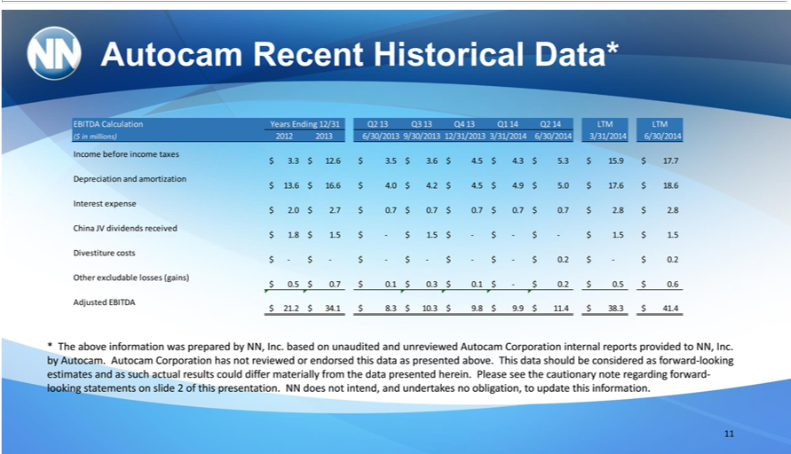

Autocam Recent Historical Data*
EBITDA Calculation Years Ending 12/31 Q2 13 Q3 Q4 13 Q1 Q2 LTM LTM
($ in millions) 2012 2013 6/30/2013 9/30/2013 |  |  | 12/31/2013 3/31/2014 6/30/2014 | 3/31/2014 6/30/2014
Income before income taxes |  |  | $ 17.7
$ 3.3 $ 12.6 $ 3.5 $ 3.6 $ 4.5 $ 4.3 $ 5.3 $ 15.9 |  |  | $ 17.7
Depreciation and amortization
$ 13.6 $ 16.6 $ 4.0 $ 4.2 $ 4.5 $ 4.9 $ 5.0 $ 17.6 $ 18.6
Interest expense |  | $ 2.8 $ 2.8
$ 2.0 $ 2.7 $ 0.7 $ 0.7 $ 0.7 $ 0.7 $ 0.7
China JV dividends received | $ | 1.5
$ 1.8 $ 1.5 $—$ 1.5 $—$—$—$ 1.5 | $ | 1.5
Divestiture costs
$—$—$—$—$—$—$ 0.2 $—$ 0.2
Other excludable losses (gains) | $ | 0.5 $ 0.6
$ 0.5 $ 0.7 $ 0.1 $ 0.3 $ 0.1 $—$ 0.2 | $
Adjusted EBITDA | $ | 11.4 $ 38.3 $ 41.4
$ 21.2 $ 34.1 $ 8.3 $ 10.3 $ 9.8 $ 9.9 | $
* The above information was prepared by NN, Inc. based on unaudited and unreviewed Autocam Corporation internal reports provided to NN, Inc. by Autocam. Autocam Corporation has not reviewed or endorsed this data as presented above. This data should be considered as forward-looking estimates and as such actual results could differ materially from the data presented herein. Please see the cautionary note regarding forward-looking statements on slide 2 of this presentation. NN does not intend, and undertakes no obligation, to update this information.

11

