UNITED STATES
SECURITIES AND EXCHANGE COMMISSION
Washington, D.C. 20549
FORM 8-K
CURRENT REPORT
Pursuant to Section 13 OR 15(d) of The Securities Exchange Act of 1934
Date of Report (Date of earliest event reported): August 6, 2025

NN, Inc.
(Exact name of registrant as specified in its charter)
Delaware |  |  | 001-39268 |  |  | 62-1096725
(State or other jurisdiction of  incorporation) |  |  | (Commission File Number) |  |  | (I.R.S. Employer  Identification No.)

6210 Ardrey Kell Road, Suite 120
Charlotte, North Carolina |  |  |  |  |  | 28277
(Address of principal executive offices) |  |  |  |  |  | (Zip Code)

(980) 264-4300
(Registrant’s telephone number, including area code)
(Former name or former address, if changed since last report)
Check the appropriate box if the Form 8-K filing is intended to simultaneously satisfy the filing obligation of the registrant under any of the following provisions (see General Instruction A.2. below):
☐ |  |  | Written communications pursuant to Rule 425 under the Securities Act (17 CFR 230.425)
☐ |  |  | Soliciting material pursuant to Rule 14a-12 under the Exchange Act (17 CFR 240.14a-12)
☐ |  |  | Pre-commencement communications pursuant to Rule 14d-2(b) under the Exchange Act (17 CFR 240.14d- 2(b))
☐ |  |  | Pre-commencement communications pursuant to Rule 13e-4(c) under the Exchange Act (17 CFR 240.13e- 4(c))

Securities registered pursuant to Section 12(b) of the Act:
Title of each class |  |  |  |  |  | Trading symbol |  |  |  |  |  | Name of each exchange on which registered
Common Stock, par value $0.01 |  |  |  |  |  | NNBR |  |  |  |  |  | The Nasdaq Stock Market LLC

Indicate by check mark whether the registrant is an emerging growth company as defined in Rule 405 of the Securities Act of 1933 (§230.405 of this chapter) or Rule 12b-2 of the Securities Exchange Act of 1934 (§240.12b-2 of this chapter).
Emerging growth company. |  |  | ☐
If an emerging growth company, indicate by check mark if the registrant has elected not to use the extended transition period for complying with any new or revised financial accounting standards provided pursuant to Section 13(a) of the Exchange Act. ☐

ITEM 2.02 RESULTS OF OPERATIONS AND FINANCIAL CONDITION
On August 6, 2025, NN, Inc. (the “Company”) issued a press release announcing the Company’s financial results for the quarter ended June 30, 2025. The full text of the press release is furnished as Exhibit 99.1 to this Current Report on Form 8-K (the "Current Report").
Pursuant to the rules and regulations of the U.S. Securities and Exchange Commission (the “SEC”), the information furnished pursuant to Item 2.02 of this Current Report (including Exhibit 99.1) is deemed to have been furnished and shall not be deemed to be “filed” for purposes of Section 18 of the Securities Exchange Act of 1934, as amended (the "Exchange Act"), or otherwise subject to the liabilities of that section. Such information shall not be incorporated by reference into any filing of the Company, whether made before or after the date hereof, regardless of any general incorporation language in such filing.

ITEM 7.01 REGULATION FD DISCLOSURE
On August 6, 2025, the Company posted a supplemental presentation to its website, https://investors.nninc.com/, which will be presented during its quarterly investor conference call on August 7, 2025, at 9:00 a.m. ET. The supplemental presentation is included as Exhibit 99.2 to this Current Report.
Pursuant to the rules and regulations of the SEC, the information furnished pursuant to Item 7.01 of this Current Report (including Exhibit 99.2) is deemed to have been furnished and shall not be deemed to be “filed” for purposes of Section 18 of the Exchange Act or otherwise subject to the liabilities of that section. Such information shall not be incorporated by reference into any filing of the Company, whether made before or after the date hereof, regardless of any general incorporation language in such filing.

ITEM 9.01 FINANCIAL STATEMENTS AND EXHIBITS
(d) Exhibits.
Exhibit  No. |  |  |  |  |  | Description of Exhibit
99.1 |  |  |  |  |  | Press Release issued by NN, Inc., dated August 6, 2025
99.2 |  |  |  |  |  | Second Quarter 2025 Earnings Call Presentation
104 |  |  |  |  |  | Cover Page Interactive Data File (embedded within the Inline XBRL document)

SIGNATURES

Pursuant to the requirements of the Securities Exchange Act of 1934, the registrant has duly caused this report to be signed on its behalf by the undersigned hereunto duly authorized.
Date: |  |  | August 6, 2025

 |  |  | NN, INC.
 |  |  | By: |  |  | /s/ Christopher H. Bohnert
 |  |  | Name: |  |  | Christopher H. Bohnert
 |  |  | Title: |  |  | Senior Vice President and Chief Financial Officer

Exhibit 99.1


NN, Inc.
6210 Ardrey Kell Road, Suite 120
Charlotte, NC 28277

FOR IMMEDIATE RELEASE

NN, INC. REPORTS SECOND QUARTER 2025 RESULTS

Improvement in Operating Income, Adjusted EBITDA, and New Business Program

Company Reiterates Full Year 2025 Guidance

CHARLOTTE, N.C., August 6, 2025 – NN, Inc. (NASDAQ: NNBR) (“NN” or the “Company”), a global diversified industrial company that engineers and manufactures high-precision components and assemblies, today reported results for the second quarter ended June 30, 2025.

Second Quarter Highlights: (results from continuing operations compared with prior year, where comparisons are noted)
•Net sales of $107.9 million, down 2.4% on a pro forma basis
•Gross margin of 16.9%, and adjusted gross margin of 19.5%
•Operating loss of $1.5 million and adjusted operating income of $4.9 million, an increase of $2.8 million
•Adjusted EBITDA of $13.2 million, with an adjusted EBITDA margin of 12.2%
•New business wins were $32.7 million in the first half of 2025, and NN has over 100 programs launching in 2025 that are expected to add greater than $45 million in future sales at full run-rate

Harold Bevis, President and Chief Executive Officer, said, “NN delivered a solid quarter for gross margins, operating income, adjusted operating income, and adjusted EBITDA. We are pleased with our reported results, new business acquisition, and new business launches. We leveraged the soft market environment to upsize our business development activities and investments. Our soft top-line centers around certain automotive customers. Conversely, we have been able to partially offset this weakness through the contribution of new business launches and precious metals pass-through pricing.”

“We have increased the size of our new business program in terms of prospecting, launching, and investing. We now have over 40 people in business development and launch, and we expect to launch over 100 new programs in 2025. We expect those launches will add over $45 million in future sales at run-rate. We plan to invest $18 to $20 million on capital projects in 2025. The twin goals of lowering our costs overall as a company while adding increased focus on growth is working and will be the main drivers of sustained top-line growth and increased profitability.”

1

Mr. Bevis continued, “Our current expectation is that some of our automotive markets may have similar soft patterns in the second half of 2025. In response, we have activated our own mitigation levers including tight cost controls and working capital actions. We are underway with tariff mitigation efforts with our customers and have positioned ourselves as a tariff problem solver.”

“We are using this opportunity to accelerate our transformation activities. We are actively investing in growth capex, and we have hired additional personnel to accelerate growth in our targeted areas. We recently announced the hiring of Tim Erro as NN’s new Chief Commercial Officer and have also added new account managers in our targeted areas of medical, stampings, and electrical products. We now have a core team of electrical harness experts and are evaluating an organic entry into this new market, just as we have done to enter the medical market.”

Mr. Bevis concluded, “Our transformation plan is working and we have increased our efforts during this slow auto market. Lastly, we have fully kicked off an M&A program and are seeking targets that are consistent with our strategy and can help refinance our preferred stock.”

Second Quarter Results
Net sales were $107.9 million, a decrease of 12.3% compared to the second quarter of 2024 net sales of $123.0 million, primarily due to the rationalization of underperforming business and plants in 2024, the sale of our Lubbock operations in 2024, and lower automotive volumes. These decreases were partially offset by the contribution of 70 new business launches in the first half of 2025, and higher precious metals pass-through pricing. Loss from operations for the second quarter of 2025 was $1.5 million, an improvement of 28.6% compared to the second quarter of 2024 loss from operations of $2.1 million.

Second Quarter Adjusted Results
Pro forma net sales when adjusted for rationalized sales, currency changes, and the sale of Lubbock, were a decrease of 2.4% in the second quarter when compared to the second quarter of 2024.

Adjusted income from operations for the second quarter of 2025 was $4.9 million compared to adjusted income from operations of $2.1 million for the same period in 2024. Adjusted EBITDA was $13.2 million, or 12.2% of sales, compared to $13.4 million, or 10.9% of sales, for the same period in 2024.

Adjusted net income was $0.7 million, or $0.02 per diluted share, compared to adjusted net loss of $0.7 million, or $(0.02) per diluted share, for the same period in 2024. Free cash flow was a use of cash of $3.2 million compared to a use of cash of $1.3 million for the same period in 2024.

Power Solutions
Net sales for the second quarter of 2025 were $44.6 million compared to $50.2 million in the same period in 2024.
The decrease is primarily due to the sale of our Lubbock operations, partially offset by higher precious metals pass-through pricing. Income from operations was $5.8 million compared to income from operations of $5.3 million for the same period in 2024.

Adjusted income from operations was $8.4 million compared to $8.1 million in the second quarter of 2024. The increase in adjusted income from operations was primarily due to favorable product mix, and lower operating costs.

Mobile Solutions
Net sales for the second quarter of 2025 were $63.4 million compared to $72.9 million in the second quarter of 2024. The decrease in sales was primarily due to rationalized volume and lower automotive volume. Loss from operations was $1.1 million compared to loss from operations of $1.6 million for the same period in 2024.

Adjusted income from operations was $2.3 million compared to adjusted loss from operations of $0.7 million in the second quarter of 2024. The increase in adjusted income from operations was primarily due to improved margin mix of sales and lower operating costs.

2025 Outlook
NN is maintaining its full-year 2025 outlook.

2
•Net sales to range between $430 to $460 million
•Adjusted EBITDA to range between $53 to $63 million
•Free cash flow to range between $14 to $16 million; guidance assumes receipt of CARES Act refund in 2025
•New business wins to range between $60 to $70 million

Chris Bohnert, Senior Vice President and Chief Financial Officer, commented, “Our second quarter results were largely in line with expectations. We are maintaining our current guidance and given the ongoing tariff-driven uncertainties and the anticipated downstream effects for our customers, we continue to direct expectations towards the lower end of our guided ranges. We note that the uncertainty of the current macroeconomic environment, particularly the potential for shifts in trade policy and interest rates could drive variability in our results, which may fall above or below our current forecasts. Irrespective of the near-term macroeconomic backdrop, we continue to pursue expense mitigation and operational efficiencies to partially offset potential impacts to end market demand. We are investing in commercial enhancements to accelerate future growth, and we remain optimistic about the strong pace of our transformation and growth opportunities.”

3
Conference Call
NN will discuss its results during its quarterly investor conference call on August 7, 2025, at 9 a.m. ET. The call and supplemental presentation may be accessed via NN's website, www.nninc.com. The conference call can also be accessed by dialing 1-888-999-3182 or 1-848-280-6330. For those who are unavailable to listen to the live broadcast, a replay will be available shortly after the call until August 7, 2026.
NN discloses in this press release the non-GAAP financial measures of adjusted income (loss) from operations, adjusted EBITDA, adjusted EBITDA margin, adjusted net income (loss), adjusted net income (loss) per diluted common share, and free cash flow. Each of these non-GAAP financial measures provides supplementary information about the impacts of acquisition, divestiture and integration related expenses, foreign-exchange impacts on inter-company loans, reorganizational and impairment charges.
The financial tables found later in this press release include a reconciliation of adjusted income (loss) from operations, adjusted operating margin, adjusted EBITDA, adjusted EBITDA margin, adjusted net income (loss), adjusted net income (loss) per diluted share, free cash flow to the U.S. GAAP financial measures of income (loss) from operations, net income (loss), net income (loss) per diluted common share, and cash provided (used) by operating activities.

4
About NN, Inc.
NN, Inc., a global diversified industrial company, combines advanced engineering and production capabilities with in-depth materials science expertise to design and manufacture high-precision components and assemblies for a variety of markets on a global basis. Headquartered in Charlotte, North Carolina, NN has facilities in North America, South America, Europe and China. For more information about the company and its products, please visit www.nninc.com.
This press release contains express and implied forward-looking statements within the meaning of the Private Securities Litigation Reform Act of 1995, including statements regarding our financial outlook for the full year of fiscal 2025, the impact of, and our ability to execute, our corporate strategies and business initiatives and the potential impact tariffs, high interest rates, high metal costs and additional economic uncertainties may have on our financial statements and results of operations. Forward-looking statements generally will be accompanied by words such as “anticipate,” “believe,” “could,” “estimate,” “expect,” “forecast,” “growth,” “guidance,” “intend,” “may,” “will,” “possible,” “potential,” “predict,” “project”, “trajectory” or other similar words, phrases or expressions. Forward-looking statements involve a number of risks and uncertainties that are outside of management’s control and that may cause actual results to be materially different from such statements. Such factors include, among others, general economic conditions and economic conditions in the industrial sector; the potential impacts of tariffs on the U.S. economy, the economy of other countries in which we conduct operations and our industry, as well as the potential implications and ramifications of tariffs on our business and the local and global supply chains supporting the same, and our ability to mitigate any adverse impacts of such; competitive influences; risks that current customers will commence or increase captive production; risks of capacity underutilization; quality issues; material changes in the costs and availability of raw materials; economic, social, political and geopolitical instability, military conflict, currency fluctuation, and other risks of doing business outside of the United States; inflationary pressures and changes in the cost or availability of materials, supply chain shortages and disruptions, the availability of labor and labor disruptions along the supply chain; our dependence on certain major customers, some of whom are not parties to long-term agreements (and/or are terminable on short notice); the impact of acquisitions and divestitures, as well as expansion of end markets and product offerings; our ability to hire or retain key personnel; the level of our indebtedness; the restrictions contained in our debt agreements; our ability to obtain financing at favorable rates, if at all, and to refinance existing debt as it matures; our ability to secure, maintain or enforce patents or other appropriate protections for our intellectual property; uncertainty of government policies and actions after recent U.S. elections in respect to global trade, tariffs and international trade agreements; and cyber liability or potential liability for breaches of our or our service providers’ information technology systems or business operations disruptions. The foregoing factors should not be construed as exhaustive and should be read in conjunction with the sections entitled “Risk Factors” and “Management’s Discussion and Analysis of Financial Condition and Results of Operations” included in the Company’s filings made with the U.S. Securities and Exchange Commission. Any forward-looking statement speaks only as of the date of this press release and are based on information available to NN at the time those statements are made and/or management’s good faith belief as of that time with respect to future events. The Company undertakes no obligation to publicly update or review any forward-looking statement, whether as a result of new information, future developments or otherwise, except as required by law. New risks and uncertainties may emerge from time to time, and it is not possible for the Company to predict their occurrence or how they will affect the Company. The Company qualifies all forward-looking statements by these cautionary statements.

With respect to any non-GAAP financial measures included in the following document, the accompanying information required by SEC Regulation G can be found in the back of this document or in the “Investors” section of the Company’s web site, www.nninc.com, under the heading “News & Events” and subheading “Presentations.”

Investor & Media Contacts:
Joe Caminiti or Stephen Poe
NNBR@alpha-ir.com
312-445-2870

Financial Tables Follow

5
NN, Inc.
Condensed Consolidated Statements of Operations and Comprehensive Income (Loss)
(Unaudited)
 |  |  | Three Months Ended  June 30, |  |  |  |  |  |  |  |  |  |  |  | Six Months Ended  June 30,
(in thousands, except per share data) |  |  | 2025 |  |  |  |  |  | 2024 |  |  |  |  |  | 2025 |  |  |  |  |  | 2024
Net sales |  |  | $ | 107,921 |  |  |  |  | $ | 122,992 |  |  |  |  | $ | 213,609 |  |  |  |  | $ | 244,190
Cost of sales (exclusive of depreciation and amortization shown separately below) |  |  | 89,699 |  |  |  |  |  | 101,257 |  |  |  |  |  | 181,345 |  |  |  |  |  | 202,343
Selling, general, and administrative expense |  |  | 12,095 |  |  |  |  |  | 13,511 |  |  |  |  |  | 23,265 |  |  |  |  |  | 26,859
Depreciation and amortization |  |  | 8,918 |  |  |  |  |  | 11,761 |  |  |  |  |  | 17,692 |  |  |  |  |  | 24,308
Other operating income, net |  |  | (1,327) |  |  |  |  |  | (1,390) |  |  |  |  |  | (2,440) |  |  |  |  |  | (2,390)
Loss from operations |  |  | (1,464) |  |  |  |  |  | (2,147) |  |  |  |  |  | (6,253) |  |  |  |  |  | (6,930)
Interest expense |  |  | 5,657 |  |  |  |  |  | 5,873 |  |  |  |  |  | 10,851 |  |  |  |  |  | 11,239
Loss on extinguishment of debt |  |  | 3,007 |  |  |  |  |  | — |  |  |  |  |  | 3,007 |  |  |  |  |  | —
Other expense (income), net |  |  | (619) |  |  |  |  |  | (3,461) |  |  |  |  |  | (2,788) |  |  |  |  |  | 692
Loss before benefit (provision) for income taxes and share of net income from joint venture |  |  | (9,509) |  |  |  |  |  | (4,559) |  |  |  |  |  | (17,323) |  |  |  |  |  | (18,861)
Benefit (provision) for income taxes |  |  | (774) |  |  |  |  |  | 215 |  |  |  |  |  | (2,084) |  |  |  |  |  | (291)
Share of net income from joint venture |  |  | 2,181 |  |  |  |  |  | 2,141 |  |  |  |  |  | 4,620 |  |  |  |  |  | 4,412
Net loss |  |  | $ | (8,102) |  |  |  |  | $ | (2,203) |  |  |  |  | $ | (14,787) |  |  |  |  | $ | (14,740)
Other comprehensive income (loss):
Foreign currency transaction gain (loss) |  |  | 4,454 |  |  |  |  |  | (3,387) |  |  |  |  |  | 7,579 |  |  |  |  |  | (5,733)
Reclassification adjustments from the interest rate swap included in net loss, net of tax |  |  | — |  |  |  |  |  | (449) |  |  |  |  |  | — |  |  |  |  |  | (898)
Other comprehensive income (loss) |  |  | $ | 4,454 |  |  |  |  | $ | (3,836) |  |  |  |  | $ | 7,579 |  |  |  |  | $ | (6,631)
Comprehensive loss |  |  | $ | (3,648) |  |  |  |  | $ | (6,039) |  |  |  |  | $ | (7,208) |  |  |  |  | $ | (21,371)
Basic and diluted net loss per share |  |  | $ | (0.26) |  |  |  |  | $ | (0.12) |  |  |  |  | $ | (0.48) |  |  |  |  | $ | (0.46)
Shares used to calculate basic and diluted net loss per share |  |  | 49,433 |  |  |  |  |  | 48,839 |  |  |  |  |  | 49,255 |  |  |  |  |  | 48,281
6
NN, Inc.
Condensed Consolidated Balance Sheets
(Unaudited)
(in thousands, except per share data) |  |  | June 30,  2025 |  |  |  |  |  | December 31,  2024
Assets
Current assets:
Cash and cash equivalents |  |  | $ | 9,542 |  |  |  |  | $ | 18,128
Accounts receivable, net |  |  | 69,825 |  |  |  |  |  | 61,549
Inventories |  |  | 62,793 |  |  |  |  |  | 61,877
Income tax receivable |  |  | 13,084 |  |  |  |  |  | 12,634
Prepaid assets |  |  | 4,602 |  |  |  |  |  | 2,855
Other current assets |  |  | 12,133 |  |  |  |  |  | 10,519
Total current assets |  |  | 171,979 |  |  |  |  |  | 167,562
Property, plant and equipment, net |  |  | 164,248 |  |  |  |  |  | 162,034
Operating lease right-of-use assets |  |  | 37,301 |  |  |  |  |  | 39,317
Intangible assets, net |  |  | 37,599 |  |  |  |  |  | 44,410
Investment in joint venture |  |  | 40,312 |  |  |  |  |  | 34,971
Deferred tax assets |  |  | 1,329 |  |  |  |  |  | 1,329
Other non-current assets |  |  | 7,992 |  |  |  |  |  | 7,270
Total assets |  |  | $ | 460,760 |  |  |  |  | $ | 456,893
Liabilities, Preferred Stock, and Stockholders’ Equity
Current liabilities:
Accounts payable |  |  | $ | 45,793 |  |  |  |  | $ | 38,879
Accrued salaries, wages and benefits |  |  | 14,444 |  |  |  |  |  | 19,915
Income tax payable |  |  | 484 |  |  |  |  |  | 659
Current maturities of long-term debt |  |  | 5,580 |  |  |  |  |  | 5,039
Current portion of operating lease liabilities |  |  | 5,903 |  |  |  |  |  | 6,038
Other current liabilities |  |  | 16,949 |  |  |  |  |  | 13,382
Total current liabilities |  |  | 89,153 |  |  |  |  |  | 83,912
Deferred tax liabilities |  |  | 4,896 |  |  |  |  |  | 4,969
Long-term debt, net of current maturities |  |  | 154,047 |  |  |  |  |  | 143,591
Operating lease liabilities, net of current portion |  |  | 39,710 |  |  |  |  |  | 42,291
Other non-current liabilities |  |  | 10,896 |  |  |  |  |  | 14,111
Total liabilities |  |  | 298,702 |  |  |  |  |  | 288,874
Commitments and contingencies
Series D perpetual preferred stock |  |  | 102,518 |  |  |  |  |  | 93,497
Stockholders' equity:
Common stock |  |  | 503 |  |  |  |  |  | 499
Additional paid-in capital |  |  | 448,033 |  |  |  |  |  | 455,811
Accumulated deficit |  |  | (348,408) |  |  |  |  |  | (333,621)
Accumulated other comprehensive loss |  |  | (40,588) |  |  |  |  |  | (48,167)
Total stockholders’ equity |  |  | 59,540 |  |  |  |  |  | 74,522
Total liabilities, preferred stock, and stockholders’ equity |  |  | $ | 460,760 |  |  |  |  | $ | 456,893

7
NN, Inc.
Condensed Consolidated Statements of Cash Flows
(Unaudited)
Six Months Ended
June 30,
(in thousands) |  |  | 2025 |  |  |  |  |  | 2024
Cash flows from operating activities
Net loss |  |  | $ | (14,787) |  |  |  |  | $ | (14,740)
Adjustments to reconcile net loss to net cash used in operating activities:
Depreciation and amortization |  |  | 17,692 |  |  |  |  |  | 24,308
Amortization of debt issuance costs and discount |  |  | 1,024 |  |  |  |  |  | 1,106
Paid-in-kind interest |  |  | 1,236 |  |  |  |  |  | 1,436
Loss on extinguishment of debt |  |  | 3,007 |  |  |  |  |  | —
Total derivative gain, net of cash settlements |  |  | (2,036) |  |  |  |  |  | (1,068)
Share of net income from joint venture |  |  | (4,620) |  |  |  |  |  | (4,412)
Share-based compensation expense |  |  | 1,640 |  |  |  |  |  | 1,536
Deferred income taxes |  |  | (5) |  |  |  |  |  | (479)
Other |  |  | (785) |  |  |  |  |  | (758)
Changes in operating assets and liabilities:
Accounts receivable |  |  | (6,568) |  |  |  |  |  | (8,747)
Inventories |  |  | 1,044 |  |  |  |  |  | (1,185)
Other operating assets |  |  | (3,318) |  |  |  |  |  | (2,705)
Income taxes receivable and payable, net |  |  | (589) |  |  |  |  |  | (1,326)
Accounts payable |  |  | 6,564 |  |  |  |  |  | 1,726
Other operating liabilities |  |  | (3,540) |  |  |  |  |  | 4,739
Net cash used in operating activities |  |  | (4,041) |  |  |  |  |  | (569)
Cash flows from investing activities
Acquisition of property, plant and equipment |  |  | (7,630) |  |  |  |  |  | (9,052)
Proceeds from sale of property, plant, and equipment |  |  | 451 |  |  |  |  |  | 237
Net cash used in investing activities |  |  | (7,179) |  |  |  |  |  | (8,815)
Cash flows from financing activities
Proceeds from asset backed credit facilities |  |  | 21,000 |  |  |  |  |  | 25,000
Repayments of asset backed credit facilities |  |  | (21,400) |  |  |  |  |  | (25,000)
Proceeds from term loans and other long-term debt |  |  | 118,579 |  |  |  |  |  | —
Repayments of term loans and other long-term debt |  |  | (115,356) |  |  |  |  |  | (21,061)
Cash paid for debt issuance costs |  |  | (3,553) |  |  |  |  |  | (646)
Proceeds from sale-leaseback of equipment |  |  | 946 |  |  |  |  |  | 8,324
Proceeds from sale-leaseback of land and buildings |  |  | 4,300 |  |  |  |  |  | 16,863
Repayments of financing obligations |  |  | (601) |  |  |  |  |  | (211)
Other |  |  | (2,352) |  |  |  |  |  | (1,700)
Net cash provided by financing activities |  |  | 1,563 |  |  |  |  |  | 1,569
Effect of exchange rate changes on cash flows |  |  | 1,071 |  |  |  |  |  | (342)
Net change in cash and cash equivalents |  |  | (8,586) |  |  |  |  |  | (8,157)
Cash and cash equivalents at beginning of year |  |  | 18,128 |  |  |  |  |  | 21,903
Cash and cash equivalents at end of quarter |  |  | $ | 9,542 |  |  |  |  | $ | 13,746

8
Reconciliation of GAAP Gross Profit to Non-GAAP Gross Profit and Gross Margin

Three Months Ended
June 30,
(in thousands) |  |  | 2025 |  |  |  |  |  | 2024
Net sales |  |  | $ | 107,921 |  |  |  |  | $ | 122,992
Cost of sales (exclusive of depreciation and amortization) |  |  | 89,699 |  |  |  |  |  | 101,257
GAAP gross profit |  |  | 18,222 |  |  |  |  |  | 21,735
Personnel costs (1) |  |  | 2,052 |  |  |  |  |  | 298
Facility costs (2) |  |  | — |  |  |  |  |  | 10
Other |  |  | 781 |  |  |  |  |  | 778
Adjusted gross profit (a) |  |  | $ | 21,055 |  |  |  |  | $ | 22,821
Adjusted gross margin (3) |  |  | 19.5 |  | % |  |  |  | 18.6 |  | %

(1) Personnel costs include recruitment, retention, relocation, and severance costs
(2) Facility costs include costs of opening / closing facilities and relocation / exit of manufacturing operations
(3) Non-GAAP adjusted gross margin = Non-GAAP adjusted gross profit / GAAP net sales

9
Reconciliation of GAAP Income (Loss) from Operations to Non-GAAP Adjusted Income (Loss) from Operations

 |  |  | Three Months Ended June 30,
(in thousands)
NN, Inc. Consolidated |  |  | 2025 |  |  |  |  |  | 2024
GAAP loss from operations |  |  | $ | (1,464) |  |  |  |  | $ | (2,147)
Professional fees |  |  | 352 |  |  |  |  |  | (12)
Personnel costs (1) |  |  | 2,614 |  |  |  |  |  | 826
Facility costs (2) |  |  | — |  |  |  |  |  | (51)
Amortization of intangibles |  |  | 3,405 |  |  |  |  |  | 3,456
Non-GAAP adjusted income from operations (b) |  |  | $ | 4,907 |  |  |  |  | $ | 2,072
Non-GAAP adjusted operating margin (3) |  |  | 4.6 |  | % |  |  |  | 1.7 |  | %
GAAP net sales |  |  | $ | 107,921 |  |  |  |  | $ | 122,992

 |  |  | Three Months Ended June 30,
(in thousands)
Power Solutions |  |  | 2025 |  |  |  |  |  | 2024
GAAP income from operations |  |  | $ | 5,782 |  |  |  |  | $ | 5,320
Personnel costs (1) |  |  | 77 |  |  |  |  |  | 33
Facility costs (2) |  |  | — |  |  |  |  |  | 79
Amortization of intangibles |  |  | 2,567 |  |  |  |  |  | 2,617
Non-GAAP adjusted income from operations (b) |  |  | $ | 8,426 |  |  |  |  | $ | 8,049
Non-GAAP adjusted operating margin (3) |  |  | 18.9 |  | % |  |  |  | 16.0 |  | %
GAAP net sales |  |  | $ | 44,641 |  |  |  |  | $ | 50,151

 |  |  | Three Months Ended June 30,
(in thousands)
Mobile Solutions |  |  | 2025 |  |  |  |  |  | 2024
GAAP loss from operations |  |  | $ | (1,110) |  |  |  |  | $ | (1,630)
Personnel costs (1) |  |  | 2,540 |  |  |  |  |  | 265
Facility costs (2) |  |  | — |  |  |  |  |  | (130)
Amortization of intangibles |  |  | 838 |  |  |  |  |  | 837
Non-GAAP adjusted income (loss) from operations (b) |  |  | $ | 2,268 |  |  |  |  | $ | (656)
Share of net income from joint venture |  |  | 2,181 |  |  |  |  |  | 2,141
Non-GAAP adjusted income from operations with JV (b) |  |  | $ | 4,449 |  |  |  |  | $ | 1,485
Non-GAAP adjusted operating margin (3) |  |  | 7.0 |  | % |  |  |  | 2.0 |  | %
GAAP net sales |  |  | $ | 63,391 |  |  |  |  | $ | 72,855

 |  |  | Three Months Ended June 30,
(in thousands)
Elimination |  |  | 2025 |  |  |  |  |  | 2024
GAAP net sales |  |  | $ | (111) |  |  |  |  | $ | (14)

(1)Personnel costs include recruitment, retention, relocation, and severance costs
(2)Facility costs include costs of opening / closing facilities and relocation / exit of manufacturing operations
(3)Non-GAAP adjusted operating margin = Non-GAAP adjusted income (loss) from operations / GAAP net sales

10
Reconciliation of GAAP Net Income (Loss) to Non-GAAP Adjusted EBITDA

 |  |  | Three Months Ended June 30,
(in thousands) |  |  | 2025 |  |  |  |  |  | 2024
GAAP net loss |  |  | $ | (8,102) |  |  |  |  | $ | (2,203)
Benefit (provision) for income taxes |  |  | 774 |  |  |  |  |  | (215)
Interest expense |  |  | 5,657 |  |  |  |  |  | 5,873
Loss on extinguishment of debt |  |  | 3,007 |  |  |  |  |  | —
Change in fair value of preferred stock derivatives and warrants |  |  | (273) |  |  |  |  |  | (3,949)
Depreciation and amortization |  |  | 8,918 |  |  |  |  |  | 11,761
Professional fees |  |  | 352 |  |  |  |  |  | (12)
Personnel costs (1) |  |  | 2,614 |  |  |  |  |  | 826
Facility costs (2) |  |  | — |  |  |  |  |  | (51)
Non-cash stock compensation |  |  | 801 |  |  |  |  |  | 691
Non-cash foreign exchange (gain) loss on inter-company loans |  |  | (569) |  |  |  |  |  | 684
Non-GAAP adjusted EBITDA (c) |  |  | $ | 13,179 |  |  |  |  | $ | 13,405
Non-GAAP adjusted EBITDA margin (3) |  |  | 12.2 |  | % |  |  |  | 10.9 |  | %
GAAP net sales |  |  | $ | 107,921 |  |  |  |  | $ | 122,992

(1) Personnel costs include recruitment, retention, relocation, and severance costs
(2) Facility costs include costs of opening / closing facilities and relocation / exit of manufacturing operations
(3) Non-GAAP adjusted EBITDA margin = Non-GAAP adjusted EBITDA / GAAP net sales

11
Reconciliation of GAAP Net Income (Loss) to Non-GAAP Adjusted Net Income and GAAP Net Income (Loss) per Diluted Common Share to Non-GAAP Adjusted Net Income (Loss) per Diluted Common Share

 |  |  | Three Months Ended June 30,
(in thousands) |  |  | 2025 |  |  |  |  |  | 2024
GAAP net loss |  |  | $ | (8,102) |  |  |  |  | $ | (2,203)
Pre-tax loss on extinguishment of debt |  |  | 3,007 |  |  |  |  |  | —
Pre-tax professional fees |  |  | 352 |  |  |  |  |  | —
Pre-tax personnel costs |  |  | 2,614 |  |  |  |  |  | 826
Pre-tax facility costs |  |  | — |  |  |  |  |  | (51)
Pre-tax foreign exchange (gain) loss on inter-company loans |  |  | (569) |  |  |  |  |  | 684
Pre-tax change in fair value of preferred stock derivatives and warrants |  |  | (273) |  |  |  |  |  | (3,949)
Pre-tax amortization of intangibles and deferred financing costs |  |  | 3,717 |  |  |  |  |  | 4,018
Tax effect of adjustments reflected above (d) |  |  | — |  |  |  |  |  | (63)
Non-GAAP adjusted net income (loss) (e) |  |  | $ | 746 |  |  |  |  | $ | (738)
 |  |  | Three Months Ended June 30,
(per diluted common share) |  |  | 2025 |  |  |  |  |  | 2024
GAAP net loss per diluted common share |  |  | $ | (0.26) |  |  |  |  | $ | (0.12)
Pre-tax loss on extinguishment of debt |  |  | 0.06 |  |  |  |  |  | —
Pre-tax professional fees |  |  | 0.01 |  |  |  |  |  | —
Pre-tax personnel costs |  |  | 0.05 |  |  |  |  |  | 0.02
Pre-tax facility costs |  |  | — |  |  |  |  |  | —
Pre-tax foreign exchange (gain) loss on inter-company loans |  |  | (0.01) |  |  |  |  |  | 0.01
Pre-tax change in fair value of preferred stock derivatives and warrants |  |  | (0.01) |  |  |  |  |  | (0.08)
Pre-tax amortization of intangibles and deferred financing costs |  |  | 0.08 |  |  |  |  |  | 0.08
Preferred stock cumulative dividends and deemed dividends |  |  | 0.09 |  |  |  |  |  | 0.08
Non-GAAP adjusted net income (loss) per diluted common share (e) |  |  | $0.02 |  |  |  |  |  | $(0.02)
Shares used to calculate net earnings (loss) per share |  |  | 49,433 |  |  |  |  |  | 48,839

12

Reconciliation of Operating Cash Flow to Free Cash Flow
Three Months Ended
June 30,
(in thousands) |  |  | 2025 |  |  |  |  |  | 2024
Net cash used in operating activities |  |  | $ | (696) |  |  |  |  | $ | (1,281)
Acquisition of property, plant, and equipment |  |  | (3,723) |  |  |  |  |  | (3,592)
Proceeds from sale of property, plant, and equipment |  |  | 274 |  |  |  |  |  | 139
Proceeds from sale-leaseback of equipment |  |  | 946 |  |  |  |  |  | 3,415
Free cash flow |  |  | $ | (3,199) |  |  |  |  | $ | (1,319)

13
The Company discloses in this presentation the non-GAAP financial measures of adjusted income (loss) from operations, adjusted EBITDA, adjusted net income (loss), adjusted net income (loss) per diluted common share, and free cash flow. Each of these non-GAAP financial measures provides supplementary information about the impacts of acquisition, divestiture and integration related expenses, foreign-exchange impacts on inter-company loans, reorganizational and impairment charges. The costs we incur in completing acquisitions, including the amortization of intangibles and deferred financing costs, and divestitures are excluded from these measures because their size and inconsistent frequency are unrelated to our commercial performance during the period, and we believe are not indicative of our ongoing operating costs. We exclude the impact of currency translation from these measures because foreign exchange rates are not under management’s control and are subject to volatility. Other non-operating charges are excluded as the charges are not indicative of our ongoing operating cost. We believe the presentation of adjusted income (loss) from operations, adjusted EBITDA, adjusted net income (loss), adjusted net income (loss) per diluted common share, and free cash flow provides useful information in assessing our underlying business trends and facilitates comparison of our long-term performance over given periods.
The non-GAAP financial measures provided herein may not provide information that is directly comparable to that provided by other companies in the Company's industry, as other companies may calculate such financial results differently. The Company's non-GAAP financial measures are not measurements of financial performance under GAAP and should not be considered as alternatives to actual income growth derived from income amounts presented in accordance with GAAP. The Company does not consider these non-GAAP financial measures to be a substitute for, or superior to, the information provided by GAAP financial results.
(a) Non-GAAP adjusted gross margin represents GAAP gross profit, adjusted to exclude the effects of restructuring and integration expense and non-operational charges related to acquisition and transition expense. We believe this presentation is commonly used by investors and professional research analysts in the valuation, comparison, rating, and investment recommendations of companies in the industrial industry. We use this information for comparative purposes within the industry. Non-GAAP adjusted gross margin is not a measure of financial performance under GAAP and should not be considered as a measure of liquidity or as an alternative to GAAP gross margin.
(b) Non-GAAP adjusted income (loss) from operations represents GAAP income (loss) from operations, adjusted to exclude the effects of restructuring and integration expense; non-operational charges related to acquisition and transition expense, intangible amortization costs for fair value step-up in values related to acquisitions, non-cash impairment charges, and when applicable, our share of income from joint venture operations. We believe this presentation is commonly used by investors and professional research analysts in the valuation, comparison, rating, and investment recommendations of companies in the industrial industry. We use this information for comparative purposes within the industry. Non-GAAP adjusted income (loss) from operations is not a measure of financial performance under GAAP and should not be considered as a measure of liquidity or as an alternative to GAAP income (loss) from operations.
(c) Non-GAAP adjusted EBITDA represents GAAP net income (loss), adjusted to include income taxes, interest expense, write-off of unamortized debt issuance costs, interest rate swap payments and change in fair value that was recognized in earnings, change in fair value of preferred stock derivatives and warrants, depreciation and amortization, charges related to acquisition and transition costs, non-cash stock compensation expense, foreign exchange gain (loss) on inter-company loans, restructuring and integration expense, costs related to divested businesses and litigation settlements, income from discontinued operations, and non-cash impairment charges, to the extent applicable. We believe this presentation is commonly used by investors and professional research analysts in the valuation, comparison, rating, and investment recommendations of companies in the industrial industry. We use this information for comparative purposes within the industry. Non-GAAP adjusted EBITDA is not a measure of financial performance under GAAP and should not be considered as a measure of liquidity or as an alternative to GAAP income (loss) from continuing operations.
(d) This line item reflects the aggregate tax effect of all non-tax adjustments reflected in the respective table. NN, Inc. estimates the tax effect of the adjustment items identified in the reconciliation schedule above by applying the applicable statutory rates by tax jurisdiction unless the nature of the item and/or the tax jurisdiction in which the item has been recorded requires application of a specific tax rate or tax treatment.
(e) Non-GAAP adjusted net income (loss) represents GAAP net income (loss) adjusted to exclude the tax-affected effects of charges related to acquisition and transition costs, foreign exchange gain (loss) on inter-company loans, restructuring and integration charges, amortization of intangibles costs for fair value step-up in values related to acquisitions and amortization of deferred financing costs, non-cash impairment charges, write-off of unamortized debt issuance costs, interest rate swap payments and change in fair value, change in fair value of preferred stock derivatives and warrants, costs related to divested businesses and litigation settlements, income (loss) from discontinued operations, and preferred stock cumulative dividends and deemed dividends. We believe this presentation is commonly used by investors and professional research analysts in the valuation, comparison, rating, and investment recommendations of companies in the industrial industry. We use this information for comparative purposes within the industry.
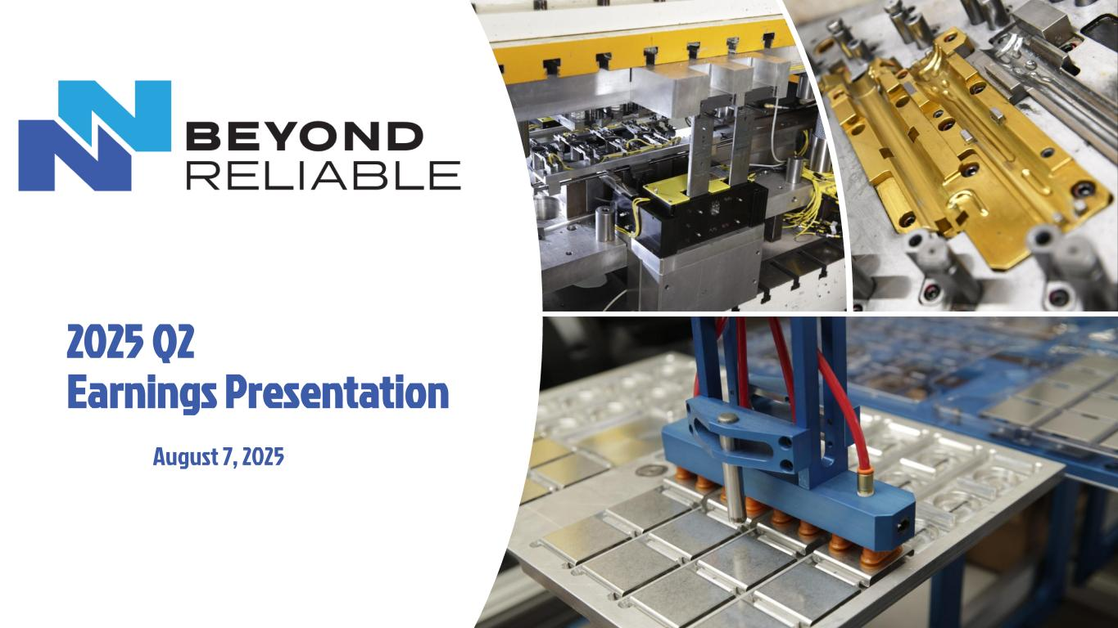
14
NN Blue Dark Charcoal Platinum Pewter Orange Green 2025 Q2 Earnings Presentation August 7, 2025

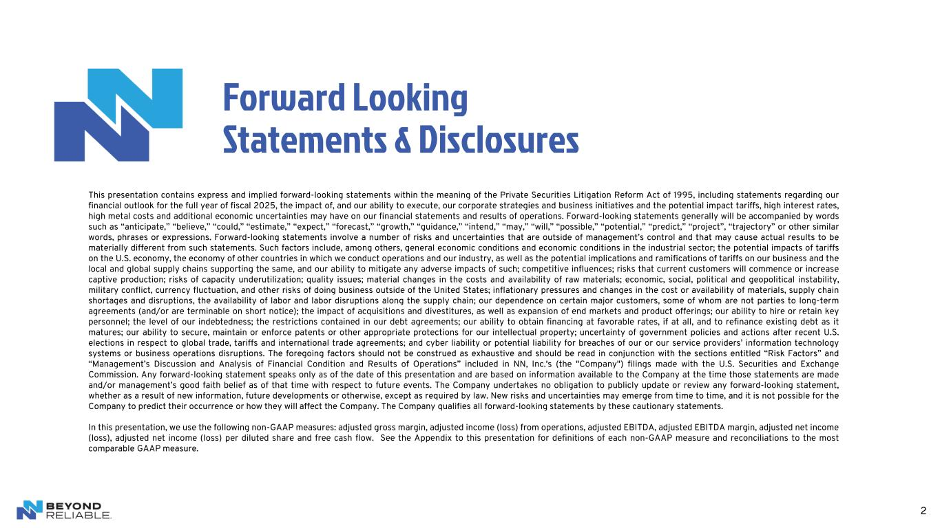
2 Forward Looking Statements & Disclosures This presentation contains express and implied forward-looking statements within the meaning of the Private Securities Litigation Reform Act of 1995, including statements regarding our financial outlook for the full year of fiscal 2025, the impact of, and our ability to execute, our corporate strategies and business initiatives and the potential impact tariffs, high interest rates, high metal costs and additional economic uncertainties may have on our financial statements and results of operations. Forward-looking statements generally will be accompanied by words such as “anticipate,” “believe,” “could,” “estimate,” “expect,” “forecast,” “growth,” “guidance,” “intend,” “may,” “will,” “possible,” “potential,” “predict,” “project”, “trajectory” or other similar words, phrases or expressions. Forward-looking statements involve a number of risks and uncertainties that are outside of management’s control and that may cause actual results to be materially different from such statements. Such factors include, among others, general economic conditions and economic conditions in the industrial sector; the potential impacts of tariffs on the U.S. economy, the economy of other countries in which we conduct operations and our industry, as well as the potential implications and ramifications of tariffs on our business and the local and global supply chains supporting the same, and our ability to mitigate any adverse impacts of such; competitive influences; risks that current customers will commence or increase captive production; risks of capacity underutilization; quality issues; material changes in the costs and availability of raw materials; economic, social, political and geopolitical instability, military conflict, currency fluctuation, and other risks of doing business outside of the United States; inflationary pressures and changes in the cost or availability of materials, supply chain shortages and disruptions, the availability of labor and labor disruptions along the supply chain; our dependence on certain major customers, some of whom are not parties to long-term agreements (and/or are terminable on short notice); the impact of acquisitions and divestitures, as well as expansion of end markets and product offerings; our ability to hire or retain key personnel; the level of our indebtedness; the restrictions contained in our debt agreements; our ability to obtain financing at favorable rates, if at all, and to refinance existing debt as it matures; our ability to secure, maintain or enforce patents or other appropriate protections for our intellectual property; uncertainty of government policies and actions after recent U.S. elections in respect to global trade, tariffs and international trade agreements; and cyber liability or potential liability for breaches of our or our service providers’ information technology systems or business operations disruptions. The foregoing factors should not be construed as exhaustive and should be read in conjunction with the sections entitled “Risk Factors” and “Management’s Discussion and Analysis of Financial Condition and Results of Operations” included in NN, Inc.'s (the "Company") filings made with the U.S. Securities and Exchange Commission. Any forward-looking statement speaks only as of the date of this presentation and are based on information available to the Company at the time those statements are made and/or management’s good faith belief as of that time with respect to future events. The Company undertakes no obligation to publicly update or review any forward-looking statement, whether as a result of new information, future developments or otherwise, except as required by law. New risks and uncertainties may emerge from time to time, and it is not possible for the Company to predict their occurrence or how they will affect the Company. The Company qualifies all forward-looking statements by these cautionary statements. In this presentation, we use the following non-GAAP measures: adjusted gross margin, adjusted income (loss) from operations, adjusted EBITDA, adjusted EBITDA margin, adjusted net income (loss), adjusted net income (loss) per diluted share and free cash flow. See the Appendix to this presentation for definitions of each non-GAAP measure and reconciliations to the most comparable GAAP measure.

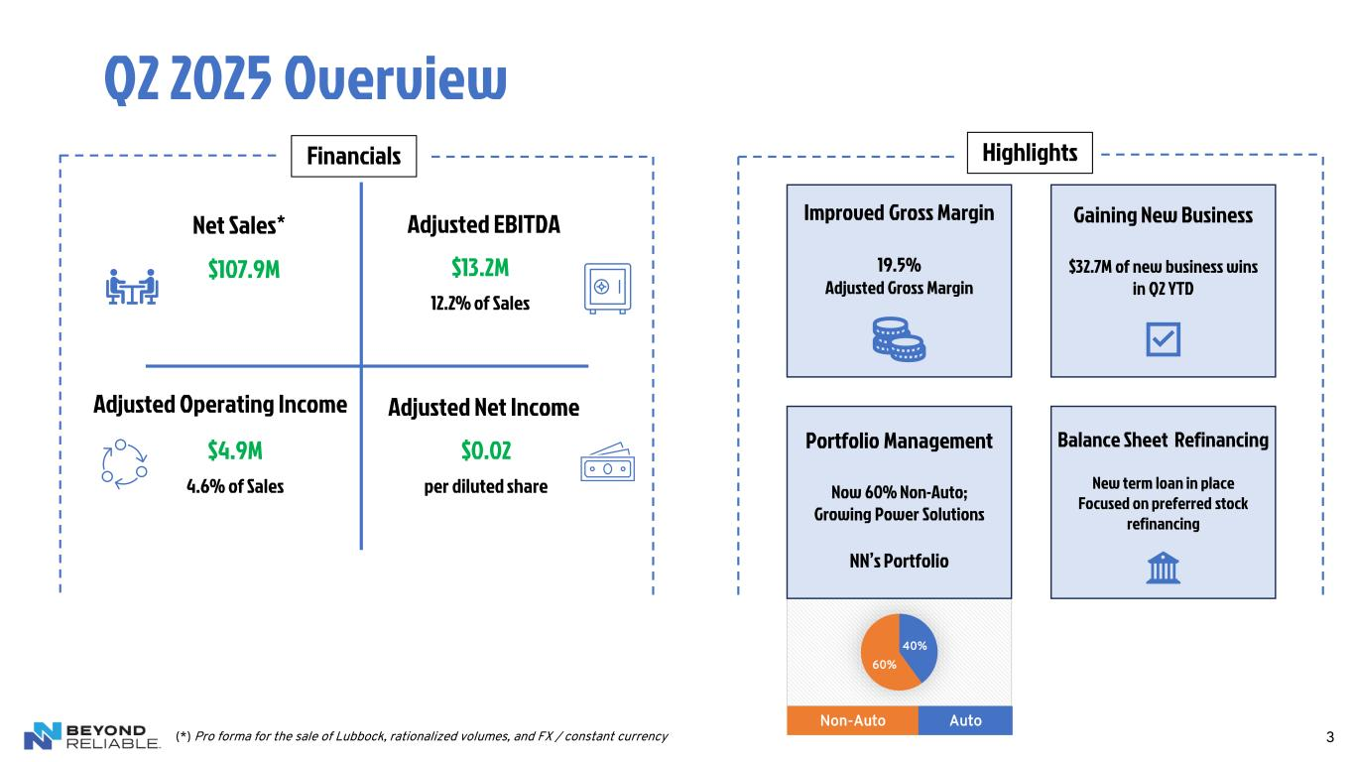
Q2 2025 Overview 3 Net Sales* $107.9M Adjusted EBITDA $13.2M 12.2% of Sales Adjusted Operating Income $4.9M 4.6% of Sales Adjusted Net Income $0.02 per diluted share Financials Improved Gross Margin 19.5% Adjusted Gross Margin Gaining New Business $32.7M of new business wins in Q2 YTD 40% 60% Portfolio Portfolio Management Now 60% Non-Auto; Growing Power Solutions NN’s Portfolio Balance Sheet Refinancing New term loan in place Focused on preferred stock refinancing Highlights (*) Pro forma for the sale of Lubbock, rationalized volumes, and FX / constant currency Non-Auto Auto

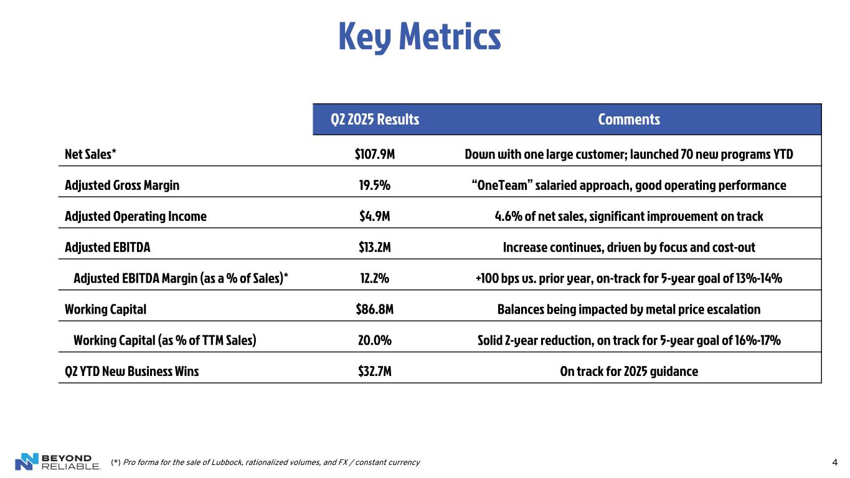
Q2 2025 Results Comments Net Sales* $107.9M Down with one large customer; launched 70 new programs YTD Adjusted Gross Margin 19.5% “OneTeam” salaried approach, good operating performance Adjusted Operating Income $4.9M 4.6% of net sales, significant improvement on track Adjusted EBITDA $13.2M Increase continues, driven by focus and cost-out Adjusted EBITDA Margin (as a % of Sales)* 12.2% +100 bps vs. prior year, on-track for 5-year goal of 13%-14% Working Capital $86.8M Balances being impacted by metal price escalation Working Capital (as % of TTM Sales) 20.0% Solid 2-year reduction, on track for 5-year goal of 16%-17% Q2 YTD New Business Wins $32.7M On track for 2025 guidance 4(*) Pro forma for the sale of Lubbock, rationalized volumes, and FX / constant currency Key Metrics

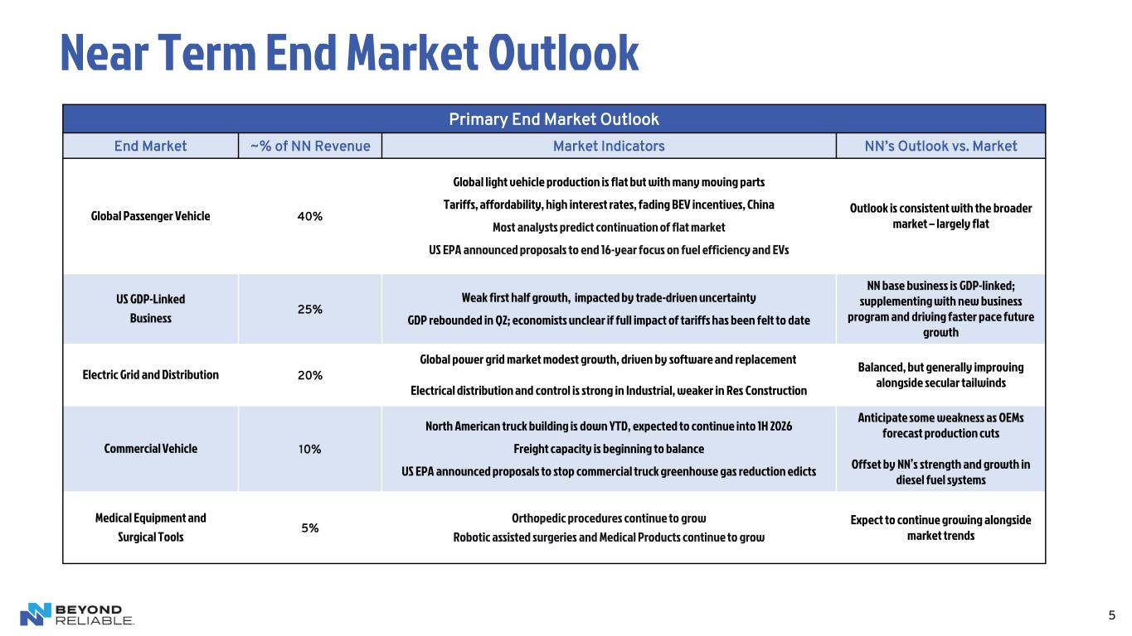
5 Near Term End Market Outlook Primary End Market Outlook End Market ~% of NN Revenue Market Indicators NN’s Outlook vs. Market Global Passenger Vehicle 40% Global light vehicle production is flat but with many moving parts Tariffs, affordability, high interest rates, fading BEV incentives, China Most analysts predict continuation of flat market US EPA announced proposals to end 16-year focus on fuel efficiency and EVs Outlook is consistent with the broader market – largely flat US GDP-Linked Business 25% Weak first half growth, impacted by trade-driven uncertainty GDP rebounded in Q2; economists unclear if full impact of tariffs has been felt to date NN base business is GDP-linked; supplementing with new business program and driving faster pace future growth Electric Grid and Distribution 20% Global power grid market modest growth, driven by software and replacement Electrical distribution and control is strong in Industrial, weaker in Res Construction Balanced, but generally improving alongside secular tailwinds Commercial Vehicle 10% North American truck building is down YTD, expected to continue into 1H 2026 Freight capacity is beginning to balance US EPA announced proposals to stop commercial truck greenhouse gas reduction edicts Anticipate some weakness as OEMs forecast production cuts Offset by NN’s strength and growth in diesel fuel systems Medical Equipment and Surgical Tools 5% Orthopedic procedures continue to grow Robotic assisted surgeries and Medical Products continue to grow Expect to continue growing alongside market trends

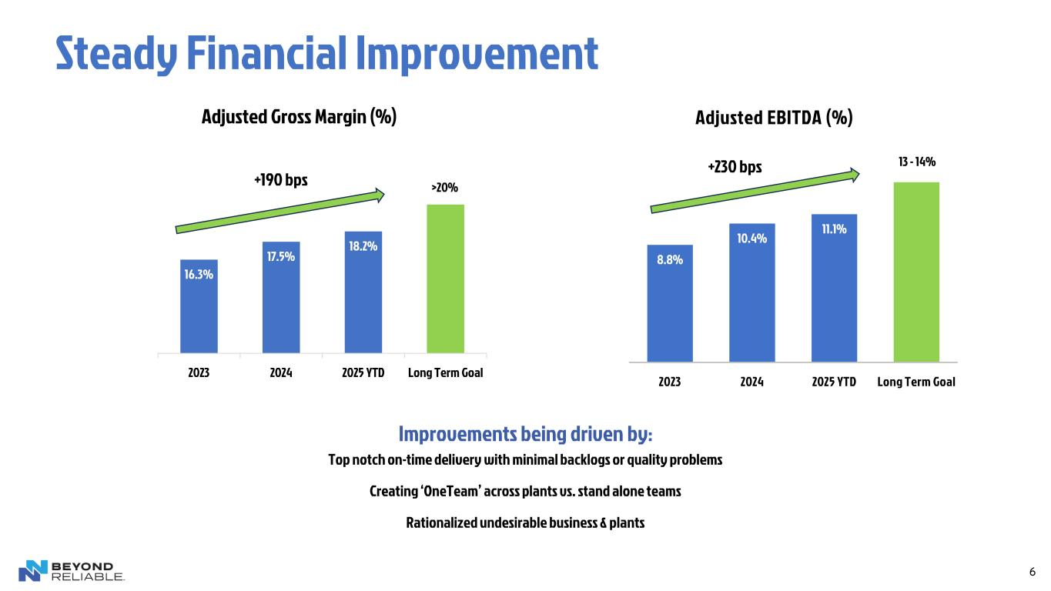
6 Steady Financial Improvement 16.3% 17.5% 18.2% 2023 2024 2025 YTD Long Term Goal Adjusted Gross Margin (%) >20% 8.8% 10.4% 11.1% 2023 2024 2025 YTD Long Term Goal Adjusted EBITDA (%) Improvements being driven by: Top notch on-time delivery with minimal backlogs or quality problems Creating ‘OneTeam’ across plants vs. stand alone teams Rationalized undesirable business & plants +230 bps +190 bps 13 - 14%

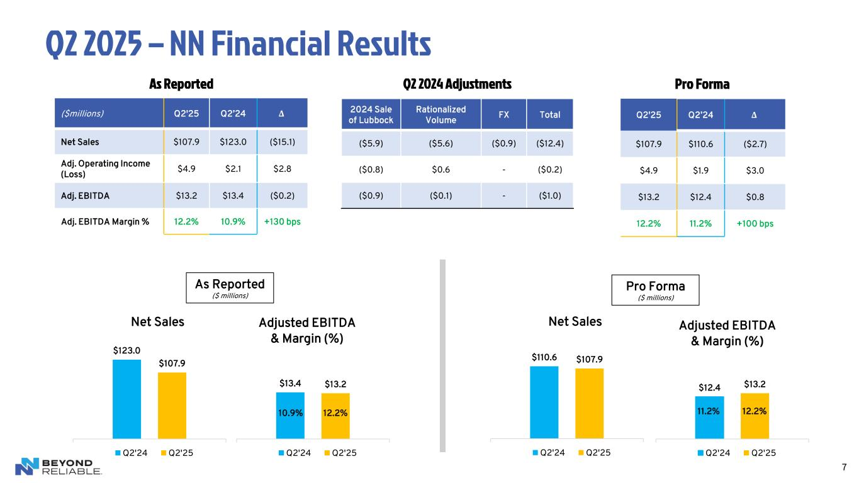
11.6 % ($millions) Q2'25 Q2’24 Δ Net Sales $107.9 $123.0 ($15.1) Adj. Operating Income (Loss) $4.9 $2.1 $2.8 Adj. EBITDA $13.2 $13.4 ($0.2) Adj. EBITDA Margin % 12.2% 10.9% +130 bps Q2'25 Q2’24 Δ $107.9 $110.6 ($2.7) $4.9 $1.9 $3.0 $13.2 $12.4 $0.8 12.2% 11.2% +100 bps 2024 Sale of Lubbock Rationalized Volume FX Total ($5.9) ($5.6) ($0.9) ($12.4) ($0.8) $0.6 - ($0.2) ($0.9) ($0.1) - ($1.0) $12.4 $13.2 Adjusted EBITDA & Margin (%) Q2'24 Q2'25 Pro FormaAs Reported Q2 2024 Adjustments Q2 2025 – NN Financial Results 7 $13.4 $13.2 Adjusted EBITDA & Margin (%) Q2'24 Q2'25 $123.0 $107.9 Net Sales Q2'24 Q2'25 12.2%10.9% 12.2%11.2% Pro Forma ($ millions) As Reported ($ millions) $110.6 $107.9 Net Sales Q2'24 Q2'25

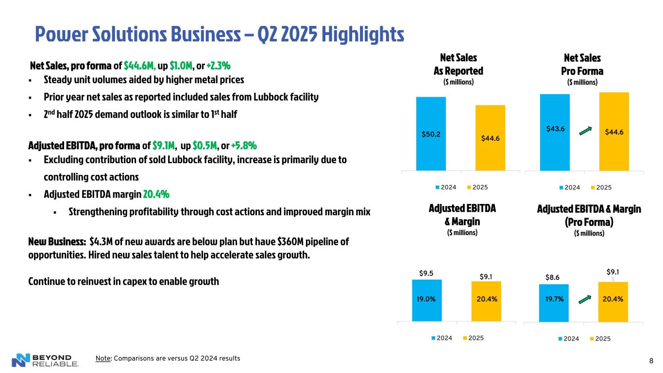
$8.6 $9.1 2024 2025 2024 2025 Adjusted EBITDA & Margin (Pro Forma) ($ millions) $9.5 $9.1 2024 2025 2024 2025 Adjusted EBITDA & Margin ($ millions) 20.4%19.0% 20.4%19.7% Power Solutions Business – Q2 2025 Highlights Net Sales, pro forma of $44.6M, up $1.0M, or +2.3% ▪ Steady unit volumes aided by higher metal prices ▪ Prior year net sales as reported included sales from Lubbock facility ▪ 2nd half 2025 demand outlook is similar to 1st half Adjusted EBITDA, pro forma of $9.1M, up $0.5M, or +5.8% ▪ Excluding contribution of sold Lubbock facility, increase is primarily due to controlling cost actions ▪ Adjusted EBITDA margin 20.4% ▪ Strengthening profitability through cost actions and improved margin mix New Business: $4.3M of new awards are below plan but have $360M pipeline of opportunities. Hired new sales talent to help accelerate sales growth. Continue to reinvest in capex to enable growth $50.2 $44.6 2024 2025 Net Sales As Reported ($ millions) 8Note: Comparisons are versus Q2 2024 results $43.6 $44.6 2024 2025 Net Sales Pro Forma ($ millions)

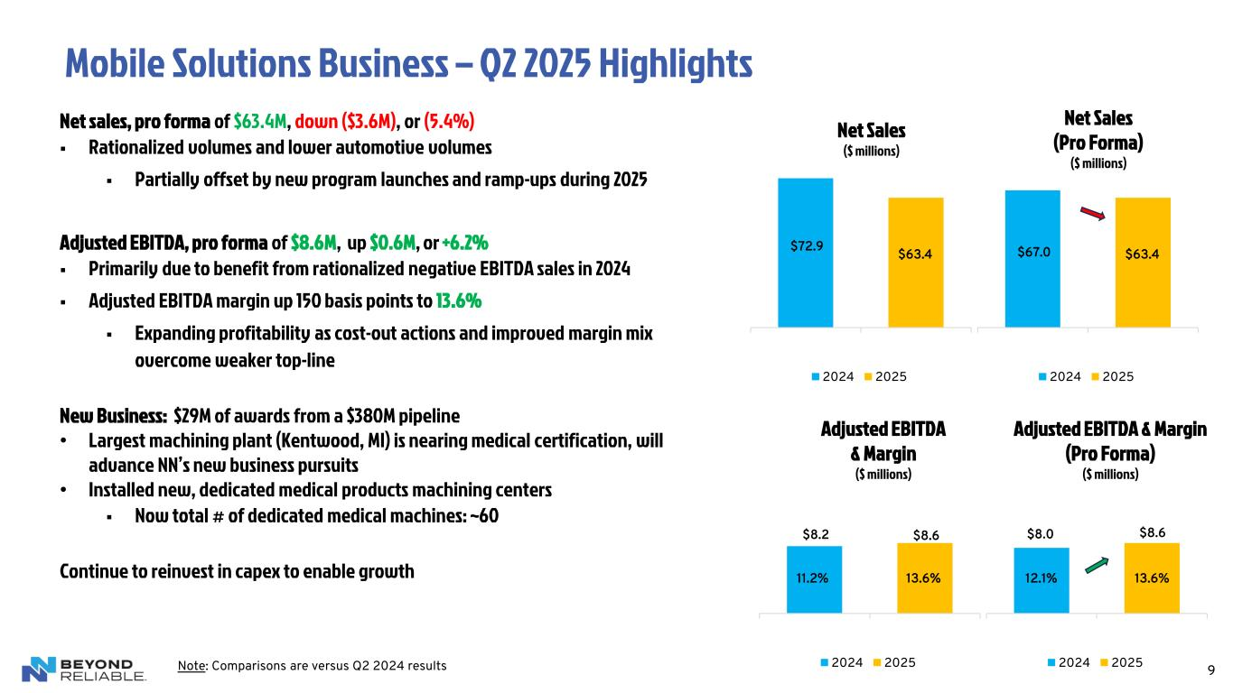
$8.2 $8.6 2024 2025 Adjusted EBITDA & Margin ($ millions) $8.0 $8.6 2024 2025 Adjusted EBITDA & Margin (Pro Forma) ($ millions) Mobile Solutions Business – Q2 2025 Highlights 13.6% $67.0 $63.4 2024 2025 Net Sales (Pro Forma) ($ millions) 12.1% Net sales, pro forma of $63.4M, down ($3.6M), or (5.4%) ▪ Rationalized volumes and lower automotive volumes ▪ Partially offset by new program launches and ramp-ups during 2025 Adjusted EBITDA, pro forma of $8.6M, up $0.6M, or +6.2% ▪ Primarily due to benefit from rationalized negative EBITDA sales in 2024 ▪ Adjusted EBITDA margin up 150 basis points to 13.6% ▪ Expanding profitability as cost-out actions and improved margin mix overcome weaker top-line New Business: $29M of awards from a $380M pipeline • Largest machining plant (Kentwood, MI) is nearing medical certification, will advance NN’s new business pursuits • Installed new, dedicated medical products machining centers ▪ Now total # of dedicated medical machines: ~60 Continue to reinvest in capex to enable growth $72.9 $63.4 2024 2025 Net Sales ($ millions) 13.6%11.2% 9Note: Comparisons are versus Q2 2024 results

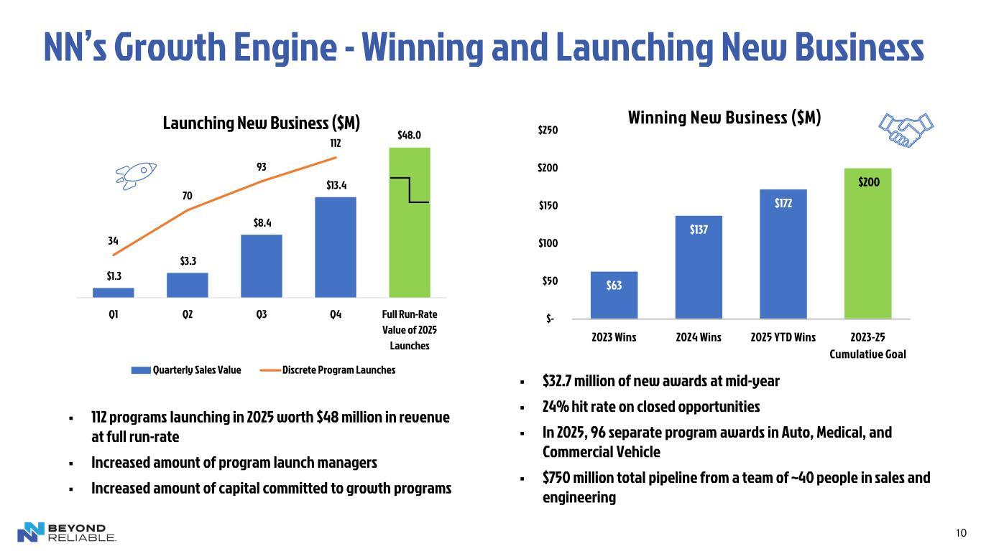
$1.3 $3.3 $8.4 $13.4 34 70 93 112 Q1 Q2 Q3 Q4 Full Run-Rate Value of 2025 Launches Launching New Business ($M) Quarterly Sales Value Discrete Program Launches NN’s Growth Engine - Winning and Launching New Business 10 ▪ 112 programs launching in 2025 worth $48 million in revenue at full run-rate ▪ Increased amount of program launch managers ▪ Increased amount of capital committed to growth programs $63 $137 $172 $200 $- $50 $100 $150 $200 $250 2023 Wins 2024 Wins 2025 YTD Wins 2023-25 Cumulative Goal Winning New Business ($M) ▪ $32.7 million of new awards at mid-year ▪ 24% hit rate on closed opportunities ▪ In 2025, 96 separate program awards in Auto, Medical, and Commercial Vehicle ▪ $750 million total pipeline from a team of ~40 people in sales and engineering $48.0

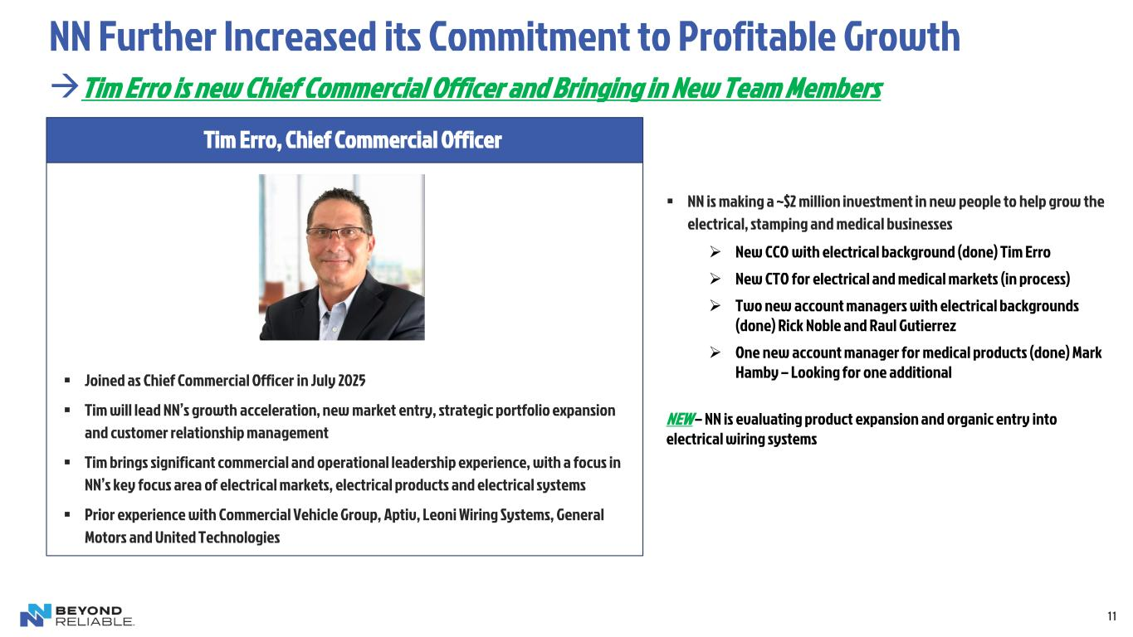
11 NN Further Increased its Commitment to Profitable Growth →Tim Erro is new Chief Commercial Officer and Bringing in New Team Members ▪ Joined as Chief Commercial Officer in July 2025 ▪ Tim will lead NN’s growth acceleration, new market entry, strategic portfolio expansion and customer relationship management ▪ Tim brings significant commercial and operational leadership experience, with a focus in NN’s key focus area of electrical markets, electrical products and electrical systems ▪ Prior experience with Commercial Vehicle Group, Aptiv, Leoni Wiring Systems, General Motors and United Technologies Tim Erro, Chief Commercial Officer ▪ NN is making a ~$2 million investment in new people to help grow the electrical, stamping and medical businesses ➢ New CCO with electrical background (done) Tim Erro ➢ New CTO for electrical and medical markets (in process) ➢ Two new account managers with electrical backgrounds (done) Rick Noble and Raul Gutierrez ➢ One new account manager for medical products (done) Mark Hamby – Looking for one additional NEW – NN is evaluating product expansion and organic entry into electrical wiring systems

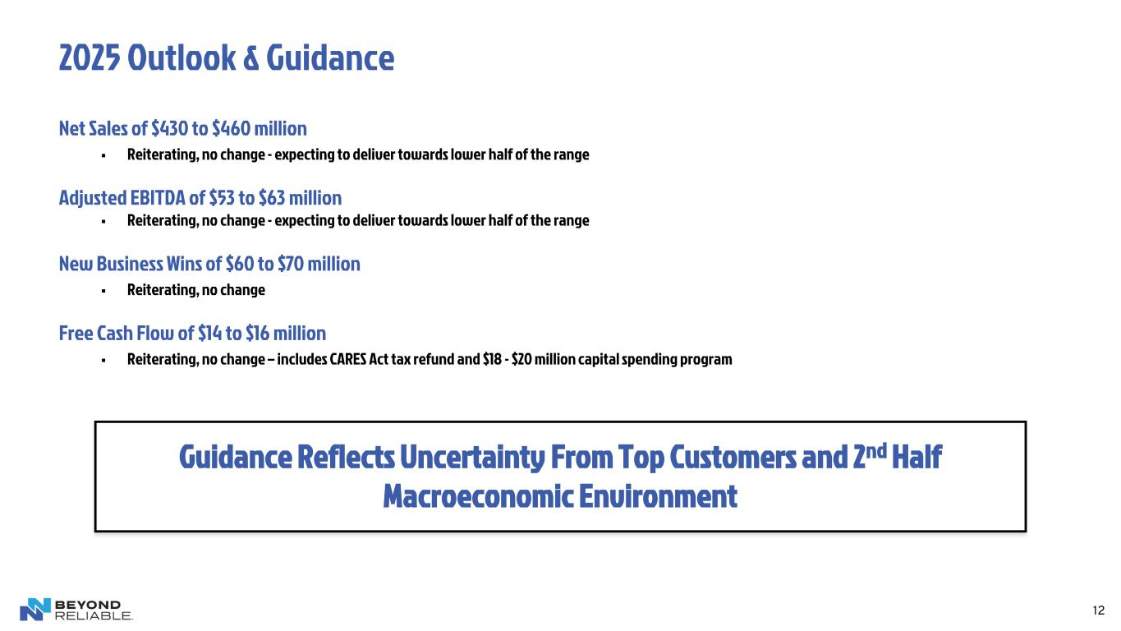
12 2025 Outlook & Guidance Net Sales of $430 to $460 million ▪ Reiterating, no change - expecting to deliver towards lower half of the range Adjusted EBITDA of $53 to $63 million ▪ Reiterating, no change - expecting to deliver towards lower half of the range New Business Wins of $60 to $70 million ▪ Reiterating, no change Free Cash Flow of $14 to $16 million ▪ Reiterating, no change – includes CARES Act tax refund and $18 - $20 million capital spending program Guidance Reflects Uncertainty From Top Customers and 2nd Half Macroeconomic Environment


13 Virtual Investor Day December 2025

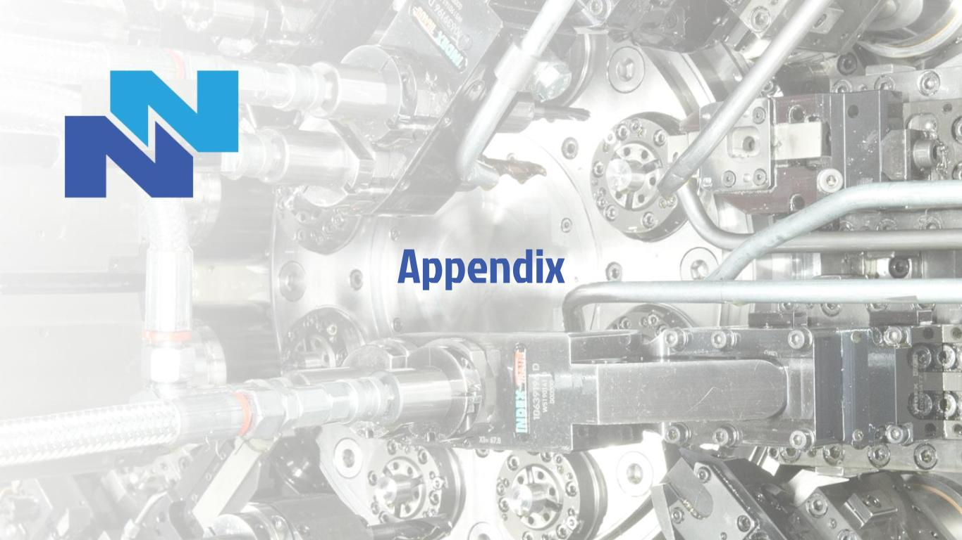
Appendix

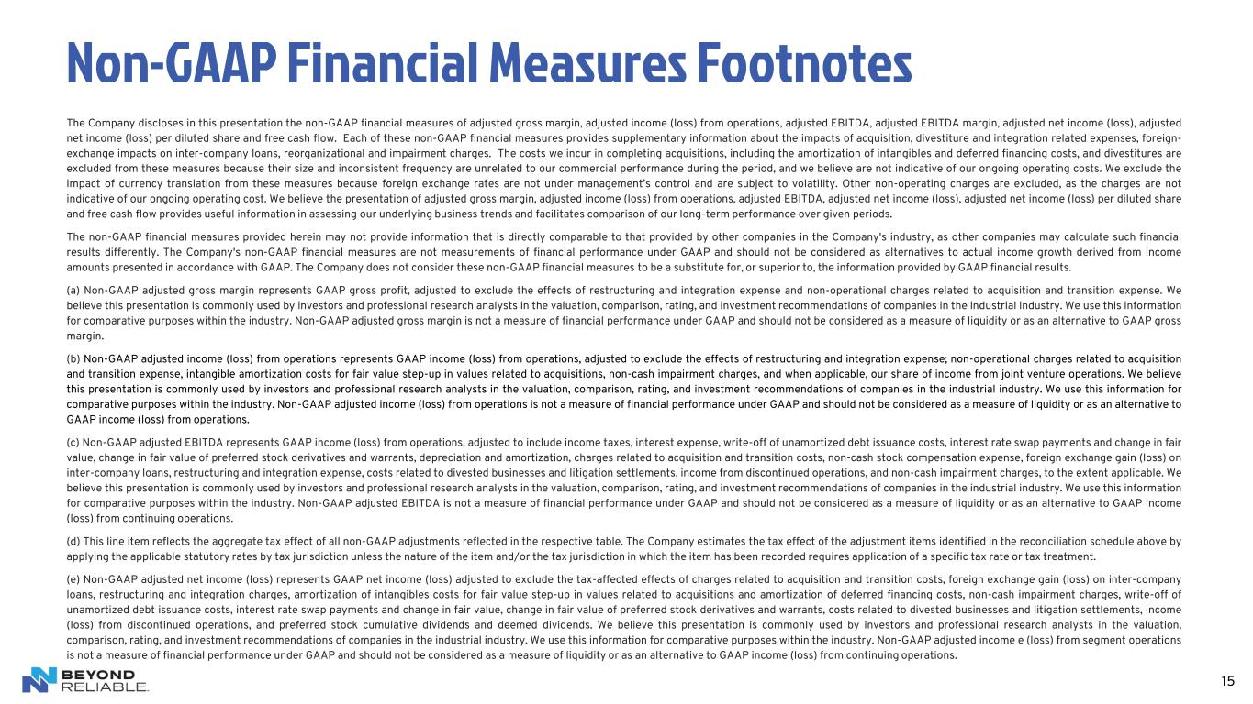
15 The Company discloses in this presentation the non-GAAP financial measures of adjusted gross margin, adjusted income (loss) from operations, adjusted EBITDA, adjusted EBITDA margin, adjusted net income (loss), adjusted net income (loss) per diluted share and free cash flow. Each of these non-GAAP financial measures provides supplementary information about the impacts of acquisition, divestiture and integration related expenses, foreign- exchange impacts on inter-company loans, reorganizational and impairment charges. The costs we incur in completing acquisitions, including the amortization of intangibles and deferred financing costs, and divestitures are excluded from these measures because their size and inconsistent frequency are unrelated to our commercial performance during the period, and we believe are not indicative of our ongoing operating costs. We exclude the impact of currency translation from these measures because foreign exchange rates are not under management’s control and are subject to volatility. Other non-operating charges are excluded, as the charges are not indicative of our ongoing operating cost. We believe the presentation of adjusted gross margin, adjusted income (loss) from operations, adjusted EBITDA, adjusted net income (loss), adjusted net income (loss) per diluted share and free cash flow provides useful information in assessing our underlying business trends and facilitates comparison of our long-term performance over given periods. The non-GAAP financial measures provided herein may not provide information that is directly comparable to that provided by other companies in the Company's industry, as other companies may calculate such financial results differently. The Company's non-GAAP financial measures are not measurements of financial performance under GAAP and should not be considered as alternatives to actual income growth derived from income amounts presented in accordance with GAAP. The Company does not consider these non-GAAP financial measures to be a substitute for, or superior to, the information provided by GAAP financial results. (a) Non-GAAP adjusted gross margin represents GAAP gross profit, adjusted to exclude the effects of restructuring and integration expense and non-operational charges related to acquisition and transition expense. We believe this presentation is commonly used by investors and professional research analysts in the valuation, comparison, rating, and investment recommendations of companies in the industrial industry. We use this information for comparative purposes within the industry. Non-GAAP adjusted gross margin is not a measure of financial performance under GAAP and should not be considered as a measure of liquidity or as an alternative to GAAP gross margin. (b) Non-GAAP adjusted income (loss) from operations represents GAAP income (loss) from operations, adjusted to exclude the effects of restructuring and integration expense; non-operational charges related to acquisition and transition expense, intangible amortization costs for fair value step-up in values related to acquisitions, non-cash impairment charges, and when applicable, our share of income from joint venture operations. We believe this presentation is commonly used by investors and professional research analysts in the valuation, comparison, rating, and investment recommendations of companies in the industrial industry. We use this information for comparative purposes within the industry. Non-GAAP adjusted income (loss) from operations is not a measure of financial performance under GAAP and should not be considered as a measure of liquidity or as an alternative to GAAP income (loss) from operations. (c) Non-GAAP adjusted EBITDA represents GAAP income (loss) from operations, adjusted to include income taxes, interest expense, write-off of unamortized debt issuance costs, interest rate swap payments and change in fair value, change in fair value of preferred stock derivatives and warrants, depreciation and amortization, charges related to acquisition and transition costs, non-cash stock compensation expense, foreign exchange gain (loss) on inter-company loans, restructuring and integration expense, costs related to divested businesses and litigation settlements, income from discontinued operations, and non-cash impairment charges, to the extent applicable. We believe this presentation is commonly used by investors and professional research analysts in the valuation, comparison, rating, and investment recommendations of companies in the industrial industry. We use this information for comparative purposes within the industry. Non-GAAP adjusted EBITDA is not a measure of financial performance under GAAP and should not be considered as a measure of liquidity or as an alternative to GAAP income (loss) from continuing operations. (d) This line item reflects the aggregate tax effect of all non-GAAP adjustments reflected in the respective table. The Company estimates the tax effect of the adjustment items identified in the reconciliation schedule above by applying the applicable statutory rates by tax jurisdiction unless the nature of the item and/or the tax jurisdiction in which the item has been recorded requires application of a specific tax rate or tax treatment. (e) Non-GAAP adjusted net income (loss) represents GAAP net income (loss) adjusted to exclude the tax-affected effects of charges related to acquisition and transition costs, foreign exchange gain (loss) on inter-company loans, restructuring and integration charges, amortization of intangibles costs for fair value step-up in values related to acquisitions and amortization of deferred financing costs, non-cash impairment charges, write-off of unamortized debt issuance costs, interest rate swap payments and change in fair value, change in fair value of preferred stock derivatives and warrants, costs related to divested businesses and litigation settlements, income (loss) from discontinued operations, and preferred stock cumulative dividends and deemed dividends. We believe this presentation is commonly used by investors and professional research analysts in the valuation, comparison, rating, and investment recommendations of companies in the industrial industry. We use this information for comparative purposes within the industry. Non-GAAP adjusted income e (loss) from segment operations is not a measure of financial performance under GAAP and should not be considered as a measure of liquidity or as an alternative to GAAP income (loss) from continuing operations. Non-GAAP Financial Measures Footnotes

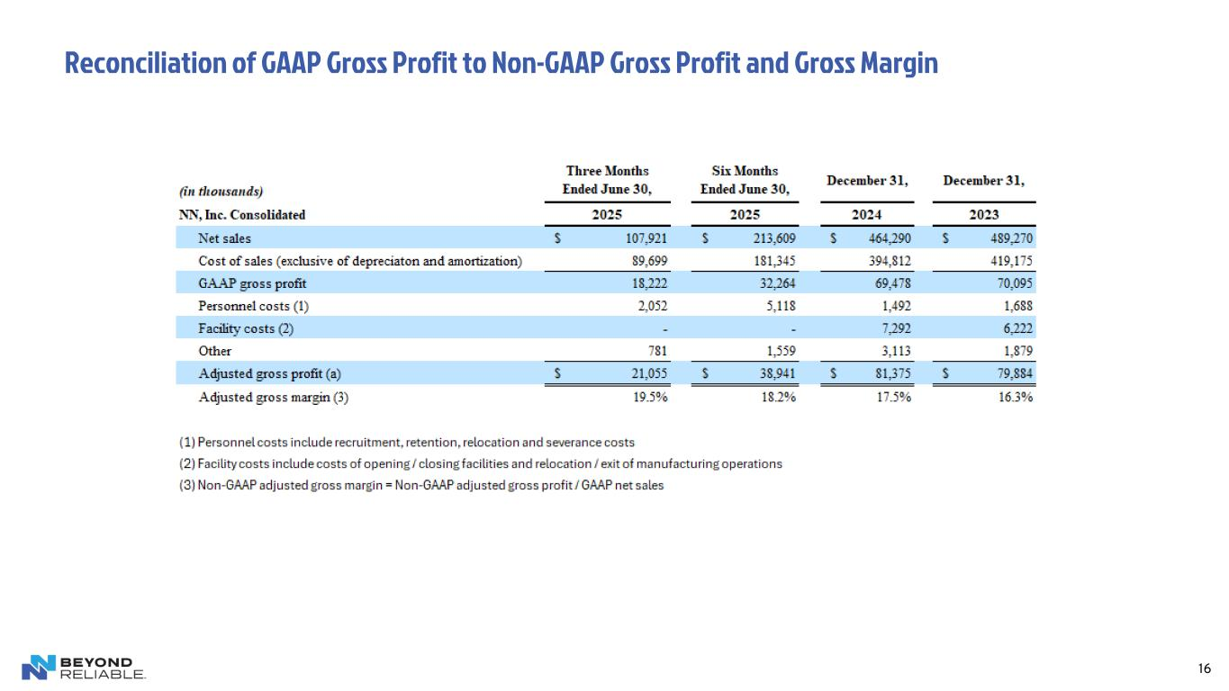
16 Reconciliation of GAAP Gross Profit to Non-GAAP Gross Profit and Gross Margin

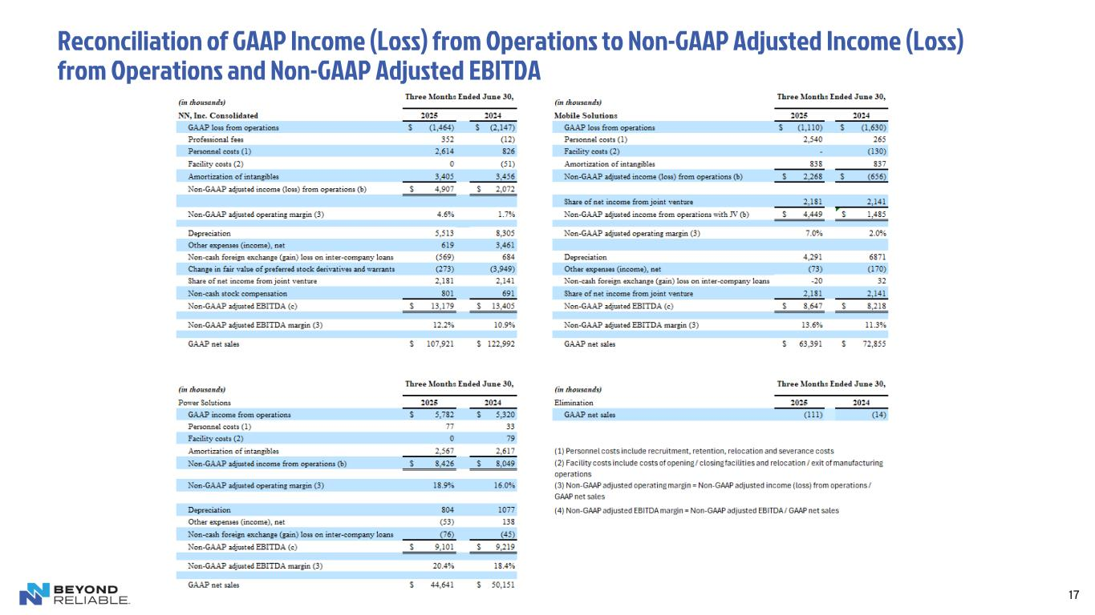
17 Reconciliation of GAAP Income (Loss) from Operations to Non-GAAP Adjusted Income (Loss) from Operations and Non-GAAP Adjusted EBITDA

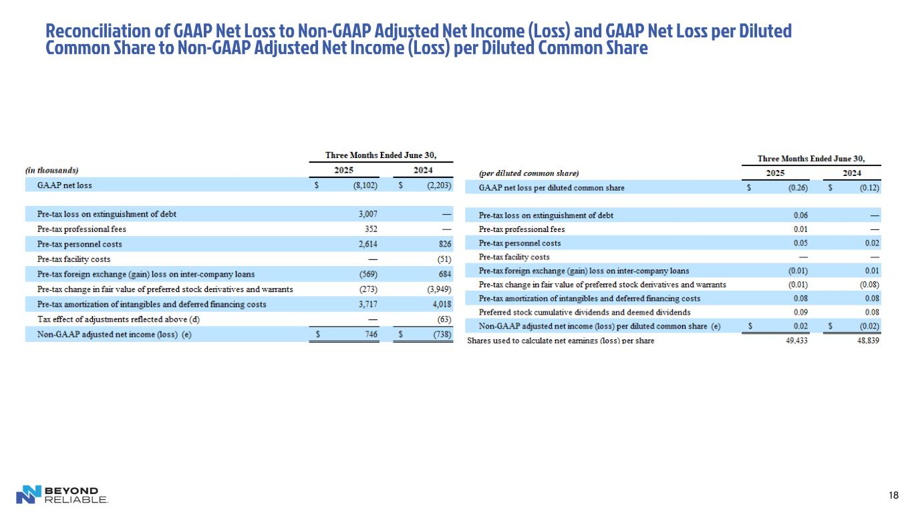
18 Reconciliation of GAAP Net Loss to Non-GAAP Adjusted Net Income (Loss) and GAAP Net Loss per Diluted Common Share to Non-GAAP Adjusted Net Income (Loss) per Diluted Common Share

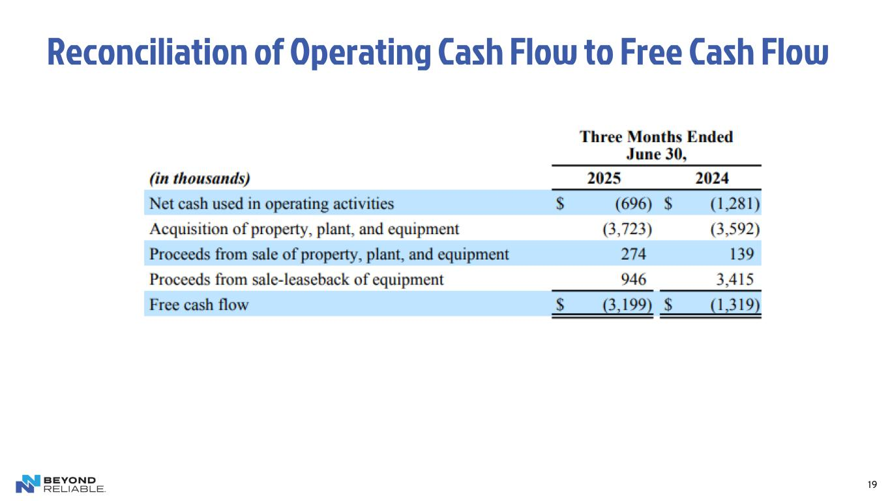
19 Reconciliation of Operating Cash Flow to Free Cash Flow


Thank You 20 Joe Caminiti or Stephen Poe NNBR@alpha-ir.com 312-445-2870 Investor & Media Contacts

