UNITED STATES
SECURITIES AND EXCHANGE COMMISSION
Washington, D.C. 20549
FORM 8-K
CURRENT REPORT
Pursuant to Section 13 OR 15(d) of The Securities Exchange Act of 1934
Date of Report (Date of earliest event reported): October 28, 2026

NN, Inc.
(Exact name of registrant as specified in its charter)
Delaware |  |  | 001-39268 |  |  | 62-1096725
(State or other jurisdiction of  incorporation) |  |  | (Commission File Number) |  |  | (I.R.S. Employer  Identification No.)

6210 Ardrey Kell Road, Suite 120
Charlotte, North Carolina |  |  |  |  |  | 28277
(Address of principal executive offices) |  |  |  |  |  | (Zip Code)

(980) 264-4300
(Registrant’s telephone number, including area code)
(Former name or former address, if changed since last report)
Check the appropriate box if the Form 8-K filing is intended to simultaneously satisfy the filing obligation of the registrant under any of the following provisions (see General Instruction A.2. below):
☐ |  |  | Written communications pursuant to Rule 425 under the Securities Act (17 CFR 230.425)
☐ |  |  | Soliciting material pursuant to Rule 14a-12 under the Exchange Act (17 CFR 240.14a-12)
☐ |  |  | Pre-commencement communications pursuant to Rule 14d-2(b) under the Exchange Act (17 CFR 240.14d- 2(b))
☐ |  |  | Pre-commencement communications pursuant to Rule 13e-4(c) under the Exchange Act (17 CFR 240.13e- 4(c))

Securities registered pursuant to Section 12(b) of the Act:
Title of each class |  |  |  |  |  | Trading symbol |  |  |  |  |  | Name of each exchange on which registered
Common Stock, par value $0.01 |  |  |  |  |  | NNBR |  |  |  |  |  | The Nasdaq Stock Market LLC

Indicate by check mark whether the registrant is an emerging growth company as defined in Rule 405 of the Securities Act of 1933 (§230.405 of this chapter) or Rule 12b-2 of the Securities Exchange Act of 1934 (§240.12b-2 of this chapter).
Emerging growth company. |  |  | ☐
If an emerging growth company, indicate by check mark if the registrant has elected not to use the extended transition period for complying with any new or revised financial accounting standards provided pursuant to Section 13(a) of the Exchange Act. ☐

ITEM 2.02 RESULTS OF OPERATIONS AND FINANCIAL CONDITION
On October 28, 2026, NN, Inc. (the “Company”) issued a press release announcing the Company’s financial results for the quarter ended September 30, 2026. The full text of the press release is furnished as Exhibit 99.1 to this Current Report on Form 8-K (the "Current Report").
Pursuant to the rules and regulations of the U.S. Securities and Exchange Commission (the “SEC”), the information furnished pursuant to Item 2.02 of this Current Report (including Exhibit 99.1) is deemed to have been furnished and shall not be deemed to be “filed” for purposes of Section 18 of the Securities Exchange Act of 1934, as amended (the "Exchange Act"), or otherwise subject to the liabilities of that section. Such information shall not be incorporated by reference into any filing of the Company, whether made before or after the date hereof, regardless of any general incorporation language in such filing.

ITEM 7.01 REGULATION FD DISCLOSURE
On October 28, 2026, the Company posted a supplemental presentation to its website, https://investors.nninc.com/, which will be presented during its quarterly investor conference call on October 29, 2026, at 9:00 a.m. ET. The supplemental presentation is included as Exhibit 99.2 to this Current Report.
Pursuant to the rules and regulations of the SEC, the information furnished pursuant to Item 7.01 of this Current Report (including Exhibit 99.2) is deemed to have been furnished and shall not be deemed to be “filed” for purposes of Section 18 of the Exchange Act or otherwise subject to the liabilities of that section. Such information shall not be incorporated by reference into any filing of the Company, whether made before or after the date hereof, regardless of any general incorporation language in such filing.

ITEM 9.01 FINANCIAL STATEMENTS AND EXHIBITS
(d) Exhibits.
Exhibit  No. |  |  |  |  |  | Description of Exhibit
99.1 |  |  |  |  |  | Press Release issued by NN, Inc., dated October 28, 2026
99.2 |  |  |  |  |  | Third Quarter 2026 Investor Presentation
104 |  |  |  |  |  | Cover Page Interactive Data File (embedded within the Inline XBRL document)

SIGNATURES

Pursuant to the requirements of the Securities Exchange Act of 1934, the registrant has duly caused this report to be signed on its behalf by the undersigned hereunto duly authorized.
Date: |  |  | October 28, 2026

 |  |  | NN, INC.
 |  |  | By: |  |  | /s/ Christopher H. Bohnert
 |  |  | Name: |  |  | Christopher H. Bohnert
 |  |  | Title: |  |  | Senior Vice President and Chief Financial Officer

FOR IMMEDIATE RELEASE

NN, INC. REPORTS THIRD QUARTER 2026 RESULTS

NN Delivers Another Quarter of Growth in Net Sales, Adjusted EBITDA, and New Wins; Raises 2026 Outlook Again

CHARLOTTE, N.C., October 28, 2026 – NN, Inc. (NASDAQ: NNBR) (“NN” or the “Company”), an entrepreneurial growth company that engineers and manufactures high-precision components and assemblies, today reported results for the third quarter ended September 30, 2026.

Q3 2026 Financial Highlights, compared to Q3 2025
•Net sales of $131.1 million, up $27.2 million or 26.2%
•Gross margin of $18.3 million, up $0.8 million or 4.6%
•Adjusted gross margin of $25.3 million, up $5.8 million or 29.5%
•Adjusted gross margin percentage of 19.3%, up 50 basis points
•Loss from operations of $3.3 million, up $1.1 million from a loss of $2.2 million
•Adjusted income from operations of $8.5 million, up $4.4 million or 109.5%
•GAAP net loss of $4.6 million, improving by $2.1 million or 31.3%
•Adjusted net income of $5.3 million, up $5.6 million
•Adjusted EBITDA of $18.5 million, up $6.1 million or 49.7%
•Adjusted EBITDA margin percentage of 14.1%, up 220 basis points

Performance Highlights:
•During 2026, NN has completed a multi-step process to transform its balance sheet. The preferred stock payoff and equity raise has unlocked growth potential. NN now has the financial flexibility to accelerate and optimize its business results. The Company had been severely constrained by its capital structure for multiple years. The Company looks forward to achieving higher results at a faster pace.
•NN’s new business program has continued to outperform expectations. On a trailing 12 months basis ended September 30, 2026, the Company has secured $130 million of annualized new business awards, a significant portion of which is not yet reflected in the Company’s run-rate. The Company is now winning more than 1 new program per day. The Company will continue to update results during quarterly earnings calls.
•NN’s 5 Pillar growth program is working well and the Company is investing its time and resources to strategically pivot the portfolio to high-growth, high-value markets and products. The Company has been aided by strong underlying market growth.
1

◦Data Center: NN’s top targeted end market and one of its fastest growing businesses. NN is ramping up the business by installing over 50 new machines dedicated to this market through Q1 2027. This business has a growing $66 million pipeline, including liquid cooling components for next generation chip designs.
◦Defense: NN has secured multiple new awards in this market in 2026 and recently became a supplier to a leading firearm accessories OEM with multiple programs currently in ramp-up mode.
◦Medical: NN has secured multiple new awards in this market in 2026 and became a supplier to a leading medical equipment OEM with 30 core platforms. The Company is significantly increasing the size of the business with multiple programs in ramp-up mode.
•NN’s cost-out program is on track to deliver $12 million of cost-out via 335 projects globally. These cost improvements are not yet fully reflected in the Company’s run-rate results. NN’s global operations team is also leading an ongoing continuum of new product development and business launches. In 2026, NN expects to launch more than 150 new programs worth approximately $100 million in peak annual sales.
•NN is underway with an intentional sales growth investment program. Overall, the Company is growing its net sales by approximately $68 million in 2026 based on updated guidance. The Company has achieved excellent working capital performance of 16.5% - 16.7% of sales over the trailing 6 months.

Management Commentary:
Harold Bevis, President and Chief Executive Officer, commented, “NN has delivered several consecutive years of improved adjusted EBITDA and sales growth wins, is now benefitting from the launching of these programs, and has a solid multi-year outlook for continued growth. This enabled the Company to initiate a transformation of its equity and debt structure. We paid off all of our preferred stock via several debt-for-equity transactions over the last 4 months. We also raised strategic capital to fund additional programs that were previously on hold due to lack of funding. Taken together, this represented $143 million of capital transactions. We executed decisively and I want to thank our Board of Directors, our new investors, and our advisors. This transformation is behind us now and we are already underway leveraging our newly enhanced flexibility.

We are operating under a new reality whereby we can move faster and improve on multiple fronts at once. While we are on track for our best year ever in 2026, our momentum is continuing into 2027, as part of an achievable multi-year growth outlook. We have a full basket of opportunities to improve, and we are taking on the next set of big improvements during 2027 now that we have the financial capacity to do so. The last remaining balance sheet financial improvements are with regards to our ABL and Term Loan, which we will fix at the right time.

While we are happy with our last four years of sustained results improvement, we are at the same time determined to continue elevating the business to a higher plane of performance. This will require us to continue shifting our portfolio. We are taking forward actions on targeted sales growth, exiting low profit auto programs, and continuously taking out costs. We are on track for our multi-year targets. We are pleased that we have secured many new customers and introduced multiple new products in 2026. Further, we have a refreshed investor roster with growth-minded investors aligned with our forward goals. We are already accelerating our pace of improvement with our newfound financial flexibility.”

Bevis continued, “Our 5 Pillar growth program is our touchstone. Now we are in a position to also explore logical, small bolt-on acquisitions to further enhance our goals and growth trajectory. We are pleased that many of our new sales programs require ‘Immediate Startup’. Overall, the new wins numbers are very good, but we have areas where we want a significantly higher level of wins and growth, especially Data Center, Medical, and Defense. We are disciplined about improving our margins at the same time, walking away from dilutive business, and exiting minimal margin, minimal ROI business. We believe we have more room to increase our gross margins, adjusted EBITDA margins, and ROIs.”

Bevis concluded, “Given the results we have delivered in 2026 year to date and our strong forward outlook, we are raising our full-year 2026 guidance. We will be more specific about 2027 when we have completed our 2027 business planning process which is underway now. We are updating our thinking now that we have more financial firepower that has been enabled by our balance sheet transformation of 2026.”

2

Third Quarter NN Results
Net sales for the third quarter were $131.1 million, an increase of 26.2% compared to net sales of $103.9 million for the same period in 2025. The increase was primarily driven by higher selling prices, reflecting the pass-through of increased raw material costs to customers, higher volumes, and favorable foreign exchange effects.

Loss from operations for the third quarter was $3.3 million, an increase of $1.1 million compared to a loss from operations of $2.2 million for the same period in 2025. The decline was primarily due to higher labor costs associated with increasing headcount to support new business and higher professional fees driven by the various strategic initiatives.

Net loss for the third quarter was $4.6 million, an improvement of 31.3% compared to net loss of $6.7 million for the same period in 2025. The improvement was primarily driven by a gain related to a favorable tax ruling in Brazil and higher income from our joint venture in China.

Third Quarter 2026 NN Adjusted Results
Adjusted EBITDA was $18.5 million, an increase of 49.7% compared to adjusted EBITDA of $12.4 million for the same period in 2025, primarily driven by improved sales mix, operating performance and higher income from our joint venture in China.

Adjusted income from operations was $8.5 million, an increase of 109.5% compared to adjusted income from operations of $4.0 million for the same period in 2025. The increase was driven primarily by higher volumes and improved mix to higher margin products, partially offset by increased selling, general and administrative expenses.

Adjusted net income was $5.3 million, or $0.07 per diluted common share, an increase of $5.6 million or $0.08 per diluted common share, compared to adjusted net loss of $0.3 million, or $(0.01) per diluted common share for the same period in 2025.

Third Quarter Power Solutions Results
Net sales for the third quarter of 2026 were $63.2 million, an increase of 40.6% compared to net sales of $44.9 million for the same period in 2025. The increase was driven primarily by higher selling prices, reflecting the pass-through of increased raw material costs to customers, increased volumes, and favorable foreign exchange effects.

Income from operations for the third quarter of 2026 was $9.2 million, an increase of 69.4% compared to income from operations of $5.4 million for the same period in 2025. The increase was primarily due to higher selling prices and increased volumes. The increase was partially offset by higher material costs and labor costs.

Adjusted income from operations for the third quarter of 2026 was $12.4 million, an increase of 53.1% compared to adjusted income from operations of $8.1 million for the same period in 2025. The increase was primarily due to the improved operating performance from higher selling prices and volumes.

Third Quarter Mobile Solutions Results
Net sales for the third quarter of 2026 were $68.2 million, an increase of 15.3% compared to net sales of $59.1 million in the same period of 2025. The increase was primarily due to higher volumes and favorable foreign exchange effects.

Loss from operations for the third quarter was $6.3 million, a decline of $3.4 million compared to $2.9 million for the same period in 2025. The increase was primarily due to higher costs from volume increases, increased labor costs due to the start-up of new programs, material cost increases, and facility costs.

3
Adjusted income from operations for the third quarter was $4.0 million, an increase of 75.2% compared to adjusted income from operations of $2.3 million in the same period of 2025. The increase in adjusted income from operations was primarily due to higher sales volumes and increased net income from our joint venture.

2026 Outlook
NN is revising its guidance ranges upward in several areas.

•Net sales are expected to range between $480 to $500 million
◦This reflects a $68 million improvement over 2025, or 16% growth year-over-year at the midpoint.
•Adjusted EBITDA is expected to range between $64 and $68 million.
◦This reflects a $17 million improvement over 2025, or 35% growth year-over-year at the midpoint.
•New business wins are expected to range between $110 to $130 million.
◦This reflects a $50 million improvement over 2025, or 71% growth year-over-year at the midpoint.

Chris Bohnert, Senior Vice President and Chief Financial Officer, commented, “Given the strength of our results year to date and the continued momentum in our targeted growth markets, we are again raising our full-year 2026 guidance across our key metrics. As we look ahead to the final quarter of 2026 and into 2027, our outlook reflects continued profitable growth and keeps us well on track to maintain pace with our 2029 financial goals. Our new capital structure enables NN to enter 2027 with a stronger balance sheet and greater financial flexibility to invest in our growth.”

4
Conference Call
NN will discuss its results during its quarterly investor conference call on October 29, 2026, at 9 a.m. ET. The call and supplemental presentation may be accessed via NN's website, www.nninc.com. The conference call can also be accessed by dialing (833) 461-5787 (domestic) or (585) 542-9983 (international) and entering Conference ID number 100337183. For those who are unavailable to listen to the live broadcast, a replay will be available shortly after the call.
NN discloses in this press release the non-GAAP financial measures of adjusted gross margin, adjusted gross margin %, adjusted income from operations, adjusted EBITDA, adjusted EBITDA margin, adjusted net income (loss), and adjusted net income (loss) per diluted common share. Each of these non-GAAP financial measures provides supplementary information about the impacts of acquisition, divestiture and integration related expenses, foreign-exchange impacts on inter-company loans, reorganizational and impairment charges.
The financial tables found later in this press release include a reconciliation of adjusted gross margin, adjusted gross margin %, adjusted income from operations, adjusted operating margin, adjusted EBITDA, adjusted EBITDA margin, adjusted net income (loss), and adjusted net income (loss) per diluted common share to the U.S. GAAP financial measures of gross margin, income (loss) from operations, net loss, net loss per diluted common share.

5
About NN, Inc.
NN, Inc. (NASDAQ: NNBR) is an entrepreneurial manufacturing company specializing in manufacturing micron-tolerance precision metal componentry for high-growth end markets, especially Data Center, Electric Grid, Medical, Defense, and High-Value Vehicle systems. Founded in 1980, NN serves over 700 customers on 4 continents through its 2,700 person workforce operating out of 27 global plants. This footprint enables rapid innovation and globally scaled solutions. For more information, visit nninc.com.

This press release may contain forward-looking statements regarding our business, operations, and financial performance. Such statements are based on current expectations and assumptions that are subject to a number of risks and uncertainties. Actual results could differ materially. Please refer to our most recently filed Form 10-K and our Form 10-Q for the period following that Form 10-K, including the risk factors described therein. We undertake no obligation to update any forward-looking statement, except as required by law. Given these risks and uncertainties, investors are cautioned not to place undue reliance on such forward-looking statements.

Investor & Media Contacts:
Joseph Caminiti
NNBR@alpha-ir.com
312-445-2870

Financial Tables Follow

6
NN, Inc.
Condensed Consolidated Statements of Operations and Comprehensive Income (Loss)
(Unaudited)
 |  |  | Three Months Ended  September 30, |  |  |  |  |  |  |  |  |  |  |  | Nine Months Ended  September 30,
(in thousands, except per share data) |  |  | 2026 |  |  |  |  |  | 2025 |  |  |  |  |  | 2026 |  |  |  |  |  | 2025
Net sales |  |  | $ | 131,100 |  |  |  |  | $ | 103,882 |  |  |  |  | $ | 378,293 |  |  |  |  | $ | 317,492
Cost of sales (exclusive of depreciation and amortization shown separately below) |  |  | 112,830 |  |  |  |  |  | 86,410 |  |  |  |  |  | 318,724 |  |  |  |  |  | 267,755
Selling, general, and administrative expense |  |  | 13,287 |  |  |  |  |  | 11,059 |  |  |  |  |  | 39,151 |  |  |  |  |  | 34,325
Depreciation and amortization |  |  | 9,260 |  |  |  |  |  | 9,064 |  |  |  |  |  | 27,844 |  |  |  |  |  | 26,756
Other operating income, net |  |  | (957) |  |  |  |  |  | (404) |  |  |  |  |  | (3,053) |  |  |  |  |  | (2,843)
Loss from operations |  |  | (3,320) |  |  |  |  |  | (2,247) |  |  |  |  |  | (4,373) |  |  |  |  |  | (8,501)
Interest expense |  |  | 5,467 |  |  |  |  |  | 5,666 |  |  |  |  |  | 16,956 |  |  |  |  |  | 16,517
Loss on extinguishment of debt |  |  | — |  |  |  |  |  | — |  |  |  |  |  | — |  |  |  |  |  | 3,007
Other income, net |  |  | (2,919) |  |  |  |  |  | (70) |  |  |  |  |  | (2,634) |  |  |  |  |  | (2,858)
Loss before provision for income taxes and share of net income from joint venture |  |  | (5,868) |  |  |  |  |  | (7,843) |  |  |  |  |  | (18,695) |  |  |  |  |  | (25,167)
Provision for income taxes |  |  | (1,872) |  |  |  |  |  | (815) |  |  |  |  |  | (2,778) |  |  |  |  |  | (2,898)
Share of net income from joint venture |  |  | 3,153 |  |  |  |  |  | 1,979 |  |  |  |  |  | 7,791 |  |  |  |  |  | 6,599
Net loss |  |  | $ | (4,587) |  |  |  |  | $ | (6,679) |  |  |  |  | $ | (13,682) |  |  |  |  | $ | (21,466)
Other comprehensive income:
Foreign currency translation gain |  |  | 468 |  |  |  |  |  | 806 |  |  |  |  |  | 3,228 |  |  |  |  |  | 8,385
Total other comprehensive income |  |  | 468 |  |  |  |  |  | 806 |  |  |  |  |  | 3,228 |  |  |  |  |  | 8,385
Comprehensive loss |  |  | $ | (4,119) |  |  |  |  | $ | (5,873) |  |  |  |  | $ | (10,454) |  |  |  |  | $ | (13,081)
Basic and diluted net loss per common share |  |  | $ | (0.13) |  |  |  |  | $ | (0.23) |  |  |  |  | $ | (0.49) |  |  |  |  | $ | (0.72)
Shares used to calculate basic and diluted net loss per common share |  |  | 78,109 |  |  |  |  |  | 49,605 |  |  |  |  |  | 59,461 |  |  |  |  |  | 49,373
7
NN, Inc.
Condensed Consolidated Balance Sheets
(Unaudited)
(in thousands, except per share data) |  |  | September 30,  2026 |  |  |  |  |  | December 31,  2025
Assets
Current assets:
Cash and cash equivalents |  |  | $ | 12,290 |  |  |  |  | $ | 11,377
Accounts receivable, net |  |  | 77,225 |  |  |  |  |  | 59,785
Inventories |  |  | 69,620 |  |  |  |  |  | 65,978
Income tax receivable |  |  | 581 |  |  |  |  |  | 13,389
Prepaid assets |  |  | 6,941 |  |  |  |  |  | 2,952
Other current assets |  |  | 11,496 |  |  |  |  |  | 10,526
Total current assets |  |  | 178,153 |  |  |  |  |  | 164,007
Property, plant and equipment, net |  |  | 164,096 |  |  |  |  |  | 158,885
Operating lease right-of-use assets |  |  | 31,270 |  |  |  |  |  | 35,155
Intangible assets, net |  |  | 20,573 |  |  |  |  |  | 30,789
Investment in joint venture |  |  | 48,008 |  |  |  |  |  | 42,543
Deferred tax assets |  |  | 1,775 |  |  |  |  |  | 1,673
Other non-current assets |  |  | 7,019 |  |  |  |  |  | 7,732
Total assets |  |  | $ | 450,894 |  |  |  |  | $ | 440,784
Liabilities, Preferred Stock, and Stockholders’ Equity
Current liabilities:
Accounts payable |  |  | $ | 59,663 |  |  |  |  | $ | 49,442
Accrued salaries, wages and benefits |  |  | 17,270 |  |  |  |  |  | 14,004
Income tax payable |  |  | 468 |  |  |  |  |  | 553
Current maturities of long-term debt |  |  | 2,962 |  |  |  |  |  | 5,791
Current portion of operating lease liabilities |  |  | 6,409 |  |  |  |  |  | 6,430
Other current liabilities |  |  | 15,116 |  |  |  |  |  | 13,575
Total current liabilities |  |  | 101,888 |  |  |  |  |  | 89,795
Deferred tax liabilities |  |  | 4,077 |  |  |  |  |  | 4,312
Long-term debt, net of current maturities |  |  | 165,851 |  |  |  |  |  | 153,758
Operating lease liabilities, net of current portion |  |  | 32,401 |  |  |  |  |  | 37,092
Other non-current liabilities |  |  | 7,351 |  |  |  |  |  | 9,420
Total liabilities |  |  | 311,568 |  |  |  |  |  | 294,377
Commitments and contingencies
Series D perpetual preferred stock |  |  | 35,594 |  |  |  |  |  | 112,409
Stockholders' equity:
Common stock |  |  | 825 |  |  |  |  |  | 502
Additional paid-in capital |  |  | 519,565 |  |  |  |  |  | 439,700
Accumulated deficit |  |  | (381,307) |  |  |  |  |  | (367,625)
Accumulated other comprehensive loss |  |  | (35,351) |  |  |  |  |  | (38,579)
Total stockholders’ equity |  |  | 103,732 |  |  |  |  |  | 33,998
Total liabilities, preferred stock, and stockholders’ equity |  |  | $ | 450,894 |  |  |  |  | $ | 440,784

8
NN, Inc.
Condensed Consolidated Statements of Cash Flows
(Unaudited)
Nine Months Ended
September 30,
(in thousands) |  |  | 2026 |  |  |  |  |  | 2025
Cash flows from operating activities
Net loss |  |  | $ | (13,682) |  |  |  |  | $ | (21,466)
Adjustments to reconcile net loss to net cash provided by operating activities:
Depreciation and amortization |  |  | 27,844 |  |  |  |  |  | 26,756
Amortization of debt issuance costs and discount |  |  | 750 |  |  |  |  |  | 1,255
Paid-in-kind interest |  |  | 5,007 |  |  |  |  |  | 2,148
Loss on extinguishment of debt |  |  | — |  |  |  |  |  | 3,007
Total derivative loss (gain) |  |  | 242 |  |  |  |  |  | (2,109)
Share of net income from joint venture, net of cash dividends received |  |  | (3,584) |  |  |  |  |  | (3,551)
Share-based compensation expense |  |  | 2,321 |  |  |  |  |  | 2,377
Deferred income taxes |  |  | (273) |  |  |  |  |  | (481)
Other |  |  | (416) |  |  |  |  |  | (363)
Changes in operating assets and liabilities:
Accounts receivable |  |  | (17,385) |  |  |  |  |  | 506
Inventories |  |  | (3,216) |  |  |  |  |  | 533
Other operating assets |  |  | (4,972) |  |  |  |  |  | (3,171)
Income taxes receivable and payable, net |  |  | 12,732 |  |  |  |  |  | (690)
Accounts payable |  |  | 7,802 |  |  |  |  |  | 7,629
Other operating liabilities |  |  | 3,726 |  |  |  |  |  | (5,256)
Net cash provided by operating activities |  |  | 16,896 |  |  |  |  |  | 7,124
Cash flows from investing activities
Acquisition of property, plant and equipment |  |  | (14,931) |  |  |  |  |  | (11,058)
Proceeds from sale of property, plant, and equipment |  |  | 133 |  |  |  |  |  | 1,837
Net cash used in investing activities |  |  | (14,798) |  |  |  |  |  | (9,221)
Cash flows from financing activities
Proceeds from asset backed credit facilities |  |  | 64,375 |  |  |  |  |  | 37,000
Repayments of asset backed credit facilities |  |  | (69,075) |  |  |  |  |  | (42,400)
Proceeds from long-term debt |  |  | 10,000 |  |  |  |  |  | 119,234
Repayments of long-term debt |  |  | (845) |  |  |  |  |  | (116,583)
Payments for debt issuance costs |  |  | (100) |  |  |  |  |  | (3,553)
Proceeds from issuance of common stock, net of issuance costs |  |  | 69,405 |  |  |  |  |  | —
Redemption of preferred stock |  |  | (70,002) |  |  |  |  |  | —
Proceeds from sale-leaseback of equipment |  |  | — |  |  |  |  |  | 989
Proceeds from sale-leaseback of land and buildings |  |  | — |  |  |  |  |  | 4,300
Repayments of financing obligations |  |  | (1,439) |  |  |  |  |  | (913)
Other |  |  | (4,580) |  |  |  |  |  | (3,351)
Net cash used in financing activities |  |  | (2,261) |  |  |  |  |  | (5,277)
Effect of exchange rate changes on cash flows |  |  | 1,076 |  |  |  |  |  | 1,461
Net change in cash and cash equivalents |  |  | 913 |  |  |  |  |  | (5,913)
Cash and cash equivalents at beginning of period |  |  | 11,377 |  |  |  |  |  | 18,128
Cash and cash equivalents at end of period |  |  | $ | 12,290 |  |  |  |  | $ | 12,215

9
Reconciliation of GAAP Gross Margin to Non-GAAP Gross Margin and Gross Margin %

Three Months Ended
September 30,
(in thousands) |  |  | 2026 |  |  |  |  |  | 2025
GAAP Net sales |  |  | $ | 131,100 |  |  |  |  | $ | 103,882
GAAP Cost of sales (exclusive of depreciation and amortization) |  |  | 112,830 |  |  |  |  |  | 86,410
GAAP gross margin |  |  | 18,270 |  |  |  |  |  | 17,472
Personnel costs (1) |  |  | 2,748 |  |  |  |  |  | 1,294
Facility costs (2) |  |  | 3,514 |  |  |  |  |  | —
Other |  |  | 763 |  |  |  |  |  | 772
Adjusted gross margin |  |  | $ | 25,295 |  |  |  |  | $ | 19,538
Adjusted gross margin % (3) |  |  | 19.3 |  | % |  |  |  | 18.8 |  | %

(1) Personnel costs include recruitment, retention, relocation, severance and start-up costs related to new programs
(2) Facility costs include costs of opening / closing facilities and relocation / exit of manufacturing operations and start-up costs related to new programs
(3) Non-GAAP adjusted gross margin % = Non-GAAP adjusted gross margin / GAAP net sales

10
Reconciliation of GAAP Income (Loss) from Operations to Non-GAAP Adjusted Income from Operations

Three Months Ended
September 30,
(in thousands)
NN, Inc. Consolidated |  |  | 2026 |  |  |  |  |  | 2025
GAAP loss from operations |  |  | $ | (3,320) |  |  |  |  | $ | (2,247)
Professional fees |  |  | 1,644 |  |  |  |  |  | 155
Personnel costs (1) |  |  | 2,896 |  |  |  |  |  | 2,075
Facility costs (2) |  |  | 3,858 |  |  |  |  |  | 661
Amortization of intangibles |  |  | 3,405 |  |  |  |  |  | 3,405
Non-GAAP adjusted income from operations |  |  | $ | 8,483 |  |  |  |  | $ | 4,049
Non-GAAP adjusted operating margin (3) |  |  | 6.5 |  | % |  |  |  | 3.9 |  | %
GAAP net sales |  |  | $ | 131,100 |  |  |  |  | $ | 103,882

Three Months Ended
September 30,
(in thousands)
Power Solutions |  |  | 2026 |  |  |  |  |  | 2025
GAAP income from operations |  |  | $ | 9,200 |  |  |  |  | $ | 5,432
Personnel costs (1) |  |  | 84 |  |  |  |  |  | 110
Facility costs (2) |  |  | 562 |  |  |  |  |  | —
Amortization of intangibles |  |  | 2,567 |  |  |  |  |  | 2,567
Non-GAAP adjusted income from operations |  |  | $ | 12,413 |  |  |  |  | $ | 8,109
Non-GAAP adjusted operating margin (3) |  |  | 19.6 |  | % |  |  |  | 18.0 |  | %
GAAP net sales |  |  | $ | 63,178 |  |  |  |  | $ | 44,948

Three Months Ended
September 30,
(in thousands)
Mobile Solutions |  |  | 2026 |  |  |  |  |  | 2025
GAAP loss from operations |  |  | $ | (6,288) |  |  |  |  | $ | (2,854)
Professional fees |  |  | 230 |  |  |  |  |  | —
Personnel costs (1) |  |  | 2,810 |  |  |  |  |  | 1,681
Facility costs (2) |  |  | 3,296 |  |  |  |  |  | 661
Amortization of intangibles |  |  | 838 |  |  |  |  |  | 838
Non-GAAP adjusted income from operations |  |  | $ | 886 |  |  |  |  | $ | 326
Share of net income from joint venture |  |  | 3,153 |  |  |  |  |  | 1,979
Non-GAAP adjusted income from operations with JV |  |  | $ | 4,039 |  |  |  |  | $ | 2,305
Non-GAAP adjusted operating margin (3) |  |  | 5.9 |  | % |  |  |  | 3.9 |  | %
GAAP net sales |  |  | $ | 68,177 |  |  |  |  | $ | 59,117

Three Months Ended
September 30,
(in thousands)
Elimination |  |  | 2026 |  |  |  |  |  | 2025
GAAP net sales |  |  | $ | (255) |  |  |  |  | $ | (183)

(1)Personnel costs include recruitment, retention, relocation, severance and start-up costs for new programs
(2)Facility costs include costs of opening / closing facilities, relocation / exit of manufacturing operations and start-up costs related to new programs
(3)Non-GAAP adjusted operating margin = Non-GAAP adjusted income from operations / GAAP net sales

11
Reconciliation of GAAP Net Loss to Non-GAAP Adjusted EBITDA and Adjusted EBITDA Margin

Three Months Ended
September 30,
(in thousands) |  |  | 2026 |  |  |  |  |  | 2025
GAAP net loss |  |  | $ | (4,587) |  |  |  |  | $ | (6,679)
Provision for income taxes |  |  | 1,872 |  |  |  |  |  | 815
Interest expense |  |  | 5,467 |  |  |  |  |  | 5,666
Change in fair value of preferred stock derivatives and warrants |  |  | (8) |  |  |  |  |  | (72)
Depreciation and amortization |  |  | 9,260 |  |  |  |  |  | 9,064
Professional fees |  |  | 1,644 |  |  |  |  |  | 155
Personnel costs (1) |  |  | 2,896 |  |  |  |  |  | 2,075
Facility costs (2) |  |  | 3,858 |  |  |  |  |  | 661
Non-cash stock compensation |  |  | 712 |  |  |  |  |  | 737
Non-cash foreign exchange (gain) loss on inter-company loans |  |  | 165 |  |  |  |  |  | (56)
Brazil tax / insurance settlement |  |  | (2,795) |  |  |  |  |  | —
Other |  |  | 27 |  |  |  |  |  | —
Non-GAAP adjusted EBITDA |  |  | $ | 18,511 |  |  |  |  | $ | 12,366
Non-GAAP adjusted EBITDA margin (3) |  |  | 14.1 |  | % |  |  |  | 11.9 |  | %
GAAP net sales |  |  | $ | 131,100 |  |  |  |  | $ | 103,882

(1) Personnel costs include recruitment, retention, relocation, severance and start-up costs related to new programs
(2) Facility costs include costs of opening / closing facilities, relocation / exit of manufacturing operations and start-up costs related to new programs
(3) Non-GAAP adjusted EBITDA margin = Non-GAAP adjusted EBITDA / GAAP net sales

12
Reconciliation of GAAP Net Loss to Non-GAAP Adjusted Net Income (Loss) and GAAP Net Loss per Diluted Common Share to Non-GAAP Adjusted Net Income per Diluted Common Share

Three Months Ended
September 30,
(in thousands) |  |  | 2026 |  |  |  |  |  | 2025
GAAP net loss |  |  | $ | (4,587) |  |  |  |  | $ | (6,679)
Pre-tax professional fees |  |  | 1,644 |  |  |  |  |  | 155
Pre-tax personnel costs |  |  | 2,896 |  |  |  |  |  | 2,075
Pre-tax facility costs |  |  | 3,858 |  |  |  |  |  | 661
Pre-tax foreign exchange (gain) loss on inter-company loans |  |  | 165 |  |  |  |  |  | (56)
Pre-tax change in fair value of preferred stock derivatives and warrants |  |  | (8) |  |  |  |  |  | (72)
Pre-tax amortization of intangibles and deferred financing costs |  |  | 3,656 |  |  |  |  |  | 3,637
Brazil tax / insurance settlement |  |  | (2,795) |  |  |  |  |  | —
Other |  |  | 27 |  |  |  |  |  | —
Tax effect of adjustments reflected above |  |  | 435 |  |  |  |  |  | —
Non-GAAP adjusted net income (loss) |  |  | $ | 5,291 |  |  |  |  | $ | (279)
Three Months Ended
September 30,
(per diluted common share) |  |  | 2026 |  |  |  |  |  | 2025
GAAP net loss per diluted common share |  |  | $ | (0.13) |  |  |  |  | $ | (0.23)
Pre-tax professional fees |  |  | 0.02 |  |  |  |  |  | —
Pre-tax personnel costs |  |  | 0.04 |  |  |  |  |  | 0.04
Pre-tax facility costs |  |  | 0.05 |  |  |  |  |  | 0.01
Pre-tax amortization of intangibles and deferred financing costs |  |  | 0.05 |  |  |  |  |  | 0.07
Brazil tax / insurance settlement |  |  | (0.04) |  |  |  |  |  | —
Tax effect of adjustments reflected above |  |  | 0.01 |  |  |  |  |  | —
Preferred stock cumulative dividends and deemed dividends |  |  | 0.07 |  |  |  |  |  | 0.10
Non-GAAP adjusted net income (loss) per diluted common share |  |  | $0.07 |  |  |  |  |  | $(0.01)
Shares used to calculate net earnings per share |  |  | 78,109 |  |  |  |  |  | 49,605

13
This presentation contains certain financial measures not presented in accordance with U.S. generally accepted accounting principles (“GAAP”), including adjusted gross margin, adjusted gross margin %, adjusted income from operations, adjusted EBITDA, adjusted EBITDA margin, adjusted net income (loss), and adjusted net income (loss) per diluted common share (collectively, the “non-GAAP financial measures”). These non-GAAP financial measures are not calculated in accordance with GAAP and should not be considered in isolation from, or as a substitute for, the most directly comparable GAAP measures, and may not be comparable to similarly titled measures used by other companies. Management uses these non-GAAP financial measures, together with the comparable GAAP measures, to evaluate the Company’s operating performance and underlying business trends across periods on a consistent basis, and to assist in operational and financial decision-making, including with respect to internal budgeting and resource allocation. Reconciliations of each non-GAAP financial measure to its most directly comparable GAAP measure are set forth in the tables accompanying this presentation.

14
NN, Inc. Q3 2026 Earnings Report October 29, 2026

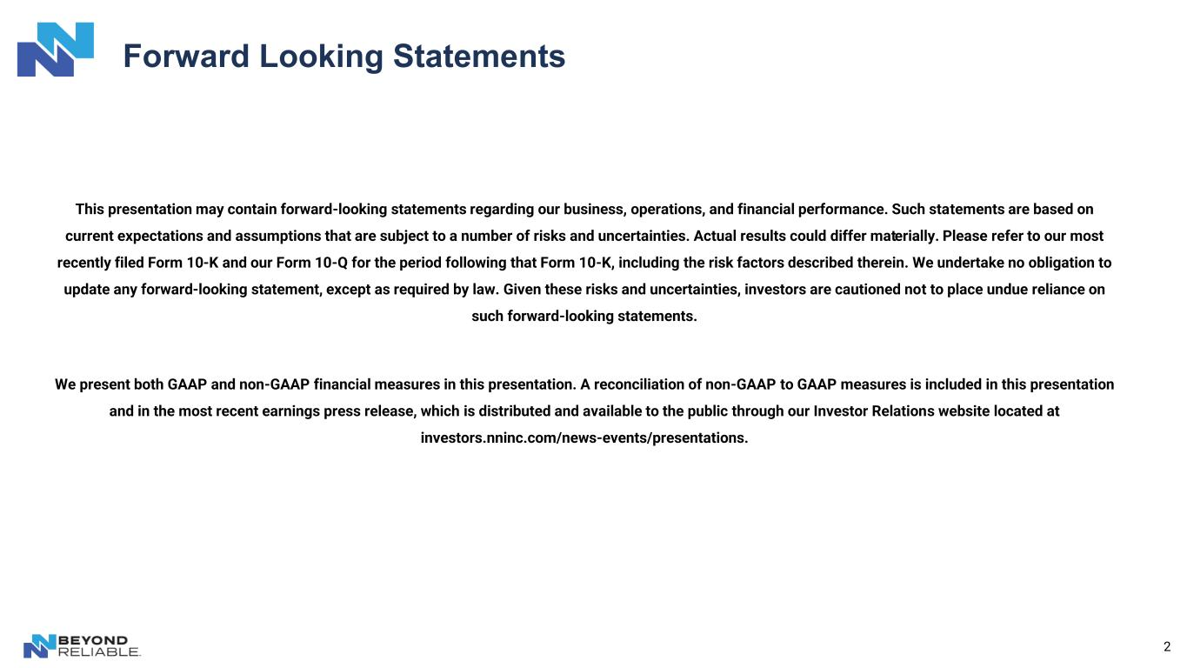
2 Forward Looking Statements This presentation may contain forward-looking statements regarding our business, operations, and financial performance. Such statements are based on current expectations and assumptions that are subject to a number of risks and uncertainties. Actual results could differ materially. Please refer to our most recently filed Form 10-K and our Form 10-Q for the period following that Form 10-K, including the risk factors described therein. We undertake no obligation to update any forward-looking statement, except as required by law. Given these risks and uncertainties, investors are cautioned not to place undue reliance on such forward-looking statements. We present both GAAP and non-GAAP financial measures in this presentation. A reconciliation of non-GAAP to GAAP measures is included in this presentation and in the most recent earnings press release, which is distributed and available to the public through our Investor Relations website located at investors.nninc.com/news-events/presentations.

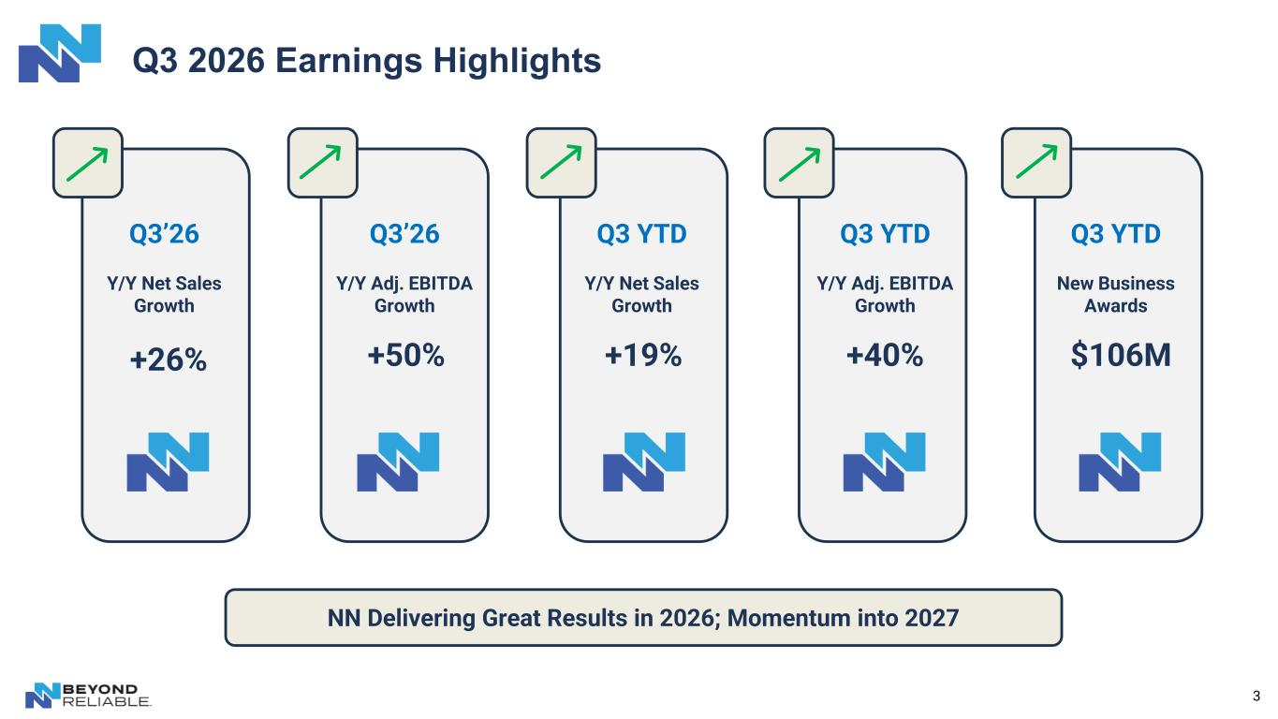
3 Q3 2026 Earnings Highlights +26% +19%+50% +40% $106M Q3’26 Y/Y Net Sales Growth Q3 YTD Y/Y Net Sales Growth Q3’26 Y/Y Adj. EBITDA Growth Q3 YTD Y/Y Adj. EBITDA Growth Q3 YTD New Business Awards NN Delivering Great Results in 2026; Momentum into 2027

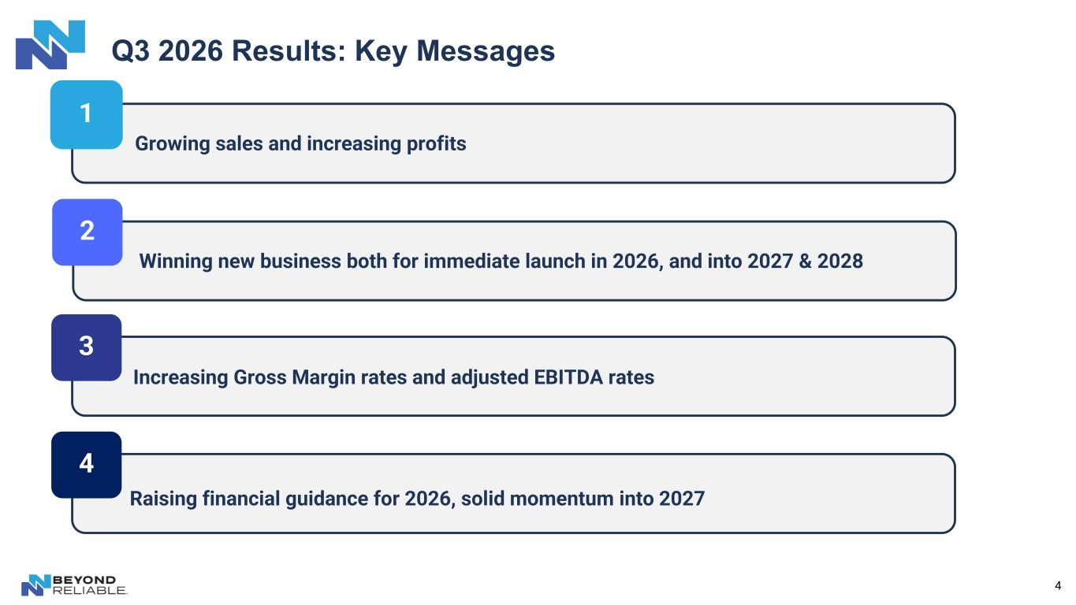
4 Q3 2026 Results: Key Messages 1 2 3 Growing sales and increasing profits Winning new business both for immediate launch in 2026, and into 2027 & 2028 4 Increasing Gross Margin rates and adjusted EBITDA rates Raising financial guidance for 2026, solid momentum into 2027

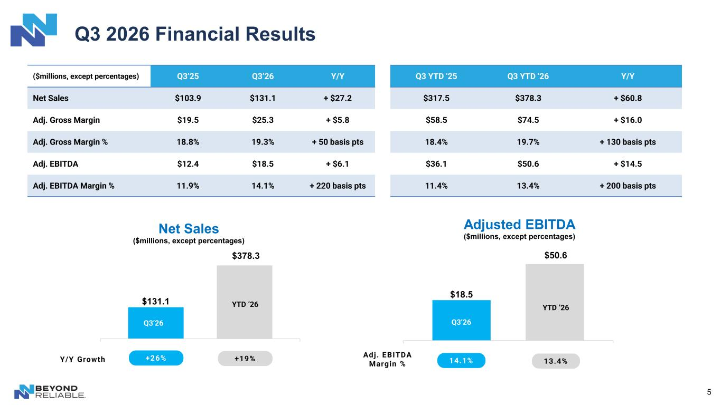
5 Q3 2026 Financial Results $18.5 $50.6 Adjusted EBITDA ($millions, except percentages) $131.1 $378.3 Net Sales ($millions, except percentages) ($millions, except percentages) Q3’25 Q3’26 Y/Y Q3 YTD ‘25 Q3 YTD ‘26 Y/Y Net Sales $103.9 $131.1 + $27.2 $317.5 $378.3 + $60.8 Adj. Gross Margin $19.5 $25.3 + $5.8 $58.5 $74.5 + $16.0 Adj. Gross Margin % 18.8% 19.3% + 50 basis pts 18.4% 19.7% + 130 basis pts Adj. EBITDA $12.4 $18.5 + $6.1 $36.1 $50.6 + $14.5 Adj. EBITDA Margin % 11.9% 14.1% + 220 basis pts 11.4% 13.4% + 200 basis pts +26% +19% 14.1% 13.4%Y/Y Growth Adj. EBITDA Margin % Q3’26 Q3’26 YTD ’26 YTD ’26

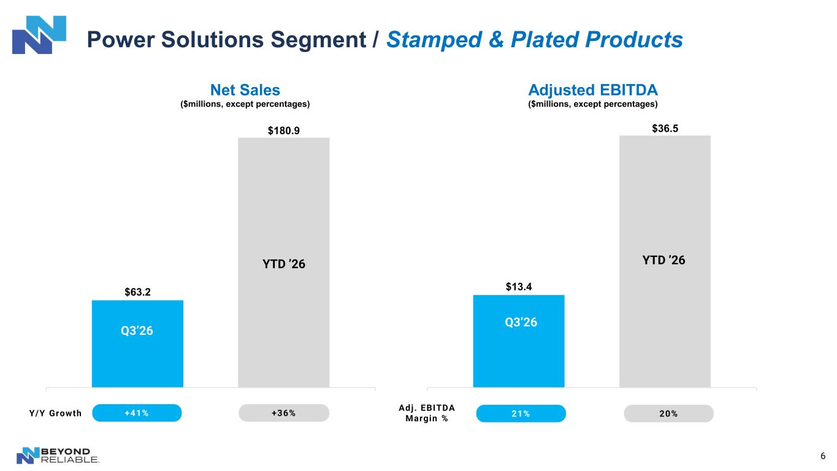
6 Power Solutions Segment / Stamped & Plated Products $63.2 $180.9 Net Sales ($millions, except percentages) +41% +36%Y/Y Growth $13.4 $36.5 Adjusted EBITDA ($millions, except percentages) Adj. EBITDA Margin % 21% 20% Q3’26 Q3’26 YTD ’26 YTD ’26

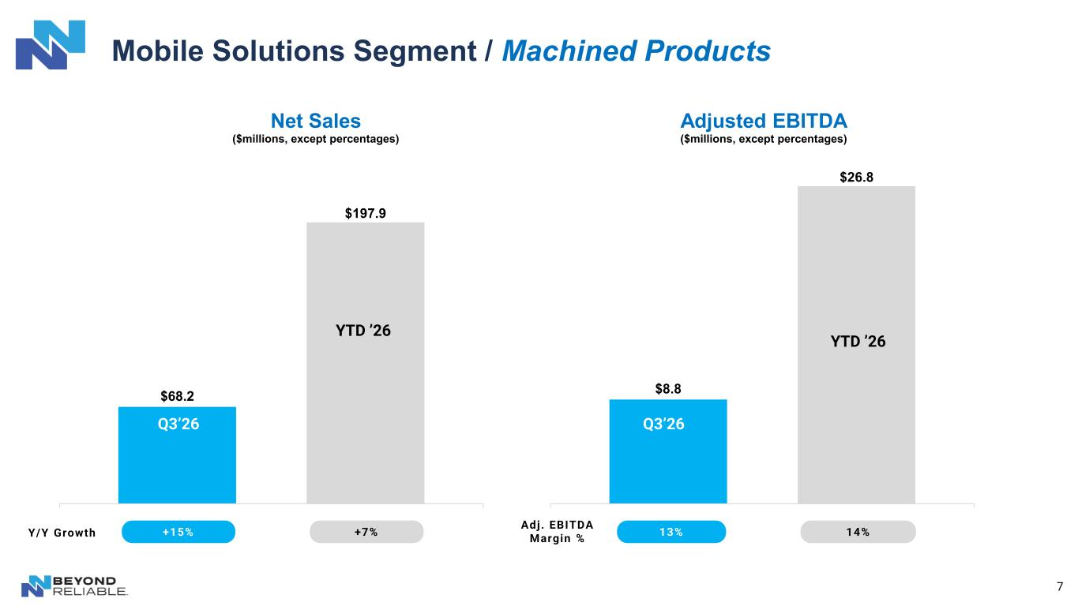
7 Mobile Solutions Segment / Machined Products $68.2 $197.9 Net Sales ($millions, except percentages) +15% +7%Y/Y Growth $8.8 $26.8 Adjusted EBITDA ($millions, except percentages) Adj. EBITDA Margin % 13% 14% Q3’26 Q3’26 YTD ’26 YTD ’26

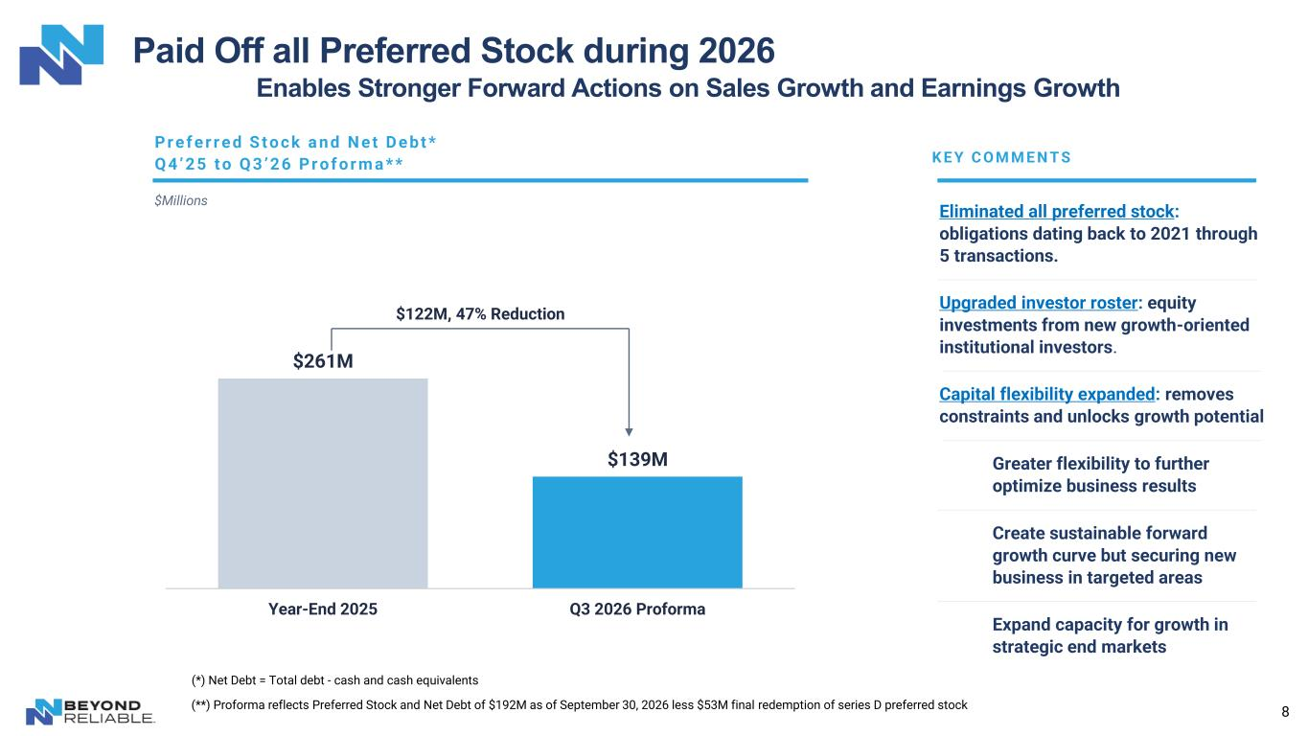
8 Paid Off all Preferred Stock during 2026 Enables Stronger Forward Actions on Sales Growth and Earnings Growth Pr e f e r r e d S t o c k a n d N e t D e b t * $Millions K E Y C O M M E N T S Eliminated all preferred stock: obligations dating back to 2021 through 5 transactions. Upgraded investor roster: equity investments from new growth-oriented institutional investors. Capital flexibility expanded: removes constraints and unlocks growth potential Greater flexibility to further optimize business results (*) Net Debt = Total debt - cash and cash equivalents (**) Proforma reflects Preferred Stock and Net Debt of $192M as of September 30, 2026 less $53M final redemption of series D preferred stock $261M $139M Year-End 2025 Q3 2026 Proforma $122M, 47% Reduction Q 4 ’ 2 5 t o Q 3 ’ 2 6 Pr o f o r m a * * Create sustainable forward growth curve but securing new business in targeted areas Expand capacity for growth in strategic end markets

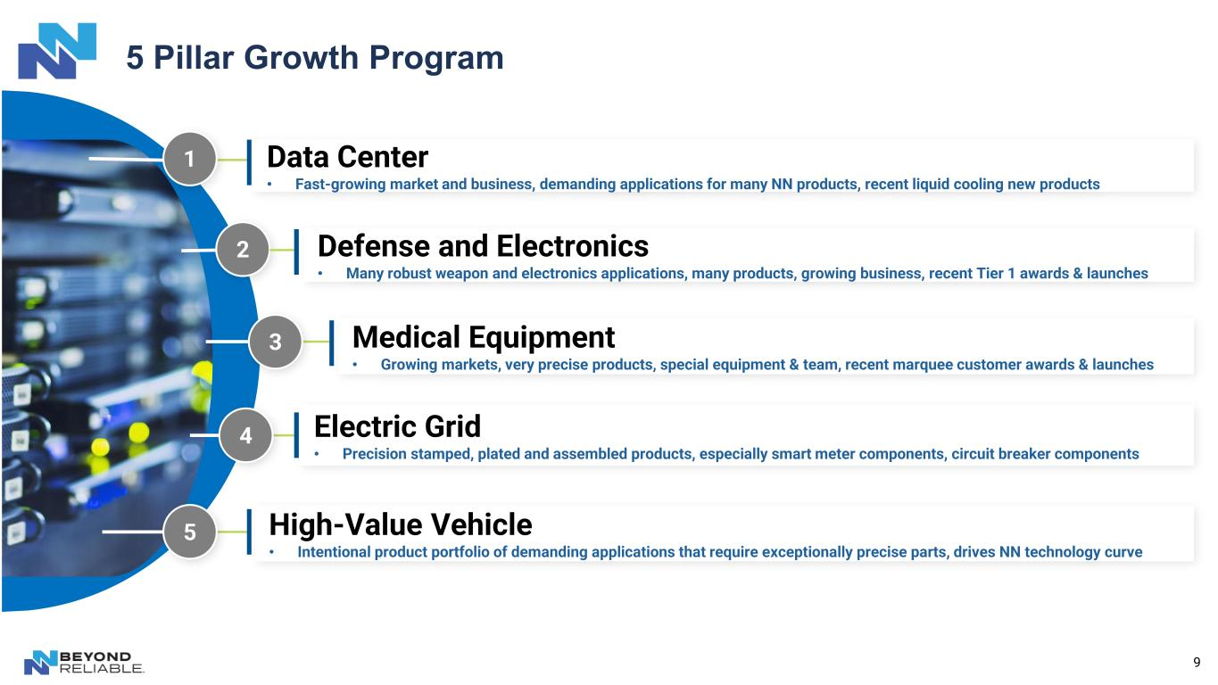
9 5 Pillar Growth Program High-Value Vehicle • Intentional product portfolio of demanding applications that require exceptionally precise parts, drives NN technology curve Electric Grid • Precision stamped, plated and assembled products, especially smart meter components, circuit breaker components 2 Medical Equipment • Growing markets, very precise products, special equipment & team, recent marquee customer awards & launches 3 Defense and Electronics • Many robust weapon and electronics applications, many products, growing business, recent Tier 1 awards & launches 4 5 1 Data Center • Fast-growing market and business, demanding applications for many NN products, recent liquid cooling new products

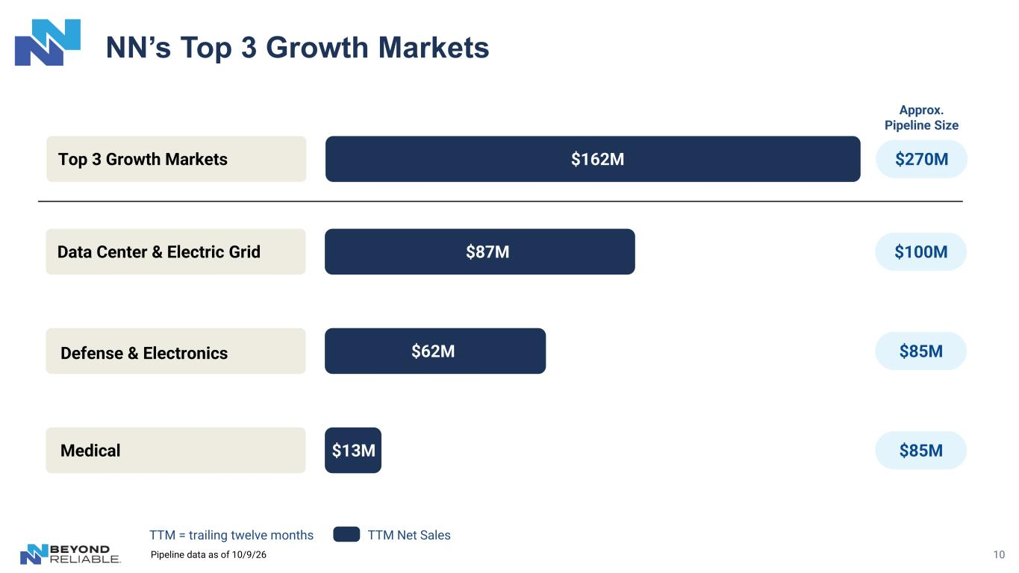
NN’s Top 3 Growth Markets TTM Net Sales Data Center & Electric Grid $87M Defense & Electronics $62M Medical $13M $100M $85M $85M Combined: $162M TTM Net Sales TTM = trailing twelve months 10 Top 3 Growth Markets $162M Approx. Pipeline Size $270M Pipeline data as of 10/9/26

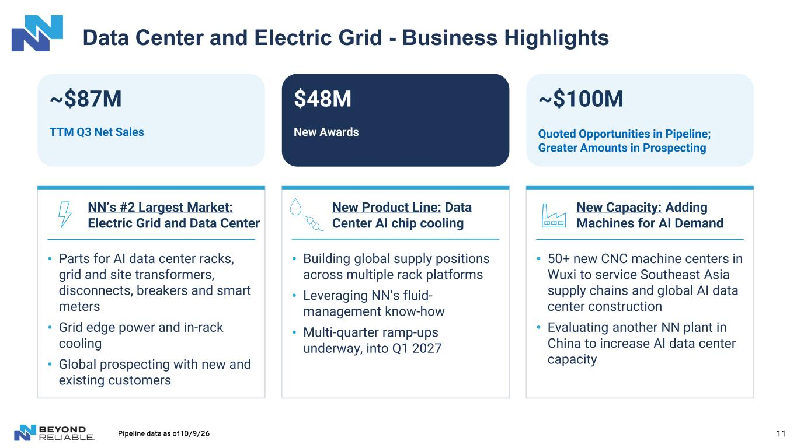
11 Data Center and Electric Grid - Business Highlights ~$87M TTM Q3 Net Sales NN’s #2 Largest Market: Electric Grid and Data Center $48M New Awards New Product Line: Data Center AI chip cooling ~$100M Quoted Opportunities in Pipeline; Greater Amounts in Prospecting New Capacity: Adding Machines for AI Demand • Parts for AI data center racks, grid and site transformers, disconnects, breakers and smart meters • Grid edge power and in-rack cooling • Global prospecting with new and existing customers • Building global supply positions across multiple rack platforms • Leveraging NN’s fluid- management know-how • Multi-quarter ramp-ups underway, into Q1 2027 • 50+ new CNC machine centers in Wuxi to service Southeast Asia supply chains and global AI data center construction • Evaluating another NN plant in China to increase AI data center capacity Pipeline data as of 10/9/26

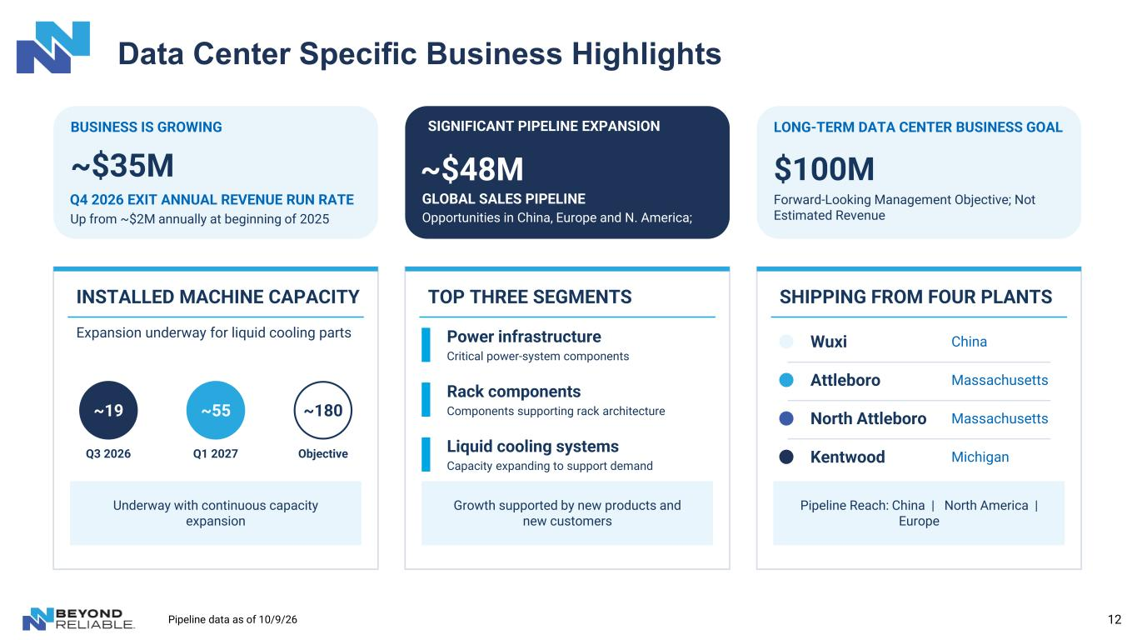
12 Data Center Specific Business Highlights ~$35M Q4 2026 EXIT ANNUAL REVENUE RUN RATE Up from ~$2M annually at beginning of 2025 INSTALLED MACHINE CAPACITY Expansion underway for liquid cooling parts Underway with continuous capacity expansion ~180 Objective ~19 Q3 2026 ~55 Q1 2027 ~$48M GLOBAL SALES PIPELINE Opportunities in China, Europe and N. America; TOP THREE SEGMENTS Growth supported by new products and new customers Power infrastructure Critical power-system components Rack components Components supporting rack architecture Liquid cooling systems Capacity expanding to support demand $100M LONG-TERM DATA CENTER BUSINESS GOAL Forward-Looking Management Objective; Not Estimated Revenue SHIPPING FROM FOUR PLANTS Pipeline Reach: China | North America | Europe Wuxi China Attleboro Massachusetts North Attleboro Massachusetts Kentwood Michigan BUSINESS IS GROWING SIGNIFICANT PIPELINE EXPANSION Pipeline data as of 10/9/26

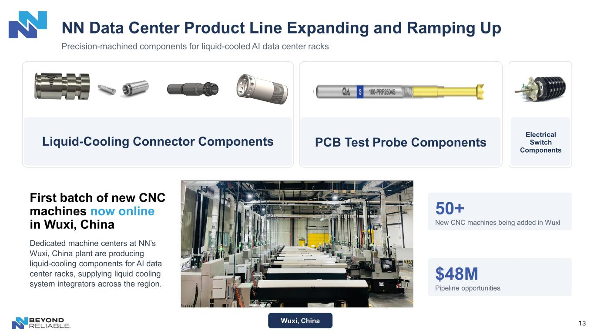
13 NN Data Center Product Line Expanding and Ramping Up Precision-machined components for liquid-cooled AI data center racks Liquid-Cooling Connector Components Electrical Switch Components Wuxi, China First batch of new CNC machines now online in Wuxi, China Dedicated machine centers at NN’s Wuxi, China plant are producing liquid-cooling components for AI data center racks, supplying liquid cooling system integrators across the region. 50+ New CNC machines being added in Wuxi $48M Pipeline opportunities PCB Test Probe Components

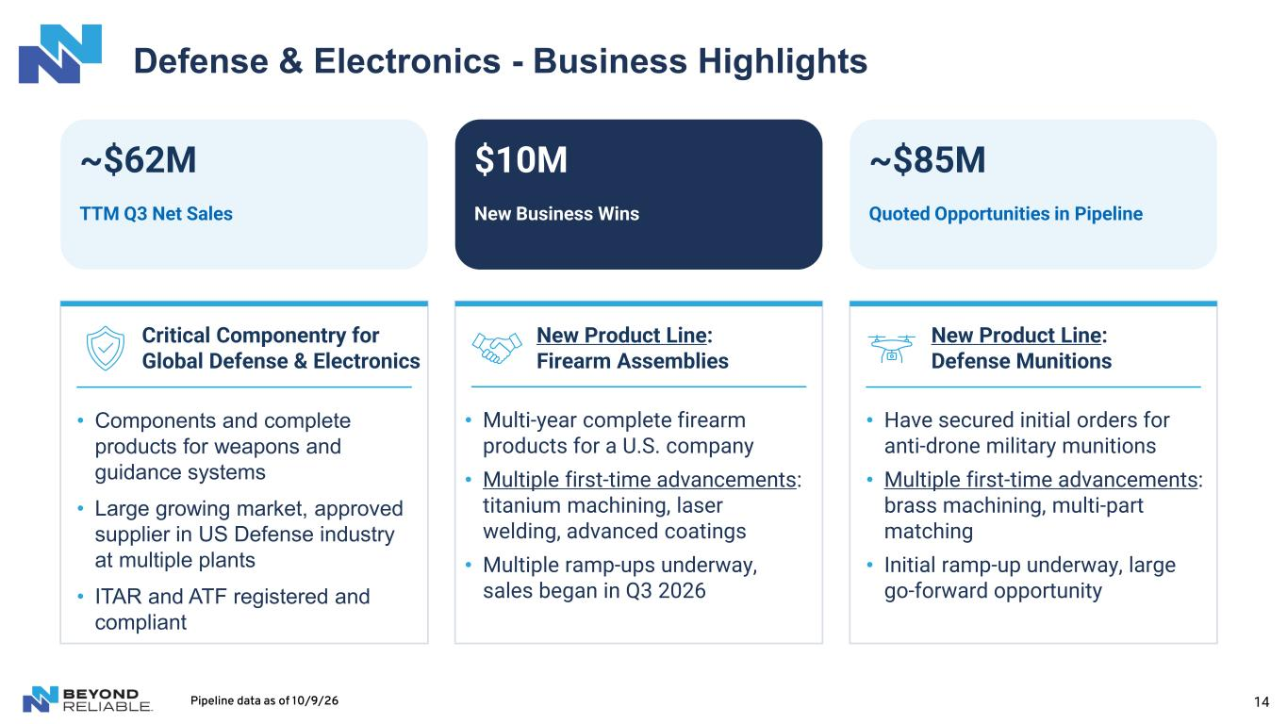
14 $10M New Business Wins New Product Line: Firearm Assemblies Defense & Electronics - Business Highlights ~$62M TTM Q3 Net Sales Critical Componentry for Global Defense & Electronics ~$85M Quoted Opportunities in Pipeline New Product Line: Defense Munitions • Components and complete products for weapons and guidance systems • Large growing market, approved supplier in US Defense industry at multiple plants • ITAR and ATF registered and compliant • Multi-year complete firearm products for a U.S. company • Multiple first-time advancements: titanium machining, laser welding, advanced coatings • Multiple ramp-ups underway, sales began in Q3 2026 • Have secured initial orders for anti-drone military munitions • Multiple first-time advancements: brass machining, multi-part matching • Initial ramp-up underway, large go-forward opportunity Pipeline data as of 10/9/26

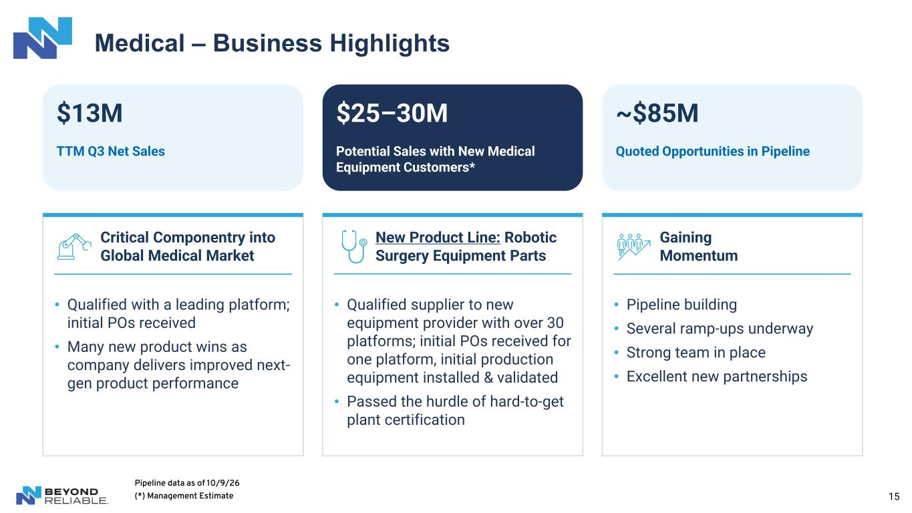
15 Medical – Business Highlights $13M TTM Q3 Net Sales Critical Componentry into Global Medical Market $25–30M Potential Sales with New Medical Equipment Customers* New Product Line: Robotic Surgery Equipment Parts ~$85M Quoted Opportunities in Pipeline Gaining Momentum • Qualified with a leading platform; initial POs received • Many new product wins as company delivers improved next- gen product performance • Qualified supplier to new equipment provider with over 30 platforms; initial POs received for one platform, initial production equipment installed & validated • Passed the hurdle of hard-to-get plant certification • Pipeline building • Several ramp-ups underway • Strong team in place • Excellent new partnerships Pipeline data as of 10/9/26 (*) Management Estimate

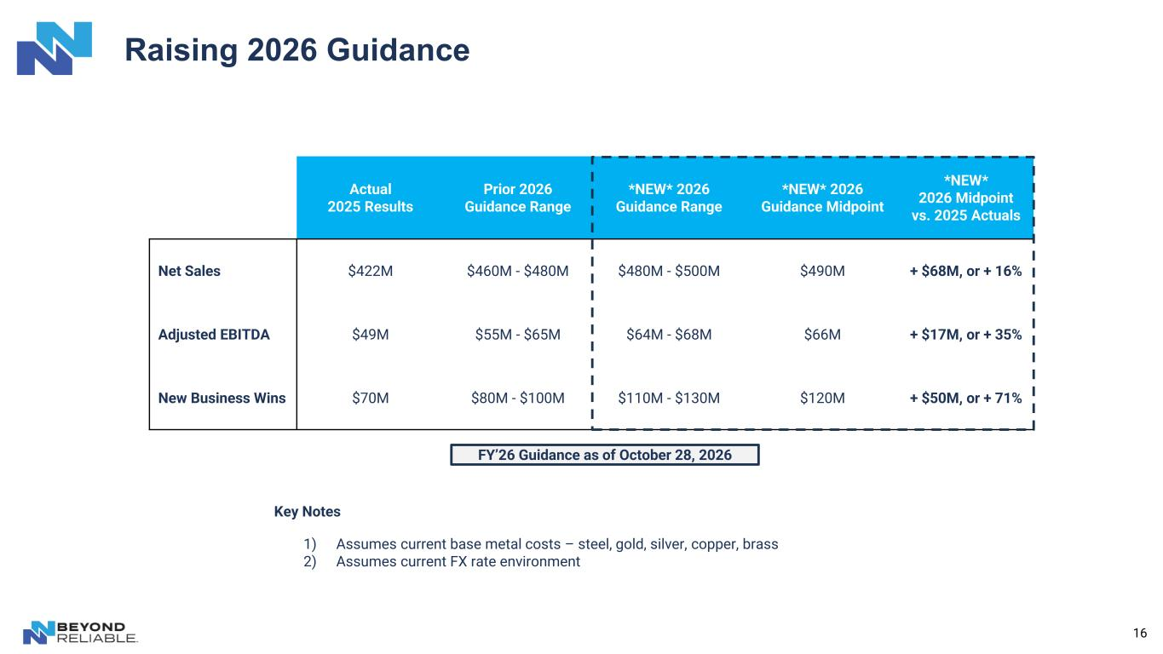
16 Raising 2026 Guidance Actual 2025 Results Prior 2026 Guidance Range *NEW* 2026 Guidance Range *NEW* 2026 Guidance Midpoint *NEW* 2026 Midpoint vs. 2025 Actuals Net Sales $422M $460M - $480M $480M - $500M $490M + $68M, or + 16% Adjusted EBITDA $49M $55M - $65M $64M - $68M $66M + $17M, or + 35% New Business Wins $70M $80M - $100M $110M - $130M $120M + $50M, or + 71% Key Notes 1) Assumes current base metal costs – steel, gold, silver, copper, brass 2) Assumes current FX rate environment FY’26 Guidance as of October 28, 2026

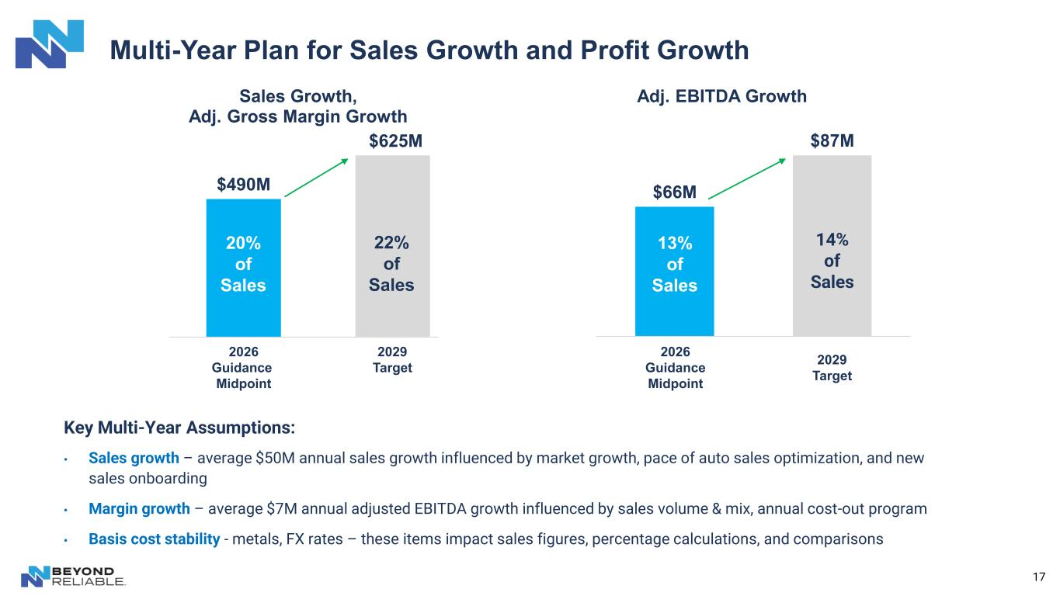
Multi-Year Plan for Sales Growth and Profit Growth 17 Key Multi-Year Assumptions: • Sales growth – average $50M annual sales growth influenced by market growth, pace of auto sales optimization, and new sales onboarding • Margin growth – average $7M annual adjusted EBITDA growth influenced by sales volume & mix, annual cost-out program • Basis cost stability - metals, FX rates – these items impact sales figures, percentage calculations, and comparisons $490M Sales Growth, Adj. Gross Margin Growth 20% of Sales 22% of Sales $66M $87M Adj. EBITDA Growth 13% of Sales 14% of Sales $625M 2029 Target Mid-Point 2029 Target 2026 Guidance Midpoint 2026 Guidance Midpoint

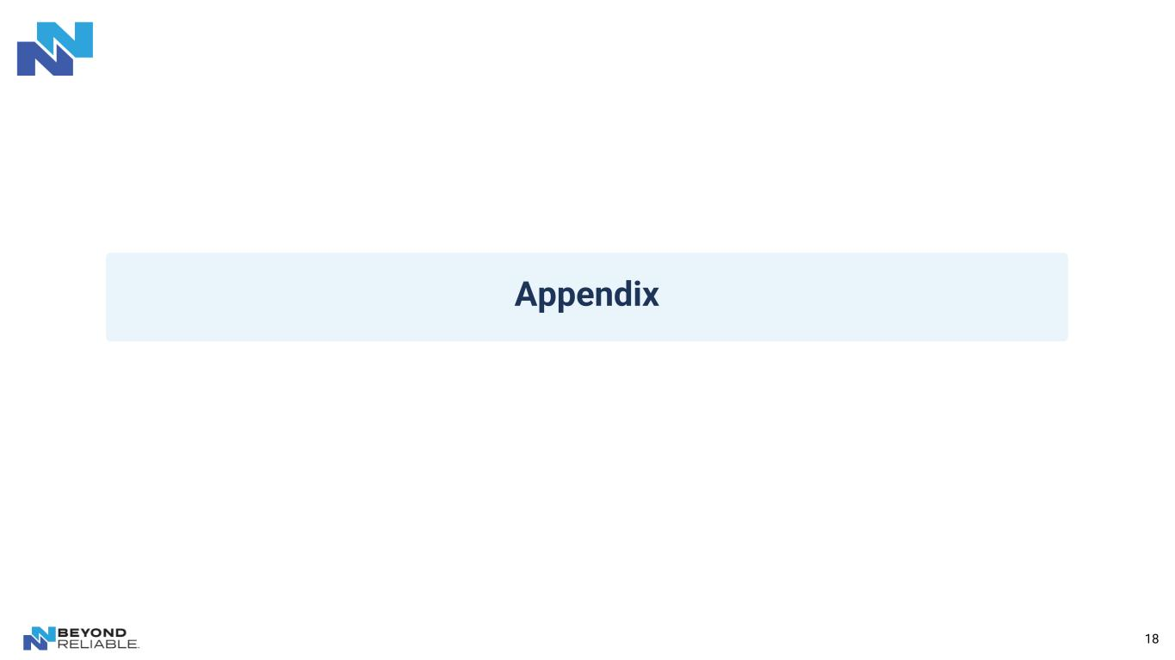
18 Appendix

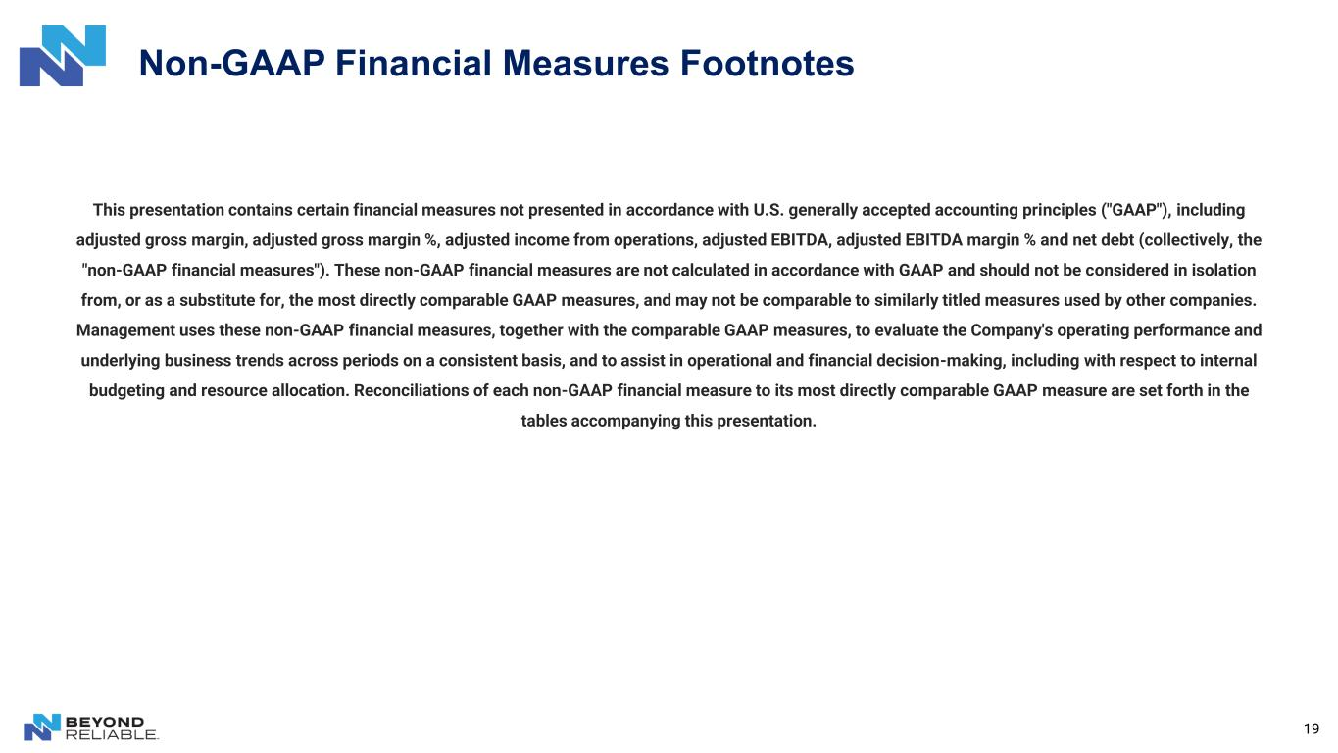
19 This presentation contains certain financial measures not presented in accordance with U.S. generally accepted accounting principles ("GAAP"), including adjusted gross margin, adjusted gross margin %, adjusted income from operations, adjusted EBITDA, adjusted EBITDA margin % and net debt (collectively, the "non-GAAP financial measures"). These non-GAAP financial measures are not calculated in accordance with GAAP and should not be considered in isolation from, or as a substitute for, the most directly comparable GAAP measures, and may not be comparable to similarly titled measures used by other companies. Management uses these non-GAAP financial measures, together with the comparable GAAP measures, to evaluate the Company's operating performance and underlying business trends across periods on a consistent basis, and to assist in operational and financial decision-making, including with respect to internal budgeting and resource allocation. Reconciliations of each non-GAAP financial measure to its most directly comparable GAAP measure are set forth in the tables accompanying this presentation. Non-GAAP Financial Measures Footnotes

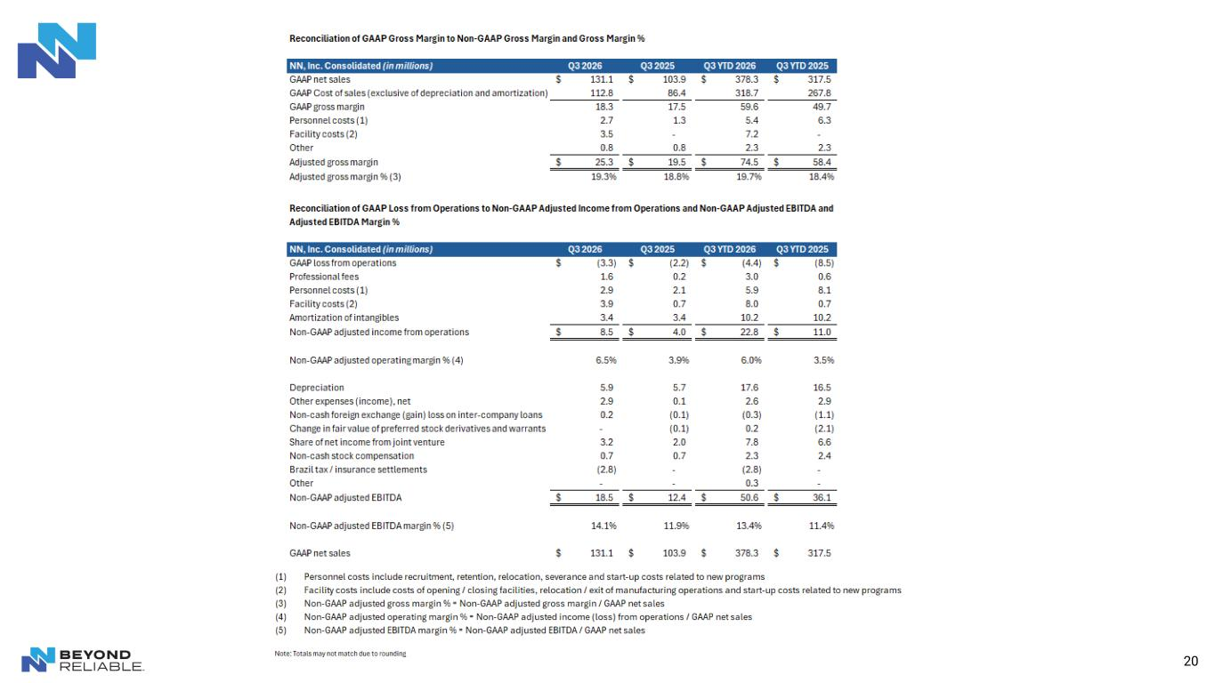
20

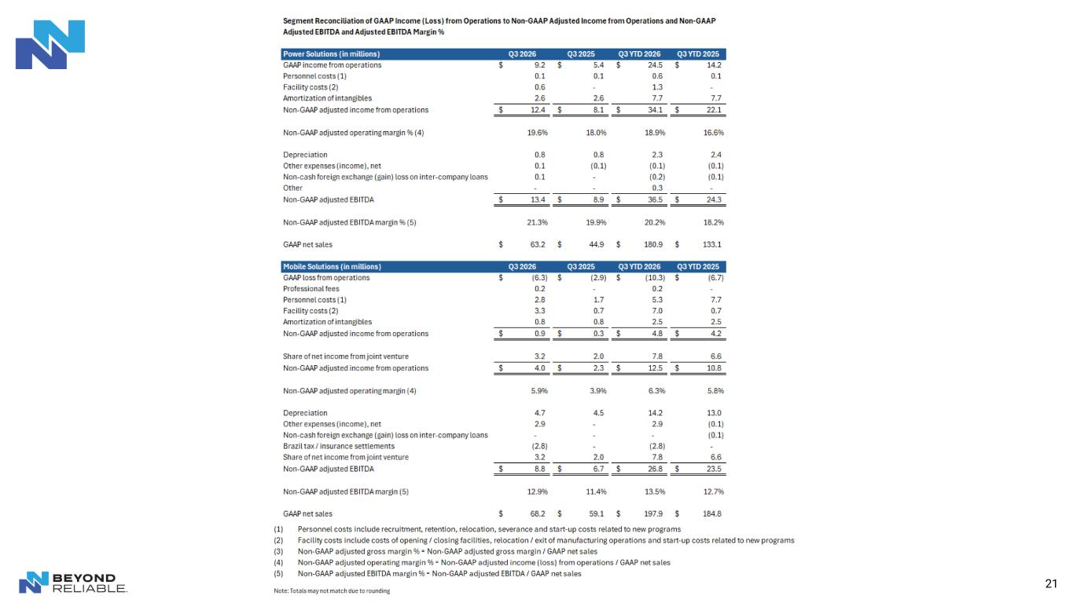
21

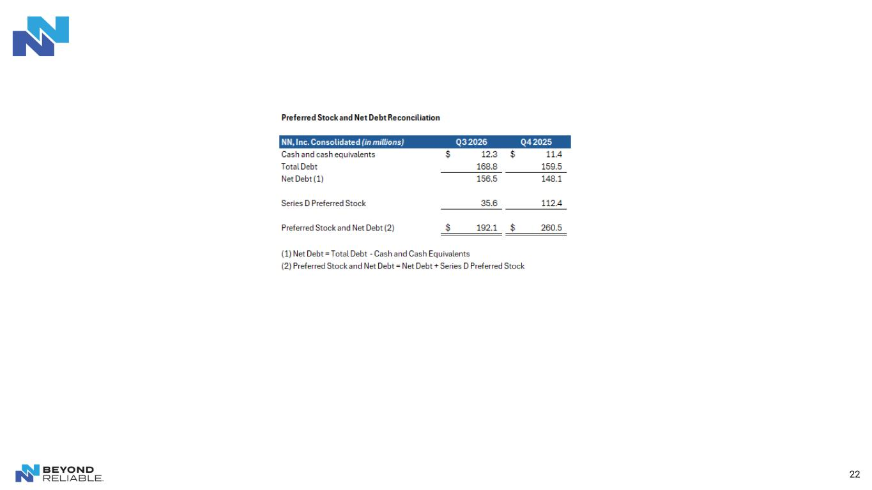
22


23 Thank You

