UNITED STATES

SECURITIES AND EXCHANGE COMMISSION
WASHINGTON, DC 20549

FORM 8-K

CURRENT REPORT

PURSUANT TO SECTION 13 OR 15(d)
OF THE SECURITIES EXCHANGE ACT OF 1934

Date of Report (Date of earliest event reported): August 17, 2015


NN, INC.

(Exact name of registrant as specified in its charter)

Delaware

0-23486

62-1096725

(State or Other Jurisdiction
of Incorporation)

(Commission
File Number)

(I.R.S. Employer
Identification No.)

207 Mockingbird Lane

37604

(Address of principal executive offices)

(Zip Code)

(423) 743-9151

(Registrant’s telephone number, including area code)

(Former name or former address, if changed since last report)

Check the appropriate box if the Form 8-K filing is intended to simultaneously satisfy the filing obligation of the registrant under any of the following provisions (see General Instruction A.2. below):

- Written communications pursuant to Rule 425 under the Securities Act (17 CFR 230.425)

- Soliciting material pursuant to Rule 14a-12 under the Exchange Act (17 CFR 240.14a-12)

- Pre-commencement communications pursuant to Rule 14d-2(b) under the Exchange Act (17 CFR 240.14d- 2(b))

- Pre-commencement communications pursuant to Rule 13e-4(c) under the Exchange Act (17 CFR 240.13e- 4(c))

ITEM 7.01 REGULATION FD DISCLOSURE

On August 17, 2015, NN, Inc. (“NN”) issued a press release announcing that NN entered into a Stock Purchase Agreement with PEP Industries, LLC, a Delaware limited liability company (“Seller”), pursuant to which NN agreed to acquire from Seller (the “Acquisition”) all of the outstanding capital stock of Precision Engineered Products Holdings, Inc., a Delaware corporation (“PEP”). A copy of the press release is attached hereto as Exhibit 99.1.

On August 17, 2015, NN posted a PEP Acquisition Overview presentation on its website to provide supplemental information regarding the Acquisition. A copy of the presentation is attached hereto as Exhibit 99.2.

Pursuant to the rules and regulations of the U.S. Securities and Exchange Commission, the information in this Item 7.01 disclosure, including Exhibits 99.1 and 99.2 and information set forth therein, is deemed to have been furnished and shall not be deemed to be “filed” for purposes of Section 18 of the Securities Exchange Act of 1934, as amended, or otherwise subject to the liabilities of that section. Such information shall not be incorporated by reference into any filing of NN, whether made before or after the date hereof, regardless of any general incorporation language in such filing.

ITEM 9.01 |  | FINANCIAL STATEMENTS AND EXHIBITS
Exhibit |  | Description
No. |  | Description
99.1 |  | Press Release of NN, Inc., dated August 17, 2015.
99.2 |  | PEP Acquisition Overview Presentation, dated August 17, 2015.

SIGNATURES

Pursuant to the requirements of the Securities Exchange Act of 1934, the registrant has duly caused this report to be signed on its behalf by the undersigned hereunto duly authorized.

Date: August 18, 2015

NN, INC.

By: | /s/ William C. Kelly, Jr.
Name: | William C. Kelly, Jr.
Title: | Vice President and Chief Administrative Officer

 |  |  | EXHIBIT INDEX
Exhibit |  | Description
No. |  | Description
99.1 |  | Press Release of NN, Inc., dated August 17, 2015.
99.2 |  | PEP Acquisition Overview Presentation, dated August 17, 2015.

Exhibit 99.1



RE: NN, Inc.

207 Mockingbird Lane

3rd Floor

Johnson City, TN 37604

FOR FURTHER INFORMATION:

AT THE COMPANY

Robbie Atkinson

Corporate Treasurer & Investor Relations

(423) 434-8398

AT FINANCIAL RELATIONS BOARD

Marilynn Meek

(General info)

212-827-3773

FOR IMMEDIATE RELEASE

August 17, 2015

NN, INC. ANNOUNCES DEFINITIVE AGREEMENT TO ACQUIRE PRECISION ENGINEERED PRODUCTS

Company to Host Conference Call to Discuss Transaction

Johnson City, Tenn, August 17, 2015 –NN, Inc., (NASDAQ: NNBR) a diversified industrial company, today announced that it has entered into a definitive agreement to acquire Precision Engineered Products Holdings, Inc. (P.E.P.) for $615 million in cash. The transaction is expected to be immediately accretive to earnings. The Company anticipates that the transaction will close by the end of October, 2015, subject to customary closing conditions and regulatory approval. NN was advised on the transaction by KeyBanc Capital Markets, Inc.

P.E.P. is a global manufacturer of highly engineered precision customized solutions serving the medical, electrical, transportation and aerospace end markets. P.E.P has built a highly respected brand on which customers rely to solve their most difficult problems across diversified end markets. P.E.P.’s net sales for the last twelve months ending June 30, 2015, including acquisitions, were $245.3 million, with approximately $180.0 million coming from the medical and electrical businesses.

Richard Holder, President and CEO commented, “The addition of the P.E.P. business into our portfolio is a transformative step in creating a diversified industrial company that serves a variety of end markets and delivers consistent results through the economic cycle. P.E.P. strengthens our technical capabilities and provides us with additional dynamic platforms to support outgrowth of our end markets. P.E.P.’s focus on the medical, electrical, and aerospace end markets and delivery of world class precision and technology to their customers aligns perfectly with our strategic plan. Utilizing the NN Operating System, P.E.P. will have the tools and resources to continue to develop new products and drive operational efficiency in the years to come. We look forward to welcoming the P.E.P. team into the NN family.”

NN expects to finance the transaction primarily with available cash and the issuance of debt from new fully committed credit facilities.

Conference Call & Supplemental Deck

A supplemental presentation on this acquisition has been posted to NN’s website. The Company will host a conference call to discuss the transaction on August 18 at 10:00 a.m. ET. Access the call by dialing 888.500.6950 in the U.S., or 719.325.2329 internationally, conference ID: 5318922. A replay of the conference call will be available shortly after the conclusion of the call. The replay along with presentation materials relating the acquisition will be available under the investor relations section of NN’s website.

NN, Inc., a diversified industrial company, manufactures and supplies high precision metal bearing components, industrial plastic and rubber products and precision metal components to a variety of markets on a global basis. Headquartered in Johnson City, Tennessee, NN has 26 manufacturing plants in North America, Western Europe, Eastern Europe, South America and China.

Except for specific historical information, many of the matters discussed in this press release may express or imply projections of revenues or expenditures, statements of plans and objectives or future operations or statements of future economic performance. These, and similar statements, are forward-looking statements concerning matters that involve risks, uncertainties and other factors which may cause the actual performance of NN, Inc. and its subsidiaries to differ materially from those expressed or implied by this discussion. All forward-looking information is provided by the Company pursuant to the safe harbor established under the Private Securities Litigation Reform Act of 1995 and should be evaluated in the context of these factors. Forward-looking statements generally can be identified by the use of forward-looking terminology such as “assumptions”, “target”, “guidance”, “outlook”, “plans”, “projection”, “may”, “will”, “would”, “expect”, “intend”, “estimate”, “anticipate”, “believe”, “potential” or “continue” (or the negative or other derivatives of each of these terms) or similar terminology. Factors which could materially affect actual results include, but are not limited to: general economic conditions and economic conditions in the industrial sector, inventory levels, regulatory compliance costs and the Company’s ability to manage these costs, start-up costs for new operations, debt reduction, competitive influences, risks that current customers will commence or increase captive production, risks of capacity underutilization, quality issues, availability and price of raw materials, currency and other risks associated with international trade, the Company’s dependence on certain major customers, and the successful implementation of the global growth plan including development of new products. Similarly, statements made herein and elsewhere regarding pending or completed acquisitions are also forward-looking statements, including statements relating to the anticipated closing date of an acquisition, the Company’s ability to obtain required regulatory approvals or satisfy closing conditions, the costs of an acquisition and the Company’s source(s) of financing, the future performance and prospects of an acquired business, the expected benefits of an acquisition on the Company’s future business and operations and the ability of the Company to successfully integrate recently acquired businesses.

For additional information concerning such risk factors and cautionary statements, please see the section titled “Risk Factors” in the Company’s periodic reports filed with the Securities and Exchange Commission, including, but not limited to, the Company’s Annual Report on Form 10-K for the fiscal year ended December 31, 2014. Except as required by law, we undertake no obligation to update or revise any forward-looking statements we make in our press releases, whether as a result of new information, future events or otherwise.

Exhibit 99.2
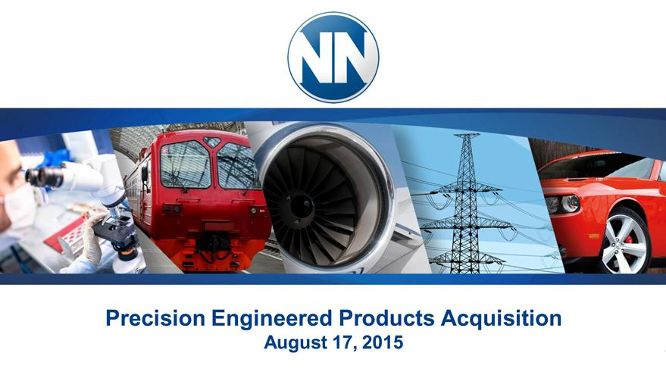

Exhibit 99.2
Precision Engineered Products Acquisition
August 17, 2015

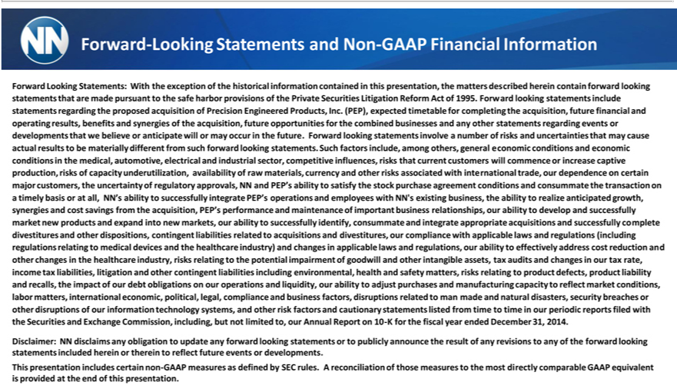

-Looking | and Non-GAAP Financial Information
Forward Looking | Statements: With the exception of the historical information contained in this presentation, the matters described herein contain forward looking statements that are made pursuant to the safe harbor
provisions of the Private Securities Litigation Reform Act of 1995. Forward looking statements include statements regarding the proposed acquisition of Precision Engineered Products, Inc. (PEP), expected timetable
for completing the acquis tion, future financial and operating results, benefits and synergies of the acquisition, future opportunities for the combined businesses and any other statements regarding events or
developments that we believe or anticipate will or may occur in the future. Forward looking statements involve a number of risks and uncertainties that may cause actual results to be materially different from such
forward looking statements. Such |  | include, among others, general economic conditions and economic conditions in the medical, automotive, electrical and industrial sector, competitive influences, risks that
current customers will commence factorsincrease captive production, risks of capacity underutilization, availability of raw materials, currency and other risks associated with international trade, our dependence on certain
major | the uncertainty of regulatory |  | NN and PEP’s ability to satisfy the stock purchase agreement conditions and consummate the transaction on a timely basis or at all, NN’s ability to successfully
integratecustomers,PEP’operations and employees withapprovals,NN’existing business, the ability to realize anticipated growth, synergies and cost savings from the acquisition, PEP’s performance and maintenance of important
business relationships, our ability to develop and successfully market new products and |  |  |  |  | into new markets, our ability to successfully identify, consummate and integrate appropriate acquisitions and successfully
complete divestitures and other dispositions, contingent liabilities related to acquisitionsexpanddivestitures, our compliance with applicable laws and regulations (including regulations relating to medical devices and the
healthcare industry) and changes in applicable laws and regulations, our ability to eff ctively address cost reduction and other changes the healthcare industry, risks relating to the potential impairment of goodwill
and other intangible assets, tax audits and changes in our tax rate, income tax liabilities, litigation and other contingent liabilities including environmental, health and safety matters, risks relating to product defects,
product liability and recalls, the impact of our debt obligations |  |  |  | our operations and liquidity, our ability to adjust purchases and manufacturing capacity to reflect market conditions, labor matters, international
economic, political, legal, compliance and |  |  | factors, disruptions related to man made and natural disasters, security breaches or other disruptions of our information technology systems, and other risk factors and
cautionary statements listed from time to timebusinessour periodic reports filed with the Securities and Exchange Commission, including, but not limited to, our Annual Report on 10-K for the fiscal year ended _{Disclaimer:}ecember31, 2014.
NN disclaims any obligation to update any forward looking statements or to publicly announce the result of any revisions to any of the forward looking statements included herein or therein to reflect future events or developments.
This presentation includes certain non-GAAP measures as defined by SEC rules. A reconciliation of those measures to the most directly comparable GAAP equivalent is provided at the end of this presentation.

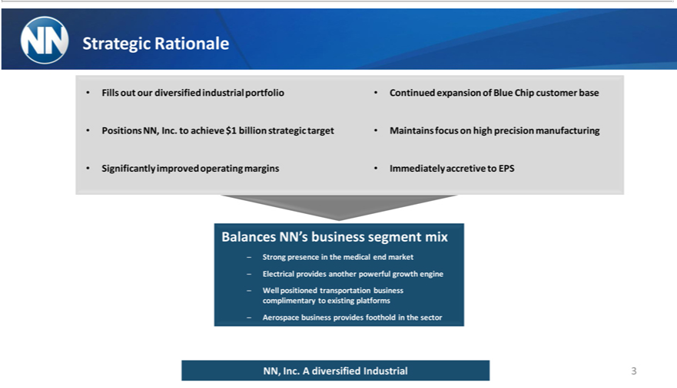

Strategic Rationale
Fills out our diversified industrial portfolio Continued expansion of Blue Chip customer base
Positions NN, Inc. to achieve $1 billion strategic target Maintains focus on high precision manufacturing
Significantly improved operating margins Immediately accretive to EPS
Balances NN’ |  | segment mix
 | Strong presencebusinessthe medical end market
 | Electrical provides another powerful growth engine
– | Well positioned transportation business complimentary to existing platforms
– | business provides foothold in the sector
NN,AerospaceInc.diversified Industrial 3

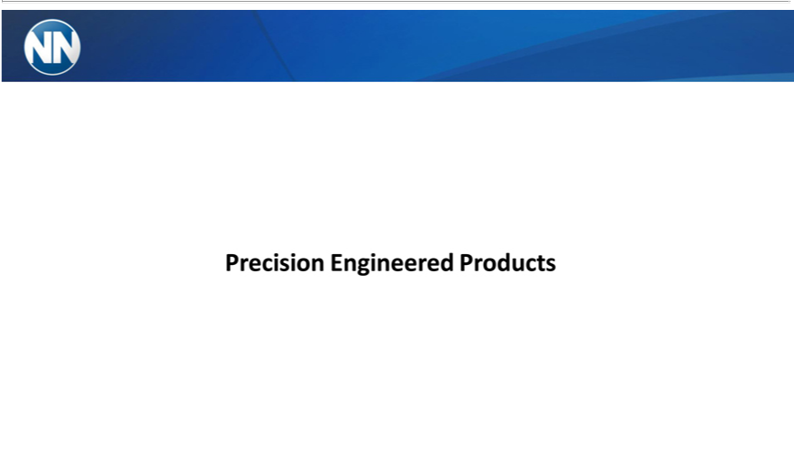

Precision Engineered Products

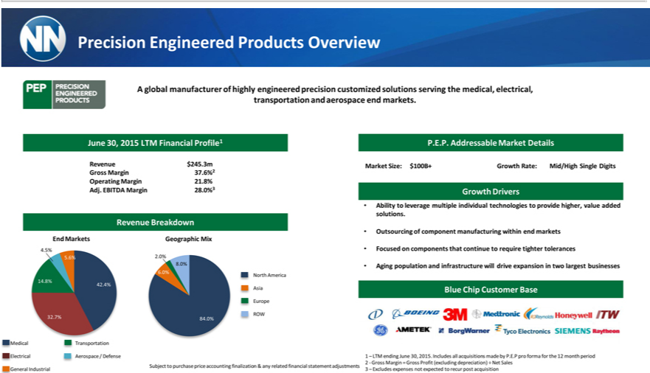

Precision Engineered Products Overview
A global manufacturer of highly engineered precision customized solutions serving the medical, electrical, transportation and aerospace end markets.
June 30, 2015 LTM Financial Profile1 P.E.P. Addressable Market Details
Revenue $245.3m Market Size: $100B+ Growth Rate: Mid/High Single Digits Gross Margin 37.6%2 Operating Margin 21.8% Adj. EBITDA Margin 28.0%3 Growth Drivers
Ability to leverage multiple individual technologies to provide higher, value added solutions.
Revenue Breakdown |  |  | manufacturing within end markets End Markets Geographic Mix
Outsourcing of |  |  | manufacturing within end markets End Markets Geographic Mix
4 | 5% • Focused componentcomponents that continue to require tighter tolerances
5 | 6% | 2.0%
8 |  | • Aging population and infrastructure will drive expansion in two largest businesses
6.0%

North America 14.8% 42.4%
EuropeAsiaBlue Chip Customer Base
edicalROW 32.7%Transportation84.0%
lectrical Aerospace / Defense 1 – LTM ending June 30, 2015. Includes all acquisitions made by P.E.P pro forma for the 12 month period 2—Gross Margin = Gross Profit (excluding depreciation) ÷ Net Sales
Subject to purchase price accounting finalization & any related financial statement adjustments eneral Industrial 3 – Excludes expenses not expected to recur post acquisition

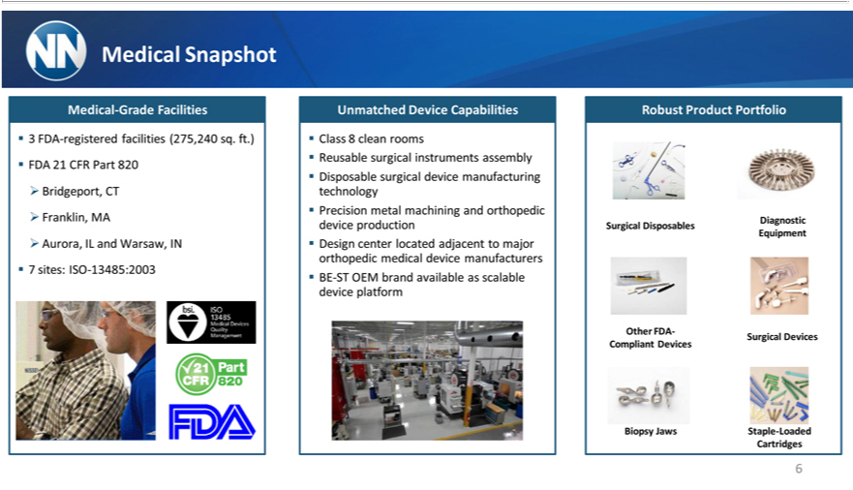

Snapshot
Medical-Grade Facilities
3 FDA-registered facilities (275,240 sq. ft.) FDA 21 CFR Part 820 Bridgeport, CT
Franklin, MA
Aurora, IL and Warsaw, IN 7 sites: ISO-13485:2003
Unmatched Device Capabilities
Class 8 clean rooms
Reusable surgical instruments assembly Disposable surgical device manufacturing technology Precision metal machining and orthopedic device production Design center located adjacent to major orthopedic medical
device manufacturers BE-ST OEM brand available as scalable device platform
Robust Product Portfolio
Surgical Disposables
Other FDA- Compliant Devices
Biopsy Jaws
Diagnostic Equipment
urgical Devices
Staple-Loaded Cartridges
6

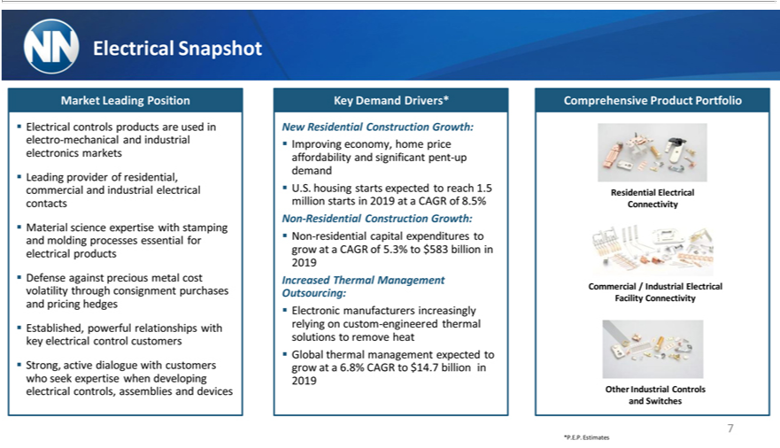

Electrical Snapshot
ElectricalMarketLeadingcontrolsPositionproducts are used in electro-mechanical and industrial electronics markets
MaterialLeading providsciece expertiofresidentwithal, stampingcommercialandandmoldingindustrialprocesseselectricalessentialcontactsfor electrical products
against precious
Established,Defense powerful relationshipsmetalcost withvolatilitykeyelectricalthrough consignmentcontrolcustomerspurchases and pricing hedges
Strong, active dialogue with customers who seek expertise when developing electrical controls, assemblies and devices ^{New}Ky Demand Drivers*
Residential Construction Growth:
^{Non}Improving⁻Residentialeconomy,ConstructionhomepriceGrowth:affordability and significant pent-up demand U.S. housing starts expected to reach 1.5 million starts in 2019 at a CAGR of 8.5%
IncreasedresidentialThermalcapitalManagementexpendituresOutsourcing:togrowat a CAGR of 5.3% to $583 billion in 2019
Electronic manufacturers increasingly relying on custom-engineered thermal solutions to remove heat Global thermal management expected to grow at a 6.8% CAGR to $14.7 billion in 2019 Comprehensive Product Portfolio
Residential Electrical Connectivity
OtherCommercialIndustrial/IndustrialControlsElectricalandSwitchesFacility Connectivity
7
*P.E.P. Estimates

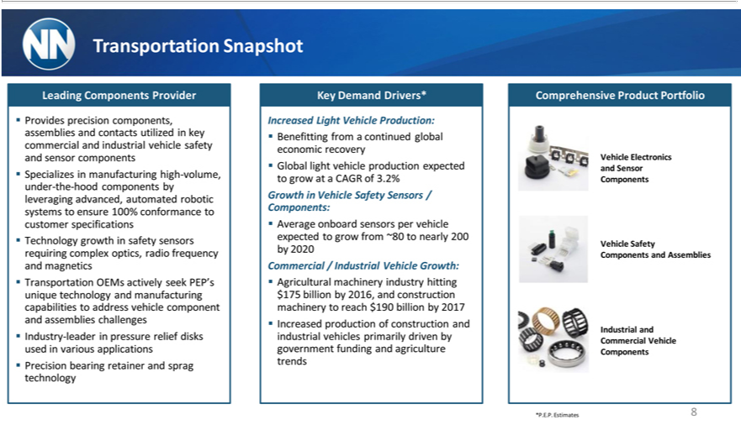

Transportation Snapshot
ProvidesLeading Componentsprecisioncomponents,Provider assemblies and contacts utilized in key commercial and industrial vehicle safety and sensor components Specializesrequiringmanufacturing high-volume, under-the-hood components by leveraging advanced, automated robotic to ensure 100% conformance to customer specifications Technology growth in safety sensors complex optics, radio frequency and magnetics
Transportation OEMs actively seek PEP’systemsunique technology and manufacturing capabilities to address vehicle component and assemblies challenges Industry-leader in pressure relief disks used in various applications Precision bearing retainer and sprag technology
_{Benefitting}IncrasedLight Vehicle Production:
Growth Vehiclefroma SafetycontinuedSensorsglobal/Components:economicrecovery Global light vehicle production expected to grow at a CAGR of 3.2%
CommercialAverageonboard/IndustrialsensorsVehiclepervehicleGrowth:expected to grow from ~80 to nearly 200 by 2020
Agricultural machinery industry hitting $175 billion by 2016, and construction machinery to reach $190 billion by 2017 Increased production of construction and industrial vehicles primarily driven by government funding and agriculture trends
Comprehensive Product Portfolio
_{Vehicle} Elec_{Safety}ronics and Sensor Components
Components and_{Commercial}Assmblies
*P.E.P.IndustrialEstimatesand 8 Vehicle Components

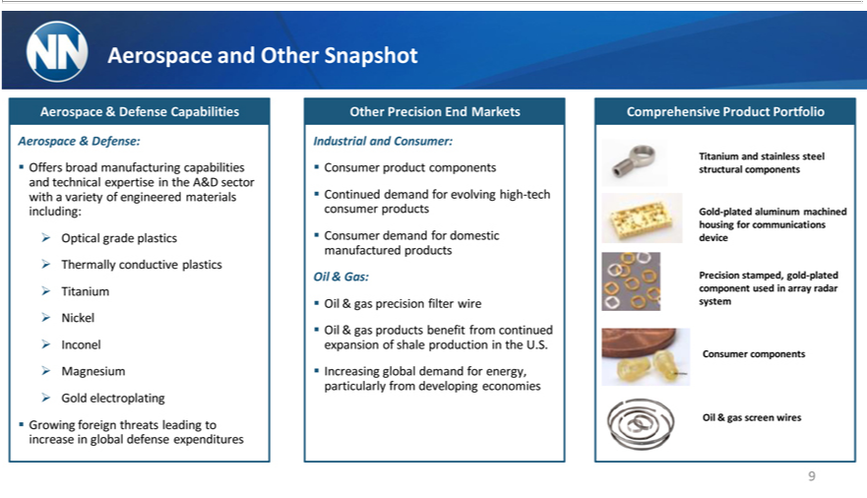

and Other Snapshot
Aerospace & Defense:^{Capabilities}
_{ptical}ffersbroad manufacturing capabilities and technical expertise in the A&D sector_{Magnesium}withvariety of engineered materials including:
^{Other} grade plastics Thermally conductive plastics Titanium Nickel Inconel Gold electroplating Growing foreign threats leading to increase in global defense expenditures Precision End Markets
_{Consumer}Industrialtinuedand^{product}Consumer:^{components}
Gas:demanddemand forfor domesticevolving highmanufactured-techconsumerproductsproducts
_{Oil & gas products}ecision filter wire
benefit from continued expansion of shale production in the U.S.
ComprehensiveIncreasingglobalProductdemandPortfolioforenergy, particularly from developing economies
Titanium and stainless steel structural components
Gold-plated aluminum machined housing for communications device
ConsumerPrecisionstamped,componentsgold-plated component used in array radar system
9Oil & gas screen wires

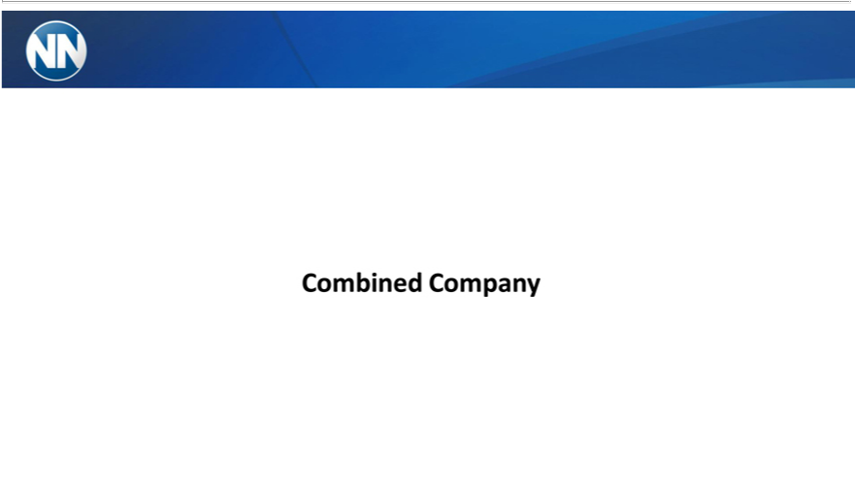

Combined Company

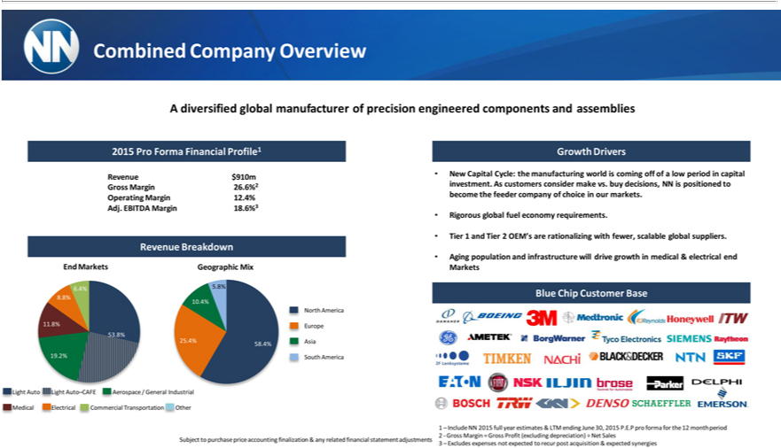

Combined Company Overview
2015AdiversifiedProFormaglobalFinancialmanufacturerProfile1of precision engineered components and assemblies
Revenue $910m
Gross Margin 26.6%2
Operating Margin 12.4%
RevenueAdj.EBITDABreakdownMargin 18.6%3
End Markets Geographic Mix
86_{.8%}4% 5.8%
10.4%
North America
11.8% Europe 53.8%
25_{.2%}4% Asia 58.4%
19 South America
ight Auto ight Auto–CAFE erospace / General Industrial
GrowthedicallectricalDriversommercial Transportation ther
New Capital Cycle: the manufacturing world is coming off of a low period in capital investment. As customers consider make vs. buy decisions, NN is positioned to become the feeder company of choice in our markets.
Rigorous global fuel economy requirements.
Tier 1 and Tier 2 OEM’_{infrastructure}arerationalizing with fewer, scalable global suppliers.
BlueAgingChippopulationCustomerandBase will drive growth in medical & electrical end Markets
1 – Include NN 2015 full year estimates & LTM ending June 30, 2015 P.E.P pro forma for the 12 month period 2—Gross Margin = Gross Profit (excluding depreciation) ÷ Net Sales adjustments

3 – Excludes expenses not expected to recur post acquisition & expected synergies

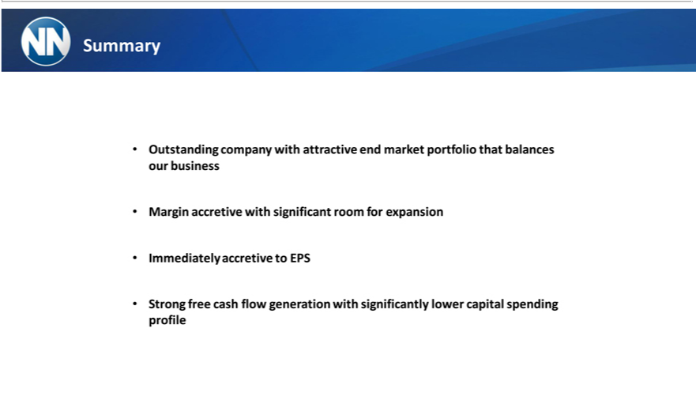

Summary
MarginOutstandingaccretivecompanywith withsignificantattractiveroomendformarketexpansionportfolio that balances our business
Immediately accretive to EPS
Strong free cash flow generation with significantly lower capital spending profile

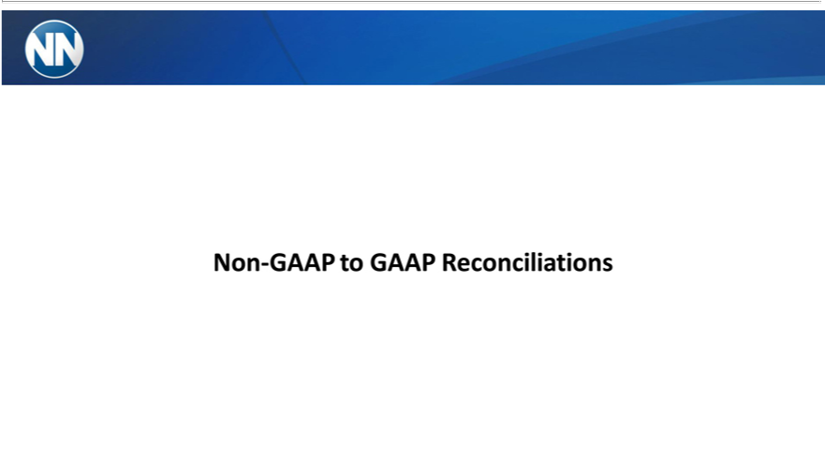

Non-GAAP to GAAP Reconciliations

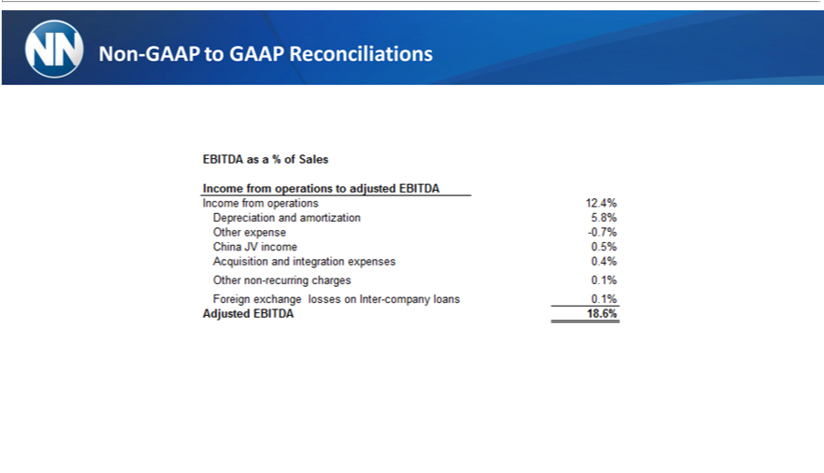

Non-GAAP to GAAP Reconciliations

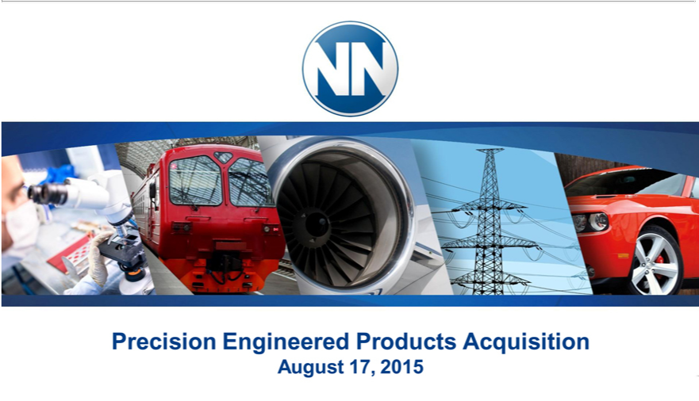

AugustPrecision17,Engineered2015 Products Acquisition

