UNITED STATES

SECURITIES AND EXCHANGE COMMISSION
WASHINGTON, DC 20549

FORM 8-K/A

CURRENT REPORT

PURSUANT TO SECTION 13 OR 15(d)
OF THE SECURITIES EXCHANGE ACT OF 1934

Date of Report (Date of earliest event reported): July 21, 2014


NN, INC.

(Exact name of registrant as specified in its charter)

Delaware

0-23486

62-1096725

(State or Other Jurisdiction
of Incorporation)

(Commission
File Number)

(I.R.S. Employer
Identification No.)

2000 Waters Edge Drive, Johnson City, Tennessee

37604

(Address of principal executive offices)

(Zip Code)

(423) 743-9151

(Registrant’s telephone number, including area code)

(Former name or former address, if changed since last report)

Check the appropriate box if the Form 8-K filing is intended to simultaneously satisfy the filing obligation of the registrant under any of the following provisions (see General Instruction A.2. below):

- Written communications pursuant to Rule 425 under the Securities Act (17 CFR 230.425)

- Soliciting material pursuant to Rule 14a-12 under the Exchange Act (17 CFR 240.14a-12)

- Pre-commencement communications pursuant to Rule 14d-2(b) under the Exchange Act (17 CFR 240.14d- 2(b))

- Pre-commencement communications pursuant to Rule 13e-4(c) under the Exchange Act (17 CFR 240.13e- 4(c))

EXPLANATORY NOTE

NN, Inc. (the “Company”) is filing this Current Report on Form 8-K/A (this “Amendment”) to amend its Current Report on Form 8-K filed with the Securities and Exchange Commission on July 22, 2014 (the “Original 8-K”). The Company revised the investor presentation filed as Exhibit 99.3 to the Original 8-K. No other changes were made to the Original 8-K or the other exhibits filed therewith.

ITEM 8.01 OTHER EVENTS

On August 8, 2014, the Company posted a revised investor presentation to its website regarding the merger contemplated by that certain Agreement and Plan of Merger, dated July 18, 2014, by and among the Company, PMC Global Acquisition Corporation, a Michigan corporation, Autocam Corporation, a Michigan corporation, Newport Global Advisors, L.P., a Delaware limited partnership, solely in its capacity as a shareholder representative, and John C. Kennedy, solely in his capacity as a shareholder representative and with respect to certain sections of the merger agreement. A copy of the revised investor presentation is attached hereto as Exhibit 99.1.

ITEM 9.01 FINANCIAL STATEMENTS AND EXHIBITS

Exhibit
No. Description

99.1 Investor Presentation Slides, dated August 8, 2014.

SIGNATURES

Pursuant to the requirements of the Securities Exchange Act of 1934, the registrant has duly caused this report to be signed on its behalf by the undersigned hereunto duly authorized.

Date: August 8, 2014 NN, INC.

By: | /s/ William C. Kelly, Jr.
Name: | William C. Kelly, Jr.
Title: | Vice President and Chief Administrative Officer

EXHIBIT INDEX

Exhibit
No. Description

99.1 Investor Presentation Slides, dated August 8, 2014.

Exhibit 99.1
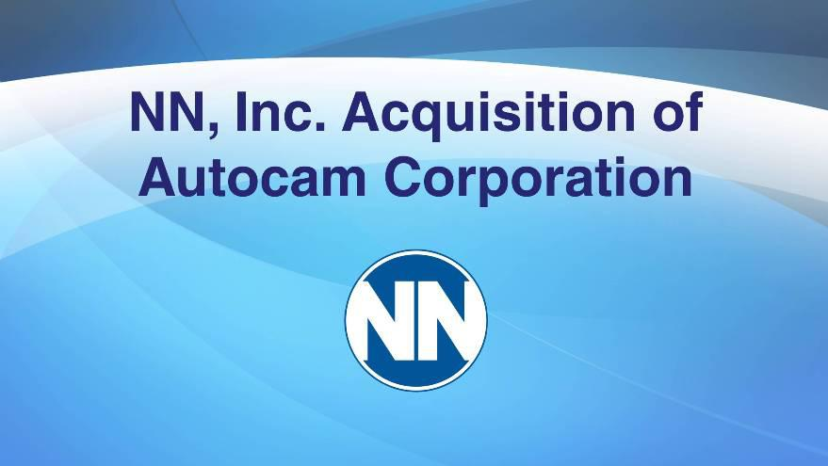

NN, Inc. Acquisition of Autocam Corporation
Exhibit 99.1

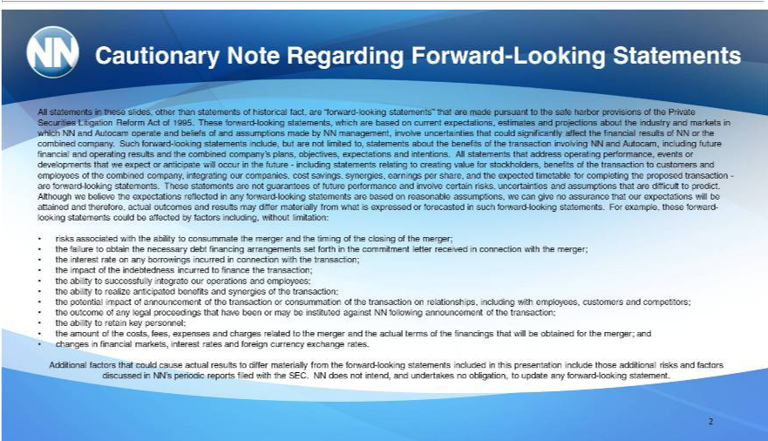

CautionaryAllstatementsNotein Regardingtheseslides,Forwardotherthan-LookingstatementsStaementsofhistorical fact, are “forward-looking statements” that are made pursuant to the safe harbor provisions of the Private Securities Litigation Reform Act of 1995.

management,Theseforwardinvolve-lookinguncertaintiesstatements, whichthatcouldare basedsignificantlyoncurrentaffectexpectations,thefinancialestimatesresultsofandNNprojectionsorthecombinedaboutthecompany.industrySuchand forwardmarkets-inlookingwhichstatementsNNandAutocaminclude, operatebutare andnot limitedbeliefs ofto, andstatementsassumptionsaboutmadethebenefitsbyNN of the transaction involving NN and Autocam, including future financial and operating results and the combined company’s plans, objectives, expectations and intentions. All statements thatcustomersaddrss operating
combinperformance,dcompany,events integratingordevelopmentsourcompanies,thatweexpectcost savings,oranticipatesynergies,willoccurearningstheperfutureshare,- includingandexpectedstatementstimetablerelatingfortocompletingcreatingvaluethe proposedforstockholders,transactionbenefits-are offorwardthetransaction-looking statements.to Theseand employeesstatements ofarethenot
guarantees of future performance and involve certain risks, uncertainties and assumptions thattherefore,adifficult to predict. Although we believe the expectations reflected in any forwa_{or}d-looking statements are based on
reasonable assumptions, we can give no assurance that our expectations will be attained and actual outcomes and results may differ materially from what is expressed forecasted in such forward-looking statements. For exampl^{the}, these forward-looking statements could be affected by factors including, without limitation:
risks associated with ability to consummate the merger and the timing of the closing of the merger;
failure to obtain the necessary debt financing arrangements set forth in the commitment letter received in connection with the merger; the interest rate on any borrowings incurred in connection with the transaction; _{the} impact of the indebtedness incurred to finance the transaction; the ability to successfully integrate our operations and employees; the _{customers}abilityrealize anticipated benefits and synergies of the transaction;

potential impact of announcement of the transaction or consummation of the transaction on relationships, including with employees, and competitors; the outcome of any legal proceedings that have been or may be instituted against NN following announcement of the transaction; the ability to retain key personnel; the amount of the costs, fees, expenses and charges related to the merger and the actual terms of the financings that will be obtained for the merger; and changes in financial markets, interest rates and foreign currency exchange rates.

Additional factors that could cause actual results to differ materially from the forward-looking statements included in this presentation include those additional risks and factors discussed in NN’s periodic reports filed with the SEC. NN does not intend, and undertakes no obligation, to update any forward-looking statement.
2

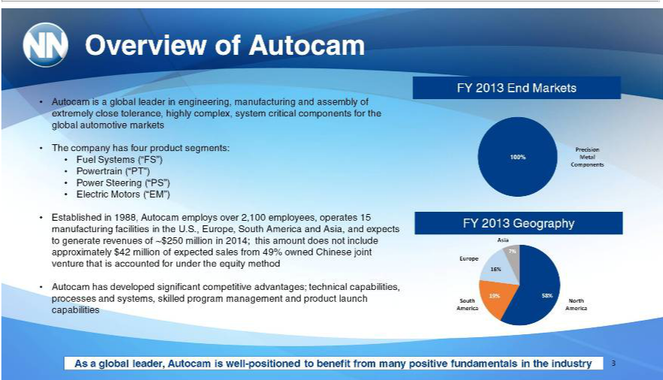

Overview of Autocam
TheAutocamcompanyis globalhasfourleaderproductinengineering,segments: manufacturing and assembly of extremely close tolerance, highly complex, system critical components for the global automotive markets
Fuel Systems (“FS”)
PowertrainSteering(“PT”)(“PS”)
EstablishedlectricMotors1988,(“EM”)Autocam employs over 2,100 employees, operates 15 manufacturing facilities in the U.S., Europe, South America and Asia, and expects to generate revenues of ~$250 million in 2014; this amount
does not include approximately $42 million of expected sales from 49% owned Chinese joint venture that is accounted for under the equity method
^{Asutocam} has developed significant competitive advantages; technical capabilities, processes and systems, skilled program management and product launch capabilities global leader, Autocam is well-positioned to benefit from many positive fundamentals in the industry
FY 2013 End Markets
100%Precision Metal Components
AsiaFY2013 Geography
Europe
^{Sou}North America
7%
19%^{6%}
58%
3

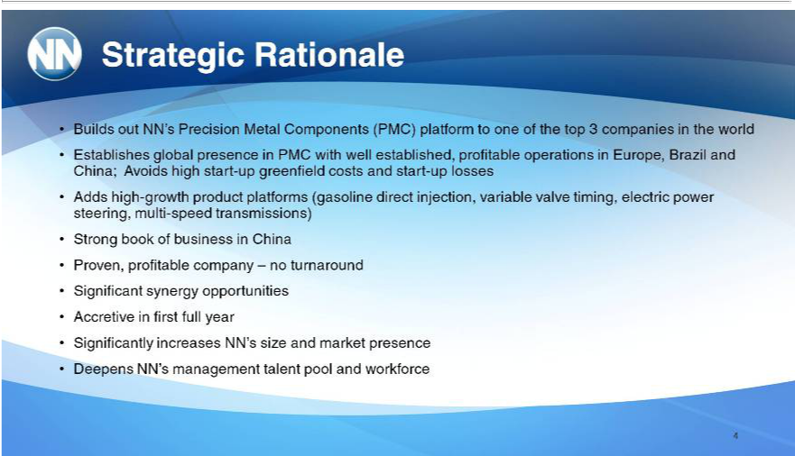

Strategic Rationale
Builds out NN’s Precision Metal Components (PMC) platform to one of the top 3 companies in the world
Establishes global presence in PMC with well established, profitable operations_{timing,}Europe, Brazil and China; Avoids high start-up greenfield costs and start-up losses
StrongAddshighbook_{profitable}-growthbusinessproductin platformsChina (gasoline direct injection, variable valve electric power steering, multi-speed transmissions)
Proven, company – no turnaround
AccretiveSignificantinsynergyfirstfullopportunitiesyear
DeepensSignificantlyNN’sincreasesmanagementNN’stalentsizeandpoolmarketand_{workforce}presen
4

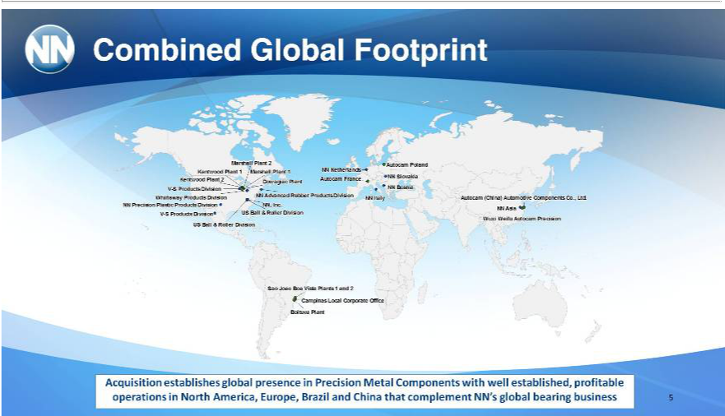

Combined Global Footprint
Marshall Plant 2
Autocam Po_{Plant}d
Kentwood 1
Marshall Plant 1
NN Netherlands
Autocam France
NN Slovakia
Kentwood Plant 2
Dowagiac Plant
NNV-S BosniaProducts Division
Whirlaway Products Division
^{NN}
ItalyAdvanced Rubber Products Division
Autocam,Precision(China)PlasticAutomotiveProducts ComponentsDivision Co., Ltd.
_{NN} AsiaInc.
V-S Products Division
US Ball & Roller Division
Wuxi Weifu Autocam Precision
US Ball & Roller Division
Sao Joao Boa Vista Plants 1 and 2
BoituvaCampinasPlantLocal Corporate Office
Acquisition establishes global presence in Precision Metal Components with well established, profitable operations in North America, Europe, Brazil and China that complement NN’s global bearing business 5

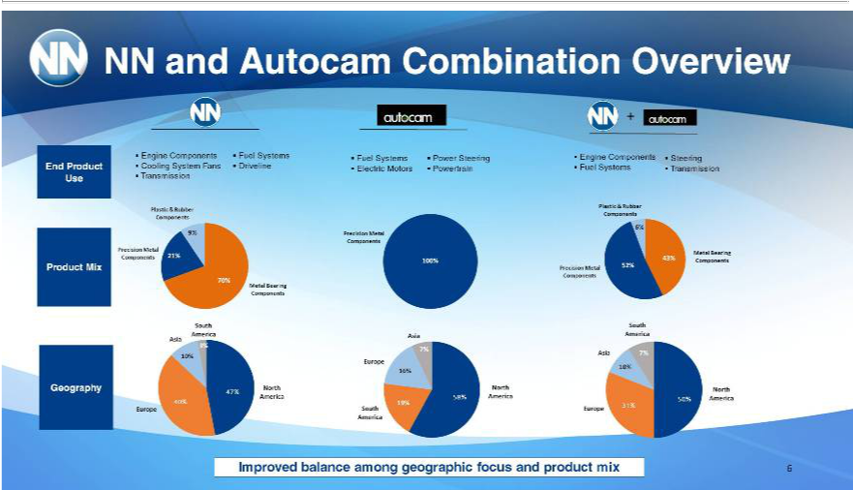

NN and Autocam Combination Overview
Engine Components Fuel_{Driveline}Systms Fuel Systems_{Powertrain}Steering Engine Components Steering
TransmissionCoolingSystem Fans Electric Motors Fuel Systems Transmission
_{Precision}lastic& RubberMetal Components
Components
M_{Precision}talBearingMetalComponents
Components
_{Precision}lastic& RubberMetal Components
Components
SouthMetal Bearing Components
_{Asia}merica
Europe
North America
Asia
Europe
^{Nor}South America
Asia
Europe
North America
End Product Use
Product Mix
Geography
9%
_{100%}7^{21%}
6%
_{43%}52%
¹0%
47%
19%^{6%}
58%
7%
31%^{10%}
50%
6Improved balance among geographic focus and product mix

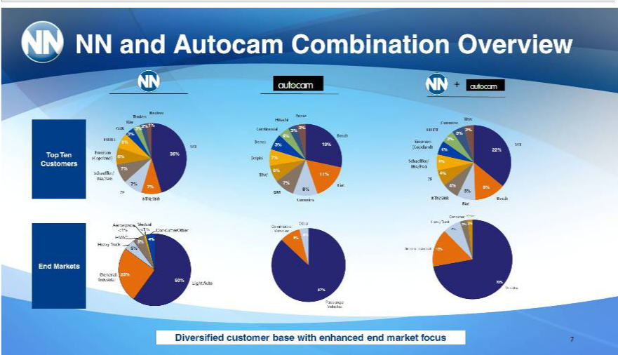

TimkenNNand NexteerAutocam Combination Overview
Iljin
GKN2%1%3%
HILITE3% 6%
SKF
(Copeland)Emerson36%6%
Schaeffler/7%
INA/FAG7%7%
ZF
BroseNTN/SNR
Hitachi
4%ContinentalBosch 3% 3%
nso 3% 19%
6%_{Delphi} ^{7%}
TRW 11%
7% Fiat
GM 8%
Cummins
TRW
HILITECummins3%
Emerson3% 3%
SKF
Schaeffler/(Copeland) 4%4% 22%
INA/FAG
ZF4%
4%_{5%} 8%
FiatNTN/SNR Bosch
Aerospace Medical
Heavy<1%^{VAC}<1%^{4%} Consumer-Other
5% Truck 5%
General 25%
Industrial 60% Light Auto
Commercial Other
Vehicles
_{9%}4%
87%
Passenger
ConsumerVehicles Other
7%Heavy Truck 3% 2%
70%General Industrial 15%
Vehicles
EndTop TenMarketsCustomers
7Diversified customer base with enhanced end market focus

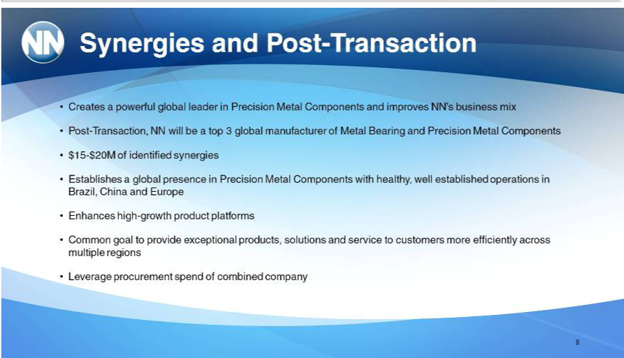

Synergies and Post-Transaction
Creates_{ransaction,}powerful global _{leader} in Precision Metal Components and improves NN’_{Precision}business mix
Post-T NN will be top 3 global manufacturer of Metal Bearing and Metal Components $15-$20M of identified synergies
_{Enhances}stablishes a global presence in Precision Metal Components with healthy, well established operations in Brazil, China and Europe high-growth product platforms
Common goal to provide exceptional products, solutions and service to customers more efficiently across multiple regions Leverage procurement spend of combined company
8

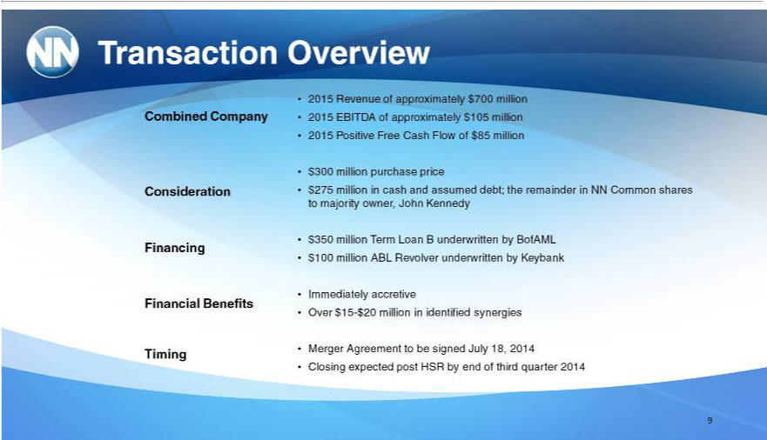

Transaction Overview
_{Consideration}mbinedCompany
Financing
Financial Benefits Timing
2015 Revenue of approximately $700 million 2015 EBITDA of approximately $105 million 2015 Positive Free Cash Flow of $85 million _{$350}00 _{million} purchase price $275 million in cash and assumed debt; the remainder in NN Common shares to majority owner, John Kennedy
Term Loan B underwritten by BofAML $100 million ABL Revolver underwritten by Keybank Immediately accretive
OverMerger$15Agreement-$20millionto bein identifiedsignedJulysynergies18,2014
9Closing expected post HSR by end of third quarter 2014

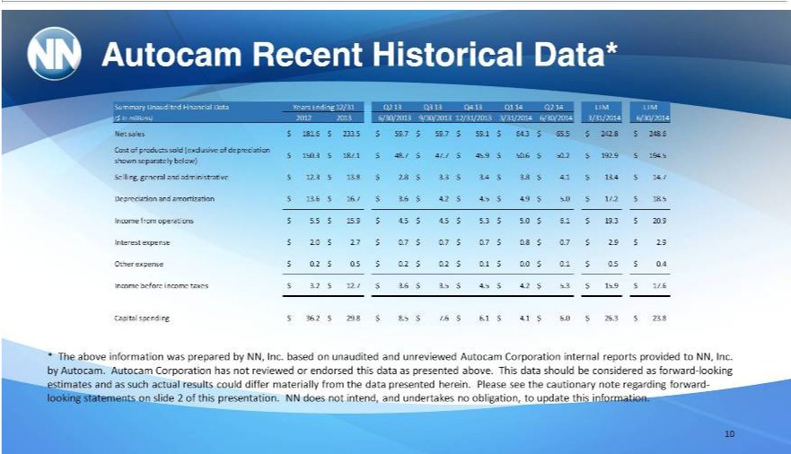

Autocam Recent Historical Data* | Q2 13 Q3 13 Q4 13 Q1 14 Q2 |  |  | LTM LTM
Summary Unaudited Financial Data Years Ending
($ in millions) 2012 2013 6/30/2013 | 3/31/2014 |  | 3/31/2014 |  | 6/30/2014
Net sales $ 181.6 $ 233.5 $ 59.7 $ 59.79/30/2013$59.$ 64. | $ 65.5 $ 242.8 $ 248.6/30/2014 |  |  |  | $ 50.2 $ 192.9 | $ 194.5
Cost of products sold (exclusive of depreciation12/31/2013$150.$187.1 $ 48.7 |  | $ 47.7 $ 45.9 $ 50.6 |  |  | $ 50.2 $ 192.9 | $ 194.5
shown separately below) |  | $ 4. $ 13.4 $ 14.7
Selling, general and administrative $ 12.3 $ 13.8 $ 2.8 $ 3.3 $ 3.4 $ 3.8
Depreciation and amortization $ 13.6 $ 16.7 $ 3.6 $ 4.2 $ 4.5 $ 4.9 $ 5.0 $ 17.2 $ 18.5
come from operations $ 5.5 $ 15.9 $ 4.5 $ 4.5 $ 5.3 | $ 5.0 $ 6.1 $ 19.3 | $ 20.9
Interest expense $ 2.0 $ 2.7 $ 0.7 $ 0.7 $ 0.7 $ 0.8 $ 0.7 $ 2.9 $ 2.9
Other expense $ 0.2 $ 0.5 $ 0.2 $ 0.2 $ 0.1 $ 0.0 $ 0.1 $ 0.5 $ 0.4
Income before income taxes $ 3.2 $ 12.7 $ 3.6 $ 3.5 $ 4.5 $ 4. $ 5.3 $ 15.9 $ 17.6
Capital spending $ 36.2 $ 29.8 $ 8.5 $ 7.6 $ 6.1 $ 4.1 | $ 6.0 $ 26.3 $ 23.8
* The above information was prepared by NN, Inc. based on unaudited and unreviewed Autocam Corporation internal reports provided to NN, Inc. by Autocam. Autocam Corporation has not reviewed or endorsed this data as presented above. This data should be considered as forward-looking estimates and as such actual results could differ materially from the data presented herein. Please see the cautionary note regarding forward-looking statements on slide 2 of this presentation. NN does not intend, and undertakes no obligation, to update this information.

10

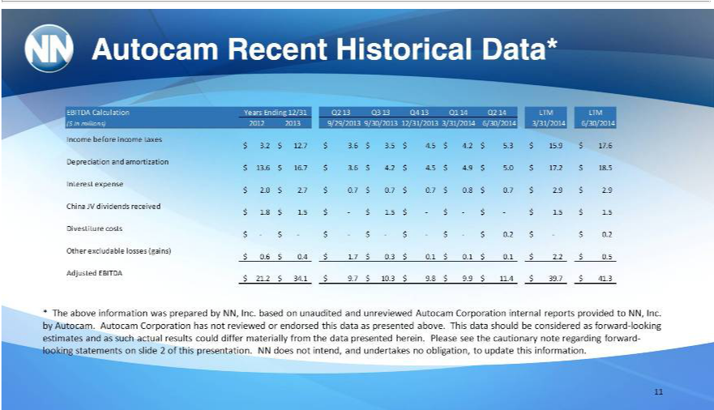

Autocam Recent Historical Data*
EBITDA Calculation Years Ending 12/31 Q2 13 Q3 Q4 13 Q1 Q2 LTM LTM
($ in millions) 2012 2013 9/29/2013 9/30/2013 |  |  |  | 12/31/2013 3/31/2014 6/30/2014 |  | 3/31/2014 6/30/2014
Income before income taxes |  |  |  | $ 17.6
$ 3.2 $ 12.7 $ 3.6 $ 3.5 $ 4.5 $ 4.2 $ 5.3 $ 15.9 |  |  |  | $ 17.6
Depreciation and amortization
$ 13.6 $ 16.7 $ 3.6 $ 4.2 $ 4.5 $ 4.9 $ 5.0 $ 17.2 $ 18.5
Interest expense | $ 0.7 | $ 2.9 | $ 2.9
$ 2.0 $ 2.7 $ 0.7 $ 0.7 $ 0.7 $ 0.8 | $ 0.7 | $ 2.9
China JV dividends received
$ 1.8 $ 1.5 $ - $ 1.5 $ - $ - $ - $ 1.5 $ 1.5
Divestiture costs
$ - $ - $ - $ - $ - $ - $ 0.2 $ - $ 0.2
Other excludable losses (gains) | $ 0.1 | $ 2.2 | $ 0.5
$ 0.6 $ 0.4 $ 1.7 $ 0.3 $ 0.1 $ 0.1 | $ 0.1 | $ 2.2 |  |  | $ 11.4 $ 39.7 $ 41.3
Adjusted EBITDA $ 21.2 $ 34.1 | $ 9.7 | $ 10.3 $ 9.8 $ 9.9 |  |  | $ 11.4 $ 39.7 $ 41.3
* The above information was prepared by NN, Inc. based on unaudited and unreviewed Autocam Corporation internal reports provided to NN, Inc. by Autocam. Autocam Corporation has not reviewed or endorsed this data as presented above. This data should be considered as forward-looking estimates and as such actual results could differ materially from the data presented herein. Please see the cautionary note regarding forward-looking statements on slide 2 of this presentation. NN does not intend, and undertakes no obligation, to update this information.

11

