UNITED STATES

SECURITIES AND EXCHANGE COMMISSION

Washington, D.C. 20549

FORM 10-K

- ANNUAL REPORT PURSUANT TO SECTION 13 OR 15(d) OF THE SECURITIES EXCHANGE ACT OF 1934 For the fiscal year ended December 31, 2024
OR

- TRANSITION REPORT PURSUANT TO SECTION 13 OR 15(d) OF THE SECURITIES EXCHANGE ACT OF 1934

For the transition period from to

Commission file number 001-39268


NN, Inc.

(Exact name of registrant as specified in its charter)

Delaware | 62-1096725
(State or other jurisdiction of incorporation or organization) | (I.R.S. Employer Identification No.)
6210 Ardrey Kell Road, Suite 120 | 28277
Charlotte, North Carolina | 28277
(Address of principal executive offices) | (Zip Code)

Registrant’s telephone number, including area code (980) 264-4300

Securities registered pursuant to Section 12(b) of the Act:

Title of each class Trading symbol Name of each exchange on which registered

Common Stock, par value $0.01 NNBR The Nasdaq Stock Market LLC

Securities registered pursuant to Section 12(g) of the Act: None

Indicate by check mark if the registrant is a well-known seasoned issuer, as defined in Rule 405 of the Securities Act. Yes ☐ No ☑ Indicate by check mark if the registrant is not required to file reports pursuant to Section 13 or Section 15(d) of the Act. Yes ☐ No

☑

Indicate by check mark whether the registrant (1) has filed all reports required to be filed by Section 13 or 15(d) of the Securities Exchange Act of 1934 during the preceding 12 months (or for such shorter period that the registrant was required to file such reports), and (2) has been subject to such filing requirements for the past 90 days. Yes ☑ No ☐

Indicate by check mark whether the registrant has submitted electronically every Interactive Data File required to be submitted pursuant to Rule 405 of Regulation S-T (§ 232.405 of this chapter) during the preceding 12 months (or for such shorter period that the registrant was required to submit such file). Yes ☑ No ☐

Indicate by check mark whether the registrant is a large accelerated filer, an accelerated filer, a non-accelerated filer, a smaller reporting company, or an emerging growth company. See the definitions of “large accelerated filer,” “accelerated filer,” “smaller reporting company,” and “emerging growth company” in Rule 12b-2 of the Exchange Act.

Large accelerated filer ☐ Accelerated filer

Non-accelerated filer ☐ Smaller reporting company

Emerging growth company

☑

☑

☐

If an emerging growth company, indicate by check mark if the registrant has elected not to use the extended transition period for complying with any new or revised financial accounting standards provided pursuant to Section 13(a) of the Exchange Act. ☐

Indicate by check mark whether the registrant has filed a report on and attestation to its management’s assessment of the effectiveness of its internal control over financial reporting under Section 404(b) of the Sarbanes-Oxley Act (15 U.S.C. 7262(b)) by the registered public accounting firm that prepared or issued its audit report. ☑

If securities are registered pursuant to Section 12(b) of the Act, indicate by check mark whether the financial statements of the registrant included in the filing reflect the correction of an error to previously issued financial statements. ☐

Indicate by check mark whether any of those error corrections are restatements that required a recovery analysis of incentive-based compensation received by any of the registrant’s executive officers during the relevant recovery period pursuant to §240.10D-1(b). ☐

Indicate by check mark whether the registrant is a shell company (as defined in Rule 12b-2 of the Act). Yes ☐ No ☑

The aggregate market value of the voting and non-voting common stock held by non-affiliates of the registrant was approximately $86.8 million as of June 28, 2024, the last business day of the registrant’s most recently completed second fiscal quarter, computed using the closing price of the registrant’s common stock as quoted on the Nasdaq Stock Market LLC on that date of $3.00. Solely for purposes of making this calculation, shares of the registrant’s common stock held by named executive officers, directors and 5% or greater stockholders of the registrant as of such date have been excluded because such persons may be deemed to be affiliates. This determination of affiliate status is not necessarily a conclusive determination for any other purposes.

As of February 14, 2025, there were 49,886,862 shares of the registrant’s common stock, par value $0.01 per share, outstanding.

DOCUMENTS INCORPORATED BY REFERENCE

Portions of the Proxy Statement with respect to the 2025 Annual Meeting of Stockholders are incorporated by reference in Part III, Items 10 to 14 of this Annual Report on Form 10-K as indicated herein. Such proxy statement will be filed with the Securities and Exchange Commission within 120 days of the registrant’s fiscal year ended December 31, 2024.

NN, Inc.

INDEX

Page

PART I . . . . . . . . . . . . . . . . . . . . . . . . . . . . . . . . . . . . . . . . . . . . . . . . . . . . . . . . . . . . . . . . . . . . . . . . . . . . . . . . . . . . . . . . . . 5

Item 1. Business . . . . . . . . . . . . . . . . . . . . . . . . . . . . . . . . . . . . . . . . . . . . . . . . . . . . . . . . . . . . . . . . . . . . . . . . . . . 5

Item 1A. Risk Factors . . . . . . . . . . . . . . . . . . . . . . . . . . . . . . . . . . . . . . . . . . . . . . . . . . . . . . . . . . . . . . . . . . . . . . . . 10

Item 1B. Unresolved Staff Comments . . . . . . . . . . . . . . . . . . . . . . . . . . . . . . . . . . . . . . . . . . . . . . . . . . . . . . . . . . . 20

Item 1C. Cybersecurity . . . . . . . . . . . . . . . . . . . . . . . . . . . . . . . . . . . . . . . . . . . . . . . . . . . . . . . . . . . . . . . . . . . . . . . 20

Item 2. Properties . . . . . . . . . . . . . . . . . . . . . . . . . . . . . . . . . . . . . . . . . . . . . . . . . . . . . . . . . . . . . . . . . . . . . . . . . . 20

Item 3. Legal Proceedings . . . . . . . . . . . . . . . . . . . . . . . . . . . . . . . . . . . . . . . . . . . . . . . . . . . . . . . . . . . . . . . . . . . 21

Item 4. Mine Safety Disclosures . . . . . . . . . . . . . . . . . . . . . . . . . . . . . . . . . . . . . . . . . . . . . . . . . . . . . . . . . . . . . . . 21

Part II . . . . . . . . . . . . . . . . . . . . . . . . . . . . . . . . . . . . . . . . . . . . . . . . . . . . . . . . . . . . . . . . . . . . . . . . . . . . . . . . . . . . . . . . . . . 22

Item 5. Market for the Registrant’s Common Equity, Related Stockholder Matters, and Issuer Purchases of
Equity Securities . . . . . . . . . . . . . . . . . . . . . . . . . . . . . . . . . . . . . . . . . . . . . . . . . . . . . . . . . . . . . . . . . . . . 22

Item 6. Reserved . . . . . . . . . . . . . . . . . . . . . . . . . . . . . . . . . . . . . . . . . . . . . . . . . . . . . . . . . . . . . . . . . . . . . . . . . . . 23

Item 7. Management’s Discussion and Analysis of Financial Condition and Results of Operations . . . . . . . . . . 24

Item 7A. Quantitative and Qualitative Disclosures About Market Risk . . . . . . . . . . . . . . . . . . . . . . . . . . . . . . . . . . 30

Item 8. Financial Statements and Supplementary Data . . . . . . . . . . . . . . . . . . . . . . . . . . . . . . . . . . . . . . . . . . . . . 31

Item 9. Changes in and Disagreements with Accountants on Accounting and Financial Disclosure . . . . . . . . . . 63

Item 9A. Controls and Procedures . . . . . . . . . . . . . . . . . . . . . . . . . . . . . . . . . . . . . . . . . . . . . . . . . . . . . . . . . . . . . . 61

Item 9B. Other Information . . . . . . . . . . . . . . . . . . . . . . . . . . . . . . . . . . . . . . . . . . . . . . . . . . . . . . . . . . . . . . . . . . . . 61

Item 9C. Disclosure Regarding Foreign Jurisdictions that Prevent Inspections . . . . . . . . . . . . . . . . . . . . . . . . . . . . 85

Part III . . . . . . . . . . . . . . . . . . . . . . . . . . . . . . . . . . . . . . . . . . . . . . . . . . . . . . . . . . . . . . . . . . . . . . . . . . . . . . . . . . . . . . . . . . 62

Item 10. Directors, Executive Officers, and Corporate Governance . . . . . . . . . . . . . . . . . . . . . . . . . . . . . . . . . . . . 62

Item 11. Executive Compensation . . . . . . . . . . . . . . . . . . . . . . . . . . . . . . . . . . . . . . . . . . . . . . . . . . . . . . . . . . . . . . 62

Item 12. Security Ownership of Certain Beneficial Owners and Management and Related Stockholder Matters . 62

Item 13. Certain Relationships and Related Transactions, and Director Independence . . . . . . . . . . . . . . . . . . . . . . 62

Item 14. Principal Accountant Fees and Services . . . . . . . . . . . . . . . . . . . . . . . . . . . . . . . . . . . . . . . . . . . . . . . . . . 62

Part IV . . . . . . . . . . . . . . . . . . . . . . . . . . . . . . . . . . . . . . . . . . . . . . . . . . . . . . . . . . . . . . . . . . . . . . . . . . . . . . . . . . . . . . . . . . 63

Item 15. Exhibits and Financial Statement Schedules . . . . . . . . . . . . . . . . . . . . . . . . . . . . . . . . . . . . . . . . . . . . . . . 63

Item 16. Form 10-K Summary . . . . . . . . . . . . . . . . . . . . . . . . . . . . . . . . . . . . . . . . . . . . . . . . . . . . . . . . . . . . . . . . . 66

SIGNATURES . . . . . . . . . . . . . . . . . . . . . . . . . . . . . . . . . . . . . . . . . . . . . . . . . . . . . . . . . . . . . . . . . . . . . . . . . . . . . . . . . . . . 67

3

Note Regarding Forward-Looking Statements

This Annual Report on Form 10-K (this “Annual Report”) contains forward-looking statements within the meaning of Section 27A of the Securities Act of 1933, as amended, and Section 21E of the Securities Exchange Act of 1934, as amended (the “Exchange Act”), which are intended to be covered by the safe harbor provisions of the Private Securities Litigation Reform Act of 1995 and include this statement for purposes of complying with these safe harbor provisions. These statements may discuss goals, intentions and expectations as to future trends, plans, events, results of operations or financial condition, or state other information relating to NN, Inc. (the “Company”), based on current beliefs of management as well as assumptions made by, and information currently available to, management. Forward-looking statements generally will be accompanied by words such as “anticipate,” “believe,” “could,” “estimate,” “expect,” “forecast,” “guidance,” “intend,” “may,” “possible,” “potential,” “predict,” “project” or other similar words, phrases or expressions. Forward-looking statements involve a number of risks and uncertainties that are outside of management’s control and that may cause actual results to be materially different from such forward-looking statements. Such factors include, among others, general economic conditions and economic conditions in the industrial sector; the impacts of pandemics, epidemics, disease outbreaks and other public health crises on our financial condition, business operations and liquidity; competitive influences; risks that current customers will commence or increase captive production; risks of capacity underutilization; quality issues; material changes in the costs and availability of raw materials; economic, social, political and geopolitical instability, military conflict, currency fluctuation, and other risks of doing business outside of the United States; inflationary pressures and changes in the cost or availability of materials, supply chain shortages and disruptions, the availability of labor and labor disruptions along the supply chain; our dependence on certain major customers, some of whom are not parties to long-term agreements (and/or are terminable on short notice); the impact of acquisitions and divestitures, as well as expansion of end markets and product offerings; our ability to hire or retain key personnel; the level of our indebtedness; the restrictions contained in our debt agreements; our ability to obtain financing at favorable rates, if at all, and to refinance existing debt as it matures; our ability to secure, maintain or enforce patents or other appropriate protections for our intellectual property; new laws and governmental regulations; the impact of climate change on our operations; uncertainty of government policies and actions after recent U.S. elections in respect to global trade, tariffs and international trade agreements; and cyber liability or potential liability for breaches of our or our service providers’ information technology systems or business operations disruptions. The foregoing factors should not be construed as exhaustive and should be read in conjunction with the sections entitled “Risk Factors” and “Management’s Discussion and Analysis of Financial Condition and Results of Operations” included in this Annual Report and in any of the Company’s subsequent filings made with the Securities and Exchange Commission (the “SEC”). Any forward-looking statement speaks only as of the date of this Annual Report, and the Company undertakes no obligation to publicly update or review any forward-looking statement, whether as a result of new information, future developments or otherwise, except as required by law. New risks and uncertainties may emerge from time to time, and it is not possible for the Company to predict their occurrence or how they will affect the Company. The Company qualifies all forward-looking statements by these cautionary statements.

4

PART I

Item 1. Business

Introduction

NN, Inc., a Delaware corporation, is a diversified industrial company that combines advanced engineering and production capabilities with in-depth materials science expertise to design and manufacture high-precision components and assemblies for a variety of end markets on a global basis. As used in this Annual Report, the terms the “Company,” “we,” “our,” or “us” refer to NN, Inc. and its subsidiaries. As of December 31, 2024, we had 26 facilities in North America, South America, Europe, and China.

Our enterprise and management structure is designed to accelerate growth and further balance our portfolio by aligning our strategic assets and businesses. Our businesses are organized into the Mobile Solutions and Power Solutions groups and are based principally on the end markets they serve.

Business Segments and Products

Mobile Solutions

Mobile Solutions is focused on growth in the automotive, general industrial, and medical end markets. We have developed an expertise in manufacturing highly complex, tight tolerance, system critical components. Our technical capabilities can be utilized in numerous applications including for use in battery electric, hybrid electric, and internal combustion engine vehicles. The group currently manufactures components on a high-volume basis for use in power steering, braking, transmissions, and gasoline fuel system applications, along with components utilized in heating, ventilation and air conditioning and diesel injection and diesel emissions treatment applications. This expertise has been gained through investment in technical capabilities, processes and systems, and allows us to provide skilled program management and product launch capabilities.

Power Solutions

Power Solutions is focused on growth in the electrical, general industrial, automotive, and medical end markets. Within this group we combine materials science expertise with advanced engineering and production capabilities to design and manufacture a broad range of high-precision metal components, assemblies, and finished devices used in applications ranging from power control to transportation electrification. We manufacture a variety of products including electrical contacts, connectors, contact assemblies, and precision stampings for the electrical end market and high precision products for the aerospace and defense end market utilizing our extensive process technologies. Our medical business includes the production of a variety of tools and instruments for the orthopedics and medical/surgical end markets.

Competitive Strengths

High-precision manufacturing capabilities

We believe our ability to produce high-precision parts at high production volumes is among the best in the market. Our technology platform consists of high precision machining, progressive stamping, laser welding, material science, assembly, and design optimization. In-house tool design and process know-how create trade secrets that enable consistent production tolerances of less than one micron while producing millions of parts per day. Parts are manufactured to application-specific customer design and co-design standards that are developed for a specific use. The high-precision capabilities are part of our zero-defect design process, which seeks to eliminate variability and manufacturing defects throughout the entire product lifecycle. We believe our production capabilities provide a competitive advantage as few other manufacturers are capable of meeting tolerance demands at any volume level requested by our customers. As the need for tight-tolerance precision parts, subassemblies, and devices continues to increase, we believe that our production capabilities will place us at the forefront of the industry. We have differentiated ourselves among our competitors by providing customers engineered solutions and a broad reach and breadth of manufacturing capabilities. We believe it is for these reasons, and because of our proven ability to produce high-quality, precision parts and components on a cost-effective basis, that customers choose us to meet their manufacturing needs.

Differentiated, system-critical products

The tight-tolerance and high-quality nature of our precision products is specifically suited for use in the most demanding applications that require superior reliability. Our products are critical components to the operation and reliability of larger mechanical and electrical systems. Precision parts are difficult to manufacture and the high cost of failure motivates our customers to focus on quality. Our products are developed for specific uses within critical systems and are typically designed in conjunction with the system designer. Our parts are often qualified for, or specified in, customer designs, reducing the ability for customers to change suppliers.

Our ability to make products with tight-tolerance and extreme precision requirements enables our customers to satisfy the critical functionality and performance requirements of their products. We are included in customer designs and deployed in

5

critical systems that involve high cost of failure applications and significant regulatory certification processes, including those for the Underwriters Laboratories.

Complete product lifecycle focus

Our engineering expertise and deep knowledge of precision manufacturing processes adds proprietary value throughout the complete lifecycle of our products. Our in-house engineering team works closely with our customers to provide parts that meet specific design specifications for a given application. The relationship with the customer begins early in the conceptual design process when we provide feedback on potential cost, manufacturability, and estimated reliability of the parts. Part designs are then prototyped, tested, and qualified in coordination with the customer design process before going to full-scale production. The close working relationship with our customers early in the product lifecycle helps to secure business, increase industry knowledge, and develop significant trade secrets. Performance verification, product troubleshooting, and post-production engineering services further deepen relationships with our customers as well as provide additional industry knowledge that is applicable to future design programs and provide continuous manufacturing process improvement.

Prototype products are developed for testing, and process validation procedures are instituted. In certain instances, we will file for regulatory production approval and include the customer’s proprietary processes, further reducing supplier changes. We will assist the customer with continuous supply chain management and comprehensive customer support for the lifetime of the product and continuously seek to identify new operational efficiencies to reduce the product’s cost and improve its quality. Once our solution is designed into a platform, it is often embedded through the multi-year manufacturing lifecycle and has a competitive advantage in supporting subsequent platforms. As an added benefit, customers generally fund development, prototypes, and manufacturing tooling expenses. This discourages supplier changes and drives recurring revenue for us.

Long-term blue-chip customer base

We maintain relationships with hundreds of customers around the world. Our customers are typically sophisticated, engineering-driven, mechanical and electrical systems manufacturers with long histories of product development and reputations for quality. We have no significant retail exposure, which limits volatility and provides enhanced sales visibility. Relationships with many of our largest customers, in terms of revenue, average more than ten years. We have significant exposure to emerging markets in Asia, South America, and Europe through these global customers as well as key local manufacturers. The diverse nature, size, and reach of our customer base provides resistance to localized market and geographic fluctuations and helps stabilize overall product demand.

Strategic global footprint

Our 26 facilities, on four continents, are strategically located to serve our customer base and provide local service and expertise. Our global footprint provides flexibility to locally supply identical products for global customers, reducing shipping time and expense, allowing us to match costs to revenue and to capitalize on industry localization trends. In total, we operate more than 1.7 million square feet of manufacturing space. North America constitutes the largest portion of our manufacturing operations with facilities in the U.S. and Mexico which are strategically located to serve major customers in those markets. Our foreign facilities are located in regional manufacturing hubs in France, Poland, China, and Brazil, and primarily serve global customers in those markets. We believe that the Chinese and South American facilities have significant growth potential as local customer bases expand and the markets for high-precision products grow in those regions.

Synergies

We continue to realize synergy effects between Mobile Solutions and Power Solutions by pairing our experienced engineering resources and wide-ranging portfolio of process technologies from each business to serve our customers’ ever evolving needs. Recent solutions developed in the electrical, electric vehicle, and general industrial markets leveraged the deep experience and expertise from each business to respond to tight, stringent requirements - all of which in a custom and innovative manner to meet each customer’s unique demand requirements. In addition, we continue to experience customer demand that utilizes multiple facilities from both businesses on a global basis due to our track record of quality and strong performance.

Customers

Our products are supplied primarily to manufacturers for use in a broad range of industrial applications, including automotive; electrical; agricultural; construction; residential devices and equipment; aerospace and defense; medical; heating, ventilation, and air conditioning; and fluid power and diesel engines. Sales to each of our top ten customers are made to multiple customer locations and divisions throughout the world. In 2024, our top ten customers accounted for approximately 51% of our net sales. In 2024, 64% of our products were sold to customers in North America, 17% to customers in Asia, 10% to customers in South America, and 9% to customers in Europe.

We sell our products to most of our largest customers under either sales contracts or agreed upon commercial terms. In general, we pass through material cost fluctuations when incurred to our customers in the form of changes in selling prices. We ordinarily ship our products directly to customers within 60 days, and in many cases, during the same calendar month of the date on which a sales order is placed.

6

Sales and Marketing

A primary emphasis of our marketing strategy is to expand key customer relationships by offering high quality, high-precision, application-specific customer solutions with the value of a single supply chain partner for a wide variety of products and components. Due to the technical nature of many of our products, our engineers and manufacturing management personnel also provide technical sales support functions, while internal sales employees handle customer orders and other general sales support activities. Our marketing strategy is to offer custom manufactured, high quality, precision products to markets with high value-added characteristics at competitive price levels. This strategy focuses on relationships with key customers that require the production of technically difficult parts and assemblies, enabling us to take advantage of our strengths in custom product development, equipment and tool design, component assembly, and machining processes.

Human Capital Management

Core Principles

Our success depends in part on our ability to successfully manage our human capital resources, including attracting, identifying, and retaining key talent. Factors that may affect our ability to attract and retain qualified employees include employee morale, our reputation, competition from other employers, and availability of qualified individuals in the communities in which we operate.

Throughout our business, we foster an ethical, safe, and supportive workplace where our employees thrive. We believe an inclusive workplace results in business growth and encourages increased innovation, retention of talent, and a more engaged workforce. Respect for human rights is fundamental to our business and our commitment to ethical business conduct, as is embodied by our Human Rights Policy, which sets forth our expectations related to workplace discrimination; workplace conditions; and freedom of association.

Headcount

As of December 31, 2024, we employed approximately 2,600 full and part-time employees and 300 temporary workers, which includes approximately 1,000 employees in the U.S. and 1,900 employees in other countries employed by our international subsidiaries. Of our total employment, approximately 12% are management/staff employees and 88% are production employees. Our employees in the France, Brazil, and Mexico City plants are subject to labor council relationships that vary due to the diverse countries in which we operate. We believe we have a good working relationship with our employees and the labor council that represent them.

Compensation, Benefits, and Employee Health and Safety

Our compensation programs are based on a strong alignment between pay and performance, and are designed to reward both financial and operational successes and support actions that drive stockholder value creation at all organizational levels. We use a combination of programs (which vary by geography and level) to attract and retain our employees, including annual performance bonuses, periodic gainsharing bonuses, and equity awards.

We also provide our employees and their families access to a range of benefits, including health insurance benefits, employer-paid life and disability insurance, health savings and flexible spending accounts, 401(k) match, vacation and paid time off, wellness offerings, education assistance, and an employee assistance program.

The health and safety of our employees and anyone who conducts business on our behalf is very important to us. Our commitment to safety starts at the top levels of our organization. We believe a safe and secure workplace is fundamental to our success. We are also committed to engaging our employees to continually improve health and safety by acting upon opportunities to reduce risk and improve our safety and health performance. In addition, we offer training programs on a regular basis. We maintain comprehensive safety programs focused on identifying hazards and eliminating risks that can lead to work-place injuries.

Talent Development

We invest resources in professional development to improve employee motivation, performance and engagement. Our annual talent management program helps identify needs at multiple levels, enabling us to provide employees with the resources they need to help achieve their career goals, build skills and lead their organizations. Further, annual goal-setting and development opportunities for employees and leaders helps our people align their professional experience with the Company’s business objectives and encourages them to take ownership of their development and career paths.

We use regular talent management and performance evaluation processes to inform the Company’s internal development processes and to calibrate assessment of individual performance organizationally. These activities form the basis for succession planning activities, up to and including the senior leadership level.

7

We also have apprenticeships, internships, and cooperative education programs in place at certain locations, which we intend to expand more broadly across the company. These programs allow us to provide a combination of education and employment options that deliver depth and context and help them build a long-term career path.

Competition

Mobile Solutions

In the market in which Mobile Solutions operates, internal production of components by our customers can impact our business as the customers weigh the risk of outsourcing strategically critical components or producing in-house. Our primary competitors are: Anton Häring KG; A. Berger Holding GmbH & Co. KG; Brovedani Group, Burgmaier Technologies GmbH & Co. KG; CIE Automotive, S.A.; IMS Companies; and MacLean-Fogg Component Solutions. We believe that we generally win new business on the basis of our technical competence, proven track record of successful product development and global platform, as well as on quality, price, and service.

Power Solutions

Power Solutions operates in competitive but very fragmented supply chains. We must compete with numerous companies in each industry market segment. Our primary competitors are: Checon Corporation; Deringer-Ney, Inc.; Electrical Contacts, Ltd.; Interplex Industries, Inc.; J&J Machining, LLC; Norstan, Inc.; Owens Industries, Inc.; and Precinmac Precision Machining. We believe that competition within the electrical end market is based principally on quality, price, design capabilities, and speed of responsiveness and delivery. We believe that our competitive strengths are product development, tool design, fabrication, tight tolerance processes, and customer solutions. With these strengths, we have built our reputation in the marketplace as a quality producer of technically difficult products.

Raw Materials

Mobile Solutions

Mobile Solutions produces products from a wide variety of metals in various forms from various sources located in North America, Europe, South America, and Asia. Basic types include hot rolled steel, cold rolled steel (both carbon and alloy), stainless steel, steel alloys, copper alloys, extruded aluminum, die cast aluminum, aluminum alloy bar, gray and ductile iron castings, hot and cold forgings, titanium alloys, plastics, and mechanical tubing. Some material is purchased directly under contracts, some is consigned by the customer, and some is purchased directly from the steel mills.

Power Solutions

Power Solutions uses a wide variety of metals in various forms, including precious metals like gold, silver, palladium, and platinum, as well as copper, copper alloys, brass, brass alloys, and plastics. Through our diverse network of suppliers, we minimize supplier concentration risk and provide a stable supply of raw materials at competitive pricing. This group also procures metal stampings from several domestic and foreign suppliers. Power Solutions bases purchase decisions on quality, service and price. Generally, we do not enter into long term supply contracts with our suppliers or commit to maintain minimum monthly purchases of materials. However, we carefully manage raw material price volatility, particularly with respect to precious metals, through the use of consignment agreements, which allow us to buy the precious metals on the same day customer shipments are priced, thereby minimizing risk of price changes from procurement to product shipment.

Supply and Cost Pressures

In each of our segments, we at times have been affected by upward price pressure on the raw materials we purchase due to changes in commodity pricing. In general, we pass through material cost fluctuations to our customers in the form of changes in selling price. Most of the raw materials we use are purchased from various suppliers and are typically available from numerous sources, some of which are located in China and Europe. Supply chain disruptions, resulting in supply shortages and higher shipping charges, have impacted our suppliers and could continue to impact our ability to maintain supplies of products and the costs associated with obtaining raw materials and key components. We continue to monitor impacts on our supply chain in order to maintain regular and timely supply of raw materials to our business segments.

Patents, Trademarks and Licenses

We have several U.S. patents, patent applications and trademarks for various trade names. However, we cannot be certain that we would be able to protect and enforce our intellectual property rights against third parties, and if we cannot do so, we may face increased competition and diminished net sales.

Furthermore, third parties may assert infringement claims against us based on their patents or other intellectual property, and we may have to pay substantial damages and/or redesign our products if we are ultimately found to infringe. Even if such intellectual property claims against us are without merit, investigating and defending these types of lawsuits takes significant time, may be expensive and may divert management attention from other business concerns.

8

Additionally, we rely on certain data and processes, including trade secrets and know-how, and the success of our business depends, to some extent, on such information remaining confidential. Each officer is subject to a non-competition and confidentiality agreement that seeks to protect this information. Additionally, all employees are subject to company code of ethics policies that prohibit the disclosure of information critical to the operations of our business.

Seasonal Nature of Business

General economic conditions impact our business and financial results, and certain businesses experience seasonal and other trends related to the industries and end markets that they serve. For example, European sales are often weaker in the summer months as customers slow production, automotive sales tend to slow in July and December, and sales to original equipment manufacturers are often stronger immediately preceding and following the launch of new products. However, as a whole, we are not materially impacted by seasonality.

Government Regulations and Environmental Matters

Our operations are subject to extensive federal, state, local, and foreign regulatory requirements, including those intended to protect public health and the environment. In the U.S. certain of our products and operations are regulated by the Environmental Protection Agency. Similar regulations have been adopted by authorities in foreign countries where we sell our products, and by state and local authorities in the U.S. In order to conduct our operations in compliance with these laws and regulations we must obtain and maintain numerous permits, approvals and certificates from various federal, state, local, and foreign governmental authorities.

We are also required to comply with increasingly complex and changing laws and regulations enacted to protect business and personal data in the U.S. and other jurisdictions regarding privacy, data protection, and data security, including those related to the collection, storage, use, transmission, and protection of personal information and other customer, supplier or employee data. Such privacy and data protection laws and regulations, and the interpretation and enforcement of such laws and regulations, are continuously developing and evolving and there is significant uncertainty with respect to how compliance with these laws and regulations may evolve and the costs and complexity of future compliance.

Based on information compiled to date, management believes that our current operations are in compliance with applicable governmental laws and regulations, the violation of which could have a material adverse effect on our business and financial condition. As of the date hereof, compliance with these laws and regulations has not had a material effect on our capital expenditures, results of operations, and competitive position. For additional information, see “Item 1A - Risk Factors.”

The potential impact of climate change on our operations is unclear. Climate change could result in an increase in severe weather events, such as hurricanes, tropical storms, blizzards and ice storms, which often results in delays or other negative consequences for our manufacturing operations, which could negatively impact our financial results. We have not identified any, and we do not believe there to be in the near term, material impacts on our business, financial condition or results of operations as a result of compliance with legislation or regulatory rules regarding climate change or from the known physical effects of climate change. Increased regulation and other climate change concerns, however, could subject us to additional costs and restrictions and could negatively affect our business, operations and financial results.

In May 2022, we released our inaugural Sustainability Report which established our global sustainability strategy. We conducted a comprehensive environmental, social and governance (“ESG”) materiality assessment to identify our most significant economic, environmental and social impacts. The material ESG topics identified during this process enable our organization to prioritize our investments and actions and provide meaningful disclosures. We continue to strengthen our focus towards providing meaningful disclosures through our sustainability reports (collectively, “ESG Reports”), which we publish on a periodic basis. Our ESG Reports identify specific actions that we have taken, and will continue to take, to address our ESG priorities. The information provided in our ESG Reports, as well as on our website, is not part of this Annual Report, and is therefore not incorporated by reference into this Annual Report or other filings with the SEC.

Information about our Executive Officers

The following table lists our executive officers as of February 14, 2025:

Name |  | Age |  | Position
Harold C. Bevis |  | 65 |  | President, Chief Executive Officer and Director
Christopher H. Bohnert | 58 |  |  | Senior Vice President and Chief Financial Officer
Timothy M. French | 61 |  |  | Senior Vice President and Chief Operating Officer
D. Gail Nixon | 54 |  |  | Senior Vice President and Chief Human Resources Officer
Jami A. Statham | 44 |  |  | Senior Vice President, General Counsel and Corporate Secretary

9

Harold C. Bevis has served the Company as President, Chief Executive Officer and Director since May 2023. Prior to joining the Company, Mr. Bevis served as President and Chief Executive Officer of Commercial Vehicle Group, Inc. (“CVGI”), from March 2020 to May 2023, and as a Director from June 2014 to May 2023. Mr. Bevis served as Chief Executive Officer of Boxlight Corporation from January 2020 to March 2020 and as a Director from March 2018 to March 2020. Previously, Mr. Bevis served as President of OmniMax International from October 2017 to February 2019 and President, Chief Executive Officer and Director of Xerium Technologies, Inc. from August 2012 to April 2017.

Christopher H. Bohnert was appointed Senior Vice President and Chief Financial Officer in June 2024. Prior to joining the Company, Mr. Bohnert served as advisor to the CEO and CFO at CVGI from September 2022 to June 2024 and as Chief Financial Officer of CVGI from October 2020 to September 2022. Previously, Mr. Bohnert served as Chief Accounting Officer at Calumet Specialty Products Partners, L.P. from October 2017 to August 2019 and as Chief Financial Officer of its Finished Lubricants & Chemicals business from August 2019 through October 2020.

Timothy M. French has served the Company as Senior Vice President and Chief Operating Officer since August 2023. Prior to joining the Company, Mr. French was President of Synergein Solutions Limited, which provides executive and C-suite level interim management and consulting services to manufacturing companies, from September 2018 to August 2023. Previously, Mr. French served as Chief Operating Officer at ProAmpac, a leading global flexible packaging company, from 2010 to 2018.

D. Gail Nixon has served the Company as Senior Vice President and Chief Human Resources Officer since January 2018. Ms. Nixon joined the Company in 2007 and previously served as our Vice President of Human Resources as well as Corporate Human Resources Manager. Ms. Nixon is a member of the Society for Human Resource Management (“SHRM”) and has earned her Senior Professional in Human Resources and SHRM – Senior Certified Professional designations.

Jami A. Statham was appointed Senior Vice President, General Counsel and Corporate Secretary in July 2024. Prior to joining the Company, Ms. Statham served as Executive Director, Deputy General Counsel for Nexteer Automotive Corporation from July 2022 to July 2024, and as Assistant General Counsel from June 2019 to July 2022. Previously, she served as Senior Legal Counsel at Autoneum North America, Inc. from March 2017 to May 2019.

Available Information - SEC Filings

We make available free of charge, in the “Investor Relations” section of our website (www.nninc.com), our annual reports on Form 10-K, quarterly reports on Form 10-Q, current reports on Form 8-K, and amendments to those reports filed or furnished pursuant to Section 13(a) or 15(d) of the Exchange Act, as soon as reasonably practicable after electronically filing such material with, or furnishing it to, the SEC.

Item 1A. Risk Factors

The following risks and uncertainties may have a material effect on our business, prospects, financial condition, results of operations, and cash flows, and should be considered in connection with the other information contained in this Annual Report on Form 10-K. If any of the events described below were to actually occur, our business, prospects, financial condition, results of operations, or cash flows could be adversely affected, and results could differ materially from expected and historical results. The risks and uncertainties described below are not the only risks facing our company. Risks and uncertainties not currently known to us or that we currently deem to be immaterial also may materially adversely affect our business, prospects, financial condition, results of operations, and cash flows.

Risks Related to Our Operations

We depend heavily on a relatively limited number of customers, and the loss of any major customer would have a material adverse effect on our business.

During 2024, sales to various U.S. and foreign divisions of our ten largest customers accounted for approximately 51% of our consolidated net sales. The loss of all or a substantial portion of sales to these customers would cause us to lose a substantial portion of our revenue and would lower our operating profit margin and cash flows from operations.

Work stoppages or similar difficulties and unanticipated business disruptions could significantly disrupt our operations, reduce our revenues and materially affect our earnings.

We have a complex network of suppliers, owned and leased manufacturing locations, co-manufacturing locations, distribution networks, and information systems that support our ability to consistently provide our products to our customers. Factors that are hard to predict or beyond our control, such as supply chain disruptions, weather, raw material shortages, natural disasters, fires or explosions, political unrest, terrorism, generalized labor unrest, including strikes at our suppliers, customers or end-users or public health crises could damage or disrupt our operations or our customers’, suppliers’, co-manufacturers’ or distributors’ operations. These disruptions may require additional resources to restore our supply chain or distribution network. If we cannot respond to disruptions in our operations, whether by finding alternative suppliers or replacing capacity at key manufacturing or distribution locations, or if we are unable to quickly repair damage to our information, production, or supply

10

systems, we may be late in delivering, or be unable to deliver, products to our customers and may also be unable to track orders, inventory, receivables, and payables. If that occurs, our customers’ confidence in us and long-term demand for our products could decline. Any of these events could materially and adversely affect our product sales, financial condition, and operating results.

We operate in and sell products to customers outside the U.S. and are subject to several risks related to doing business internationally.

We obtain a substantial portion of our raw materials from overseas suppliers, actively participate in overseas manufacturing operations, and sell to a large number of international customers. During the year ended December 31, 2024, sales to customers located outside of the U.S. accounted for 43% of our consolidated net sales. As a result of doing business internationally, we face risks associated with the following:

- changes in tariff regulations, which may make our products more costly to export or import;

- changes in monetary and fiscal policies, laws and regulations, and other activities of governments, agencies and similar organizations;

- recessions or marked declines specific to a particular country or region;

- the potential imposition of trade restrictions or prohibitions;

- the potential imposition of import tariffs or other duties or taxes;

- difficulties establishing and maintaining relationships with local original equipment manufacturers, distributors and dealers;

- difficulty in staffing and managing geographically diverse operations;

- compliance with respect to anti-bribery, competition, export and import, trade sanctions, data privacy, environmental, human rights and other laws;

- political uncertainty, instability, civil unrest, government controls over certain sectors and human rights concerns in countries, including but not limited to, China, in which our suppliers, manufacturing operations, and customers are located; and

- changes in the geopolitical environment, wars, conflicts, or trade barriers or blockades in the European Union and Asia, which may adversely affect business activity and economic conditions globally and could continue to contribute to instability in global financial and foreign exchange markets, as well as disrupt the free movement of goods, services, and people between countries.

These and other risks may also increase the relative price of our products compared to those manufactured in other countries, thereby reducing the demand for our products in the markets in which we operate, which could have a material adverse effect on our business, prospects, financial condition, results of operations, or cash flows.

In addition, we could be adversely affected by violations of the Foreign Corrupt Practices Act (the “FCPA”) and similar worldwide anti-bribery laws, as well as export controls, which may include International Traffic in Arms Regulation and Export Administration Regulations, and economic sanction laws. The FCPA and similar anti-bribery laws in other jurisdictions generally prohibit companies and their intermediaries from making improper payments to non-U.S. officials for the purpose of obtaining or retaining business. Our policies mandate compliance with these laws. We operate in many parts of the world that have experienced governmental corruption to some degree and, in certain circumstances, strict compliance with anti-bribery laws may conflict with local customs and practices. We cannot assure you that our internal controls and procedures will always protect us from the improper acts committed by our employees or agents. If we are found to be liable for FCPA, export control or sanction violations, we could suffer from criminal or civil penalties or other sanctions, including loss of export privileges or authorization needed to conduct aspects of our international business, which could have a material adverse effect on our business, prospects, financial condition, results of operations, or cash flows.

The prices we pay for raw materials used in our products may be impacted by tariffs. The tariffs initiated by the U.S. government in 2018 under Section 232 of the Trade Expansion Act of 1962 resulted in increased metals prices in the United States. With respect to taxes, trade policies and tariffs there is uncertainty as the political landscape changes due to the recent U.S. presidential and congressional elections. Changes in U.S. administrative policy may lead to significant increases in tariffs for imported goods among other possible changes, which could strain international trade relations and increase the risk that foreign governments implement retaliatory tariffs on goods imported from the United States. Any widespread imposition of new or increased tariffs could increase the cost of, and reduce the demand for, our products, as well as result in increased inflationary pressure, any of which could have a material adverse effect on our business, prospects, financial condition, results of operations, or cash flows. We cannot predict whether, and to what extent, there may be changes to international trade agreements or whether quotas, duties, tariffs, exchange controls or other restrictions on our products will be changed or imposed.

11

In addition, an open conflict or war across any region could affect our ability to obtain raw materials. The military conflicts (including the ongoing war between Russia and Ukraine and conflict in the Middle East), and related sanctions, export controls or other actions that may be initiated by nations could adversely affect our business and our supply chain or our business partners or customers in other countries. If we are unable to source our products from the countries where we wish to purchase them, either because of the occurrence or threat of wars or other conflicts, regulatory changes or for any other reason, or if the cost of doing so increases, it could have a material adverse effect on our business, financial condition and results of operations. Disruptions in the supply of raw materials and components could temporarily impair our ability to manufacture our products for our customers or require us to pay higher prices to obtain these raw materials or components from other sources, which could have a material adverse effect on our business and our results of operations.

Quality problems with our products could harm our reputation, erode our competitive advantage and could result in a product recall.

Quality is important to us and our customers, and our products and solutions are held to high quality and performance standards. In the event our products and solutions fail to meet these standards, our reputation could be harmed, which could damage our competitive advantage, causing us to lose customers and resulting in lower revenues.

The majority of our products are components of our customers’ products that are used in critical industrial applications. A failure of our components could lead to a product recall. If a recall were to happen as a result of our components failing, we could bear a substantial part of the cost of correction. In addition to the cost of fixing the parts affected by the component, a recall could result in the loss of a portion of or all of the customer’s business and damage our reputation. A successful product recall claim requiring that we bear a substantial part of the cost of correction, or the loss of a key customer could have a material adverse effect on our business, prospects, financial condition, results of operations, or cash flows.

Our inability to effectively manage the timing, quality and costs of new program launches could adversely affect our financial performance.

In connection with the award of new business, we obligate ourselves to deliver new products and services that are subject to our customers' timing, performance and quality standards. Additionally, we must effectively coordinate the activities of numerous suppliers in order for the program launches of our products to be successful. Given the complexity of new program launches, we may experience difficulties managing product quality, timeliness and associated costs. In addition, new program launches require a significant ramp up of costs; however, our sales related to these new programs generally are dependent upon the timing and success of our customers' introduction of new products. Our inability to effectively manage the timing, quality and costs of these new program launches could adversely affect our financial condition, operating results and cash flows.

We face the challenge of accurately aligning our capacity with our demand.

We face periods when demand fluctuates significantly higher or lower than our normal operating levels, including variability driven by supply chain inconsistency. Accurately forecasting our expected volumes and appropriately adjusting our capacity are important factors in determining our results of operations and cash flows. We manage our capacity by adjusting our manufacturing workforce, capital expenditures and purchases from suppliers. In periods of weak demand, we may face under-utilized capacity and un-recovered overhead costs, while in periods of strong demand we may experience unplanned costs and could fail to meet customer demand. We cannot guarantee that we will be able to adequately adjust our manufacturing capacity in response to significant changes in customer demand, which could harm our business. If we do not accurately align our manufacturing capabilities with demand it could have a material adverse effect on our results of operations, financial condition and cash flows.

Our markets are highly competitive, and many of our competitors have significant advantages that could adversely affect our business.

We face substantial competition in the sale of components, system subassemblies, and finished devices in the vertical end markets into which we sell our products. Our competitors are continuously exploring and implementing improvements in technology and manufacturing processes in order to improve product quality, and our ability to remain competitive will depend, among other things, on whether we are able to keep pace with such quality improvements in a cost-effective manner. Due to this competitiveness, we may not be able to increase prices for our products to cover cost increases. In many cases we face pressure from our customers to reduce prices, which could adversely affect our business, prospects, financial condition, results of operations, or cash flows. In addition, our customers may choose to purchase products from one of our competitors rather than pay the prices we seek for our products, which could adversely affect our business, prospects, financial condition, results of operations, or cash flows.

The loss of key personnel and the inability to attract and retain qualified employees could have a material adverse impact on our operations.

We are dependent on the continued services of key executives and personnel. The departure of our key personnel without adequate replacement could severely disrupt our business operations. Additionally, we need qualified managers and skilled

12

employees with technical and manufacturing industry experience to operate our businesses successfully. From time to time, there may be shortages of skilled labor, which may make it more difficult and expensive for us to attract and retain qualified employees. If we are unable to attract and retain qualified individuals or our costs to do so increase significantly, our operations would be materially adversely affected.

A security breach or disruption to our information technology systems could materially adversely affect our business, financial condition, results of operations, and reputation.

We rely on proprietary and third-party information technology systems to process, transmit and store information and to manage or support our business processes. We store and maintain confidential financial and business information regarding us and persons with whom we do business on our information technology systems. We also collect and hold personally identifiable information of our employees in connection with their employment. In addition, we engage third-party service providers that may collect and hold personally identifiable information of our employees in connection with providing business services to us, including, but not limited to, web hosting, accounting, payroll and benefit services. The protection of the information technology systems on which we rely is critically important to us. We take steps, and generally require third-party service providers to take steps, to protect the security of the information maintained in our and our service providers’ information technology systems, including the use of systems, software, tools, and monitoring to provide security for processing, transmitting, and storing of the information. Despite our security measures and business continuity plans, we face risks associated with security breaches or disruptions to the information technology systems on which we rely, which could result from, among other incidents, attacks by hackers, computer viruses, malware (including “ransomware”), phishing attacks or breaches due to errors or malfeasance by employees, contractors, and others who have access to these systems. Our third-party service providers could also be the source of a cybersecurity attack on, or breach of, our information technology systems. Techniques used in cybersecurity attacks to obtain unauthorized access, disable or sabotage information technology systems change frequently, as data breaches and other cybersecurity events have become increasingly commonplace, including as a result of the intensification of state-sponsored cybersecurity attacks during periods of geopolitical conflict.

The security measures put in place by us and our service providers cannot provide absolute security and there can be no assurance that we or our service providers will not suffer a data security incident in the future, that unauthorized parties will not gain access to sensitive information stored on our or our service providers’ systems, that such access will not, whether temporarily or permanently, impact, interfere with, or interrupt our operations, or that any such incident will be discovered in a timely manner. Even the most well-protected information, networks, systems, and facilities remain potentially vulnerable as the techniques used in such attempted security breaches evolve and generally are not recognized until launched against a target, and in some cases are designed to not be detected and, in fact, may not be detected. In addition, third-party information technology providers may not provide us with fixes or updates to hardware or software in a manner as to avoid an unauthorized loss or disclosure or to address a known vulnerability, which may subject us to known threats or downtime as a result of those delays. Accordingly, we and our service providers may be unable to anticipate these techniques or to implement adequate security barriers or other preventative measures. Further, we may be required to expend significant additional resources to continue to enhance information security measures and internal processes and procedures or to investigate and remediate any information security vulnerabilities.

A data security incident could compromise our or our service providers’ information technology systems, and the information stored by us or our service providers, including personally identifiable information of employees, could be accessed, misused, publicly disclosed, corrupted, lost, or stolen. Any failure to prevent a data breach or a security failure of our or our service providers’ information technology systems could interrupt our operations, result in downtime, divert our planned efforts and resources from other projects, damage our reputation and brand, damage our competitive position, subject us to liability claims or regulatory penalties under laws protecting the privacy of personal information. Similarly, if our third-party service providers fail to use adequate security or data protection processes, or use personal information in an unpermitted or improper manner, we may be liable for certain losses and it may damage our reputation. Various events described above have occurred in the past and may occur in the future. Although impacts of past events have been immaterial, the impacts of such events in the future may materially and adversely affect our business, financial condition, or results of operations.

Pandemics, epidemics, disease outbreaks and other public health crises could materially adversely impact our business, financial condition, results of operations and cash flows.

Pandemics, epidemics or disease outbreaks in the U.S. or globally have disrupted, and may in the future disrupt, our business, which could materially affect our results of financial condition, results of operations and cash flows. Any such events may adversely impact our global supply chain and global manufacturing operations and cause us to again suspend our operations in countries and states where we operate. In particular, we have experienced, and could continue to experience, among other things: (1) global supply disruptions, especially in China; (2) labor disruptions; (3) an inability to manufacture; (4) an inability to sell and distribute our products to our customers; (5) a decline in customer demand during and following the pandemic, whether as a result of our inability to satisfy customer demand in a timely manner due to raw material shortages, supply chain disruptions, inflationary cost pressures, or work stoppages experienced by one or more of our customers; and (6) an impaired

13

ability to access credit and the capital markets, especially in light of the rising interest rates. Any new pandemic or other public health crises, or future public health crises, could have a material impact on our business, financial condition, results of operations and cash flows going forward. To the extent any new pandemic or other public health crises adversely affects our business, financial condition, results of operation and cash flows, it may also have the effect of heightening other risks and uncertainties disclosed below.

Physical effects of climate change or legal, regulatory or market measures intended to address climate change could materially adversely affect our business and operations.

Risks associated with climate change are subject to increasing societal, regulatory and political focus in the U.S. and globally. Shifts in weather patterns caused by climate change could increase the frequency, severity, or duration of certain adverse weather conditions and natural disasters, such as hurricanes, tornadoes, earthquakes, wildfires, droughts, extreme temperatures, or flooding, which could result in more significant business and supply chain interruptions, damage to our products and facilities as well as the infrastructure of our customers, reduced workforce availability, increased costs of raw materials and components, increased liabilities, and decreased revenues than what we have experienced in the past from such events. In addition, increased public concern over climate change could result in new legal or regulatory requirements designed to mitigate the effects of climate change, which could include the adoption of more stringent environmental laws and regulations or stricter enforcement of existing laws and regulations. Such developments could result in increased compliance costs and adverse impacts on raw material sourcing, manufacturing operations, and the distribution of our products, which could adversely affect our business and operations.

If we are unable to secure and maintain patent or other intellectual property protection for our intellectual property, our ability to compete will be harmed.

We rely upon patents, copyrights, trademarks, and trade secret laws to establish and maintain its proprietary rights for various trade names . There can be no assurance that any of our patents, trademarks or other intellectual property rights will not be challenged, invalidated, or circumvented, or that any rights granted thereunder will provide competitive advantages to us. In addition, there can be no assurance that patents will be issued from pending patent applications filed by us or that claims allowed on any future patents will be sufficiently broad to protect us from infringement. Further, the laws of some foreign countries may not permit the protection of our proprietary rights to the same extent as do the laws of the U.S.

Risks Related to Legal and Regulatory Compliance

Environmental, health and safety laws and regulations impose substantial costs and limitations on our operations, environmental compliance may be more costly than we expect, and any adverse regulatory action may materially adversely affect our business.

We are subject to extensive federal, state, local, and foreign environmental, health, and safety laws and regulations concerning matters such as air emissions, wastewater discharges, solid and hazardous waste handling, and disposal and the investigation and remediation of contamination. The risks of substantial costs, liabilities, and limitations on our operations related to compliance with these laws and regulations are an inherent part of our business, and future conditions may develop, arise or be discovered that create substantial environmental compliance or remediation liabilities and costs.

Our business activities are subject to various laws and regulations relating to pollution control and protection of the environment. These laws and regulations govern, among other things, discharges to air or water, the generation, storage, handling, and use of automotive hazardous materials, and the handling and disposal of hazardous waste generated at our facilities. Under such laws and regulations, we are required to obtain permits from governmental authorities for some of our operations. If we violate or fail to comply with these laws, regulations, or permits, we could be fined or otherwise sanctioned by regulators. Under some environmental laws and regulations, we could also be held responsible for all the costs relating to any contamination at our past or present facilities and at third-party waste disposal sites. We maintain a compliance program to assist in preventing and, if necessary, correcting environmental problems.

Compliance with environmental, health, and safety legislation and regulatory requirements may prove to be more limiting and costly than we anticipate. To date, we have committed significant expenditures in our efforts to achieve and maintain compliance with these requirements at our facilities, and we expect that we will continue to make significant expenditures related to such compliance in the future. From time to time, we may be subject to legal proceedings brought by private parties or governmental authorities with respect to environmental matters, including matters involving alleged noncompliance with or liability under environmental, health and safety laws, property damage or personal injury. New laws and regulations, including those which may relate to emissions of greenhouse gases, stricter enforcement of existing laws and regulations, the discovery of previously unknown contamination or the imposition of new clean-up requirements could require us to incur costs or become the basis for new or increased liabilities that could have a material adverse effect on our business, prospects, financial condition, results of operations, or cash flows.

14

Some of the medical devices that we produce may be subject to regulation by numerous government agencies, including the Food and Drug Administration (“FDA”) and comparable agencies outside the U.S. To varying degrees, each of these agencies requires us to comply with laws and regulations governing the development, testing, manufacturing, labeling, marketing and distribution of medical devices. We cannot guarantee that we will be able to obtain marketing clearance for our new products or enhancements or modifications to existing products. If such approval is obtained, it may:

- take a significant amount of time;

- require the expenditure of substantial resources;

- involve stringent clinical and pre-clinical testing, as well as increased post-market surveillance;

- involve modifications, repairs or replacements of our products; and

- result in limitations on the proposed uses of our products.

We are subject to periodic inspections by the FDA to determine compliance with the FDA’s requirements, including primarily the quality system regulations and medical device reporting regulations. The results of these inspections can include inspectional observations on FDA’s Form-483, warning letters, or other forms of enforcement. If the FDA were to conclude that we are not in compliance with applicable laws or regulations, or that any of our medical devices are ineffective or pose an unreasonable health risk, the FDA could ban such medical devices, detain or seize adulterated or misbranded medical devices, order a recall, repair, replacement or refund of such devices, refuse to grant pending pre-market approval applications or require certificates of foreign governments for exports, and/or require us to notify health professionals and others that the devices present unreasonable risks of substantial harm to the public health. The FDA may also impose operating restrictions on a company-wide basis, enjoin and/or restrain certain conduct resulting in violations of applicable law pertaining to medical devices, and assess civil or criminal penalties against our officers, employees, or us. The FDA may also recommend prosecution to the Department of Justice. Any adverse regulatory action, depending on its magnitude, may restrict us from effectively marketing and selling our products.

U.S. and foreign governmental regulations have become increasingly stringent and more common, and we may become subject to more rigorous regulation by governmental authorities in the future. Penalties for a company’s non-compliance with foreign governmental regulation could be severe, including revocation or suspension of a company’s business license and criminal sanctions. Any domestic or foreign governmental law or regulation imposed in the future may have a material adverse effect on us.

Increasing scrutiny and evolving expectations with respect to our environmental, social and governance practices may impose additional costs on us or expose us to new or additional risks.

In addition to the increased legislative and regulatory attention to climate change, customer, investor, and employee expectations in ESG have been rapidly evolving and increasing. While we have been committed to continuous improvements to our product portfolio to meet anticipated regulatory standard levels, if customers, regulators or investors demand we increase our greenhouse gas emission or renewable energy disclosures or our ESG initiatives, we may have to implement additional reporting standards and reporting requirements. If we fail to meet customer, investor, or employee expectations, we may be unable to attract or retain our consumer base or talent. Further, there can be no assurance that our commitments will be successful, that our products will be accepted by the market, that proposed regulation or deregulation will not have a negative competitive impact or that economic returns will reflect our investments in new product development.

The standards by which ESG efforts and related matters are measured are developing and evolving, and we could be criticized for the scope of our initiatives and goals, or lack thereof. If we fail to comply with the evolving customer or investor or employee expectations and standards, or if we are perceived to have failed to adequately respond to such expectations and standards, we may suffer from reputational damage, which could have an adverse impact on our business or financial condition.

Risks Related to Our Capitalization

Our indebtedness could adversely affect our business, prospects, financial condition, results of operations, or cash flows.

The principal amount outstanding under our term loan facility (the “Term Loan Facility”) as of December 31, 2024, was $114.4 million, and based on the interest rate then in effect, annual cash interest payments would be approximately $13.0 million, with an additional $1.1 million accrued as paid-in-kind interest. In addition, we have $15.0 million available for future borrowings under our asset backed credit facility (the “ABL Facility”). Our debt obligations could have important consequences, including:

- increasing our vulnerability to adverse economic, industry, or competitive developments;

- requiring a substantial portion of our cash flows from operations to be dedicated to the payment of principal and interest on our indebtedness, therefore reducing our ability to use our cash flows to fund operations, capital expenditures, and future business opportunities;

15

- exposing us to the risk of increased interest rates, which could cause our debt service obligations to increase significantly;

- making it more difficult for us to satisfy our obligations with respect to our indebtedness, and any failure to comply with the obligations of any of our debt instruments, including restrictive covenants and borrowing conditions, could result in an event of default under our debt agreements;

- restricting us from making strategic acquisitions or causing us to make non-strategic divestitures;

- limiting our ability to obtain additional financing for working capital, capital expenditures, product and service development, debt service requirements, acquisitions, and general corporate or other purposes; and

- limiting our flexibility in planning for, or reacting to, changes in our business or market conditions and placing us at a competitive disadvantage compared to our competitors who are less highly leveraged and who, therefore, may be able to take advantage of opportunities that our leverage may prevent us from exploiting.

If any one of these events were to occur, our business, prospects, financial condition, results of operations, or cash flows could be materially and adversely affected. For more information regarding our indebtedness, please see “Management’s Discussion and Analysis of Financial Condition and Results of Operations — Liquidity and Capital Resources.”

Despite our indebtedness level, we may still be able to incur substantial additional amounts of debt, which could further exacerbate the risks associated with our substantial indebtedness.

We and our subsidiaries may be able to incur substantial additional indebtedness in the future. Although our debt agreements contain restrictions on the incurrence of additional indebtedness, these restrictions are subject to a number of significant qualifications and exceptions, and under certain circumstances, the amount of indebtedness that could be incurred in compliance with these restrictions could be substantial. If new debt is added to our and our subsidiaries’ debt levels, the related risks that we now face could increase.

Our debt agreements contain restrictions that will limit our flexibility in operating our business.

Our debt agreements contain various incurrence covenants that limit our ability to engage in specified types of transactions.

These incurrence covenants will limit our ability to, among other things:

- incur additional indebtedness or issue certain preferred equity;

- pay dividends on, repurchase, or make distributions in respect of our capital stock, prepay, redeem, or repurchase certain debt or make other restricted payments;

- make certain investments and acquisitions;

- create certain liens;

- enter into agreements restricting our subsidiaries’ ability to pay dividends to us;

- consolidate, merge, sell, or otherwise dispose of all or substantially all of our assets;

- alter our existing businesses; and

- enter into certain transactions with our affiliates.

In addition, the covenants in our debt agreements require us to meet specified financial ratios and satisfy other financial condition tests. Our ability to meet those financial ratios and tests will depend on our ongoing financial and operating performance, which, in turn, will be subject to economic conditions and to financial, market, and competitive factors, many of which are beyond our control. A breach of any of these covenants could result in a default under one or more of our debt agreements and permit our lenders to cease making loans to us under our credit facility (as defined below) or to accelerate the maturity date of the indebtedness incurred thereunder. Furthermore, if we were unable to repay the amounts due and payable under our secured debt agreements, our secured lenders could proceed against the collateral granted to them to secure our borrowings. Such actions by the lenders could also cause cross defaults under our other debt agreements.

We may not be able to generate sufficient cash to service all of our indebtedness, and we may not be able to refinance our debt obligations as they mature.

Our ability to make scheduled payments on or to refinance our debt obligations depends on our financial condition and operating performance, which is subject to prevailing economic and competitive conditions and to certain financial, business and other factors beyond our control. We may not be able to maintain a level of cash flows from operating activities sufficient to permit us to pay the principal, premium, if any, and interest on our indebtedness.

We regularly review our capital structure, various financing alternatives and conditions in the debt and equity markets in order to opportunistically enhance our capital structure. In connection therewith, we may seek to refinance or retire existing indebtedness, incur new or additional indebtedness or issue equity or equity-linked securities, in each case, depending on market and other conditions. As our debt obligations mature or if our cash flows and capital resources are insufficient to fund our debt service obligations, we may be forced to reduce or delay investments and capital expenditures, or to sell assets, seek

16

additional capital, or restructure or refinance our indebtedness. Our ability to restructure or refinance our debt will depend on the condition of the capital markets and our financial condition at such time. Any refinancing of our debt could be at higher interest rates and may require us to comply with more onerous covenants, which could further restrict our business operations. The terms of our existing or future debt instruments may restrict us from adopting some of these alternatives. In addition, any failure to make payments of interest and principal on our outstanding indebtedness on a timely basis would likely result in a reduction of our credit rating, which could harm our ability to incur additional indebtedness. These alternative measures may not be successful and may not permit us to meet our scheduled debt service obligations.

We have international operations that are subject to foreign economic uncertainties and foreign currency fluctuation.

Approximately 31% of our revenues are denominated in foreign currencies, which may result in additional risk of fluctuating currency values and exchange rates and controls on currency exchange. Changes in the value of foreign currencies could increase our U.S. dollar costs for, or reduce our U.S. dollar revenues from, our foreign operations. Any increased costs or reduced revenues as a result of foreign currency fluctuations could affect our profits. In 2024, the U.S. dollar strengthened against foreign currencies which unfavorably affected our revenue by $3.5 million. In contrast, a weakening of the U.S. dollar may beneficially affect our business, prospects, financial condition, results of operations, or cash flows.

The price of our common stock may be volatile.

The market price of our common stock could be subject to significant fluctuations and may decline. Among the factors that could affect our stock price are:

- macro or micro-economic factors;

- our operating and financial performance and prospects;

- quarterly variations in the rate of growth of our financial indicators, such as earnings per share, net income and revenues;

- changes in revenue or earnings estimates or publication of research reports by analysts;

- loss of any member of our senior management team;

- speculation in the press or investment community;

- strategic actions by us or our competitors, such as acquisitions or restructuring;

- sales of our common stock by stockholders;

- general market conditions;

- domestic and international economic, legal, and regulatory factors unrelated to our performance;

- loss of a major customer; and

- the declaration and payment of a dividend.

The stock markets in general have experienced extreme volatility that has often been unrelated to the operating performance of particular companies. These broad market fluctuations may adversely affect the trading price of our common stock. In addition, due to the market capitalization of our stock, our stock tends to be more volatile than large capitalization stocks that comprise the Dow Jones Industrial Average or Standard and Poor’s 500 Index.

Provisions in our charter documents and Delaware law may inhibit a takeover, which could adversely affect the value of our common stock.

Our certificate of incorporation and bylaws, as well as Delaware corporate law, contain provisions that could delay or prevent a change of control or changes in our management that a stockholder might consider favorable and may prevent stockholders from receiving a takeover premium for their shares. These provisions include, for example, the authorization of our board of directors to issue up to five million preferred shares without a stockholder vote and that stockholders may not call a special meeting.

We are a Delaware corporation subject to the provisions of Section 203 of the Delaware General Corporation Law, an anti-takeover law. Generally, this statute prohibits a publicly-held Delaware corporation from engaging in a business combination with an interested stockholder for a period of three years after the date of the transaction in which such person became an interested stockholder, unless the business combination is approved in a prescribed manner. A business combination includes a merger, asset sale or other transaction resulting in a financial benefit to the stockholder. We anticipate that the provisions of Section 203 may encourage parties interested in acquiring us to negotiate in advance with our board of directors, because the stockholder approval requirement would be avoided if a majority of the directors then in office approve either the business combination or the transaction that results in the stockholder becoming an interested stockholder.

These provisions apply even if the offer may be considered beneficial by some of our stockholders. If a change of control or change in management is delayed or prevented, the market price of our common stock could decline.

17

Risks Related to Acquisitions and Divestitures

Acquisitions may constitute an important part of our future growth strategy.

Acquiring businesses that complement or expand our operations has been and may continue to be a key element of our business strategy. We regularly evaluate acquisition transactions, sign non-disclosure agreements, and participate in processes with respect to acquisitions, some of which may be material to us. We cannot assure you that we will be successful in identifying attractive acquisition candidates or completing acquisitions on favorable terms in the future. In addition, we may borrow funds or issue equity to acquire other businesses, increasing our interest expense and debt levels or diluting our existing stockholders’ ownership interest in us. Our inability to acquire businesses, or to operate them profitably once acquired, could have a material adverse effect on our business, financial condition, results of operations, and cash flows. Our borrowing agreements limit our ability to complete acquisitions without prior approval of our lenders. We have had difficulty with purchase accounting and other aspects related to the accounting for our acquisitions, which resulted in material weaknesses in our internal control over financial reporting. Although we have remediated these material weaknesses, there can be no assurances we will not face similar issues with respect to any future acquisitions.

We may not realize all of the anticipated benefits from any future strategic portfolio acquisition, or those benefits may take longer to realize than expected.

We either may not realize all of the anticipated benefits from any future strategic portfolio acquisition, or it may take longer to realize such benefits. Achieving those benefits depends on the timely, efficient, and successful execution of a number of post-acquisition events, including integrating the acquired businesses into our existing businesses. The integration process may disrupt the businesses and, if implemented ineffectively, would preclude the realization of the full anticipated benefits. The difficulties of combining the operations of acquired companies include, among others:

- the diversion of management’s attention to integration matters;

- difficulties in the integration of operations and systems, including, without limitation, the complexities associated with managing the expanded operations of a significantly larger and more complex company, addressing possible differences in corporate cultures and management philosophies and the challenge of integrating complex systems, technology, networks, and other assets of each of the acquired companies;

- difficulties in achieving anticipated cost savings, synergies, business opportunities, and growth prospects from combining the acquired businesses with our own;

- the inability to implement effective internal controls, procedures, and policies for acquired businesses as required by the Sarbanes-Oxley Act of 2002 within the time periods prescribed thereby;

- the exposure to potential unknown liabilities and unforeseen increased expenses or delays associated with acquired businesses;

- challenges in keeping existing customers and obtaining new customers;

- challenges in attracting and retaining key personnel; and

- the disruption of, or the loss of momentum in, ongoing operations or inconsistencies in standards, controls, procedures and policies.

Many of these factors will be outside of our control and any one of them could result in increased costs, decreases in the amount of expected revenues and diversion of management’s time and energy, which could materially impact our business, prospects, financial condition, results of operations, or cash flows.

The indemnification provisions of acquisition agreements by which we have acquired companies may not fully protect us and may result in unexpected liabilities.

Certain of the acquisition agreements from past acquisitions require the former owners to indemnify us against certain liabilities related to the operation of each of their companies before we acquired it. In most of these agreements, however, the liability of the former owners is limited in amount and duration and certain former owners may not be able to meet their indemnification responsibilities. These indemnification provisions may not fully protect us, and as a result we may face unexpected liabilities that adversely affect our profitability and financial position.

Our participation in joint ventures could expose us to additional risks from time to time.

We currently have a 49% investment in a Chinese joint venture (the “JV”) and may participate in additional joint ventures from time to time. Our participation in joint ventures is subject to risks that may not be present with other methods of ownership, including:

- our joint venture partners could have investment and financing goals that are not consistent with our objectives, including the timing, terms, and strategies for any investments, and what levels of debt to incur or carry;

18

- we could experience an impasse on certain decisions because we do not have sole decision-making authority, which could require us to expend additional resources on resolving such impasses or potential disputes, including litigation or arbitration;

- our ability to transfer our interest in a joint venture to a third party may be restricted and the market for our interest may be limited;

- our joint venture partners might become bankrupt, fail to fund their share of required capital contributions or fail to fulfill their obligations as a joint venture partner, which may require us to infuse our own capital into the venture on behalf of the partner despite other competing uses for such capital; and

- our joint venture partners may have competing interests in our markets that could create conflict of interest issues.

Any divestitures and discontinued operations could negatively impact our business and retained liabilities from businesses that we may sell could adversely affect our financial results.

As part of our portfolio management process, we review our operations for businesses which may no longer be aligned with our strategic initiatives and long-term objectives. Divestitures pose risks and challenges that could negatively impact our business, including required separation or carve-out activities and costs, disputes with buyers, or potential impairment charges. We may also dispose of a business at a price or on terms that are less than we had previously anticipated. After reaching an agreement with a buyer for the disposition of a business, we are also subject to satisfaction of pre-closing conditions, as well as necessary regulatory and governmental approvals on acceptable terms, which may prevent us from completing a transaction. Dispositions may also involve continued financial involvement, as we may be required to retain responsibility for, or agree to indemnify buyers against contingent liabilities related to businesses sold, such as lawsuits, tax liabilities, lease payments, product liability claims, or environmental matters. Under these types of arrangements, performance by the divested businesses or other conditions outside of our control could affect future financial results.

General Risk Factors

Damage to our reputation could harm our business, including our competitive position and business prospects.

Our ability to attract and retain customers, suppliers, investors, and employees is impacted by our reputation. Harm to our reputation can arise from various sources, including employee misconduct, security breaches, unethical behavior, litigation, or regulatory outcomes. The consequences of damage to our reputation include, among other things, increasing the number of litigation claims and the size of damages asserted or subjecting us to enforcement actions, fines, and penalties, all of which would cause us to incur significant defense related costs and expenses.

Changes in U.S. or foreign tax laws could have a material adverse effect on our business, cash flow, results of operations, and financial condition.

The U.S. and foreign tax laws and regulations, as well as the administrative interpretations of those laws and regulations, are constantly under review and may be changed at any time, possibly with retroactive effect. No assurance can be given as to whether, when, or in what form changes to the applicable tax laws applicable to us may be enacted. Changes in tax laws, tax rulings, or interpretations of existing laws could materially affect our business, cash flow, results of operations, and financial condition.

Unstable market and economic conditions and adverse developments with respect to financial institutions and associated liquidity risk may have serious adverse consequences on our business, financial condition and stock price.

The global credit and financial markets have recently experienced extreme volatility and disruptions, including severely diminished liquidity and credit availability, declines in consumer confidence, declines in economic growth, inflationary pressure and interest rate changes, increases in unemployment rates and uncertainty about economic stability. The financial markets and the global economy may also be adversely affected by the current or anticipated impact of military conflict, terrorism or other geopolitical events. Sanctions imposed by the United States and other countries in response to such conflicts may also adversely impact the financial markets and the global economy, and any economic countermeasures by the affected countries or others could exacerbate market and economic instability.

More recently, the closures of Silicon Valley Bank and Signature Bank and their placement into receivership with the Federal Deposit Insurance Corporation (“FDIC”) created bank-specific and broader financial institution liquidity risk and concerns. Although the Department of the Treasury, the Federal Reserve and the FDIC jointly confirmed that depositors at Silicon Valley Bank and Signature Bank would continue to have access to their funds, even those in excess of the standard FDIC insurance limits, under a systemic risk exception, future adverse developments with respect to specific financial institutions or the broader financial services industry may lead to market-wide liquidity shortages, impair the ability of companies to access near-term working capital needs, and create additional market and economic uncertainty. Although we do not have any funds deposited with SVB or Signature Bank, we currently have our cash and cash equivalents held in deposit in accounts at certain FDIC-insured financial institutions, some of which include amounts in excess of the insurance coverage offered by the FDIC. In the future, we may maintain our cash and cash equivalents at financial institutions in the United States in amounts that may be in excess of the FDIC insurance limit of $250,000. Though to date, we have experienced no loss or lack of access to cash in our

19

operating accounts, in the event of a failure of any of these financial institutions where we maintain our deposits or other assets, we may incur a loss to the extent such loss exceeds the FDIC insurance limitation, which could have a material adverse effect upon our liquidity, financial condition and our results of operations.

There can be no assurance that future credit and financial market instability and a deterioration in confidence in economic conditions will not occur. Our general business strategy may be adversely affected by any such economic downturn, liquidity shortages, volatile business environment or continued unpredictable and unstable market conditions. If the equity and credit markets deteriorate, or if adverse developments are experienced by financial institutions, it may cause short-term liquidity risk and also make any necessary debt or equity financing more difficult, more costly and more dilutive. Failure to secure any necessary financing in a timely manner and on favorable terms could have a material adverse effect on our growth strategy, financial performance and stock price and could require us to delay or modify our business plans.

Item 1B. Unresolved Staff Comments

None.

Item 1C. Cybersecurity

Cybersecurity Overview

We rely on proprietary and third-party information systems to process, transmit and store information and to manage or support our business processes. We store and maintain confidential financial and business information regarding us and persons with whom we do business on our information technology systems. We also collect and hold personally identifiable information of our employees in connection with their employment. In addition, we engage third-party service providers that may collect and hold personally identifiable information of our employees in connection with providing business services to us, including web hosting, accounting, payroll and benefit services.

Cybersecurity Governance

The protection of the information technology systems on which we rely is critically important to us. The Audit Committee of the Board of Directors has oversight for the reliability and security of our information systems, including identifying material risks and cybersecurity threats arising in our business. The Audit Committee receives updates from management of the ongoing cybersecurity initiatives and events at least once per quarter. In the event of a material cybersecurity incident, management will notify the Cybersecurity Sub-Committee of the Board of Directors, which will provide oversight for the Company’s response and mitigation to the incident.

Our Chief Financial Officer is responsible for the management of the Company’s information systems and oversees the Company’s information technology team (“IT Team”). The IT Team has in place documented procedures for cybersecurity response plans, which are reviewed annually or as events warrant. The IT Team utilizes third party security experts to provide continuous external penetration testing, conduct security reviews, and to provide a managed security operations center that does 24/7 monitoring as well as provide additional resources for threat and incident response activities.

Cybersecurity Risk Management and Strategy

We employ a multi-layered approach to protect our information systems from cybersecurity threats. We have around the clock security operations center coverage that uses an industry leading security information and event management tool to aggregate and analyze data and provide immediate alerts of potential breaches. All hardware within our information systems run an industry-standard anti-virus solution, and we have an established patching program in place to keep security updates current. Penetration testing is conducted by an outside party on a continual basis, resulting in rapid discovery and remediation of potential weaknesses. To ensure employee compliance with our processes, we require yearly cybersecurity training and conduct phish testing, including simulated phishing attempts, multiple times per month. Additional training is assigned to employees as deemed necessary to reduce the risk of cybersecurity threats. In case of a cybersecurity incident, we maintain a cybersecurity insurance policy to reduce any direct costs that could be incurred.

A cybersecurity incident could interrupt our operations, result in downtime, divert our planned efforts and resources from other projects, damage our reputation and brand, damage our competitive position, subject us to liability claims or regulatory penalties under laws protecting the privacy of personal information. Although impacts of past cybersecurity incidents have been immaterial to date, the impacts of such events in the future may materially and adversely affect our business, financial condition, or results of operations.

Item 2. Properties

As of December 31, 2024, we owned or leased 26 facilities in a total of six countries, which includes a manufacturing facility owned by the JV in China. Utilization of these sites may vary with product mix and economic, seasonal, and other business conditions. Our plants generally have sufficient capacity for existing needs and expected near-term growth. These plants are

20

generally well maintained, in good operating condition, and suitable and adequate for their use. The following table lists the current locations of our facilities by segment.

Mobile Solutions Group

Location |  |  |  | General Character |  |  | Country |  |  |  | Owned or Leased
Campinas, Brazil |  |  |  | Office |  |  | Brazil |  |  |  | Leased
Dowagiac, Michigan (1) |  |  |  | Plant |  |  | U.S.A. |  |  |  | Owned
Juarez, Mexico (1) |  |  |  | Plant |  |  | Mexico |  |  |  | Leased
Kamienna Gora, Poland |  |  |  | Plant |  |  | Poland |  |  |  | Owned
Kentwood, Michigan |  |  |  | Plant 1 |  |  | U.S.A. |  |  |  | Leased
Kentwood, Michigan |  |  |  | Plant 2 |  |  | U.S.A. |  |  |  | Leased
Kentwood, Michigan |  |  |  | Plant 3, Warehouse |  |  | U.S.A. |  |  |  | Leased
Kentwood, Michigan |  |  |  | Office |  |  | U.S.A. |  |  |  | Owned
Marnaz, France |  |  |  | Plant |  |  | France |  |  |  | Owned
Marshall, Michigan |  |  |  | Plant 1 |  |  | U.S.A. |  |  |  | Leased
Sao Joao da Boa Vista, Brazil |  |  |  | Plant 1 |  |  | Brazil |  |  |  | Leased
Sao Joao da Boa Vista, Brazil |  |  |  | Plant 2 |  |  | Brazil |  |  |  | Leased
Sao Joao da Boa Vista, Brazil |  |  |  | Plant 3 |  |  | Brazil |  |  |  | Leased
Wellington, Ohio |  |  |  | Plant 1 |  |  | U.S.A. |  |  |  | Leased
Wuxi, China |  |  |  | Plant |  |  | China |  |  |  | Leased
Power Solutions Group
Location |  |  |  | General Character |  |  | Country |  |  |  | Owned or Leased
Algonquin, Illinois |  |  |  | Plant |  |  | U.S.A. |  |  |  | Owned
Attleboro, Massachusetts |  |  |  | Plant 1 |  |  | U.S.A. |  |  |  | Leased
Attleboro, Massachusetts |  |  |  | Plant 2 |  |  | U.S.A. |  |  |  | Leased
Attleboro, Massachusetts |  |  |  | Plant 3 |  |  | U.S.A. |  |  |  | Leased
Attleboro, Massachusetts |  |  |  | Office, Warehouse |  |  | U.S.A. |  |  |  | Leased
Foshan City, China |  |  |  | Plant |  |  | China |  |  |  | Leased
Mexico City, Mexico |  |  |  | Plant |  |  | Mexico |  |  |  | Owned
North Attleboro, Massachusetts |  |  |  | Plant |  |  | U.S.A. |  |  |  | Owned
Palmer, Massachusetts |  |  |  | Plant |  |  | U.S.A. |  |  |  | Leased
Joint Venture
Location |  |  |  | General Character |  |  | Country |  |  |  | Owned or Leased
Wuxi, China |  |  |  | Plant |  |  | China |  |  |  | Leased
Corporate
Location |  |  |  | General Character |  |  | Country |  |  |  | Owned or Leased
Charlotte, North Carolina |  |  |  | Office |  |  | U.S.A |  |  |  | Leased
(1) Facilities that we plan to close during 2025.


Item 3. Legal Proceedings

As disclosed in Note 12 of the Notes to Consolidated Financial Statements included elsewhere in this Annual Report, we are engaged in certain legal proceedings, and the disclosure set forth in Note 12 relating to certain commitments and contingencies is incorporated herein by reference.

Item 4. Mine Safety Disclosures

Not applicable.

21

PART II

Item 5. Market for the Registrant’s Common Equity, Related Stockholder Matters, and Issuer Purchases of Equity Securities

Our common stock is traded on Nasdaq under the trading symbol “NNBR.” As of February 11, 2025, there were 4,040 beneficial owners of record of our common stock.

The following graph and table compare the cumulative total shareholder return on our common stock with the cumulative total shareholder return of: (i) the Russell 2000® Index, which is a broad equity market index, and (ii) the S&P SmallCap 600® Industrials Index, which is a published industry index, for the period from December 31, 2019, to December 31, 2024. The following graph and table assume that a $100 investment was made at the close of trading on December 31, 2019. We cannot assure you that the performance of our common stock will continue in the future with the same or similar trend depicted on the graph.

Comparison of Five-Year Cumulative Total Return

(Performance results through December 31, 2024)

250
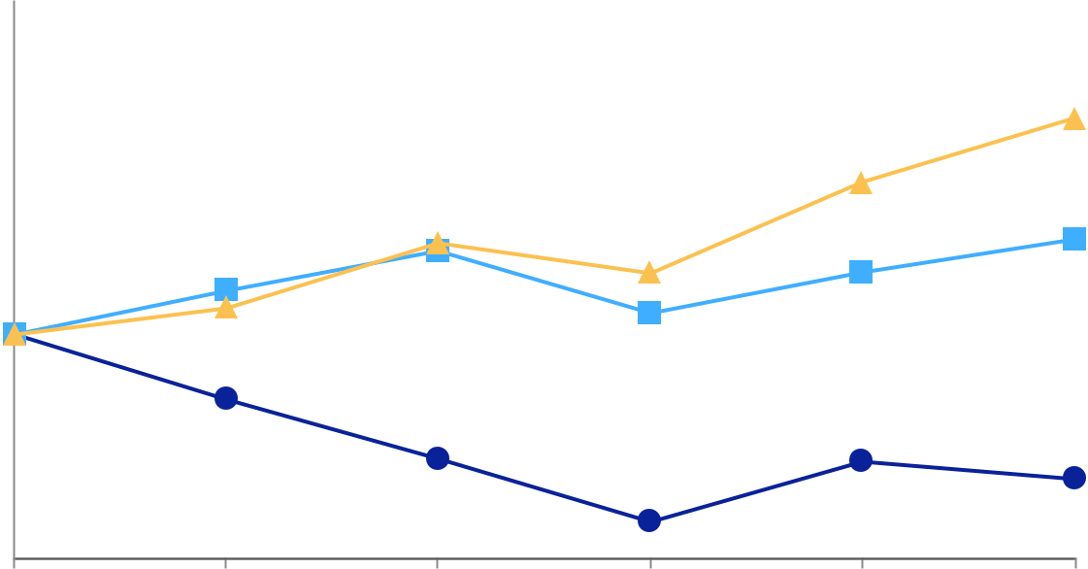

200

150

100

50

0

2019 | 2020 |  |  |  |  | 2021 |  |  |  |  |  |  |  | 2022 |  |  | 2023 |  |  |  | 2024
 |  | NN, Inc. |  |  | Russell 2000 |  |  |  |  |  |  | S&P SmallCap 600 Industrials
 |  |  |  |  | 2019 |  |  |  | 2020 |  |  |  |  | 2021 |  |  | 2022 |  |  | 2023 |  |  | 2024
NN, Inc. |  |  |  | $ | 100.00 | $ |  |  | 71.02 |  | $ |  |  | 44.31 | $ |  | 16.21 | $ |  | 43.22 | $ |  | 35.33
Russell 2000 |  |  |  | $ | 100.00 | $ |  |  | 119.96 |  | $ |  |  | 137.74 | $ |  | 109.59 | $ |  | 128.14 | $ |  | 142.93
S&P SmallCap 600 Industrials |  |  |  | $ | 100.00 | $ |  |  | 111.97 |  | $ |  |  | 140.98 | $ |  | 127.72 | $ |  | 168.39 | $ |  | 197.28

Source: Zachs Investment Research, Inc.

The declaration and payment of dividends are subject to the sole discretion of our Board of Directors and depend upon our profitability, financial condition, capital needs, credit agreement restrictions, future prospects, and other factors deemed relevant by the Board of Directors.

See Part III, Item 12 – “Security Ownership of Certain Beneficial Owners and Management and Related Stockholder Matters” of this Annual Report for information required by Item 201(d) of Regulation S-K.

22

Issuer Purchases of Equity Securities

The following table provides information about purchases we made during the quarter ended December 31, 2024.

 |  |  |  |  |  |  | Total Number of |  | Maximum Number (or
 |  |  |  |  |  |  | Shares Purchased |  | Approximate Dollar Value)
 |  | Total Number of |  | Average Price Paid |  |  | as Part of Publicly |  | of Shares That May Yet
Period |  | Total Number of |  |  |  |  | Announced Plans |  | Be Purchased Under the
Period |  | Shares Purchased ⁽¹⁾ |  |  | Per Share |  | or Programs ⁽¹⁾ |  | Plan or Programs ⁽¹⁾
October 2024 | 3,689 |  | $ |  | 3.74 |  | — |  | —
November 2024 |  | — |  |  | — |  | — |  | —
December 2024 |  | 1,396 |  |  | 3.27 |  | — |  | —
Total | 5,085 |  | $ |  | 3.61 |  | — |  | —

_______________________________

- Shares were withheld to pay for tax obligations due upon the vesting of share-based awards held by employees granted under the NN, Inc. Amended and Restated 2022 Omnibus Incentive Plan and prior plans (collectively the “Incentive Plans”). The Incentive Plans provides for the withholding of shares or units to satisfy income tax obligations. It does not specify a maximum number of shares or units that can be withheld for this purpose. These shares may be deemed to be “issuer purchases” of shares that are required to be disclosed pursuant to this Item.

Item 6. Reserved

23

Item 7. Management’s Discussion and Analysis of Financial Condition and Results of Operations

The following discussion should be read in conjunction with, and is qualified in its entirety by, the Consolidated Financial Statements and the Notes thereto included elsewhere in this Annual Report. Historical operating results and percentage relationships among any amounts included in the Consolidated Financial Statements are not necessarily indicative of trends in operating results for any future period. Unless as otherwise noted indicated, all U.S. dollar amounts presented in tables are in thousands.

A detailed discussion of our results of operations and liquidity and capital resources for the year ended December 31, 2023 compared to the year ended December 31, 2022 are not included herein and can be found in Item 7. Management's Discussion and Analysis of Financial Condition and Results of Operations of our Annual Report on Form 10-K for the fiscal year ended December 31, 2023, filed with the SEC on March 12, 2024.

Overview and Management Focus

During 2024, the Company continued its enterprise transformation plan to grow sales, profits, free cash flow and shareholder value. The main tenets of the Company’s transformation plan are:

- Strengthening our team with new executive and functional leadership;

- Fixing unprofitable areas of the business;

- Advancing and strengthening profitability;

- Improving our balance sheet; and

- Accelerating sales growth.

We continue to execute our transformation plan through:

- Obtaining new business wins in targeted growth areas;

- Cost improvement plans and the rationalizing of our footprint;

- Improving underperforming plants;

- Achieving net cost-down through our continuous improvement program;

- Reduced leverage through improved operating performance and a strategic divestiture; and

- Lowering our cost of capital and improving our capital structure.

We are a strategic partner to a diversified and global customer base with long standing business relationships and long-running business streams. We participate in growing and attractive end markets, including global automotive parts and passenger vehicles, commercial vehicles, grid and electrical investment, and medical components.

Management generally focuses on these trends and relevant market indicators:

- Trends related to the geographic migration of competitive manufacturing, electric vehicles, and electrification;

- Costs subject to regional and global inflationary environments, including, but not limited to:

  - Raw materials;

  - Wages and benefits, including health care costs;

  - Regulatory compliance; and

  - Energy;

- Global automotive production rates;

- Global industrial growth and economics;

- Residential and non-residential construction rates;

- Regulatory environment for U.S. public companies and manufacturing companies;

- Currency and exchange rate movements and trends;

- Interest rate levels and expectations; and

- Changes in tariff regulations.

Results of Operations

Factors That May Influence Results of Operations

The following paragraphs describe factors that have influenced results of operations for the year ended December 31, 2024, that management believes are important to provide an understanding of the business and results of operations or that may influence operations in the future.

24

Macroeconomic Conditions

We continue to monitor the ongoing impacts of current macroeconomic and geopolitical events, including changing conditions from ongoing military conflicts, inflationary cost pressures, elevated interest rates, supply chain disruptions, and labor shortages and disruptions.

Ongoing military conflicts continue to create volatility in global financial and energy markets, creating energy and supply chain shortages, which has added to the inflationary pressures experienced by the global economy. We continue to actively work with our suppliers to minimize impacts of supply shortages on our manufacturing capabilities. Although our business has not been materially impacted by these ongoing military conflicts as of the date of this filing, we cannot reasonably predict the extent to which our operations, or those of our customers or suppliers, will be impacted in the future, or the ways in which the conflicts may impact our business, financial condition, results of operations and cash flows.

The U.S. economy has experienced inflationary increases and elevated interest rates, as well as supply issues in materials, services, and labor due to economic policy and military conflicts. We cannot predict the future impact on our end-markets or input costs nor our ability to recover cost increases through pricing.

Footprint Optimization

We have taken specific steps to consolidate our footprint by identifying less profitable end markets and focusing our strategic growth initiatives in markets where we believe we will be able to maximize profitability. During the second half of 2024, we identified two manufacturing facilities to close due to volume rationalization which will reduce costs and improve operational efficiency. In January 2025, we ceased production activities at our Mobile Solutions plant in Juarez, Mexico. We plan to stop production activity at our Mobile Solutions plant in Dowagiac, Michigan by the end of the first quarter of 2025. Additionally, we continue to evaluate our global footprint, which may result in further consolidation actions to further improve our overall cost structure.

Sales Concentration

During the years ended December 31, 2024, 2023 and 2022, no single customer accounted for 10% or more of consolidated net sales.

Financial Data as a Percentage of Net Sales

The following table presents the percentage of our net sales represented by statement of operations line item.

 | Years Ended December 31,
 | 2024 |  | 2023 |  |  | 2022
Net sales | 100.0 % | 100.0 % |  |  |  | 100.0 %
Cost of sales (exclusive of depreciation and amortization shown separately
below) | 85.0 % | 85.7 % |  |  |  | 84.4 %
Selling, general, and administrative expense | 10.7 % | 9.7 % |  |  |  | 10.0 %
Depreciation and amortization | 9.8 % | 9.4 % |  |  |  | 9.5 %
Other operating expense (income), net | 0.5 % |  | (0.3)% |  |  | 0.4 %
Loss from operations | (5.9)% | (4.5)% |  |  |  | (4.2)%
Interest expense | 4.8 % | 4.3 % |  |  |  | 3.0 %
Loss on extinguishment of debt | 0.1 % |  | — % |  |  | — %
Other expense (income), net | (1.0)% |  | 2.2 % |  |  | (1.0)%
Loss before provision for income taxes and share of net income from joint | (9.8)% | (11.0)% |  |  |  | (6.2)%
venture | (9.8)% |  |  |  |  | (6.2)%
Provision for income taxes | (0.5)% | (0.5)% |  |  |  | (0.3)%
Share of net income from joint venture | 2.1 % |  | 1.2 % |  |  | 1.3 %
Net loss | (8.2)% | (10.2)% |  |  |  | (5.2)%
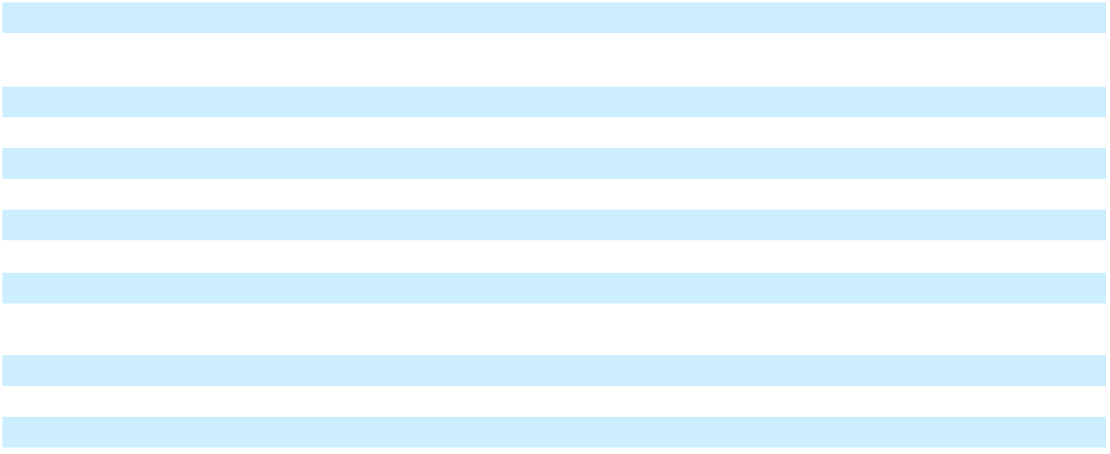

25

Year Ended December 31, 2024 compared to the Year Ended December 31, 2023

 |  | Years Ended December 31,
 |  | 2024 |  |  | 2023 |  |  | $ Change
Net sales | $ | 464,290 | $ |  | 489,270 | $ |  | (24,980)
Cost of sales (exclusive of depreciation and amortization shown separately
below) |  | 394,812 |  |  | 419,175 |  |  | (24,363)
Selling, general, and administrative expense |  | 49,481 |  |  | 47,436 |  |  | 2,045
Depreciation and amortization |  | 45,302 |  |  | 46,120 |  |  | (818)
Other operating expense (income), net |  | 2,243 |  |  | (1,657) |  |  | 3,900
Loss from operations |  | (27,548) |  |  | (21,804) |  |  | (5,744)
Interest expense |  | 22,095 |  |  | 21,137 |  |  | 958
Loss on extinguishment of debt |  | 349 |  |  | — |  |  | 349
Other expense (income), net |  | (4,558) |  |  | 10,730 |  |  | (15,288)
Loss before provision for income taxes and share of net income from joint
venture |  | (45,434) |  |  | (53,671) |  |  | 8,237
Provision for income taxes |  | (2,410) |  |  | (2,285) |  |  | (125)
Share of net income from joint venture |  | 9,571 |  |  | 5,806 |  |  | 3,765
Net loss | $ | (38,273) | $ |  | (50,150) | $ |  | 11,877
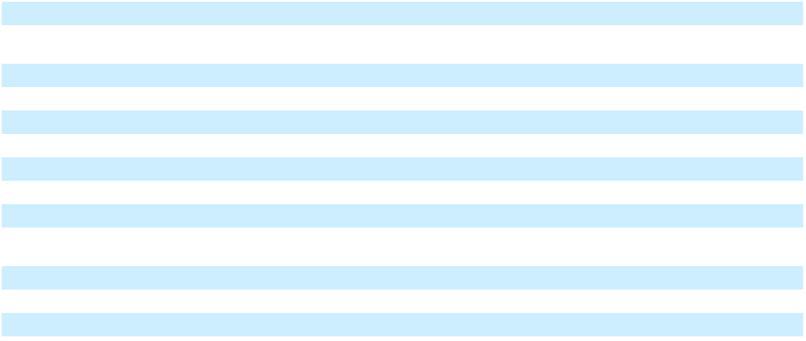

Net Sales. Net sales decreased by $25.0 million, or 5.1%, during the year ended December 31, 2024, compared to the year ended December 31, 2023, primarily due to the sale of our Lubbock operations, customer settlements received in 2023, rationalized volume at plants undergoing turnarounds and unfavorable foreign exchange effects of $3.5 million. These decreases were partially offset by the net impact of contractual pass-through material pricing provisions.

Cost of Sales. Cost of sales decreased by $24.4 million, or 5.8%, during the year ended December 31, 2024, compared to the year ended December 31, 2023, primarily due to lower sales volume and lower labor costs associated with facility closures.

Selling, General, and Administrative Expense. Selling, general, and administrative expense increased by $2.0 million during the year ended December 31, 2024, compared to the year ended December 31, 2023, primarily due to higher travel, stock compensation and severance expense, partially offset by lower salaries due to a reduction in headcount.

Other Operating Expense (Income), Net. Other operating expense (income), net changed unfavorably by $3.9 million primarily due to the impairment of machinery and equipment at a plant that will close in 2025, partially offset by increased sublease income earned on closed facilities and gains on sale of property, plant and equipment.

Interest Expense. Interest expense increased by $1.0 million during the year ended December 31, 2024, compared to the year ended December 31, 2023, primarily due to a decrease in the gain recognized on interest rate swap and an increase in the amortization of debt issuance costs. These were partially offset by lower interest rates and lower outstanding balances.

 |  | Years Ended December 31,
 |  | 2024 |  |  | 2023
Interest on debt | $ | 21,320 | $ |  | 21,638
Gain recognized on interest rate swap |  | (1,048) |  |  | (1,815)
Amortization of debt issuance costs and discount |  | 2,288 |  |  | 1,941
Capitalized interest |  | (1,191) |  |  | (1,330)
Other |  | 726 |  |  | 703
Total interest expense | $ | 22,095 | $ |  | 21,137
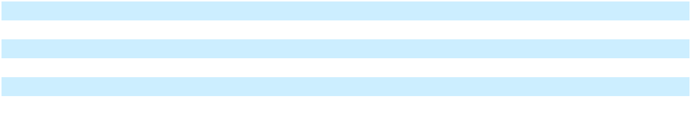

Other Expense (Income), Net. Other expense (income), net changed favorably by $15.3 million during the year ended December 31, 2024, compared to the year ended December 31, 2023, primarily due to the $7.2 million gain on sale of the Lubbock operations and a $10.8 million decrease in noncash derivative mark-to-market losses, partially offset by unfavorable foreign exchange effects associated with intercompany borrowings.

Provision for Income Taxes. Our effective tax rate was (5.3)% for the year ended December 31, 2024, compared to (4.3)% for the year ended December 31, 2023. Our effective tax rate for the years ended December 31, 2024 and 2023 were unfavorably impacted by the accrual of tax on non-permanently reinvested unremitted earnings of foreign subsidiaries and by the limitation on the amount of tax benefit recorded for loss carryforwards in certain jurisdictions where we believe it is more likely than not that a portion of the future tax benefit may not be realized. The effective tax rate for the years ended December 31, 2024 and

26

2023 were favorably impacted by the recording of interest income on the Company’s federal income tax refund requested as a result of the Coronavirus Aid, Relief, and Economic Security Act, as well as the recording of a benefit of a state refund claim.

Share of Net Income from Joint Venture. Share of net income from the joint venture increased by $3.8 million during the year ended December 31, 2024, compared to the year ended December 31, 2023, primarily due to higher sales and increased margin partially offset by higher fixed costs, depreciation and income taxes. The joint venture, in which we own a 49% investment, recognized net sales of $130.8 million and $109.6 million for the years ended December 31, 2024 and 2023, respectively.

Results by Segment

MOBILE SOLUTIONS

 |  | Year Ended December 31,
 |  | 2024 |  |  | 2023 |  |  | $ Change
Net sales | $ | 283,944 | $ |  | 303,335 | $ |  | (19,391)
Loss from operations | $ | (18,078) | $ |  | (11,749) | $ |  | (6,329)

Net sales decreased by $19.4 million, or 6.4%, during the year ended December 31, 2024, compared to the year ended December 31, 2023, primarily due rationalized volume at plants undergoing turnarounds, contractual reduction in customer pass-through material pricing, a customer settlement received in 2023 and unfavorable foreign exchange effects of $3.3 million.

Loss from operations changed unfavorably by $6.3 million during the year ended December 31, 2024 compared to the prior year, primarily due to the impairment of machinery and equipment at a plant that will close in 2025. The change was also impacted by higher depreciation expense and selling, general and administrative costs.

POWER SOLUTIONS

 |  | Year Ended December 31,
 |  | 2024 |  |  | 2023 |  |  | $ Change
Net sales | $ | 180,545 | $ |  | 185,948 | $ |  | (5,403)
Income from operations | $ | 13,111 | $ |  | 11,096 | $ |  | 2,015

Net sales decreased by $5.4 million, or 2.9%, during the year ended December 31, 2024, compared to the year ended December 31, 2023, primarily due to the sale of our Lubbock operations, premium pricing received on a certain customer project during the first quarter of 2023 and unfavorable foreign exchange effects of $0.2 million. These decreases were partially offset by higher precious metals pass-through pricing.

Income from operations increased by $2.0 million during the year ended December 31, 2024 compared to the same period in the prior year, primarily due to an increase in sublease income earned on closed facilities and lower depreciation and amortization expense due to sold or fully utilized assets.

Changes in Financial Condition from December 31, 2023 to December 31, 2024 Overview
From December 31, 2023 to December 31, 2024, total assets decreased by $54.0 million primarily due to decreases in property, plant and equipment and intangible assets due to depreciation and amortization as well as the impairment of machinery and equipment at a plant that will close in 2025. Additionally, accounts receivable, inventory and property, plant and equipment decreased due to the sale of our Lubbock operations during the year. These decreases were partially offset by increases in our investment in a joint venture.

From December 31, 2023 to December 31, 2024, total liabilities decreased by $19.2 million, primarily due to a decrease in accounts payable, a decrease in other non-current liabilities due to the exercise of warrants in 2024 and a reduction in long-term debt due to the partial pay down of the outstanding balance with proceeds from the sale of our Lubbock operations. These decreases were partially offset by an increase in accrued salaries, wages and benefits.

Working capital, which consists of current assets less current liabilities, was $83.7 million as of December 31, 2024, compared to $100.9 million as of December 31, 2023. The decrease in working capital was primarily due to decreases in accounts receivable and inventory, and an increase in accrued salaries, wages and benefits. These were partially offset by a decrease in accounts payable.

Cash Flows

Cash provided by operations was $11.1 million for the year ended December 31, 2024, compared with $29.3 million for the year ended December 31, 2023. The decline was due to decreases in accounts receivable and inventory during 2023 compared

27

with a decrease in accounts payable during 2024. These declines were partially offset by a larger dividend received from the JV in 2024.

Cash used in investing activities was $1.0 million for the year ended December 31, 2024, compared with cash used in investing activities of $17.6 million for the year ended December 31, 2023. The favorable change is primarily due to the $17.0 million received for the sale of the Lubbock operations during 2024.

Cash used in financing activities increased by $10.4 million during the year ended December 31, 2024 compared to the same period in 2023, primarily due to higher repayments of long-term debt and debt issuance costs in 2024, partially offset by proceeds from the sale-leaseback transactions in 2024 and proceeds from international loans in 2023.

Liquidity and Capital Resources

Credit Facilities

The principal amount outstanding under our Term Loan Facility as of December 31, 2024, was $114.4 million, without regard to unamortized debt issuance costs and discount. As of December 31, 2024, we had $5.4 million outstanding borrowings under the ABL Facility and $15.0 million available for future borrowings under the ABL Facility. This amount of borrowing capacity is net of $10.4 million of outstanding letters of credit at December 31, 2024, which are considered as usage of the ABL Facility.

The Term Loan Facility requires quarterly principal payments of $0.4 million with the remaining unpaid principal amount due on the final maturity date of September 22, 2026. We may be required to make additional principal payments annually that are calculated as a percentage of our excess cash flow, as defined by the lender, based on our net leverage ratio. Outstanding borrowings under the Term Loan Facility bear interest at either: 1) one-month, three-month, or six-month Adjusted Term SOFR, subject to a 1.00% floor, plus an applicable margin of 6.875%; or 2) the greater of various benchmark rates plus an applicable margin of 5.875%. Beginning with the second quarter of 2023, interest was increased on a paid-in-kind basis at a rate between 1.00% and 2.00%, dependent on our net leverage ratio, for the most recently reported fiscal quarter and subject to reduction upon the occurrence of certain conditions as set forth in the credit agreement governing the Term Loan Facility. Based on the interest rate in effect at December 31, 2024, annual cash interest payments would be approximately $13.0 million, with an additional $1.1 million accrued as paid-in-kind interest.

The ABL Facility bears interest on a variable borrowing rate based on either: 1) the one, three or six month SOFR plus 1.50%, plus an adjustment of 0.10% (“Term SOFR Rate”); or 2) the highest of the base commercial lending rate of the lender or various benchmark rates plus an applicable margin of 0.50% or 1.0%, depending on the benchmark. We pay a commitment fee of 0.25% for unused capacity under the ABL Facility.

We were in compliance with all requirements under our Term Loan Facility and ABL Facility as of December 31, 2024. Both credit facilities allow for optional expansion of available borrowings, subject to certain terms and conditions.

Sale Leaseback Transactions

During the year ended December 31, 2024, we entered into several sale-leaseback transactions. We received $16.9 million from the sale and leaseback of three properties, with the net proceeds used to repay a portion of the outstanding borrowings under the Term Loan Facility. The effective interest rate of 9.715% on this transaction, which terminates in 2044, was lower than the borrowings on the Term Loan Facility. In addition, we received $8.3 million from the sale and leaseback of equipment, with $3.4 million of the net proceeds used to repay a portion of the outstanding borrowings under the Term Loan Facility and the balance used for ongoing operational investments

Accounts Receivable Sales Programs

We participate in programs established by our customers which allows us to sell certain receivables from that customer on a non-recourse basis to a third-party financial institution. In exchange, we receive payment on the receivables, less a discount, sooner than under the customary credit terms we have extended to that customer. These programs allow us to improve working capital and cash flows at the same or lower interest rates as available on our ABL Facility. Our access to these programs is dependent on our customers ongoing agreements with the third-parties. Our participation in these programs is based on our specific cash needs throughout the year, the discount charged to receive payment earlier, the length of the payment terms with our customers, as well being subject to limits in our ABL Facility and Term Loan Facility agreements.

Other Receivables

In 2021, we filed a refund claim with the IRS as a result of the Coronavirus Aid, Relief, and Economic Security Act. Including interest accrued on the initial refund amount, we have a $12.3 million tax refund receivable at December 31, 2024, which is in the process of IRS review. The timing of the receipt of the refund is expected in the first half of 2025.

28

Functional Currencies

We currently have foreign operations in Brazil, China, France, Mexico, and Poland. The local currency of each foreign facility is also its functional currency.

Seasonality and Fluctuation in Quarterly Results

General economic conditions impact our business and financial results, and certain businesses experience seasonal and other trends related to the industries and end markets that they serve. For example, European sales are often weaker in the summer months as customers slow production and sales to original equipment manufacturers are often stronger immediately preceding and following the launch of new products. However, as a whole, we are not materially impacted by seasonality.

Critical Accounting Estimates

Our significant accounting policies, including the assumptions and judgment underlying them, are disclosed in Note 1 of the Notes to Consolidated Financial Statements. As disclosed in Note 1, the preparation of financial statements in conformity with generally accepted accounting principles requires management to make estimates and assumptions about future events that affect the amounts reported in the financial statements and accompanying notes. Actual results could differ significantly from those estimates. We believe that the following discussion addresses our most critical accounting estimates, which are those that are most important to the portrayal of our financial condition and results of operations and require management’s most difficult, subjective, and complex judgments.

Income Taxes

Income taxes are accounted for under the asset and liability method. Deferred tax assets and liabilities are recognized for the future tax consequences attributable to differences between the consolidated financial statement carrying amounts of existing assets and liabilities and their respective tax bases and operating loss and tax credit carryforwards. Deferred tax assets and liabilities are measured using enacted tax rates expected to apply to taxable income in the years in which those temporary differences are expected to be recovered or settled. The effect on deferred tax assets and liabilities of a change in tax rates is recognized in income in the period that includes the enactment date. Valuation allowances are recorded to reduce deferred tax assets when it is more likely than not that a tax benefit will not be realized. Provision has been made for income taxes on unremitted earnings of certain foreign subsidiaries as these earnings are not deemed to be permanently reinvested. We recognize income tax positions that meet the more likely than not threshold and accrue interest and potential penalties related to unrecognized income tax positions which are recorded as a component of the provision (benefit) for income taxes. We eliminate disproportionate tax effects from accumulated other comprehensive income (loss) when the circumstances upon which they are premised cease to exist.

The calculation of tax assets, liabilities, and expenses under U.S. GAAP is largely dependent on management judgment of the current and future deductibility and utilization of taxable expenses and benefits using a more likely than not threshold. Specifically, the realization of deferred tax assets and the certainty of tax positions taken are largely dependent upon management weighting the current positive and negative evidence for recording tax benefits and expenses. A significant piece of objective negative evidence evaluated is cumulative losses incurred over the three-year period ended December 31, 2024. Such objective evidence limits the ability to consider other subjective evidence, such as our projections for future earnings growth. We have recorded a U.S. deferred tax liability for foreign earnings which are not indefinitely reinvested. We treat global intangible low-taxed income (“GILTI”) as a periodic charge in the year in which it arises and therefore do not record deferred taxes for basis differences associated with GILTI.

In the event that the actual outcome from future tax consequences differs from management estimates and assumptions or management plans and positions are amended, the resulting change to the provision for income taxes could have a material impact on the consolidated results of operations and financial position.

Impairment of Long-Lived Assets

Long-lived tangible and intangible assets subject to depreciation or amortization are tested for recoverability when changes in circumstances indicate the carrying value of these assets may not be recoverable. A test for recoverability is also performed when management has committed to a plan to dispose of a reporting unit or asset group. Assets to be held and used are tested for recoverability when indications of impairment are evident. Recoverability of a long-lived tangible or intangible asset is evaluated by comparing its carrying value to the future estimated undiscounted cash flows expected to be generated by the asset or asset group. If the asset is deemed not recoverable, then the asset is considered impaired and adjusted to fair value which is then depreciated or amortized over its remaining useful life. Assets to be disposed of are recorded at the lesser of carrying value or fair value less costs of disposal. In assessing potential impairment for long-lived assets, we consider forecasted financial performance based, in large part, on management business plans and projected financial information which are subject to a high degree of management judgment and complexity. Future adverse changes in market conditions or adverse operating results of the underlying assets could result in having to record additional impairment charges not previously recognized.

29

Item 7A. Quantitative and Qualitative Disclosures About Market Risk

We are exposed to changes in financial market conditions in the normal course of business due to use of certain financial instruments as well as transacting business in various foreign currencies. To mitigate the exposure to these market risks, we have established policies, procedures, and internal processes governing the management of financial market risks. We are exposed to changes in interest rates primarily as a result of borrowing activities.

Interest Rate Risk

We are subject to interest rate risk due to our variable rate debt, which comprises a majority of our outstanding indebtedness. The nature and amount of borrowings may vary as a result of future business requirements, market conditions, and other factors. To manage interest rate risk, we have used, and may in the future use, interest rate swap agreements.

At December 31, 2024, we had $114.4 million of principal outstanding under the Term Loan Facility without regard to capitalized debt issuance costs. A one-percent increase in one-month SOFR would have resulted in a net increase in interest expense of $1.1 million on an annualized basis.

At December 31, 2024, based on a one-month Term SOFR Rate, the interest rate on outstanding borrowings under the ABL Facility was 5.94%.

Foreign Currency Risk

Translation of our operating cash flows denominated in foreign currencies is impacted by changes in foreign exchange rates. We invoice and receive payment from many of our customers in various other currencies. Additionally, we are party to third party and intercompany loans, payables, and receivables denominated in currencies other than the U.S. dollar. To help reduce exposure to foreign currency fluctuation, we have incurred debt in euros in the past. Various strategies to manage this risk are available to management, including producing and selling in local currencies and hedging programs. We did not hold a position in any foreign currency derivatives as of December 31, 2024.

30

Item 8. Financial Statements and Supplementary Data

Index to Financial Statements

Page

Reports of Independent Registered Public Accounting Firm (PCAOB ID: 248) . . . . . . . . . . . . . . . . . . . . . . . . . . . . . . . . . 32

Consolidated Statements of Operations and Comprehensive Income (Loss) . . . . . . . . . . . . . . . . . . . . . . . . . . . . . . . . . . . . 34

Consolidated Balance Sheets . . . . . . . . . . . . . . . . . . . . . . . . . . . . . . . . . . . . . . . . . . . . . . . . . . . . . . . . . . . . . . . . . . . . . . . . . 35

Consolidated Statements of Cash Flows . . . . . . . . . . . . . . . . . . . . . . . . . . . . . . . . . . . . . . . . . . . . . . . . . . . . . . . . . . . . . . . . 36

Consolidated Statements of Changes in Stockholders’ Equity . . . . . . . . . . . . . . . . . . . . . . . . . . . . . . . . . . . . . . . . . . . . . . . 38

Notes to Consolidated Financial Statements . . . . . . . . . . . . . . . . . . . . . . . . . . . . . . . . . . . . . . . . . . . . . . . . . . . . . . . . . . . . . 39

Note 1. Significant Accounting Policies . . . . . . . . . . . . . . . . . . . . . . . . . . . . . . . . . . . . . . . . . . . . . . . . . . . . . . . . . . . . . . 39

Note 2. Segment Information . . . . . . . . . . . . . . . . . . . . . . . . . . . . . . . . . . . . . . . . . . . . . . . . . . . . . . . . . . . . . . . . . . . . . . 42

Note 3. Revenue from Contracts with Customers . . . . . . . . . . . . . . . . . . . . . . . . . . . . . . . . . . . . . . . . . . . . . . . . . . . . . . . 45

Note 4. Accounts Receivable . . . . . . . . . . . . . . . . . . . . . . . . . . . . . . . . . . . . . . . . . . . . . . . . . . . . . . . . . . . . . . . . . . . . . . . 46

Note 5. Inventories . . . . . . . . . . . . . . . . . . . . . . . . . . . . . . . . . . . . . . . . . . . . . . . . . . . . . . . . . . . . . . . . . . . . . . . . . . . . . . 46

Note 6. Property, Plant and Equipment . . . . . . . . . . . . . . . . . . . . . . . . . . . . . . . . . . . . . . . . . . . . . . . . . . . . . . . . . . . . . . . 47

Note 7. Intangible Assets . . . . . . . . . . . . . . . . . . . . . . . . . . . . . . . . . . . . . . . . . . . . . . . . . . . . . . . . . . . . . . . . . . . . . . . . . . 47

Note 8. Investment in Joint Venture . . . . . . . . . . . . . . . . . . . . . . . . . . . . . . . . . . . . . . . . . . . . . . . . . . . . . . . . . . . . . . . . . 48

Note 9. Debt . . . . . . . . . . . . . . . . . . . . . . . . . . . . . . . . . . . . . . . . . . . . . . . . . . . . . . . . . . . . . . . . . . . . . . . . . . . . . . . . . . . . 48

Note 10. Preferred Stock . . . . . . . . . . . . . . . . . . . . . . . . . . . . . . . . . . . . . . . . . . . . . . . . . . . . . . . . . . . . . . . . . . . . . . . . . . 50

Note 11. Leases . . . . . . . . . . . . . . . . . . . . . . . . . . . . . . . . . . . . . . . . . . . . . . . . . . . . . . . . . . . . . . . . . . . . . . . . . . . . . . . . . 51

Note 12. Commitments and Contingencies . . . . . . . . . . . . . . . . . . . . . . . . . . . . . . . . . . . . . . . . . . . . . . . . . . . . . . . . . . . . 52

Note 13. Income Taxes . . . . . . . . . . . . . . . . . . . . . . . . . . . . . . . . . . . . . . . . . . . . . . . . . . . . . . . . . . . . . . . . . . . . . . . . . . . 53

Note 14. Net Income (Loss) Per Common Share . . . . . . . . . . . . . . . . . . . . . . . . . . . . . . . . . . . . . . . . . . . . . . . . . . . . . . . 56

Note 15. Share-Based Compensation . . . . . . . . . . . . . . . . . . . . . . . . . . . . . . . . . . . . . . . . . . . . . . . . . . . . . . . . . . . . . . . . 56

Note 16. Accumulated Other Comprehensive Income . . . . . . . . . . . . . . . . . . . . . . . . . . . . . . . . . . . . . . . . . . . . . . . . . . . 58

Note 17. Fair Value Measurements . . . . . . . . . . . . . . . . . . . . . . . . . . . . . . . . . . . . . . . . . . . . . . . . . . . . . . . . . . . . . . . . . . 58

Note 18. Divestiture . . . . . . . . . . . . . . . . . . . . . . . . . . . . . . . . . . . . . . . . . . . . . . . . . . . . . . . . . . . . . . . . . . . . . . . . . . . . . . 60

Note 19. Plant Optimization Activities . . . . . . . . . . . . . . . . . . . . . . . . . . . . . . . . . . . . . . . . . . . . . . . . . . . . . . . . . . . . . . . 60

31

REPORT OF INDEPENDENT REGISTERED PUBLIC ACCOUNTING FIRM

Board of Directors and Stockholders

NN, Inc.

Opinion on internal control over financial reporting

We have audited the internal control over financial reporting of NN, Inc. (a Delaware corporation) and subsidiaries (the “Company”) as of December 31, 2024, based on criteria established in the 2013 Internal Control—Integrated Framework issued by the Committee of Sponsoring Organizations of the Treadway Commission (“COSO”). In our opinion, the Company maintained, in all material respects, effective internal control over financial reporting as of December 31, 2024, based on criteria established in the 2013 Internal Control—Integrated Framework issued by COSO.

We also have audited, in accordance with the standards of the Public Company Accounting Oversight Board (United States) (“PCAOB”), the consolidated financial statements of the Company as of and for the year ended December 31, 2024, and our report dated March 5, 2025 expressed an unqualified opinion on those financial statements.

Basis for opinion

The Company’s management is responsible for maintaining effective internal control over financial reporting and for its assessment of the effectiveness of internal control over financial reporting, included in the accompanying Management’s Report on Internal Control Over Financial Reporting. Our responsibility is to express an opinion on the Company’s internal control over financial reporting based on our audit. We are a public accounting firm registered with the PCAOB and are required to be independent with respect to the Company in accordance with the U.S. federal securities laws and the applicable rules and regulations of the Securities and Exchange Commission and the PCAOB.

We conducted our audit in accordance with the standards of the PCAOB. Those standards require that we plan and perform the audit to obtain reasonable assurance about whether effective internal control over financial reporting was maintained in all material respects. Our audit included obtaining an understanding of internal control over financial reporting, assessing the risk that a material weakness exists, testing and evaluating the design and operating effectiveness of internal control based on the assessed risk, and performing such other procedures as we considered necessary in the circumstances. We believe that our audit provides a reasonable basis for our opinion.

Definition and limitations of internal control over financial reporting

A company’s internal control over financial reporting is a process designed to provide reasonable assurance regarding the reliability of financial reporting and the preparation of financial statements for external purposes in accordance with generally accepted accounting principles. A company’s internal control over financial reporting includes those policies and procedures that (1) pertain to the maintenance of records that, in reasonable detail, accurately and fairly reflect the transactions and dispositions of the assets of the company; (2) provide reasonable assurance that transactions are recorded as necessary to permit preparation of financial statements in accordance with generally accepted accounting principles, and that receipts and expenditures of the company are being made only in accordance with authorizations of management and directors of the company; and (3) provide reasonable assurance regarding prevention or timely detection of unauthorized acquisition, use, or disposition of the company’s assets that could have a material effect on the financial statements.

Because of its inherent limitations, internal control over financial reporting may not prevent or detect misstatements. Also, projections of any evaluation of effectiveness to future periods are subject to the risk that controls may become inadequate because of changes in conditions, or that the degree of compliance with the policies or procedures may deteriorate.

/s/ GRANT THORNTON LLP

Charlotte, North Carolina

March 5, 2025

32

REPORT OF INDEPENDENT REGISTERED PUBLIC ACCOUNTING FIRM

Board of Directors and Stockholders

NN, Inc.

Opinion on the financial statements

We have audited the accompanying consolidated balance sheets of NN, Inc. (a Delaware corporation) and subsidiaries (the “Company”) as of December 31, 2024 and 2023, the related consolidated statements of operations and comprehensive income (loss), changes in stockholders’ equity, and cash flows for each of the three years in the period ended December 31, 2024, and the related notes (collectively referred to as the “consolidated financial statements”). In our opinion, the consolidated financial statements present fairly, in all material respects, the financial position of the Company as of December 31, 2024 and 2023, and the results of its operations and its cash flows for each of the three years in the period ended December 31, 2024, in conformity with accounting principles generally accepted in the United States of America.

We also have audited, in accordance with the standards of the Public Company Accounting Oversight Board (United States) (“PCAOB”), the Company’s internal control over financial reporting as of December 31, 2024, based on criteria established in the 2013 Internal Control—Integrated Framework issued by the Committee of Sponsoring Organizations of the Treadway Commission (“COSO”), and our report dated March 5, 2025 expressed an unqualified opinion.

Basis for opinion

These consolidated financial statements are the responsibility of the Company’s management. Our responsibility is to express an opinion on the Company’s consolidated financial statements based on our audits. We are a public accounting firm registered with the PCAOB and are required to be independent with respect to the Company in accordance with the U.S. federal securities laws and the applicable rules and regulations of the Securities and Exchange Commission and the PCAOB.

We conducted our audits in accordance with the standards of the PCAOB. Those standards require that we plan and perform the audit to obtain reasonable assurance about whether the financial statements are free of material misstatement, whether due to error or fraud. Our audits included performing procedures to assess the risks of material misstatement of the financial statements, whether due to error or fraud, and performing procedures that respond to those risks. Such procedures included examining, on a test basis, evidence regarding the amounts and disclosures in the financial statements. Our audits also included evaluating the accounting principles used and significant estimates made by management, as well as evaluating the overall presentation of the financial statements. We believe that our audits provide a reasonable basis for our opinion.

Critical audit matters

Critical audit matters are matters arising from the current period audit of the financial statements that were communicated or required to be communicated to the audit committee and that: (1) relate to accounts or disclosures that are material to the financial statements and (2) involved our especially challenging, subjective, or complex judgments. We determined that there are no critical audit matters.

/s/ GRANT THORNTON LLP

We have served as the Company’s auditor since 2020.

Charlotte, North Carolina

March 5, 2025

33

NN, Inc.

Consolidated Statements of Operations and Comprehensive Income (Loss)

 |  | Years Ended December 31,
(in thousands, except per share data) |  | 2024 |  |  | 2023 |  |  | 2022
Net sales | $ | 464,290 | $ |  | 489,270 | $ |  | 498,738
Cost of sales (exclusive of depreciation and amortization shown separately below) |  | 394,812 |  |  | 419,175 |  |  | 421,105
Selling, general, and administrative expense |  | 49,481 |  |  | 47,436 |  |  | 49,635
Depreciation and amortization |  | 45,302 |  |  | 46,120 |  |  | 47,231
Other operating expense (income), net |  | 2,243 |  |  | (1,657) |  |  | 1,859
Loss from operations |  | (27,548) |  |  | (21,804) |  |  | (21,092)
Interest expense |  | 22,095 |  |  | 21,137 |  |  | 15,041
Loss on extinguishment of debt |  | 349 |  |  | — |  |  | —
Other expense (income), net |  | (4,558) |  |  | 10,730 |  |  | (5,064)
Loss before provision for income taxes and share of net income from joint venture |  | (45,434) |  |  | (53,671) |  |  | (31,069)
Provision for income taxes |  | (2,410) |  |  | (2,285) |  |  | (1,621)
Share of net income from joint venture |  | 9,571 |  |  | 5,806 |  |  | 6,592
Net loss | $ | (38,273) | $ |  | (50,150) | $ |  | (26,098)
Other comprehensive loss:
Foreign currency translation gain (loss) | $ | (9,405) | $ |  | 1,410 | $ |  | (8,156)
Interest rate swap:
Change in fair value, net of tax |  | — |  |  | (230) |  |  | 3,358
Reclassification adjustments included in net loss, net of tax |  | (1,007) |  |  | (1,815) |  |  | (420)
Other comprehensive loss | $ | (10,412) |  | $ | (635) |  | $ | (5,218)
Comprehensive loss | $ | (48,685) |  | $ | (50,785) |  | $ | (31,316)
Basic and diluted net loss per common share
Basic and diluted net loss per common share | $ | (1.11) | $ |  | (1.35) | $ |  | (0.83)
Shares used to calculate basic and diluted net loss per share |  | 48,653 |  |  | 46,738 |  |  | 44,680
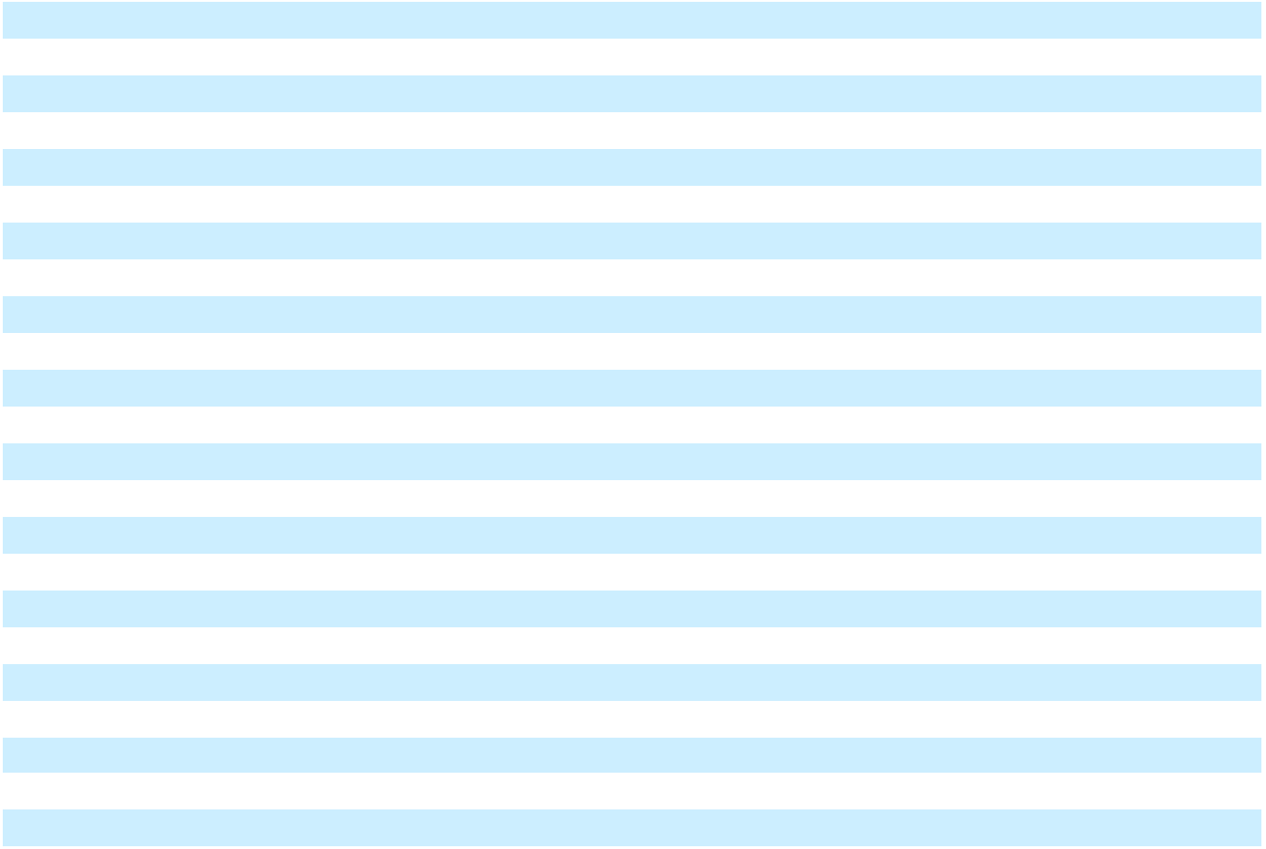

See Notes to Consolidated Financial Statements.

34

NN, Inc.

Consolidated Balance Sheets

 |  | December 31,
(in thousands, except per share data) |  | 2024 |  |  | 2023
Assets
Current assets:
Cash and cash equivalents | $ | 18,128 | $ |  | 21,903
Accounts receivable, net |  | 61,549 |  |  | 65,545
Inventories |  | 61,877 |  |  | 71,563
Income tax receivable |  | 12,634 |  |  | 11,885
Prepaid assets |  | 2,855 |  |  | 2,464
Other current assets |  | 10,519 |  |  | 9,194
Total current assets |  | 167,562 |  |  | 182,554
Property, plant and equipment, net |  | 162,034 |  |  | 185,812
Operating lease right-of-use assets |  | 39,317 |  |  | 43,357
Intangible assets, net |  | 44,410 |  |  | 58,724
Investment in joint venture |  | 34,971 |  |  | 32,701
Deferred tax assets |  | 1,329 |  |  | 734
Other non-current assets |  | 7,270 |  |  | 7,003
Total assets | $ | 456,893 | $ |  | 510,885
Liabilities, Preferred Stock, and Stockholders’ Equity
Current liabilities:
Accounts payable | $ | 38,879 | $ |  | 45,480
Accrued salaries, wages and benefits |  | 19,915 |  |  | 15,464
Income tax payable |  | 659 |  |  | 524
Short-term debt and current maturities of long-term debt |  | 5,039 |  |  | 3,910
Current portion of operating lease liabilities |  | 6,038 |  |  | 5,735
Other current liabilities |  | 13,382 |  |  | 10,506
Total current liabilities |  | 83,912 |  |  | 81,619
Deferred tax liabilities |  | 4,969 |  |  | 4,988
Long-term debt, net of current maturities |  | 143,591 |  |  | 149,369
Operating lease liabilities, net of current portion |  | 42,291 |  |  | 47,281
Other non-current liabilities |  | 14,111 |  |  | 24,827
Total liabilities |  | 288,874 |  |  | 308,084
Commitments and contingencies (Note 12)
Series D perpetual preferred stock - $0.01 par value per share, 65 shares authorized, issued
and outstanding at December 31, 2024 and 2023, respectively |  | 93,497 |  |  | 77,799
Stockholders’ equity:
Common stock - $0.01 par value per share, 90,000 shares authorized, 49,908 and 47,269
shares issued and outstanding at December 31, 2024 and 2023, respectively |  | 499 |  |  | 473
Additional paid-in capital |  | 455,811 |  |  | 457,632
Accumulated deficit |  | (333,621) |  |  | (295,348)
Accumulated other comprehensive loss |  | (48,167) |  |  | (37,755)
Total stockholders’ equity |  | 74,522 |  |  | 125,002
Total liabilities, preferred stock, and stockholders’ equity | $ | 456,893 | $ |  | 510,885


See Notes to Consolidated Financial Statements.

35

NN, Inc.

Consolidated Statements of Cash Flows

 |  | Years Ended December 31,
(in thousands) |  | 2024 |  |  | 2023 |  |  | 2022
Cash flows from operating activities
Net loss | $ | (38,273) | $ |  | (50,150) | $ |  | (26,098)
Adjustments to reconcile net loss to net cash provided by operating activities:
Depreciation and amortization |  | 45,302 |  |  | 46,120 |  |  | 47,231
Amortization of debt issuance costs and discount |  | 2,288 |  |  | 1,941 |  |  | 1,361
Paid-in-kind interest |  | 2,677 |  |  | 2,239 |  |  | —
Impairments of property, plant and equipment |  | 6,546 |  |  | — |  |  | —
Loss on extinguishment of debt |  | 349 |  |  | — |  |  | —
Total derivative loss (gain), net of cash settlements |  | (1,036) |  |  | 11,933 |  |  | (5,265)
Share of net income from joint venture, net of cash dividends received |  | (3,311) |  |  | (1,868) |  |  | (347)
Gain on sale of business |  | (7,154) |  |  | — |  |  | —
Share-based compensation expense |  | 3,140 |  |  | 2,821 |  |  | 4,377
Deferred income taxes |  | (690) |  |  | (1,273) |  |  | (1,814)
Other |  | (1,074) |  |  | (785) |  |  | (3,207)
Changes in operating assets and liabilities:
Accounts receivable |  | (2,839) |  |  | 9,087 |  |  | (4,920)
Inventories |  | 4,210 |  |  | 9,997 |  |  | (6,672)
Other operating assets |  | (1,558) |  |  | (5,041) |  |  | (1,825)
Income taxes receivable and payable, net |  | (662) |  |  | (89) |  |  | (1,457)
Accounts payable |  | (3,894) |  |  | 1,142 |  |  | 8,619
Other operating liabilities |  | 7,049 |  |  | 3,270 |  |  | (2,266)
Net cash provided by operating activities |  | 11,070 |  |  | 29,344 |  |  | 7,717
Cash flows from investing activities
Acquisition of property, plant and equipment |  | (18,314) |  |  | (20,496) |  |  | (17,952)
Proceeds from sale of property, plant, and equipment |  | 306 |  |  | 2,898 |  |  | 460
Proceeds received from sale of business |  | 17,000 |  |  | — |  |  | —
Net cash used in investing activities |  | (1,008) |  |  | (17,598) |  |  | (17,492)
Cash flows from financing activities
Proceeds from long-term debt |  | 63,400 |  |  | 61,000 |  |  | 46,000
Repayments of long-term debt |  | (96,031) |  |  | (65,395) |  |  | (47,958)
Cash paid for debt issuance costs |  | (2,011) |  |  | (169) |  |  | (136)
Proceeds from sale-leaseback of equipment |  | 8,324 |  |  | — |  |  | —
Proceeds from sale-leaseback of land and buildings |  | 16,863 |  |  | — |  |  | —
Repayments of financing obligations |  | (781) |  |  | — |  |  | —
Proceeds from short-term debt |  | — |  |  | 3,648 |  |  | —
Other |  | (3,009) |  |  | (1,967) |  |  | (3,092)
Net cash used in financing activities |  | (13,245) |  |  | (2,883) |  |  | (5,186)
Effect of exchange rate changes on cash flows |  | (592) |  |  | 232 |  |  | (887)
Net change in cash and cash equivalents |  | (3,775) |  |  | 9,095 |  |  | (15,848)
Cash and cash equivalents at beginning of year |  | 21,903 |  |  | 12,808 |  |  | 28,656
Cash and cash equivalents at end of year | $ | 18,128 | $ |  | 21,903 | $ |  | 12,808


See Notes to Consolidated Financial Statements.

36

NN, Inc.

Consolidated Statements of Cash Flows

(in thousands)
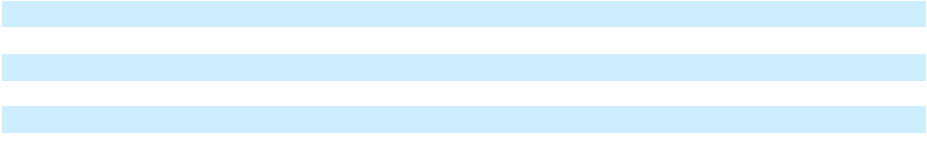

Supplemental schedule of non-cash investing activities:

Non-cash additions to property, plant and equipment Non-cash additions to debt issuance costs

Supplemental disclosures:

Cash paid for interest, net of capitalized interest Cash paid for income taxes

Years Ended December 31,

 | 2024 |  |  | 2023 |  |  | 2022
$ | 3,119 | $ |  | 2,743 | $ |  | 1,266
 | — |  |  | 2,712 |  |  | —

- 17,988 $ 15,272 $ 13,344

3,9063,0834,739

See Notes to Consolidated Financial Statements.

37

NN, Inc.

Consolidated Statements of Changes in Stockholders’ Equity

 | Common Stock |  |  |  |  |  |  |  |  | Accumulated
 |  |  |  |  | Additional |  |  |  |  |  | other
 | Number |  | Par |  | Additional |  | Accumulated |  |  |  | other
(in thousands) | Number |  | Par |  | paid-in |  |  |  |  | comprehensive |  |  |  | Total
(in thousands) | of shares |  | value |  | capital |  |  | deficit |  |  | loss |  |  | Total
Balance as of December 31, 2021 | 43,027 | $ 430 |  | $ 474,757 |  | $ |  | (219,100) | $ |  | (31,902) | $ |  | 224,185
Net loss | — |  | — |  | — |  |  | (26,098) |  |  | — |  |  | (26,098)
Dividends accrued for preferred stock | — |  | — | (10,894) |  |  |  |  |  |  | — |  |  | (10,894)
Shares issued under stock incentive plans, net of
forfeitures | 860 | 9 |  | (9) |  |  |  | — |  |  | — |  |  | —
Share-based compensation expense | — |  | — | 4,377 |  |  |  | — |  |  | — |  |  | 4,377
Restricted shares surrendered for tax withholdings
under stock incentive plans | (31) |  | — | (88) |  |  |  | — |  |  | — |  |  | (88)
Other comprehensive loss | — |  | — |  | — |  |  | — |  |  | (5,218) |  |  | (5,218)
Balance as of December 31, 2022 | 43,856 | $ 439 |  | $ 468,143 |  | $ |  | (245,198) | $ |  | (37,120) | $ |  | 186,264
Net loss | — |  | — |  | — |  |  | (50,150) |  |  | — |  |  | (50,150)
Dividends accrued for preferred stock | — |  | — | (13,098) |  |  |  | — |  |  | — |  |  | (13,098)
Shares issued under stock incentive plans, net of
forfeitures and tax withholdings | 3,561 | 36 |  | (57) |  |  |  | — |  |  | — |  |  | (21)
Share-based compensation expense | — |  | — | 2,821 |  |  |  | — |  |  | — |  |  | 2,821
Restricted shares surrendered for tax withholdings
under stock incentive plans | (148) | (2) |  | (177) |  |  |  | — |  |  | — |  |  | (179)
Other comprehensive loss | — |  | — |  | — |  |  | — |  |  | (635) |  |  | (635)
Balance as of December 31, 2023 | 47,269 | $ 473 |  | $ 457,632 |  | $ |  | (295,348) | $ |  | (37,755) | $ |  | 125,002
Net loss | — |  | — |  | — |  |  | (38,273) |  |  | — |  |  | (38,273)
Dividends accrued for preferred stock | — |  | — | (15,698) |  |  |  | — |  |  | — |  |  | (15,698)
Shares issued for warrants exercised | 2,395 | 24 |  | 11,352 |  |  |  |  |  |  |  |  |  | 11,376
Shares issued under stock incentive plans, net of
forfeitures | 401 | 4 |  | (4) |  |  |  | — |  |  | — |  |  | —
Share-based compensation expense | — |  | — | 3,140 |  |  |  | — |  |  | — |  |  | 3,140
Restricted shares surrendered for tax withholdings
under stock incentive plans | (157) | (2) |  | (611) |  |  |  | — |  |  | — |  |  | (613)
Other comprehensive loss | — |  | — |  | — |  |  | — |  |  | (10,412) |  |  | (10,412)
Balance as of December 31, 2024 | 49,908 | $ 499 |  | $ 455,811 |  | $ |  | (333,621) | $ |  | (48,167) | $ |  | 74,522
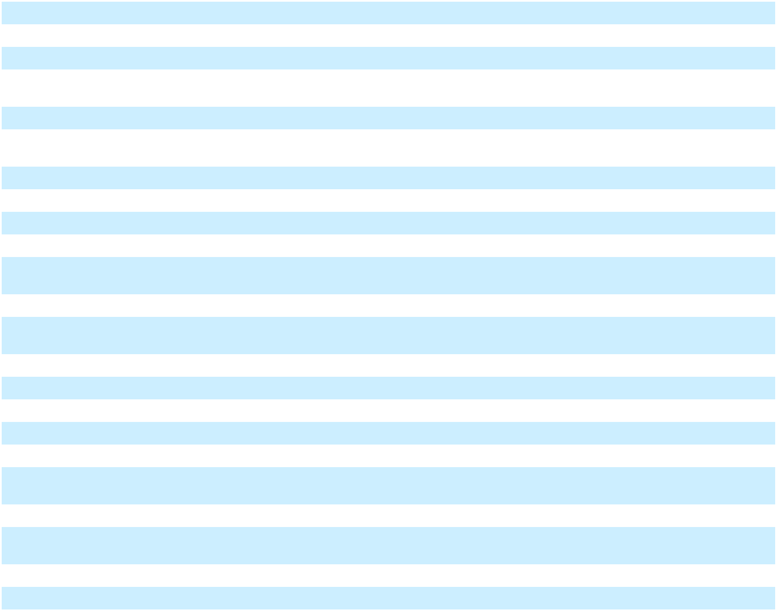

See Notes to Consolidated Financial Statements.

38

NN, Inc.

Notes to Consolidated Financial Statements

Note 1. Significant Accounting Policies

Nature of Business

NN, Inc., a Delaware corporation, is a diversified industrial company that combines advanced engineering and production capabilities with in-depth materials science expertise to design and manufacture high-precision components and assemblies for a variety of end markets on a global basis. As of December 31, 2024, we had 26 facilities in North America, South America, Europe, and China. As used in the Notes to Consolidated Financial Statements, the terms the “Company,” “we,” “our,” or “us” refer to NN, Inc. and its subsidiaries.

Basis of Presentation

The accompanying consolidated financial statements are prepared in accordance with accounting principles generally accepted in the United States (“U.S. GAAP”). Certain prior period amounts have been reclassified to conform to the current year’s presentation. Except for per share data or as otherwise indicated, all U.S. dollar amounts and share counts presented in the tables in these Notes to Consolidated Financial Statements are in thousands.

Principles of Consolidation

Our consolidated financial statements include the accounts of NN, Inc., and its wholly owned subsidiaries. We own a 49% investment in a joint venture (the “JV”) which we account for using the equity method (see Note 8). All intercompany transactions and balances have been eliminated in consolidation.

Use of Estimates in the Preparation of Consolidated Financial Statements

The preparation of consolidated financial statements in accordance with U.S. GAAP requires management to use estimates and assumptions that affect the reported amounts of certain assets and liabilities, disclosure of contingent assets and liabilities, and the reported amounts of revenues and expenses. Actual results may differ from those estimates.

Accounting Standards Recently Adopted

In November 2023, the Financial Accounting Standards Board (“FASB”) issued Accounting Standards Update 2023-07, Segment Reporting (Topic 832): Improvements to Reportable Segment Disclosures (“ASU 2023-07”), which requires additional disclosures related to reportable segments, including significant segment expenses and other segment items. ASU 2023-07 also permits entities to disclose more than one measure of a segment’s profit or loss and requires quarterly disclosure of certain information that is now only required annually. We have adopted ASU 2023-07 for the year ended December 31, 2024 on a retrospective basis, and will present the required interim disclosures beginning with our March 31, 2025 Form 10-Q.

Accounting Standards Not Yet Adopted

In December 2023, the FASB issued ASU 2023-09, “Income Taxes (Topic 740): Improvements to Income Tax Disclosures” (“ASU 2023-09”), which requires additional annual income tax disclosures. These include a tabular rate reconciliation comprised of eight specific categories, the disaggregation of income taxes paid between federal, state, and foreign jurisdictions, and to disaggregate income from continuing operations before income tax expense and income tax expense from continuing operations between domestic and foreign. ASU 2023-09 eliminates the disclosure of the nature and estimate of reasonably possible changes to unrecognized tax benefits in the next 12 months or that an estimated range cannot be made. ASU 2023-09 is effective for fiscal years beginning on or after December 15, 2024, with early adoption permitted, and can be applied on a prospective or retrospective basis. We plan to adopt ASU 2023-09 in our Form 10-K for the year ended December 31, 2025 and are in the process of assessing the impact on our disclosures.

In November 2024, the FASB issued ASU 2024-03, “Expense Disaggregation Disclosures (Subtopic 220-40): Disaggregation of Income Statement Expenses” (“ASU 2024-03”), which requires disaggregated disclosures of certain categories of expenses that are included in income statement line items. ASU 2024-03 is effective for fiscal years beginning on or after December 15, 2026, and interim periods within fiscal years beginning after December 15, 2027. Companies may early adopt and can apply the guidance prospectively or retrospectively. The Company has not yet determined the potential impact of adopting this standard.

Cash and Cash Equivalents

Cash and cash equivalents include cash and highly liquid investments with original maturities of three months or less. We maintain cash balances in transaction accounts with various financial institutions that are insured by the Federal Deposit Insurance Corporation. Although we maintain balances that exceed the federally insured limit, we have not experienced any losses related to these balances, and we believe credit risk to be minimal. We had $9.0 million and $13.5 million in cash and cash equivalents as of December 31, 2024 and 2023, respectively, held at foreign financial institutions.

39

Accounts Receivable and Allowance for Credit Losses

Trade accounts receivable are recorded at their net realizable value. We maintain allowances for estimated losses resulting from the inability of our customers to make required payments. The allowances are based on the amount that we ultimately expect to collect from our customers. We evaluate the collectability of accounts receivable based on a combination of factors including number of days receivables are past due, historical collection experience, current market conditions, and forecasted direction of economic and business environment. Accounts receivable are written off at the time a customer receivable is deemed uncollectible.

Inventories

Inventories are stated at the lower of cost or net realizable value. Cost is determined using standard costs, which approximates the average cost method. Our policy is to expense abnormal amounts of idle facility expense, freight, handling cost, and waste included in cost of products sold. In addition, we allocate fixed production overheads based on the normal production capacity of our facilities. Inventory valuations were developed using normalized production capacities for each of our manufacturing locations. The costs from excess capacity or under-utilization of fixed production overheads were expensed in the period incurred and are not included as a component of inventory.

Inventories also include tools, molds, and dies in progress that we are producing and will ultimately sell to our customers.

These inventories are also carried at the lower of cost or net realizable value.

Property, Plant and Equipment

Property, plant and equipment are stated at cost less accumulated depreciation. Assets to be disposed of are stated at the lower of depreciated cost or fair market value less estimated selling costs. Expenditures for maintenance and repairs are charged to expense as incurred. Major renewals and improvements are capitalized. When a property item is retired, its cost and related accumulated depreciation are removed from the property accounts and any gain or loss is recorded in the Consolidated Statements of Operations and Comprehensive Income (Loss). We review the carrying values of long-lived assets for impairment whenever events or changes in circumstances indicate the carrying amount of an asset may not be recoverable. Property, plant and equipment also includes tools, molds, and dies used in manufacturing.

Depreciation is calculated based on historical cost using the straight-line method over the estimated useful lives of the depreciable assets. Estimated useful lives for buildings and land improvements generally range from 10 years to 40 years. Estimated useful lives for machinery and equipment generally range from 3 years to 12 years.

Leases

We determine whether an arrangement is a lease at inception. Lease right-of-use (“ROU”) assets represent our right to use an underlying asset for the lease term, and lease liabilities represent our obligation to make lease payments arising from the lease. Lease ROU assets and liabilities are recognized at the lease commencement date based on the present value of lease payments over the lease term. When the implicit rate is not readily determinable, we use the estimated incremental borrowing rate based on the information available at the lease commencement date in determining the present value of lease payments. The lease terms may include options to extend or terminate the lease when it is reasonably certain that we will exercise that option. Amortization of lease ROU assets is recognized in expense on a straight-line basis over the lease term.

We recognize short-term leases, which have a term of twelve months or less, on a straight-line basis and do not record a related lease asset or liability for such leases. Finance lease ROU assets consist primarily of equipment used in the manufacturing process with terms of two years to eight years. Operating lease ROU assets consist of the following:

- Equipment used in the manufacturing process as well as office equipment with terms of five years; and

- Manufacturing plants and office facilities with terms of four years to 20 years.

We sublease certain leased buildings or portions of leased buildings when no longer needed for our current operational needs. Since we retain the obligation to the lessor, the underlying leases continue to be accounted for as operating leases. Sublease income is recognized on a straight-line basis over the lease term and is recognized in the “Other operating expense (income), net” line in the Consolidated Statements of Operations and Comprehensive Income (Loss).

Impairment of Long-Lived Assets

Long-lived tangible and intangible assets subject to depreciation or amortization are tested for recoverability when changes in circumstances indicate the carrying value of these assets, or asset groups, may not be recoverable. A test for recoverability is also performed when management has committed to a plan to dispose of a reporting unit or asset group. Recoverability of a long-lived tangible or intangible asset, or asset group, is evaluated by comparing its carrying value to the future estimated undiscounted cash flows expected to be generated by the asset or asset group. If the asset is deemed not recoverable, then the asset is considered impaired and adjusted to fair value which is then depreciated or amortized over its remaining useful life. Assets to be disposed of are recorded at the lesser of carrying value or fair value less costs of disposal.

40

Equity Method Investments

Our equity method investment is subject to a review for impairment if, and when, circumstances indicate that a decline in value below its carrying amount may have occurred. Examples of such circumstances include, but are not limited to, a significant deterioration in the earnings performance or business prospects of the investee; a significant adverse change in the regulatory, economic or technological environment of the investee; a significant adverse change in the general market condition of either the geographic area or the industry in which the investee operates; and recurring negative cash flows from operations. If management considers the decline to be other than temporary, we would write down the investment to its estimated fair market value.

Revenue Recognition

We generally transfer control and recognize revenue when we ship the product from our manufacturing facilities to our customer at a point in time, as this is when our customer obtains the ability to direct use of, and obtain substantially all of the remaining benefits from, the product. In limited circumstances, we recognize revenue over time as services are rendered. We have elected to recognize the cost for freight and shipping when control over products has transferred to the customer as a component of cost of sales.

We use an observable price to determine the stand-alone selling price for separate performance obligations or a cost-plus-margin approach when an observable price is not available. The expected duration of our contracts is one year or less, and we have elected to apply the practical expedient that allows entities to disregard the effects of financing when the contract length is less than one year. The amount of consideration we receive and the revenue we recognize varies with volume rebates and incentives we offer to our customers. We estimate the amount of variable consideration that should be included in the transaction price utilizing the expected value method or the most likely amount method depending on the nature of the variable consideration. Variable consideration is included in the transaction price if, in our judgment, it is probable that a significant future reversal of cumulative revenue under the contract will not occur.

We utilize the portfolio approach practical expedient to evaluate sales-related discounts on a portfolio basis to contracts with similar characteristics. The effect on our consolidated financial statements of applying the portfolio approach would not differ materially from evaluation of individual contracts.

We give our customers the right to return only defective products in exchange for functioning products or rework of the product. These transactions are evaluated and accounted for under ASC Topic 460, Guarantees, and we estimate the impact to the transaction price based on an analysis of historical experience.

Share Based Compensation

The cost of restricted stock awards, performance share units, and stock options is recognized as compensation expense over the vesting periods based on the grant date fair value, as determined under ASC Topic 718, Compensation – stock compensation. The grant-date fair value of restricted stock awards is based on the closing price of our common stock on the date of grant. We use a Monte Carlo simulation for performance share units that include a market condition. The grant-date fair value of performance share units that include performance conditions is based on the closing price of our common stock on the date of grant and compensation expense is recognized based on the estimated outcome of the performance condition. Stock options are valued using the Black Scholes financial pricing model.

Common Stock and Preferred Stock Dividends

Dividends are recorded as a reduction to retained earnings. When we have an accumulated deficit, dividends are recorded as a reduction of additional paid-in capital.

Foreign Currency Translation

Assets and liabilities of our foreign subsidiaries are translated at current exchange rates. Revenue, costs, and expenses are translated at average rates prevailing during each reporting period. Translation adjustments arising from the translation of foreign subsidiary financial statements are reported as a component of other comprehensive income (loss) and accumulated other comprehensive income (loss) within stockholders’ equity. Transactions denominated in foreign currencies, including intercompany transactions, are initially recorded at the current exchange rate at the date of the transaction. The balances are adjusted to the current exchange rate as of each balance sheet date and as of the date when the transaction is consummated.

Transaction gains or losses are recognized as incurred in the “Other expense (income), net” line in the Consolidated Statements of Operations and Comprehensive Income (Loss). For the years ended December 31, 2024, 2023, and 2022, transaction gains (losses) were $(1.3) million, $0.3 million, and $0.2 million, respectively.

Net Income (Loss) Per Common Share

In accordance with ASC 260, Earnings Per Share, we allocate earnings or losses to common stockholders and participating securities using the two-class method to compute earnings per share (“EPS”) unless the treasury stock method results in a lower EPS. The two-class method is an earnings allocation formula that treats participating securities as having rights to earnings that

41

otherwise would have been available to common stockholders. Participating securities may participate in undistributed earnings with common stock whether or not that participation is conditioned upon the occurrence of a specified event. Under the two-class method, our net income (loss) is reduced (or increased) by the amount that has been or will be distributed to our participating security holders. We have elected to allocate undistributed income to participating securities based on year-to-date results. Our participating securities, which include restricted stock awards and preferred stock, do not participate in losses.

Basic net income (loss) per common share is computed by dividing net income (loss) allocable to common shares by the weighted average number of common shares outstanding, adjusted for participating securities and certain outstanding warrants. Diluted net income (loss) per common share includes the effect of warrants and stock options unless inclusion would not be dilutive.

Income Taxes

Income taxes are accounted for under the asset and liability method. Deferred tax assets and liabilities are recognized for the future tax consequences attributable to differences between the consolidated financial statement carrying amounts of existing assets and liabilities and their respective tax bases and operating loss and tax credit carryforwards. Deferred tax assets and liabilities are measured using enacted tax rates expected to apply to taxable income in the years in which those temporary differences are expected to be recovered or settled. The effect on deferred tax assets and liabilities of a change in tax rates is recognized in income in the period that includes the enactment date. Valuation allowances are recorded to reduce deferred tax assets when it is more likely than not that a tax benefit will not be realized. Provision has been made for income taxes on unremitted earnings of certain foreign subsidiaries as these earnings are not deemed to be permanently reinvested. We recognize income tax positions that meet the more likely than not threshold and accrue interest and potential penalties related to unrecognized income tax positions which are recorded as a component of the provision (benefit) for income taxes. We treat global intangible low-taxed income (“GILTI”) as a periodic charge in the year in which it arises and therefore do not record deferred taxes for basis differences associated with GILTI. We eliminate disproportionate tax effects from accumulated other comprehensive income (loss) when the circumstances upon which they are premised cease to exist.

Fair Value Measurements

Fair value principles prioritize valuation inputs across three broad levels. Level 1 inputs are quoted prices (unadjusted) in active markets for identical assets or liabilities. Level 2 inputs are quoted prices for similar assets and liabilities in active markets or inputs that are observable for the asset or liability, either directly or indirectly through market corroboration, for substantially the full term of the financial instrument. Level 3 inputs are unobservable inputs based on the assumptions used to measure assets and liabilities at fair value. An asset or liability’s classification within the various levels is determined based on the lowest level input that is significant to the fair value measurement.

Government Assistance

For the year ended December 31, 2024, we received $1.0 million in grants and other programs from various governments outside of the U.S. These amounts were received as rent abatements and incentives for capital expenditures in specific locations. Amounts received were recognized as reductions to the underlying expense or capital assets.

Note 2. Segment Information

Our business is aggregated into the following two reportable segments.

- Mobile Solutions. Mobile Solutions is focused on growth in the automotive, general industrial, and medical end markets. We have developed an expertise in manufacturing highly complex, tight tolerance, system critical components. Our technical capabilities can be utilized in numerous applications including for use in battery electric, hybrid electric, and internal combustion engine vehicles. The group currently manufactures components on a high-volume basis for use in power steering, braking, transmissions, and gasoline fuel system applications, along with components utilized in heating, ventilation and air conditioning and diesel injection and diesel emissions treatment applications. This expertise has been gained through investment in technical capabilities, processes and systems, and allows us to provide skilled program management and product launch capabilities.

- Power Solutions. Power Solutions is focused on growth in the electrical, general industrial, automotive, and medical end markets. Within this group we combine materials science expertise with advanced engineering and production capabilities to design and manufacture a broad range of high-precision metal and plastic components, assemblies, and finished devices used in applications ranging from power control to transportation electrification. We manufacture a variety of products including electrical contacts, connectors, contact assemblies, and precision stampings for the electrical end market and high precision products for the aerospace and defense end market utilizing our extensive process technologies for optical grade plastics, thermally conductive plastics, titanium, Inconel, magnesium, and electroplating. Our medical business includes the production of a variety of tools and instruments for the orthopaedics and medical/surgical end markets.

42

These divisions are considered our two operating segments as each has engaged in business activities for which it earns revenues and incurs expenses, discrete financial information is available for each, and this is the level at which the chief operating decision maker (“CODM”) reviews discrete financial information for purposes of allocating resources and assessing performance. The CODM, who is our President and Chief Executive Officer, uses segment operating income (loss) to evaluate the performance of our segments each quarter and for annual forecasting purposes. Operating income (loss) is used to make key operating decisions, such as the amount and timing of capital expenditures, plant optimization actions, and allocation of management resources. In addition to our two reportable segments, we report a Corporate category which includes corporate costs and unallocated expenses.

The following tables reconcile segment revenues to consolidated loss before provision for income taxes and share of net income from joint venture.

Year Ended December 31, 2024 |  |  | Mobile |  |  | Power |  | Corporate and |  |  |  | Total
Year Ended December 31, 2024 |  |  | Solutions |  |  | Solutions |  |  | Eliminations |  |  | Total
Sales
 |  | $ | 283,944 | $ |  | 180,545 |  |  | (199) | $ |  | 464,290
Cost of sales |  |  | 251,847 |  |  | 143,197 |  |  | (232) |  |  | 394,812
Selling, general, and administrative expense |  |  | 14,672 |  |  | 12,987 |  |  | 21,822 |  |  | 49,481
Depreciation expense |  |  | 26,027 |  |  | 3,994 |  |  | 1,558 |  |  | 31,579
Other segment items (1) |  |  | 9,476 |  |  | 7,256 |  |  | (766) |  |  | 15,966
Segment operating income (loss) |  | $ | (18,078) | $ |  | 13,111 | $ |  | (22,581) | $ |  | (27,548)
Interest expense |  |  |  |  |  |  |  |  |  |  |  | 22,095
Loss on extinguishment of debt |  |  |  |  |  |  |  |  |  |  |  | 349
Other income, net |  |  |  |  |  |  |  |  |  |  |  | (4,558)
Loss before provision for income taxes and share of net |  |  |  |  |  |  |  |  |  | $ |  | (45,434)
income from joint venture |  |  |  |  |  |  |  |  |  |  |  | (45,434)
 |  |  | Mobile |  |  | Power |  | Corporate and
Year Ended December 31, 2023 |  |  | Mobile |  |  | Power |  |  |  |  |  | Total
Year Ended December 31, 2023 |  |  | Solutions |  |  | Solutions |  |  | Eliminations |  |  | Total
Sales
 |  | $ | 303,335 | $ |  | 185,948 |  |  | (13) | $ |  | 489,270
Cost of sales |  |  | 271,110 |  |  | 148,096 |  |  | (31) |  |  | 419,175
Selling, general, and administrative expense |  |  | 14,471 |  |  | 13,104 |  |  | 19,861 |  |  | 47,436
Depreciation expense |  |  | 25,803 |  |  | 4,504 |  |  | 1,646 |  |  | 31,953
Other segment items (1) |  |  | 3,700 |  |  | 9,148 |  |  | (338) |  |  | 12,510
Segment operating income (loss) |  | $ | (11,749) | $ |  | 11,096 | $ |  | (21,151) | $ |  | (21,804)
Interest expense |  |  |  |  |  |  |  |  |  |  |  | 21,137
Other expense, net |  |  |  |  |  |  |  |  |  |  |  | 10,730
Loss before provision for income taxes and share of net |  |  |  |  |  |  |  |  |  | $ |  | (53,671)
income from joint venture |  |  |  |  |  |  |  |  |  |  |  | (53,671)
 |  |  | Mobile |  |  | Power |  | Corporate and
Year Ended December 31, 2022 |  |  | Mobile |  |  | Power |  |  |  |  |  | Total
Year Ended December 31, 2022 |  |  | Solutions |  |  | Solutions |  |  | Eliminations |  |  | Total
Sales
 |  | $ | 293,536 | $ |  | 205,204 |  |  | (2) | $ |  | 498,738
Cost of sales |  |  | 253,906 |  |  | 167,206 |  |  | (7) |  |  | 421,105
Selling, general, and administrative expense |  |  | 13,559 |  |  | 15,147 |  |  | 20,929 |  |  | 49,635
Depreciation expense |  |  | 24,839 |  |  | 5,009 |  |  | 1,556 |  |  | 31,404
Other segment items (1) |  |  | 3,397 |  |  | 14,306 |  |  | (17) |  |  | 17,686
Income (loss) from operations |  | $ | (2,165) | $ |  | 3,536 | $ |  | (22,463) | $ |  | (21,092)
Interest expense |  |  |  |  |  |  |  |  |  |  |  | 15,041
Other income, net |  |  |  |  |  |  |  |  |  |  |  | (5,064)
Loss before provision for income taxes and share of net |  |  |  |  |  |  |  |  |  | $ |  | (31,069)
income from joint venture |  |  |  |  |  |  |  |  |  |  |  | (31,069)
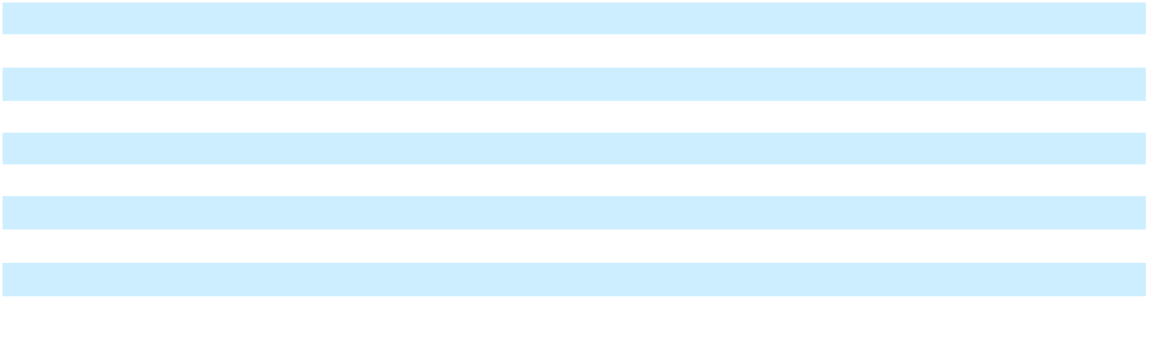
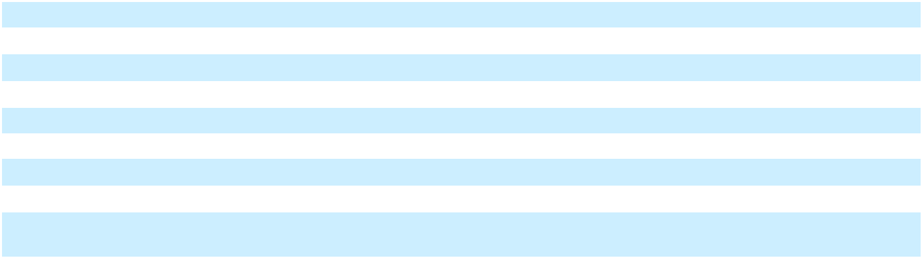
_______________________________

(1) Other segment items includes amortization expense and other operating expenses and income.

43

The following table presents capital expenditures and depreciation and amortization by reportable segment.

 |  | Year Ended December 31,
 |  | 2024 |  |  | 2023 |  |  | 2022
Capital expenditures:
Mobile Solutions | $ | 13,438 | $ |  | 15,387 | $ |  | 14,590
Power Solutions |  | 3,252 |  |  | 3,643 |  |  | 2,401
Corporate |  | 1,624 |  |  | 1,466 |  |  | 961
Total | $ | 18,314 | $ |  | 20,496 | $ |  | 17,952
Depreciation and amortization:
Mobile Solutions | $ | 29,381 | $ |  | 29,156 | $ |  | 28,192
Power Solutions |  | 14,363 |  |  | 15,318 |  |  | 17,483
Corporate |  | 1,558 |  |  | 1,646 |  |  | 1,556
Total | $ | 45,302 | $ |  | 46,120 | $ |  | 47,231
The following table summarizes total assets by reportable segment.
 |  |  |  |  | As of December 31,
 |  |  |  |  | 2024 |  |  | 2023
Mobile Solutions (1) |  |  | $ |  | 294,204 | $ |  | 329,610
Power Solutions |  |  |  |  | 124,460 |  |  | 147,155
Corporate |  |  |  |  | 38,229 |  |  | 34,120
Total |  |  | $ |  | 456,893 | $ |  | 510,885
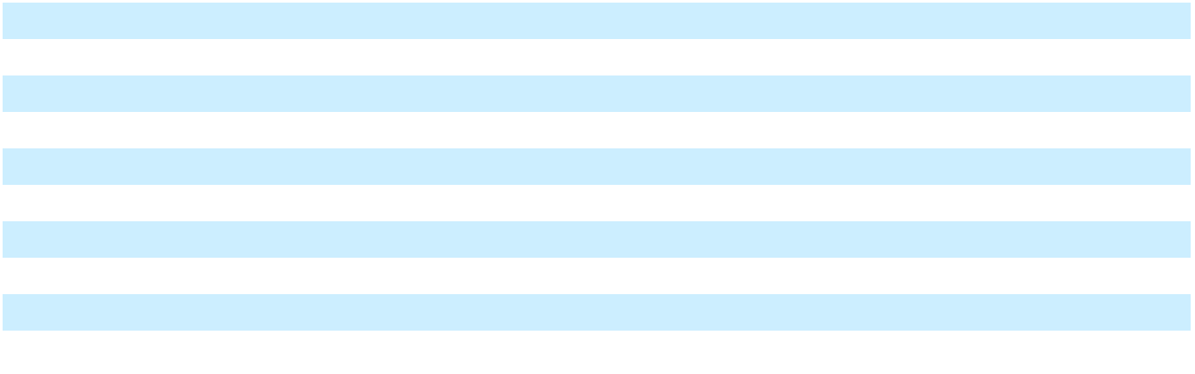
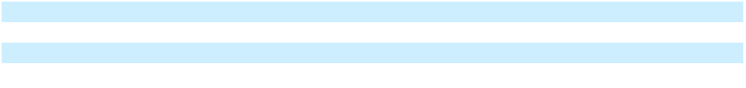
_______________________________

- Total assets in Mobile Solutions includes $35.0 million and $32.7 million as of December 31, 2024 and 2023, respectively, related to our investment in the JV.

The following table summarizes long-lived tangible assets by country.

 |  |  |  |  | As of December 31,
 |  |  |  |  | 2024 |  |  | 2023
United States |  |  |  | $ | 113,846 | $ |  | 127,186
China |  |  |  |  | 39,909 |  |  | 36,188
France |  |  |  |  | 20,713 |  |  | 24,298
Brazil |  |  |  |  | 12,585 |  |  | 17,088
Poland |  |  |  |  | 9,131 |  |  | 10,371
Mexico |  |  |  |  | 5,167 |  |  | 14,038
All foreign countries |  |  |  | $ | 87,505 |  | $ | 101,983
Total |  |  |  | $ | 201,351 |  | $ | 229,169
The following table summarizes revenue by country, based on our customers’ shipping destination.
 |  | Year Ended December 31,
 |  | 2024 |  |  | 2023 |  |  | 2022
United States | $ | 265,020 |  | $ | 294,045 | $ |  | 301,823
China |  | 67,957 |  |  | 58,195 |  |  | 51,556
Brazil |  | 44,302 |  |  | 48,696 |  |  | 48,216
Mexico |  | 25,663 |  |  | 26,683 |  |  | 40,645
Germany |  | 10,083 |  |  | 8,700 |  |  | 5,506
Poland |  | 4,120 |  |  | 6,161 |  |  | 5,042
Other |  | 47,145 |  |  | 46,790 |  |  | 45,950
Total net sales | $ | 464,290 |  | $ | 489,270 | $ |  | 498,738
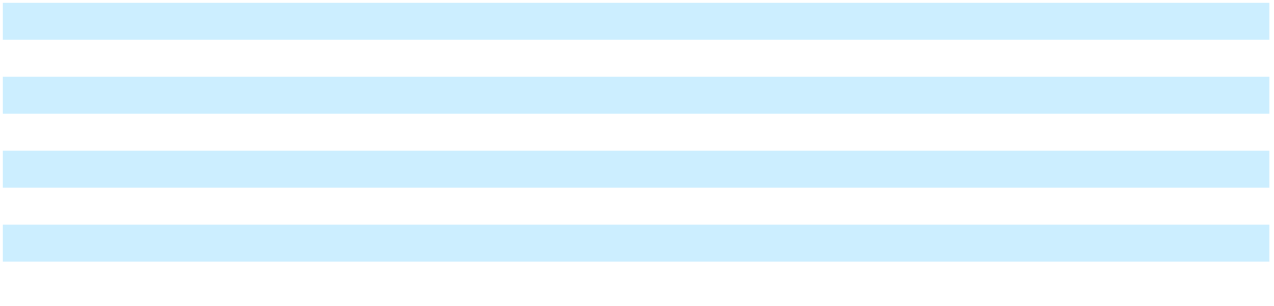

44

Note 3. Revenue from Contracts with Customers

Revenue is recognized when control of the good or service is transferred to the customer either at a point in time or, in limited circumstances, as our services are rendered over time. Revenue is measured as the amount of consideration we expect to receive in exchange for transferring goods or services. During the year ended December 31, 2022, we received equipment from a customer as part of the selling price of goods transferred. This noncash consideration was recognized as revenue equal to the fair value of the equipment received.

The following tables summarize revenue by customer industry. Our products in the automotive industry include high-precision components and assemblies for electric power steering systems, electric braking, electric motors, fuel systems, emissions control, transmissions, moldings, stampings, sensors, and electrical contacts. Our products in the general industrial industry include high-precision metal and plastic components for a variety of industrial applications including diesel industrial motors, heating and cooling systems, fluid power systems, power tools, and more. While many of the industries we serve include electrical components, our products in the residential/commercial electrical industry category in the following tables include components used in smart meters, charging stations, circuit breakers, transformers, electrical contact assemblies, precision stampings, welded contact assemblies, specification plating, and surface finishing. The other category includes products sold in aerospace, defense, medical, and other industries.

 |  |  | Mobile |  |  | Power |  |  | Intersegment
Year Ended December 31, 2024 |  |  | Mobile |  |  | Power |  |  | Sales |  |  | Total
Year Ended December 31, 2024 |  |  | Solutions |  |  | Solutions |  |  | Eliminations |  |  | Total
Automotive
 |  | $ | 192,277 | $ |  | 28,915 | $ |  | — | $ |  | 221,192
General Industrial |  |  | 71,244 |  |  | 46,490 |  |  | — |  |  | 117,734
Residential/Commercial Electrical |  |  | — |  |  | 80,545 |  |  | — |  |  | 80,545
Other |  |  | 20,423 |  |  | 24,595 |  |  | (199) |  |  | 44,819
Total net sales |  | $ | 283,944 | $ |  | 180,545 | $ |  | (199) | $ |  | 464,290
 |  |  | Mobile |  |  | Power |  |  | Intersegment
Year Ended December 31, 2023 |  |  | Mobile |  |  | Power |  |  | Sales |  |  | Total
Year Ended December 31, 2023 |  |  | Solutions |  |  | Solutions |  |  | Eliminations |  |  | Total
Automotive
 |  | $ | 212,582 | $ |  | 34,959 | $ |  | — | $ |  | 247,541
General Industrial |  |  | 73,350 |  |  | 52,276 |  |  | — |  |  | 125,626
Residential/Commercial Electrical |  |  | — |  |  | 67,546 |  |  | — |  |  | 67,546
Other |  |  | 17,403 |  |  | 31,167 |  |  | (13) |  |  | 48,557
Total net sales |  | $ | 303,335 | $ |  | 185,948 | $ |  | (13) | $ |  | 489,270
 |  |  | Mobile |  |  | Power |  |  | Intersegment
Year Ended December 31, 2022 |  |  | Mobile |  |  | Power |  |  | Sales |  |  | Total
Year Ended December 31, 2022 |  |  | Solutions |  |  | Solutions |  |  | Eliminations |  |  | Total
Automotive
 |  | $ | 197,341 | $ |  | 40,890 | $ |  | — | $ |  | 238,231
General Industrial |  |  | 78,142 |  |  | 61,828 |  |  | — |  |  | 139,970
Residential/Commercial Electrical |  |  | — |  |  | 70,055 |  |  | — |  |  | 70,055
Other |  |  | 18,053 |  |  | 32,431 |  |  | (2) |  |  | 50,482
Total net sales |  | $ | 293,536 | $ |  | 205,204 | $ |  | (2) | $ |  | 498,738
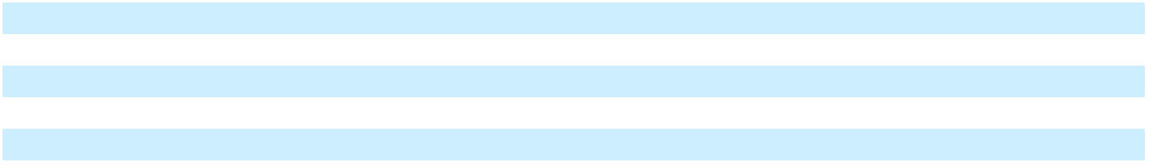

Other Sources of Revenue

We provide pre-production activities related to engineering efforts to develop molds, dies, and machines that are owned by our customers. We may receive advance payments from customers which are deferred until satisfying our performance obligations by compliance with customer-specified milestones, recognizing revenue at a point in time. These contracts generally have an original expected duration of less than one year.

Deferred Revenue

The timing of revenue recognition, billings, and cash collections results in billed accounts receivable and customer advances and deposits (e.g. contract liability) on the Consolidated Balance Sheets. These contract liabilities are reported on the Consolidated Balance Sheets on a contract-by-contract basis at the end of each reporting period as deferred revenue, which is reported in the “Other current liabilities” line on the Consolidated Balance Sheets.

Deferred revenue relates to payments received in advance of performance under the contract and recognized as revenue as (or when) we perform under the contract. Changes in the contract liability balances during the year ended December 31, 2024, were not materially impacted by any other factors. The balance of deferred revenue was $0.2 million, $0.4 million and $0.7

45

million as of December 31, 2024, 2023 and 2022, respectively. Revenue recognized for performance obligations satisfied or partially satisfied during the years ended December 31, 2024, 2023 and 2022, included $0.4 million, $0.7 million and $0.5 million, respectively, that was included in deferred revenue as of the prior year-end.

Transaction Price Allocated to Future Performance Obligations

We are required to disclose the aggregate amount of transaction price that is allocated to performance obligations that have not yet been satisfied as of December 31, 2024, unless our contracts meet one of the practical expedients. Our contracts met the practical expedient for a performance obligation that is part of a contract that has an original expected duration of one year or less.

Costs to Obtain and Fulfill a Contract

We recognize commissions paid to internal sales personnel that are incremental to obtaining customer contracts as an expense when incurred since the amortization period is less than one year. Costs to obtain a contract are expensed as selling, general and administrative expense.

Sales, VAT, and other taxes we collect concurrent with revenue-producing activities are excluded from revenue. Incidental items that are immaterial in the context of the contract are recognized as expense.

Sales Concentration

No single customer accounted for 10% or more of consolidated net sales, during the years ended December 31, 2024, 2023, and 2022.

Note 4. Accounts Receivable

The following table presents changes in the allowance for credit losses.

 |  | Years Ended December 31,
 |  | 2024 |  |  | 2023 |  |  | 2022
Balance at beginning of year | $ | 1,241 | $ |  | 1,469 | $ |  | 1,352
Additions |  | 615 |  |  | 118 |  |  | 326
Write-offs and other |  | (308) |  |  | (353) |  |  | (182)
Currency impact |  | (33) |  |  | 7 |  |  | (27)
Balance at end of year | $ | 1,515 | $ |  | 1,241 | $ |  | 1,469
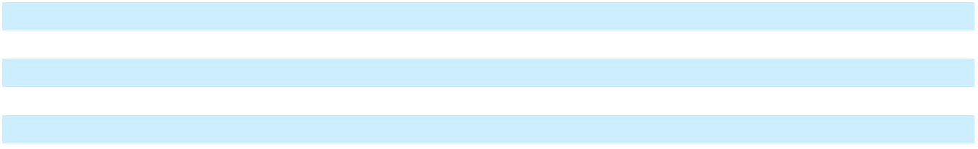

As of December 31, 2024 and 2023, one customer represented 11% and 13%, respectively, of our consolidated accounts receivable balance. Amounts due from this customer are primarily related to Mobile Solutions.

Accounts Receivable Sales Programs

We participate in programs established by our customers which allows us to sell certain receivables from that customer on a non-recourse basis to a third-party financial institution. During the years ended December 31, 2024, 2023 and 2022, we incurred fees of $1.1 million, $1.1 million and $0.6 million, respectively, related to the sale of receivables which is recorded in the Other expense (income), net line item on the Consolidated Statements of Operations and Comprehensive Income (Loss).

Note 5. Inventories

Inventories are comprised of the following amounts:

 |  | As of December 31,
 |  | 2024 |  |  | 2023
Raw materials | $ | 20,664 | $ |  | 25,456
Work in process |  | 22,139 |  |  | 22,942
Finished goods |  | 19,074 |  |  | 23,165
Total inventories | $ | 61,877 | $ |  | 71,563

46

Note 6. Property, Plant and Equipment

Property, plant and equipment are comprised of the following amounts:

 |  | As of December 31,
 |  | 2024 |  |  | 2023
Land and buildings | $ | 56,205 | $ |  | 61,007
Machinery and equipment |  | 339,792 |  |  | 375,352
Construction in progress |  | 6,569 |  |  | 3,466
Gross cost |  | 402,566 |  |  | 439,825
Less: Accumulated depreciation |  | 240,532 |  |  | 254,013
Property, plant and equipment, net | $ | 162,034 | $ |  | 185,812

For the years ended December 31, 2024, 2023, and 2022, we recorded depreciation expense of $31.6 million, $32.0 million, and $31.4 million, respectively. During the year ended 2024, we recognized $0.9 million of accelerated depreciation expense due to changes in the estimated remaining useful life of certain machinery and equipment.

We monitor property, plant and equipment for any indicators of potential impairment. We recognized an impairment of $6.5 million for the year ended December 31, 2024, related to machinery and equipment located at a plant that will close in 2025. The machinery and equipment were adjusted down to their fair value, which was determined based on quoted market prices for similar assets. The impairment loss, which was reported within our Mobile Solutions group, is recognized in the “Other expense (income), net” line in the Consolidated Statements of Operations and Comprehensive Income (Loss). There were no impairment charges for the years ended December 31, 2023, and 2022.

Note 7. Intangible Assets

The following table shows changes in the carrying amount of intangible assets, net, by reportable segment.

 | Mobile Solutions |  |  | Power Solutions |  |  |  | Total
Balance as of December 31, 2022 | $ | 22,356 | $ |  | 50,535 | $ |  | 72,891
Amortization |  | (3,353) |  |  | (10,814) |  |  | (14,167)
Balance as of December 31, 2023 |  | 19,003 |  |  | 39,721 |  |  | 58,724
Amortization |  | (3,354) |  |  | (10,369) |  |  | (13,723)
Intangible assets sold (1) |  | — |  |  | (591) |  |  | (591)
Balance as of December 31, 2024 | $ | 15,649 | $ |  | 28,761 | $ |  | 44,410
_______________________________

- Represents customer relationships associated with the Industrial Molding Corporation business, which was sold during the year ended December 31, 2024 (see Note 18).

The following table shows the cost and accumulated amortization of our intangible assets as of December 31, 2024 and 2023.

 |  | December 31, 2024 |  |  |  |  |  |  |  |  | December 31, 2023
 | Gross Carrying |  |  | Accumulated |  |  |  | Net |  | Gross Carrying |  |  | Accumulated |  |  |  | Net
 |  | Value as of |  |  |  |  |  | Carrying |  |  | Value as of |  |  |  |  |  | Carrying
 | Acquisition Date |  |  | Amortization |  |  |  | Value |  | Acquisition Date |  |  | Amortization |  |  |  | Value
Customer relationships | $ | 169,416 | $ |  | (126,281) | $ |  | 43,135 | $ |  | 171,846 | $ |  | (114,671) | $ |  | 57,175
Trademark and trade name |  | 4,100 |  |  | (2,825) |  |  | 1,275 |  |  | 7,527 |  |  | (5,978) |  |  | 1,549
Total identified intangible assets | $ | 173,516 |  | $ | (129,106) |  | $ | 44,410 |  | $ | 179,373 |  | $ | (120,649) |  | $ | 58,724

Intangible assets that are fully amortized are removed and no longer represented in the gross carrying value or accumulated amortization.

The following table shows estimated future amortization expense for each of the next five years.

Year Ending December 31,
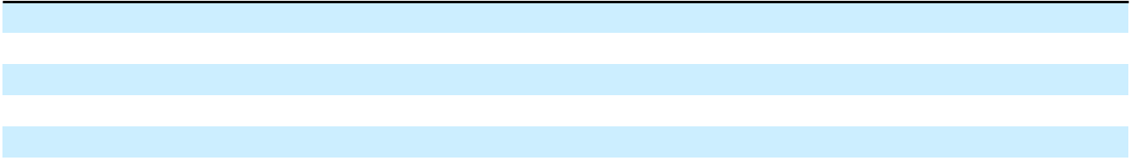

2025 | $ | 13,621
2026 |  | 13,621
2027 |  | 11,579
2028 |  | 3,353
2029 |  | 2,236

47

Intangible assets are reviewed for impairment when changes in circumstances indicate the carrying value of those assets may not be recoverable. There were no impairment charges for the years ended December 31, 2024, 2023, and 2022.

Note 8. Investment in Joint Venture

We own a 49% investment in Wuxi Weifu Autocam Precision Machinery Company, Ltd., a joint venture located in Wuxi, China. The JV is jointly controlled and managed, and we account for it under the equity method, with the share of net income from the joint venture recorded in the Mobile Solutions segment.

The following table shows changes in our investment in the JV.
Balance as of December 31, 2023 | $ | 32,701
Share of earnings |  | 9,571
Dividends paid by joint venture |  | (6,260)
Foreign currency translation loss |  | (1,041)
Balance as of December 31, 2024 | $ | 34,971

The following tables show summarized financial information of the unconsolidated JV.

 | Year Ended December 31,
 | 2024 |  | 2023 |  |  | 2022
Net sales | 130,807 | 109,630 |  |  |  | 101,565
Cost of sales | 106,166 | 93,609 |  |  |  | 84,654
Income from operations | 22,790 | 14,175 |  |  |  | 15,111
Net income | 19,533 | 11,848 |  |  |  | 13,453
 |  |  | December 31,
 |  |  | 2024 |  |  | 2023
Current assets |  | 84,409 |  |  |  | 68,508
Noncurrent assets |  | 73,399 |  |  |  | 77,554
Current liabilities |  | 76,859 |  |  |  | 68,665
Noncurrent liabilities |  | 7,639 |  |  |  | 8,662
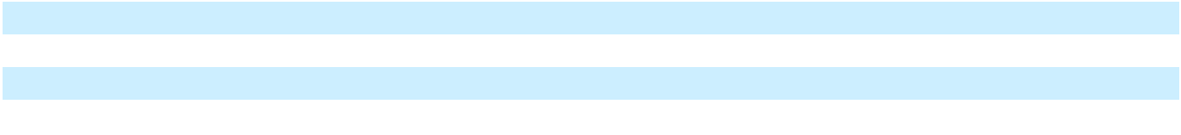

We recognized sales to the JV of $0, $0, and $0.1 million during the years ended December 31, 2024, 2023, and 2022, respectively.

Note 9. Debt

The following table presents amounts outstanding on our debt facilities.

 |  | As of December 31,
 |  | 2024 |  |  | 2023
Term Loan Facility | $ | 114,397 | $ |  | 148,114
ABL Facility |  | 5,400 |  |  | —
Financing obligations from sale-leaseback transactions |  | 24,496 |  |  | —
International loans |  | 8,485 |  |  | 10,655
Unamortized debt issuance costs and discount (1) |  | (4,148) |  |  | (5,490)
Total debt | $ | 148,630 | $ |  | 153,279
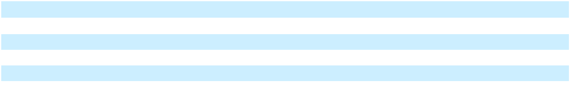
_______________________________

- In addition to this amount, costs of $1.2 million and $0.5 million related to asset backed credit facilities were recorded in other non-current assets as of December 31, 2024 and 2023, respectively.

We capitalized interest costs of $1.2 million, $1.3 million, and $0.6 million in the years ended December 31, 2024, 2023, and 2022, respectively, related to construction in progress.

Term Loan Facility

On March 22, 2021, we entered into a $150.0 million term loan facility (as amended from time to time, the “Term Loan Facility”), on which outstanding borrowings bear interest at either: 1) one-month, three-month, or six-month term secured overnight finance rate (“SOFR”) with a duration adjustment (“Adjusted Term SOFR”), subject to a 1.000% floor, plus an applicable margin of 6.875%, or 2) the greater of various benchmark rates plus an applicable margin of 5.875%. Beginning in

48

the second quarter of 2023, interest was increased on a paid-in-kind basis at a rate between 1.00% and 2.00% (“PIK interest”), dependent on our net leverage ratio for the most recently reported fiscal quarter and subject to reduction upon the occurrence of certain conditions as set forth in the credit agreement governing the Term Loan Facility. The PIK interest is payable on the loan maturity date of September 22, 2026. At December 31, 2024, the Term Loan Facility bore interest, including PIK interest, based on one-month Adjusted Term SOFR, at 12.332%.

The Term Loan Facility requires quarterly principal payments of $0.4 million with the remaining unpaid principal amount due at the loan maturity date. We may be required to make additional principal payments annually that are calculated as a percentage of our excess cash flow, as defined by the lender, based on our net leverage ratio. The Term Loan Facility is collateralized by all of our assets. The Term Loan Facility has a first lien on all domestic assets, other than accounts receivable and inventory and has a second lien on domestic accounts receivable and inventory. We were in compliance with all requirements under the Term Loan Facility as of December 31, 2024.

The Term Loan Facility was issued at a $3.8 million discount and we capitalized an additional $5.5 million in new debt issuance costs. These costs are recorded as a direct reduction to the carrying amount of the associated long-term debt and amortized over the term of the debt.

We had an interest rate swap that changed the applicable variable base rate to a fixed rate of 1.291% on $60.0 million of the outstanding balance of the Term Loan Facility. During the first quarter of 2023, we terminated the interest rate swap and received cash proceeds of $2.5 million which was equal to its fair value.

ABL Facility

On December 30, 2024, we entered into a new asset backed credit facility (the “ABL Facility”) which provides for a senior

secured revolving credit facility in the amount of $50.0 million, of which $15.0 million is available in the form of letters of

credit and $5.0 million is available for the issuance of short-term swingline loans. The availability of credit under the ABL

Facility is limited by a borrowing base calculation derived from accounts receivable and inventory held in the United States. Outstanding borrowings under the ABL Facility bear interest at either: 1) the one, three or six month SOFR plus 1.50%, plus an adjustment of 0.10% (“Term SOFR Rate”); or 2) the highest of the base commercial lending rate of the lender or various benchmark rates plus an applicable margin of 0.50% or 1.00%, depending on the benchmark (“Alternative Base Rate”). At December 31, 2024, based on a one-month Term SOFR Rate, the interest rate on outstanding borrowings under the ABL Facility was 5.94%. We incur a commitment fee of 0.25% for unused capacity under the ABL Facility and a 1.85% fee on the amount of letters of credit outstanding. The final maturity date of the ABL Facility is the earlier of: 1) December 30, 2029; or

- 91 days prior to the loan maturity date of the Term Loan Facility. We capitalized a total of $1.2 million in new debt issuance costs related to the ABL Facility.

As of December 31, 2024, we had $5.4 million outstanding borrowings under the ABL Facility, $10.4 million of outstanding letters of credit, and $15.0 million available for future borrowings under the ABL Facility. The ABL Facility is secured by a perfected lien over substantially all of the Company’s assets. We were in compliance with all requirements under the ABL Facility as of December 31, 2024.

2021 ABL Facility

On March 22, 2021, we entered into an asset backed credit facility (as amended from time to time, the “2021 ABL Facility”) which provided for a $50.0 million senior secured revolving credit facility, of which a maximum of $30.0 million was available in the form of letters of credit and a maximum of $5.0 million was available for the issuance of short-term swingline loans. On December 30, 2024, we terminated the 2021 ABL Facility and paid down the $12.0 million of outstanding borrowings. The availability of credit under the 2021 ABL Facility was limited by a borrowing base calculation derived from accounts receivable and inventory held in the United States. Outstanding borrowings under the 2021 ABL Facility bore interest on a variable rate structure plus an interest rate spread that was based on the average amount of aggregate revolving commitment available. The variable borrowing rate was either: 1) Adjusted Term SOFR plus an applicable margin of 1.75% or 2.00%, depending on availability; or 2) the greater of the federal funds rate or prime, plus an applicable margin of 0.75% or 1.00%, depending on availability. At December 30, 2024, using one-month Adjusted Term SOFR plus a 2.00% margin, the interest rate on outstanding borrowings under the 2021 ABL Facility was 6.568%. We incurred a commitment fee of 0.375% for unused capacity under the 2021 ABL Facility and a 2.125% fee on the amount of letters of credit outstanding. During the year ended December 31, 2024, we recognized a $0.3 million loss on extinguishment in connection with the termination of the 2021 ABL Facility.

Sale-Leaseback Transactions

In March 2024, we sold three of our properties for an aggregate sales price of $16.9 million, with the net proceeds used to repay a portion of the outstanding borrowings under the Term Loan Facility. Concurrent with the sale, we entered into a 20-year lease agreement for these properties. Since the lease agreement allows for us to exercise renewal options that extend for substantially all of the remaining economic life, we have the ability to maintain the risks and rewards of ownership. Since the transaction did not transfer control of the assets, it cannot be accounted for as a sale under ASC 606. As a result, the properties

49

remain on our Consolidated Balance Sheets and the non-land assets will continue to be depreciated over their remaining useful lives. The $16.9 million of gross proceeds was recognized as a financing obligation as a component of long-term debt. The monthly lease payments, which increase 3.0% each year, are being amortized as principal payments and interest expense based on an effective interest rate of 9.715%. We incurred $0.6 million in debt issuance costs related to this transaction, which are being amortized over the term of the debt.

In March 2024, we sold multiple pieces of manufacturing equipment for an aggregate sales price of $4.9 million. Concurrent with the sale, we entered into a 5-year lease agreement that includes a repurchase option for this equipment. In May 2024, we sold additional pieces of manufacturing equipment for an aggregate sales price of $3.4 million and entered into 5-year and 6-year lease agreements for the equipment. Since the three lease agreements allow for us to exercise an early buyout option, we have the ability to maintain the risks and rewards of ownership. Since the transactions did not transfer control of the assets, they cannot be accounted for as sales under ASC 606. As a result, the assets remain on our Consolidated Balance Sheets and will continue to be depreciated over their remaining useful lives. The $8.3 million of gross proceeds was recognized as a financing obligation as a component of long-term debt. The monthly lease payments are being amortized as principal payments and interest expense on a weighted average effective interest rate of 10.540%.

International Loans

We have fixed rate debt with various financial institutions in France, Poland and China, with maturity dates between 2025 and 2033. These loans, which were obtained to fund working capital and equipment purchases, had a weighted average interest rate of 2.320% at December 31, 2024.

Future Maturities

The following table lists aggregate maturities of debt for each of the next five years.
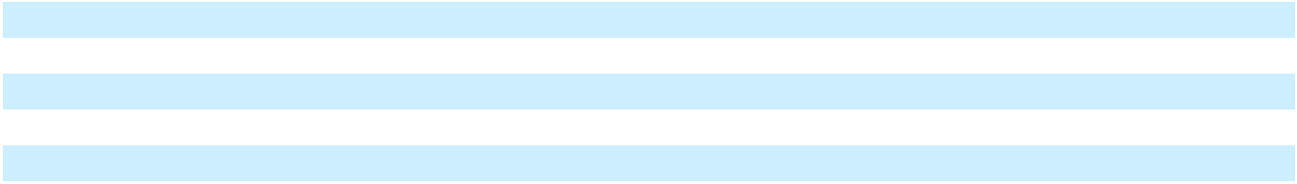

2025 | $ | 5,039
2026 |  | 122,018
2027 |  | 3,245
2028 |  | 3,599
2029 |  | 700

Note 10. Preferred Stock

On March 22, 2021, we completed a private placement of 65,000 shares of newly designated Series D Perpetual Preferred Stock, with a par value of $0.01 per share (the “Series D Preferred Stock”), at a price of $1,000 per share. The Series D Preferred Stock has an initial liquidation preference of $1,000 per share and is redeemable at our option in cash at a redemption price equal to the liquidation preference then in effect. Series D Preferred Stock shares earn cash dividends at a rate of 10.0% per year, payable quarterly in arrears, accruing whether or not earned or declared. If no cash dividend is paid, then the liquidation preference per share effective on the dividend date increases by 12.0% per year. On March 22, 2026, the cash dividend rate and in-kind dividend rate increase by 2.5% per year. Cash dividends are required beginning on September 30, 2027 and are limited based on terms and conditions of the Term Loan Agreement.

The Series D Preferred Stock is classified as mezzanine equity, between liabilities and stockholders’ equity, because certain features of the Series D Preferred Stock could require redemption of the Series D Preferred Stock upon a change of control event that is considered not solely within our control. For initial recognition, the Series D Preferred Stock was recognized at a discounted value, net of issuance costs and allocation to warrants and a bifurcated embedded derivative. The aggregate discount is amortized as a deemed dividend through March 22, 2026, which is the date the dividend rate begins to increase by 2.5% per year. Deemed dividends adjust additional paid-in capital due to the absence of retained earnings.

As of December 31, 2024, the carrying value of the Series D Preferred Stock shares was $93.5 million, which included $46.8 million of accumulated unpaid and deemed dividends. The following table presents the change in the Series D Preferred Stock carrying value.

 |  | Years Ended December 31,
 |  | 2024 |  |  | 2023 |  |  | 2022
Balance at beginning of year | $ | 77,799 | $ |  | 64,701 | $ |  | 53,807
Accrual of in-kind dividends |  | 11,351 |  |  | 10,085 |  |  | 8,961
Amortization |  | 4,347 |  |  | 3,013 |  |  | 1,933
Balance at end of year | $ | 93,497 | $ |  | 77,799 | $ |  | 64,701
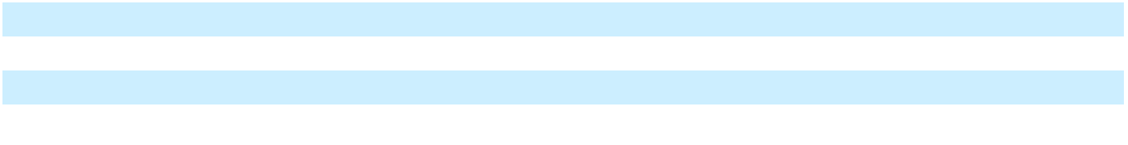

50

Note 11. Leases

The following table presents components of lease expense:

 |  | Years Ended December 31,
 |  | 2024 |  |  | 2023 |  |  | 2022
Operating lease cost | $ | 7,995 | $ |  | 8,077 | $ |  | 8,285
Finance lease cost:
Amortization of right-of-use assets |  | 1,596 |  |  | 1,600 |  |  | 1,318
Interest expense |  | 359 |  |  | 345 |  |  | 351
Short-term lease cost (1) |  | 477 |  |  | 604 |  |  | 438
Sublease income |  | (3,845) |  |  | (2,284) |  |  | (195)
Total lease cost | $ | 6,582 | $ |  | 8,342 | $ |  | 10,197
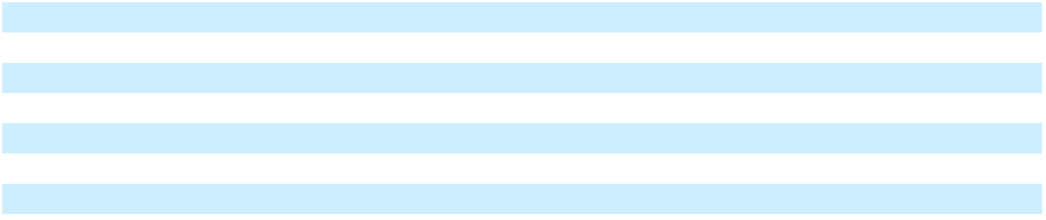
_______________________________

(1) Excludes expenses related to leases with a lease term of one month or less.

The following table presents lease-related assets and liabilities recorded on the balance sheet.

 |  |  |  | As of December 31,
 | Financial Statement Line Item |  |  | 2024 |  |  | 2023
Assets:
Operating lease assets | Operating lease right-of-use assets |  | $ | 39,317 | $ |  | 43,357
Finance lease assets | Property, plant and equipment, net |  |  | 16,579 |  |  | 13,599
Total lease assets |  |  | $ | 55,896 | $ |  | 56,956
Liabilities:
Current liabilities:
Operating lease liabilities | Current portion of operating lease liabilities |  | $ | 6,038 | $ |  | 5,735
Finance lease liabilities | Other current liabilities |  |  | 3,565 |  |  | 2,047
Non-current liabilities:
Operating lease liabilities | Operating lease liabilities, net of current portion |  |  | 42,291 |  |  | 47,281
Finance lease liabilities | Other non-current liabilities |  |  | 5,469 |  |  | 4,488
Total lease liabilities |  |  | $ | 57,363 | $ |  | 59,551
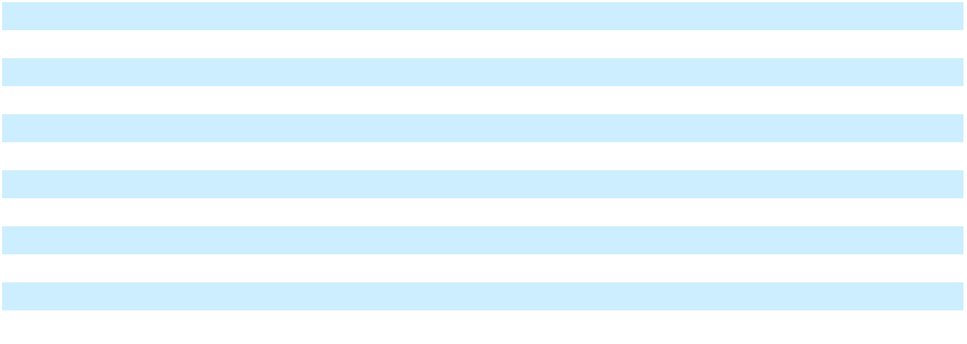

The following table contains supplemental cash flow information related to leases.

 |  | Years Ended December 31,
 |  | 2024 |  |  | 2023 |  |  | 2022
Cash paid for amounts included in the measurement of lease liabilities:
Operating cash flows used in operating leases | $ | 8,511 | $ |  | 8,462 | $ |  | 14,214
Operating cash flows used in finance leases |  | 359 |  |  | 345 |  |  | 351
Financing cash flows used in finance leases |  | 2,400 |  |  | 1,766 |  |  | 3,003
Right-of-use assets obtained in exchange for new operating lease liabilities (1) |  | 692 |  |  | 1,028 |  |  | 5,181
Right-of-use assets obtained in exchange for new finance lease liabilities |  | 5,170 |  |  | 1,619 |  |  | 1,263
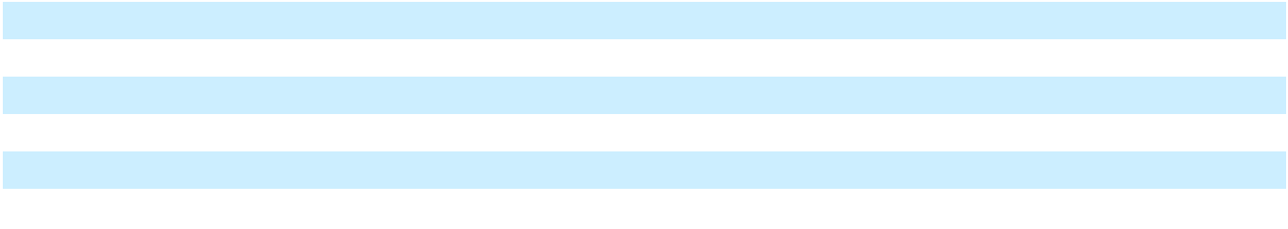

_______________________________

(1) Includes new leases, renewals, and modifications.

The weighted average remaining lease term and weighted-average discount rate for operating and finance leases were as follows:

 | As of December 31,
 | 2024 |  | 2023
Weighted-average remaining lease term - operating leases | 8.5 years |  |  | 9.2 years
Weighted-average remaining lease term - finance leases | 2.6 years |  |  | 3.1 years
Weighted-average discount rate - operating leases | 7.7 | % | 7.7 |  | %
Weighted-average discount rate - finance leases | 5.8 | % | 5.2 |  | %
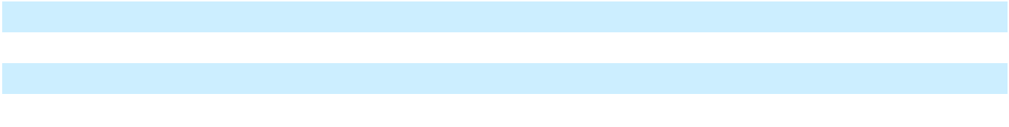

51

The maturities of lease liabilities as of December 31, 2024, is as follows:

 |  | Operating Leases |  |  | Finance Leases
2025 | $ | 8,675 | $ |  | 4,004
2026 |  | 8,516 |  |  | 3,398
2027 |  | 8,319 |  |  | 2,141
2028 |  | 6,773 |  |  | 167
2029 |  | 6,909 |  |  | 78
Thereafter |  | 25,227 |  |  | —
Total future minimum lease payments |  | 64,419 |  |  | 9,788
Less: imputed interest |  | 16,090 |  |  | 754
Total lease liabilities | $ | 48,329 | $ |  | 9,034
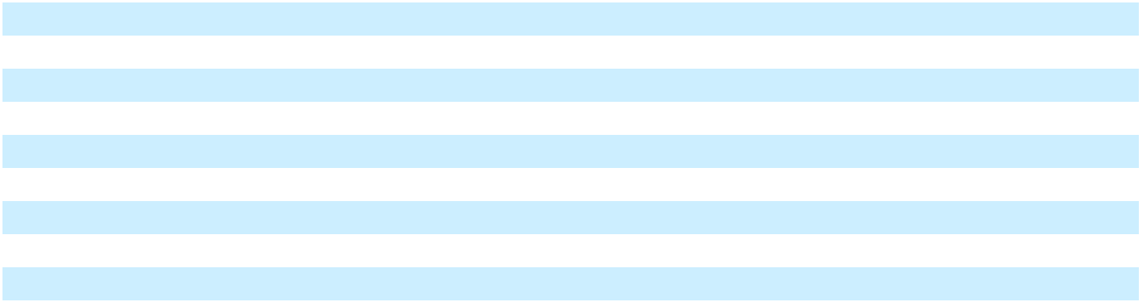

Subleases

We have entered into subleases for certain leased buildings or portions of leased buildings when no longer needed for our current operational needs. The weighted-average remaining lease term of our subleases is 9.7 years. In June 2023, we began subleasing our Taunton and Irvine sites, under subleases that extend through the lease termination dates of the respective head leases. We are subleasing a portion of our leased corporate headquarters office space under two separate subleases that expire in 2027 and 2029, respectively. The undiscounted cash flows to be received under operating subleases subsequent to December 31, 2024, is as follows:
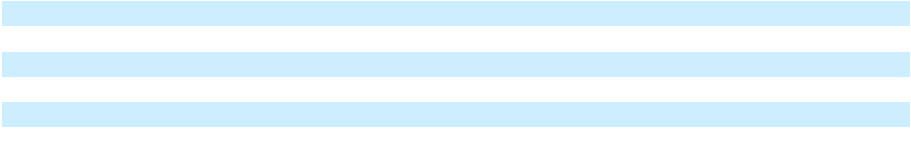

2025 | $ | 3,820
2026 |  | 3,937
2027 |  | 3,920
2028 |  | 3,626
2029 |  | 3,374
Thereafter |  | 19,261

Note 12. Commitments and Contingencies

Brazil ICMS Tax Matter

Prior to the acquisition of Autocam Corporation (“Autocam”) in 2014, Autocam’s Brazilian subsidiary (“Autocam Brazil”) received notification from the Brazilian tax authority regarding ICMS (state value added tax) tax credits claimed on intermediary materials (e.g., tooling and perishable items) used in the manufacturing process. The Brazilian tax authority notification disallowed state ICMS tax credits claimed on intermediary materials based on the argument that these items are not intrinsically related to the manufacturing processes. Autocam Brazil filed an administrative defense with the Brazilian tax authority arguing, among other matters, that it should qualify for an ICMS tax credit, contending that the intermediary materials are directly related to the manufacturing process.

We believe that we have substantial legal and factual defenses, and we plan to defend our interests in this matter vigorously. The matter encompasses several lawsuits filed with the Brazilian courts requesting declaratory actions that no tax is due or seeking a stay of execution on the collection of the tax. We have obtained multiple favorable decisions and one unfavorable decision. Although we anticipate a favorable resolution to the remaining matters, we can provide no assurances that we will be successful in achieving dismissal of all pending cases. The U.S. dollar amount that would be owed in the event of an unfavorable decision is subject to interest, penalties, and currency impacts and therefore is dependent on the timing of the decision. For the remaining open lawsuits, we currently believe the cumulative potential liability in the event of unfavorable decisions on all matters will be less than $2.0 million, inclusive of interest and penalties.

We are entitled to indemnification from the former shareholders of Autocam, subject to the limitations and procedures set forth in the agreement and plan of merger relating to the Autocam acquisition. Accordingly, we do not expect such losses, if any, to have a material impact on our business, operations or financial results.

Other Legal Matters

All other legal proceedings are of an ordinary and routine nature and are incidental to our operations. Management believes that such proceedings should not, individually or in the aggregate, have a material adverse effect on our business, financial condition, results of operations, or cash flows. In making that determination, we analyze the facts and circumstances of each case at least quarterly in consultation with our attorneys and determine a range of reasonably possible outcomes.

52

Note 13. Income Taxes

The following table summarizes income (loss) before benefit (provision) for income taxes and share of net income from joint venture.

 |  | Years Ended December 31,
 |  | 2024 |  |  | 2023 |  |  | 2022
United States | $ | (54,703) | $ |  | (64,394) | $ |  | (40,543)
Foreign |  | 9,269 |  |  | 10,723 |  |  | 9,474
Loss before provision for income taxes and share of net income from
joint venture | $ | (45,434) |  | $ | (53,671) |  | $ | (31,069)
The following table summarizes total income tax expense (benefit) recognized in each year.
 |  | Years Ended December 31,
 |  | 2024 |  |  | 2023 |  |  | 2022
Current taxes:
U.S. Federal | $ | (583) | $ |  | (580) | $ |  | (545)
State |  | (378) |  |  | 126 |  |  | (625)
Foreign |  | 4,292 |  |  | 3,901 |  |  | 4,576
Total current tax expense |  | 3,331 |  |  | 3,447 |  |  | 3,406
Deferred taxes:
U.S. Federal | $ | (10,421) | $ |  | (9,057) | $ |  | (6,245)
State |  | (2,262) |  |  | (1,833) |  |  | 70
Foreign |  | (1,138) |  |  | (721) |  |  | (986)
U.S. federal, state and foreign valuation allowance |  | 12,900 |  |  | 10,449 |  |  | 5,376
Total deferred tax benefit |  | (921) |  |  | (1,162) |  |  | (1,785)
Total income tax expense | $ | 2,410 | $ |  | 2,285 | $ |  | 1,621
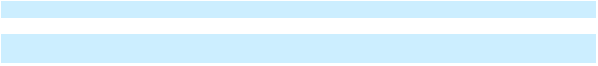
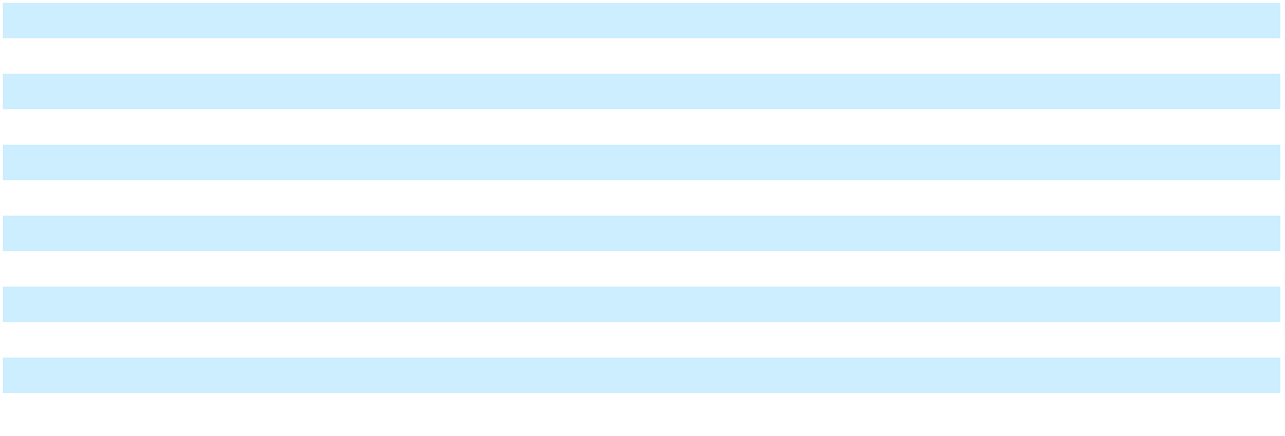

The following table presents a reconciliation of income taxes based on the U.S. federal statutory income tax rate.

 | Years Ended December 31,
 | 2024 |  | 2023 |  |  | 2022
U.S federal statutory income tax rate | 21.0 % | 21.0 % |  |  |  | 21.0 %
Change in valuation allowance, exclusive of state | (23.4)% | (16.1)% |  |  |  | (17.5)%
State taxes, net of federal taxes, exclusive of tax reform | 0.7 % | (0.2)% |  |  |  | 1.6 %
Non-U.S. earnings taxed at different rates | 1.9 % | 1.1 % |  |  |  | 0.7 %
Global intangible low-taxed income | (3.9)% | (2.3)% |  |  |  | (3.9)%
Deferred true-up | (0.3)% | (0.8)% |  |  |  | (6.4)%
Research and development tax credit | — % | 0.2 % |  |  |  | 0.3 %
Interest on CARES Act refund | 1.6 % | 1.1 % |  |  |  | 1.8 %
Return to provision | 0.4 % | 0.1 % |  |  |  | 1.3 %
Taxes on unremitted foreign earnings | (3.8)% | (2.4)% |  |  |  | (3.9)%
Intercompany lending | (0.5)% | (1.3)% |  |  |  | (2.7)%
Warrant revaluation | — % | (4.3)% |  |  |  | 3.6 %
Other adjustments, net | 1.0 % |  | (0.4)% |  |  | (1.1)%
Effective tax rate | (5.3)% | (4.3)% |  |  |  | (5.2)%
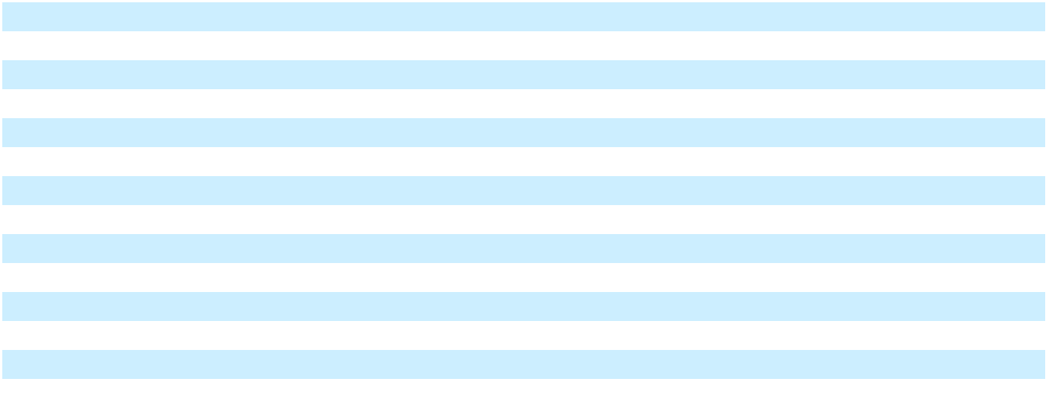

Our effective tax rate was (5.3)% for the year ended December 31, 2024. The effective tax rate differed from the U.S. federal statutory tax rate of 21% primarily due to the accrual of tax on non-permanently reinvested unremitted earnings of foreign subsidiaries, foreign tax rate differences and the limitation on the amount of tax benefit recorded for losses in certain jurisdictions where we believe it is more likely than not that a future tax benefit may not be realized. Our effective tax rate was (4.3)% and (5.2)% for the years ended December 31, 2023 and 2022, respectively, which differed from the U.S. federal statutory tax rate of 21% primarily due to the impact of our valuation allowance changes during each year.

53

In 2021, we filed a refund claim with the IRS as a result of the Coronavirus Aid, Relief, and Economic Security Act (the “CARES Act”). During the years ended December 31, 2024 and 2023, we accrued $0.7 million and $0.6 million, respectively, of interest on the CARES Act refund. Including interest accrued on the initial refund amount, we have a $12.3 million tax refund receivable at December 31, 2024, which is in the process of IRS review. The timing of the receipt of the refund is expected in the first half of 2025.

The following table summarizes the principal components of the deferred tax assets and liabilities.

 |  | As of December 31,
 |  | 2024 |  |  | 2023
Deferred income tax liabilities:
Tax in excess of book depreciation | $ | 11,917 | $ |  | 21,497
Intangible assets |  | 10,533 |  |  | 13,659
Operating leases |  | 9,005 |  |  | 9,970
Taxes on unremitted foreign earnings |  | 4,488 |  |  | 4,658
Other deferred tax liabilities |  | 682 |  |  | 725
Total deferred income tax liabilities |  | 36,625 |  |  | 50,509
Deferred income tax assets:
Interest expense limitation |  | 18,571 |  |  | 14,920
Goodwill |  | 18,393 |  |  | 20,419
Inventories |  | 5,062 |  |  | 2,456
Section 174 research and development costs |  | 3,123 |  |  | 2,400
Pension and personnel accruals |  | 2,297 |  |  | 1,818
Operating leases |  | 11,154 |  |  | 12,238
Net operating loss carryforwards |  | 29,304 |  |  | 32,043
Interest rate swap |  | — |  |  | 251
Credit carryforwards |  | 3,099 |  |  | 3,235
Accruals and reserves |  | 341 |  |  | 904
Other deferred tax assets |  | 981 |  |  | 3,099
Deferred income tax assets before valuation allowance |  | 92,325 |  |  | 93,783
Valuation allowance on deferred tax assets |  | (59,340) |  |  | (47,528)
Total deferred income tax assets |  | 32,985 |  |  | 46,255
Net deferred income tax liabilities | $ | 3,640 | $ |  | 4,254
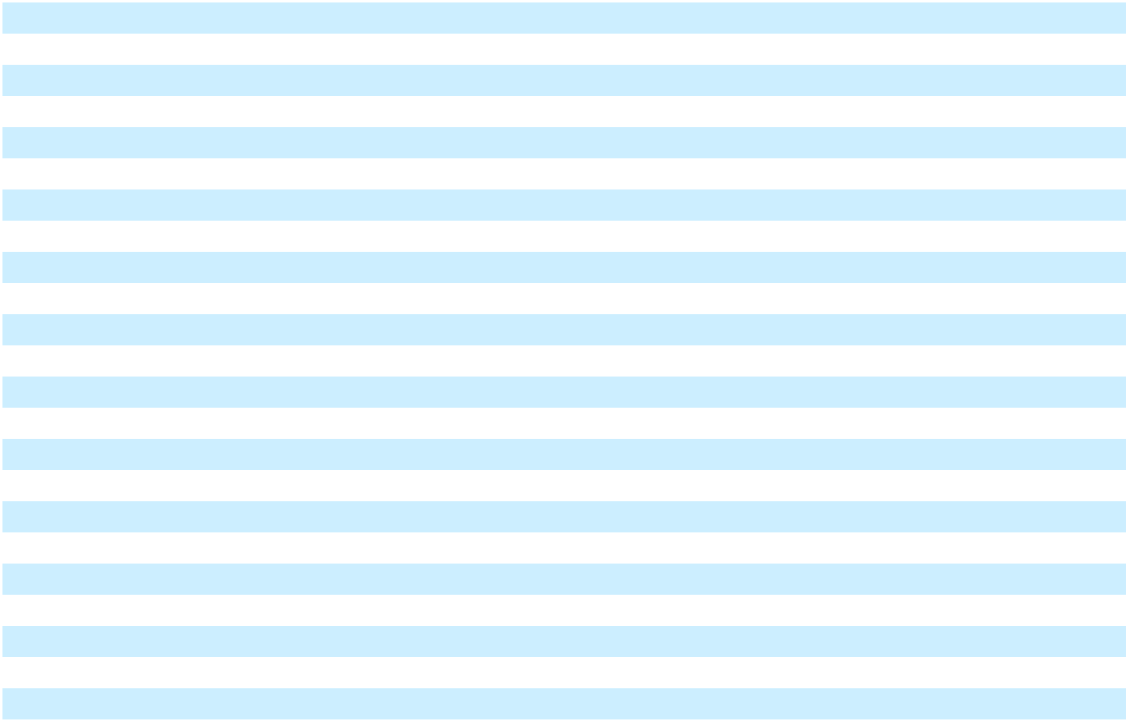

As of December 31, 2024, we had a $28.4 million U.S. federal net operating loss (“NOL”) carryover. The federal NOL has an indefinite life, but utilization within any tax year is limited to 80% of taxable income. Management has determined it is more likely than not this NOL will not be realized and has established a full valuation allowance against the deferred tax asset. As of December 31, 2024, we had $16.3 million of tax effected, state NOL carryovers, which begin to expire in 2030. Management has determined it is more likely than not these state NOL’s will not be realized and has established a full valuation allowance against these deferred tax assets. We also have $10.5 million, tax-effected, of foreign NOL carryovers at December 31, 2024. The foreign NOLs have an indefinite life; however, management believes that benefit for certain of the foreign NOLs may not be realized. Therefore, we have established a valuation allowance of $7.7 million to reduce the carrying value of the asset related to foreign NOLs to the amount that has been determined to be more likely than not realized.

We have $0.4 million and $2.7 million of U.S. federal tax credits and tax credits in foreign jurisdictions, respectively, as of December 31, 2024. We have recognized a full valuation allowance against these tax credits. In addition, we have other federal and state deferred tax assets of $11.7 million that we believe it is more likely than not will not be realized for which we have established a full valuation allowance.

We have a U.S. federal and state deferred tax asset related to interest expense carryforwards. Management believes it is more likely than not that the benefit for this asset will not be realized. We have established a valuation allowance of $18.6 million to eliminate the carrying value of this asset.

Management assesses available positive and negative evidence to estimate whether it is more likely than not sufficient future taxable income will be generated to provide use of the existing deferred tax assets. A significant piece of objective negative evidence evaluated is cumulative losses incurred over the three-year period ended December 31, 2024. Such objective evidence limits the ability to consider other subjective evidence, such as our projections for future earnings growth. On the basis of this

54

evaluation, as of December 31, 2024, a valuation allowance of $59.3 million has been recorded to recognize only the portion of the deferred tax asset that is more likely than not to be realized without consideration of future earnings growth.

Management believes all remaining tax assets will more likely than not be realized. However, the amount of the deferred tax asset realized will change based on future conditions, and the amount considered realizable will be adjusted if objective negative evidence in the form of cumulative losses is no longer present allowing additional weight to be given to subjective evidence such as our projections for growth.

During 2024, the valuation allowance increased by $11.8 million, primarily due to allowances recorded against U.S. federal net operating loss carryforwards, and carryforwards of disallowed interest expense which are subject to certain annual deduction limitations.

As a result of the deemed mandatory repatriation provisions in the U.S. Tax Cuts and Jobs Act of 2017 and subsequent recognition in income of GILTI, we do not have material basis differences related to cumulative unremitted earnings for U.S. income tax purposes. However, we continue to evaluate the impact that repatriation of foreign earnings would have on withholding and other taxes. As of December 31, 2024, we have recorded a liability of $4.5 million for the anticipated withholding taxes that would be due upon repatriation of the unremitted earnings of those subsidiaries for which management does not intend to permanently reinvest.

We are subject to U.S. federal income tax as well as tax in several foreign jurisdictions. We are also subject to tax by various state authorities. The tax years subject to examination vary by jurisdiction. We are no longer subject to U.S. federal examination for periods before 2021. We regularly assess the outcomes of both ongoing and future examinations for the current or prior years to ensure our provision for income taxes is sufficient. We recognize liabilities based on estimates of whether additional taxes will be due, and we believe our reserves are adequate in relation to any potential assessments. The outcome of any one examination, some of which may conclude during the next twelve months, is not expected to have a material impact on our financial position or results of operations.

Interest and penalties related to federal, state, and foreign income tax matters are recorded as a component of the provision for income taxes in our Consolidated Statements of Operations and Comprehensive Income (Loss). Accrued interest and penalties of $0.5 million and $0.5 million are included in other non-current liabilities as of December 31, 2024 and 2023, respectively.

The following table presents a reconciliation of the beginning and ending amounts of unrecognized tax benefits, excluding interest and penalties.

 |  | Years Ended December 31,
 | 2024 |  |  |  | 2023 |  |  | 2022
Balance at beginning of year | $ | 121 | $ |  | 118 | $ |  | 125
Additions for tax positions of prior years |  | — |  |  | 3 |  |  | —
Reductions for tax positions of prior years |  | (4) |  |  | — |  |  | (7)
Balance at end of year | $ | 117 | $ |  | 121 | $ |  | 118

The decrease to unrecognized tax benefits in 2024 is related to the foreign currency remeasurement of previously unrecognized tax benefits. As of December 31, 2024, the unrecognized tax benefits would, if recognized, impact our effective tax rate by $0.7 million, inclusive of the impact of interest and penalties. Management believes that it is reasonably possible that the amount of unrecognized income tax benefits, including interest and penalties, may not decrease during the next twelve months as no statutes are expected to lapse within the period.

55

Note 14. Net Income (Loss) Per Common Share

The following table summarizes the computation of basic and diluted net income (loss) per common share.

 |  | Years Ended December 31,
 |  | 2024 |  |  | 2023 |  |  | 2022
Numerator:
Net loss | $ | (38,273) | $ |  | (50,150) | $ |  | (26,098)
Adjustment for preferred stock cumulative dividends and deemed dividends |  | (15,698) |  |  | (13,098) |  |  | (10,894)
Numerator for basic and diluted net loss per common share | $ | (53,971) | $ |  | (63,248) | $ |  | (36,992)
Denominator:
Weighted average common shares outstanding |  | 49,596 |  |  | 46,174 |  |  | 43,738
Adjustment for participating securities |  | (2,724) |  |  | (2,636) |  |  | (951)
Adjustment for warrants outstanding (1) |  | 1,781 |  |  | 3,200 |  |  | 1,893
Shares used to calculate basic and diluted net loss per share |  | 48,653 |  |  | 46,738 |  |  | 44,680
Basic and diluted net loss per common share | $ | (1.11) | $ |  | (1.35) | $ |  | (0.83)
_______________________________
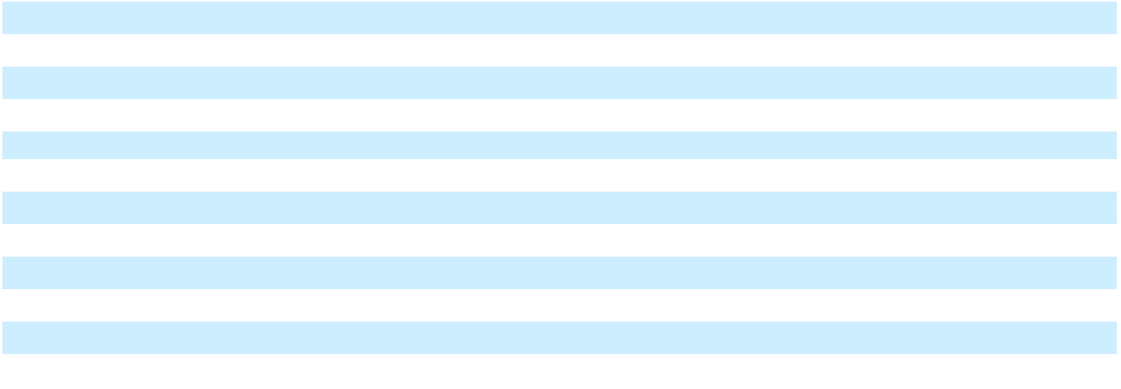

- Outstanding warrants that are exercisable at an exercise price of $0.01 per share, are included in shares outstanding for calculation of basic earnings per share (see Note 17).

The following table presents potentially dilutive securities that were excluded from the calculation of diluted net income (loss) per common share because they had an anti-dilutive effect.

 | Years Ended December 31,
 | 2024 |  | 2023 |  |  | 2022
Stock options | 212 | 381 |  |  |  | 557
Warrants | 1,500 | 1,500 |  |  |  | 1,500
Performance share units | 802 |  | 133 |  |  | —
Total antidilutive securities | 2,514 | 2,014 |  |  |  | 2,057
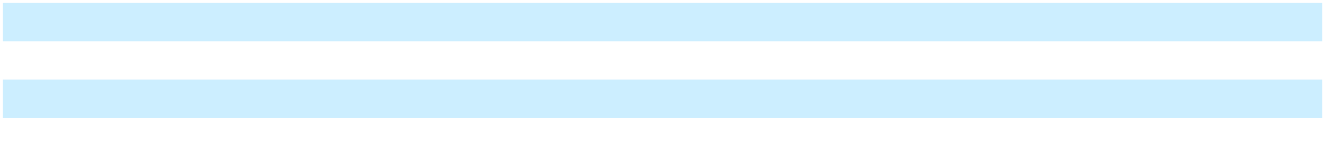

Stock options excluded from the EPS calculations had a per share exercise price ranging from $7.93 to $25.16 for the year ended December 31, 2024. The 2019 Warrants excluded from the EPS calculations for the year ended December 31, 2024 had a per share exercise price of $11.03 (see Note 17). Performance share units are potentially dilutive when the related performance criterion has been met.

Note 15. Share-Based Compensation

As of December 31, 2024, we have 3.4 million shares available that can be issued to employees and non-executive directors under the NN, Inc. 2022 Amended and Restated Omnibus Incentive Plan and prior plans (collectively, the “Incentive Plans”), as options, stock appreciation rights, and other share-based awards. Shares of our common stock delivered upon exercise or vesting may consist of newly issued shares of our common stock or shares acquired in the open market.

Share-based compensation expense is recognized in the “Selling, general, and administrative expense” line in the Consolidated Statements of Operations and Comprehensive Income (Loss). The following table lists the components of share-based compensation expense by type of award.

 |  | Years Ended December 31,
 | 2024 |  |  |  | 2023 |  |  | 2022
Restricted stock | $ | 2,119 | $ |  | 2,237 | $ |  | 3,635
Performance share units |  | 1,021 |  |  | 570 |  |  | 602
Stock options |  | — |  |  | 14 |  |  | 140
Share-based compensation expense | $ | 3,140 | $ |  | 2,821 | $ |  | 4,377
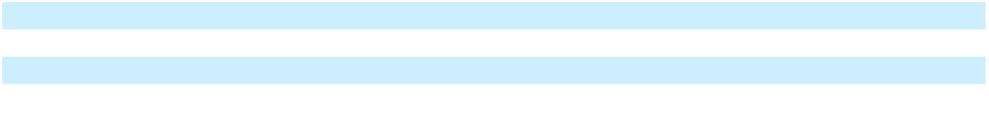

Unrecognized compensation cost related to unvested awards was $7.4 million as of December 31, 2024, which will be recognized over a weighted-average period of 3.4 years.

56

Restricted Stock

During the years ended December 31, 2024, 2023, and 2022, we granted 660,000, 3,782,000, and 897,000 shares of restricted stock with weighted average grant-date fair values of $4.25, $1.37, and $3.31 per share, respectively. The total grant-date fair value of restricted stock that vested in the years ended December 31, 2024, 2023, and 2022, was $2.0 million, $4.2 million, and $2.1 million, respectively.

The following table presents the status of unvested restricted stock awards as of December 31, 2024 and changes during the year then ended.
 | Nonvested |  | Weighted Average
 | Restricted |  |  | Grant-Date
 | Shares |  |  | Fair Value
Unvested at January 1, 2024 | 3,405 | $ |  | 1.41
Granted | 660 |  |  | 4.25
Vested | (1,480) |  |  | 1.33
Forfeited | (259) |  |  | 2.13
Unvested at December 31, 2024 | 2,326 | $ |  | 2.18
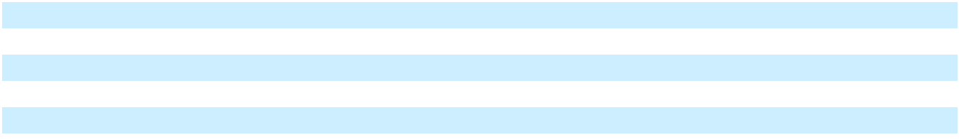

During the year ended December 31, 2024, we granted 390,000 shares of restricted stock to non-executive directors, officers and certain other employees which vest pro-rata over three years for employees and over one year for non-executive directors. In addition, we granted 270,000 shares of restricted stock to new executive officers as inducement grants, during the year ended December 31, 2024, which vest pro-rata over five years.

Performance Share Units

Performance Share Units (“PSUs”) are a form of long-term incentive compensation awarded to executive officers and certain other key employees designed to directly align the interests of employees to the interests of our stockholders, and to create long-term stockholder value. PSUs vest upon achieving specified performance targets over a performance period, which are based on total shareholder return (“TSR Awards”), return on invested capital (“ROIC Awards”), or on the Company’s stock price meeting specified thresholds (“Inducement Awards”). PSUs cliff-vest at the end of the performance period and expire automatically if the performance metric thresholds are not met during the performance period.

The TSR Awards vest, if at all, upon our achieving a specified relative total shareholder return, which will be measured against the total shareholder return of a specified index, as defined by the Incentive Plans, during the performance periods. The ROIC Awards vest, if at all, upon our achieving a specified average return on invested capital during the performance periods. The performance periods for TSR Awards and ROIC Awards begins on January 1st of the year of grant and ends three years later on December 31st. The Inducement Awards are earned upon our stock price meeting specified thresholds for any 20 consecutive trading days during the five-year performance period.

PSUs that vest will be settled by the issuance of shares of our common stock with the actual number of shares interpolated between a threshold and maximum payout amount based on actual performance results. No dividends will be paid on outstanding PSUs during the performance period; however, dividend equivalents will be paid based on the number of shares of common stock that are ultimately earned at the end of the performance periods.

The following table presents the status of unvested PSUs as of December 31, 2024 and activity during the year then ended.

 | Nonvested PSU |  | Weighted Average
 | Nonvested PSU |  |  | Grant-Date
 | Awards |  |  | Fair Value
Nonvested at January 1, 2024 | 3,789 | $ |  | 1.29
Granted | 590 |  |  | 3.71
Vested | (12) |  |  | 2.53
Forfeited | (427) |  |  | 2.40
Expired | (269) |  |  | 2.58
Nonvested at December 31, 2024 | 3,671 | $ |  | 1.45
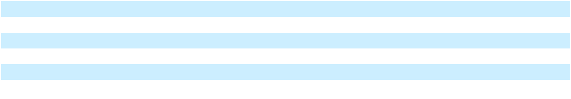

During the year ended December 31, 2024, we granted 175,000 TSR Awards to executive officers under the Incentive Plans for the 2023 to 2025 performance period, and 415,000 Inducement Awards to new executive officers. During the years ended December 31, 2023 and 2022, we granted 3,621,000 and 790,000 PSUs with weighted average grant-date fair values of $1.14 and $2.58 per share, respectively.

The total grant-date fair value of PSU’s that vested in the years ended December 31, 2024, 2023, and 2022, was $0.1 million, $0.3 million, and $0, respectively.

57

Stock Options

Stock options, which were last granted in 2020, have an exercise price equal to the closing price of our stock on the date of grant, an exercise term of ten years, and a vesting period of three years. The following table presents stock option activity for the year ended December 31, 2024.

 | Number of |  |  | Weighted- |  | Weighted-Average |  |  | Aggregate
 | Number of |  |  | Average |  | Remaining |  |  | Intrinsic
 | Options |  |  | Exercise Price |  | Contractual Term |  |  | Value
Outstanding at January 1, 2024 | 296 | $ |  | 14.46
Expired | (127) |  |  | 15.07
Outstanding and exercisable at December 31, 2024 | 169 | $ |  | 13.99 |  | 2.6 years $ |  |  | — (1)
_______________________________

- The aggregate intrinsic value is the sum of intrinsic values for each exercisable individual option grant. The intrinsic value is the amount by which the closing market price of our stock at December 31, 2024, was greater than the exercise price of any individual option grant.

Note 16. Accumulated Other Comprehensive Income

The components of accumulated other comprehensive income (loss) (“AOCI”) are as follows:

 |  | Foreign |  |  | Interest rate |  |  | Income taxes
 |  | Currency |  |  | Interest rate |  |  | Income taxes |  |  | Total
 |  | Translation |  |  | swap |  |  | (1) |  |  | Total
Balance as of December 31, 2021 | $ | (32,016) | $ |  | 151 | $ |  | (37) | $ |  | (31,902)
Other comprehensive income (loss) before reclassifications |  | (8,156) |  |  | 3,426 |  |  | (68) |  |  | (4,798)
Amounts reclassified from AOCI to interest expense (2) |  | — |  |  | (428) |  |  | 8 |  |  | (420)
Net other comprehensive income (loss) |  | (8,156) |  |  | 2,998 |  |  | (60) |  |  | (5,218)
Balance as of December 31, 2022 | $ | (40,172) | $ |  | 3,149 | $ |  | (97) | $ |  | (37,120)
Other comprehensive income (loss) before reclassifications |  | 1,410 |  |  | (327) |  |  | 97 |  |  | 1,180
Amounts reclassified from AOCI to interest expense (2) |  | — |  |  | (1,815) |  |  | — |  |  | (1,815)
Net other comprehensive income (loss) |  | 1,410 |  |  | (2,142) |  |  | 97 |  |  | (635)
Balance as of December 31, 2023 | $ | (38,762) | $ |  | 1,007 | $ |  | — | $ |  | (37,755)
Other comprehensive income (loss) before reclassifications |  | (9,405) |  |  | — |  |  | — |  |  | (9,405)
Amounts reclassified from AOCI to interest expense (2) |  | — |  |  | (1,007) |  |  | — |  |  | (1,007)
Net other comprehensive income (loss) |  | (9,405) |  |  | (1,007) |  |  | — |  |  | (10,412)
Balance as of December 31, 2024 | $ | (48,167) | $ |  | — | $ |  | — | $ |  | (48,167)
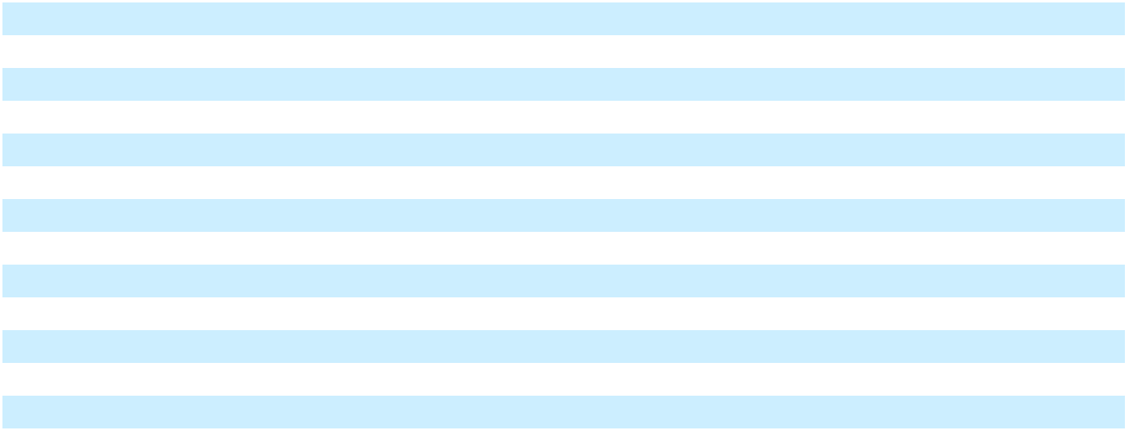
_______________________________

- Income tax effect of changes in interest rate swap.

- Represents gain recognized in interest expense on effective interest rate swap.

Note 17. Fair Value Measurements

Fair value is an exit price representing the expected amount that an entity would receive to sell an asset or pay to transfer a liability in an orderly transaction with market participants at the measurement date. We followed consistent methods and assumptions to estimate fair values as more fully described in Note 1.

Embedded Derivatives

In accordance with ASC 815-15, Derivatives and Hedging - Embedded Derivatives, certain features of our preferred stock and long-term debt were bifurcated and accounted for as derivatives separately.

In conjunction with an amendment to our Term Loan in 2023, we issued warrants to purchase up to 2.0 million shares of our common stock at an exercise price of $0.01 per share (the “2023 Warrants”). The 2023 Warrants are exercisable, in full or in part, at any time prior to June 30, 2033. The 2023 Warrants include anti-dilution adjustments in the event of certain future equity issuances, stock splits, stock dividends, combinations or similar events. During the year ended December 31, 2024, 500,000 of the 2023 Warrants were exercised on a cashless basis, resulting in the issuance of 499,000 shares.

In conjunction with our placement of the Series D Preferred Stock in 2021, we issued warrants to purchase up to 1.9 million shares of our common stock (the “2021 Warrants”). The 2021 Warrants were exercisable, in full or in part, at an exercise price

58

of $0.01 per share, subject to anti-dilution adjustments in the event of certain future equity issuances, stock splits, stock dividends, combinations or similar events. During the year ended December 31, 2024, all of the 2021 Warrants were exercised on a cashless basis, resulting in the issuance of 1,896,000 shares.

In conjunction with our placement of the Series B Preferred Stock in 2019, we issued warrants to purchase up to 1.5 million shares of our common stock (the “2019 Warrants”). The 2019 Warrants, are exercisable, in full or in part, at any time prior to December 11, 2026, at an exercise price of $11.03 per share, and are subject to anti-dilution adjustments in the event of future below market issuances, stock splits, stock dividends, combinations or similar events.

The following table presents the changes in the liability balance of the embedded derivatives.

 |  | Years Ended December 31,
 |  | 2024 |  |  | 2023
Balance at beginning of year | $ | 16,556 | $ |  | 2,959
Issuances |  | — |  |  | 2,712
Change in fair value (1) |  | 12 |  |  | 10,885
Settlements |  | (11,376) |  |  | —
Balance at end of year | $ | 5,192 | $ |  | 16,556
_______________________________

- Changes in the fair value are recognized in the “Other expense (income), net” line in the Consolidated Statements of Operations and Comprehensive Income (Loss).

The following tables show the fair values of the embedded derivatives within the fair value hierarchy.

 |  | Quoted Prices in |  | Significant Other |  | Significant
 |  | Active Markets for |  | Significant Other |  | Unobservable
December 31, 2024 |  | Identical Assets |  | Observable Inputs |  | Inputs
December 31, 2024 |  | (Level 1) |  | (Level 2) |  | (Level 3)
Derivative liability - other non-current liabilities |  | 4,776 |  | — | 416
 |  | Quoted Prices in |  | Significant Other |  | Significant
 |  | Active Markets for |  | Significant Other |  | Unobservable
December 31, 2023 |  | Identical Assets |  | Observable Inputs |  | Inputs
December 31, 2023 |  | (Level 1) |  | (Level 2) |  | (Level 3)
Derivative liability - other non-current liabilities |  | 15,421 |  | — | 1,135

The fair value of the 2023 Warrants and 2021 Warrants is determined using the observable market price of a share of our common stock, less the $0.01 per share exercise price (Level 1).

The fair value of the 2019 Warrants is determined using a valuation model that utilizes unobservable inputs to determine the probability that the 2019 Warrants will remain outstanding for future periods (Level 3). The probabilities resulted in a weighted average term of 2.0 years as of December 31, 2024 and 2.9 years as of December 31, 2023.

Interest Rate Swap

On July 22, 2021, we entered into a fixed-rate interest rate swap agreement to change the applicable variable base rate component of the interest rate on a portion of our variable rate debt to a fixed rate of 1.291% (the “2021 Swap”). The 2021 Swap had a notional amount of $60.0 million and a maturity date of July 31, 2024. We designated the 2021 Swap as a cash flow hedge at inception with cash settlements recognized in interest expense. During the first quarter of 2023, we terminated the 2021 Swap and received cash proceeds of $2.5 million which was the fair value of the 2021 Swap. Since the 2021 Swap was an effective cash flow hedge and the forecasted interest payments remain probable of occurring, the gain was recognized as a reduction to interest expense through the original maturity date of July 31, 2024.

During the years ended December 31, 2024, 2023, and 2022, we recognized an interest benefit of $1.0 million, $1.8 million, and $0.4 million, respectively, from gains recognized in interest expense on the effective interest rate swap in the Consolidated Statements of Operations and Comprehensive Income (Loss). As of December 31, 2024 and 2023, we reported $0 and $1.0 million gains, respectively, net of tax, in accumulated other comprehensive loss related to the interest rate swap.

Fair Value Disclosures

Our financial instruments that are subject to fair value disclosure consist of cash and cash equivalents, accounts receivable, accounts payable, and debt. As of December 31, 2024 and 2023, the carrying values of these financial instruments, except for debt, approximated fair value. The fair value of our debt was $147.8 million and $162.2 million, with a carrying amount of $148.6 million and $153.3 million, as of December 31, 2024 and 2023, respectively. The fair value of debt was calculated by

59

discounting the future cash flows to its present value using prevailing market interest rates for debt with similar creditworthiness, terms and maturities (Level 3).

Note 18. Divestiture

On July 2, 2024, we completed the sale of our Lubbock operations, known as Industrial Molding Corporation (“IMC”), for

$17.0 million in cash, subject to customary purchase price adjustments. We received net proceeds of $15.4 million after paying certain transaction costs, which was used to repay a portion of the outstanding borrowings under the Term Loan Facility. We determined that the sale of IMC did not represent a strategic shift that will have a major effect on the consolidated results of operations, therefore the results of this business will continue to be reported within our Power Solutions segment. The gain on sale of business is recognized in the “Other expense (income), net” line in the Consolidated Statements of Operations and Comprehensive Income (Loss).

The following is a summary of the net gain recognized in connection with the divestiture:
Net proceeds | $ | 17,000
Net assets disposed |  | 8,281
Direct costs to sell |  | 1,565
Gain on sale of business | $ | 7,154

Note 19. Plant Optimization Activities

During the second half of 2024, we took specific steps to consolidate our footprint by identifying two manufacturing facilities to close due to volume rationalization which will reduce costs and improve operational efficiency. In January 2025, we ceased production activities at our Mobile Solutions plant in Juarez, Mexico. We plan to stop production activity at our Mobile Solutions plant in Dowagiac, Michigan by the end of the first quarter of 2025. In addition, we implemented operational and cost optimization actions to reduce indirect and overhead costs. We expect the facility closures and organizational changes to be completed in the first half of 2025. We estimate incurring $13.6 million in charges which will be recognized in 2024 and 2025. Once fully implemented, we expect to recognize annual benefits of approximately $5.4 million. All costs incurred have been recognized in the Mobile Solutions segment.

The following is a summary of costs incurred and amounts accrued during the year ended December 31, 2024.

 |  | Severance and |  |  | Impairment of |  | Costs associated
 |  | Severance and |  |  | property and |  |  | with exit or |  |  | Total
 | employee related |  |  |  | equipment |  | disposal activities |  |  |  | Total
Balance as of December 31, 2023 | $ | — | $ |  | — | $ |  | — | $ |  | —
Restructuring costs |  | 3,267 |  |  | 6,546 |  |  | 2,787 |  |  | 12,600
Amounts paid |  | (581) |  |  | — |  |  | (257) |  |  | (838)
Charges against assets |  | — |  |  | (6,546) |  |  | (2,530) |  |  | (9,076)
Balance as of December 31, 2024 | $ | 2,686 | $ |  | — | $ |  | — | $ |  | 2,686

Of the $12.6 million incurred during the year ended December 31, 2024, $5.0 million are recognized in the “Cost of sales” line, $1.1 million in the “Selling, general, and administrative expense” line, and $6.5 million in the “Other expense (income), net” line in the Consolidated Statements of Operations and Comprehensive Income (Loss).

Voluntary Early Retirement Program

During the year ended December 31, 2024, we recognized $1.2 million related to an early retirement incentive program (“ERIP”) that was open to to certain U.S. employees that met specified age and service requirements, and who terminated employment in 2024. We plan to recognize an additional $0.5 million under the ERIP for employees that will terminate during the first quarter of 2025. The estimated total cost of the ERIP is $1.7 million with all benefit payments expected to be made in 2025.

60

Item 9. Changes in and Disagreements with Accountants on Accounting and Financial Disclosure

None.

Item 9A. Controls and Procedures

Disclosure Controls and Procedures

Under the supervision and with the participation of management, including our Chief Executive Officer and Chief Financial Officer, we evaluated the effectiveness of disclosure controls and procedures (as defined in Rules 13a-15(e) and 15d-15(e) of the Exchange Act). Based upon that evaluation, our Chief Executive Officer and Chief Financial Officer concluded that our disclosure controls and procedures were effective as of December 31, 2024, to ensure that information required to be disclosed in the reports that we file or submit under the Exchange Act is recorded, processed, summarized, and reported within the time periods specified in the SEC’s rules and forms, and that such information is accumulated and communicated to management, including the Chief Executive Officer and Chief Financial Officer, as appropriate, to allow for timely decisions regarding required disclosure.

Management’s Report on Internal Control Over Financial Reporting

The management of NN, Inc. is responsible for establishing and maintaining adequate internal control over financial reporting, as such term is defined in Exchange Act Rule 13a-15(f). Because of its inherent limitations, internal control over financial reporting may not prevent or detect misstatements. Also, projections of any evaluation of effectiveness to future periods are subject to the risk that controls may become inadequate because of changes in conditions, or that the degree of compliance with the policies or procedures may deteriorate.

Management, under the supervision and with the participation of the Chief Executive Officer and Chief Financial Officer, conducted an evaluation of the effectiveness of our internal control over financial reporting as of December 31, 2024, based on the criteria described in Internal Control – Integrated Framework (2013) issued by the Committee of Sponsoring Organizations of the Treadway Commission (“COSO”). Based on this assessment, management has determined that the Company's internal control over financial reporting was effective as of December 31, 2024.

Grant Thornton LLP, the independent registered public accounting firm that has audited our consolidated financial statements, has audited the effectiveness of the Company’s internal control over financial reporting as of December 31, 2024, as stated in their report included in Item 8 of this Annual Report.

Changes in Internal Control Over Financial Reporting

There have been no changes in our internal control over financial reporting (as defined in the Exchange Act Rules 13a-15(f) and 15d-15(f)) that occurred during the quarter ended December 31, 2024, that have materially affected, or are reasonably likely to materially affect, our internal control over financial reporting.

Item 9B. Other Information

Adoption or Termination of Trading Arrangements

During the quarter ended December 31, 2024, none of the Company’s directors or executive officers adopted or terminated any Rule 10b5-1 trading arrangement or non-Rule 10b5-1 trading arrangement, as defined in Item 408 of Regulation S-K.

Item 9C. Disclosure Regarding Foreign Jurisdictions that Prevent Inspections Not applicable.

61

PART III

Item 10. Directors, Executive Officers, and Corporate Governance

The information required by this Item 10 of Form 10-K concerning our directors is contained in our definitive proxy statement to be filed with the Securities and Exchange Commission within 120 days after December 31, 2024 (“our definitive proxy statement”), and in accordance with General Instruction G to Form 10-K, is hereby incorporated herein by reference.

Code of Ethics

Our Code of Conduct/Ethics Statement, as amended (the “Code”), is applicable to all officers, directors, and employees. The Code is posted on our website at www.nninc.com. Information contained on our website is not part of this Annual Report. We will satisfy any disclosure requirements under Item 5.05 of Form 8-K regarding an amendment to, or waiver from, any provision of the Code with respect to our principal executive officer, principal financial officer, principal accounting officer, and persons performing similar functions by disclosing the nature of such amendment or waiver on our website or in a Current Report on Form 8-K.

Insider Trading Policy

We have adopted an insider trading policy governing the purchase, sale and other dispositions of the Company’s stock by its directors, officers and employees that is reasonably designed to promote compliance with insider trading laws, rules and regulations, as well as the NASDAQ Stock Market. A copy of our Insider Trading Policy is furnished as Exhibit 19.1 to this Annual Report.

Item 11. Executive Compensation

The information required by Item 11 of Form 10-K is contained in the sections entitled “Information about the Directors and the Director Nominees – Compensation of Directors” and “Executive Compensation” of our definitive proxy statement and, in accordance with General Instruction G to Form 10-K, is hereby incorporated herein by reference.

Item 12. Security Ownership of Certain Beneficial Owners and Management and Related Stockholder Matters

The information required by Item 12 of Form 10-K is contained in the section entitled “Beneficial Ownership of Common Stock” of our definitive proxy statement and, in accordance with General Instruction G to Form 10-K, is hereby incorporated herein by reference.

Information required by Item 201(d) of Regulation S-K concerning our equity compensation plans is set forth in the table below.
 | Table of Equity Compensation Plan Information
 | (in thousands, except per share data)
 |  |  |  |  |  | Number of securities
 |  |  |  |  |  | remaining available for
 |  |  |  |  |  | future issuance under
 | Number of securities to |  |  | Weighted-average |  | equity compensation
 | Number of securities to |  |  | Weighted-average |  | plans
 | be issued upon exercise |  |  | exercise price of |  | (excluding securities
 | of outstanding options, |  |  | outstanding options, |  | reflected in
Plan Category | warrants, and rights |  |  | warrants, and rights |  | column (a))
Plan Category | (a) |  |  | (b) |  | (c)
Equity compensation plans approved by security holders | 169 | $ |  | 13.99 | 3,391
Equity compensation plans not approved by security holders | — |  |  | — |  | —
Total | 169 | $ |  | 13.99 | 3,391

Item 13. Certain Relationships and Related Transactions, and Director Independence

The information required by this Item 13 of Form 10-K regarding review, approval, or ratification of transactions with related persons is contained in the section entitled “Certain Relationships and Related Transactions” of our definitive proxy statement and, in accordance with General Instruction G to Form 10-K, is hereby incorporated herein by reference.

The information required by this Item 13 of Form 10-K regarding director independence is contained in the section entitled “Information about the Directors and the Director Nominees” of our definitive proxy statement and, in accordance with General Instruction G to Form 10-K, is hereby incorporated herein by reference.

Item 14. Principal Accountant Fees and Services

The information required by this Item 14 of Form 10-K concerning our accounting fees and services is contained in the section entitled “Fees Paid to Registered Independent Public Accounting Firm” of our definitive proxy statement and, in accordance with General Instruction G to Form 10-K, is hereby incorporated herein by reference.

62

PART IV

Item 15. Exhibit and Financial Statement Schedules

(a) Documents Filed as Part of this Report

1. Financial Statements

The consolidated financial statements of NN, Inc. filed as part of this Annual Report on Form 10-K begin on the following pages hereof:

 | Page
Reports of Independent Registered Public Accounting Firm | 32
Consolidated Statements of Operations and Comprehensive Income (Loss) | 34
Consolidated Balance Sheets | 35
Consolidated Statements of Cash Flows | 36
Consolidated Statements of Changes in Stockholders’ Equity | 38
Notes to Consolidated Financial Statements | 39

2. Financial Statement Schedules

The required information is reflected in the Notes to Consolidated Financial Statements within Item 8.

3. Exhibits

NN, Inc. will provide without charge to any person, upon the written request of such person, a copy of any of the following Exhibits to this Form 10-K.

 |  |  |  |  |  | Incorporation by Reference
Exhibit
Number |  | Description of Exhibit |  | Form |  | SEC File No. |  | Exhibit |  | Filing Date
2.1 |  | Agreement and Plan of Merger, dated as of July |  | 8-K | 000-23486 |  | 2.1 |  |  | July 22, 2014
 |  | 18, 2014, by and among NN, Inc., PMC Global
 |  | Acquisition Corporation, Autocam Corporation,
 |  | Newport Global Advisors, L.P., and John C.
 |  | Kennedy
3.1 |  | Restated Certificate of Incorporation of NN, Inc. |  | S-3 | 333-89950 |  | 3.1 |  |  | June 6, 2002
3.2 |  | Certificate of Amendment to Restated Certificate |  | 8-K | 000-23486 |  | 3.1 |  |  | May 20, 2019
 |  | of Incorporation of NN, Inc. (Declassification).
3.3 |  | Certificate of Amendment to Restated Certificate |  | 8-K | 000-23486 |  | 3.2 |  |  | May 20, 2019
 |  | of Incorporation of NN, Inc. (Share Increase)
3.4 |  | Amended and Restated By-Laws of NN, Inc. |  | 8-K | 001-39268 |  | 3.1 |  |  | January 20, 2023
3.5 |  | Certificate of Designation of Series D Preferred |  | 8-K | 000-39268 |  | 3.1 |  |  | March 22, 2021
 |  | Stock
4.1 |  | The specimen stock certificate representing NN, |  | S-3 | 333-89950 |  | 4.1 |  |  | June 6, 2002
 |  | Inc.’s Common Stock, par value $0.01 per share
4.2 |  | Stockholders’ Agreement, effective as of |  | 8-K | 000-23486 |  | 4.1 |  |  | September 2, 2014
 |  | August 29, 2014, by and between NN, Inc. and
 |  | John C. Kennedy
4.3 |  | Form of Common Stock Purchase Warrant |  | 8-K | 000-23486 |  | 4.1 |  |  | December 11, 2019
4.4 |  | Description of Securities |  | 10-K | 000-39268 |  | 4.5 |  |  | March 15, 2021
4.5 |  | Common Stock Warrant |  | 8-K | 000-39268 |  | 4.1 |  |  | March 22, 2021
4.6 |  | Common Stock Purchase Warrant |  | 8-K | 001-39268 |  | 4.1 |  |  | March 7, 2023
10.1* |  | Form of Indemnification Agreement |  | S-3/A | 333-89950 |  | 10.6 |  |  | July 15, 2002
10.2 |  | Escrow Agreement, effective as of August 29, |  | 8-K | 000-23486 |  | 10.3 |  |  | September 2, 2014
 |  | 2014, by and among NN, Inc., Newport Global
 |  | Advisors, L.P., John C. Kennedy and
 |  | Computershare Trust Company, N.A.
10.3 |  | Indemnity Agreement, effective as of August 29, |  | 8-K | 000-23486 |  | 10.4 |  |  | September 2, 2014
 |  | 2014, by and among NN, Inc. and each of the
shareholders of Autocam Corporation identified

therein

63

Exhibit
Number |  | Description of Exhibit
10.4* |  | NN, Inc. 2019 Omnibus Incentive Plan.
10.5 |  | Separation Agreement, dated as of April 1, 2017,
 |  | by and between NN, Inc. and D. Gail Nixon.
10.6* |  | Form of Incentive Stock Option Agreement under
 |  | the 2019 Omnibus Incentive Plan.
10.7* |  | Form of Nonqualified Stock Option Agreement
 |  | under the 2019 Omnibus Incentive Plan.
10.8* |  | Form of Restricted Share Award Agreement under
 |  | the 2019 Omnibus Incentive Plan.
10.9* |  | Form of Performance Share Unit Award
 |  | Agreement under the 2019 Omnibus Incentive
 |  | Plan.
10.10 |  | Securities Purchase Agreement, dated March 22,
 |  | 2021, by and between NN, Inc. and the NGTV
 |  | Nevada Holdings LP
10.11 |  | Board Observer Agreement, dated March 22, 2021,
 |  | by and between NN, Inc. and the NHTV Nevada
 |  | Holdings LP
10.12 |  | Term Loan Credit Agreement, dated March 22,
 |  | 2021, by and among NN, Inc., as borrower, and
 |  | Oaktree Fund Administration, LLC, as
 |  | administrative agent
10.13 |  | Credit Agreement, dated March 22, 2021, by and
 |  | among NN, Inc., as borrower, and JPMorgan
 |  | Chase Bank, N.A., as administrative agent
10.14* |  | Separation Agreement by and between NN, Inc.
 |  | and Michael C. Felcher
10.15 |  | Amendment No. 1 to Term Loan Credit
 |  | Agreement, dated as of March 3, 2022, by and
 |  | among NN, Inc., certain subsidiaries of NN, Inc.,
 |  | the lenders party thereto, and Oaktree Fund
 |  | Administration, LLC, as administrative agent.
10.16* |  | 2022 Omnibus Incentive Plan
10.17 |  | Amendment No. 2 to Term Loan Credit
 |  | Agreement, dated as of March 3, 2023, by and
 |  | among NN, Inc., certain subsidiaries of NN, Inc.,
 |  | the lenders party thereto and Oaktree Fund
 |  | Administration, LLC, as administrative agent
10.18 |  | Amendment No. 1 to Credit Agreement, dated as
 |  | of March 3, 2023, by and among NN, Inc., certain
 |  | subsidiaries of NN, Inc., the lenders party thereto
 |  | and JPMorgan Chase Bank, N.A., as administrative
 |  | agent
10.19 |  | Warrant Letter Agreement, dated as of March 3,
 |  | 2023, by and between NN, Inc. and the affiliates of
 |  | Oaktree Capital Management, L.P. party thereto
10.20* |  | Letter of Understanding, dated May 8, 2023, by
 |  | and between NN, Inc. and Harold Bevis.
10.21* |  | Form of Restricted Share Award Agreement, by
 |  | and between NN, Inc. and Harold Bevis.
10.22* |  | Form of Performance Share Unit Award
 |  | Agreement, by and between NN, Inc. and Harold
 |  | Bevis.
10.23* |  | Form of Separation Agreement, by and between
 |  | NN, Inc. and Harold Bevis.

Incorporation by Reference

Form |  | SEC File No. |  | Exhibit |  | Filing Date
DEF14A | 000-23486 |  |  | Appendix C |  | April 8, 2019
10-Q | 000-23486 |  | 10.1 |  |  | May 10, 2019
10-Q | 000-23486 |  | 10.4 |  |  | August 9, 2019
10-Q | 000-23486 |  | 10.5 |  |  | August 9, 2019
10-Q | 000-23486 |  | 10.6 |  |  | August 9, 2019
10-Q | 000-23486 |  | 10.7 |  |  | August 9, 2019
8-K | 001-39268 |  | 10.1 |  |  | March 22, 2021
8-K | 001-39268 |  | 10.2 |  |  | March 22, 2021
8-K | 001-39268 |  | 10.3 |  |  | March 22, 2021
8-K | 001-39268 |  | 10.4 |  |  | March 22, 2021
8-K | 001-39268 |  | 10.2 |  |  | June 15, 2021
8-K | 001-39268 |  | 10.1 |  |  | March 4, 2022
DEF14A | 001-39268 |  |  | Appendix |  | April 15, 2022
 |  |  |  | A
8-K | 001-39268 |  | 10.1 |  |  | March 7, 2023
8-K | 001-39268 |  | 10.2 |  |  | March 7, 2023
8-K | 001-39268 |  | 10.3 |  |  | March 7, 2023
8-K | 001-39268 |  | 10.1 |  |  | May 9, 2023
8-K | 001-39268 |  | 10.2 |  |  | May 9, 2023
8-K | 001-39268 |  | 10.3 |  |  | May 9, 2023
8-K | 001-39268 |  | 10.4 |  |  | May 9, 2023

64

Exhibit
Number |  | Description of Exhibit
10.24* |  | Executive Employment Agreement, effective as of
 |  | August 10, 2023, by and between NN Canada, Inc.
 |  | and Tim French.
10.25* |  | Form of Restricted Share Award Agreement, by
 |  | and between NN, Inc. and Tim French.
10.26* |  | Form of Performance Share Unit Award
 |  | Agreement, by and between NN, Inc. and Tim
 |  | French.
10.27* |  | Form of Separation Agreement, by and between
 |  | NN Canada, Inc. and Tim French.
10.28* |  | Form of Indemnification Agreement, by and
 |  | between NN Canada, Inc. and Tim French.
10.29* |  | Form of Restricted Share Award Agreement under
 |  | the 2022 Omnibus Incentive Plan.
10.30* |  | Form of Performance Share Unit Award
 |  | Agreement under the 2022 Omnibus Incentive
 |  | Plan.
10.31 |  | Purchase and Sale Agreement and Escrow
 |  | Agreement, dated March 5, 2024, by and between
 |  | NN, Inc. and Tenet Equity Funding SPE III, LLC.
10.32 |  | Amendment No. 3 to Term Loan Credit
 |  | Agreement, dated March 15, 2024, by and among
 |  | NN, Inc., certain subsidiaries of NN, Inc., the
 |  | lenders party thereto and Oaktree Fund
 |  | Administration, LLC, as administrative agent.
10.33 |  | Amendment No. 2 to Credit Agreement, dated as
 |  | of March 15, 2024, by and among NN, Inc., certain
 |  | subsidiaries of NN, Inc., the lenders party thereto
 |  | and JPMorgan Chase Bank, N.A., as administrative
 |  | agent.
10.34* |  | NN, Inc. Amended and Restated 2022 Omnibus
 |  | Incentive Plan.
10.35* |  | Consulting Agreement by and between NN, Inc.
 |  | and Michael C. Felcher.
10.36* |  | Letter of Understanding by and between NN, Inc.
 |  | and Christopher H. Bohnert.
10.37* |  | Restricted Share Award Agreement by and
 |  | between NN, Inc. and Christopher H. Bohnert.
10.38* |  | Performance Share Unit Award Agreement by and
 |  | between NN, Inc. and Christopher H. Bohnert.
10.39* |  | Separation Agreement by and between NN, Inc.
 |  | and Christopher H. Bohnert.
10.40* |  | Indemnification Agreement by and between NN,
 |  | Inc. and Christopher H. Bohnert.
10.41 |  | Amendment No. 4 to Term Loan Credit
 |  | Agreement, dated as of August 29, 2024, by and
 |  | among NN, Inc., certain subsidiaries of NN, Inc.,
 |  | the lenders party thereto and Oaktree Fund
 |  | Administration, LLC, as administrative agent.
10.42 |  | Amendment No. 3 to Credit Agreement, dated as
 |  | of August 29, 2024, by and among NN, Inc.,
 |  | certain subsidiaries of NN, Inc., the lenders party
 |  | thereto and JPMorgan Chase Bank, N.A., as
 |  | administrative agent.

Incorporation by Reference

Form |  | SEC File No. |  | Exhibit |  | Filing Date
8-K | 001-39268 |  | 10.1 |  |  | August 8, 2023
8-K | 001-39268 |  | 10.2 |  |  | August 8, 2023
8-K | 001-39268 |  | 10.3 |  |  | August 8, 2023
8-K | 001-39268 |  | 10.4 |  |  | August 8, 2023
8-K | 001-39268 |  | 10.5 |  |  | August 8, 2023
10-K | 001-39268 |  | 10.31 |  |  | March 12, 2024
10-K | 001-39268 |  | 10.32 |  |  | March 12, 2024
8-K | 001-39268 |  | 10.1 |  |  | March 8, 2024
8-K | 001-39268 |  | 10.1 |  |  | March 15, 2024

8-K 001-39268 10.2 March 15, 2024

DEF14A | 001-39268 | Appendix | April 4, 2024
 |  | A
8-K | 001-39268 | 10.1 | June 24, 2024
8-K | 001-39268 | 10.2 | June 24, 2024
8-K | 001-39268 | 10.3 | June 24, 2024
8-K | 001-39268 | 10.4 | June 24, 2024
8-K | 001-39268 | 10.5 | June 24, 2024
8-K | 001-39268 | 10.6 | June 24, 2024
8-K | 001-39268 | 10.1 | August 30, 2024

8-K 001-39268 10.2 August 30, 2024

65

Exhibit
Number

10.43

 |  |  |  | Incorporation by Reference
Description of Exhibit |  | Form |  | SEC File No. |  | Exhibit |  |  | Filing Date
Revolving Credit and Security Agreement, dated as |  | 8-K | 001-39268 |  | 10.1 |  |  |  | January 2, 2025
of December 30, 2024, by and among NN, Inc.,
certain subsidiaries of NN, Inc., the lenders party
thereto and PNC Bank, National Association., as
administrative agent.

10.44 | Amendment No. 5 to Term Loan Credit | 8-K | 001-39268 | 10.2 | January 2, 2025
 | Agreement, dated as of December 30, 2024, by and
 | between NN, Inc., certain subsidiaries of NN, Inc.
 | and Oaktree Fund Administration, LLC, as
 | administrative agent and collateral agent.
19.1# | NN, Inc. Amended and Restated Insider Trading
 | Policy
21.1# | List of Subsidiaries of NN, Inc.
23.1# | Consent of Grant Thornton LLP, Independent
 | Registered Public Accounting Firm
31.1# | Certification of Chief Executive Officer pursuant
 | to Section 302 of Sarbanes-Oxley Act
31.2# | Certification of Chief Financial Officer pursuant to
 | Section 302 of Sarbanes-Oxley Act
32.1## | Certification of Chief Executive Officer pursuant
 | to Section 906 of Sarbanes-Oxley Act
32.2## | Certification of Chief Financial Officer pursuant to
 | Section 906 of Sarbanes-Oxley Act
97.1 | Amended and Restated Incentive Compensation | 10-K | 001-39268 | 97.10 | March 12, 2024
 | Recoupment Policy
101.INS# | XBRL Instance Document (the instance document
 | does not appear in the Interactive Data File
 | because its XBRL tags are embedded within the
 | Inline XBRL document)
101.SCH# | XBRL Taxonomy Extension Schema Document
101.CAL# | XBRL Taxonomy Extension Calculation Linkbase
 | Document
101.LAB# | XBRL Taxonomy Extension Label Linkbase
 | Document
101.PRE# | XBRL Taxonomy Extension Presentation Linkbase
 | Document
101.DEF# | XBRL Taxonomy Extension Definition Linkbase
 | Document
104# | Cover Page Interactive Data File (formatted as
 | Inline XBRL and contained in Exhibit 101)

_______________________________

- Management contract or compensatory plan or arrangement.

#Filed herewith

- This certification is being furnished solely to accompany this Annual Report pursuant to 18 U.S.C. Section 1350 and is not being filed for purposes of Section 18 of the Exchange Act and is not to be incorporated by reference into any filing of the Company, whether made before or after the date hereof, regardless of any general incorporation language in such filings.

Item 16. Form 10-K Summary

None.

66

SIGNATURES

Pursuant to the requirements of Section 13 or 15(d) of the Securities Exchange Act of 1934, the registrant has duly caused this report to be signed on its behalf by the undersigned, thereunto duly authorized.

NN, Inc.

By: /s/ Harold C. Bevis

Harold C. Bevis

President, Chief Executive Officer and Director

Date: March 5, 2025

Pursuant to the requirements of the Securities Exchange Act of 1934, this report has been signed below by the following persons on behalf of the registrant and in the capacities and on the dates indicated.

Name and Signature Title Date

/s/ Harold C. Bevis

Harold C. Bevis

/s/ Christopher H. Bohnert

Christopher H. Bohnert

/s/ Jeri J. Harman

Jeri J. Harman

/s/ Raynard D. Benvenuti

Raynard D. Benvenuti

/s/ Christina E. Carroll

Christina E. Carroll

/s/ João Faria

João Faria

/s/ Rajeev Gautam, Ph.D.

Rajeev Gautam, Ph.D.

/s/ Thomas H. Wilson, Jr.

Thomas H. Wilson, Jr.

President, Chief Executive Officer and Director March 5, 2025
(Principal Executive Officer)

Senior Vice President and Chief Financial Officer March 5, 2025
(Principal Financial and Accounting Officer)

Non-Executive Chairman, Director March 5, 2025

Director March 5, 2025

Director March 5, 2025

Director March 5, 2025

Director March 5, 2025

Director March 5, 2025

67

Exhibit 31.1

CERTIFICATION OF PRINCIPAL EXECUTIVE OFFICER PURSUANT TO RULES 13a-14(a) AND 15d-14(a) UNDER THE SECURITIES EXCHANGE ACT OF 1934, AS AMENDED

I, Harold C. Bevis, certify that:

- I have reviewed this annual report on Form 10-K of NN, Inc.;

- Based on my knowledge, this report does not contain any untrue statement of a material fact or omit to state a material fact necessary to make the statements made, in light of the circumstances under which such statements were made, not misleading with respect to the period covered by this report;

- Based on my knowledge, the financial statements, and other financial information included in this report, fairly present in all material respects the financial condition, results of operations and cash flows of the registrant as of, and for, the periods presented in this report;

- The registrant’s other certifying officer and I are responsible for establishing and maintaining disclosure controls and procedures (as defined in Exchange Act Rules 13a-15(e) and 15d-15(e)) and internal control over financial reporting (as defined in Exchange Act Rules 13a-15(f) and 15d-15(f)) for the registrant and have:

  - Designed such disclosure controls and procedures, or caused such disclosure controls and procedures to be designed under our supervision, to ensure that material information relating to the registrant, including its consolidated subsidiaries, is made known to us by others within those entities, particularly during the period in which this report is being prepared;

  - Designed such internal control over financial reporting, or caused such internal control over financial reporting to be designed under our supervision, to provide reasonable assurance regarding the reliability of financial reporting and the preparation of financial statements for external purposes in accordance with generally accepted accounting principles;

  - Evaluated the effectiveness of the registrant’s disclosure controls and procedures and presented in this report our conclusions about the effectiveness of the disclosure controls and procedures, as of the end of the period covered by this report based on such evaluation; and

  - Disclosed in this report any change in the registrant’s internal control over financial reporting that occurred during the registrant’s most recent fiscal quarter (the registrant’s fourth fiscal quarter in the case of the annual report) that has materially affected, or is reasonably likely to materially affect, the registrant’s internal control over financial reporting; and

- The registrant’s other certifying officer and I have disclosed, based on our most recent evaluation of internal control over financial reporting, to the registrant’s auditors and the audit committee of the registrant’s board of directors (or persons performing the equivalent functions):

  - All significant deficiencies and material weaknesses in the design or operation of internal control over financial reporting which are reasonably likely to adversely affect the registrant’s ability to record, process, summarize and report financial information; and

  - Any fraud, whether or not material, that involves management or other employees who have a significant role in the registrant’s internal control over financial reporting.

Date: March 5, 2025 /s/ Harold C. Bevis

Harold C. Bevis

President, Chief Executive Officer and Director

(Principal Executive Officer)

Exhibit 31.2

CERTIFICATION OF PRINCIPAL FINANCIAL OFFICER PURSUANT TO RULES 13a-14(a) AND 15d-14(a) UNDER THE SECURITIES EXCHANGE ACT OF 1934, AS AMENDED

I, Christopher H. Bohnert, certify that:

- I have reviewed this annual report on Form 10-K of NN, Inc.;

- Based on my knowledge, this report does not contain any untrue statement of a material fact or omit to state a material fact necessary to make the statements made, in light of the circumstances under which such statements were made, not misleading with respect to the period covered by this report;

- Based on my knowledge, the financial statements, and other financial information included in this report, fairly present in all material respects the financial condition, results of operations and cash flows of the registrant as of, and for, the periods presented in this report;

- The registrant’s other certifying officer and I are responsible for establishing and maintaining disclosure controls and procedures (as defined in Exchange Act Rules 13a-15(e) and 15d-15(e)) and internal control over financial reporting (as defined in Exchange Act Rules 13a-15(f) and 15d-15(f)) for the registrant and have:

  - Designed such disclosure controls and procedures, or caused such disclosure controls and procedures to be designed under our supervision, to ensure that material information relating to the registrant, including its consolidated subsidiaries, is made known to us by others within those entities, particularly during the period in which this report is being prepared;

  - Designed such internal control over financial reporting, or caused such internal control over financial reporting to be designed under our supervision, to provide reasonable assurance regarding the reliability of financial reporting and the preparation of financial statements for external purposes in accordance with generally accepted accounting principles;

  - Evaluated the effectiveness of the registrant’s disclosure controls and procedures and presented in this report our conclusions about the effectiveness of the disclosure controls and procedures, as of the end of the period covered by this report based on such evaluation; and

  - Disclosed in this report any change in the registrant’s internal control over financial reporting that occurred during the registrant’s most recent fiscal quarter (the registrant’s fourth fiscal quarter in the case of the annual report) that has materially affected, or is reasonably likely to materially affect, the registrant’s internal control over financial reporting; and

- The registrant’s other certifying officer and I have disclosed, based on our most recent evaluation of internal control over financial reporting, to the registrant’s auditors and the audit committee of the registrant’s board of directors (or persons performing the equivalent functions):

  - All significant deficiencies and material weaknesses in the design or operation of internal control over financial reporting which are reasonably likely to adversely affect the registrant’s ability to record, process, summarize and report financial information; and

  - Any fraud, whether or not material, that involves management or other employees who have a significant role in the registrant’s internal control over financial reporting.

Date: March 5, 2025 /s/ Christopher H. Bohnert

Christopher H. Bohnert

Senior Vice President and Chief Financial Officer

(Principal Financial Officer)

Exhibit 32.1

CERTIFICATION OF PRINCIPAL EXECUTIVE OFFICER PURSUANT

TO SECTION 906 OF THE SARBANES-OXLEY ACT OF 2002

In connection with the Annual Report of NN, Inc. (the “Company”) on Form 10-K for the annual period ended December 31, 2024, as filed with the Securities and Exchange Commission on the date hereof (the “Report”), the undersigned, in the capacity and date indicated below, hereby certifies pursuant to 18 U.S.C. §1350, as adopted pursuant to §906 of the Sarbanes-Oxley Act of 2002, that, to my knowledge: (1) the Report fully complies with the requirements of Section 13(a) or 15(d) of the Securities Exchange Act of 1934, and (2) the information contained in the Report fairly presents, in all material respects, the financial condition and results of operations of the Company as of the dates and for the periods indicated.

Date: March 5, 2025 /s/ Harold C. Bevis

Harold C. Bevis

President, Chief Executive Officer and Director

(Principal Executive Officer)

Exhibit 32.2

CERTIFICATION OF PRINCIPAL FINANCIAL OFFICER PURSUANT

TO SECTION 906 OF THE SARBANES-OXLEY ACT OF 2002

In connection with the Annual Report of NN, Inc. (the “Company”) on Form 10-K for the annual period ended December 31, 2024, as filed with the Securities and Exchange Commission on the date hereof (the “Report”), the undersigned, in the capacity and date indicated below, hereby certifies pursuant to 18 U.S.C. §1350, as adopted pursuant to §906 of the Sarbanes-Oxley Act of 2002, that, to my knowledge: (1) the Report fully complies with the requirements of Section 13(a) or 15(d) of the Securities Exchange Act of 1934, and (2) the information contained in the Report fairly presents, in all material respects, the financial condition and results of operations of the Company as of the dates and for the periods indicated.

Date: March 5, 2025 /s/ Christopher H. Bohnert

Christopher H. Bohnert

Senior Vice President and Chief Financial Officer

(Principal Financial Officer)

