UNITED STATES
SECURITIES AND EXCHANGE COMMISSION
WASHINGTON, D.C. 20549

FORM 8-K

CURRENT REPORT

Pursuant to Section 13 or 15(d) of the
Securities Exchange Act of 1934

Date of Report (Date of earliest event reported) December 4, 2003 (December 3, 2003)

-----------------------------------

NN, INC.

- ------------------------------------------------------------------------------------

(Exact name of registrant as specified in its charter)

DELAWARE | 0-23486 | 62-1096725

- ------------------------------------------------------------------------------------

(State or other jurisdiction (Commission (IRS Employer
of incorporation) File Number) Identification No.)

2000 Waters Edge Drive, Johnson City, Tennessee 37604

- ------------------------------------------------------------------------------------

(Address of principal executive offices) (Zip Code)

Registrant's telephone number, including area code

(423) 743-9151

----------------------------------

Not applicable

- ------------------------------------------------------------------------------------

(Former name or former address, if changed since last report)

Item 5. Other Events and Regulation FD Disclosure.

On December 3, 2003, the Company issued a press release announcing it had received a notice from Nasdaq related to the delayed filing of its quarterly report on Form 10-Q for the fiscal third quarter 2003. A copy of the press release is attached as Exhibit 99.1 hereto and incorporated herein by reference.

Item 7. Financial Statements and Exhibits.

- EXHIBITS. The following exhibits are filed herewith:

99.1Press Release dated December 3, 2003.

SIGNATURE

Pursuant to the requirements of the Securities Exchange Act of 1934, the registrant has duly caused this report to be signed on its behalf by the undersigned hereunto duly authorized.

Date: December 4, 2003

NN, INC.

By: /s/ William C. Kelly, Jr.

-------------------------------------

William C. Kelly, Jr.,
Secretary, Treasurer and Chief
Administrative Officer

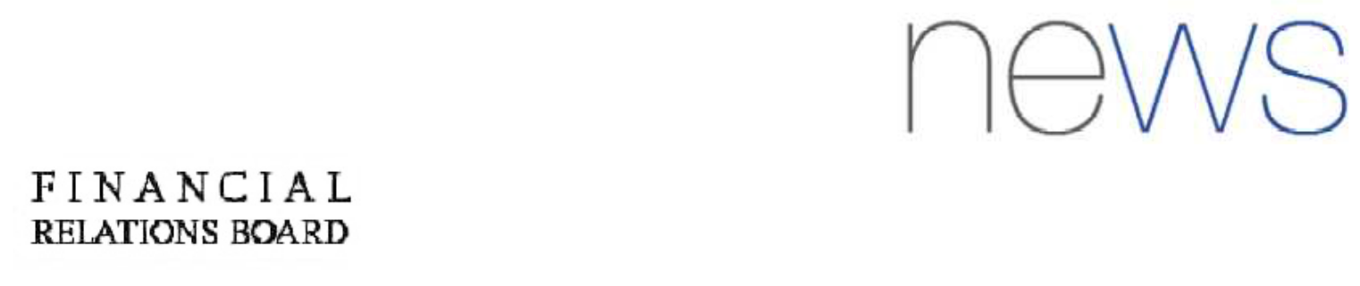

 |  |  |  |  | Exhibit 99.1
FOR FURTHER | INFORMATION:
AT THE COMPANY: |  |  | AT FINANCIAL RELATIONS BOARD
Will Kelly |  |  | Alison Ziegler |  | Susan Garland
Treasurer & | Manager of Investor Relations |  | (General info) |  | (Analyst info)
(423) 743-9151 |  |  | 212-445-8432 |  | 212-445-8458
FOR IMMEDIATE RELEASE
December 3, | 2003

NN, INC. RECEIVES NASDAQ NOTIFICATION RELATED
TO DELAYED 10-Q FILING

Johnson City, Tenn -December 3, 2003- NN, Inc. (Nasdaq: NNBR) today announced that on November 21, 2003 the Company announced that it had delayed the filing of its third quarter Form 10-Q due November 14, 2003 pending the resolution of the accounting treatment related to two historical minority interest purchase transactions.

- announced today that it has received a notice from The Nasdaq Stock Market that the Company is currently in violation of Marketplace Rule 4310(c)(14) due to the Company's failure to file its quarterly report on Form 10-Q for the period ended September 30, 2003. Accordingly, Nasdaq has changed the Company's trading symbol from "NNBR" to "NNBRE" to reflect the Company's filing delinquency and according to standard practice and has advised the Company that its common stock is subject to delisting effective December 5, 2003, which will be stayed pending a hearing with the Nasdaq Listing Qualifications Panel which has been requested by the Company. Until the decision by the Hearing Panel, the Company's common stock will continue to trade on the Nasdaq NMS without interruption. The Company and its auditor continue to work together to conclude the necessary research related to the accounting treatment of the indicated purchase transactions in an effort to resolve the issue as quickly as possible.

NN, Inc. manufacturers and supplies high precision bearing components, consisting of balls, rollers, seals and retainers, for leading bearing manufacturers on a global basis and had sales of US $193 million in 2002.

